# **Team Control #18020712**

Economic growth has always been the important consideration and goal for governments around the world. This therefore draw force a series of questions concerning growth itself. This paper is thus designed to build a model that can econometrically describe growth using past data, calculate the impact of education, and estimate whether 7% growth is possible for the Chinese economy for the next 20 years.

The first part of our model deals with the question of building an econometric model to empirically describe economic development, especially the relationship between education and development. As the economy is buildup of multiple elements, we first determine the main factors influencing the economy, with the example of education as the independent variable to the model. Then we select 24 countries in the world that are representative accordingly. Utilizing the method of *multi factor linear regression* to historic data in a stable period of 25 years, we ascertain the correlations between growth and the selected factors in a universal model.

The result of the regression is not satisfying because of the huge differences between countries. Thus, we divide the basket of selected countries into three categories based on income level and proceed with the regression process respectively. This gives us three precise models. **Specifically, in middle-income countries, the effect of education to growth is positive and highly significant (with the highest coefficient of 1.53), yet the impact of labor force is slightly negative (the ratio is -1.1).**

The second part of our model mainly deals with predictions to future growth.

Firstly, we use the coefficients of the factors in the previous model to determine how important education is to the economy in future years. **We find out that in low and middle-income countries, the coefficient for education is 0.09 and 1.53, the highest among all coefficients, meaning that the impact of education is the most important boost and greatly significant. In rich countries, however, education’s boost seems to have reached its “bottleneck” as its coefficient drops to 0.06.**

For the second part on estimating future growth rates, we use the *ARIMA Model*, a non-linear recursive prediction model, to first expand the time series of the factors in the previous model. By doing this, we can calculate and predict the data of education, endowment, etc. in the future 20 years. Putting the data into the previous regression model, we can calculate the future growth rate. **The result is GDP growth rate would first increase to approximate 10% and slowly decline throughout the two decades.**

For the third part, estimating whether 7% is possible, we substitute the 7% rate and other expanded factors’ data into the function, calculating the value that *Education Index* should be if 7% is to be guaranteed. As China would enter the ranks of high-income country in 5 years, the prediction utilizes two separate models. **The result shows that through large educational improvement, 7% growth can be guaranteed.**

Combining the factors above, we give out several suggestions to the Chinese government, including developing education and solving unemployment.

At the end of this paper, we analyze the strengths and weaknesses of our model, including but not limited to feasibility, efficiency and authenticity of our model.

**Introduction**

Economic growth has always been the important consideration and goal for governments around the world. This expectancy, importance and the complexity of the economy therefore leads to a series of questions concerning growth itself. This paper is thus designed to build a model that can econometrically describe growth using past data, calculate the impact of education, and estimate whether 7% growth is possible for the Chinese economy for the next 20 years.

**Restatement**

* The first question requires our team to provide a model to econometrically describe economic growth, using independent variables including education, population and other factors.
* In the second question, our team is asked to use the model in the first question to analyze how education affects the economic growth in the future, evaluate whether it is plausible for China to maintain an economic growth of 7% in the following 20 years and to offer suggestions to the Chinese Government on this issue.

**Definition of Important Terms**

**Capital Endowment**: the amount of [land](https://en.wikipedia.org/wiki/Land_(economics)), [labor](https://en.wikipedia.org/wiki/Labour_(economics)), [capital](https://en.wikipedia.org/wiki/Capital_(economics)) that a country possesses and can be exploited for [manufacturing](https://en.wikipedia.org/wiki/Manufacturing)

**Labor Force**: Labor force comprises people ages 15 and older who supply labor for the production of goods and services during a specified period. It includes people who are currently employed and people who are unemployed but seeking work as well as first-time job-seekers. Not everyone who works is included, however. Unpaid workers, family workers, and students are often omitted, and some countries do not count members of the armed forces. Labor force size tends to vary during the year as seasonal workers enter and leave. [1]

**Arable Land Proportion**: Arable land refers to the share of land area that is arable, under permanent crops, and under permanent pastures. Arable land includes land defined by the FAO as land under temporary crops (double-cropped areas are counted once), temporary meadows for mowing or for pasture, land under market or kitchen gardens, and land temporarily fallow. Land abandoned as a result of shifting cultivation is excluded. Land under permanent crops is land cultivated with crops that occupy the land for long periods and need not be replanted after each harvest, such as cocoa, coffee, and rubber. This category includes land under flowering shrubs, fruit trees, nut trees, and vines, but excludes land under trees grown for wood or timber. Permanent pasture is land used for five or more years for forage, including natural and cultivated crops.[2]

**General Assumption and Justifications**

* **Assumption I**: War, political crisis, huge natural disasters, systematic financial crisis and phenomena that have a low possibility of occurring in today yet might cause huge destruction to the world economy is not considered in the model.

**Justification**: The events stated in Assumption I are rare, hard to predict, yet may cause catastrophic damage and fluctuation to economic development and growth. Thus, it is a surplus to consider it.

* **Assumption II**: A country’s governance index can be seen as a constant in the future 20 years.

**Justification**: As according to historic data published by the World Bank[3], a country’s governance do not change significantly throughout the past decades. And also as there is no justification to believe that a country’s governance moves in a specific trend (it is mainly influenced by election results), it is justifiable to see it as a constant that seldom fluctuates in the future 20 years.

* **Assumption III**: Economic growth and the factors relating to it have an approximate linear relationship.

**Justification**: Previous works done by Buyuan Zhang[4], Jing Wen[5], Fang Guo[6] all adopt the assumption of linear relationship between studied factors and growth. Thus, it is justifiable to adopt the same assumption that the relationship is linear.

**Symbols**

**Table 1 Symbols**

|  |  |
| --- | --- |
| Symbols | Meaning |
| *G* | GDP growth |
| *ALP* | Arable land proportion to a country’s total land |
| *EI* | Education Index |
| *FLP* | Forest land proportion to a country’s total land |
| *LF* | Labor force (defined in the definition section) |
| *PGDP* | Previous year GDP |
| *POP* | Population |
| *GOV* | Government Efficiency Index |
| *C* | Regression constant |
| *X* | A vector that includes all independent variables |
| *a* | A vector that includes all the coefficient for the variables |

**Analysis of the Model**

**1. Model for the First Question**

For the first question on building an econometric model to describe growth, we are required to give out a function that can describe economic growth based on a cluster of other factors. Econometrics is defined as the application of statistical methods to economic data that aims to give empirical content to economic relations. As we need to determine the relationship between different economic indicators, the idea of using the method of multi factor linear regression naturally come to mind.

*1.1 Determine the factors*

In order to regress and calculate the function, we need to first determine the factors that are needed. The initial GDP per capita, used to represent the base for economic development, is a key factor that determines the baseline for a countries development. Education, as according to Sameeo Sheesh et al. at the BRAC University, have a high influence on the economy and especially in Medium-Income Countries[7]. Factor endowment, as defined as the amount of [land](https://en.wikipedia.org/wiki/Land_(economics)), [labor](https://en.wikipedia.org/wiki/Labour_(economics)), [capital](https://en.wikipedia.org/wiki/Capital_(economics)) that a country possesses and can be exploited for [manufacturing](https://en.wikipedia.org/wiki/Manufacturing)[8], is also highly related to economic growth as according to Natasha Xingyuan Che from the IMF.[9] Governance, a factor indicating a country’s government’s effectiveness and efficiency is also crucial in discussing economic growth states a paper from the World Bank Institute.[10] Population should also be considered as it decides the scale of a country’s development.

For initial income level, we use the previous years’ GDP per capita as the indicator.

As there is not a direct index or variable to represent capital endowment directly, we split this variable into multiple factors, including a country’s labor force, arable land and forest land’s percentage to total land.

For education, we use the *United Nations Education Index*, an index indicating the average years of education a country’s people is estimated to receive at a given year. The index is a number in the range [0, 1] that considers the mean years and expected years of schooling for a country’s citizens.

For governance, we use the *Government Efficiency Index* published by the World Bank to show how effective the country’s government is.

The other factors including population is described using data from the world bank.

*1.2 Preprocess the data*

Before going through the regression process, we need to pre-process our data.

We first determine the year span that we need to consider. As according to the Heritage Foundation [11], the first part of the 20th Century is not a good period to study as the huge fluctuation on the economy caused about by the two world wars is greatly distracting to a model aimed at predicting future growth in peace times. The middle and last part of the 20th Century is also a bad choice as the Cold War, a rare political event that has a huge and possibly negative effect on economic growth, is also not relevant to the 21th Century. Thus, we select the period between 1990 to 2014, a span of 25 years that avoids massive political events and huge scale wars as many as possible.

Also, as there is no point in processing every single country in the world, we select some of the most representative countries out of the entire more than 200 countries. In such a process we need to select countries from all regions, with all levels of income and sufficient statistical data (countries with the example of South Africa have large pieces of data missing in the late 20th century). In the end, we select 24 countries throughout the world including Albania, Australia, Bolivia, Brazil, Botswana, Canada, Chile, China, Democratic Republic of Congo, Germany, Egypt, United Kingdom, Haiti, India, Indonesia, Iran, Italy, Japan, Kazakhstan, Mexico, Russia, Saudi Arabia, Sweden and United States of America. These countries are all representative in there all way. The Democratic Republic of Congo, for example, is a representative for low income countries and African countries while Kazakhstan is a typical Central Asian country with middle income. We extract the data from the 24 countries, forming the ones we need to process.

As data in some countries are not complete and some even lack specific statistical data in certain years, we use spline curves to fit the data points as a function of time and to interpolate the data points in the middle that are missing. Spline curves are utilized because the indicator of data fitness, *R2*, should exceed a certain leverage to be acceptable, and spline curves’ *R2* could exceed 0.95 in this specific scenario. By utilizing this method, we fill the gaps in the data matrices. An example of this process is demonstrated in Graph 1 and Table 2 below using China’s Education data.

**Table 2 Data Before Interpolation**

|  |  |  |  |  |  |  |
| --- | --- | --- | --- | --- | --- | --- |
| Year | 1990 | 1995 | 2000 | 2005 | 2006 | 2007 |
| *EI* | 0.406 | 0.436 | 0.478 | 0.531 | 0.544 | 0.561 |
| Year | 2008 | 2009 | 2010 | 2011 | 2012 | 2013 |
| *EI* | 0.575 | 0.590 | 0.599 | 0.610 | 0.610 | 0.610 |

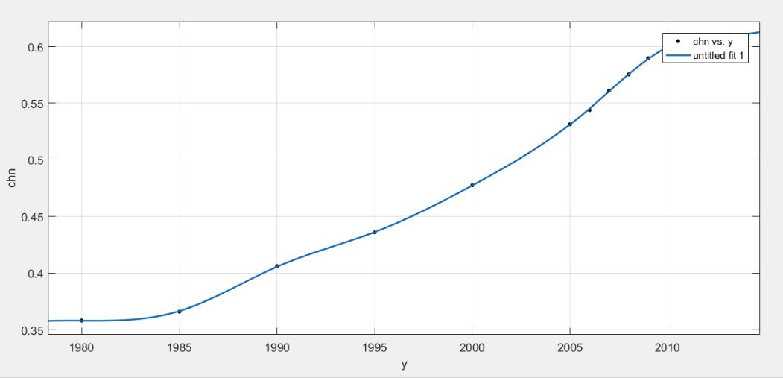

**Graph 1 Spline Fitting Curves**

Then we go through a process of data standardization. This process is necessary as variables with different dimensions have no meaning when calculating. Also, to narrow the influence brought about by the difference of inherently large and small numbers (population might seem to have a smaller impact than education simply because of its large scale), we map all data points into the interval [0, 1].

For most *PGDP*, we first calculate the difference between a country’s specific data and the mean of all 24 countries and year span of 25 years before dividing it by the range of the 24ⅹ25 variables. The expression of the standardization process is shown below:

$$y_{ij}= \frac{x_{ij}-m_{s}}{M_{s}-m_{s}}$$

In which:

$$m_{s}=\min_{p ∈\left[1, 24\right], q ∈\left[1, 25\right] p, q∈Z }{x_{pq}}$$

$$M_{s}=\max_{p ∈\left[1, 24\right], q ∈\left[1, 25\right] p, q∈Z }{x_{pq}}$$

As the *Education Index* is already a number in the interval [0, 1], *EI* does not need to be changed.

To demonstrate the population growth relative to the global average, we standardize the factor indicating population, which is to calculate the proportion of the country’s population to the total sum of the population in 24 countries. The expression is shown in the expression below:

$$POP= \frac{POP}{Total sum of population in 24 countries}$$

*LF* is standardized by dividing it to the country’s total population.

*1.3 Regress of a universal model*

The process of the MATLAB program that regresses the data is shown in the flowchart below.



**Graph 2 Regression Flowchart**

We then use MATLAB to carry out the regression process using data from all 24 countries we chose, we reached the result that 202 of the 24ⅹ25 data points’ confidence interval is not acceptable. Even though certain data points can be explained using international political, environmental and other extreme events, the number of data points erased is a little too much to be acceptable. Thus, we concluded that a universal model is not the best fit to represent the function and therefore cannot be applied. To countries of different levels of development, the impact of these independent variables on their GDP growth rates should vary.

*1.4 Regression of three separate models*

Based on the average income level of the 24 countries, we divide the countries into three categories. According to the World Bank, countries in the world are separated into low-income countries, lower-middle income countries, upper-middle income countries and high-income countries[12]. Countries that belong to low-income countries or lower-middle income countries are put in the first category. Those with upper-middle income countries are put in the second category. Countries that belong to high-income countries are put in the third category. The result of the categorization is listed in Table 3:

**Table 3 The Three Category of Countries Divided by Income**

|  |  |  |
| --- | --- | --- |
| *Category I: Low and Lower-Middle Income Countries* | *Category II: Middle Income Countries* | *Category III: High-Income Countries* |
| Bolivia | Albania | Australia |
| Congo, Democratic Republic | Brazil | Canada |
| Egypt, Arab Republic | Botswana | Germany |
| Haiti | Chile | United Kingdom |
| Indonesia | China | Italy |
| India | Iran, Islamic Republic | Japan |
|  | Kazakhstan | Saudi Arabia |
|  | Mexico | Sweden |
|  | Russia | United States of America |

Then we calculate the regression model with the three specific categories, reaching the result. The expression of the model is shown as below:

$$X= (ALP, EI, FLP, LF, PGDP, POP, GOV,1)$$

$$a=(a_{1}, a_{2}, a_{3}, a_{4}, a_{5}, a_{6}, a_{7}, C)$$

$$G= a∙X^{T}$$

**2. Model for the Second Question**

*2.1 Impact of education on the economy*

We use the coefficient of the factors in the previous model to determine how important education is to the economy in future years. As the coefficients of the model will not change along with time, the impact would be similar.

*2.2 Expanding time series*

For the question on predicting future growth, we are required to forecast future growth on the base of present data, more specifically education. This requires us to extend our present data into future times and, in other words expand the time series of historical data of all the factors utilized. To achieve this, we use a version of the *ARIMA Model*, or the *Autoregressive Integrated Moving Average Model*, because ordinary regression models have flaws and cannot be used to predict time series. If a series of data is not *statistically stable*, or if the series of averages, variances and covariances is related to time, the result of the regression has a huge probability of being spurious. A good example is that the height of a growing tree and the amount of a developing countries’ economy may have a high match as the growing trend is similar even though the two phenomena have no connection.

The *ARIMA* *Model* is a non-linear recursive model used to analyze the trend of a particular discrete variable $x$. Let $x_{t}$ denote the value of variable $x$ at the $t^{th}$ data point.

First of all, we compute the difference of variable $x$ to the order of *d,* and we then obtain sequence $∆^{d}x_{t}$, in which *d* is the smallest integer that satisfies that $∆^{d}x$ is *statistically stable.*

Then, we determine the parameter $p$, where $p$ represents the lags of the time series data. Thus, the autoregression expression can be written as: $$∆^{d}x_{t}=ε_{t}+\sum_{j=1}^{p}{{(∆}^{d}x_{t-j}ϕ_{j})}$$

In this expression, $ϕ_{j}$ is an undetermined coefficient, and $ε_{t}$ denotes the residual at the $t^{th}$ data point.

However, in many cases, $∆^{d}x_{t}$ has certain correlation with residuals. We assume $ε_{t-1}, ε_{t-2},… ,ε_{t-q}$ have influence on the value $∆^{d}x_{t}.$ Therefore, we put $q$ additional terms containing $ε_{t-1}, ε_{t-2},… ,ε_{t-q}$ respectively to the original formula and generates the expression below:

$$∆^{d}x_{t}=ε_{t}+\sum_{j=1}^{p}{{(∆}^{d}x_{t-j}ϕ_{j})}+\sum_{j=1}^{q}{(\left(ε_{t-j}\right)}θ_{j})$$

In this expression, $θ_{j}$ is an undetermined coefficient.

Through regression, for any integer *t*, the values for $ϕ_{1}, ϕ_{2}, …, ϕ_{p}$ and $θ_{1},θ_{2}, …, θ_{q}$ can be determined.

The flow chart of the MATLAB program to run the *ARIMA Model* is shown in the flowchart below.

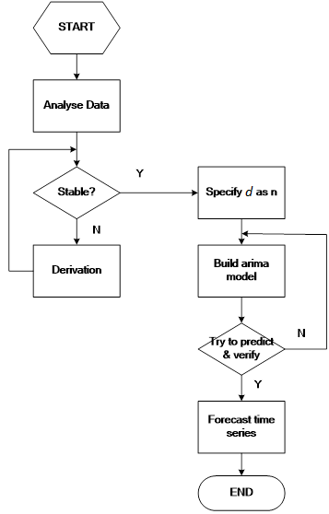

**Graph 4 Expand Time Series Flowchart**

A test of the *ARIMA Model* can be shown in Graph below.

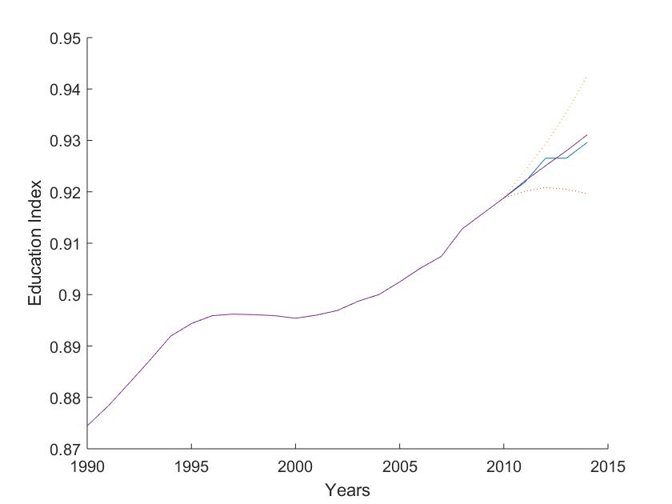

**Graph 5 Test of the *ARIMA Model***

Using the data of the *Education Index* from the past 20 years and use it to predict the data in the last 4 years and then compare it to the real data. The purple curve in Graph is the predicted data, while the blue curve is the actual data. The curve is reached with $p = 4, d = 3, q = 2$. The high fit between the two curves show that the model is appropriate.

*2.3 Forecast GDP growth*

After expanding the time series, we need to give out a forecast of future GDP growth. This can be achieved by substituting the expanded time series into the previous model, therefore reaching the result.

*2.4 Calculate the feasibility growth*

Then, we need to answer the question of whether 7% growth is achievable by adapting the level of education in a reasonable range. We first assume that 7% growth is reachable. This requires us to substitute the other value into the model, then in turn solving it to calculate the level of the Education Index needed to achieve the proposed growth. With the targeted GDP growth in mind, we can substitute the 7% growth into the model. Thus, we now have got all the other data in the equation except education.

**Solving the Model**

**1. Solving the First Question**

*1.1 Data processing*

We first gather the data that is needed, data sources include the World Bank (data of the countries’ initial GDP, governance, population, labor force, forest and arable land proportion) and the United Nations (*United Nations Education Index*). An example of the transformation of the agricultural data in Albania is shown below in Table 4.

**Table 4 Standardization of data**

|  |  |  |
| --- | --- | --- |
| Year | *ALP* before | *ALP* after |
| 1990 | 40.91241 | 0.4091241 |
| 1991 | 41.13139 | 0.4113139 |
| 1992 | 41.13139 | 0.4113139 |
| 1993 | 41.09489 | 0.4109489 |
| 1994 | 41.09489 | 0.4109489 |
| 1995 | 41.13139 | 0.4113139 |
| 1996 | 41.27737 | 0.4127737 |
| 1997 | 41.42336 | 0.4142336 |
| 1998 | 41.56934 | 0.4156934 |
| 1999 | 41.78832 | 0.4178832 |
| 2000 | 41.75182 | 0.4175182 |
| 2001 | 41.56934 | 0.4156934 |
| 2002 | 41.60584 | 0.4160584 |
| 2003 | 40.91241 | 0.4091241 |
| 2004 | 40.94891 | 0.4094891 |
| 2005 | 39.30657 | 0.3930657 |
| 2006 | 40.87591 | 0.4087591 |
| 2007 | 40.83942 | 0.4083942 |
| 2008 | 43.10219 | 0.4310219 |
| 2009 | 43.84307 | 0.4384307 |
| 2010 | 43.84307 | 0.4384307 |
| 2011 | 43.83212 | 0.4383212 |
| 2012 | 43.84307 | 0.4384307 |
| 2013 | 43.33212 | 0.4333212 |
| 2014 | 42.85730 | 0.4285730 |

The data in the left row is the original data, while the data in the right row is the data after standardization.

*1.2 Regression of the universal model*

The data then go through the process of linear regression model to fit the function. The result of the first regression process is shown in Graph below.

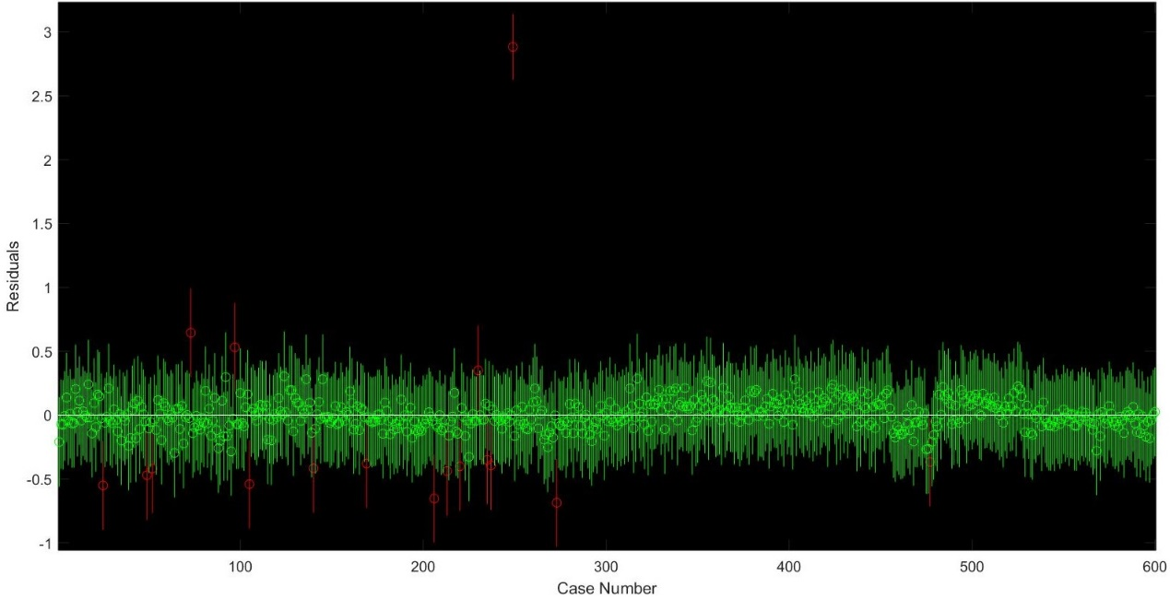

**Graph 6 Original Residual Map**

If the residual of a specific data point does not include the predicted value, in other words the *confidence interval* does not include 0, this data point should not be considered and therefore deleted. After each regression process, we delete the data point which has the largest residual and carry out the linear regression again. This process is repeated for a certain number of times until the residual of every data point is reliable. Eventually, 202 of the 600 data points are deleted. This final residual graph is shown below:

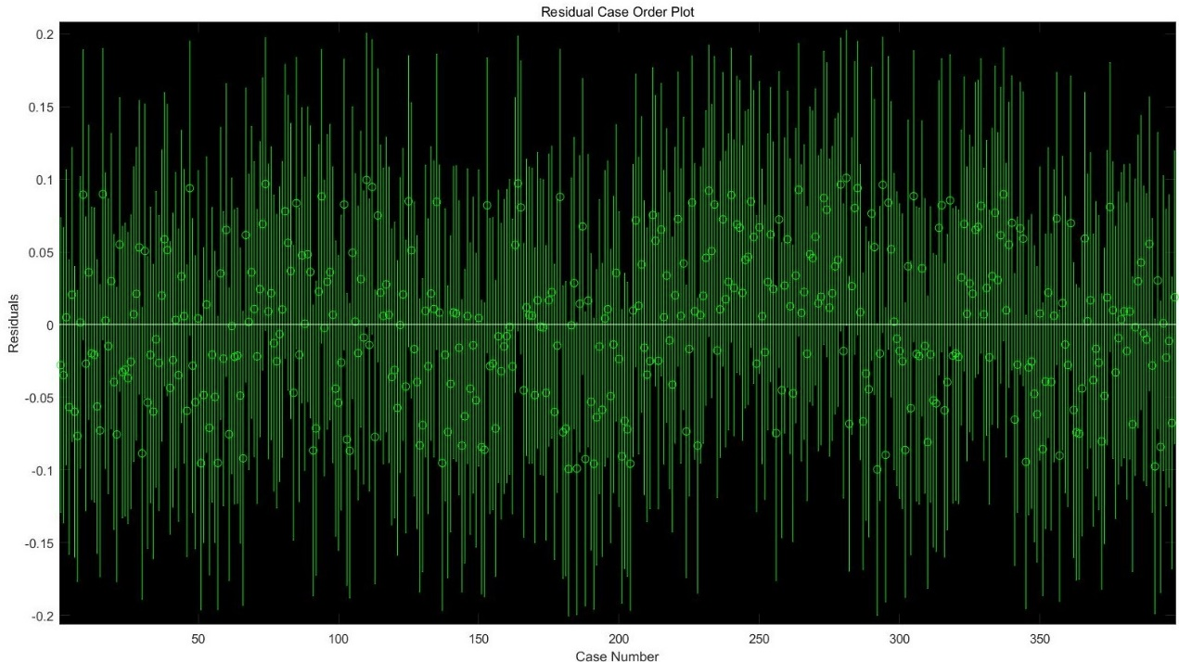

**Graph 7 Final Residual Map**

We then analyze the 202 deleted data points and check if any unpredictable incidents happened to the country in that particular year. We found out that most deviated data points are results of warfare, financial crisis and natural disasters.

For instance, the residual of Congo in 2000 is 2.6274, while the residual at 2001 is 0.3886. This huge deviation is a result of the Second Congo War lasting from 1998 to 2003. In 2000, both sides reached a ceasefire agreement, and Congo’s economy underwent a sudden boom, increasing from 102 dollars to 405 dollars per capita. However, in 2001, after the assassination of President Laurent-Désiré Kabila, the war restarted, and Congo’s economy fell rapidly, decreasing to 153 dollars per capita. [13] As these steep changes are caused by political changes with low possibility, the data is not relevant and can be ignored.

Another example is the Ruble Crisis that occurred in Russia during late 1990s[14]. This caused the residual of Russia in 1998 to be an abnormal 0.2080. Systematic financial risks of low possibility that are hard to calculate and irrelevant today is the cause of this unusual change in trend, thus it could also be ignored.

An additional example is the Hurricane Katrina in the US. This event caused a significant decline in the figure of the US’s GDP per capita[15]. The residual at this data point is 0.0127. Natural Disasters like this are incidental and can’t be predicted. Thus, neglecting data like this is justified.

Even if some data points can be reasonably neglected because of Assumption I, the number of the neglected points is a little bit too much to be satisfying.

*1.3 Regression of the separate model*

1.3.1 Low and lower-middle income model

In the lower and lower-middle income model designed of countries in *Category I*, the values of the coefficients are:

$$\left\{\begin{aligned}a_{1}=-0.4468 \\ a_{2}=0.0944 \\ a_{3}=0.5658 \\ a_{4}=0.0000 \\ a_{5}=0.0215 \\ a_{6}=0.7264 \\ a_{7}=0.0484 \\ C=-0.0883\end{aligned}\right.$$

Therefore, it can be inferred from this expression that labor force is slightly negatively affecting the economic growth. As labor force contains both the employed and the unemployed at a certain age.[1] In these low-income and middle-income states, a considerable fraction of the labor force remains unemployed. For example, the unemployment rate in Botswana, Brazil and Haiti is 13.8%, 10.1% and 13.0%,[16] respectively. With the low-income level and poor economic condition in mind, the unemployed population has a high possibility of becoming criminals, causing harm to the society rather than good. This logic could be used to explain the negative coefficient of the labor force

1.3.2 Middle income model

In the model of countries in Category II, the values of the coefficients are:

$$\left\{\begin{aligned}a_{1}=0.158156 \\ a_{2}=1.527256 \\ a_{3}=0.306215 \\ a_{4}=-1.0677 \\ a_{5}=-0.27165 \\ a_{6}=1.023103 \\ a_{7}=-0.01159 \\ C=-0.48658\end{aligned}\right.$$

The circumstance for countries in this category is in some ways similar to the ones in the previous category, only the impact of education is more significant (1.53), probably because of the refinement of infrastructure and other basic necessities. As basic infrastructure and country building increase in these countries, the impact of education increases and result in the coefficient of 1.53. Labor force on the other hand is still slightly negative with the same reason in low income countries.

1.3.3 High income model

In the model of countries in *Category III*, the values of the coefficients are:

$$\left\{\begin{aligned}a_{1}=0.052308 \\ a_{2}=0.066746 \\ a_{3}=0.126723 \\ a_{4}=0.01278 \\ a_{5}=0.057036 \\ a_{6}=0.036103 \\ a_{7}=-0.01876 \\ C=-0.03798\end{aligned}\right.$$

Therefore, it can be inferred from this expression that labor force is a vital factor that positively affects the economic growth in developed states as its coefficient $a_{4}$ reached 1.27. We conclude that in high-income countries, the level of education is usually high, ergo every single labor force creates a relatively high wealth. In contrast, education seems to have reached its “bottleneck” and does not make that a significant impact to GDP growth rates because in these countries, education is extremely developed, and the differences of these figures are not significant.

**2. Solving the Second Question**

*2.1 Education’s future impact on economic growth*

We find out that in low and middle-income countries, the coefficient for education is 0.09 and 1.53, the highest among all coefficients, meaning that the impact of education is the most important boost and highly significant. In rich countries, however, education’s boost effect seems to have reached its “bottleneck” as its coefficient drops to 0.06.

*2.2 Forecasting GDP growth*

The result of future GDP growth is shown in Table 5 and Graph 8.

**Table 5 GDP Future Growth Rate**

|  |  |  |  |
| --- | --- | --- | --- |
| Year | Growth Rate | Year | Growth Rate |
| 2018 | 13.85% | 2028 | 3.27% |
| 2019 | 12.30% | 2029 | 2.86% |
| 2020 | 10.79% | 2030 | 2.51% |
| 2021 | 9.36% | 2031 | 2.21% |
| 2022 | 8.06% | 2032 | 1.95% |
| 2023 | 6.91% | 2033 | 1.72% |
| 2024 | 5.91% | 2034 | 1.51% |
| 2025 | 5.07% | 2035 | 1.32% |
| 2026 | 4.36% | 2036 | 1.15% |
| 2027 | 3.77% | 2037 | 0.98% |

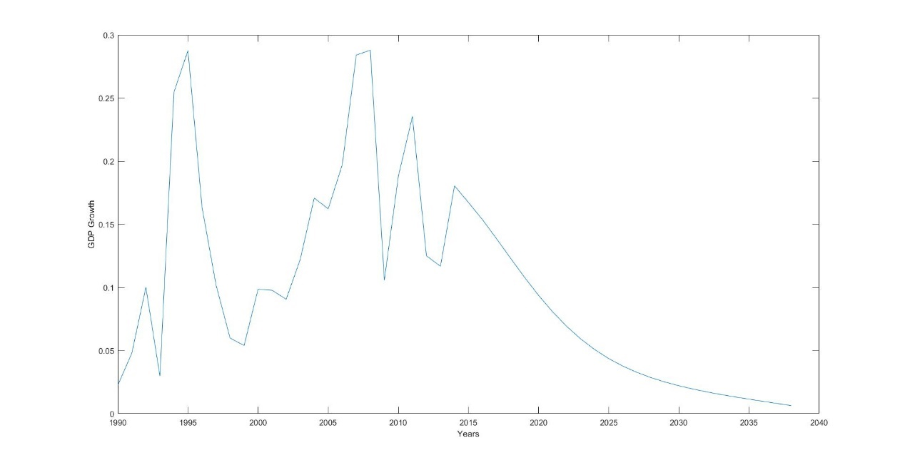

**Graph 8 GDP Growth Rate**

The forecasted GDP is shown in Table 6 and Graph 9.

**Table 6 Future GDP Per Capita**

|  |  |  |  |
| --- | --- | --- | --- |
| Year | GDP | Year | GDP |
| 2018 | $13,902.99 | 2028 | $27,196.43 |
| 2019 | $15,613.64 | 2029 | $27,973.25 |
| 2020 | $17,297.85 | 2030 | $28,674.37 |
| 2021 | $18,916.51 | 2031 | $29,307.42 |
| 2022 | $20,440.71 | 2032 | $29,878.58 |
| 2023 | $21,852.80 | 2033 | $30,392.60 |
| 2024 | $23,145.34 | 2034 | $30,852.90 |
| 2025 | $24,318.83 | 2035 | $31,261.70 |
| 2026 | $25,379.11 | 2036 | $31,620.15 |
| 2027 | $26,334.99 | 2037 | $32,391.59 |

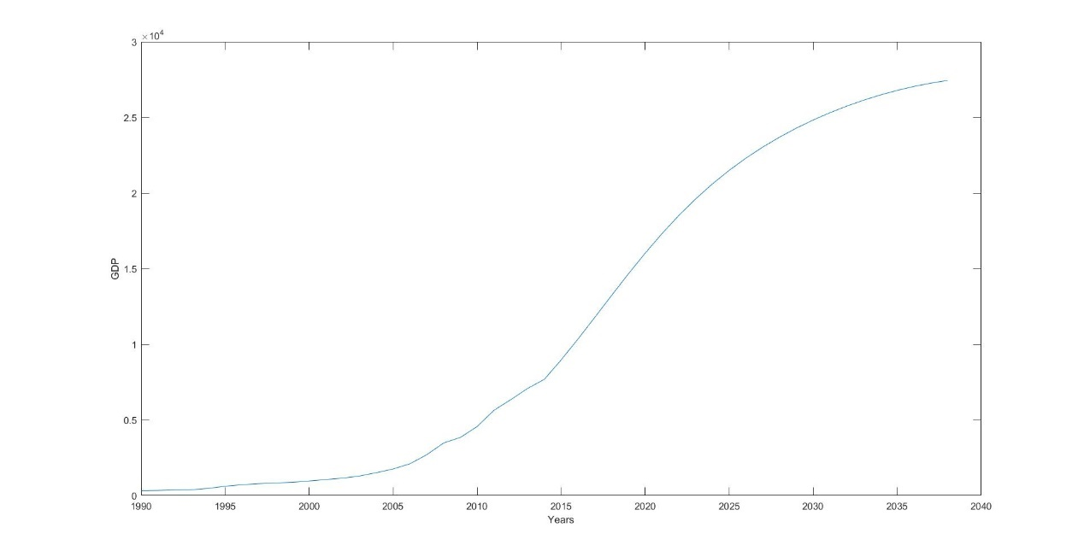

**Graph 9 GDP Per Capita**

As the coefficients fluctuates in a region, it is possible that GDP growth will fluctuate in a region, it is also possible that the growth rate and GDP will fall into the upper and lower area on Graph 8 and 9.

*2.3 Determining whether 7% is possible*

In this section, we need to consider two scenarios, the first when China is a Medium-Income country, the second when China reached the leverage between medium and high-income and become a high-income country. Thus, the result is divided into two sections. From the section above, we observe that after 5 years, in 2022, China would enter the ranks of a high-income country, thus we need to apply the high-income model and to analyze the data.

The Education Index needed to achieve 7% growth in the medium-income model is shown in Table 7 and Graph 10.

**Table 7 *Education Index***

|  |  |  |  |
| --- | --- | --- | --- |
| Year | GDP | Year | GDP |
| 2018 | 0.576109089 | 2028 | 0.701013508 |
| 2019 | 0.584397313 | 2029 | 0.719872452 |
| 2020 | 0.593463251 | 2030 | 0.740210285 |
| 2021 | 0.60335978 | 2031 | 0.762126523 |
| 2022 | 0.614142598 | 2032 | 0.785728249 |
| 2023 | 0.625870539 | 2033 | 0.811130819 |
| 2024 | 0.638605924 | 2034 | 0.838458658 |
| 2025 | 0.652414963 | 2035 | 0.867846131 |
| 2026 | 0.667368176 | 2036 | 0.89943852 |
| 2027 | 0.683540847 | 2037 | 0.93339312 |

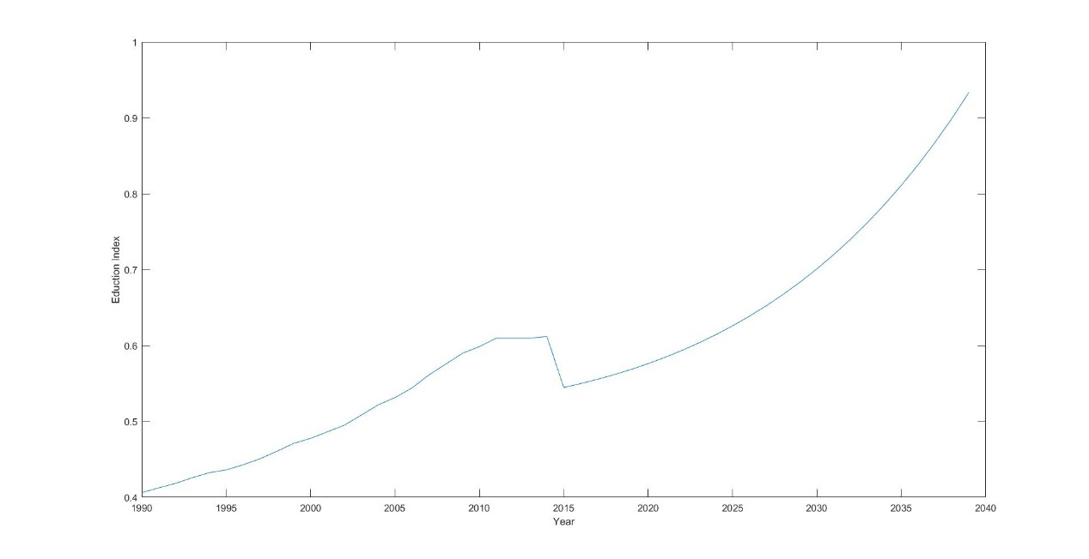

**Graph 10 *Education Index* in the Medium-Income scenario**

In the medium-income scenario, we can see that the level of education needed is in a reasonable level, in other words, the 7% growth rate is achievable in the medium-scenario, in other words the first 5 years.

As the relationship between education and growth is lower in the high-income scenario, the Education Index would definitely be in an acceptable range.

*2.4 Suggestions to the Chinese government*

Based on the results we concluded from the model and the current situation of China, we provide the following suggestions to the Chinese Government.

First, according to the linear regression formula for middle-income states, education is strongly and positively correlated with economic growth (the coefficient is 1.53). Thus, in order to promote economic growth in China, the most straightforward and effective way is to invest in education.

Also, we discovered that, in many cases, such as in Brazil and Haiti, labor force is actually negatively related to growth. This is caused by high unemployment which is actually causing harm to the economy as the unemployed population are potential criminals. Nowadays, China’s college graduates are struggling to find a job. More than 10% of Chinese college graduates remain unemployed. The Chinese Government should take certain measures to improve the marketization of education. Such practices can not only solve the problem of unemployment but also put advanced labors into the society, creating more wealth to the country.

**Strengths and Weaknesses**

**1. Strengths**

* Our model provides separate developmental models for countries of different income levels. The accuracy of this econometric model is higher than a universally-applied model, which makes it more convenient for governments to draft their distinctive policies according to the current circumstance of the particular country.
* Our analyzed data from multiple representative countries throughout the world and abundant data that is relatively stable.
* Our prediction model used to expand the time series, is based on the *ARIMA* model, which is a better prediction than ordinary linear regression.
* Our model is highly relevant to the future decades and is meaningful to the present.

**2. Weakness**

* Even though real-life scenarios including warfare, systematic financial crisis and natural disasters are important constraints of economic growth have low possibility of occurring. Our model does not take the factors above into account and is unable to predict the happening of such events.
* Different administrations have different levels of governance. As this model cannot predict results of future elections, we can only assume the governance of a certain country is a fixed value, whereas in reality the governance index will unavoidably alter.

**References**

[1] World Bank

https://data.worldbank.org/indicator/SL.TLF.TOTL.IN

[2] World Bank

https://data.worldbank.org/indicator/AG.LND.ARBL.ZS

[3] World Bank

<https://data.worldbank.org/data-catalog/worldwide-governance-indicators>

[4]张卜元，刘冰冰，张东旭. 我国国内生产总值影响因素实证分析.

[5]文静. 影响国内生产总值的因素分析.

[6]郭芳，冷洛. 国内生产总值影响因素的计量分析.

[7] Sameeo Sheesh et al.

<https://www.scribd.com/document/51770711/the-relationship-between-education-index-and-gdp-index>

[8] M. Hashem Pesaran (1987). "Econometrics," The New Palgrave: A Dictionary of Economics, v. 2, p. 8 [pp. 8–22].

[9] Natasha Xingyuan Che. Factor Endowment, Structural Coherence, and Economic Growth

<http://www20.iadb.org/intal/catalogo/PE/2012/12077.pdf>

[10] World Bank Institute

<http://siteresources.worldbank.org/INTWBIGOVANTCOR/Resources/1740479-1149112210081/2604389-1149699431307/edouardpresentation_munich_inwent.pdf>

[11] Heritage Foundation

<http://www.heritage.nf.ca/articles/politics/economic-impacts-wwii.php>

[12] <http://chartsbin.com/view/2438>

# [13] [Walter C.Soderlund](http://muse.jhu.edu/results?section1=author&search1=Walter%20C.Soderlund), [E. Donald Briggs](http://muse.jhu.edu/results?section1=author&search1=E.%20DonaldBriggs), [Tom Pierre Najem](http://muse.jhu.edu/results?section1=author&search1=Tom%20PierreNajem), [Blake C.Roberts](http://muse.jhu.edu/results?section1=author&search1=Blake%20C.Roberts). Africa’s Deadliest Conflict, Media Coverage of the Humanitarian Disaster in the Congo and the United Nations Response, 1997–2008.

# [14] Abbigail J. Chiodo and Michael T. Owyang. A Case Study of a Currency Crisis: The Russian Default of 1998. <https://files.stlouisfed.org/files/htdocs/publications/review/02/11/ChiodoOwyang.pdf>

# [15] Hurricane Katrina: A Nation Still Unprepared

<https://www.gpo.gov/fdsys/pkg/CRPT-109srpt322/pdf/CRPT-109srpt322.pdf>

[16] World Bank

https://data.worldbank.org/indicator/SL.UEM.TOTL.ZS

Appendix

Education Index

Each set of data is listed under the order of time from 1990 to 2014

|  |  |  |  |  |  |  |
| --- | --- | --- | --- | --- | --- | --- |
| ALB | Albania | 0.537187 | 0.5351 | 0.533 | 0.5301 | 0.5287 |
| AUS | Australia | 0.874467 | 0.8783 | 0.8827 | 0.8872 | 0.8919 |
| BOL | Bolivia | 0.52785 | 0.5372 | 0.5457 | 0.558 | 0.571 |
| BRA | Brazil | 0.463059 | 0.4745 | 0.487 | 0.4982 | 0.5142 |
| BWA | Botswana | 0.45855 | 0.4686 | 0.4829 | 0.4979 | 0.5104 |
| CAN | Canada | 0.808756 | 0.8162 | 0.821 | 0.825 | 0.8268 |
| CHL | Chile | 0.625015 | 0.6249 | 0.6238 | 0.6201 | 0.6169 |
| CHN | China | 0.406144 | 0.4124 | 0.4183 | 0.4258 | 0.4324 |
| COD | Congo, Dem. Rep. | 0.253202 | 0.2556 | 0.2591 | 0.2631 | 0.2673 |
| DEU | Germany | 0.645878 | 0.6603 | 0.6763 | 0.7054 | 0.7246 |
| EGY | Egypt, Arab Rep. | 0.385544 | 0.3947 | 0.4061 | 0.4182 | 0.4279 |
| GBR | UK | 0.642178 | 0.665 | 0.6892 | 0.7256 | 0.7645 |
| HTI | Haiti | 0.284916 | 0.2896 | 0.2951 | 0.2981 | 0.3024 |
| IDN | Indonesia | 0.392867 | 0.3943 | 0.3971 | 0.4033 | 0.413 |
| IND | India | 0.31067 | 0.3165 | 0.3224 | 0.3282 | 0.3353 |
| IRN | Iran, Islamic Rep. | 0.381886 | 0.3954 | 0.4142 | 0.4392 | 0.4603 |
| ITA | Italy | 0.592051 | 0.6043 | 0.6136 | 0.6273 | 0.6381 |
| JPN | Japan | 0.699044 | 0.7073 | 0.7137 | 0.7216 | 0.731 |
| KAZ | Kazakhstan | 0.606267 | 0.6109 | 0.6162 | 0.6218 | 0.6286 |
| MEX | Mexico | 0.478678 | 0.4861 | 0.4909 | 0.4986 | 0.5052 |
| RUS | Russian Federation | 0.659578 | 0.6594 | 0.6584 | 0.6573 | 0.6579 |
| SAU | Saudi Arabia | 0.426673 | 0.4351 | 0.4463 | 0.459 | 0.4701 |
| SWE | Sweden | 0.692473 | 0.7085 | 0.7306 | 0.7514 | 0.7743 |
| USA | US | 0.833556 | 0.8415 | 0.846 | 0.8523 | 0.8581 |

|  |  |  |  |  |  |  |
| --- | --- | --- | --- | --- | --- | --- |
| ALB | Albania | 0.528694 | 0.5336 | 0.5398 | 0.5493 | 0.5572 |
| AUS | Australia | 0.894367 | 0.8959 | 0.8962 | 0.8961 | 0.8959 |
| BOL | Bolivia | 0.577001 | 0.5881 | 0.5972 | 0.6077 | 0.6174 |
| BRA | Brazil | 0.523538 | 0.5355 | 0.5482 | 0.5616 | 0.5728 |
| BWA | Botswana | 0.515944 | 0.5281 | 0.5395 | 0.5524 | 0.5651 |
| CAN | Canada | 0.826444 | 0.8214 | 0.8161 | 0.8108 | 0.8082 |
| CHL | Chile | 0.615244 | 0.6181 | 0.6234 | 0.6319 | 0.6408 |
| CHN | China | 0.436044 | 0.4428 | 0.4507 | 0.4606 | 0.471 |
| COD | Congo, Dem. Rep. | 0.271867 | 0.2775 | 0.2828 | 0.2881 | 0.294 |
| DEU | Germany | 0.7388 | 0.7499 | 0.7587 | 0.7707 | 0.7808 |
| EGY | Egypt, Arab Rep. | 0.433767 | 0.4322 | 0.4307 | 0.4292 | 0.4304 |
| GBR | UK | 0.791137 | 0.8069 | 0.8183 | 0.8292 | 0.8322 |
| HTI | Haiti | 0.307197 | 0.3118 | 0.3164 | 0.3208 | 0.3269 |
| IDN | Indonesia | 0.4242 | 0.4396 | 0.455 | 0.4758 | 0.5 |
| IND | India | 0.339489 | 0.3421 | 0.3446 | 0.3473 | 0.3523 |
| IRN | Iran, Islamic Rep. | 0.4766 | 0.4906 | 0.5023 | 0.5143 | 0.5217 |
| ITA | Italy | 0.650003 | 0.6608 | 0.667 | 0.6766 | 0.6845 |
| JPN | Japan | 0.739787 | 0.7468 | 0.7523 | 0.7591 | 0.7641 |
| KAZ | Kazakhstan | 0.633433 | 0.6405 | 0.6505 | 0.6599 | 0.6722 |
| MEX | Mexico | 0.511389 | 0.5175 | 0.5248 | 0.5314 | 0.5385 |
| RUS | Russian Federation | 0.659967 | 0.6686 | 0.6799 | 0.6941 | 0.711 |
| SAU | Saudi Arabia | 0.481593 | 0.5013 | 0.5176 | 0.5382 | 0.5536 |
| SWE | Sweden | 0.791593 | 0.8079 | 0.8279 | 0.8459 | 0.8582 |
| USA | US | 0.860811 | 0.8595 | 0.857 | 0.8543 | 0.8518 |

|  |  |  |  |  |  |  |
| --- | --- | --- | --- | --- | --- | --- |
| ALB | Albania | 0.565465 | 0.5726 | 0.578 | 0.5853 | 0.5914 |
| AUS | Australia | 0.8954 | 0.896 | 0.8969 | 0.8987 | 0.9 |
| BOL | Bolivia | 0.620389 | 0.6265 | 0.6379 | 0.6442 | 0.6491 |
| BRA | Brazil | 0.581496 | 0.5884 | 0.5944 | 0.6007 | 0.6092 |
| BWA | Botswana | 0.5761 | 0.585 | 0.5922 | 0.5997 | 0.6038 |
| CAN | Canada | 0.807522 | 0.8184 | 0.8211 | 0.8337 | 0.8452 |
| CHL | Chile | 0.6501 | 0.6599 | 0.6729 | 0.6863 | 0.6982 |
| CHN | China | 0.477639 | 0.4863 | 0.495 | 0.5082 | 0.5217 |
| COD | Congo, Dem. Rep. | 0.297204 | 0.3007 | 0.3047 | 0.3101 | 0.3133 |
| DEU | Germany | 0.7873 | 0.8025 | 0.8139 | 0.8286 | 0.8478 |
| EGY | Egypt, Arab Rep. | 0.433767 | 0.4483 | 0.4649 | 0.4885 | 0.5015 |
| GBR | UK | 0.835551 | 0.8451 | 0.8526 | 0.858 | 0.8619 |
| HTI | Haiti | 0.331144 | 0.3372 | 0.3422 | 0.3472 | 0.352 |
| IDN | Indonesia | 0.521347 | 0.533 | 0.5428 | 0.5524 | 0.556 |
| IND | India | 0.355378 | 0.3631 | 0.3713 | 0.3849 | 0.4 |
| IRN | Iran, Islamic Rep. | 0.526478 | 0.5301 | 0.5354 | 0.5395 | 0.5484 |
| ITA | Italy | 0.695473 | 0.7109 | 0.7216 | 0.7385 | 0.7496 |
| JPN | Japan | 0.766997 | 0.7716 | 0.7749 | 0.7786 | 0.7805 |
| KAZ | Kazakhstan | 0.682811 | 0.6953 | 0.7129 | 0.7291 | 0.7481 |
| MEX | Mexico | 0.544288 | 0.5546 | 0.5618 | 0.5716 | 0.5812 |
| RUS | Russian Federation | 0.722678 | 0.7338 | 0.7442 | 0.7537 | 0.7588 |
| SAU | Saudi Arabia | 0.565279 | 0.5796 | 0.5902 | 0.6011 | 0.609 |
| SWE | Sweden | 0.866283 | 0.8618 | 0.8544 | 0.8469 | 0.8317 |
| USA | US | 0.849882 | 0.8518 | 0.8539 | 0.8576 | 0.8624 |

|  |  |  |  |  |  |  |
| --- | --- | --- | --- | --- | --- | --- |
| ALB | Albania | 0.59467 | 0.596323 | 0.597976 | 0.599629 | 0.600652 |
| AUS | Australia | 0.902473 | 0.905156 | 0.90744 | 0.912785 | 0.9158 |
| BOL | Bolivia | 0.653556 | 0.654628 | 0.6557 | 0.661633 | 0.667567 |
| BRA | Brazil | 0.614378 | 0.626789 | 0.6392 | 0.656959 | 0.657926 |
| BWA | Botswana | 0.607333 | 0.603 | 0.607 | 0.611 | 0.615 |
| CAN | Canada | 0.853167 | 0.852593 | 0.85202 | 0.851447 | 0.850873 |
| CHL | Chile | 0.707039 | 0.70527 | 0.71739 | 0.739644 | 0.737104 |
| CHN | China | 0.531396 | 0.543902 | 0.561038 | 0.575396 | 0.589753 |
| COD | Congo, Dem. Rep. | 0.316074 | 0.319715 | 0.323356 | 0.345978 | 0.349156 |
| DEU | Germany | 0.85801 | 0.872152 | 0.87494 | 0.877478 | 0.878565 |
| EGY | Egypt, Arab Rep. | 0.525222 | 0.534422 | 0.543622 | 0.552822 | 0.562022 |
| GBR | UK | 0.866236 | 0.853535 | 0.851945 | 0.858689 | 0.865432 |
| HTI | Haiti | 0.355258 | 0.359055 | 0.362851 | 0.366647 | 0.371331 |
| IDN | Indonesia | 0.559318 | 0.564134 | 0.56543 | 0.566893 | 0.58797 |
| IND | India | 0.408956 | 0.419614 | 0.430273 | 0.441627 | 0.444647 |
| IRN | Iran, Islamic Rep. | 0.553644 | 0.570162 | 0.58668 | 0.605976 | 0.616938 |
| ITA | Italy | 0.761746 | 0.768409 | 0.775072 | 0.778958 | 0.780065 |
| JPN | Japan | 0.784889 | 0.790067 | 0.792467 | 0.794867 | 0.800044 |
| KAZ | Kazakhstan | 0.7553 | 0.759471 | 0.758087 | 0.75948 | 0.755318 |
| MEX | Mexico | 0.588328 | 0.60137 | 0.604487 | 0.612261 | 0.621042 |
| RUS | Russian Federation | 0.763944 | 0.764924 | 0.768682 | 0.77244 | 0.778976 |
| SAU | Saudi Arabia | 0.61694 | 0.623622 | 0.630304 | 0.641153 | 0.660335 |
| SWE | Sweden | 0.829667 | 0.826689 | 0.823711 | 0.823511 | 0.823311 |
| USA | US | 0.866785 | 0.869515 | 0.876344 | 0.880394 | 0.883683 |

|  |  |  |  |  |  |  |
| --- | --- | --- | --- | --- | --- | --- |
| ALB | Albania | 0.601675 | 0.608519 | 0.608519 | 0.608519 | 0.6099 |
| AUS | Australia | 0.918815 | 0.921831 | 0.926536 | 0.926536 | 0.9296 |
| BOL | Bolivia | 0.6735 | 0.6735 | 0.6735 | 0.6735 | 0.6743 |
| BRA | Brazil | 0.662463 | 0.661306 | 0.661306 | 0.661306 | 0.6609 |
| BWA | Botswana | 0.619 | 0.619 | 0.619 | 0.619 | 0.6189 |
| CAN | Canada | 0.8503 | 0.8503 | 0.8503 | 0.8503 | 0.8503 |
| CHL | Chile | 0.74012 | 0.745675 | 0.745675 | 0.745675 | 0.7466 |
| CHN | China | 0.598556 | 0.609667 | 0.609667 | 0.609667 | 0.6118 |
| COD | Congo, Dem. Rep. | 0.355111 | 0.360667 | 0.371778 | 0.371778 | 0.3772 |
| DEU | Germany | 0.878845 | 0.884372 | 0.884372 | 0.884372 | 0.8851 |
| EGY | Egypt, Arab Rep. | 0.573444 | 0.573444 | 0.573444 | 0.573444 | 0.5733 |
| GBR | UK | 0.877731 | 0.86026 | 0.86026 | 0.86026 | 0.8562 |
| HTI | Haiti | 0.374278 | 0.374278 | 0.374278 | 0.374278 | 0.3742 |
| IDN | Indonesia | 0.594164 | 0.603136 | 0.603136 | 0.603136 | 0.6045 |
| IND | India | 0.456 | 0.472667 | 0.472667 | 0.472667 | 0.4762 |
| IRN | Iran, Islamic Rep. | 0.625122 | 0.639011 | 0.683456 | 0.683456 | 0.7 |
| ITA | Italy | 0.78395 | 0.789506 | 0.789506 | 0.789506 | 0.7908 |
| JPN | Japan | 0.802444 | 0.808 | 0.808 | 0.808 | 0.8092 |
| KAZ | Kazakhstan | 0.753933 | 0.759489 | 0.762267 | 0.762267 | 0.7642 |
| MEX | Mexico | 0.630643 | 0.635627 | 0.637833 | 0.637833 | 0.6394 |
| RUS | Russian Federation | 0.779956 | 0.779956 | 0.779956 | 0.779956 | 0.7798 |
| SAU | Saudi Arabia | 0.68785 | 0.707032 | 0.720659 | 0.723174 | 0.7335 |
| SWE | Sweden | 0.832912 | 0.830134 | 0.830134 | 0.830134 | 0.83 |
| USA | US | 0.886981 | 0.889759 | 0.889759 | 0.889759 | 0.89 |

Forest Land Portion

|  |  |  |  |  |  |  |
| --- | --- | --- | --- | --- | --- | --- |
| ALB | Albania | 28.78832 | 28.71715 | 28.64599 | 28.57482 | 28.50365 |
| AUS | Australia | 16.7321 | 16.736 | 16.73991 | 16.74381 | 16.74772 |
| BOL | Bolivia | 57.9664 | 57.71679 | 57.46718 | 57.21758 | 56.96797 |
| BRA | Brazil | 65.40989 | 65.10562 | 64.80136 | 64.49709 | 64.19282 |
| BWA | Botswana | 24.20553 | 23.99679 | 23.78805 | 23.57931 | 23.37056 |
| CAN | Canada | 38.29907 | 38.29389 | 38.28871 | 38.28353 | 38.27835 |
| CHL | Chile | 20.5277 | 20.60449 | 20.68129 | 20.75808 | 20.83488 |
| CHN | China | 16.73801 | 16.94955 | 17.16109 | 17.37263 | 17.58417 |
| COD | Congo, Dem. Rep. | 70.73642 | 70.59906 | 70.4617 | 70.32434 | 70.18698 |
| DEU | Germany | 32.36617 | 32.38163 | 32.3971 | 32.4135 | 32.42989 |
| EGY | Egypt, Arab Rep. | 0.044201 | 0.045708 | 0.047215 | 0.048722 | 0.050229 |
| GBR | UK | 11.48266 | 11.55541 | 11.62816 | 11.70091 | 11.77365 |
| HTI | Haiti | 4.208999 | 4.183599 | 4.1582 | 4.132801 | 4.107402 |
| IDN | Indonesia | 65.43771 | 64.38139 | 63.32507 | 62.26875 | 61.21243 |
| IND | India | 21.50518 | 21.55399 | 21.60279 | 21.65159 | 21.7004 |
| IRN | Iran, Islamic Rep. | 5.572374 | 5.587699 | 5.603023 | 5.618348 | 5.633672 |
| ITA | Italy | 25.80667 | 26.07154 | 26.3364 | 26.60127 | 26.86614 |
| JPN | Japan | 68.43116 | 68.41086 | 68.39057 | 68.37027 | 68.34997 |
| KAZ | Kazakhstan | 1.267548 | 1.267548 | 1.263326 | 1.261214 | 1.259103 |
| MEX | Mexico | 35.8857 | 35.78775 | 35.68981 | 35.59186 | 35.49392 |
| RUS | Russian Federation | 49.35647 | 49.35647 | 49.36035 | 49.37365 | 49.39021 |
| SAU | Saudi Arabia | 0.454484 | 0.454484 | 0.454484 | 0.454484 | 0.454484 |
| SWE | Sweden | 68.38963 | 68.414 | 68.43837 | 68.46274 | 68.48711 |
| USA | US | 33.02231 | 33.03417 | 33.04602 | 33.05788 | 33.06974 |

|  |  |  |  |  |  |  |
| --- | --- | --- | --- | --- | --- | --- |
| ALB | Albania | 28.43248 | 28.36131 | 28.29015 | 28.21898 | 28.14781 |
| AUS | Australia | 16.75162 | 16.75553 | 16.75943 | 16.76334 | 16.76724 |
| BOL | Bolivia | 56.71836 | 56.46875 | 56.21915 | 55.96954 | 55.71993 |
| BRA | Brazil | 63.88856 | 63.58429 | 63.28002 | 62.97576 | 62.67149 |
| BWA | Botswana | 23.16182 | 22.95308 | 22.74434 | 22.5356 | 22.32686 |
| CAN | Canada | 38.27318 | 38.268 | 38.26282 | 38.25764 | 38.25246 |
| CHL | Chile | 20.91168 | 20.98847 | 21.06527 | 21.14206 | 21.21886 |
| CHN | China | 17.79573 | 18.00729 | 18.21883 | 18.43037 | 18.64191 |
| COD | Congo, Dem. Rep. | 70.04962 | 69.91226 | 69.77491 | 69.63755 | 69.50019 |
| DEU | Germany | 32.44629 | 32.46269 | 32.48188 | 32.50014 | 32.51934 |
| EGY | Egypt, Arab Rep. | 0.051735 | 0.053242 | 0.054749 | 0.056256 | 0.057763 |
| GBR | UK | 11.8464 | 11.91915 | 11.9919 | 12.06465 | 12.1374 |
| HTI | Haiti | 4.082003 | 4.056604 | 4.031205 | 4.005806 | 3.980406 |
| IDN | Indonesia | 60.15611 | 59.09979 | 58.04347 | 56.98714 | 55.93082 |
| IND | India | 21.7492 | 21.798 | 21.8468 | 21.89561 | 21.94441 |
| IRN | Iran, Islamic Rep. | 5.648997 | 5.664321 | 5.679646 | 5.69497 | 5.710295 |
| ITA | Italy | 27.13101 | 27.39587 | 27.66074 | 27.92561 | 28.19047 |
| JPN | Japan | 68.32968 | 68.32812 | 68.30782 | 68.28752 | 68.26722 |
| KAZ | Kazakhstan | 1.256992 | 1.25488 | 1.252769 | 1.250657 | 1.248546 |
| MEX | Mexico | 35.39597 | 35.29803 | 35.20008 | 35.10214 | 35.00419 |
| RUS | Russian Federation | 49.40105 | 49.40426 | 49.40413 | 49.39808 | 49.37829 |
| SAU | Saudi Arabia | 0.454484 | 0.454484 | 0.454484 | 0.454484 | 0.454484 |
| SWE | Sweden | 68.51148 | 68.53585 | 68.56022 | 68.58459 | 68.60896 |
| USA | US | 33.08159 | 33.09345 | 33.10531 | 33.11717 | 33.12902 |

|  |  |  |  |  |  |  |
| --- | --- | --- | --- | --- | --- | --- |
| ALB | Albania | 28.07664 | 28.17226 | 28.26788 | 28.3635 | 28.45912 |
| AUS | Australia | 16.77115 | 16.73991 | 16.70867 | 16.67743 | 16.64619 |
| BOL | Bolivia | 55.47032 | 55.21979 | 54.96926 | 54.71873 | 54.4682 |
| BRA | Brazil | 62.36723 | 62.0193 | 61.67138 | 61.32345 | 60.97553 |
| BWA | Botswana | 22.11812 | 21.9092 | 21.70028 | 21.49136 | 21.28244 |
| CAN | Canada | 38.24728 | 38.24231 | 38.23734 | 38.23237 | 38.2274 |
| CHL | Chile | 21.29565 | 21.3516 | 21.40755 | 21.4635 | 21.51945 |
| CHN | China | 18.85347 | 19.19526 | 19.53704 | 19.87881 | 20.22059 |
| COD | Congo, Dem. Rep. | 69.36283 | 69.22547 | 69.08811 | 68.95075 | 68.81339 |
| DEU | Germany | 32.53761 | 32.55947 | 32.5804 | 32.60228 | 32.62322 |
| EGY | Egypt, Arab Rep. | 0.05927 | 0.060877 | 0.062484 | 0.064092 | 0.065699 |
| GBR | UK | 12.21014 | 12.26553 | 12.32092 | 12.37631 | 12.4317 |
| HTI | Haiti | 3.955007 | 3.92598 | 3.896952 | 3.867925 | 3.838897 |
| IDN | Indonesia | 54.8745 | 54.70316 | 54.53181 | 54.36047 | 54.18913 |
| IND | India | 21.99321 | 22.14921 | 22.3052 | 22.46119 | 22.61719 |
| IRN | Iran, Islamic Rep. | 5.725619 | 5.893391 | 6.061169 | 6.228941 | 6.396719 |
| ITA | Italy | 28.45534 | 28.72055 | 28.98575 | 29.24798 | 29.51316 |
| JPN | Japan | 68.24691 | 68.27929 | 68.31166 | 68.34403 | 68.37641 |
| KAZ | Kazakhstan | 1.246435 | 1.24436 | 1.242286 | 1.240212 | 1.238138 |
| MEX | Mexico | 34.90625 | 34.82672 | 34.74719 | 34.66766 | 34.58813 |
| RUS | Russian Federation | 49.40185 | 49.39872 | 49.39137 | 49.38541 | 49.37881 |
| SAU | Saudi Arabia | 0.454484 | 0.454484 | 0.454484 | 0.454484 | 0.454484 |
| SWE | Sweden | 68.63333 | 68.66014 | 68.68694 | 68.71375 | 68.74056 |
| USA | US | 33.13017 | 33.15683 | 33.18348 | 33.21013 | 33.23679 |

|  |  |  |  |  |  |  |
| --- | --- | --- | --- | --- | --- | --- |
| ALB | Albania | 28.55474 | 28.51022 | 28.46569 | 28.42117 | 28.37664 |
| AUS | Australia | 16.61495 | 16.49962 | 16.38429 | 16.26896 | 16.15363 |
| BOL | Bolivia | 54.21767 | 53.7515 | 53.28533 | 52.81916 | 52.353 |
| BRA | Brazil | 60.6276 | 60.42957 | 60.23153 | 60.0335 | 59.83547 |
| BWA | Botswana | 21.07353 | 20.86461 | 20.65569 | 20.44677 | 20.23786 |
| CAN | Canada | 38.22242 | 38.2164 | 38.21037 | 38.20435 | 38.19832 |
| CHL | Chile | 21.5754 | 21.62624 | 21.67708 | 21.72791 | 21.77875 |
| CHN | China | 20.56237 | 20.72356 | 20.88475 | 21.04594 | 21.20713 |
| COD | Congo, Dem. Rep. | 68.67603 | 68.53867 | 68.40131 | 68.26396 | 68.1266 |
| DEU | Germany | 32.64136 | 32.65944 | 32.67846 | 32.69656 | 32.71277 |
| EGY | Egypt, Arab Rep. | 0.067306 | 0.067909 | 0.068512 | 0.069114 | 0.069717 |
| GBR | UK | 12.48708 | 12.5185 | 12.54991 | 12.58133 | 12.61274 |
| HTI | Haiti | 3.809869 | 3.780842 | 3.751814 | 3.722787 | 3.693759 |
| IDN | Indonesia | 54.01779 | 53.63966 | 53.26154 | 52.88341 | 52.50529 |
| IND | India | 22.77318 | 22.91317 | 23.05315 | 23.19314 | 23.33312 |
| IRN | Iran, Islamic Rep. | 6.564491 | 6.564491 | 6.564491 | 6.564491 | 6.564491 |
| ITA | Italy | 29.77834 | 29.96124 | 30.14415 | 30.32706 | 30.50996 |
| JPN | Japan | 68.40878 | 68.42579 | 68.4428 | 68.45981 | 68.47682 |
| KAZ | Kazakhstan | 1.236063 | 1.233989 | 1.231915 | 1.22984 | 1.227766 |
| MEX | Mexico | 34.5086 | 34.44842 | 34.38823 | 34.32804 | 34.26786 |
| RUS | Russian Federation | 49.37249 | 49.46098 | 49.53847 | 49.6186 | 49.69609 |
| SAU | Saudi Arabia | 0.454484 | 0.454484 | 0.454484 | 0.454484 | 0.454484 |
| SWE | Sweden | 68.76736 | 68.69669 | 68.62602 | 68.55534 | 68.48467 |
| USA | US | 33.26344 | 33.34995 | 33.43646 | 33.57611 | 33.66276 |

|  |  |  |  |  |  |  |
| --- | --- | --- | --- | --- | --- | --- |
| ALB | Albania | 28.33212 | 28.29708 | 28.26204 | 28.22701 | 28.19197 |
| AUS | Australia | 16.0383 | 16.07839 | 16.11848 | 16.15857 | 16.19866 |
| BOL | Bolivia | 51.88683 | 51.62005 | 51.35327 | 51.08649 | 50.81972 |
| BRA | Brazil | 59.63743 | 59.5197 | 59.40197 | 59.28424 | 59.16651 |
| BWA | Botswana | 20.02894 | 19.84861 | 19.66827 | 19.48794 | 19.30761 |
| CAN | Canada | 38.19229 | 38.18717 | 38.18204 | 38.17692 | 38.1718 |
| CHL | Chile | 21.82959 | 22.23415 | 22.6387 | 23.04326 | 23.44781 |
| CHN | China | 21.36832 | 21.53259 | 21.69686 | 21.86113 | 22.0254 |
| COD | Congo, Dem. Rep. | 67.98924 | 67.85188 | 67.71452 | 67.57716 | 67.4398 |
| DEU | Germany | 32.73087 | 32.73755 | 32.74517 | 32.71899 | 32.72284 |
| EGY | Egypt, Arab Rep. | 0.07032 | 0.070923 | 0.071525 | 0.072128 | 0.072731 |
| GBR | UK | 12.64415 | 12.71442 | 12.78469 | 12.85496 | 12.92523 |
| HTI | Haiti | 3.664731 | 3.635704 | 3.606676 | 3.577649 | 3.548621 |
| IDN | Indonesia | 52.12716 | 51.74937 | 51.37157 | 50.99378 | 50.61599 |
| IND | India | 23.4731 | 23.53311 | 23.59311 | 23.65311 | 23.71312 |
| IRN | Iran, Islamic Rep. | 6.564491 | 6.564491 | 6.564491 | 6.564491 | 6.564491 |
| ITA | Italy | 30.69287 | 30.87577 | 31.05868 | 31.24159 | 31.42449 |
| JPN | Japan | 68.48443 | 68.4791 | 68.47378 | 68.46939 | 68.465 |
| KAZ | Kazakhstan | 1.225692 | 1.225692 | 1.225692 | 1.225692 | 1.225692 |
| MEX | Mexico | 34.20767 | 34.16055 | 34.11343 | 34.06631 | 34.01919 |
| RUS | Russian Federation | 49.77359 | 49.77108 | 49.76858 | 49.76607 | 49.76357 |
| SAU | Saudi Arabia | 0.454484 | 0.454484 | 0.454484 | 0.454484 | 0.454484 |
| SWE | Sweden | 68.414 | 68.414 | 68.91786 | 68.91786 | 68.92293 |
| USA | US | 33.74941 | 33.77947 | 33.80953 | 33.8396 | 33.86966 |

Labor Force

|  |  |  |  |  |  |  |
| --- | --- | --- | --- | --- | --- | --- |
| ALB | Albania | 1420576 | 1435963 | 1426958 | 1405239 | 1383894 |
| AUS | Australia | 8498108 | 8542518 | 8616564 | 8651104 | 8820272 |
| BOL | Bolivia | 2752904 | 2830086 | 2900362 | 2982624 | 3070268 |
| BRA | Brazil | 59935577 | 61720975 | 63507965 | 65327662 | 67218887 |
| BWA | Botswana | 478103 | 495786 | 513625 | 531720 | 550240 |
| CAN | Canada | 14716537 | 14808532 | 14790440 | 14876763 | 14987271 |
| CHL | Chile | 4998773 | 5081350 | 5288599 | 5512659 | 5608611 |
| CHN | China | 6.4E+08 | 6.48E+08 | 6.58E+08 | 6.69E+08 | 6.79E+08 |
| COD | Congo, Dem. Rep. | 13622069 | 14125892 | 14687353 | 15277897 | 15844392 |
| DEU | Germany | 38880161 | 40037069 | 39883565 | 39661205 | 39918479 |
| EGY | Egypt, Arab Rep. | 15785954 | 16188631 | 16577142 | 17024784 | 17843258 |
| GBR | UK | 29039812 | 28910812 | 28744620 | 28507906 | 28449475 |
| HTI | Haiti | 2721319 | 2767944 | 2811798 | 2855216 | 2901435 |
| IDN | Indonesia | 72986915 | 75999960 | 79029363 | 81199754 | 83416968 |
| IND | India | 3.28E+08 | 3.35E+08 | 3.43E+08 | 3.52E+08 | 3.61E+08 |
| IRN | Iran, Islamic Rep. | 14234939 | 14390442 | 14600285 | 14794306 | 15009853 |
| ITA | Italy | 23918612 | 24092677 | 23334563 | 23201147 | 23007875 |
| JPN | Japan | 63873046 | 65025744 | 65844811 | 66169981 | 66492577 |
| KAZ | Kazakhstan | 7968816 | 8046032 | 8071872 | 8076996 | 8035994 |
| MEX | Mexico | 30409942 | 31461100 | 32765288 | 34139141 | 35036383 |
| RUS | Russian Federation | 76378184 | 76344455 | 76565109 | 74772568 | 72873311 |
| SAU | Saudi Arabia | 5045471 | 5202464 | 5353005 | 5455217 | 5546689 |
| SWE | Sweden | 4743244 | 4726218 | 4634914 | 4533345 | 4510536 |
| USA | US | 1.28E+08 | 1.29E+08 | 1.31E+08 | 1.32E+08 | 1.35E+08 |

|  |  |  |  |  |  |  |
| --- | --- | --- | --- | --- | --- | --- |
| ALB | Albania | 1357661 | 1353840 | 1368608 | 1363899 | 1354617 |
| AUS | Australia | 9025032 | 9153651 | 9220558 | 9322131 | 9416410 |
| BOL | Bolivia | 3162065 | 3253232 | 3351442 | 3440164 | 3529454 |
| BRA | Brazil | 69195648 | 71175736 | 73222972 | 75322036 | 77450114 |
| BWA | Botswana | 569104 | 585295 | 601869 | 619045 | 628199 |
| CAN | Canada | 15052449 | 15194462 | 15445178 | 15698925 | 15986114 |
| CHL | Chile | 5605414 | 5693568 | 5829984 | 5977589 | 6088746 |
| CHN | China | 6.88E+08 | 7E+08 | 7.1E+08 | 7.17E+08 | 7.25E+08 |
| COD | Congo, Dem. Rep. | 16371395 | 16810979 | 17221390 | 17617681 | 18042063 |
| DEU | Germany | 39792480 | 39816458 | 40043647 | 40075066 | 40291865 |
| EGY | Egypt, Arab Rep. | 17872813 | 18195492 | 18488622 | 18773739 | 19957075 |
| GBR | UK | 28418895 | 28517559 | 28692672 | 28761310 | 29049964 |
| HTI | Haiti | 2951661 | 3003103 | 3057669 | 3114925 | 3174059 |
| IDN | Indonesia | 85704581 | 87940408 | 90265781 | 93616250 | 96880894 |
| IND | India | 3.68E+08 | 3.75E+08 | 3.83E+08 | 3.9E+08 | 3.98E+08 |
| IRN | Iran, Islamic Rep. | 15270744 | 15667137 | 16393876 | 17191073 | 18052187 |
| ITA | Italy | 22871399 | 22973422 | 23011761 | 23160460 | 23302553 |
| JPN | Japan | 66839823 | 67366127 | 67975965 | 68028511 | 67824431 |
| KAZ | Kazakhstan | 7956785 | 7879305 | 7789395 | 7699484 | 7660638 |
| MEX | Mexico | 35889131 | 36806954 | 38548729 | 39290228 | 39625843 |
| RUS | Russian Federation | 72616905 | 71893831 | 70579115 | 69878120 | 73911076 |
| SAU | Saudi Arabia | 5631863 | 5714593 | 5810136 | 5923926 | 6070061 |
| SWE | Sweden | 4563205 | 4556823 | 4529692 | 4518047 | 4544066 |
| USA | US | 1.37E+08 | 1.38E+08 | 1.41E+08 | 1.43E+08 | 1.45E+08 |

|  |  |  |  |  |  |
| --- | --- | --- | --- | --- | --- |
| ALB | Albania | 1350707 | 1338336 | 1338098 | 1319860 |
| AUS | Australia | 9603052 | 9790007 | 9946984 | 10126897 |
| BOL | Bolivia | 3619866 | 3728972 | 3841501 | 3956819 |
| BRA | Brazil | 79593872 | 81661056 | 84421534 | 86249413 |
| BWA | Botswana | 635696 | 658678 | 682040 | 705872 |
| CAN | Canada | 16235329 | 16492182 | 16944642 | 17361800 |
| CHL | Chile | 6060038 | 6168468 | 6240464 | 6388229 |
| CHN | China | 7.35E+08 | 7.41E+08 | 7.47E+08 | 7.54E+08 |
| COD | Congo, Dem. Rep. | 18517555 | 19019342 | 19568567 | 20162060 |
| DEU | Germany | 40252431 | 40335921 | 40453886 | 40657950 |
| EGY | Egypt, Arab Rep. | 20449251 | 20823165 | 21206700 | 22074045 |
| GBR | UK | 29295735 | 29259481 | 29588608 | 29868880 |
| HTI | Haiti | 3234917 | 3320433 | 3410825 | 3505264 |
| IDN | Indonesia | 99019108 | 1.01E+08 | 1.02E+08 | 1.04E+08 |
| IND | India | 4.06E+08 | 4.17E+08 | 4.29E+08 | 4.41E+08 |
| IRN | Iran, Islamic Rep. | 18974125 | 20003917 | 21099625 | 22261186 |
| ITA | Italy | 23334999 | 23456106 | 23716402 | 24027000 |
| JPN | Japan | 67670439 | 67597135 | 67157523 | 67069236 |
| KAZ | Kazakhstan | 7655064 | 7673612 | 7710568 | 7758778 |
| MEX | Mexico | 40336551 | 40703546 | 41578414 | 41975250 |
| RUS | Russian Federation | 74243534 | 72919734 | 73863871 | 73728880 |
| SAU | Saudi Arabia | 6403495 | 6615763 | 6890859 | 7235695 |
| SWE | Sweden | 4513517 | 4560918 | 4578419 | 4604434 |
| USA | US | 1.47E+08 | 1.48E+08 | 1.49E+08 | 1.49E+08 |

|  |  |  |  |  |  |  |
| --- | --- | --- | --- | --- | --- | --- |
| ALB | Albania | 1282209 | 1266923 | 1250642 | 1234727 | 1226709 |
| AUS | Australia | 10556744 | 10801486 | 10969572 | 11259228 | 11494942 |
| BOL | Bolivia | 4192805 | 4312858 | 4340154 | 4461408 | 4562902 |
| BRA | Brazil | 90912749 | 92907938 | 93952091 | 95687467 | 97400037 |
| BWA | Botswana | 755535 | 782724 | 799327 | 816291 | 833677 |
| CAN | Canada | 17734868 | 17911925 | 18274696 | 18573501 | 18709013 |
| CHL | Chile | 6738501 | 6937954 | 7238057 | 7466191 | 7534880 |
| CHN | China | 7.66E+08 | 7.7E+08 | 7.74E+08 | 7.77E+08 | 7.79E+08 |
| COD | Congo, Dem. Rep. | 21454861 | 22119797 | 22824392 | 23567082 | 24350460 |
| DEU | Germany | 41260778 | 41609392 | 41888720 | 41895711 | 41956725 |
| EGY | Egypt, Arab Rep. | 23825411 | 24616983 | 25778937 | 26560514 | 27333687 |
| GBR | UK | 30589672 | 31037532 | 31240727 | 31647715 | 31825341 |
| HTI | Haiti | 3702751 | 3805011 | 3908843 | 4012105 | 4119991 |
| IDN | Indonesia | 1.07E+08 | 1.09E+08 | 1.11E+08 | 1.13E+08 | 1.15E+08 |
| IND | India | 4.66E+08 | 4.67E+08 | 4.68E+08 | 4.69E+08 | 4.7E+08 |
| IRN | Iran, Islamic Rep. | 24692848 | 24718067 | 24706348 | 23958560 | 24639373 |
| ITA | Italy | 24402785 | 24440157 | 24417098 | 24732648 | 24516729 |
| JPN | Japan | 66739484 | 66800469 | 67142130 | 67091931 | 66914881 |
| KAZ | Kazakhstan | 7947785 | 8080685 | 8226670 | 8382502 | 8572985 |
| MEX | Mexico | 44833107 | 46406199 | 47576210 | 48488083 | 49561496 |
| RUS | Russian Federation | 74945250 | 75195686 | 76180462 | 76697117 | 76762068 |
| SAU | Saudi Arabia | 7978202 | 8313245 | 8647351 | 8966080 | 9289917 |
| SWE | Sweden | 4752353 | 4750094 | 4824750 | 4891996 | 4908101 |
| USA | US | 1.52E+08 | 1.54E+08 | 1.55E+08 | 1.57E+08 | 1.57E+08 |

|  |  |  |  |  |  |  |
| --- | --- | --- | --- | --- | --- | --- |
| ALB | Albania | 1225742 | 1271831 | 1325040 | 1249109 | 1275847 |
| AUS | Australia | 11692512 | 11859920 | 12018673 | 12190657 | 12332671 |
| BOL | Bolivia | 4662563 | 4757848 | 4669707 | 4803653 | 5052933 |
| BRA | Brazil | 97300431 | 97105848 | 98202022 | 99541505 | 1.01E+08 |
| BWA | Botswana | 813664 | 891080 | 962236 | 1028356 | 1052484 |
| CAN | Canada | 18913406 | 19059119 | 19264090 | 19506457 | 19606213 |
| CHL | Chile | 8005309 | 8276628 | 8379161 | 8503234 | 8640611 |
| CHN | China | 7.8E+08 | 7.83E+08 | 7.84E+08 | 7.86E+08 | 7.87E+08 |
| COD | Congo, Dem. Rep. | 25161271 | 25978658 | 26834532 | 27724783 | 28649572 |
| DEU | Germany | 42016390 | 41699671 | 41807592 | 42203910 | 42457330 |
| EGY | Egypt, Arab Rep. | 28163153 | 28501344 | 29133910 | 29844352 | 29972986 |
| GBR | UK | 32010605 | 32192080 | 32542976 | 32852279 | 33143656 |
| HTI | Haiti | 4223851 | 4335674 | 4449629 | 4567010 | 4682457 |
| IDN | Indonesia | 1.17E+08 | 1.19E+08 | 1.2E+08 | 1.22E+08 | 1.23E+08 |
| IND | India | 4.71E+08 | 4.74E+08 | 4.77E+08 | 4.86E+08 | 4.95E+08 |
| IRN | Iran, Islamic Rep. | 24633128 | 24725517 | 24818725 | 24901319 | 24960813 |
| ITA | Italy | 24451239 | 24438810 | 24962170 | 25064920 | 25416870 |
| JPN | Japan | 66665009 | 65970890 | 65649967 | 65993279 | 66182585 |
| KAZ | Kazakhstan | 8719602 | 8806196 | 8887013 | 8961708 | 9050690 |
| MEX | Mexico | 50543143 | 51691522 | 53380887 | 54293385 | 54836337 |
| RUS | Russian Federation | 76595335 | 76961488 | 76799644 | 76520694 | 76349185 |
| SAU | Saudi Arabia | 9834235 | 10487644 | 11202464 | 11845663 | 12391353 |
| SWE | Sweden | 4941183 | 4998123 | 5034011 | 5097752 | 5140794 |
| USA | US | 1.57E+08 | 1.57E+08 | 1.58E+08 | 1.59E+08 | 1.6E+08 |

Agriculture Land Portion

|  |  |  |  |  |  |  |
| --- | --- | --- | --- | --- | --- | --- |
| ALB | Albania | 40.91241 | 41.13139 | 41.13139 | 41.09489 | 41.09489 |
| AUS | Australia | 60.46119 | 60.26502 | 60.68209 | 59.91513 | 61.06244 |
| BOL | Bolivia | 32.7287 | 33.04348 | 33.07579 | 33.42841 | 33.5558 |
| BRA | Brazil | 28.90691 | 29.30568 | 29.51721 | 29.84671 | 30.08062 |
| BWA | Botswana | 45.91428 | 45.70254 | 45.61431 | 45.79076 | 45.87017 |
| CAN | Canada | 7.452348 | 7.450698 | 7.457406 | 7.464005 | 7.470603 |
| CHL | Chile | 21.38307 | 21.23513 | 20.92176 | 20.81551 | 20.7792 |
| CHN | China | 53.86456 | 54.47011 | 54.78273 | 55.19911 | 55.69014 |
| COD | Congo, Dem. Rep. | 11.451 | 11.45983 | 11.46865 | 11.46865 | 11.46865 |
| DEU | Germany | 51.64838 | 49.082 | 48.55212 | 49.15788 | 49.5775 |
| EGY | Egypt, Arab Rep. | 2.660103 | 2.655081 | 3.009975 | 3.260837 | 3.260837 |
| GBR | UK | 75.24077 | 74.99277 | 74.69103 | 72.47551 | 71.95883 |
| HTI | Haiti | 57.9463 | 57.91001 | 57.14804 | 57.14804 | 57.87373 |
| IDN | Indonesia | 24.88615 | 22.92155 | 22.82606 | 23.19314 | 23.1683 |
| IND | India | 61.01628 | 61.07447 | 60.97996 | 61.00586 | 60.97525 |
| IRN | Iran, Islamic Rep. | 37.75879 | 38.67789 | 39.16292 | 39.38702 | 39.39009 |
| ITA | Italy | 57.25749 | 54.58502 | 54.32661 | 54.09541 | 53.38819 |
| JPN | Japan | 15.61437 | 15.50741 | 15.40044 | 15.28799 | 15.17553 |
| KAZ | Kazakhstan | |  | 82.03245 | 82.13764 | 82.10209 |
| MEX | Mexico | 54.09141 | 54.60737 | 54.6192 | 54.62075 | 54.62589 |
| RUS | Russian Federation | |  | 13.52237 | 13.35241 | 13.29019 |
| SAU | Saudi Arabia | 57.44131 | 57.53016 | 57.56458 | 80.84189 | 80.84189 |
| SWE | Sweden | 8.317493 | 8.183458 | 8.14934 | 8.178584 | 8.178584 |
| USA | US | 46.61534 | 46.61534 | 46.44949 | 46.17861 | 45.98109 |

|  |  |  |  |  |  |  |
| --- | --- | --- | --- | --- | --- | --- |
| ALB | Albania | 41.13139 | 41.27737 | 41.42336 | 41.56934 | 41.78832 |
| AUS | Australia | 60.31371 | 60.55752 | 60.16427 | 60.37072 | 59.06161 |
| BOL | Bolivia | 33.78565 | 33.8632 | 34.03859 | 34.13828 | 34.21859 |
| BRA | Brazil | 30.92458 | 30.99003 | 31.05547 | 31.1208 | 31.19821 |
| BWA | Botswana | 45.78194 | 45.78194 | 45.70254 | 45.57902 | 45.59667 |
| CAN | Canada | 7.477201 | 7.483909 | 7.471702 | 7.459606 | 7.447399 |
| CHL | Chile | 20.61781 | 20.486 | 20.47256 | 20.46852 | 20.25468 |
| CHN | China | 55.6902 | 55.69442 | 55.74352 | 55.7808 | 55.72222 |
| COD | Congo, Dem. Rep. | 11.38043 | 11.38043 | 11.33632 | 11.33632 | 11.29221 |
| DEU | Germany | 49.67918 | 49.66341 | 49.64045 | 49.77652 | 49.14895 |
| EGY | Egypt, Arab Rep. | 3.298006 | 3.190979 | 3.259752 | 3.274519 | 3.49892 |
| GBR | UK | 71.83483 | 72.31017 | 72.68631 | 72.40937 | 71.17348 |
| HTI | Haiti | 57.69231 | 57.69231 | 61.32075 | 61.32075 | 61.32075 |
| IDN | Indonesia | 23.72417 | 23.71865 | 24.02723 | 24.22043 | 25.32444 |
| IND | India | 60.85888 | 60.73914 | 60.87098 | 60.835 | 60.88444 |
| IRN | Iran, Islamic Rep. | 39.4214 | 39.55586 | 39.19055 | 39.77689 | 39.10153 |
| ITA | Italy | 52.13356 | 52.18796 | 52.17436 | 52.64697 | 53.718 |
| JPN | Japan | 14.92869 | 14.81207 | 14.68861 | 14.5679 | 14.46091 |
| KAZ | Kazakhstan | 80.44838 | 79.81391 | 79.89473 | 79.76064 | 79.66637 |
| MEX | Mexico | 54.62846 | 54.68762 | 54.68762 | 54.69534 | 54.69585 |
| RUS | Russian Federation | 13.21254 | 13.19523 | 13.30934 | 13.26433 | 13.22817 |
| SAU | Saudi Arabia | 80.84189 | 80.84189 | 80.84189 | 80.84189 | 80.84189 |
| SWE | Sweden | 7.96169 | 8.0348 | 7.942194 | 7.873958 | 7.783789 |
| USA | US | 45.87191 | 45.45341 | 45.29827 | 45.26584 | 45.1893 |

|  |  |  |  |  |  |  |
| --- | --- | --- | --- | --- | --- | --- |
| ALB | Albania | 41.75182 | 41.56934 | 41.60584 | 40.91241 | 40.94891 |
| AUS | Australia | 59.29214 | 59.31817 | 58.1857 | 57.20943 | 57.28883 |
| BOL | Bolivia | 34.2869 | 34.2989 | 34.44198 | 33.82904 | 33.80135 |
| BRA | Brazil | 31.27562 | 31.52197 | 31.80947 | 32.12066 | 32.55892 |
| BWA | Botswana | 45.79076 | 45.52609 | 45.60549 | 45.51727 | 45.57197 |
| CAN | Canada | 7.435303 | 7.423096 | 7.424746 | 7.426725 | 7.428485 |
| CHL | Chile | 20.32192 | 20.37572 | 20.93387 | 20.74558 | 21.43149 |
| CHN | China | 55.60191 | 55.37954 | 55.23234 | 54.9767 | 55.00866 |
| COD | Congo, Dem. Rep. | 11.29221 | 11.27015 | 11.27015 | 11.27015 | 11.27015 |
| DEU | Germany | 48.91245 | 48.82201 | 48.63556 | 48.74 | 48.78 |
| EGY | Egypt, Arab Rep. | 3.306042 | 3.353257 | 3.43965 | 3.424582 | 3.493897 |
| GBR | UK | 70.11946 | 70.07399 | 70.16906 | 70.08639 | 70.47906 |
| HTI | Haiti | 61.32075 | 60.59507 | 60.59507 | 60.59507 | 60.59507 |
| IDN | Indonesia | 26.04205 | 26.33075 | 26.59627 | 28.15569 | 29.45843 |
| IND | India | 60.86897 | 60.70483 | 60.72938 | 60.62478 | 60.66716 |
| IRN | Iran, Islamic Rep. | 38.60851 | 39.18502 | 39.32071 | 39.4564 | 39.59208 |
| ITA | Italy | 53.16718 | 52.70817 | 51.92955 | 50.67995 | 50.59835 |
| JPN | Japan | 14.42524 | 13.14952 | 13.06722 | 12.99314 | 12.93278 |
| KAZ | Kazakhstan | 79.78416 | 79.44794 | 79.07134 | 78.89817 | 78.7756 |
| MEX | Mexico | 54.69791 | 54.81108 | 54.81108 | 54.81108 | 54.82137 |
| RUS | Russian Federation | 13.25667 | 13.23902 | 13.2258 | 13.20293 | 13.1846 |
| SAU | Saudi Arabia | 80.84189 | 80.84468 | 80.84561 | 80.84794 | 80.80653 |
| SWE | Sweden | 7.683872 | 7.686309 | 7.725301 | 7.708242 | 7.759419 |
| USA | US | 45.23058 | 45.29007 | 45.08487 | 45.17885 | 44.91646 |

|  |  |  |  |  |  |  |
| --- | --- | --- | --- | --- | --- | --- |
| ALB | Albania | 39.30657 | 40.87591 | 40.83942 | 43.10219 | 43.84307 |
| AUS | Australia | 57.94476 | 56.6139 | 55.38042 | 54.31811 | 53.24304 |
| BOL | Bolivia | 34.11982 | 34.25828 | 34.51491 | 34.6026 | 34.77615 |
| BRA | Brazil | 32.59488 | 32.63693 | 32.49981 | 32.72259 | 32.72738 |
| BWA | Botswana | 45.59755 | 45.52962 | 45.49609 | 45.66725 | 45.73254 |
| CAN | Canada | 7.430464 | 7.252865 | 7.17901 | 7.105155 | 7.03141 |
| CHL | Chile | 21.36425 | 21.24993 | 21.15847 | 21.22841 | 21.22572 |
| CHN | China | 55.11518 | 54.76368 | 54.81002 | 54.80799 | 54.80842 |
| COD | Congo, Dem. Rep. | 11.27015 | 11.28603 | 11.31426 | 11.33632 | 11.35617 |
| DEU | Germany | 48.83301 | 48.59486 | 48.6133 | 48.5357 | 48.43808 |
| EGY | Egypt, Arab Rep. | 3.539103 | 3.549149 | 3.554171 | 3.55819 | 3.705862 |
| GBR | UK | 70.08639 | 73.73207 | 72.94259 | 73.09552 | 71.61162 |
| HTI | Haiti | 60.59507 | 60.59507 | 66.03774 | 64.22351 | 65.17888 |
| IDN | Indonesia | 28.61937 | 28.42838 | 29.25639 | 29.8084 | 30.69161 |
| IND | India | 60.58341 | 60.50942 | 60.41323 | 60.4593 | 60.56391 |
| IRN | Iran, Islamic Rep. | 29.24372 | 29.37941 | 29.51509 | 28.66291 | 28.66365 |
| ITA | Italy | 50.09859 | 48.28653 | 48.14714 | 49.15074 | 47.53655 |
| JPN | Japan | 12.87243 | 12.81481 | 12.7572 | 12.69684 | 12.64472 |
| KAZ | Kazakhstan | 78.63318 | 78.4815 | 78.31818 | 78.10179 | 78.07656 |
| MEX | Mexico | 54.82137 | 54.82137 | 54.88824 | 54.89082 | 54.89082 |
| RUS | Russian Federation | 13.16616 | 13.15737 | 13.15584 | 13.15844 | 13.15575 |
| SAU | Saudi Arabia | 80.81026 | 80.79025 | 80.79072 | 80.7428 | 80.67907 |
| SWE | Sweden | 7.837403 | 7.708242 | 7.64488 | 7.537652 | 7.503534 |
| USA | US | 44.94516 | 44.66474 | 45.06235 | 45.18352 | 44.81709 |

|  |  |  |  |  |  |  |
| --- | --- | --- | --- | --- | --- | --- |
| ALB | Albania | 43.84307 | 43.83212 | 43.84307 | 43.33212 | 42.8573 |
| AUS | Australia | 51.8829 | 53.32682 | 52.78029 | 51.62716 | 52.88377 |
| BOL | Bolivia | 34.63122 | 34.66907 | 34.70507 | 34.73461 | 34.80522 |
| BRA | Brazil | 32.71816 | 32.94668 | 32.97468 | 33.35767 | 33.81003 |
| BWA | Botswana | 45.63196 | 45.74665 | 45.67784 | 45.66372 | 45.87899 |
| CAN | Canada | 6.957555 | 6.883701 | 6.885328 | 6.886956 | 6.888583 |
| CHL | Chile | 21.17326 | 21.23513 | 21.1894 | 21.22437 | 21.19774 |
| CHN | China | 54.8081 | 54.80842 | 54.80842 | 54.80842 | 54.80842 |
| COD | Congo, Dem. Rep. | 11.36499 | 11.48629 | 11.55687 | 11.55687 | 11.55687 |
| DEU | Germany | 47.91003 | 47.96592 | 47.81087 | 47.85886 | 47.93637 |
| EGY | Egypt, Arab Rep. | 3.687779 | 3.636546 | 3.712894 | 3.778191 | 3.762118 |
| GBR | UK | 71.19415 | 70.94614 | 71.02054 | 71.30244 | 71.22721 |
| HTI | Haiti | 67.85196 | 66.40058 | 64.22351 | 66.76343 | 66.76343 |
| IDN | Indonesia | 30.69161 | 31.18842 | 31.18842 | 31.46442 | 31.46442 |
| IND | India | 60.39742 | 60.43004 | 60.42063 | 60.43946 | 60.4472 |
| IRN | Iran, Islamic Rep. | 28.57352 | 28.48339 | 28.39326 | 28.30374 | 28.21361 |
| ITA | Italy | 48.71082 | 47.09526 | 46.67505 | 46.33848 | 44.7474 |
| JPN | Japan | 12.59909 | 12.51114 | 12.47806 | 12.44514 | 12.39576 |
| KAZ | Kazakhstan | 80.43923 | 80.37504 | 80.38378 | 80.37712 | 80.37634 |
| MEX | Mexico | 54.89082 | 54.89082 | 54.89082 | 54.89082 | 54.89082 |
| RUS | Russian Federation | 13.06428 | 13.1069 | 13.08858 | 13.24063 | 13.29447 |
| SAU | Saudi Arabia | 80.66558 | 80.65721 | 80.63721 | 80.61395 | 80.77779 |
| SWE | Sweden | 7.518156 | 7.471853 | 7.484166 | 7.482447 | 7.44568 |
| USA | US | 44.64933 | 44.23863 | 44.67998 | 44.36679 | 44.58804 |

Governance

|  |  |  |
| --- | --- | --- |
| ALB | Albania | -0.29 |
| AUS | Australia | 1.71 |
| BOL | Bolivia | -0.56 |
| BRA | Brazil | -0.13 |
| BWA | Botswana | 0.51 |
| CAN | Canada | 1.80 |
| CHL | Chile | 1.19 |
| CHN | China | 0.12 |
| COD | Congo, Dem. Rep. | -1.61 |
| DEU | Germany | 1.60 |
| EGY | Egypt, Arab Rep. | -0.54 |
| GBR | UK | 1.64 |
| HTI | Haiti | -1.62 |
| IDN | Indonesia | -0.25 |
| IND | India | -0.05 |
| IRN | Iran, Islamic Rep. | -0.49 |
| ITA | Italy | 0.42 |
| JPN | Japan | 1.54 |
| KAZ | Kazakhstan | -0.39 |
| MEX | Mexico | 0.19 |
| RUS | Russian Federation | -0.37 |
| SAU | Saudi Arabia | -0.06 |
| SWE | Sweden | 1.93 |
| USA | US | 1.55 |

GDP

|  |  |  |  |  |  |  |
| --- | --- | --- | --- | --- | --- | --- |
| ALB | Albania | 723.4096 | 639.4639 | 348.7113 | 218.4922 | 380.5274 |
| AUS | Australia | 17838.36 | 18249.29 | 18865.34 | 18616.32 | 17681.15 |
| BOL | Bolivia | 701.4646 | 709.9489 | 764.1413 | 791.3804 | 788.399 |
| BRA | Brazil | 2901.285 | 3093.037 | 3966.795 | 2591.797 | 2786.171 |
| BWA | Botswana | 2301.99 | 2750.95 | 2783.022 | 2848.207 | 2783.238 |
| CAN | Canada | 20638.29 | 21371.29 | 21664.6 | 20771.25 | 20017.43 |
| CHL | Chile | 2294.346 | 2500.646 | 2811.482 | 3362.169 | 3551.03 |
| CHN | China | 310.8819 | 317.8847 | 333.1421 | 366.4607 | 377.3898 |
| COD | Congo, Dem. Rep. | 269.5874 | 270.1106 | 253.0422 | 219.7342 | 275.7353 |
| DEU | Germany | 17697.16 | 22219.57 | 23269.38 | 26333.54 | 25488.52 |
| EGY | Egypt, Arab Rep. | 707.9248 | 751.2411 | 629.2605 | 697.1869 | 760.1497 |
| GBR | UK | 16239.28 | 19095.47 | 19900.73 | 20487.17 | 18389.02 |
| HTI | Haiti | 518.1 | 478.4 | 479.5493 | 305.5554 | 249.4127 |
| IDN | Indonesia | 564.2322 | 622.866 | 672.5881 | 725.9761 | 881.3617 |
| IND | India | 342.7239 | 363.9641 | 300.0966 | 313.8601 | 298.2177 |
| IRN | Iran, Islamic Rep. | 2199.757 | 2219.842 | 1886 | 1389 | 1080.561 |
| ITA | Italy | 16332.61 | 20757.09 | 21884.1 | 23166.8 | 18676.95 |
| JPN | Japan | 24792.19 | 25417.28 | 28874.36 | 31376.14 | 35865.66 |
| KAZ | Kazakhstan | 1729 | 1647.463 | 1512.485 | 1515.104 | 1433.462 |
| MEX | Mexico | 2664.07 | 3077.745 | 3611.444 | 4093.394 | 5562.476 |
| RUS | Russian Federation | 3428.762 | 3485.112 | 3485.056 | 3095.66 | 2929.462 |
| SAU | Saudi Arabia | 6051.333 | 7204.729 | 7838.784 | 7888.21 | 7445.115 |
| SWE | Sweden | 25300.4 | 30162.32 | 31374.12 | 32338.5 | 24080.9 |
| USA | US | 22922.44 | 23954.48 | 24405.16 | 25492.95 | 26464.85 |

|  |  |  |  |  |  |  |
| --- | --- | --- | --- | --- | --- | --- |
| ALB | Albania | 619.0652 | 760.5594 | 1046.359 | 749.5846 | 865.3022 |
| AUS | Australia | 18102.32 | 20384.67 | 21944.16 | 23551.22 | 21365.98 |
| BOL | Bolivia | 806.2215 | 887.4685 | 958.4738 | 1006.965 | 1058.719 |
| BRA | Brazil | 3494.641 | 4840.788 | 5156.805 | 5271.411 | 5075.631 |
| BWA | Botswana | 2779.114 | 3014.868 | 3022.177 | 3065.527 | 2869.183 |
| CAN | Canada | 19859.2 | 20577.49 | 21183.22 | 21770.13 | 20887.84 |
| CHL | Chile | 4045.621 | 5137.375 | 5382.847 | 5781.103 | 5479.498 |
| CHN | China | 473.4923 | 609.6567 | 709.4138 | 781.7442 | 828.5805 |
| COD | Congo, Dem. Rep. | 144.5207 | 135.6735 | 134.9399 | 138.9646 | 138.6155 |
| DEU | Germany | 27087.56 | 31729.7 | 30564.25 | 27045.72 | 27340.67 |
| EGY | Egypt, Arab Rep. | 830.4243 | 944.2019 | 1041.523 | 1185.718 | 1258.998 |
| GBR | UK | 19709.24 | 23013.46 | 24219.62 | 26621.48 | 28014.89 |
| HTI | Haiti | 282.4227 | 359.7677 | 365.0114 | 411.6086 | 450.9186 |
| IDN | Indonesia | 971.1076 | 1092.697 | 1210.948 | 1132.562 | 493.9996 |
| IND | India | 342.7175 | 370.1014 | 396.0146 | 411.3877 | 409.1944 |
| IRN | Iran, Islamic Rep. | 1202.868 | 1591.716 | 1955.146 | 1816.587 | 1725.756 |
| ITA | Italy | 19273.84 | 20596.39 | 23020.1 | 21779.62 | 22252.36 |
| JPN | Japan | 39268.57 | 43440.37 | 38436.93 | 35021.72 | 31902.77 |
| KAZ | Kazakhstan | 1320.322 | 1288.239 | 1350.334 | 1445.569 | 1468.702 |
| MEX | Mexico | 5710.055 | 3655.598 | 4153.148 | 4939.824 | 5079.972 |
| RUS | Russian Federation | 2663.395 | 2665.74 | 2643.898 | 2737.557 | 1834.847 |
| SAU | Saudi Arabia | 7382.132 | 7650.739 | 8293.221 | 8508.519 | 7382.161 |
| SWE | Sweden | 25747.24 | 29914.33 | 32587.26 | 29897.79 | 30143.63 |
| USA | US | 27776.64 | 28782.18 | 30068.23 | 31572.69 | 32949.2 |

|  |  |  |  |  |  |  |
| --- | --- | --- | --- | --- | --- | --- |
| ALB | Albania | 1098.425 | 1175.789 | 1326.97 | 1453.643 | 1890.682 |
| AUS | Australia | 20561.48 | 21690.92 | 19517.84 | 20081.82 | 23465.39 |
| BOL | Bolivia | 1012.51 | 1007.003 | 958.2367 | 913.5756 | 917.3643 |
| BRA | Brazil | 3469.504 | 3739.119 | 3146.95 | 2819.65 | 3059.588 |
| BWA | Botswana | 3226.296 | 3349.069 | 3128.098 | 3055.618 | 4163.066 |
| CAN | Canada | 22167.23 | 24124.17 | 23691.59 | 24167.8 | 28172.15 |
| CHL | Chile | 4986.007 | 5101.368 | 4595.666 | 4463.546 | 4787.7 |
| CHN | China | 873.2871 | 959.3725 | 1053.108 | 1148.508 | 1288.643 |
| COD | Congo, Dem. Rep. | 102.6448 | 405.4697 | 153.6996 | 175.1361 | 173.9164 |
| DEU | Germany | 26795.99 | 23718.75 | 23687.32 | 25205.16 | 30359.95 |
| EGY | Egypt, Arab Rep. | 1321.8 | 1428.183 | 1370.717 | 1210.229 | 1120.875 |
| GBR | UK | 28383.67 | 27982.36 | 27427.59 | 29785.99 | 34173.98 |
| HTI | Haiti | 494.2324 | 462.4807 | 413.7383 | 393.0163 | 329.7821 |
| IDN | Indonesia | 714.5453 | 830.5846 | 796.3959 | 957.7806 | 1133.411 |
| IND | India | 437.5861 | 438.8646 | 447.0139 | 466.2008 | 541.1352 |
| IRN | Iran, Islamic Rep. | 1749.828 | 1657.17 | 1890.992 | 1892.036 | 2231.343 |
| ITA | Italy | 21936.82 | 20051.24 | 20400.81 | 22196.51 | 27387.23 |
| JPN | Japan | 36026.56 | 38532.04 | 33846.47 | 32289.35 | 34808.39 |
| KAZ | Kazakhstan | 1130.114 | 1229.001 | 1490.927 | 1658.031 | 2068.124 |
| MEX | Mexico | 5777.232 | 6720.902 | 7031.379 | 7106.082 | 6751.999 |
| RUS | Russian Federation | 1330.751 | 1771.587 | 2100.362 | 2375.059 | 2975.133 |
| SAU | Saudi Arabia | 7968.549 | 9126.954 | 8643.494 | 8655.312 | 9567.458 |
| SWE | Sweden | 30577.08 | 29283.01 | 26969.24 | 29571.7 | 36961.43 |
| USA | US | 34620.93 | 36449.86 | 37273.62 | 38166.04 | 39677.2 |

|  |  |  |  |  |  |  |  |
| --- | --- | --- | --- | --- | --- | --- | --- |
| ALB | Albania | 2416.588 | 2709.143 | 3005.013 | 3603.014 | 4370.54 | 4114.137 |
| AUS | Australia | 30472.38 | 34016.71 | 36118.28 | 40991.98 | 49664.69 | 42743 |
| BOL | Bolivia | 978.3346 | 1046.427 | 1233.594 | 1389.635 | 1736.935 | 1776.866 |
| BRA | Brazil | 3623.048 | 4770.183 | 5860.146 | 7313.558 | 8787.61 | 8553.38 |
| BWA | Botswana | 4896.584 | 5351.254 | 5374.555 | 5714.048 | 5623.38 | 5185.73 |
| CAN | Canada | 31979.87 | 36189.59 | 40386.7 | 44544.53 | 46596.34 | 40773.45 |
| CHL | Chile | 6210.828 | 7615.305 | 9484.681 | 10526.88 | 10781.37 | 10243.33 |
| CHN | China | 1508.668 | 1753.418 | 2099.229 | 2695.366 | 3471.248 | 3838.434 |
| COD | Congo, Dem. Rep. | 194.1668 | 218.5235 | 252.843 | 280.1217 | 318.1201 | 318.5 |
| DEU | Germany | 34165.93 | 34696.62 | 36447.87 | 41814.82 | 45699.2 | 41732.71 |
| EGY | Egypt, Arab Rep. | 1045.943 | 1168.115 | 1375.196 | 1640.476 | 2011.246 | 2291.667 |
| GBR | UK | 39983.98 | 41732.64 | 44252.32 | 50134.32 | 46767.59 | 38262.18 |
| HTI | Haiti | 387.943 | 465.3102 | 505.4706 | 615.8198 | 674.7564 | 668.2976 |
| IDN | Indonesia | 1222.912 | 1342.544 | 1688.874 | 1975.167 | 2300.371 | 2400.368 |
| IND | India | 621.3184 | 707.008 | 792.026 | 1018.166 | 991.4846 | 1090.318 |
| IRN | Iran, Islamic Rep. | 2729.838 | 3215.653 | 3738.689 | 4857.368 | 5574.41 | 5619.118 |
| ITA | Italy | 31174.56 | 31959.26 | 33410.75 | 37698.79 | 40640.18 | 36976.85 |
| JPN | Japan | 37688.72 | 37217.65 | 35433.99 | 35275.23 | 39339.3 | 40855.18 |
| KAZ | Kazakhstan | 2874.288 | 3771.279 | 5291.576 | 6771.415 | 8513.565 | 7165.277 |
| MEX | Mexico | 7199.06 | 7986.798 | 8767.92 | 9330.342 | 9689.053 | 7748.123 |
| RUS | Russian Federation | 4102.372 | 5323.474 | 6920.194 | 9101.253 | 11635.26 | 8562.81 |
| SAU | Saudi Arabia | 11138.81 | 13739.83 | 15334.67 | 16472.17 | 20037.83 | 16094.29 |
| SWE | Sweden | 42442.22 | 43085.35 | 46256.47 | 53324.38 | 55746.84 | 46207.06 |
| USA | US | 41921.81 | 44307.92 | 46437.07 | 48061.54 | 48401.43 | 47001.56 |

|  |  |  |  |  |  |  |  |
| --- | --- | --- | --- | --- | --- | --- | --- |
| ALB | Albania | 4114.137 | 4094.359 | 4437.178 | 4247.614 | 4413.082 | 4578.667 |
| AUS | Australia | 42743 | 51874.08 | 62245.1 | 67677.63 | 67792.3 | 62214.61 |
| BOL | Bolivia | 1776.866 | 1981.161 | 2377.676 | 2645.228 | 2947.939 | 3124 |
| BRA | Brazil | 8553.38 | 11224.15 | 13167.47 | 12291.47 | 12216.9 | 12026.62 |
| BWA | Botswana | 5185.73 | 6346.156 | 7645.215 | 7029.231 | 7007.626 | 7497.762 |
| CAN | Canada | 40773.45 | 47447.48 | 52082.21 | 52496.69 | 52413.72 | 50440.43 |
| CHL | Chile | 10243.33 | 12860.18 | 14705.69 | 15431.9 | 15941.4 | 14817.38 |
| CHN | China | 3838.434 | 4560.513 | 5633.796 | 6337.883 | 7077.771 | 7683.503 |
| COD | Congo, Dem. Rep. | 318.5 | 318.0758 | 357.4835 | 398.1407 | 420.8705 | 461.5681 |
| DEU | Germany | 41732.71 | 41785.56 | 46810.33 | 44065.25 | 46530.91 | 48042.56 |
| EGY | Egypt, Arab Rep. | 2291.667 | 2602.48 | 2747.48 | 3181.442 | 3213.389 | 3327.754 |
| GBR | UK | 38262.18 | 38893.02 | 41412.35 | 41790.78 | 42724.07 | 46783.47 |
| HTI | Haiti | 668.2976 | 662.2795 | 740.9358 | 766.8438 | 810.2656 | 830.1148 |
| IDN | Indonesia | 2400.368 | 3113.481 | 3634.277 | 3687.954 | 3620.664 | 3491.596 |
| IND | India | 1090.318 | 1345.77 | 1461.672 | 1446.985 | 1452.195 | 1573.118 |
| IRN | Iran, Islamic Rep. | 5619.118 | 6531.927 | 7729.343 | 7832.903 | 6036.192 | 5540.984 |
| ITA | Italy | 36976.85 | 35849.37 | 38334.68 | 34814.13 | 35370.28 | 35396.67 |
| JPN | Japan | 40855.18 | 44507.68 | 48168 | 48603.48 | 40454.45 | 38096.21 |
| KAZ | Kazakhstan | 7165.277 | 9070.65 | 11634.42 | 12387.19 | 13890.86 | 12806.57 |
| MEX | Mexico | 7748.123 | 8959.581 | 9834.473 | 9820.533 | 10298.87 | 10452.78 |
| RUS | Russian Federation | 8562.81 | 10674.99 | 14212.06 | 15154.46 | 15543.68 | 14125.91 |
| SAU | Saudi Arabia | 16094.29 | 19259.59 | 23770.75 | 25303.09 | 24934.39 | 24575.4 |
| SWE | Sweden | 46207.06 | 52076.26 | 59593.29 | 57134.08 | 60283.25 | 59180.2 |
| USA | US | 47001.56 | 48373.88 | 49790.67 | 51450.12 | 52787.03 | 54598.55 |