Zac Gallagher
HW4 Report
COMP 271
The functionality is for the 2 character and does function correctly. The IDE used for this code was Visual Studio. The files used are BinaryTree.cpp, BinaryTree.h, main.cpp, genome_file.txt, test_file_BT.txt.

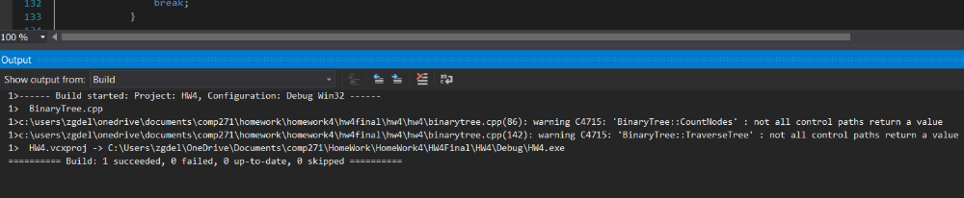
This first picture show that code builds without any errors.
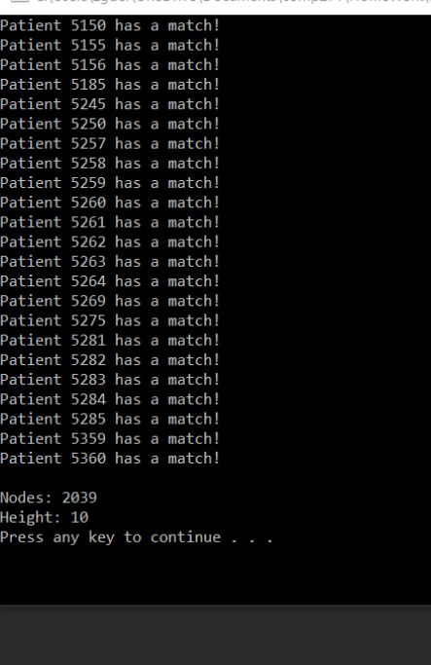

This screenshot shows that code compiles to the very end. Shows all the data that is expected by the code including the number of nodes and the height of the tree.

The user doesn’t do much once the code starts running. The user will be asked which tree they want to use. Since this one only uses the binary tree then user only selects the b and the rest is done for the user. To keep it simple, the user doesn’t have to enter the text files since there’s two .txt files in the project and mixing them up would return an error right way. The code will then print out all the patients that have a sequence match to the disease and then it will also print out the height and the number of nodes. The code itself will take the code from the genome file and translate it into rs and ts. Then it stores these values in to strings the size of 10 into a vector. The code will also take the file from the BT .txt file and put it into a vector of the same size. Then the genome vector is created into a binary tree. Each sequence will go through and its characters will be placed into individual nodes. After the tree is created, the vector from the test file will send its sequences through a traverse function and return which patients have the disease. Below is how I thought the tree would be formed using the two lines of a sequence of characters.

