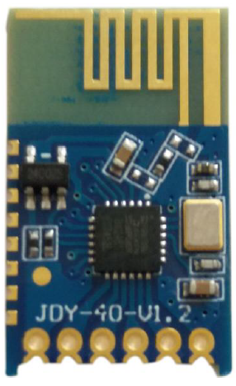
1kΩ
(25) PA15
(24) PA14
(23) PA13
(18) PA8
STM32L051
JDY40 connections to the STM32L051.
3.3V
3.3V
3.3V

