Use the FRED Space to download 3 financial series of your choice. (Series of quotations of a stock

index; series of prices of a specific bond, GDP…)

Argument your choice by referring to a financial issue you are interested in. The choices should be

different for the different groups.

a) Analysis of the dynamics of each series:

- Justify the choice of the observation period and of the frequency

- Transform the series (log); decompose each series separately and analyze the different components

• Is there a stochastic trend? Perform a unit root test (ADF; see documentation); if it is the case

examine the first differences of each series and check that there is no more stochastic trend.

• Turning to the first differences, ask questions about the presence a deterministic trend

(constant or constant and time trend) (test for the significance of the related parameters).

• Are there seasonal variations? (idem)

• For the cyclical component, estimate a stationary ARMA model

Data Collection and preliminary analysis:

Introduction   
We use The FRED (Federal Reserve Economic Data) database, renowned for its extensive collection of economic series and historical depth. In this analysis, we aim to understand how the Real GDP of the United States is influenced by the stock markets of both the U.S. and the U.K.

Here are the shortened descriptions of the selected financial series:

* **NASDAQ Composite Index (NASDAQCOM)**: Broad U.S. stock market index, focusing on technology sectors, started in 1971.
* **US GDP**
* **10-Year Treasury Yield (GS10) **: Measures U.S. 10-year Treasury bond yields, indicative of long-term interest rates.
* **\*\*U.K. All Shares Index (SPASTT01GBM661N) **: Represents U.K. stock market performance, based on 2015 values.**
* **\*\*GBP/USD Exchange Rate (DEXUSUK)**: Tracks the exchange rate from U.S. dollars to U.K. pounds.**
* **U.K. Consumer Price Index (GBRCPIALLMINMEI)**: Indicates U.K. inflation trends, based on 2015 consumer prices.
* **\*\*U.K. GDP (GBRRGDPQDSNAQ)**: Seasonally adjusted measurement of U.K.'s economic output in 2015 pounds.**

The rationale behind choosing these series is to explore the interaction between major stock indices and economic growth, particularly focusing on the U.S. Real GDP. The NASDAQ index, with its emphasis on technology and innovation-driven companies, is a vital barometer of the U.S. economy's strength and future growth prospects. Given the globalized nature of the world economy, the U.K. stock index also plays a significant role. It can act as a proxy for international economic conditions, which in turn influence the U.S. economic landscape.

Analyzing the relationship between NASDAQ and U.K. All Shares indices with U.S. Real GDP is vital for understanding:

* **Inter-Market Dynamics**: Insights into how U.S. and U.K. stock markets influence U.S. economic growth, highlighting global financial interconnections.
* **Interest Rate Impact**: The role of the 10-Year Treasury Yield in shaping investment decisions and its effect on U.S. Real GDP.
* **Currency Exchange Influence**: How the GBP/USD rate impacts U.S.-U.K. economic interactions and U.S. growth.
* **Inflation Trends**: The U.K. CPI's role in signaling global inflation patterns and their repercussions on the U.S. economy.

Overall, this analysis aims to provide a comprehensive view of how U.S. and U.K. stock markets affect U.S. economic health, offering key insights for economists, policymakers, and investors in a globally linked economy.

## A-Period and frequency choices:

Our analysis focuses on monthly data from January 2000 to October 2023, encompassing key economic events. This approach provides a detailed view of short-term fluctuations, crucial for understanding market reactions and seasonal patterns. Monthly data is particularly valuable for dynamic indicators like stock indices (e.g., NASDAQ, U.K. All Shares Index) and volatile metrics such as GBP/USD exchange rates and U.K. CPI. This ensures a continuous and reliable dataset, promoting consistency in our analysis. Figure 1 will visually depict the time plot of untransformed variables, offering insights into their movements over the selected period.

## B-Log transform and decompose the time series:

The series have been log transformed and decomposed, below are the results for every one of them:

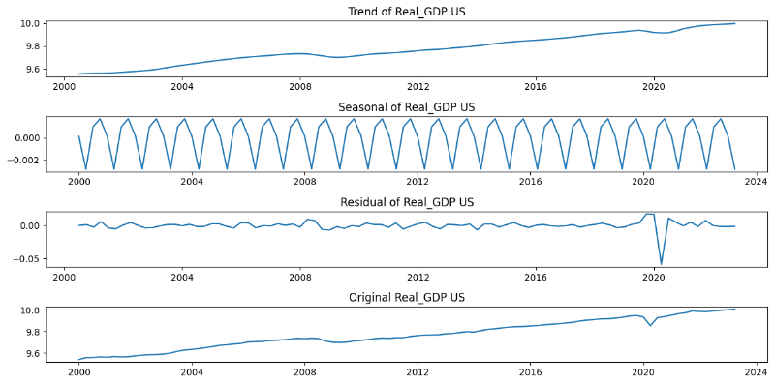

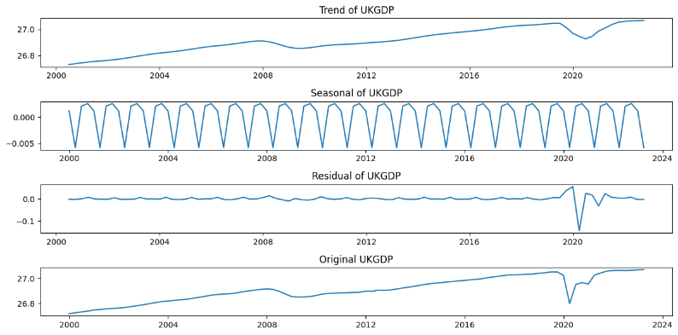

## C-Is there is a trend (drift) in each of the time series?

In the previous section’s figures, we established that our series exhibit different kind of trends and have seasonal components, leading to possible non-stationarity of our data. To corroborate our visual hypotheses, we conduct a series of tests to identify formally the existence of a drift and the trend in each series. By regressing each on their time trend, with an intercept, we find:

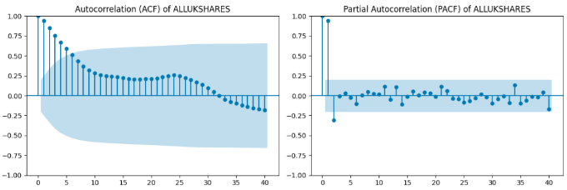

## Une image contenant Tracé, ligne, capture d’écran, texte Description générée automatiquementD. Are there any seasonal variations?

Kruskal-Wallis Test Results:

Detrend the series that exhibit a trend :