**Tinder with Chuck**

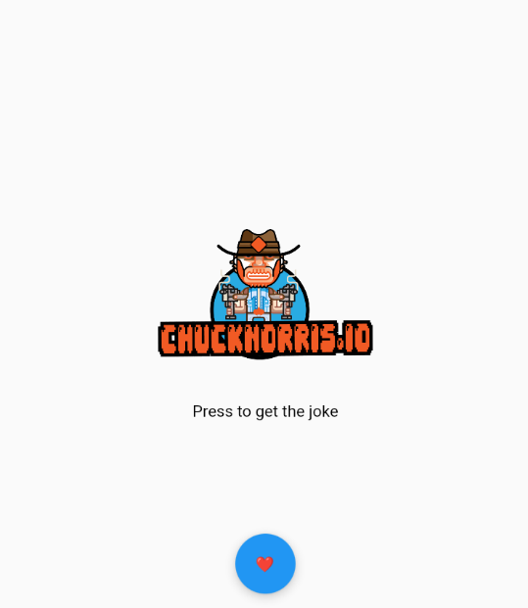Hello user, this is a simple application that shows jokes about Chuck Norris. The start page looks like this:

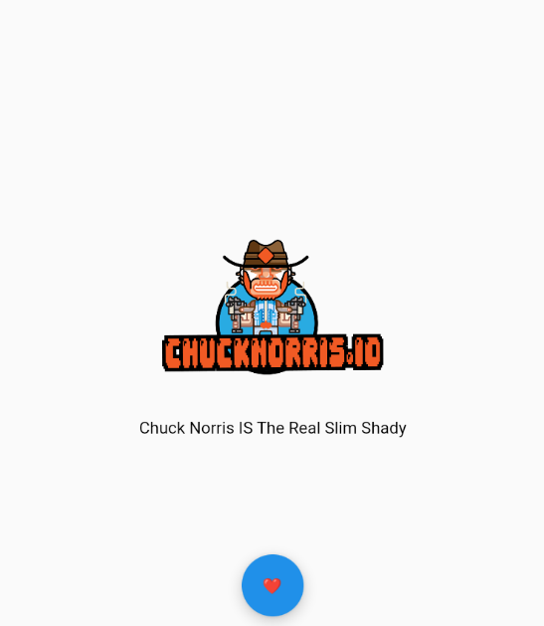After clicking you will get a random joke:

After a like (You can't dislike a joke about Chuck Norris -_-) you will get the following random joke. That’s all.

Link for APK: