# 2018-12-03

## 祈愿修改

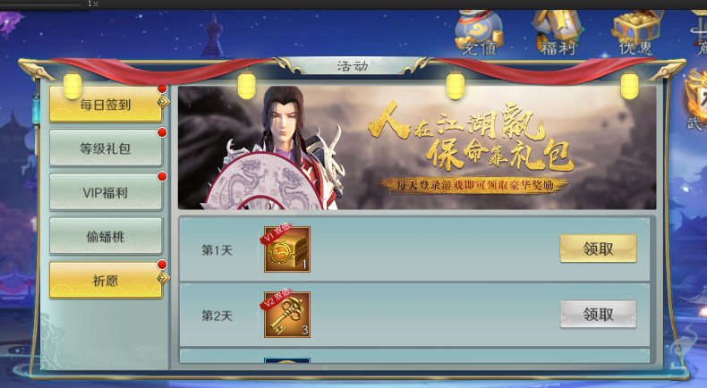



## 小7充值bug

是因为测试2服没有更新到最新的代码

# 2018-12-04

## 太乙活动更新

## 太乙了活动数据存放位置

是放在activity_humandata表里面

## 祈愿第二天状态：

id: 18

team: 3

type: ACTIVITY_BLESS

name: "\347\245\210\346\204\277"

desc: "\347\245\210\346\204\277"

beginTime: 1543766400000

endTime: 1544457600000

paramList {

numParam: 1

numParam: 1

items {

sn: 5001025

num: 10

bind: 0

}

}

paramList {

numParam: 2

numParam: -1

numParam: 0

numParam: 0

numParam: 100

items {

sn: 5001005

num: 150

bind: 0

}

items {

sn: 6001005

num: 5

bind: 0

}

items {

sn: 5001003

num: 10

bind: 0

}

}

showPoint: true

## 祈愿需要修改：因为增加了体力类型

# 2018-12-04

## 消消乐，起始需要根据活动的时间来确定

# 2018-12-08

## 全服boss打开的协议：

2018-12-08 14:08:18,093 (Connection.java:611) [DEBUG][CORE_CONN] ===客户端请求消息：msg=5803:CSOpenWorldBoss:[], account=lzh112, connId=-198005462

2018-12-08 14:08:18,102 (MsgHandler.java:81) [DEBUG][CORE_MSG] ====客户端请求消息：msg=5803:CSOpenWorldBoss:[]

2018-12-08 14:08:18,151 (Connection.java:265) [DEBUG][CORE_CONN] ===服务端返回消息：msg=5804:SCOpenWorldBoss:[], account=lzh112, connId=-198005462, remoteAddress=/10.163.86.113:59619

2018-12-08 14:08:18,365 (Connection.java:611) [DEBUG][CORE_CONN] ===客户端请求消息：msg=1122:CSServerTime:[], account=lzh112, connId=-198005462

2018-12-08 14:08:18,367 (MsgHandler.java:81) [DEBUG][CORE_MSG] ====客户端请求消息：msg=1122:CSServerTime:[]

2018-12-08 14:08:18,371 (Connection.java:265) [DEBUG][CORE_CONN] ===服务端返回消息：msg=1123:SCServerTime:[], account=lzh112, connId=-198005462, remoteAddress=/10.163.86.113:59619

2018-12-08 14:08:18,578 (Connection.java:611) [DEBUG][CORE_CONN] ===客户端请求消息：msg=5824:CSOpenSimpleRank:[], account=lzh112, connId=-198005462

2018-12-08 14:08:18,587 (MsgHandler.java:81) [DEBUG][CORE_MSG] ====客户端请求消息：msg=5824:CSOpenSimpleRank:[]

2018-12-08 14:08:18,611 (Connection.java:265) [DEBUG][CORE_CONN] ===服务端返回消息：msg=5823:SCSimpleRank:[], account=lzh112, connId=-198005462, remoteAddress=/10.163.86.113:59619

2018-12-08 14:08:24,296 (Log.java:174) [INFO][GAME] ---null:-1 AccountService.java:163 总人数totalNum=1,最大9999

返回SCOpenWorldBoss

harmValue: -1

rankValue: -1

relive {

rest: 5

time: 0

}

hpPer: 20499289

bossSn: 1

SCServerTime：

serverTime: 1544249566606

serverStartDate: 1541382600000

## 攻打开始瞬间协议：

2018-12-10 15:00:00,043 (Connection.java:265) [DEBUG][CORE_CONN] ===服务端返回消息：msg=5834:SCWorldBossIsStart:[], account=lzh112, connId=1341117152, remoteAddress=/10.163.86.113:61807

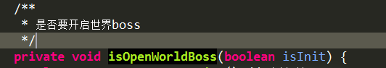此方法触发了SCWorldBossIsStart

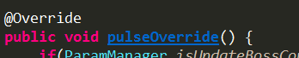心跳中触发了

2018-12-10 15:00:00,078 (Connection.java:611) [DEBUG][CORE_CONN] ===客户端请求消息：msg=5803:CSOpenWorldBoss:[], account=lzh112, connId=1341117152

2018-12-10 15:00:00,097 (MsgHandler.java:81) [DEBUG][CORE_MSG] ====客户端请求消息：msg=5803:CSOpenWorldBoss:[]

2018-12-10 15:00:00,123 (Connection.java:265) [DEBUG][CORE_CONN] ===服务端返回消息：msg=5804:SCOpenWorldBoss:[], account=lzh112, connId=1341117152, remoteAddress=/10.163.86.113:61807

2018-12-10 15:00:00,139 (Connection.java:611) [DEBUG][CORE_CONN] ===客户端请求消息：msg=1122:CSServerTime:[], account=lzh112, connId=1341117152

2018-12-10 15:00:00,157 (MsgHandler.java:81) [DEBUG][CORE_MSG] ====客户端请求消息：msg=1122:CSServerTime:[]

2018-12-10 15:00:00,164 (Connection.java:265) [DEBUG][CORE_CONN] ===服务端返回消息：msg=1123:SCServerTime:[], account=lzh112, connId=1341117152, remoteAddress=/10.163.86.113:61807

2018-12-10 15:00:00,184 (Connection.java:611) [DEBUG][CORE_CONN] ===客户端请求消息：msg=5824:CSOpenSimpleRank:[], account=lzh112, connId=1341117152

2018-12-10 15:00:00,197 (MsgHandler.java:81) [DEBUG][CORE_MSG] ====客户端请求消息：msg=5824:CSOpenSimpleRank:[]

2018-12-10 15:00:00,223 (Connection.java:265) [DEBUG][CORE_CONN] ===服务端返回消息：msg=5823:SCSimpleRank:[], account=lzh112, connId=1341117152, remoteAddress=/10.163.86.113:61807

2018-12-10 15:00:00,948 (Log.java:174) [INFO][GAME] ---null:-1 AccountService.java:163 总人数totalNum=1,最大9999

2018-12-10 15:00:01,044 (Connection.java:265) [DEBUG][CORE_CONN] ===服务端返回消息：msg=5834:SCWorldBossIsStart:[], account=lzh112, connId=1341117152, remoteAddress=/10.163.86.113:61807

2018-12-10 15:00:01,054 (Connection.java:611) [DEBUG][CORE_CONN] ===客户端请求消息：msg=5803:CSOpenWorldBoss:[], account=lzh112, connId=1341117152

2018-12-10 15:00:01,058 (MsgHandler.java:81) [DEBUG][CORE_MSG] ====客户端请求消息：msg=5803:CSOpenWorldBoss:[]

2018-12-10 15:00:01,083 (Connection.java:265) [DEBUG][CORE_CONN] ===服务端返回消息：msg=5804:SCOpenWorldBoss:[], account=lzh112, connId=1341117152, remoteAddress=/10.163.86.113:61807

2018-12-10 15:00:01,106 (Connection.java:611) [DEBUG][CORE_CONN] ===客户端请求消息：msg=1122:CSServerTime:[], account=lzh112, connId=1341117152

2018-12-10 15:00:01,119 (MsgHandler.java:81) [DEBUG][CORE_MSG] ====客户端请求消息：msg=1122:CSServerTime:[]

2018-12-10 15:00:01,126 (Connection.java:265) [DEBUG][CORE_CONN] ===服务端返回消息：msg=1123:SCServerTime:[],

## 攻打时间过期瞬间的协议

2018-12-08 14:15:00,036 (Connection.java:265) [DEBUG][CORE_CONN] ===服务端返回消息：msg=5834:SCWorldBossIsStart:[], account=lzh112, connId=-198005462, remoteAddress=/10.163.86.113:59619

2018-12-08 14:15:00,056 (Connection.java:265) [DEBUG][CORE_CONN] ===服务端返回消息：msg=3104:SCMailNewRemind:[], account=lzh112, connId=-198005462, remoteAddress=/10.163.86.113:59619

2018-12-08 14:15:00,058 (Connection.java:265) [DEBUG][CORE_CONN] ===服务端返回消息：msg=3104:SCMailNewRemind:[], account=lzh112, connId=-198005462, remoteAddress=/10.163.86.113:59619

2018-12-08 14:15:00,090 (Connection.java:611) [DEBUG][CORE_CONN] ===客户端请求消息：msg=5815:CSWorldBossBoxNum:[], account=lzh112, connId=-198005462

2018-12-08 14:15:00,091 (Connection.java:611) [DEBUG][CORE_CONN] ===客户端请求消息：msg=5807:CSOpenWolrdBossRank:[type: WBRankTotalHarm

], account=lzh112, connId=-198005462

2018-12-08 14:15:00,103 (MsgHandler.java:81) [DEBUG][CORE_MSG] ====客户端请求消息：msg=5807:CSOpenWolrdBossRank:[type: WBRankTotalHarm

]

2018-12-08 14:15:00,104 (MsgHandler.java:81) [DEBUG][CORE_MSG] ====客户端请求消息：msg=5815:CSWorldBossBoxNum:[]

2018-12-08 14:15:00,136 (Connection.java:265) [DEBUG][CORE_CONN] ===服务端返回消息：msg=5808:SCOpenWolrdBossRank:[], account=lzh112, connId=-198005462, remoteAddress=/10.163.86.113:59619

2018-12-08 14:15:00,136 (Connection.java:265) [DEBUG][CORE_CONN] ===服务端返回消息：msg=5816:SCWorldBossBoxNum:[], account=lzh112, connId=-198005462, remoteAddress=/10.163.86.113:59619

2018-12-08 14:15:00,293 (Connection.java:611) [DEBUG][CORE_CONN] ===客户端请求消息：msg=1122:CSServerTime:[], account=lzh112, connId=-198005462

2018-12-08 14:15:00,303 (MsgHandler.java:81) [DEBUG][CORE_MSG] ====客户端请求消息：msg=1122:CSServerTime:[]

2018-12-08 14:15:00,316 (Connection.java:265) [DEBUG][CORE_CONN] ===服务端返回消息：msg=1123:SCServerTime:[],

## 全服boss打开，下发的协议。。。根据开服时间？

2018-12-08 14:17:15,823 (Connection.java:611) [DEBUG][CORE_CONN] ===客户端请求消息：msg=5815:CSWorldBossBoxNum:[], account=lzh112, connId=-198005462

2018-12-08 14:17:15,830 (MsgHandler.java:81) [DEBUG][CORE_MSG] ====客户端请求消息：msg=5815:CSWorldBossBoxNum:[]

2018-12-08 14:17:15,863 (Connection.java:265) [DEBUG][CORE_CONN] ===服务端返回消息：msg=5816:SCWorldBossBoxNum:[], account=lzh112, connId=-198005462, remoteAddress=/10.163.86.113:59619

2018-12-08 14:17:15,888 (Connection.java:611) [DEBUG][CORE_CONN] ===客户端请求消息：msg=1122:CSServerTime:[], account=lzh112, connId=-198005462

2018-12-08 14:17:15,890 (MsgHandler.java:81) [DEBUG][CORE_MSG] ====客户端请求消息：msg=1122:CSServerTime:[]

2018-12-08 14:17:15,903 (Connection.java:265) [DEBUG][CORE_CONN] ===服务端返回消息：msg=1123:SCServerTime:[], account=lzh112, connId=-198005462, remoteAddress=/10.163.86.113:59619

2018-12-08 14:17:15,934 (Connection.java:611) [DEBUG][CORE_CONN] ===客户端请求消息：msg=5824:CSOpenSimpleRank:[], account=lzh112, connId=-198005462

2018-12-08 14:17:15,950 (MsgHandler.java:81) [DEBUG][CORE_MSG] ====客户端请求消息：msg=5824:CSOpenSimpleRank:[]

2018-12-08 14:17:15,983 (Connection.java:265) [DEBUG][CORE_CONN] ===服务端返回消息：msg=5823:SCSimpleRank:[], account=lzh112, connId=-198005462, remoteAddress=/10.163.86.113:59619

## 0点下发协议SCWorldBossIsStart

世界boss了解：

1. 战斗后，宝箱的问题

2. 0点重置的问题

3. 基础奖励的问题

## 修改后的boss

登陆时，发送宝箱的相关信息：（已经打过一次）

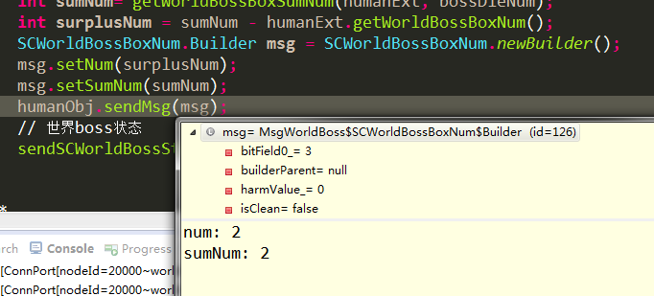

下发攻打世界boss的时间：

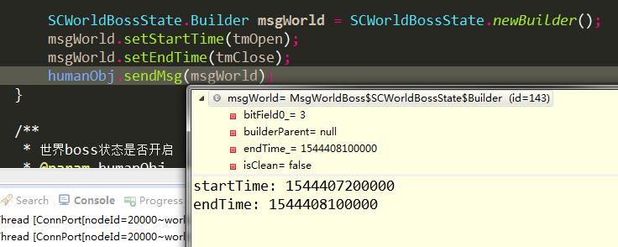

领完后：

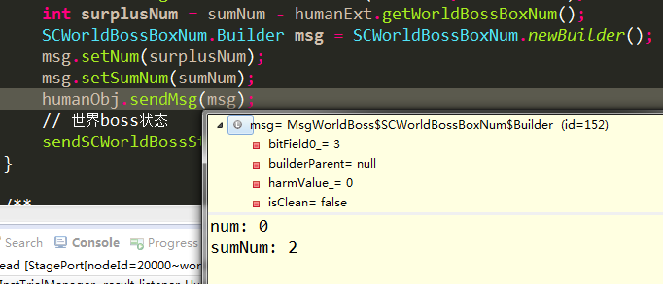

在线等到下一次boss战斗的开始：

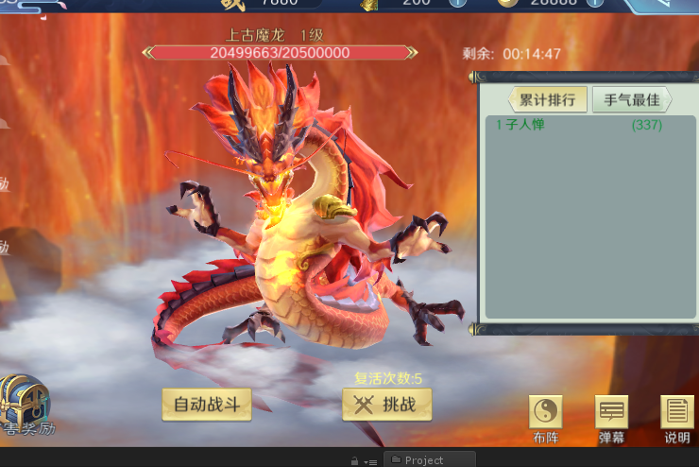

重登后：

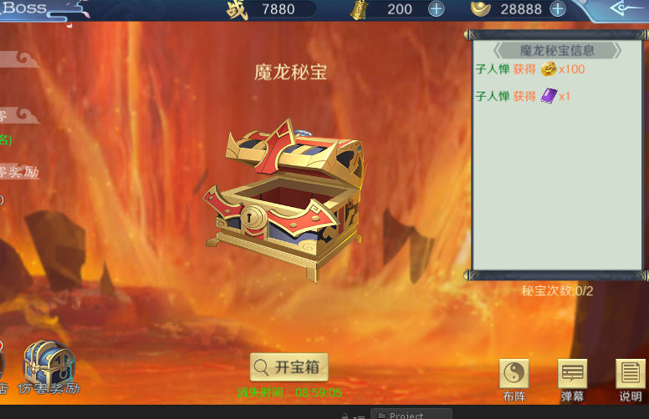

在线等到下一次boss战斗的开始，状态不对，需要修改

# 2018-12-11

## 今日工作：

1.小七IOS登陆测试， 1

2.小七IOS付费测试 1

3.BT安卓登陆测试 1

4.BT IOS登录测试

5.BT 安卓付费测试

6.BT IOS付费测试

BT的扩展参数：

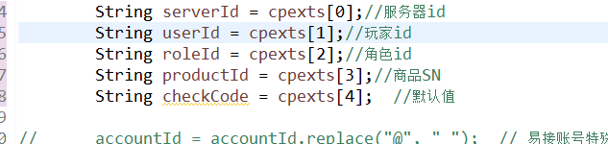

# 2018-12-12

## BT热更：

sudo sh /qzdata1/server/ty_bt1game/updata.taiyi_game gametaiyi

sudo sh /qzdata1/server/ty_bt1game/updata.taiyi_game gamedata

sudo sh /qzdata1/server/ty_bt2game/updata.taiyi_game gametaiyi

sudo sh /qzdata1/server/ty_bt2game/updata.taiyi_game gamedata

## BT重启

sudo sh /qzdata1/server/ty_bt1game/taiyi_game restart

sudo sh /qzdata1/server/ty_bt2game/taiyi_game restart

## 世界boss功能修改

每次战斗完就发送排行奖励

每次战斗完boss血量就回到最大值

## 股票买卖：

兴业证券：5.29 2000 10580

今日价格：5.00 2000 10000

## Taiyi活动更新

## 世界boss各个参数的生存周期：

：每日重置点清空,活动开启时清空

## 修改开服时间第一种方法：

保存，但不退出vi                          :w  
   
保存并退出vi                                 :wq  
   
退出vi，但不保存更改                   :q!  
   
用其他文件名保存                         :w filename  
   
在现有文件中保存并覆盖该文件    :w! filename

### Vim taiyi_game.conf 进入编辑模式，i

数字的修改只能是在键盘上横幅数字上取

### 修改完后，按ESC，然后在输入:q! 退出 :wq 保存并退出

sudo sh updata.taiyi_game updata_db

### 脚本将会自动修改游戏服的配置文件

## 修改开服时间第二种方法：

### 1先到平台上钩掉游戏的开服状态

### 2 sudo sh set.taiyi_game opentime '2018/12/03 06:00'

# 2018-12-13

## Linux查看指定端口的连接状态：

netstat -lanp|grep '10001'

## 修改版本号

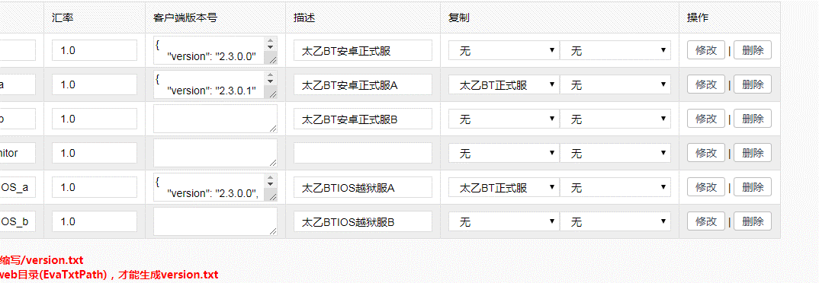

# 2018-12-18

## 模拟机器人登陆到界面

## Java虚拟机最多登陆人数统计：分配的内存与人数关系

1.服务器id=0

2.登陆验证失败

# 2018-12-20

## 机器人压力测试，进入副本战斗

## Java虚拟机 各个配置的意义：

-Xms1g -Xmx1g -Xmn250m -XX:MaxDirectMemorySize=512m -XX:MetaspaceSize=256m -XX:MaxMetaspaceSize=512m

-XX:+UseParallelGC -XX:+UseParallelOldGC -XX:+AlwaysLockClassLoader

-XX:+DisableExplicitGC

-XX:+PrintGCDateStamps -XX:+PrintGCDetails -verbose:gc -Xloggc:%gcDir%/%srvName%_gc.log

-XX:ErrorFile=%gcDir%/%srvName%_error_%p.log -XX:HeapDumpPath=%gcDir%/%srvName%_heapDump_%p.hprof

-Dsun.zip.disableMemoryMapping=true

-javaagent:libs\\classReloader.jar

# 2018-12-21

## 股票买卖

三七 11.51 400 4604

完美 28.04 200 5608

13G

Croscc 2.5g

13-2.5 = 10.5

10.5

7 4

World xmx + MaxDirectMemorySize + MaxMetaspaceSize

5 4 1

2

## Java内存监控：

### 堆内存使用量：961,536 KB

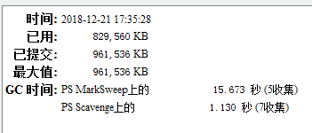

### 非堆内存使用量：1,638,400 KB

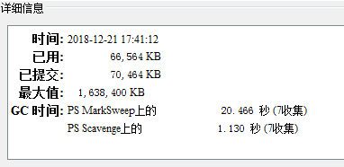

### 内存池 ps old gen：787,456 KB



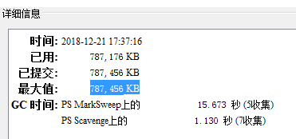

### Ps eden space: 87,040 KB

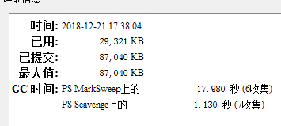

### Ps survivor space: 87,040 KB

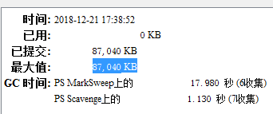

### Metaspace 524,288 KB

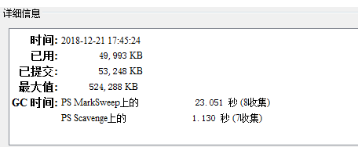

### Code cache 65,536 KB

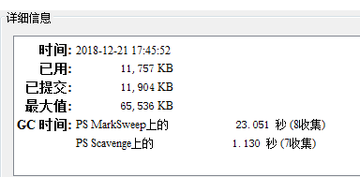

### Compressed class space 1,048,576 KB

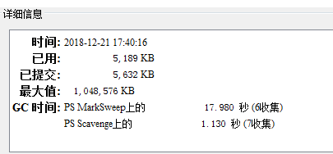

## 机器人报错：

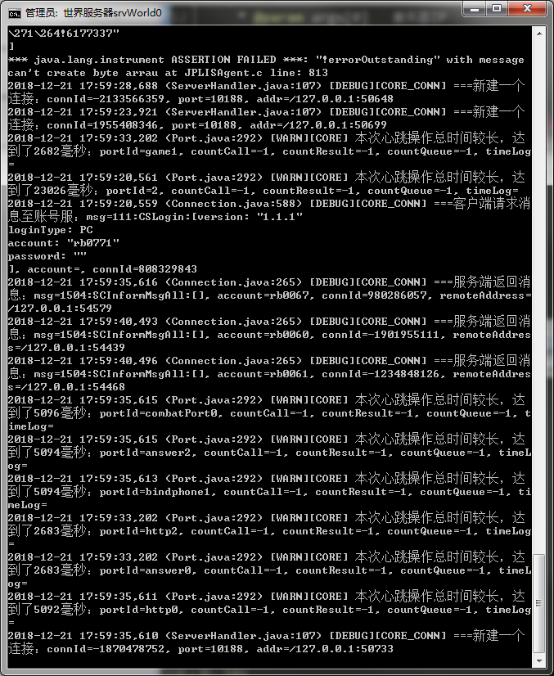

### Gc报错

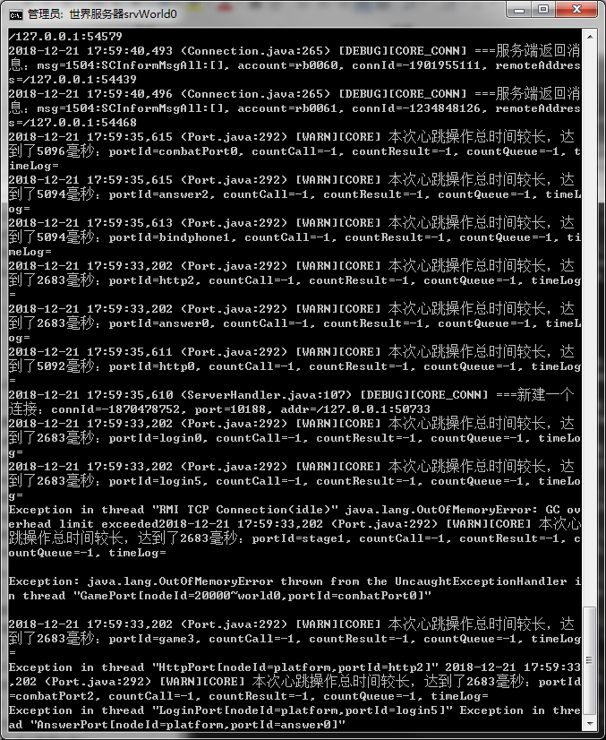

# 2018-12-24

## 今日任务：

1.vip6 跳过扫荡 1

2.抽卡元宝抽 1

3.新手引导跳过 1

4.平台代充设置 1（原本就有代充功能）

5.自开服问题解决 1

6.客户端切换断线问题 1

tickTimerConnCheck

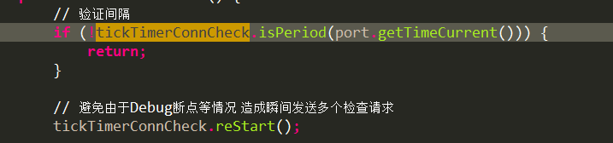

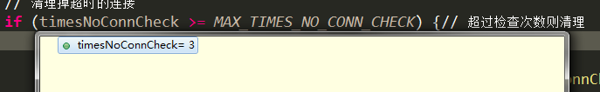

手机APP后台杀死线程：

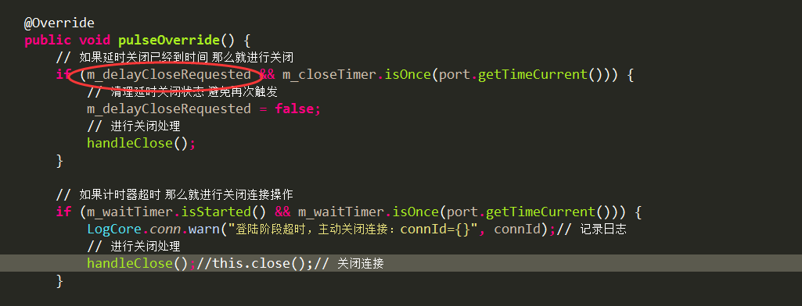

# 2018-12-26

## 股票买卖：

瀚叶股份 2.99 1600 4784

特变电工 6.93 600 4159

兴业证券（卖出） 4.60 2000 9200