# 2019-01-02

1.Viking 升级模式是否能够改成太乙的模式，单次升级，升级五次

2.跨服添加测试是否连接功能

3.在线服更新配表

# 2019-01-04

## 1.bt 和 小七的开服

## 服务器白名单

# 2019-01-07

## 删除排行榜排名

gmtestnotify 200050000046000388

## 跨服1的配置：

crossDB_port=27001

**cross0_port=28001**

**crossSrv0.conn0.ipPort=172.19.161.84:26001**

crossSrv0.node.addr.crossDB=tcp://127.0.0.1:27001

**crossSrv0.node.addr.cross0=tcp://127.0.0.1:28001**

## 跨服2的配置：

crossDB_port=27002

cross0_port=28002

crossSrv0.conn0.ipPort=172.19.161.87:26002

crossSrv0.node.addr.crossDB=tcp://127.0.0.1:27002

crossSrv0.node.addr.cross0=tcp://172.19.161.87:28002

## bt6的配置：

#服务器基础配置文件，请谨慎修改！！！

####################################

#Control script

#Port Check

#服务器ID前缀+服务器ID+2000

srvDB_port=22006

#服务器ID前缀+服务器ID

srvWorld0_port=20006

conn.port=20006

#太乙跨服连接设置,跨服游戏服不在同台机器，ipPort，cross0配置需要为外网IP

crossSrv0.conn0.ipPort=47.101.186.119:26001 本机对外开放的端口和地址

crossSrv0.node.addr.crossDB=tcp://127.0.0.1:27001

crossSrv0.node.addr.cross0=tcp://47.101.186.119:28001 //跨服的绝对地址和开放的端口

正确的配置到跨服2：

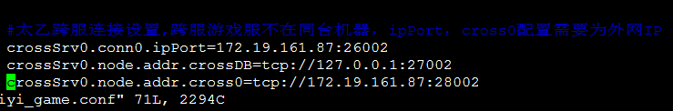

## bt7的配置：

srvDB_port=22007

#服务器ID前缀+服务器ID

srvWorld0_port=20007

conn.port=20007

#太乙跨服连接设置,跨服游戏服不在同台机器，ipPort，cross0配置需要为外网IP

crossSrv0.conn0.ipPort=172.19.161.87:26002

crossSrv0.node.addr.crossDB=tcp://127.0.0.1:27002

crossSrv0.node.addr.cross0=tcp://127.0.0.1:28002

## 自开服服务器连接跨服：

crossSrv0.id=1000

crossSrv0.node.addr.cross0=tcp://127.0.0.1:33000

node.addRemoteNode(Config.getCrossDefaultNodeId(crossServerId), Distr.getCrossNodeAddr(i,D.CROSS_NODE_DEFALUT));

node.addRemoteNode(1000~cross0, tcp://127.0.0.1:33000);

## 本机对客户端的绝对地址和端口



## 配置修改后保存：

sudo sh taiyi_game check

## 重启：

sudo sh taiyi_game restart

# 2019-01-08

## 客户端登录本地和外网设置：

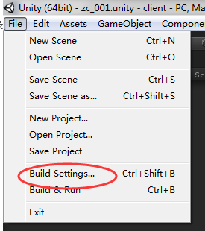

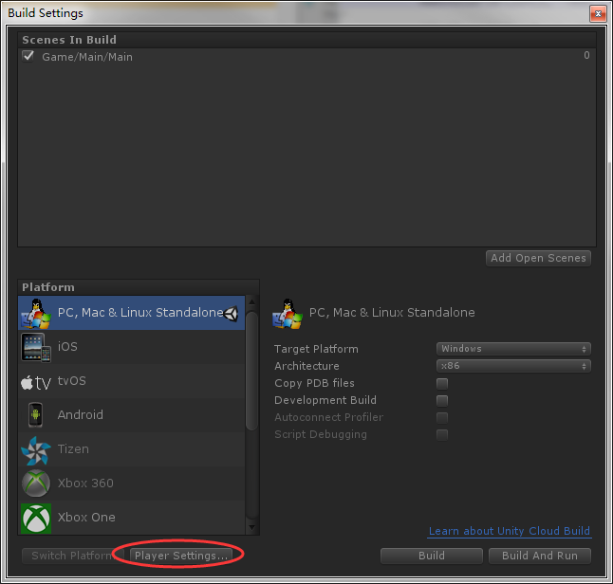

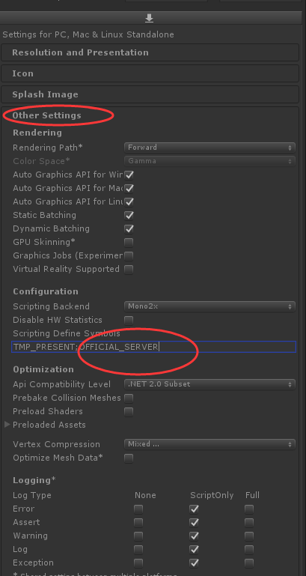

连接外网的时候添加OFFICIAL_SERVER,连接本地的时候删除掉

## 组队副本的bug：



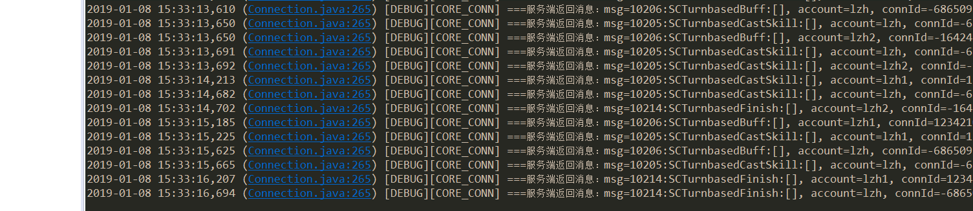

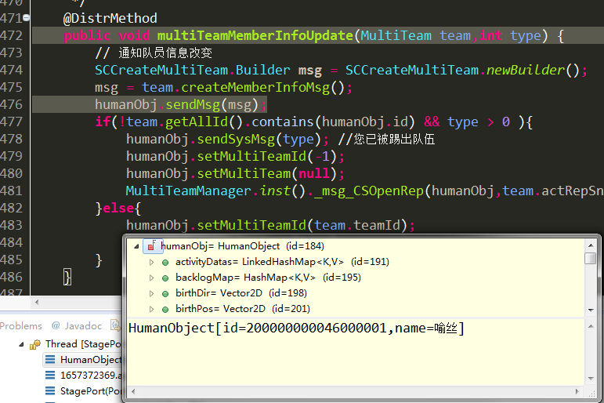

membersInfo {

name: "\345\226\273\344\270\235"

guildName: ""

combat: 1337868

model: 1000001

isLeader: true

location: 1

id: 200000000046000001

vipLv: 0

grade: 2

isReady: true

teamId: 10009

percent: 25

}

membersInfo {

name: "\345\215\203\344\273\243\350\216\253\350\213\261"

guildName: ""

combat: 2326599

model: 1000001

isLeader: false

location: 3

id: 200000000046000002

vipLv: 0

grade: 2

isReady: true

teamId: 10009

percent: -1

}

isOpen: true

isSuccess: true

# 2019-01-11

## 1.组队副本bug合并到主干（需要重启，暂时不合并到旧的服务器）

主干：1

IOS，应用宝，安卓： 暂时不合

## 2.玄兵，符文bug，英雄置换合并到主干，ios，安卓，应用宝

小7：1

变态：1

安卓：

应用宝：

IOS：

主干：1

## 3.猎魂bug查看修改----合并到各个版本

小7：1

变态：1

安卓：

应用宝：

IOS：

主干：1

## 4.每日登陆方法研究

1每日都会在重置时间先清空记录：

humanExt2.setDayResetInfo("");//重置每日标记

2之后各个系统再等级自己的记录

## 5.活动豪华签到bug：

前一天所有档位都打开，并领取奖励：



过十二点后没变：



充值一笔后：



结论：充值时，判断充值时间和记录的时间，如果同时间，则记录消除，如果相同，则在记录上修改

# 2019-01-15

## 股票买卖：

卖出：

三七 10.040 400 4016

买入：

兴业 5.26 100 526

特变： 7.4 500 3700

内存总量：961536 k

老年区大小 787456 KB

老年区比例：

# 2019-01-17

## 战斗bug跟踪—战胜却显示失败

// 进入挑战

message CSCompeteFight {

option (msgid) = 4303;

required int64 fightId = 1; // 被挑战的玩家id

}

录像id：300000000162000047

Win: false

胜负判断错误的战斗：

300000000162000113

leftinfo

{"PP":"{\"DamPhyRedEx\":150,\"DefMag\":6170,\"DamMagRedEx\":150,\"DamMagAddEx\":300,\"DamPhyAddEx\":300,\"DamPhyAdd\":250,\"DamComAdd\":600,\"DamPhyRed\":250,\"RageCur\":100,\"AntiCrit\":2000,\"HpMax\":134178,\"DamMagRed\":250,\"HealAdd\":250,\"DamComRed\":600,\"Block\":1600,\"Atk\":17825,\"DamMagAdd\":250,\"Crit\":3000,\"DefPhy\":5287}","SX":2,"pvpCa":900,"G0":{"PP":"{\"DamComAdd\":300,\"DamComRed\":300,\"DamPhyRedEx\":150,\"RageCur\":100,\"Dodge\":495,\"DamMagRed\":100,\"Crit\":600,\"DefPhy\":3811,\"DefMag\":3497,\"Hit\":450,\"AntiCrit\":1410,\"HpMax\":153095,\"HealAdd\":250,\"Atk\":21736,\"DamMagRedEx\":150,\"DamPhyRed\":100}","SK":"1093001,1094001,50553,50554,50555,50556,50557,50558,50559","FP":0,"ID":53005,"SN":53005},"FP":2,"LV":56,"G2":{"PP":"{\"RageCur\":100,\"Dodge\":750,\"Crit\":600,\"DefPhy\":2900,\"DefMag\":3602,\"Hit\":450,\"AntiCrit\":1200,\"HpMax\":74131,\"Atk\":16333}","SK":"1091001,1092001,50541,50542,50543,50544,50545,50546","FP":2,"ID":53004,"SN":53004},"G3":{"PP":"{\"DamPhyAdd\":250,\"DamComAdd\":600,\"DamComRed\":600,\"DamMagAdd\":250,\"RageCur\":100,\"Dodge\":1500,\"DamMagRed\":250,\"Crit\":2700,\"DefPhy\":7175,\"DefMag\":5969,\"Hit\":1680,\"AntiCrit\":2240,\"HpMax\":179816,\"Atk\":32146,\"DamPhyRed\":250}","SK":"1243001,1244001,51071,51072,51073,51074,51075","FP":3,"ID":63003,"SN":63003},"G4":{"PP":"{\"DamComAdd\":1100,\"RageCur\":100,\"Dodge\":450,\"Crit\":1160,\"DefPhy\":4164,\"DefMag\":4636,\"Hit\":1140,\"AntiCrit\":600,\"HpMax\":85565,\"Atk\":27567}","SK":"1107001,1108001,50637,50638,50639,50640,50641,50642","FP":4,"ID":53007,"SN":53007},"G5":{"PP":"{\"DamComAdd\":650,\"RageCur\":100,\"Dodge\":450,\"Crit\":2680,\"DefPhy\":2308,\"DefMag\":3002,\"Hit\":450,\"AntiCrit\":1680,\"HpMax\":75934,\"Atk\":16485}","SK":"1085001,1086001,50505,50506,50507,50508,50509","FP":5,"ID":53002,"SN":53002},"AP":10,"NA":"如若丶不是你","MD":1000001,"SK":"1000001,1000002,50673,50674,50675,50676,50677,50678,50679","pvpCR":900,"ID":500010000076001231,"SN":2,"FC":2289844}

rightinfo

{"PP":"{\"DamPhyRedEx\":600,\"DefMag\":3488,\"DamMagRedEx\":600,\"Hit\":720,\"DamComAdd\":500,\"RageCur\":100,\"AntiCrit\":720,\"HpMax\":130532,\"Dodge\":540,\"Block\":1600,\"Atk\":21672,\"Crit\":1720,\"DefPhy\":4190}","SX":1,"pvpCa":900,"G0":{"PP":"{\"DefMag\":3998,\"DamComRed\":150,\"Hit\":540,\"DamComAdd\":300,\"AntiCrit\":720,\"HealAdd\":250,\"Dodge\":1140,\"Crit\":720,\"DefPhy\":2736,\"HpMax\":150741,\"RageCur\":100,\"DamMagRedEx\":150,\"DamPhyRedEx\":150,\"Atk\":18434}","SK":"1005001,1006001,50025,50026,50027,50028,50029,50030,50031","FP":0,"ID":52002,"SN":52002},"FP":3,"LV":57,"G1":{"PP":"{\"DefMag\":4967,\"Hit\":720,\"DamComAdd\":650,\"AntiCrit\":1470,\"DamPhyAddEx\":150,\"Dodge\":540,\"DamMagAddEx\":150,\"Crit\":720,\"DefPhy\":5211,\"HpMax\":143605,\"RageCur\":100,\"Atk\":22092}","SK":"1007001,1008002,50037,50038,50039,50040,50041,50042,50043","FP":1,"ID":52005,"SN":52005},"G3":{"PP":"{\"DefMag\":4651,\"AntiBurnAddEx\":800,\"AntiBlock\":600,\"Hit\":585,\"AntiCrit\":480,\"HealAdd\":2000,\"Dodge\":360,\"CureAdd\":250,\"BurnAddEx\":600,\"Crit\":720,\"DefPhy\":4398,\"HpMax\":120100,\"RageCur\":100,\"Atk\":12313}","SK":"1013001,1014001,50073,50074,50075,50076,50077,50078,50079","FP":3,"ID":52010,"SN":52010},"G4":{"PP":"{\"DefMag\":4028,\"Hit\":900,\"DamComAdd\":800,\"AntiCrit\":720,\"DamPhyAddEx\":1530,\"Dodge\":540,\"DamMagAddEx\":1530,\"Crit\":2220,\"DefPhy\":4870,\"HpMax\":166364,\"RageCur\":100,\"Atk\":40388}","SK":"1241001,1242002,51023,51024,51025,51026,51027","FP":4,"ID":62001,"SN":62001},"G5":{"PP":"{\"DefMag\":4173,\"Hit\":540,\"DamComAdd\":150,\"AntiCrit\":720,\"HealAdd\":250,\"Dodge\":390,\"AtkMag\":200,\"Crit\":1720,\"DefPhy\":3355,\"HpMax\":80240,\"RageCur\":100,\"Atk\":13540}","SK":"1001001,1002001,50001,50002,50003,50004,50005","FP":5,"ID":52001,"SN":52001},"AP":10,"NA":"小羽","MD":90001,"SK":"900001,900002,50673,50674,50675,50676,50677,50678,50679","pvpCR":900,"ID":500010000076000397,"SN":1,"FC":2344277}

finishinfo

{"0":{"Pos":5,"Hp":30815,"Team":1,"Rage":30},"FN":1,"Win":1}

开始战斗：

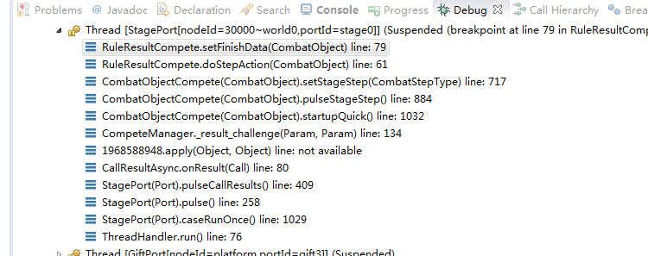

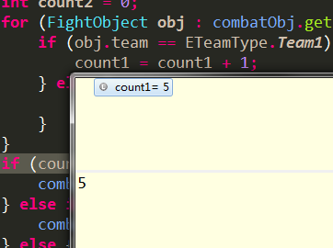

战斗结束：

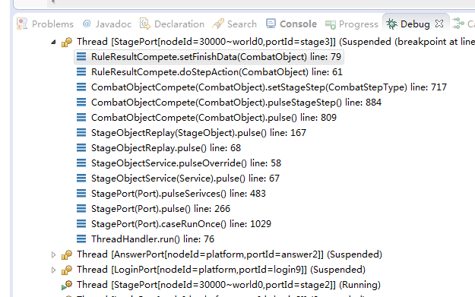

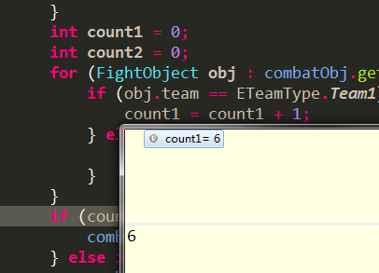

结果：



战斗：

快速战斗显示失败，

