Document Title: AutoBAHN System Deployment Guidelines SA2 Task5 Release 1.0.4
Document Details
Activity: | SA2
Work Item: | Task5
Nature of Deliverable: | O
Author: | Jacek Lukasik, Ophelia Neofytou, Afrodite Sevasti, Stella-Maria Thomas, Kostas Stamos, Giannis Zaoudis, Giorgos Adam
Dissemination: | PP (Project Participants)

Document History
Version | Date | Description of work | Person
 | 26-02-08 | First draft issued | Jacek Lukasik
 | 05-03-10 | First version issued | Kostas Stamos
 | 08-03-10 | Comments added | Jacek Lukasik
 | 15-07-10 | Comments by Michal Giertych and other improvements | Kostas Stamos
 | 06-10-10 | Updates for 0.6, 0.7 releases | Kostas Stamos
 | 14-02-11 | Updates for 1.0RC release | Kostas Stamos
 | 01-03-11 | Updates for 1.0 release | Kostas Stamos, Jacek Lukasik
 | 01-06-11 | Updates for 1.0.1 release | Giorgos Adam
 | 04-11-11 | Updates ahead of 1.0.2 release | Kostas Stamos
 | 21-12-11 | Updates for 1.0.3 release | Kostas Stamos
 | 23-01-12 | Minor fixes / updates | Kostas Stamos
 | 02-04-12 | WebGUI HTTPS Support | Akis Kalligeros

Table of Contents
1 Introduction 3
2 Control plane: AutoBAHN software suite installation 5
2.1 AutoBAHN server specifications 5
2.1.1 Hardware 5
2.1.2 Default ports used (may be reconfigured) 5
2.2 Prerequisites for AutoBAHN system installation 6
2.2.1 Java installation 6
2.2.2 RDBMS installation 6
2.2.3 GRE and Quagga installation (optional) 7
2.2.3.1 GRE kernel module installation 7
2.2.3.2 Quagga installation 7
2.3 Adding the network topology information 8
2.3.1 cNIS as topology information registry for AutoBAHN 8
2.3.1.1 Inserting topology information in cNIS 9
2.3.1.2 Adding the connections to the external domains 10
2.3.1.3 Connections to end points 10
2.3.1.4 Configure DM to use cNIS as topology information source 11
2.3.2 Public identifiers 11
2.3.3 Multiple links attached to a single port 11
2.4 Installation using the wizard (for Ubuntu, Debian and Fedora Linux) 12
2.4.1 Wizard guide 12
2.4.1.1 OSPF / Quagga not used (recommended) 13
2.4.1.2 OSPF / Quagga used (deprecated) 16
2.4.2 Generic Routing Encapsulation (GRE) tunnels setup example (optional) 22
2.5 Initializing the AutoBAHN service 23
2.6 Shutting down the service 23
3 Technology Proxy configuration 25
3.1 Configuring DM to communicate with the TP 25
3.2 Supporting more technologies 25
3.2.1 Case A: End host at the domain’s ingress Point-of-Presence from GÉANT 26
3.2.2 Case B: End host connected to any Point-of-Presence in the domain 26
4 Appendix 28
4.1 Manual installation 28
4.1.1 Database creation 28
4.1.2 Generic Routing Encapsulation tunnel configuration (optional) 28
4.1.3 AutoBAHN system configuration 30
services.properties (Configuration of AutoBAHN server IP and port) 30
autobahn.properties (Configuration of general AutoBAHN parameters) 30
public_ids.properties (Configuration of public identifiers’ mappings) 32
idcp.properties (Configuration of IDCP interoperability parameters and servers) 32
security/security.properties (Configuration of exchanged messages security) 32
security/edugain/edugain.properties (Configuration of edugain-based security) 32
security/aai/dm_security.xml (Configuration of local authorization policies) 32
4.1.4 Providing topology information through sql file (without cNIS) 33
4.2 AutoBAHN Web Services interfaces addresses 34
4.3 Installing LS 35
4.3.1 On Linux 35
4.3.2 Configuring LS 35
4.4 WebGUI deployment 37
4.4.1 Web Application Container installation 37
4.4.2 Web GUI installation 37
4.4.3 Web GUI configuration 37
4.4.3.1 Configure AAI 37
4.4.3.2 Configure LS access 40
4.4.3.3 Configure communication security 40
4.4.3.4 Configure Tomcat HTTPS Support 40
4.4.4 Google Maps configuration 41
4.4.5 Accessing the portal 41
4.5 Security mechanisms summary 42
4.5.1.1 Trusted communication between system components 42
4.5.1.2 Secure CLI access 42
4.5.1.3 User authentication / authorization at the Web GUI 43
4.5.1.4 Authorization policies at each AutoBAHN instance 43
4.5.1.5 Secure communication to IDCP compatible peers (OSCARS) 43
4.6 AA how-to 44
4.6.1.1 Audience 44
4.6.1.2 Prerequisites 44
4.6.1.3 Step-by-step guide 44
5 AutoBAHN references 45
6 Glossary 46
7 References 47

Introduction
The document describes the prerequisites needed, and sets out the instructions to follow, in order to deploy the Automated Bandwidth Allocation across Heterogeneous Networks (AutoBAHN) system in a domain.
To provide guaranteed end-to-end dynamic circuit service with resource reservation, service requests must be co-ordinated across domains. This role is undertaken by instances of the AutoBAHN system deployed in each involved domain.
AutoBAHN system comes with the following software components:
Single AutoBAHN instance – software suite to be deployed in each involved domain:
- InterDomain Manager (IDM)
- Domain Manager (DM)
- Technology Proxy (TP)
Additionally to make separate instances of AutoBAHN be aware of each other and operate as one environment following components need to be deployed (once per a whole AutoBAHN environment):
- Lookup Service
- Web based graphical user interface (Web GUI)
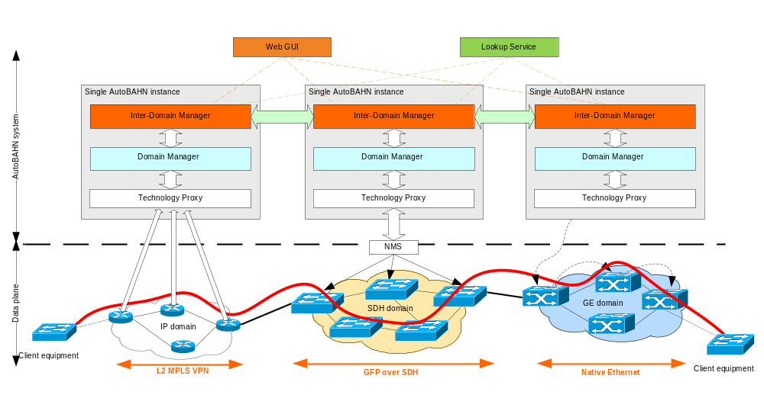

Below is a table with an overview of prerequisites for installing each part of the software (details are given in the corresponding sections):
Prerequisite | AutoBAHN software suite (IDM, DM, TP) | Lookup Service | WebGUI
Java 1.6 VM | Required | Required | Required
NTP server synchronization | Required | Required | Required
PostgreSQL 8.x or higher | Required  (see section 2.2.2) | Not needed | Not needed
- Quagga 0.99.6 or higher  - GRE kernel module (ip_gre.o) | Optional  (see section 2.2.3) | Not needed | Not needed
cNIS 2.3.2 | Recommended  (see section 2.3) | Not needed | Not needed
Tomcat 6 or 7 | Required if cNIS is used, Not needed otherwise | Required  (see section 4.3.1) | Required  (see section 4.4.1)
ncurses library-based Dialog application | Optional  (see section 2.4.1) | Not needed | Not needed
perfSonar LS | Not needed | Required  (see section 4.3.1) | Not needed
eXist | Not needed | Required  (see section 4.3.1) | Not needed

Control plane: AutoBAHN software suite installation

AutoBAHN server specifications
The server that hosts the AutoBAHN system must fulfil the following requirements hardware:

Hardware
- Central Processing Unit (CPU) – minimum 500 megaherz (MHz), recommended 1 gigahertz (GHz).
- RAM – minimum 512 megabytes (MB), recommended 1 gigabyte (GB).
- Disk space – minimum 50 MB, recommended 500 MB (for long term logs).
- Network Information Centre (NIC) – 1 Fast Ethernet NIC.
- Operating System (OS) – any supporting Java. Ubuntu or debian Linux is recommended for easier installation (software has been tested on Fedora, Debian, Suse, Ubuntu, Windows XP).

Default ports used (may be reconfigured)
- 8080 – Inter-domain; IDM – IDM, IDM – WebGUI, IDM – IDCP compatible domain
- 8080 – Intra-domain; IDM –DM, DM – TA, DM – Calendar, etc.
- 5432 – Database access within the domain.
- 25 – Simple Mail Transfer Protocol (SMTP) for sending mails with notifications (optional).

If the OSPF method of exchanging topology information is used (not recommended), then the following ports are also used (default values):
- 2607 – Intra-domain; IDM-Quagga Application Program Interface (API) access.
- 4000 – Inter-domain; sending Link State Advertisement (LSA) messages.
- 40001 – Inter-domain; receiving LSA.

AutoBAHN should be running on a server with a globally routable IP address. It cannot properly function on a machine that has only been configured with a NAT address because some of the messages exchanged by AutoBAHN instances contain IP addresses, and therefore NAT operation is not transparent.
Please also check section 4.2 for configuring HTTP and HTTPS ports.

Prerequisites for AutoBAHN system installation
AutoBAHN system require following software to be installed on the target machine:
- Java 1.6 VM.
- PostgreSQL 8.x or higher (any other SQL RDBMS can be used, so long as it is supported by Hibernate).

Important: It is recommended to use NTP based time synchronization on hosts that runs the AutoBAHN instance. Certain reservations events are launched at the strictly specified time in all domains across a path so it is highly important to have the hosts in synchronization.
Detailed instructions on how to install and configure PostgreSQL and Quagga is given below.
Optionally you may also install:
- cNIS for topology storage (details on installation and usage in section 2.3)
- The ncurses library-based “Dialog” application for installation in Text User Interface (details in section 2.4.1)

If the OSPF method of exchanging topology information is used (not recommended), then the following software is also needed:
- GRE kernel module.
- Quagga 0.99.6 or higher.

Java installation
Download Sun Java 1.6. You may use either your preferred package manager (such as apt-get) or directly download and install it from Oracle/Sun website following the instructions there.
For example, in a Debian / Ubuntu system you may run:
apt-get install sun-java6-jre

RDBMS installation
Install PostgreSQL 8.x or higher (You can download the latest release from http://www.postgresql.org/ and follow the installation instructions from the documentation).
Any other SQL RDBMS can also be used, so long as it is supported by Hibernate [Hibernate].
For example, in a Debian / Ubuntu system you may run:
apt-get install postgresql-8.4
Make sure that local access to the database is allowed (e.g. you can connect to PostgreSQL by running psql). In order to do that, you can perform the following steps:
/etc/init.d/postgresql start
Then try to connect to the database to make sure that local access has been opened. In order to connect you have to be a user that is registered in the database. So connect as the default user (postgres) user, for example by running in Ubuntu:
sudo –i
su postgres
psql

GRE and Quagga installation (optional)
This part is only needed if the OSPF topology exchange method is used (instead of the default topology exchange method using the Lookup Service). Since configuration of the OSPF topology exchange method is more complicated and error-prone, it is recommended to skip this.

GRE kernel module installation
GRE kernel module is ip_gre.o (or ip_gre.ko since kernel version 2.6). You can load it using the modprobe command:
modprobe ip_gre

Quagga installation
Qugga is used as the routing daemon for the AutoBAHN system for exchanging topology information. One instance of Quagga must run on each AutoBAHN server. To install Quagga, install appropriate Quagga package from your system distribution or download the latest tarball from http://www.quagga.net/, and unpack it to a convenient location.
Configure (you may need to install some additional libraries to successfully fulfill this point, but it depends on your current configuration):
cd quagga-0.99.4
./configure --enable-opaque-lsa --enable-ospf-te
Check the output of the configure script for your config file directory (/usr/local/etc). You can alter this with the option --sysconfdir=dir at the configure script.
Compile and install:
make
make install
Insert the following lines into /etc/services, if they are not already present:
zebrasrv 2600/tcp # zebra service
zebra 2601/tcp # zebra vty
ripd 2602/tcp # RIPd vty
ripngd 2603/tcp # RIPngd vty
ospfd 2604/tcp # OSPFd vty
bgpd 2605/tcp # BGPd vty
ospf6d 2606/tcp # OSPF6d vty
ospfapi 2607/tcp # ospfapi
isisd 2608/tcp # ISISd vty

Adding the network topology information
Network topology of your domain (including links connecting with neighbouring domains) should be stored in a topology database.
A valid topology which can be utilized by AutoBAHN needs to include at least two connections to the external domains. By “external domain” we mean a neighbouring AutoBAHN domain (which is out of our management) or an end point (place where the circuit may terminate – called client domain). AutoBAHN is designed to set up the connections between a pair of end points across multiple heterogeneous domains. In order to be able to build a valid connection each domain should have the connections to at least two external domains (valid possibilities are: two other AutoBAHN domains, one AutoBAHN domain and one end point, or two end points).
You may use Geant cNIS software to describe your network topology and provide it to AutoBAHN. If cNIS is not available in your domain you may insert the topology information directly to the AutoBAHN’s database using sql file (as described in 4.1.4).
The following sections describe the steps of using cNIS to provide the topology information to AutoBAHN system.

cNIS as topology information registry for AutoBAHN
In order to configure your domain’s internal topology using cNIS, the following steps have to be performed:
- Install cNIS (visit https://forge.geant.net/forge/display/cNIS/Home for instructions). You need to install at least two components of cNIS – cma (web application for topology information management) and abs (service providing the topology data to AutoBAHN)
Quick cNIS installation steps (if you want to skip reading the whole cNIS installation guide):
  - Download cma.war and abs.war from https://forge.geant.net/forge/display/autobahn/Downloads and store them in Tomcat webapps folder.
  - Connect to postgres and create a cnis database owned by cnis user
sudo -u postgres psql
postgres=# create user cnis with password ‘cnis’;
postgres=# create database cnis with owner cnis;
postgres=# \q
  - Run the following command to increase Tomcat memory allocation:
export JAVA_OPTS="$JAVA_OPTS -Xmx512M -XX:PermSize=128M"
  - Run (or restart) Tomcat.
- Verify that abs works – launch an internet browser and enter the following URL: Error! Hyperlink reference not valid. (if an xml file is displayed then your abs instance has been launched properly).
- Insert information about the topology of your domain using cNIS cma web application (see 2.3.1.1)
- Add connections to other AutoBAHN enabled domains or client end points (see 2.3.1.2 and 2.3.1.3)
- Populate the public_ids.properties file in the configuration of AutoBAHN
- Change the DM configuration to use cNIS as a topology information source (autobahn.properties file).
Steps 5 and 6 are performed during the installation of the AutoBAHN software, either using the wizard (section 2.4.1) or manually (section 4.1.3).
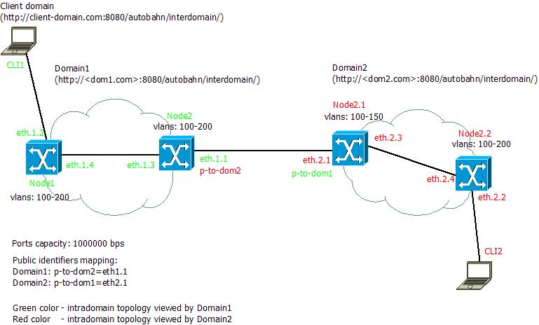
Figure 1 Sample physical topology (two ethernet domains)
Figure 1 presents a sample physical ethernet topology of two AutoBAHN enabled domains: Domain1 and Domain2. There is a single connection between these two domains, each domain has a single client connected to it (CLI1 and CLI2).
The following sections describes the process of configuring AutoBAHN for this sample scenario. The scenario assumes two AutoBAHN domains, each of them is controlling separate network, cNIS and AutoBAHN instances have to be deployed and configured for each of them separately.

Inserting topology information in cNIS
Launch cNIS cma in your internet browser, credentials are admin/admin for the default installation. Insert the information about network elements using web forms.
You can learn more about editing a topology using cma by watching the screencasts available at: https://forge.geant.net/forge/display/cNIS/Screenshots.
Topology for Domain1:
- Add the nodes (Navigation: ‘Ethernet’ Tab -> ‘Nodes’ \ ‘Add Node’) (in the example: two nodes – Node1 and Node2)
  - Specify the ‘name’ attribute of the node
  - Specify the ‘IP address’ (management address) of the node
- Add the interfaces (ports) for each of the nodes (Navigation: ‘Ethernet’ Tab -> ‘Nodes’ \ ‘Node list’ -> ‘view’ -> ‘Ports’ Tab -> ‘Add new port’) (in the example ports: eth1.4 and eth1.2 belong to Node1)
  - Fill in the attributes required by AutoBAHN:
    - Name
    - Business ID (this can be the same as Name)
    - Bandwidth (in bps)
    - Status
  - Specify Vlan range available for ports on the given node (Navigation: Node details page ->Autobahn tab -> Edit button ->Vlan ranges) (in the example: add the range of available vlan ids 100-200)
- Add the link between the interfaces eth1.4 (Node1) and eth1.3 (Node2) (Navigation: Ethernet Tab -> Add Link)
Process of adding the topology information for Domain2 is similar.

Adding the connections to the external domains
Since cNIS 2.1.0 it is possible to add information on connections to external domains using cNIS web interface cma.
Choose the Ethernet tab and Add Link from the left menu labeled ‘External domains links’. Then a form should be displayed. Following information must be provided:
- External domain ID:
  - Specify here the identifier of the external domain. This has to be exactly the domain name that your neighboring domain is using (e.g. GEANT). If your connection goes to an end point then you can put an arbitrary identifier (i.e. Client-domain).
- Bandwidth:
  - Specify here the capacity of the connection (in bps)
- Start node:
  - Choose a node from the list. It is the node from your domain where the external link is attached.
- Start interface:
  - Choose an interface from the list. It is the termination of the connection that belongs to your domain.
- End port ID:
  - Specify the public identifier of the terminating interface in the other domain (i.e. p-to-dom1)
- VLAN ranges:
  - Specify range of available VLAN identifiers on your side of the connection. (it can be a range or a single value or a combination i.e. 5,800-802,100-120)
If the connection is to another domain (e.g. GEANT), click on the Start port name, then click on the ‘Tags’ tab, choose ‘Edit’ and in the text area put following information:
public-name=the port’s public name (e.g. public-name=p-to-dom2)
The public name is the identifier that this port will be known to other domains (so that you do not have to announce internal identifiers to other domains). For more details, read section 2.3.2.

Connections to end points
Client end points are treated similarly to neighboring domains. No separate node is needed to represent the client end host. In other words, all you have to add in cNIS is an external link (using the same steps shown above needed to create a connection to an external domain). The difference for client end points is that you also have to do the following step:
Navigate to the ‘Tags’ tab, choose ‘Edit’ and in the text area put following information:
client=true
description=your description (e.g. description=Data calculation cluster in Poznan)
Click ‘Ok’ button to submit the data.

Configure DM to use cNIS as topology information source
To plug cNIS to your DM you must edit the <autobahn_home>/etc/autobahn.properties file. Find the line with cnis.address property and insert the correct address to the abs service of your cNIS instance.
cnis.address=http://<host>:<port>/abs/AutobahnService
For example:
cnis.address=http://192.168.74.128:8080/abs/AutobahnService
The above configuration are should take place during the installation of the AutoBAHN software, either using the wizard (section 2.4.1) or manually (section 4.1.3).

Public identifiers
As the domain administrators may not want to announce the topology details such as port or node identifiers to the external domains, in AutoBAHN we introduced a concept of public identifiers hiding real ports/nodes physical identifiers.
In the sample diagram we can see that although the port connecting Domain2 with Domain1 has identifier ‘eth.2.1’, Domain1 sees it as ‘p-to-dom1’ while Domain2 sees ‘eth1.1’ as ‘p-to-dom2’. And this is the only information that Domain2 has got about the physical topology of Domain1. The topology information seen by Domain1 is shown by the green colour and by Domain2 by the red one.
There are 2 alternative ways to store information about the mapping:
1. Insert the relevant information in cNIS, as described in section 2.3.1.2.
2. Enter the information about the mapping in a special property file named <autobahn_home>/etc/public_ids.properties:
At <autobahn_home>/etc/public_ids.properties file of Domain1 installation:
#Public names for domain ports
p-to-dom2=eth.1.1
At <autobahn_home>/etc/public_ids.properties file of Domain2 installation:
#Public names for domain ports
p-to-dom1=eth.2.1

Multiple links attached to a single port
cNIS allows to define a topology where more than one links are attached to the same port. However, AutoBAHN will normally not allow such a topology: it will assume an insertion error and report it as such when reading the topology information from cNIS. In most cases this is desirable and helps the user identify insertion errors and correct the link and port definitions.
However, there may be cases where this scenario (having multiple links attached to the same port) is actually intended. In order to allow this, you have to find the relevant port in cNIS, click on the ‘Tags’ tab, choose ‘Edit’ and in the text area put following information:
multiple-links-allowed=true
AutoBAHN will then make an exception for this specific port and allow it to have more than one links attached to it.

Installation using the wizard (for Ubuntu, Debian and Fedora Linux)
The easiest way to install the AutoBAHN system under Ubuntu, Debian or Fedora distributions is by using the automated installer (wizard) included in the distribution (distribution can be downloaded from the downloads section at https://forge.geant.net/forge/display/autobahn/Home). If the automated installer is not suitable for your environment or you wish to have more control over the installation procedure, you can follow the manual steps at the appendix (section 4.1).
In order to run the wizard installation, perform the following steps:
- Extract AutoBAHN.zip at the folder where you intend to install autobahn. The zip contains everything in a single folder named autobahn.
- Go to the installer folder
- Run the following command to make sure all scripts are executable:
chmod +x *.sh
- Run the setupall.sh script with root priviledges (sudo setupall.sh)

The wizard configures properly the following:
- Database
- System configuration parameters (detailed listing in appendix section 4.1.3)

Also, if the user wishes to use the OSPF topology exchange method (instead of the default and recommended topology exchange method based on the Lookup Service), the wizard can configure:
- Quagga and its OSPF daemon
- GRE tunnels for Quagga communication with other domains

Wizard guide
The wizard presents either a text-mode dialog-based interface or a simple command-line sequence, depending on the existence of the Dialog application (which is based on the ncurses library) in the system where the installation takes place.
Below is a sample screenshot of the command-line wizard interface.
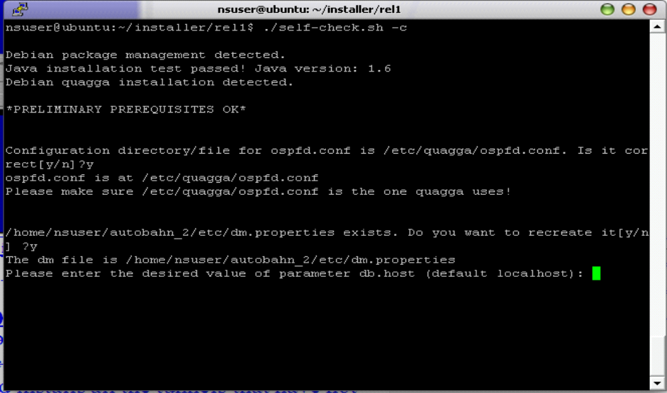

Below a step-by-step guide of the ncurses dialog-based wizard interface is given.
Initially the wizard asks whether the OSPF topology exchange method will be used. If you choose No, which is the recommended answer, the rest of the installation is simplified significantly because topology exchange then will take place using the Lookup Service and not the deprecated OSPF method. The rest of this section is therefore divided in two sub-sections, depending on the answer to this question.

OSPF / Quagga not used (recommended)
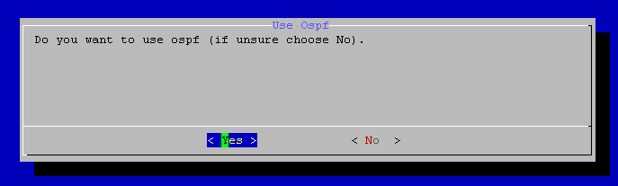

Click the No button (unless you know you want OSPF).
The wizard performs then some tests to check whether all the required software dependencies exist, and informs about any possible problems. Click on the Continue button if no problems are reported.
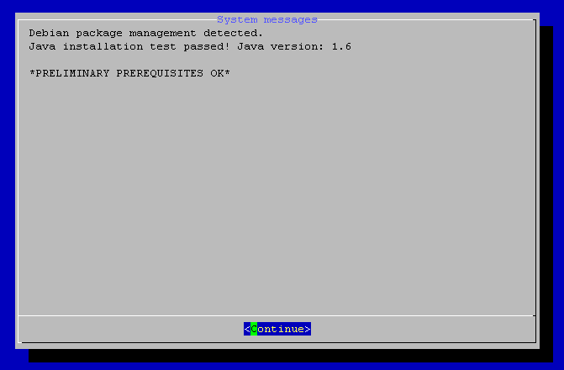

Then the wizard asks whether you want to edit configuration properties one-by-one at this point, or whether you want to leave this step for later. You can select either option here. Quicker approach is probably to select No as shown below.
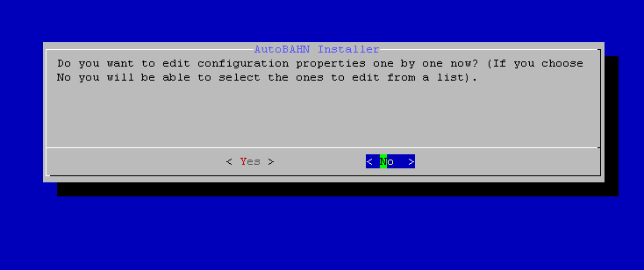

Then the wizard proceeds to configuration file editing as shown below. You can select a configuration file (autobahn.properties, or services.properties), click the OK button and edit its values.
A complete listing of the available properties and their meaning can be found in section 4.1.3.
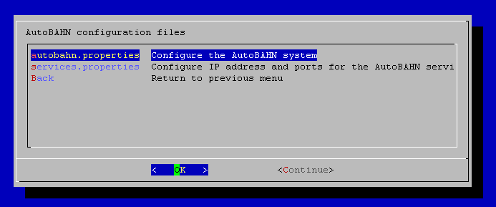

Below an example of editing the autobahn.properties file is shown.

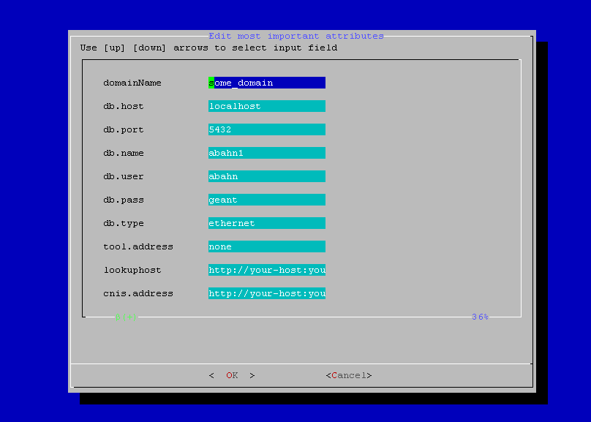

After you have finished editing the configuration files, click on the Continue button.
The wizard then creates the internal AutoBAHN database and user. Click on the Continue button to progress through these screens as shown below. If any errors are reported make sure to fix them (e.g. if the postgreSQL server is not running).
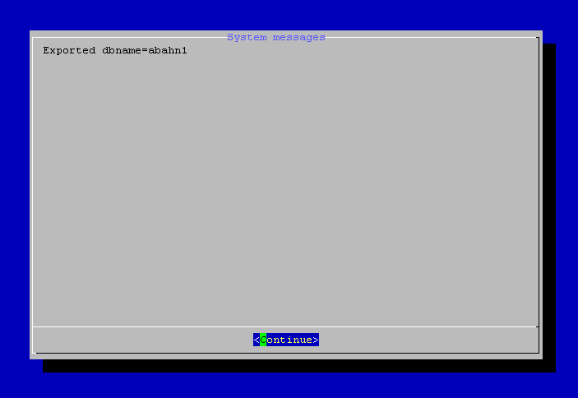

Next, the wizard reaches the final menu shown below. The Ospf option allows you to change your initial choice regarding usage of OSPF / Quagga. The Property Editor option allows you to go back and edit the autobahn.properties and service.properties configuration files. Choose Exit and the installation is complete.
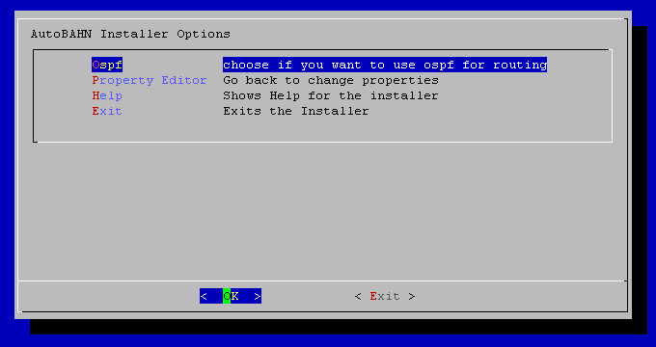

OSPF / Quagga used (deprecated)

Click the Yes button.
The wizard then asks for several values for properly setting up the ospfd daemon. In order to understand the proper values that should be inserted here, you can see an example at section 2.4.2.
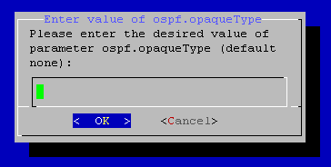

Then the wizard asks for the location of the folder where Quagga configuration files are located (on a standard debian installation it may be /etc/quagga). Select the appropriate folder and click OK as shown below.
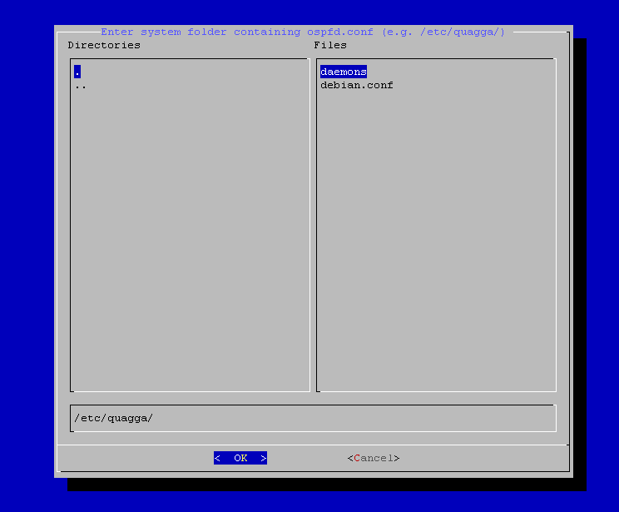

The wizard then reports the files it has copied. Click on the Continue button.
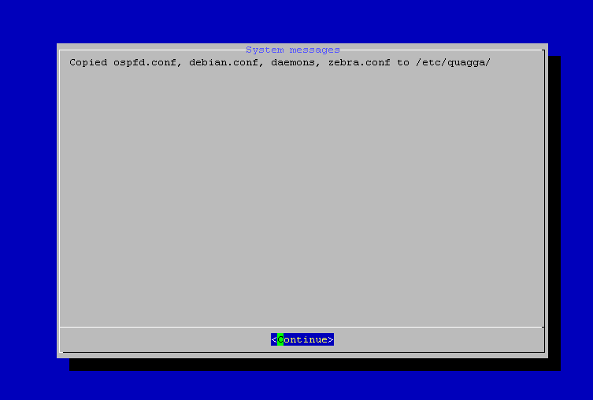

Then the wizard asks for the location of the folder where Quagga startup files are located (on a standard debian installation it may be /etc/init.d). Select the appropriate folder and click OK as shown below.
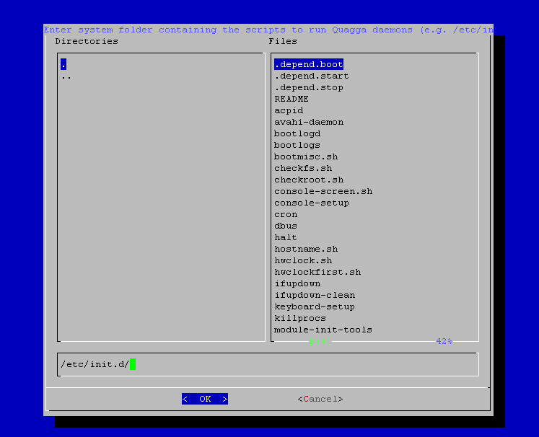

The wizard then reports the supplied folder (or possible problems if any). Click on the Continue button.
Then the wizard asks whether you want to edit configuration properties one-by-one at this point, or whether you want to leave this step for later. You can select either option here. Quicker approach is probably to select No as shown below.

Click on the button to progress through these screens as shown below.
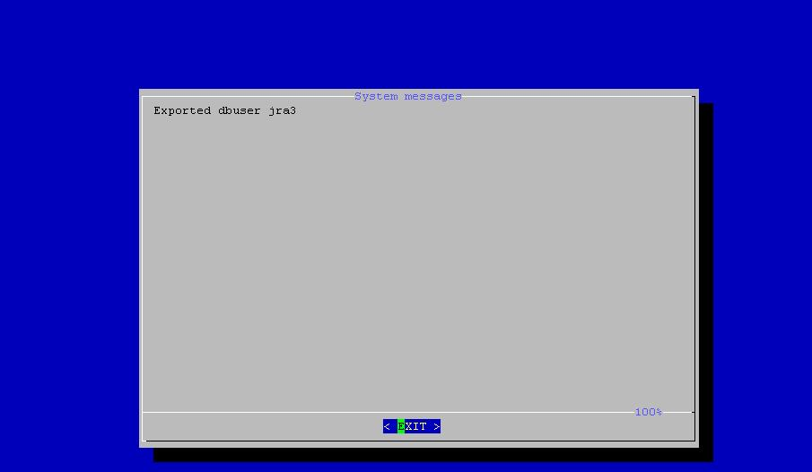

Then the wizard proceeds to configuration file editing as shown below. You can select a configuration file (autobahn.properties, or services.properties) and edit its values.
A complete listing of the available properties and their meaning can be found in section 4.1.3.
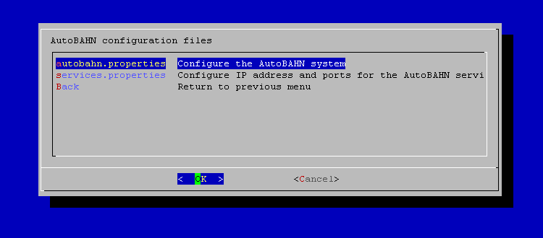

Below an example of editing the autobahn.properties file is shown.

After you have finished editing the configuration files, the wizard creates the database user and tables and displays informational screens. Press Continue in these and make sure no error message appears.
Then the wizard presents the following menu.
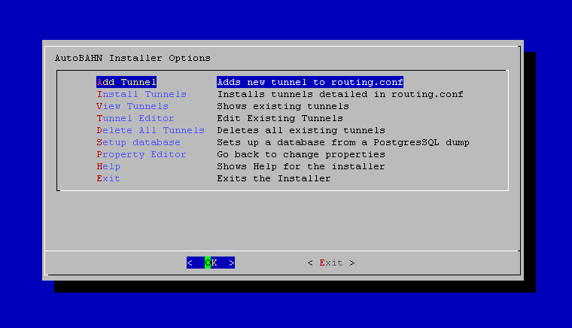

From this menu you can add, edit or view tunnels. These actions are recorded in a temporary file. In order to apply them to the OS you should then install the tunnels. Another menu option is to fill the database with an SQL script, if available. This step is optional, as you may choose to retrieve network topology via cNIS (which is also the preferred way). Finally, the menu gives you the option to go back to editing the system properties.

Generic Routing Encapsulation (GRE) tunnels setup example (optional)
Generic Routing Encapsulation (GRE) tunnels that transfer OSPF traffic are one method of control plane communication; that is to implement communication channels between the different AutoBAHN servers in the domains participating in Bandwidth on Demand (BoD) service provisioning. It has currently been superseded by the usage of the Lookup Service, so this section relevant only if the OSPF topology exchange method is used, otherwise it may be skipped.
Suppose that the control plane for the example presented in section 2.3.1 is the following:

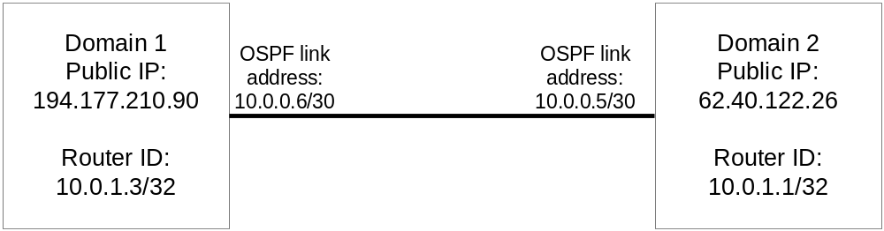

The Internet Protocol (IP) address of the local end of tunnel at Domain 1 is 194.177.210.90 (the IP address of the Domain1 AutoBAHN server) while the IP address of the remote end of the tunnel is 62.40.122.26 (the IP address of the Domain2 AutoBAHN server).
Assume that the following values were agreed on by the partners:
- Private addressing for Open Shortest Path First (OSPF):
OSPF area = 100
network 10.0.0.0/8 area 0.0.0.100
- HOST OSPF loopback address (router ID):
Domain1 10.0.1.3/32
Domain2 10.0.1.1/32
- Address for GRE tunnel (OSPF link addresses):
Remote to Local: 10.0.0.5/30 <----> 10.0.0.6/30

In order to create the tunnel at Domain 1, you have to select “Add tunnel” in the wizard menu and specify the following values:
- Remote IP: 62.40.122.26
- Local IP: 194.177.210.90
- Local Subnet: 10.0.0.6/30
- Local Router ID: 10.0.1.3
- Network: 10.0.0.0/8
- Area: 0.0.0.100

If you wish to edit an already existing tunnel, you can select “Tunnel Editor”. A screenshot of the relevant wizard menu is presented below.
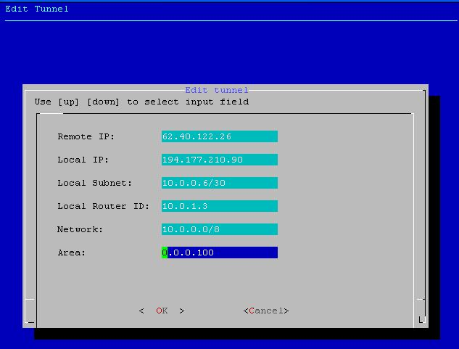

Then click OK and select “Install tunnels” in order for the tunnel to be installed in the OS environment.

Initializing the AutoBAHN service
In the distribution directory type: ./start.sh
You may need Java in your classpath.
The start.sh script uses the nohup command in order to start AutoBAHN in the background and write console output from latest execution in nohup.out file.

If there are no mistakes in configuration or topology, you can see the log messages of the initialization process. You may also check whether the service is running by accessing the URL http://(your-host):(your-port)/autobahn/uap?wsdl using your favourite browser.
Services are started at the 8080 port and secure services at 8090 port. You may change the default ports by editing the etc/services.properties file (see also section 4.2).

Shutting down the service
In the distribution directory type: ./stop.sh
Alternatively, you can also telnet to the Autobahn instance (port 5000 is default):
telnet localhost 5000
Then login (default password is abahn) and type:
halt

Technology Proxy configuration
Low-level data plane configuration is done by the Technology Proxy (TP), which is the intermediate module for connecting the AutoBAHN control plane software with the underlying Network Elements or NMS. As such, it is highly dependant on the type of networking technology used at the data plane, and a different TP has to be used for each different networking technology.
Currently, the following TPs are available:
Technology | Equipment | Access to equipment
L2 MPLS VPNs | Cisco routers supporing AToM working under Bluenet / ANStool (760x, 3750, 3500) | Bluenet / ANStool
Ethernet over MPLS | Brocade (Foundry) Network NetIron 8000 | SSH
Ethernet | Juniper EX4200 Ethernet switches | SSH
Ethernet | Juniper MX80 Ethernet switches | SSH
SDH/SONET | Alcatel MCC 1678 | Alcatel NMS 1353NM/1354RM/1359ISN
OPST (Optical Packet Switched Transport) | Intune Networks (Verisma iVX8000) | Intune NMS
If your domain falls under one of the above categories, you can download and install the respective TP according to the instructions supplied by the TP developers.

Configuring DM to communicate with the TP
As soon as the TP (either one of the available ones or a custom implementation) has been setup, it is necessary to configure DM to be able to access it. As described in section 4.1.3, the tool.address property in the autobahn.properties file has to be edited, so that it points to the URL where the TP Web Service is listening.

Supporting more technologies
In case that none of the already available solutions fits your domain, there is the option of creating a new TP module. The system architecture has been designed so that only the minimum necessary functionality is needed at the TP, while its internal structure may be freely chosen, as long as the TP adheres to a Web Services interface that has been specified for DM<->TP communication.
The WS interface definition and detailed description can be found here (Technology Proxy interface section):
https://forge.geant.net/forge/display/autobahn/Documentation
What is essentially required by the TP is that it is able to handle requests by the DM for creation and deletion of physical circuits.
The following sections provide some examples of the minimum configuration required to enable a domain to participate in the AutoBAHN service cloud. Such configuration setup will have to be supported by a TP that will operate in the domain in order for the automated creation of circuits to be possible.

Case A: End host at the domain’s ingress Point-of-Presence from GÉANT
Here a host is connected on the Point-of-Presence (PoP) where the domain peers with the AutoBAHN cloud. The example is taken from GRNET deployment during GEANT2 (see Figure 3.2).
The configuration is minimal, with one end host with two 1GE NICs located in the GÉANT PoP in Greece, co-located with a GRNET PoP. One of the NICs is connected to the public Internet. The other terminates the AutoBAHN circuit on the host.
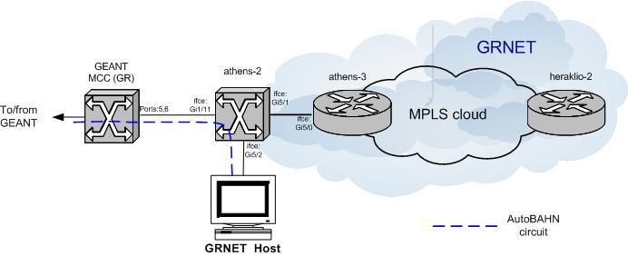
Figure 3.2: Case A: Minimal data plane configuration required to join the AutoBAHN cloud
The AutoBAHN circuit arrives at GRNET through one of the GE client interfaces on the GÉANT PoP Metro Core Connect (MCC) in Athens. The circuit is received at a Layer 2 (L2) switch on the border of GRNET and then switched directly to the host. In this case, the GRNET part of the AutoBAHN circuit data plane comprises a single L2 switch.

Case B: End host connected to any Point-of-Presence in the domain
Here the host is connected on any other PoP of the domain, other than the peering PoP with GÉANT. The example is again taken from GRNET deployment during GEANT2 (see Figure 3.3).
The end-host has two 1GE NICs, one of which is connected to the public Internet. The other terminates the AutoBAHN circuit on the host.
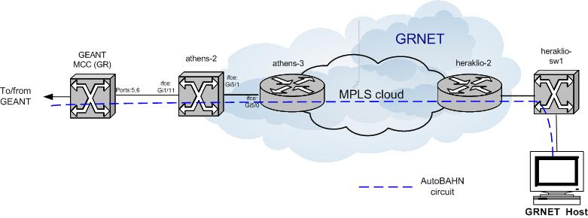
Figure 3.3: Case B: Minimal data plane configuration required to join the AutoBAHN cloud
GRNET implements AutoBAHN circuits within its core using L2 Multiprotocol Label Switching (MPLS) Virtual Private Networks (VPNs). The AutoBAHN circuit arrives at GRNET through one of the GE client interfaces on the GÉANT PoP MCC in Athens. The circuit is switched through a L2 switch to the border router of the GRNET MPLS cloud in Athens and then through a L2 MPLS VPN to the border router of the GRNET MPLS cloud in Heraklion (Crete). The circuit is then switched through another L2 switch to the end host.
In Figure 3.3 the host is assumed to reside in a PoP of the domain. If this is not feasible (for example, the end host is located in a campus, lab, or similar that does not belong to the domain), then the AutoBAHN circuit should reach the end host using a fixed or virtual L2 circuit. The detailed implementation depends on the existing technologies at the last mile.
The AutoBAHN group is investigating possible solutions to the last mile problem but at present manual configuration is required.

Appendix

Manual installation
Under operational systems where automated installation is not supported, or if for any reason the automated installation is not available, you may perform the installation manually as described in this section.

Database creation
Create an empty database and execute .sql file located at: sql/create_db.sql.

Generic Routing Encapsulation tunnel configuration (optional)
Generic Routing Encapsulation (GRE) tunnels that transfer OSPF traffic are one method of control plane communication; that is to implement communication channels between the different AutoBAHN servers in the domains participating in Bandwidth on Demand (BoD) service provisioning. It has currently been superseded by the usage of the Lookup Service, so this section relevant only if the OSPF topology exchange method is used, otherwise it may be skipped.
You need the ip_gre.o kernel module to configure the tunnels.
The example below shows the configuration use in the demonstration of AutoBAHN run during the 5th GÉANT2 Technical Workshop where four AutoBAHN servers were deployed for the GRNET, HEAnet, GÉANT and PIONIER domains (Figure 4.4).
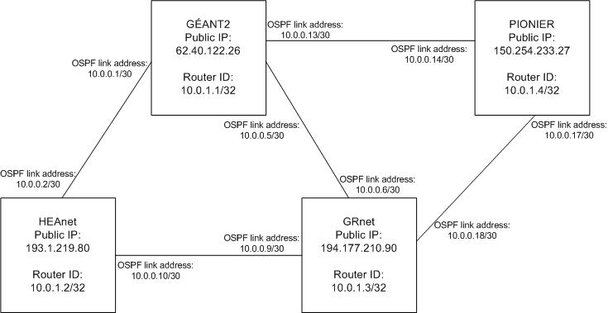
Figure 4.4: Control plane tunnel configurations used in the 5th GÉANT2 Technical Workshop demonstration
The example describes the tunnel between GRNET and GÉANT.
The Internet Protocol (IP) address of the local end of tunnel is 194.177.210.90 (the IP address of the GRNET AutoBAHN server) while the IP address of the remote end of the tunnel is 62.40.122.26 (the IP address of the GÉANT AutoBAHN server).
Assume that the following values were agreed on by the partners:
Private addressing for Open Shortest Path First (OSPF):
- OSPF area = 100
network 10.0.0.0/8 area 0.0.0.100

HOST OSPF loopback address (router ID):
- GRNET 10.0.1.3/32
Address for GRE tunnel (OSPF link addresses):
- Remote to Local: 10.0.0.5/30 <----> 10.0.0.6/30
To configure the above, execute the following commands (where gre1 is the tunnel interface name):
#ip tunnel add gre1 mode gre remote 62.40.122.26 local 194.177.210.90 ttl 255
#ip link set gre1 up multicast on
#ip addr add 10.0.0.6/30 brd + dev gre1
Also, edit the ospfd configuration file so that it contains the following:
Sample of ospfd.conf:
!
! Zebra configuration saved from vty
router ospf
ospf router-id 10.0.1.3
network 10.0.0.0/8 area 0.0.0.100
capability opaque
!
password XXXX
log file /var/log/quagga/ospfd.log
!

The password is required to telnet to the ospfd (#telnet localhost ospfd, or see the documentation on the quagga site for more information). The log file is not mandatory, but may be useful for debugging.
Finally, start the zebra and ospf daemons:
#zebra –d
#ospfd -d -a -u <username>

AutoBAHN system configuration
The AutoBAHN configuration files can be found in the etc directory in your distribution. Following listing describes the most important properties that should be set to run the application properly. In general, when you do not want to supply a value to a property you may comment it out using the hash character (#), delete the line or enter the value none.

services.properties (Configuration of AutoBAHN server IP and port)
- server.ip – The globally accessible IP of the AutoBAHN server instance. It should not be a localhost, loopback or NAT address.
- server.port – The port where AutoBAHN services will be listening. Make sure that this port is not already taken by another process (e.g. Tomcat if it also running on the same machine).
- server.securePort – The secure port where AutoBAHN services will be listening. Make sure that this port is not already taken by another process (e.g. Tomcat if it also running on the same machine).

autobahn.properties (Configuration of general AutoBAHN parameters)
- domainName – The name of your domain (e.g. Geant). This should be the same name that other IDMs use to refer to this domain.
- latitude, longitude – Coordinates of your IDM instance. Needed by AutoBAHN client portal to draw a map of IDMs
- domain – Address of your AutoBAHN server. Change the domain and port accordingly to the location where it is deployed.
- idm.address – IDM address. Change the domain and port accordingly to the location where it is deployed.
- dm.address – DM address. Change the domain and port accordingly to the location where it is deployed.
- topologyabstraction.address – TA address. Change the domain and port accordingly to the location where it is deployed.
- resourcesreservationcalendar.address – Calendar address. Change the domain and port accordingly to the location where it is deployed.
- ospf.use – Whether to use OSPF topology exchange mechanism. This mechanism has been superseded by the usage of the Lookup Service, so you can typically leave this option to false.
- ospf.address, ospf.port, ospf.ifAddr, ospf.areaId, ospf.lsaType, ospf.opaqueType, ospf.opaqueId – Address (host) of your Quagga router, listening port and other parameters needed to connect and retrieve abstracted topology information from the OSPF Quagga daemon. Only relevant if the ospf.use property above has been set to true.
- db.host, db.port, db.name, db.user, db.pass, db.type – Change them to the values you are using to access the local AutoBAHN database.
- gui.address – The URL of the location for the WebGUI that this IDM will connect to.
- gui.update – The number of seconds between successive update messages from the IDM to the WebGUI.
- lookuphost – The URL of the location for the Lookup Service (if available, otherwise comment the line or specify the value none).
- cnis.address – The URL of the cNIS service. If you do not wish to retrieve the topology information from the cNIS service, either leave the field blank, or set the value none or comment it.
- tool.address – The Technology Proxy address where reservations requests will be sent for adding / removing the circuits. If set to none, no control plane will be used.
- tool.time.setup – Extends a submitted reservation by the selected time in seconds before its start time to allow for setup time.
- tool.time.teardown – Extends a submitted reservation by the selected time in seconds after its ending time to allow for teardown time.
- tool.canHandleVlanTagAt1GE – Some TPs reject requests that contain VLANs for 1GE ports, even if the VLAN is set to 0. For those cases (e.g. Geant), set this flag to false, otherwise leave the default value of true.
- framework.commandLine – Possible values are none, interactive, localhost and remote. Interactive means that commands can be entered at the command line, while localhost and remote allow a local or remote telnet connection accordingly.
- framework.port – If localhost or remote was selected above, it determines the commandLine server listening port.
- framework.password – The password needed in order to connect to the console (stored as MD5 hash value).
- mail.use – Whether mail sending will be used or not (true or false).
- mail.smtp.host – The mail server to send mails from through SMTP.
- mail.smtp.port – The mail server SMTP port.
- mail.address.from – The email address that will be used at the “from” field of the email.
- mail.user – The username that will be used to authenticate to the mail server.
- mail.pass – The password that will be used to authenticate to the mail server.
- mail.address.admin – The email address of the local administrator (will receive all outgoing emails).
- timeout.activating – Specify here how long (in seconds) the system should wait in the activating state before timing out.
- timeout.scheduling – Specify here how long (in seconds) the system should wait in the scheduling state before timing out.
- authorization.enabled – true/false, whether authorization operations will be performed in this domain.
- public.ids.file – Path to the file with mapping between device names and their public identifiers.

public_ids.properties (Configuration of public identifiers’ mappings)
- Add keypairs in the format PORT1=port_eth2.1_cxx, where one part is the public identifier and the other the internal private identifier of interfaces that are attached to interdomain links. For more information, see section 2.3.2.

idcp.properties (Configuration of IDCP interoperability parameters and servers)
- interoperability.enabled – Set to true if you want IDCP interoperability to be enabled.
- debugging.enabled – Prints more info if set to true.
- max.subscription.time – Interval for renew messages, should be less than hour.
- oscars.url, oscarsnotify.url, oscarsnotifyonly.url – Point to local Oscars services.
- domain.name – Domain name representing autobahn topology
- pstopology.file – Topology file with autobahn topology converted to idcp xml format. Set to none if it does not exist.
- pstopology.url – AutoBAHN topology service. Set to none if it does not exist.
- endpoints.whitelist – File with valid idcp endpoints (whitelist).
- idcp.* – The URL of a connected IDCP server. Multiple values starting with the idcp.* prefix are allowed, for example
  - idcp.server1 = https://some_server.com
  - idcp.server2 = https://some_other_server.com

security/security.properties (Configuration of exchanged messages security)
- net.geant.autobahn.security.activated – Whether security will be enabled. If set to true, signing and validation of messages is enabled. If set to false, the rest of the properties in this file are ignored.
- net.geant.autobahn.edugain.timestamp – Set to true if you want to activate timestamping for exchanged messages. Please note that this option requires the communicating servers to be synchronized, so improper configuration may create communication problems.
- net.geant.autobahn.edugain.encrypt – Set to true if you want to activate message encryption.
- net.geant.autobahn.edugain.activated – Set to true if you also want to validate incoming messages using the Edugain CA.
- org.apache.ws.security.crypto.merlin.keystore.password – The password for accessing the file containing the PKI keys.
- org.apache.ws.security.crypto.merlin.keystore.alias – The alias for accessing the file containing the PKI keys.
- org.apache.ws.security.crypto.merlin.file – The location in the disk of the file containing the PKI keys (preferably use the default relative paths).

security/edugain/edugain.properties (Configuration of edugain-based security)
- org.opensaml.ssl.truststore – The location in the disk of the file containing the PKI keys.
- org.opensaml.ssl.truststore-pwd – The password for accessing the file containing the PKI keys.
- net.geant.edugain.validation.crl.url – URL to retrieve Certificate Revocation List.
- net.geant.edugain.validation.crl.timeout – Timeout for checking Certificate Revocation List.

security/aai/dm_security.xml (Configuration of local authorization policies)
- Modify the access attribute under <global-method-security> / < protect-pointcut > tag in order to define the authorization policy, using combinations of authorities that are allowed to make reservations. In the syntax of this attribute, spaces are treated as the operator “AND”, while commas as the operator “OR”. E.g. an expression such as “allow (ROLE_USER and ORG_GRNET) or (ROLE_ADMINISTRATOR)” has to be written as access=”ROLE_USER ORG_GRNET,ROLE_ADMINISTRATOR”.

Providing topology information through sql file (without cNIS)
In order to provide the topology information to AutoBAHN when not using the cNIS system a dedicated sql file describing the topology should be prepared. The sql query should populate the Domain Manager’s physical topology database with the information on: nodes, interfaces, links and available vlan ranges.
The topology information can be provided to AutoBAHN by executing the following command:
#setup.sh –d
Then AutoBAHN installer will prompt for a path to the sql file (in example: ./grnet-intradomain.sql).
Important:
    - Database schema should be already created (as described in 4.1.1)
    - AutoBAHN configuration files should be properly filled in.
    - cnis.address property in etc/autobahn.properties file should be set to “none” (cnis.address=none)

AutoBAHN Web Services interfaces addresses
The basic modules of an AutoBAHN instance are bound by default to the following addresses, as defined in etc/cxf/cxf.xml configuration file:
- InterDomain Manager (IDM): http://${server.ip}:${server.port}/autobahn/interdomain
- Domain Manager (DM): http://${server.ip}:${server.port}/autobahn/idm2dm
- Topology Abstraction (TA): http://${server.ip}:${server.port}/autobahn/topologyabstraction
- Resources Reservation Calendar: http://${server.ip}:${server.port}/autobahn/resourcesreservationcalendar
The following addresses are also bound by the AutoBAHN system for various services, as defined in etc/cxf/cxf.xml configuration file:
- IDM interface for intradomain information: http://${server.ip}:${server.port}/autobahn/dm2idm
- User Access Point for user interface access to IDM: http://${server.ip}:${server.port}/autobahn/uap
- IDM Administration interface: http://${server.ip}:${server.port}/autobahn/administration
- DM Administration interface: http://${server.ip}:${server.port}/autobahn/dmadmin
- DICE IDCP [DICE] interoperability interface: Error! Hyperlink reference not valid.
- DICE IDCP [DICE] interoperability notification interface: Error! Hyperlink reference not valid.notify
The ${server.ip}:${server.port} part is substituted from the values in the etc/services.properties file. You can therefore change the default HTTP port (8080) or the default HTTPS port (8090) by editing the etc/services.properties file.
You should also set the server.ip property in the etc/services.properties file to the public IP address of the server hosting the software.

Installing LS
AutoBAHN instances can take advantage of the existence of a Lookup Service, which functions as a central registry for:
- Registration of friendly names of end ports.
- Registration of AutoBAHN instances so that neigboring domains may discover them.
- Registration of ports attached to interdomain links, so that neigboring domains can automatically discover their connected ports (at present this automated procedure only works if two neigboring domains have only a single interdomain link).
- Topology exchange. This is the preferred method for the domains to exchange their abstracted topology. Usage of the LS for this purpose requires no special configuration and deprecates the more error-prone OSPF topology exchange method.
The current AutoBAHN implementation uses the Lookup Service module as developed by PerfSonar.
A single LS instance is therefore needed across the whole AutoBAHN federation. Below are instructions for the LS installation. If the LS has already been installed and a URL where it is located is available, then this section can be skipped.
Hardware and software requirements are the same as for the respective Tomcat installation that will be used.

On Linux
- Download apache-tomcat-6.x.x from the official site and install it (just place the apache folder in your preferred directory).
- Download the perfsonar-java-xml-ls.war file from the AutoBAHN site, a properly customized version of the perfSonar LS (https://forge.geant.net/forge/display/autobahn/Downloads) and place it inside Tomcat webapps directory
- Download the exist.war file from the AutoBAHN site, a properly customized distribution of the eXist database, (https://forge.geant.net/forge/display/autobahn/Downloads) and place it inside Tomcat webapps directory.
- Restart Tomcat.

Configuring LS
The LS is pre-configured to run on port 8080, so Tomcat also has to be configured to run at the 8080 port.
If you want to run Tomcat at a different port, you can configure the LS through its administrative interface:
- Go to Error! Hyperlink reference not valid.
- Log in with default credentials (perfsonaruser/perfsonarpass).
- Select “Advanced Service Settings”
- Change the port in the “Exist DB url” to the appropriate value

The Lookup Service by default “clears” the xml database where information is stored after specific intervals. In order to properly configure the Lookup Service for usage by AutoBAHN this behaviour has to be disabled. There are 2 ways to do this:
1. Follow the steps above and make sure that the “Cleanup action enabled?” is set to “off”.
2. Find the configuration.xml file that is located at the Tomcat folder /webapps/perfsonar-java-xml-ls/WEB-INF/classes/perfsonar/conf/. Set the value of the “status” tag inside the LSCleanup_1 action to “off”, as shown below (changed line in red bold).
<!-- Scheduler -->
<component name="scheduling"
className="org.perfsonar.base2.service.scheduler.SchedulingComponent">

<option name="schedulerClassName" value="org.perfsonar.base2.service.scheduler.SimpleScheduler"/>
<option name="interval" value="60"/> <!-- sec -->
<actions>

<action name="LSCleanup_1" className="org.perfsonar.service.lookupservice.LSCleanupSchedulerAction">
<option name="status" value="off" />
<option name="interval" value="1" />
<option name="lsTTL" value="1"/>
</action>

</actions>
</component>

After the changes in the configuration.xml file, restart Tomcat in order for the changes to take effect.

WebGUI deployment
The WebGUI is a web-based User Interface where the user can connect and submit reservations to associated AutoBAHN IDM instances. Hardware and software requirements are the same as for the respective Tomcat installation that will be used.

Web Application Container installation
Install Tomcat 5.x or higher (versions up to Tomcat 7 have been tested successfully).

Web GUI installation
Place the autobahn-gui.war file inside Tomcat webapps and restart tomcat.
For better performance, it is advisable to set the following environment property before running Tomcat, so that its memory allocation is increased:
export JAVA_OPTS="$JAVA_OPTS -Xmx512M -XX:PermSize=128M"
This variable will either have to be exported each time before running Tomcat or as part of the Tomcat startup script.

Web GUI configuration

Configure AAI
Web GUI currently provides authentication using two available Identity Providers (IdPs): local XML file and Crowd.

XML file IdP
There is a WebGUI page (user administration) with a graphical UI for adding/removing users, which can be used as soon as the WebGUI is up and running in order to avoid manual configuration editing. For the first WebGUI login after its installation, you can either use the default set of username/password credentials (demo/demo), or manually edit the credentials configuration as shown below:
Find userdetails.xml in webapps/autobahn-gui/WEB-INF/ folder.
- Add a new entry under the <userdetails>/<users> tag in order to create a new WebGUI user (you can also use the existing accounts listed there). E.g. to be able to log into the WebGUI using the credentials testUser / md5(some password) add the following entry:
<user>
<USERNAME>testUser</USERNAME>
<PASSWORD>md5_hashed_password</PASSWORD>
<ENABLED>1</ENABLED>
</user>
- Add new authorities under the <userdetails>/<authorities> tag in order to assign new authorities to a specific WebGUI user. The authorities describe the user parameters:
  - Role (authority prefix: ROLE_)
  - Organization (authority prefix: ORG_)
  - Project membership (authority prefix: PM_).
- To declare that the user testUser is administrator and belongs to GRNET organization, you can add the following entries:
<authority>
<USERNAME>testUser</USERNAME>
<AUTHORITY>ROLE_ADMINISTRATOR</AUTHORITY>
</authority>
<authority>
<USERNAME>testUser</USERNAME>
<AUTHORITY>ORG_GRNET</AUTHORITY>
</authority>
<authority>
<USERNAME>testUser</USERNAME>
<AUTHORITY>MAIL_test@user.com</AUTHORITY>
</authority>
You can obtain the MD5 hash of a password using an online MD5 generator such as http://www.adamek.biz/md5-generator.php.
Security note: Don’t forget to remove the demo account after you have created your own!

Crowd IDP
To enable the usage of Crowd as an IDP for the Web GUI, you have to:
- Add an application to the Crowd server (or use an existing one), e.g. abahn
- Configure the webapps/autobahn-gui/WEB-INF/classes/crowd.properties file:
  - application.name – Set the name of the selected application (e.g. abahn) at the Crowd server
  - application.password – Set the password of the selected application at the Crowd server
  - application.login.url – Crowd will redirect the user to this URL if their authentication token expires or is invalid due to security restrictions. Can be set to the web user interface of the crowd server
  - crowd.server.url – Edit the URL to point to the proper Crowd server.
- Configure the webapps/autobahn-gui/WEB-INF/security.xml file:
  - Uncomment the following lines:
<beans:import resource="classpath:/applicationContext-CrowdClient.xml" />

<beans:bean id="crowdUserDetailsService"
class="com.atlassian.crowd.integration.springsecurity.user.CrowdUserDetailsServiceImpl">
<beans:property name="authenticationManager" ref="crowdAuthenticationManager" />
<beans:property name="groupMembershipManager" ref="crowdGroupMembershipManager" />
<beans:property name="userManager" ref="crowdUserManager" />
</beans:bean>

<beans:bean id="crowdAuthenticationProvider" class="net.geant.security.crowd.WebAuthNProvider">
<custom-authentication-provider />
<beans:constructor-arg ref="crowdAuthenticationManager" />
<beans:constructor-arg ref="httpAuthenticator" />
<beans:constructor-arg ref="crowdUserDetailsService" />
</beans:bean>
  - Ensure that any other authentication provider (e.g. XML IdP) is disabled by commenting it out:
<!-- XML IDP
<beans:bean id="xmlUserDetailsAdmin"
class="net.geant.security.xml.userdetails.XmlUserDetailsAdmin">

<beans:constructor-arg value="classpath:../userdetails.xml" />
</beans:bean>

<authentication-provider user-service-ref="xmlUserDetailsAdmin">
<password-encoder hash="md5" />
</authentication-provider>
-->
You can add new users to your Crowd application by selecting “Users>Add User” at the Crowd server. (Make sure that the application configured above at the Crowd server is mapped to the directory where the user belongs.)
AutoBAHN requires that each user must have the following 3 attributes:
- organization
- projectMembership
- projectRole
These attributes can be added using the form which is located at user’s “Attributes” tab.
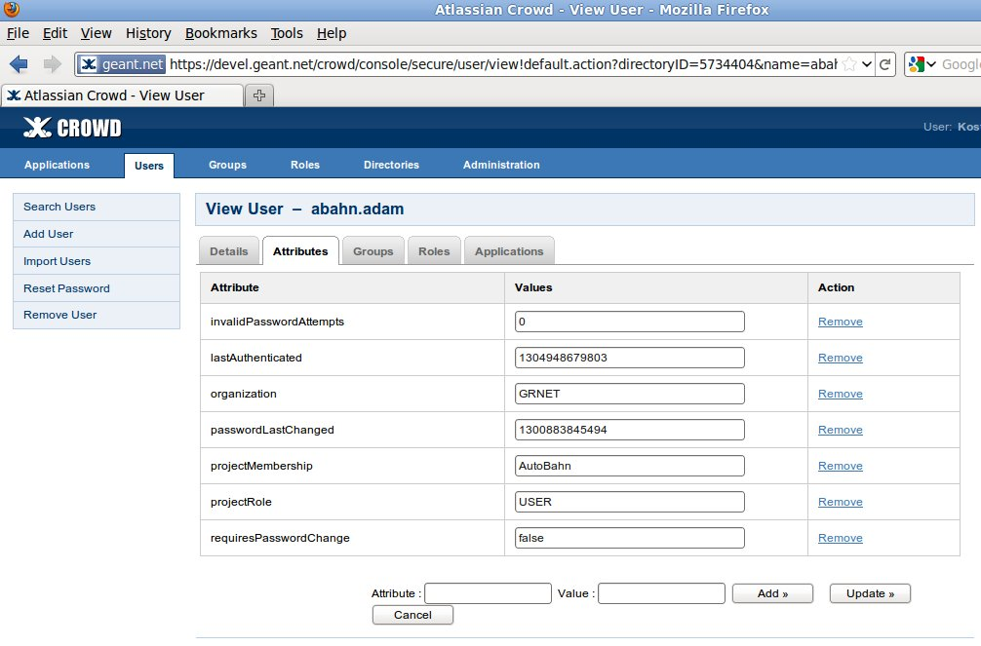
Figure 4.5: User’s attributes for Crowd IDP

Configure LS access
Find webgui.properties in webapps/autobahn-gui/WEB-INF/etc/ folder.
- Set the proper URL for accessing the Lookup Service.
- Restart TOMCAT for any changes to take effect.

Configure communication security
Find security.properties in webapps/autobahn-gui/WEB-INF/etc/security/ folder.
- Select if you want to activate communication security between the Web GUI and AutoBAHN components by setting the net.geant.autobahn.security.activated property to true. You can also select whether timestamps and encryption will be activated by setting the corresponding properties. Please note that in order for the Web GUI to communicate with AutoBAHN IDMs, it has to be configured with the same security properties as the IDMs.
- If you activate communication security, make sure all the properties in the security.properties file are correct. Their explanation can be found at section 4.1.3, at the subsection for the security/security.properties file. If eduGAIN-based validation is also enabled, also make sure the properties in webapps/autobahn-gui/WEB-INF/etc/security/edugain/edugain.properties file are also correct.
- Restart TOMCAT for any changes to take effect.

Configure Tomcat HTTPS Support
To enable HTTPS support for WebGUI, proper configuration needs to take place in both Autobahn and Tomcat sides. First of all, regarding Tomcat configuration, you can follow the official instructions http://tomcat.apache.org/tomcat-6.0-doc/ssl-howto.html#Configuration. To sum up, you need to:
- Create a self-signed certificate (not recommended for production environment) using java keytool.
- Define a Java JSSE Connector for handling the SSL support. This takes place usually in $TOMCAT_HOME/conf/server.xml. A configuration that is already tested is the following

<Connector port="8443" protocol="HTTP/1.1" SSLEnabled="true"
maxThreads="150" scheme="https" secure="true"
keystoreFile="/home/tomcat.jks" keystorePass="changeit" clientAuth="false" sslProtocol="TLS" />

If you want to totally disable plain HTTP support, you can comment out Tomcat’s default handler

<!--Connector port="8080" protocol="HTTP/1.1"
connectionTimeout="20000"
redirectPort="8443" /-->

In AutoBAHN, we need to configure SSL support for GuiService which is responsible for the communication of AutoBAHN with WebGUI. This part is already configured in etc/cxf/cxf.xml. The administrator needs to do two things:
- Export the public certificate that he created for Tomcat and import it in local Java cacerts keystore which is usually placed in $JAVA_HOME/jre/lib/security/ folder.
- Change gui.address field in etc/autobahn.properties to the new HTTPS URL e.g. https://150.140.141.15:8443/autobahn-gui/service/gui. CXF configuration will automatically handle the SSL support and in conjunction with the imported certificate in cacerts, AutoBAHN will manage to communicate with WebGUI.

WARNING: Currently, AutoBAHN cannot handle SSL requests to Lookup Service. So, if HTTPS is enabled in Tomcat then LS mustn’t be hosted at the same machine as WebGUI because in that way neither AutoBAHN nor WebGUI will be able to communicate with LS. You need to deploy LS on a different Tomcat configuration with plain HTTP support.

Google Maps configuration
A page within WebGUI that depicts a map with the connected IDMs and the reservations is based on Google Maps support. A valid Google Maps API key is needed for each WebGUI installation. You can go to the related Google Maps page (search for “Google Maps API key” or go to http://code.google.com/apis/maps/signup.html) and generate an API key there. Please note that if you also want to access the WebGUI through an IP address you have to generate 2 Google Maps keys, one for the IP URL (e.g. http://1.2.3.4/autobahn-gui/) and one for the domain name URL (e.g. http://my-domain/autobahn-gui/).
- Generate the Google Maps API key(s) by providing the installation URL at the Google Maps page.
- Locate the WEB-INF/classes/messages.properties file
- For a domain name URL, copy this value to the google.maps.key entry
- For an IP URL, copy this value to the google.maps.key.IP entry
- Restart TOMCAT for any changes to take effect.

Accessing the portal
You can access the WebGUI at http://<your-domain>:<your-port>/autobahn-gui/.

Security mechanisms summary
This section is intended to serve as a summary of all security-related aspects of the system and reference the appropriate sections in this guide for more detailed information on proper security configuration of the system.
There are the following security aspects in the AutoBAHN architecture, which can be independently enabled and be made more or less strict:
- Trusted communication between system components
- Secure console (CLI) access to an AutoBAHN instance
- User authentication and level of access (authorization) at the Web GUI
- Authorization policies at each AutoBAHN instance for handling incoming requests
- Secure communication with other IDCP-compatible domains (currently OSCARS)
In the following sections each one of these aspects and the appropriate system configuration is examined. Of course, security can be enhanced by mechanisms such as connectivity restrictions to the machines hosting the software using firewalls etc., but since these mechanisms are external to the software they are out of scope of this guide.

Trusted communication between system components
Trusted communication between system components (such as between IDM and DM, between Web GUI and IDM and all other interfaces listed at section 4.2) is done by securing the WS interfaces using WS-Security for signing/validating and encrypting/decrypting the exchanged messages.
Each AutoBAHN instance contains the file etc/security/security.properties (its contents are described in detail in section 4.1.3, and section 4.4.3.3 for Web GUI component). There you can enable/disable whether trusted communication will be used. At its most basic level trusted communication implies the signing/validation of exchanged messages. Additionally, encryption/decryption and timestamping operations can also be enabled for exchanged messages.
Activating secure communication means that when a message is sent, it is signed using the private key contained in the keystore defined in the etc/security/security.properties file (property org.apache.ws.security.crypto.merlin.file). If encryption is also enabled, the message is encrypted using the public key contained in the keystore. If timestamps are enabled, timestamp is also added. When the message is received at the other end, if encryption is enabled, it is decrypted using the private key contained in the keystore. The message signature is also validated using the public key contained in the keystore. Timestamp is also checked if enabled.
Therefore, for properly setting up secure communication each communicating end has to:
- Enable the same level of security
- Create keystore that contains a public/private key pair
In addition to plain signature validation, eduGAIN-based validation may also be used. For eduGAIN-based validation to work, the net.geant.autobahn.edugain.activated property in etc/security/security.properties file must be set to true, and the values in etc/security/edugain/edugain.properties file must be correct. In order for the public key to be accepted by the other end, it has to be signed from the edugain root CA.

Secure CLI access
As described in section 4.1.3, the configuration file etc/framework.properties contains the values that configure the console access to an AutoBAHN instance. Console access allows an administrator to log in to the AutoBAHN instance and perform a number of operations through a command line interface. At the etc/framework.properties file you can configure:
- Whether the CLI login will be available from a different machine, only from the local machine, or not at all
- At which port access to CLI will take place
- The password required to access the CLI (value is stored as an MD5 hash)

User authentication / authorization at the Web GUI
The users that have access to the Web GUI are restricted according to the userdetails.xml file (described in detail in section 4.4.3.1. Except from providing authentication, the information in this file also determines the level of access (authorization) that a user is going to have at the Web GUI. The level of access depends on the ROLE attribute of the user: A simple user only has limited access to the Web GUI pages, while an administrator has full access.
After starting the Web GUI, the userdetails.xml file can be edited through a dedicated Web GUI page (in order to avoid having to manually edit the xml file).

Authorization policies at each AutoBAHN instance
When a request is received at a specific domain, the corresponding AutoBAHN instance uses a local policy that has been defined in order to decide whether the request can be authorized or not. This local policy is defined in the etc/dm_security.xml file and the process to configure it is described in detail in section 4.1.3.

Secure communication to IDCP compatible peers (OSCARS)
Communication to other IDCP-compatible servers is done over a secure TLS connection using encryption/decryption and signing/validation. The keys for these operations are retrieved from the keystore(s) defined in the etc/oscars/client-sec.properties and etc/oscars/server-sec.properties files.

AA how-to
This section is intended as a step-by-step guide for the procedure of adding new users of the AutoBAHN system and defining their authorization rights.

Audience
This guide is intended for administrators who are installing an AutoBAHN instance in their domain.

Prerequisites
The following prerequisites have to be in place before performing the steps mentioned in this guide:
- A Web GUI has been setup at a central location, with access to all AutoBAHN instances participating in the BoD service. We assume the Web GUI is administered by a Coordination Unit for the BoD service.
- An AutoBAHN instance has been setup at the local domain, according to the instructions in the installation guide

Step-by-step guide
- List the new users that will have to be given access to the BoD service. Each user must have a set of credentials (username/password) and 3 more attributes:
  - Organization: The organization of the user, which is for example the NREN that the user works for.
  - Project Membership: The project on behalf of which the user is accessing the BoD service. This for example might be LHCOPN, Autobahn, etc.
  - Project Role: The role may be Administrator or User. A User is typically able to perform service requests, while an administrator typically has additional rights related to system maintenance and administration. However both roles are configurable and depend on the policies specified below.
- Send the new users list (with all attributes mentioned above filled in) to the Coordination Unit. As soon as the Coordination Unit applies the changes, the users will be able to login to the Web GUI and submit BoD service requests.
- Define local authorization policies for your domain. This is done by editing the etc/dm_security.xml file at the local AutoBAHN installation, as described in section 4.2.3 of the installation guide:
  - Modify the access attribute under <global-method-security> / < protect-pointcut > tag in order to define the authorization policy, using combinations of authorities that are allowed to make reservations. In the syntax of this attribute, spaces are treated as the operator “AND”, while commas as the operator “OR”. E.g. an expression such as “allow (ROLE_USER and ORG_GRNET) or (ROLE_ADMINISTRATOR)” has to be written as access=”ROLE_USER ORG_GRNET,ROLE_ADMINISTRATOR”.
- You can now test your AA configuration. Go to the Web GUI (web address should be provided by the Coordination Unit), log in using a set of user credentials you have specified at step 1, and try submitting a test reservation that traverses your domain.
Note that in the configuration for step 3 the attributes should be prefixed as follows:
- Organization: ORG_ (example: ORG_GRNET)
- Project Membership: PM_ (example: PM_AUTOBAHN)
- Project Role: ROLE_ (example ROLE_ADMINISTRATOR)
Also note that step 3 is optional and is only needed if you wish to have a more fine-grained control over who is authorized to submit requests to your domain. If step 3 is skipped, then all authenticated WebGUI users will be able to reserve resources in your domain.

AutoBAHN references
- Project homepage: http://forge.geant.net
- Download page: http://downloads.geant.net/repository/public/AutoBAHN?artifactId=AutoBAHN
- Mailing list: gn3-sa2-t5-autobahn@geant.net

Glossary
API Application Program Interface
AutoBAHN Automated Bandwidth Allocation across Heterogeneous Networks
BoD Bandwidth on Demand
CA Certificate Authority
CPU Central Processing Unit
DICE Dante, Internet2, CANARIE, ESnet
DM Domain Manager
GB gigabyte
GHz gigahertz
GRE Generic Routing Encapsulation
IDCP InterDomain Controller Protocol
IDM Inter Domain Manager
IP Internet Protocol
L2 Layer 2
LHC Large Hadron Collider
LSA Large Hadron Collider Software Applications
MB megabyte
MCC Metro Core Connect
MHz megahertz
MPLS Multiprotocol Label Switching
NIC Network Information Centre
NMS Network Management System
OS Operating System
OSPF Open Shortest Path First
PoP Point-of-Presence
RDBMS Relational DataBase Management System
SMTP Simple Mail Transfer Protocol
VPN Virtual Private Network
WS Web Services

References

[ABAHN] AutoBAHN, http://forge.geant.net
[cNIS] Geant cNIS, http://cnis.psnc.pl
[PS] perfSONAR, http://www.perfsonar.net , https://wiki.man.poznan.pl/perfsonar-mdm/
[PS LS] PerfSONAR LS, https://wiki.man.poznan.pl/perfsonar-mdm/index.php/Lookup_Service_Release
[Quagga] Quagga, http://www.quagga.net/
[GRE] IP GRE kernel module, http://www.linuxfoundation.org/collaborate/workgroups/networking/tunneling
[Postgres] PostgreSQL, http://www.postgresql.org
[Hibernate] Hibernate, https://www.hibernate.org/
[DICE] DICE IDCP, http://www.controlplane.net/

