電通二乙微處理器實驗 實驗結報

實驗名稱 | Lab01-LED Blink
組別 | 03 | 組員 | 05050545魏靖珊

- 實驗目的
- 使用 Tinkercad模擬Arduino UNO電路及程式
- 繪製電路圖
- 觀察Arduino UNO之輸出
- 學習將程式碼及實驗報告上傳至Github

- 實驗步驟
  - 填寫分組表單
  - 啟動Arduino IDE，載入Blink程式碼
  - 至www.tinkercad.com註冊帳號，啟動Arduino模擬器
  - 接上LED電路
  - 修改程式，將LED輸出改為Pin 9
  - 觀察LED之閃爍間隔
  - 修改程式，使LED閃爍間格分別增加為2倍及1/2倍
  - 畫出電路圖

- 程式碼
/*
Blink

Turns an LED on for one second, then off for one second, repeatedly.

Most Arduinos have an on-board LED you can control. On the UNO, MEGA and ZERO
it is attached to digital pin 13, on MKR1000 on pin 6. LED_BUILTIN is set to
the correct LED pin independent of which board is used.
If you want to know what pin the on-board LED is connected to on your Arduino
model, check the Technical Specs of your board at:
https://www.arduino.cc/en/Main/Products

modified 8 May 2014
by Scott Fitzgerald
modified 2 Sep 2016
by Arturo Guadalupi
modified 8 Sep 2016
by Colby Newman

This example code is in the public domain.

http://www.arduino.cc/en/Tutorial/Blink
*/
int led = 9;
// the setup function runs once when you press reset or power the board
void setup() {
// initialize digital pin LED_BUILTIN as an output.
pinMode(led, OUTPUT);
}

// the loop function runs over and over again forever
void loop() {
digitalWrite(led, HIGH); // turn the LED on (HIGH is the voltage level)
delay(2000); // wait for a second
digitalWrite(led, LOW); // turn the LED off by making the voltage LOW
delay(2000); // wait for a second
}

- 實驗結果及分析
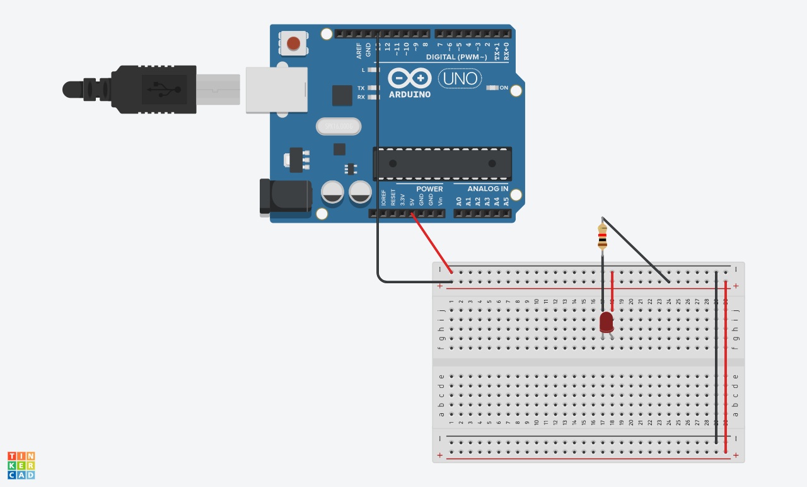
LED的正極連接5V及電阻，負極連接Pin腳，要注意必須加上電阻降低電路中的電壓，避免LED負載電壓過大

- 心得討論
這次第一次使用Github這個網站儲存程式，雖然摸索如何上傳了許久，但最後在各方詢問下也大致摸清楚了。
也許之後可以嘗試把去年存在電腦中的程式設計課程內的程式都放上去，也許之後哪天需要時可以上去翻翻找找。
- 修正電路圖
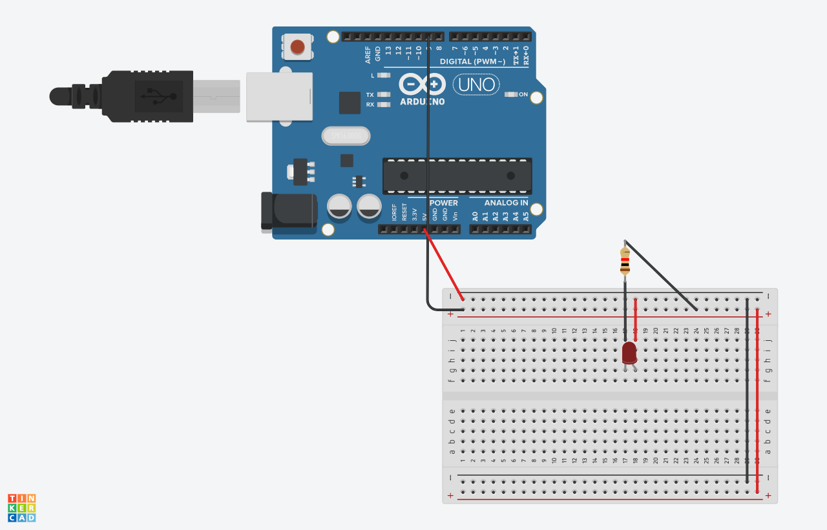
- 修正程式碼

