電通二乙微處理器實驗 實驗結報

實驗名稱 | Lab10-Bluetooth Low Energy
組別 | 03 | 組員 | 05050545 魏靖珊

- 實驗目的
由手機APP看到自己的7697 iBeacon
由手機APP看到自己的7697 EddyStone URL Beacon
由手機APP控制7697 LED
- 實驗步驟
由手機APP看到自己的7697 iBeacon
由手機APP看到自己的7697 EddyStone URL Beacon
由手機APP控制7697 LED
- 程式碼
Code1
/*
This example configures LinkIt 7697 to send iBeacon-compatbile advertisement data.

You should be able to search this device with iOS or Android iBeacon tools.

created Mar 2017
*/
#include <LBLE.h>
#include <LBLEPeriphral.h>

void setup() {
//Initialize serial and wait for port to open:
Serial.begin(9600);

// Initialize BLE subsystem
Serial.println("BLE begin");
LBLE.begin();
while (!LBLE.ready()) {
delay(100);
}
Serial.println("BLE ready");

// configure our advertisement data as iBeacon.
LBLEAdvertisementData beaconData;

// This is a common AirLocate example UUID.
LBLEUuid uuid("E2C56DB5-DFFB-48D2-B060-D0F5A71096E0");
beaconData.configAsIBeacon(uuid, 01, 02, -40);

Serial.print("Start advertising iBeacon with uuid=");
Serial.println(uuid);

// start advertising it
LBLEPeripheral.advertise(beaconData);
}

void loop() {
// The underlying framework will advertise periodically.
// we simply wait here.
//
// You can use iBeacon apps such as
// "Locate Beacon" by Radius Networks on iOS devices
// to locate this beacon.
delay(3000);
}
Code2
/*
This example configures LinkIt 7697 to send Eddyston-URL advertisement data.

You should be able to search this beacon with tools such as "Beacon Tools" on iOS or
"Physical Web" app on Android.

created April 2017
*/
#include <LBLE.h>
#include <LBLEPeriphral.h>

void setup() {
//Initialize serial and wait for port to open:
Serial.begin(115200);

// Initialize BLE subsystem
Serial.println("BLE begin");
LBLE.begin();
while (!LBLE.ready()) {
delay(100);
}
Serial.println("BLE ready");

// configure our advertisement data as iBeacon.
LBLEAdvertisementData beaconData;

// make an Eddystone-URL beacon that board casts
// https://labs.mediatek.com
// Note 1: You can obmit the suffix and tail part, e.g.
// https://goo.gl/Aq18zF
// can be constructed with
// configAsEddystoneURL(EDDY_HTTPS, "goo.gl/Aq18zF");
// Note 2: Note that total url length must not exceed 17 bytes.
//
// Please refer to https://github.com/google/eddystone/tree/master/eddystone-url#url-scheme-prefix
// to know how the prefix/suffix/tails are expanded.
beaconData.configAsEddystoneURL(EDDY_HTTPS, "labs.mediatek", EDDY_DOT_COM);

Serial.print("Start advertising Eddystone-URL");

// start advertising it
LBLEPeripheral.advertiseAsBeacon(beaconData);
}

void loop() {
// The underlying framework will advertise periodically.
// we simply wait here.
//
// You should be able to search this beacon with tools such as "Beacon Tools" on iOS or
// "Physical Web" app on Android.
delay(3000);
}
Code3
/*
This example configures LinkIt 7697 to act as a simple GATT server with 1 characteristic.

To use it, open AppInventor project:

*

Build & install it on Android id

created Mar 2017
*/
#include <LBLE.h>
#include <LBLEPeriphral.h>

// Define a simple GATT service with only 1 characteristic
LBLEService ledService("19B10010-E8F2-537E-4F6C-D104768A1214");
LBLECharacteristicInt switchCharacteristic("19B10011-E8F2-537E-4F6C-D104768A1214", LBLE_READ | LBLE_WRITE);

void setup() {

// Initialize LED pin
pinMode(LED_BUILTIN, OUTPUT);
digitalWrite(LED_BUILTIN, LOW);

//Initialize serial and wait for port to open:
Serial.begin(9600);

// to check if USR button is pressed
pinMode(6, INPUT);

// Initialize BLE subsystem
LBLE.begin();
while (!LBLE.ready()) {
delay(100);
}
Serial.println("BLE ready");

Serial.print("Device Address = [");
Serial.print(LBLE.getDeviceAddress());
Serial.println("]");

// configure our advertisement data.
// In this case, we simply create an advertisement that represents an
// connectable device with a device name
LBLEAdvertisementData advertisement;
advertisement.configAsConnectableDevice("BLE LED");

// Configure our device's Generic Access Profile's device name
// Ususally this is the same as the name in the advertisement data.
LBLEPeripheral.setName("BLE LED");

// Add characteristics into ledService
ledService.addAttribute(switchCharacteristic);

// Add service to GATT server (peripheral)
LBLEPeripheral.addService(ledService);

// start the GATT server - it is now
// available to connect
LBLEPeripheral.begin();

// start advertisment
LBLEPeripheral.advertise(advertisement);
}

void loop() {
delay(1000);

Serial.print("conected=");
Serial.println(LBLEPeripheral.connected());

if (digitalRead(6))
{
Serial.println("disconnect all!");
LBLEPeripheral.disconnectAll();
}

if (switchCharacteristic.isWritten()) {
const char value = switchCharacteristic.getValue();
switch (value) {
case 1:
digitalWrite(LED_BUILTIN, HIGH);
break;
case 0:
digitalWrite(LED_BUILTIN, LOW);
break;
default:
Serial.println("Unknown value written");
break;
}
}

}
- 實驗結果及分析
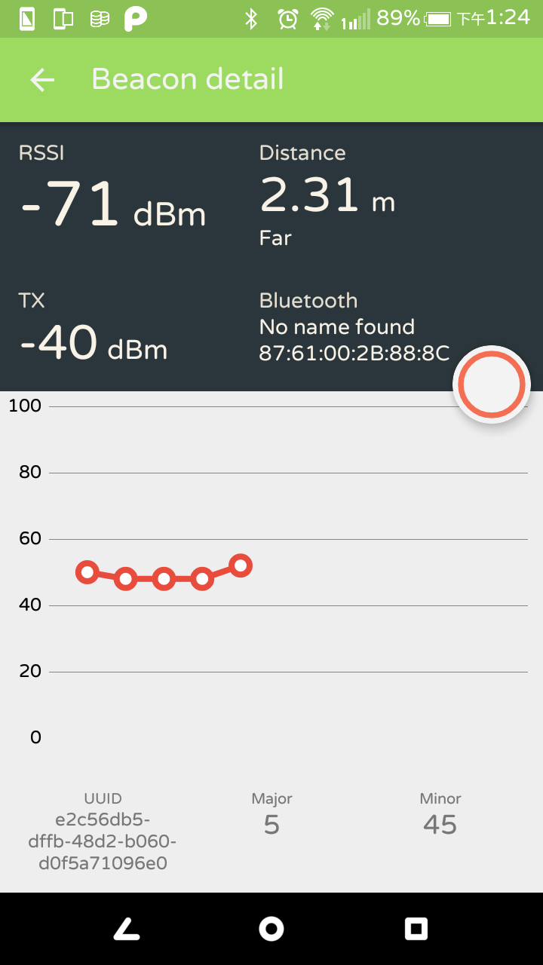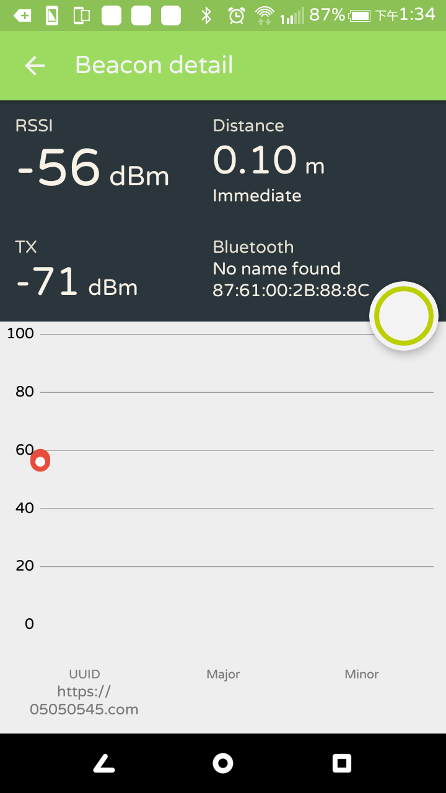
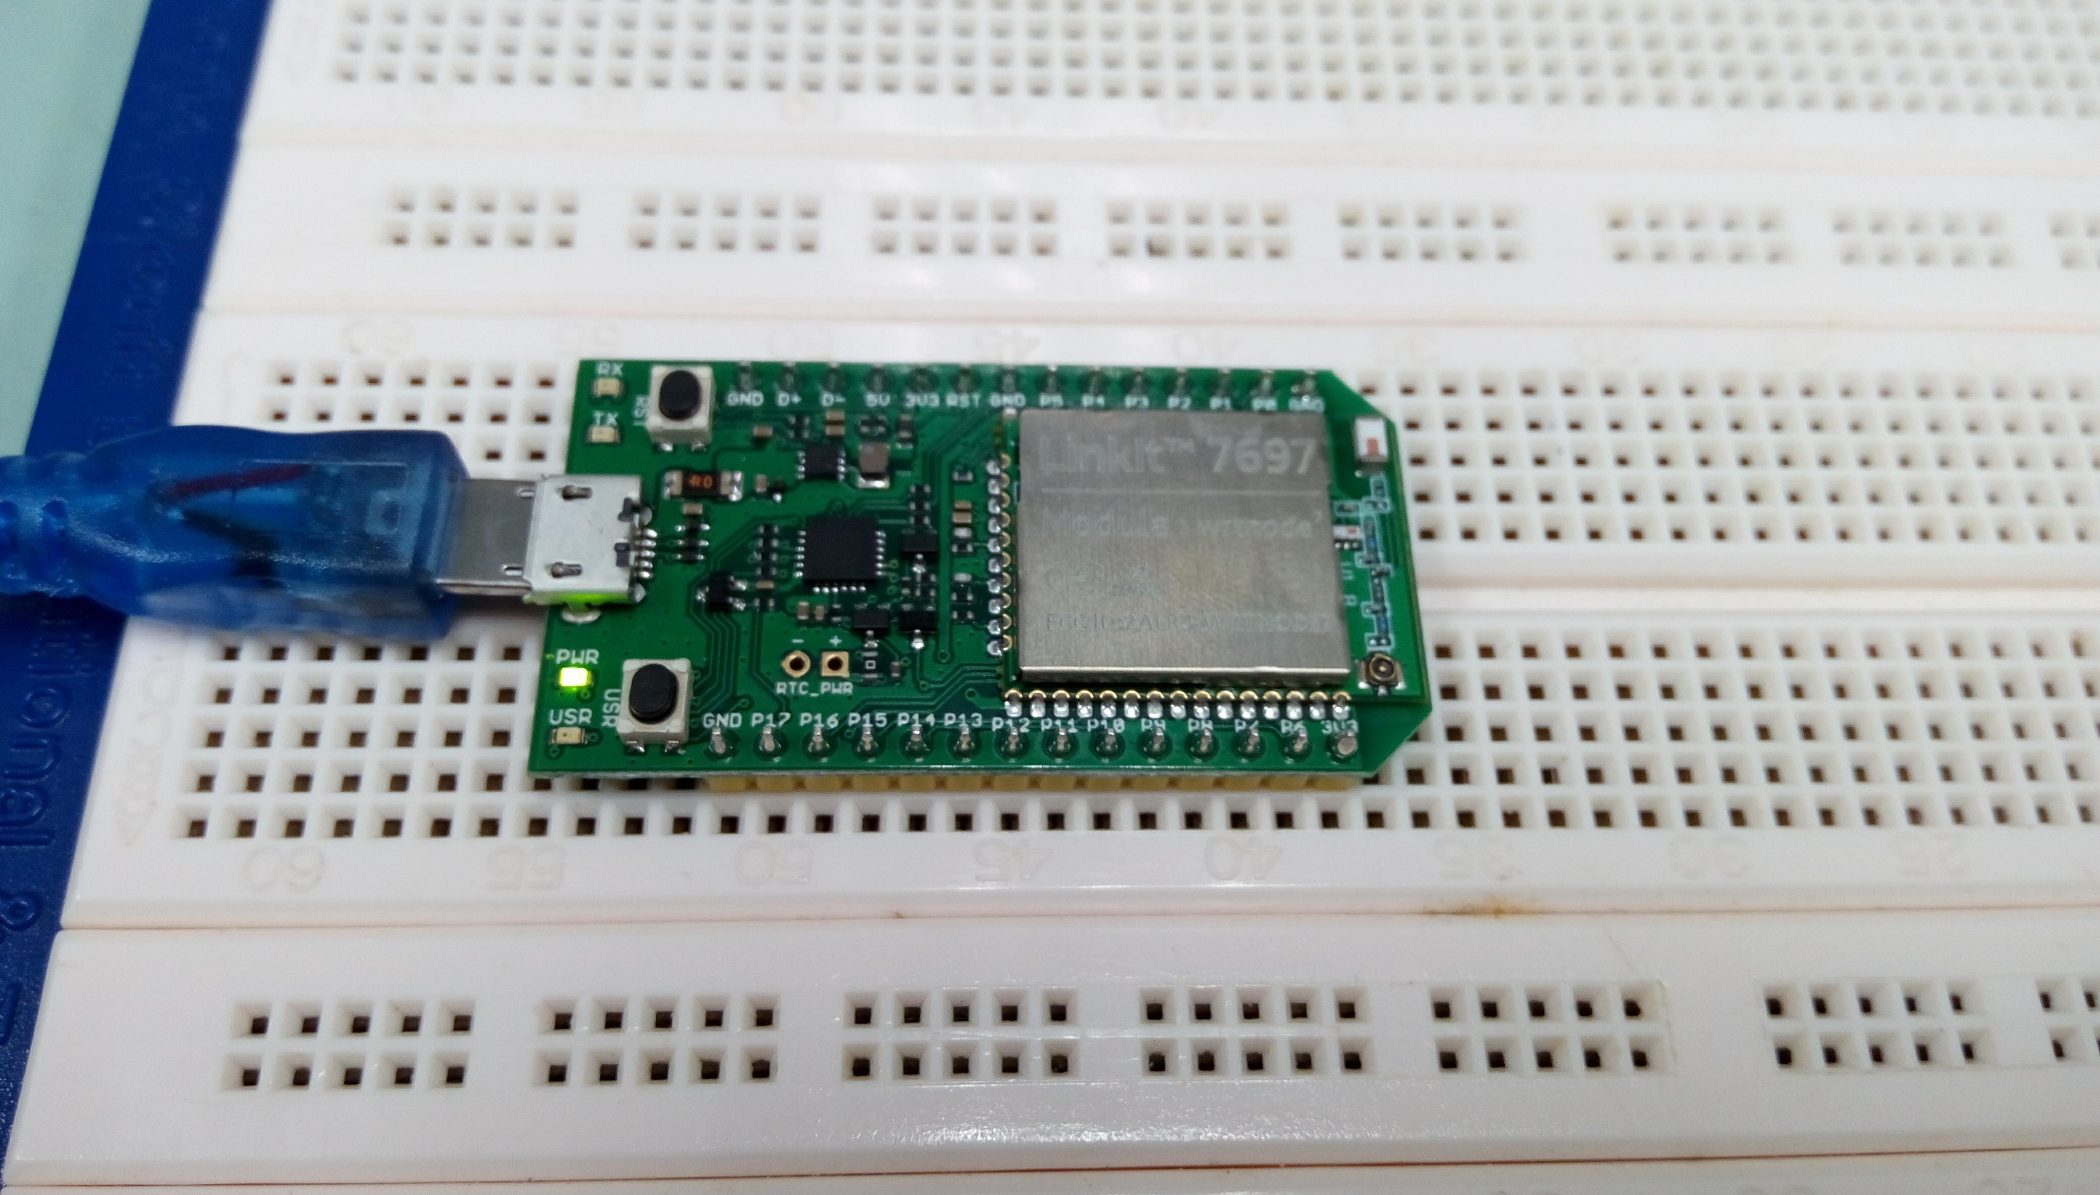
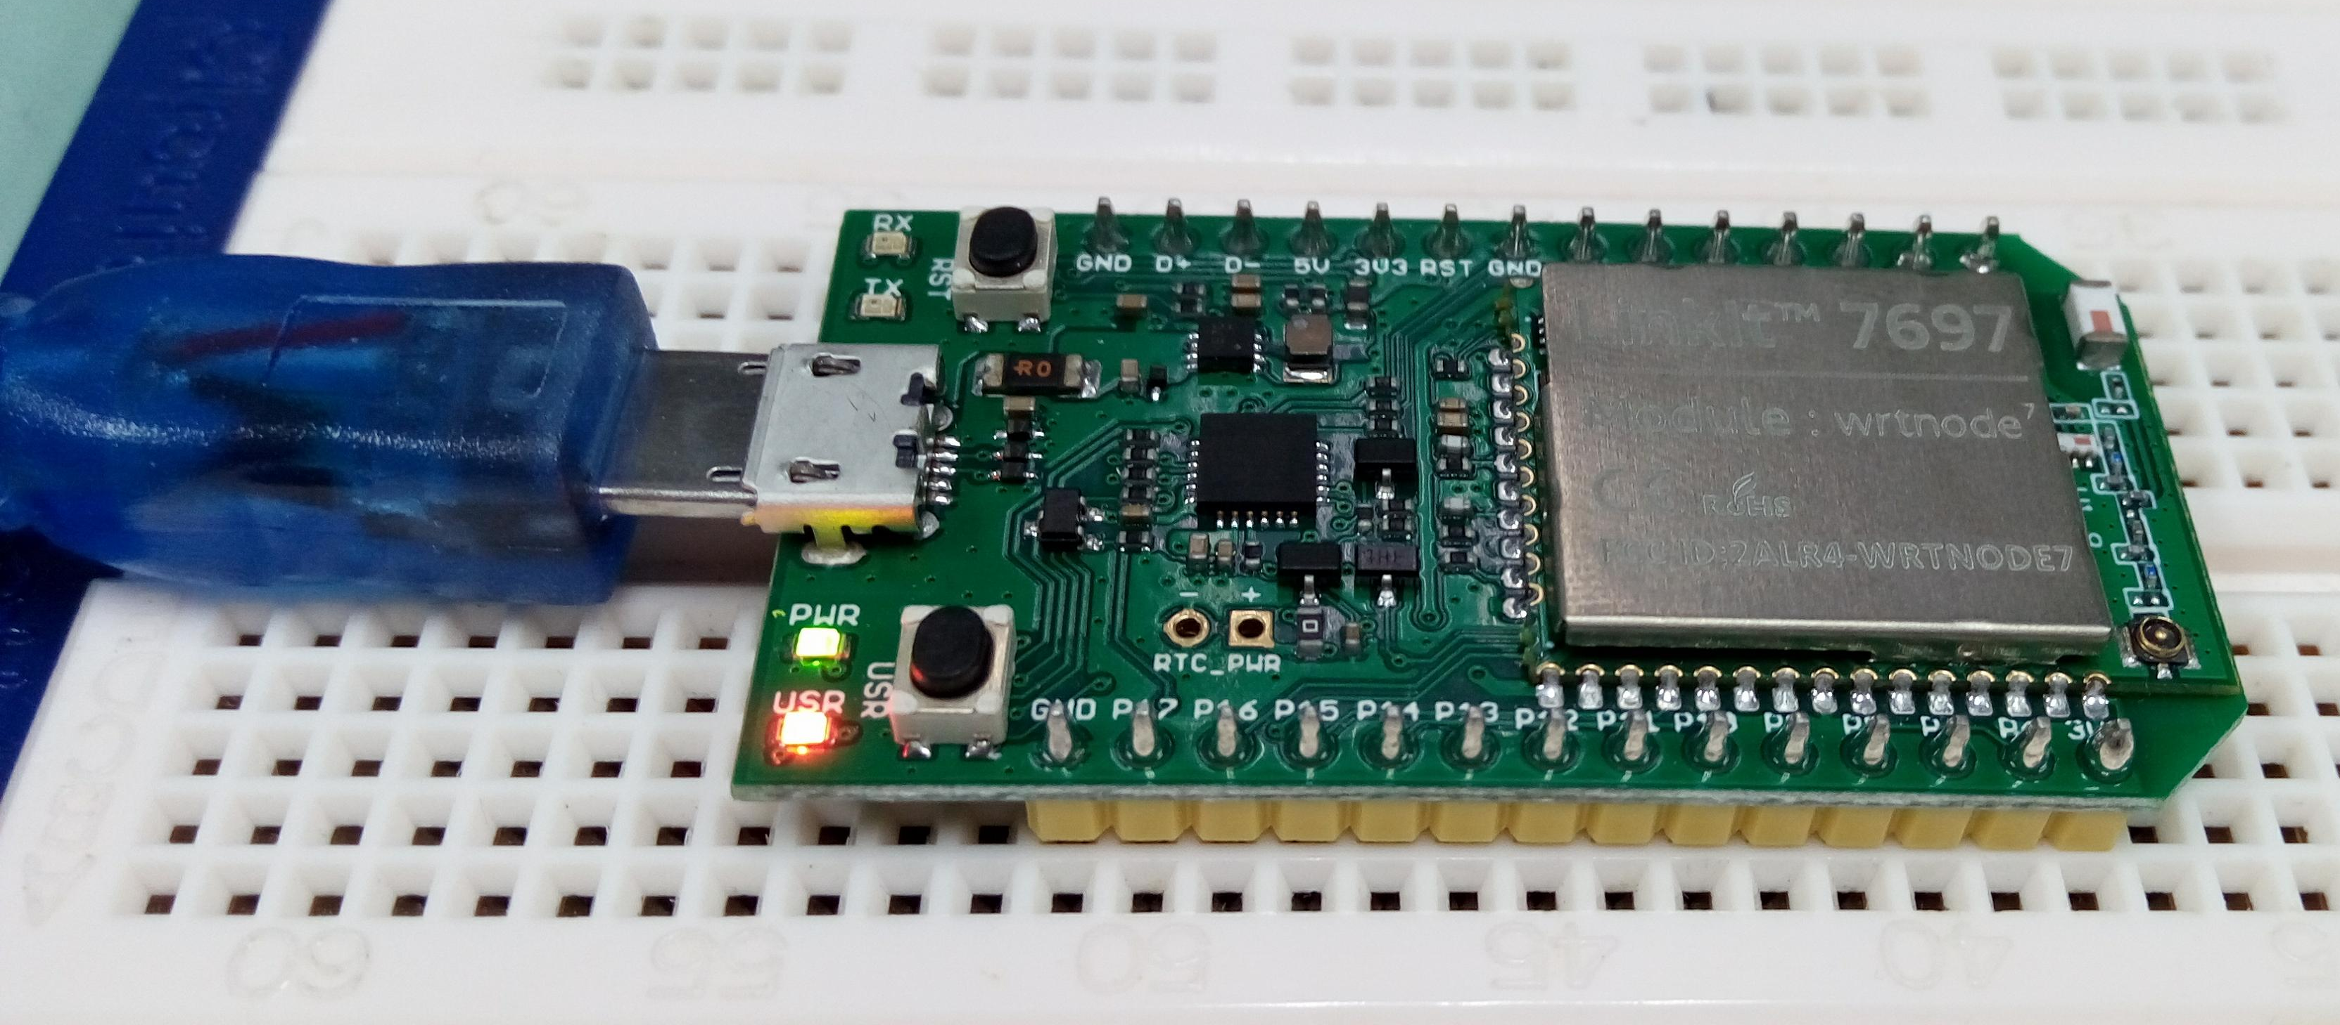
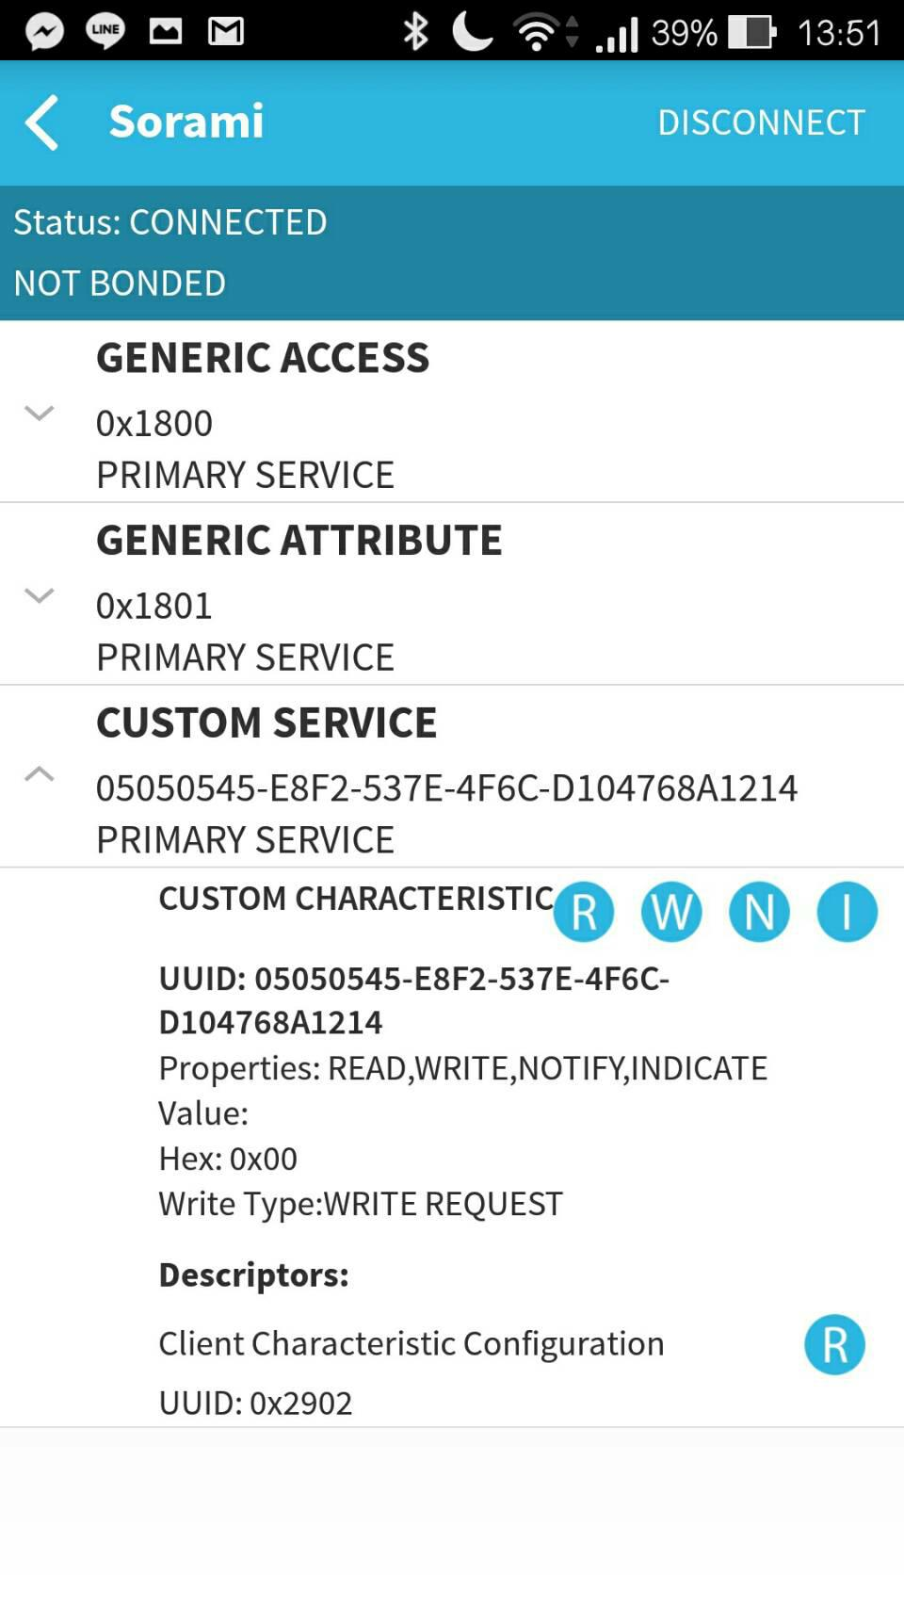
- 心得討論
- 修正電路圖

- 修正程式碼
Code1
/*
This example configures LinkIt 7697 to send iBeacon-compatbile advertisement data.

You should be able to search this device with iOS or Android iBeacon tools.

created Mar 2017
*/
#include <LBLE.h>
#include <LBLEPeriphral.h>

void setup() {
//Initialize serial and wait for port to open:
Serial.begin(9600);

// Initialize BLE subsystem
Serial.println("BLE begin");
LBLE.begin();
while (!LBLE.ready()) {
delay(100);
}
Serial.println("BLE ready");

// configure our advertisement data as iBeacon.
LBLEAdvertisementData beaconData;

// This is a common AirLocate example UUID.
LBLEUuid uuid("E2C56DB5-DFFB-48D2-B060-D0F5A71096E0");
beaconData.configAsIBeacon(uuid, 05, 45, -40);

Serial.print("Start advertising iBeacon with uuid=");
Serial.println(uuid);

// start advertising it
LBLEPeripheral.advertise(beaconData);
}

void loop() {
// The underlying framework will advertise periodically.
// we simply wait here.
//
// You can use iBeacon apps such as
// "Locate Beacon" by Radius Networks on iOS devices
// to locate this beacon.
delay(3000);
}

Code2
/*
This example configures LinkIt 7697 to send Eddyston-URL advertisement data.

You should be able to search this beacon with tools such as "Beacon Tools" on iOS or
"Physical Web" app on Android.

created April 2017
*/
#include <LBLE.h>
#include <LBLEPeriphral.h>

void setup() {
//Initialize serial and wait for port to open:
Serial.begin(115200);

// Initialize BLE subsystem
Serial.println("BLE begin");
LBLE.begin();
while (!LBLE.ready()) {
delay(100);
}
Serial.println("BLE ready");

// configure our advertisement data as iBeacon.
LBLEAdvertisementData beaconData;

// make an Eddystone-URL beacon that board casts
// https://labs.mediatek.com
// Note 1: You can obmit the suffix and tail part, e.g.
// https://goo.gl/Aq18zF
// can be constructed with
// configAsEddystoneURL(EDDY_HTTPS, "goo.gl/Aq18zF");
// Note 2: Note that total url length must not exceed 17 bytes.
//
// Please refer to https://github.com/google/eddystone/tree/master/eddystone-url#url-scheme-prefix
// to know how the prefix/suffix/tails are expanded.
beaconData.configAsEddystoneURL(EDDY_HTTPS, "05050545", EDDY_DOT_COM);

Serial.print("Start advertising Eddystone-URL");

// start advertising it
LBLEPeripheral.advertiseAsBeacon(beaconData);
}

void loop() {
// The underlying framework will advertise periodically.
// we simply wait here.
//
// You should be able to search this beacon with tools such as "Beacon Tools" on iOS or
// "Physical Web" app on Android.
delay(3000);
}
Code3
/*
This example configures LinkIt 7697 to act as a simple GATT server with 1 characteristic.

To use it, open AppInventor project:

*

Build & install it on Android id

created Mar 2017
*/
#include <LBLE.h>
#include <LBLEPeriphral.h>

// Define a simple GATT service with only 1 characteristic
LBLEService ledService("05050545-E8F2-537E-4F6C-D104768A1214");
LBLECharacteristicInt switchCharacteristic("05050545-E8F2-537E-4F6C-D104768A1214", LBLE_READ | LBLE_WRITE);

void setup() {

// Initialize LED pin
pinMode(LED_BUILTIN, OUTPUT);
digitalWrite(LED_BUILTIN, LOW);

//Initialize serial and wait for port to open:
Serial.begin(9600);

// to check if USR button is pressed
pinMode(6, INPUT);

// Initialize BLE subsystem
LBLE.begin();
while (!LBLE.ready()) {
delay(100);
}
Serial.println("BLE ready");

Serial.print("Device Address = [");
Serial.print(LBLE.getDeviceAddress());
Serial.println("]");

// configure our advertisement data.
// In this case, we simply create an advertisement that represents an
// connectable device with a device name
LBLEAdvertisementData advertisement;
advertisement.configAsConnectableDevice("Sorami");

// Configure our device's Generic Access Profile's device name
// Ususally this is the same as the name in the advertisement data.
LBLEPeripheral.setName("Sorami");

// Add characteristics into ledService
ledService.addAttribute(switchCharacteristic);

// Add service to GATT server (peripheral)
LBLEPeripheral.addService(ledService);

// start the GATT server - it is now
// available to connect
LBLEPeripheral.begin();

// start advertisment
LBLEPeripheral.advertise(advertisement);
}

void loop() {
delay(1000);

Serial.print("conected=");
Serial.println(LBLEPeripheral.connected());

if (digitalRead(6))
{
Serial.println("disconnect all!");
LBLEPeripheral.disconnectAll();
}

if (switchCharacteristic.isWritten()) {
const char value = switchCharacteristic.getValue();
switch (value) {
case 1:
digitalWrite(LED_BUILTIN, HIGH);
break;
case 0:
digitalWrite(LED_BUILTIN, LOW);
break;
default:
Serial.println("Unknown value written");
break;
}
}

}

