電通二乙微處理器實驗 實驗結報

實驗名稱 | Lab11-MCS Cloud
組別 | 03 | 組員 | 05050545 魏靖珊

- 實驗目的
MCS 控制 LED 閃爍
上傳A0資料
- 實驗步驟
修改 MCS_GET code, 加入 MCS Remote
將 A0 電阻值上傳
- 程式碼
Code1
#include <LWiFi.h>
#include "MCS.h"

char _lwifi_ssid[] = "Android50";
char _lwifi_pass[] = "12345678";
MCSDevice mcs("DaMvLhnh", "tauidCWcirhDhoXX");

MCSControllerOnOff led("LED_control");

void setup()
{
Serial.begin(9600);

Serial.println("Connect to Wifi");
while (WiFi.begin(_lwifi_ssid, _lwifi_pass) != WL_CONNECTED) {
Serial.println("Wifi Reconnecting..");
delay(1000);
}

Serial.println("Connect to MCS...");
while (!mcs.connected()) {
Serial.println("MCS Reconnecting..");
mcs.connect();
}
Serial.println("MCS Connected!");
mcs.addChannel(led);

pinMode(7, OUTPUT);

}

void loop()
{
while (!mcs.connected()) {
mcs.connect();
if (mcs.connected()) {
Serial.println("MCS Reconnect");
}
}
mcs.process(1000);

if (led.value() == 1) {
digitalWrite(7, HIGH);

} else {
digitalWrite(7, LOW);

}

delay(200);
}
Code2
#include <LWiFi.h>
#include "MCS.h"

char _lwifi_ssid[] = "Android50";
char _lwifi_pass[] = "12345678";
MCSDevice mcs("DaMvLhnh", "tauidCWcirhDhoXX");

MCSDisplayInteger Temp("Temp");

void setup()
{
Serial.begin(9600);

Serial.println("Connect to Wifi");
while (WiFi.begin(_lwifi_ssid, _lwifi_pass) != WL_CONNECTED) {
Serial.println("Wifi Reconnecting..");
delay(1000);
}

Serial.println("Connect to MCS...");
while (!mcs.connected()) {
Serial.println("MCS Reconnecting..");
mcs.connect();
}
Serial.println("MCS Connected!");

mcs.addChannel(Temp);

}

void loop()
{
while (!mcs.connected()) {
mcs.connect();
if (mcs.connected()) {
Serial.println("MCS Reconnect");
}
}
mcs.process(1000);

int sensor = analogRead(A0);

Temp.set(sensor);
Serial.println("Add sensor value.");
delay(200);
}
- 實驗結果及分析
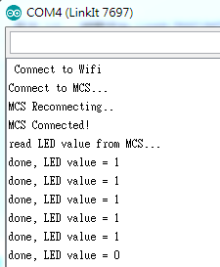
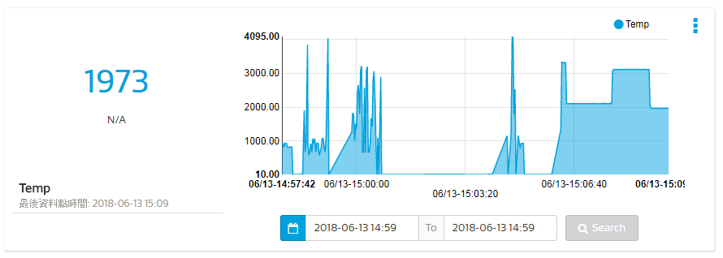
- 心得討論
這次的實驗雖說簡單，但其實一開始讓我有點摸不清頭緒。不清楚哪些文字會對應到哪個部分，也不清楚到底第二個實驗所寫的「Temp」其實是指電流而不是溫度。還是一樣問了韋澔才清楚，一語道破了我迷茫的心情，希望期末我們倆都能順利PASS。
- 修正電路圖
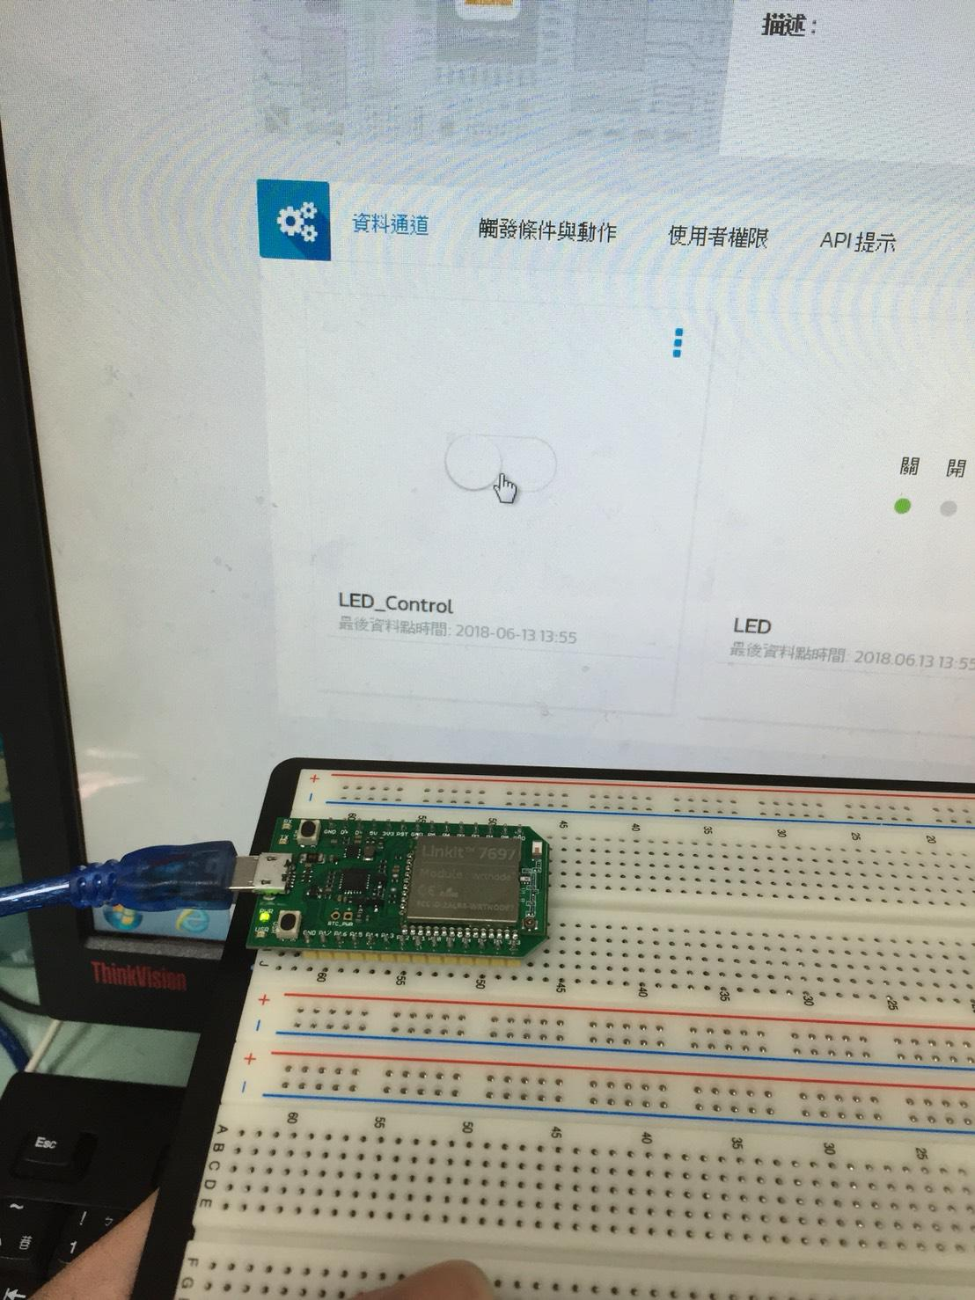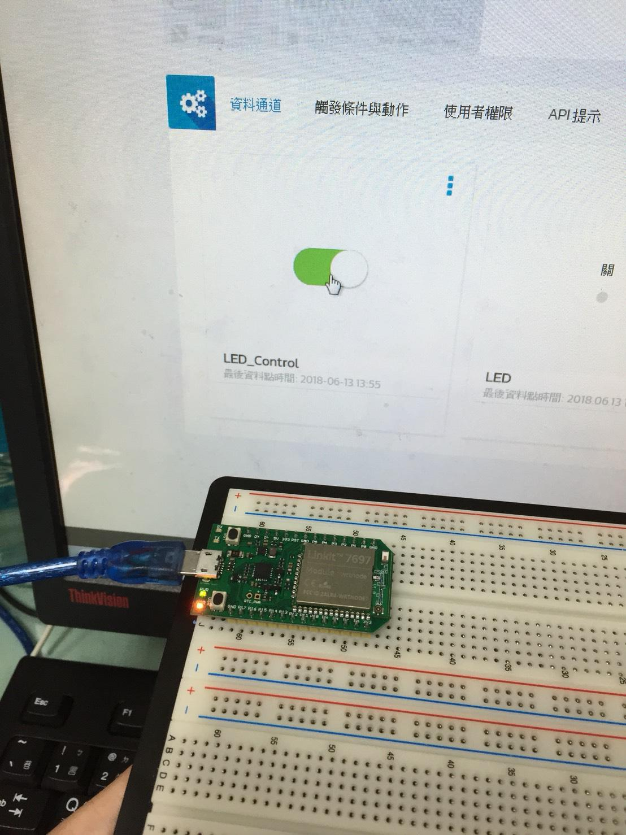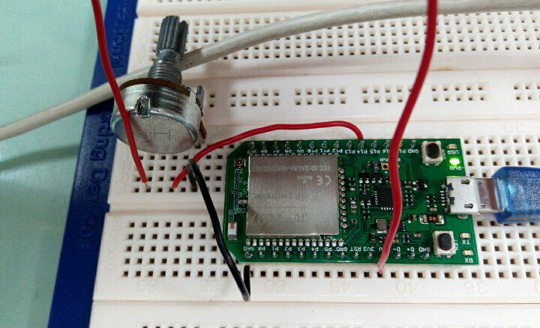
- 修正程式碼
Code1
#include <LWiFi.h>
#include "MCS.h"

char _lwifi_ssid[] = "Sorami";
char _lwifi_pass[] = "1110rope1110";
MCSDevice mcs("DwbW0ck0", "Tn8uWDVyAVlSAKyD");
MCSControllerOnOff led("0545");
MCSDisplayOnOff remote("0505");
void setup()
{
Serial.begin(9600);
Serial.println("Connect to Wifi");
while (WiFi.begin(_lwifi_ssid, _lwifi_pass) != WL_CONNECTED) {
Serial.println("Wifi Reconnecting..");
delay(1000);
}
Serial.println("MCS.connect()...");
while (!mcs.connected()) {
Serial.println("MCS Reconnecting..");
mcs.connect();
}
Serial.println("MCS Connected!");
mcs.addChannel(led);
mcs.addChannel(remote);
while(!mcs.connected())
{
Serial.println("MCS.connect()...");
mcs.connect();
}
pinMode(7, OUTPUT);
}

void loop()
{
while(!led.valid())
{
Serial.println("read LED value from MCS...");
led.value();
}
Serial.print("done, LED value = ");
Serial.println(led.value());
while (!mcs.connected()) {
digitalWrite(7,led.value() ?HIGH:LOW);
mcs.connect();
if (mcs.connected()) {
Serial.println("MCS Reconnect");
}
}
mcs.process(1000);
if (led.value() == 1) {
digitalWrite(7, HIGH);
} else {
digitalWrite(7, LOW);
}

if(!remote.set(led.value()))
{
Serial.print("Failed to update remote");
Serial.println(remote.value());
}
delay(200);
}

Code2
#include <LWiFi.h>
#include "MCS.h"

char _lwifi_ssid[] = "Sorami";
char _lwifi_pass[] = "1110rope1110";
MCSDevice mcs("DB7QxPCv", "ukmniIxNZFYd3mXL");

MCSDisplayInteger Temp("Temp");

void setup()
{
Serial.begin(9600);

Serial.println("Connect to Wifi");
while (WiFi.begin(_lwifi_ssid, _lwifi_pass) != WL_CONNECTED) {
Serial.println("Wifi Reconnecting..");
delay(1000);
}

Serial.println("Connect to MCS...");
while (!mcs.connected()) {
Serial.println("MCS Reconnecting..");
mcs.connect();
}
Serial.println("MCS Connected!");

mcs.addChannel(Temp);

}

void loop()
{
while (!mcs.connected()) {
mcs.connect();
if (mcs.connected()) {
Serial.println("MCS Reconnect");
}
}
mcs.process(1000);

int sensor = analogRead(A0);

Temp.set(sensor);
Serial.println("Add sensor value.");
delay(200);
}

