1. HPC1
Interrogating the ultrafast dynamics of an efficient dye for sunlight conversion
http://pubs.rsc.org/en/content/articlehtml/2010/cp/c002338h

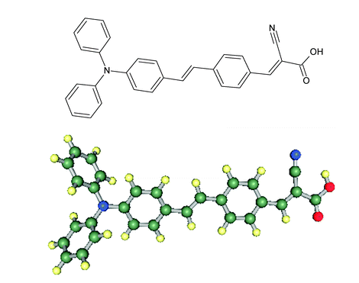

2.
Ultrafast excited state dynamics of S2 and S1 states of triphenylmethane dyes
http://pubs.rsc.org/en/content/articlehtml/2014/cp/c4cp01766h

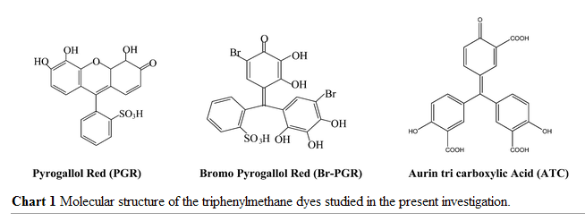

3.

Sequential photoisomerisation dynamics of the push–pull azobenzene Disperse Red 1
http://pubs.rsc.org/en/content/articlehtml/2012/pp/c2pp05400k

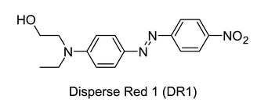

2.
Design of Dye Acceptors for Photovoltaics from First-Principles Calculations
dx.doi.org/10.1021/jp201646q | J. Phys. Chem. C 2011, 115, 9276–9282

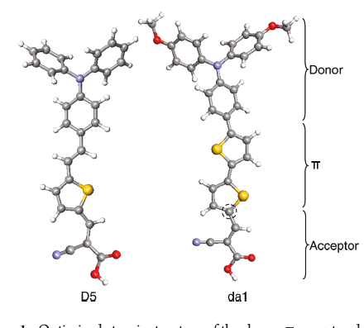

http://pubs.rsc.org/en/content/articlehtml/2011/cp/c1cp22429h

