GILLIS V2 · OPERATOR MANUAL
Gillis Weld-bot
V2.0 · Touchscreen GUI Operating Instructions
Revision 1 · May 2026
Audience: Production operators
Machine: Gillis Weld-bot V2.0 with Teensy 4.1 firmware
Controller: Raspberry Pi · 7" Touch Display 2

Contents
Welcome
How to use this manual
Safety
The E-Stop button
Before each shift
Your First Run
1 — Power on
2 — Home the machine
3 — Select a program
4 — Confirm and run
The GUI at a Glance
The top status bar
The bottom navigation bar
Numeric and text keypads
Fault and E-Stop overlays
Production — Running a Program
The Production Screen
The Run Screen
Pause and resume
Aborting a run
Completing a run
Programs
Layout
Test Run
Edit Program
Create New
Import from USB
Manual Cell Select
Calibration — Setting the Start Position
When to recalibrate
Calibration workflow
Machine Setup
Homing
Loading Position
X-Axis Tramming
Fault Recovery
The general fault flow
E-Stop
Common faults
Diagnostics
Health indicators
Runtime metrics
Settings
Motion Speed and Acceleration — Fast Profile
Cell-to-Cell Profile — Running a Program
Weld-Cycle Timing
Air Pressure Threshold
Home on Boot
Bench Mode
Saving
Test Motion
Manual jog
Drivers Enabled / Disabled
Sensor lamps
End-of-Shift Shutdown
Troubleshooting Quick Reference
Hidden System Info Panel
How to open it
What it shows
GUI Map
Notes

SECTION 1

Welcome
This manual covers everything an operator needs to know to safely run the Gillis Weld-bot V2.0 from the touchscreen pendant. It is written for production-floor use. Keep it close to the machine.
The Gillis V2 is a CNC battery-pack welder built around a Teensy 4.1 motion controller and a Raspberry Pi pendant running a touchscreen GUI. The pendant is your primary interface — it shows machine status, lets you load and run welding programs, handles homing and calibration, and walks you through fault recovery.

How to use this manual
Section 3 (Your First Run) is the fastest path from cold start to a finished weld and is the right place to start if you are new to the machine. Sections 4 through 8 are reference material for each GUI screen. Section 9 covers fault recovery — bookmark it. The troubleshooting quick-reference at the back lists the most common faults.

SECTION 2

Safety
The Gillis V2 uses a high-power laser, pneumatic Z-axis motion, and 48 V servo drives. Read this section in full before operating the machine.
WARNING
Laser radiation. The welder uses a Class 4 fibre laser. Never operate the machine without the enclosure closed and interlocks intact. Never look at the weld head during firing. Use the supplied laser-safety glasses at all times in the vicinity of the machine.

WARNING
Crush hazard. The X and Y axes can move at over 100 mm/s with hundreds of newtons of force. Keep hands and tools clear of the work area when the machine is powered. The pendant warns before any commanded move — read the prompt before tapping Move.

CAUTION
Stored pneumatic energy. The Z cylinder is driven by shop air. Releasing E-Stop cuts solenoid power but does not vent the air supply. Before any maintenance, isolate the air supply at the wall and verify the cylinder has bled down.

The E-Stop button
The red mushroom-head E-Stop on the pendant cuts AC power to the 48 V servo PSU and drops 24 V from the solenoid bank. The pendant Pi stays powered. When E-Stop is engaged you will see a red E-STOP pill in the top status bar and a full-screen red overlay.
1. Twist the E-Stop button clockwise to release it.
2. Wait for the red overlay to dismiss — this is automatic once the firmware sees the loop close.
3. Re-home the machine via Machine Setup → Homing → Start Home. Any motion taken before homing will be flagged as NOT HOMED.
NOTE
After every E-Stop, the machine forgets where it is. You must re-home before running any program. The pendant will block access to coordinate-dependent screens with a Gillis is lost message and offer you a one-tap Home Now button.

Before each shift
- Confirm the laser-safety enclosure is closed and undamaged.
- Check that the air supply is connected and the regulator shows at least 4 bar.
- Look at the pendant's air-pressure readout — it must be above the Air Threshold set in Settings.
- Verify the E-Stop button is released and the red E-STOP pill is not visible in the top status bar.
- Check the work surface is clean and the loading fixture is secure.

SECTION 3

Your First Run
This is the quickest path from a cold machine to a finished battery pack. Each step references the detailed screen documentation later in the manual.

1 — Power on
1. Turn on the wall isolator. The Pi pendant boots in roughly 30 seconds and lands on the splash screen.
2. Wait for the splash to give way to the Home Screen. You should see the Ionetic logo with rotating scan rings and four navigation buttons on the right.
3. Check the top status bar. The Link indicator on the right should pulse green. If you see TEENSY OFFLINE, the motion controller has not booted — power-cycle and wait.
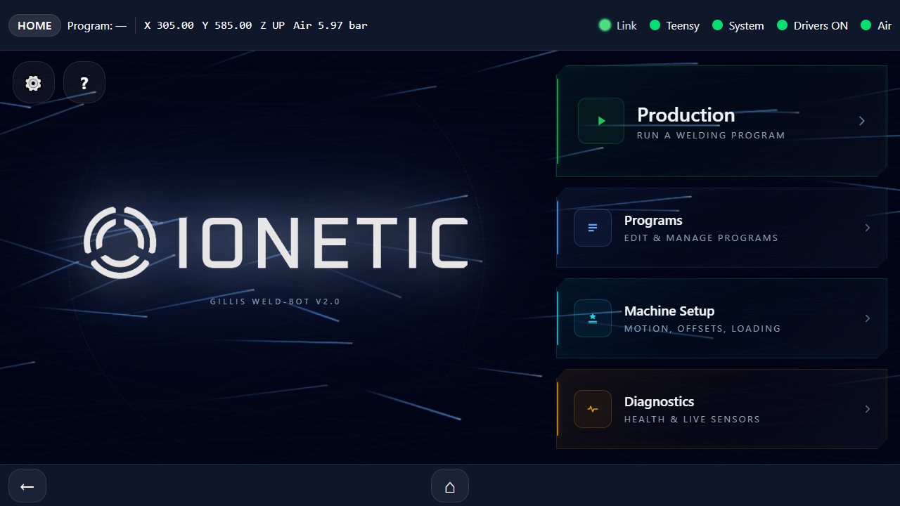
Home Screen — the four primary tiles (Production, Programs, Machine Setup, Diagnostics) on the right; settings (⚙) and operator manual (?) at the top-left. Status bar across the top shows current axis position, air pressure, and health indicators.

2 — Home the machine
On first power-up you'll see a yellow NOT HOMED warning in the top bar. The machine doesn't know where the table is until the home switches have been touched.
1. Tap Machine Setup on the Home Screen.
2. Tap the Homing tile.
3. Tap Start Home. The table will travel slowly toward the home switches in X and Y, back off, and re-touch for precision.
4. Wait for the overlay to dismiss. The NOT HOMED warning disappears and live X/Y coordinates appear in the top bar.
CAUTION
Keep the work envelope clear during homing. The table moves under the gantry through its full travel, so the entire work area passes beneath the weld head.

3 — Select a program
1. Tap Home (⌂) to return to the Home Screen.
2. Tap the large green Production button.
3. Pick a program from the list on the left. The right panel previews the cell pattern.
4. Choose Positive or Negative mode using the toggle — this selects which side of the pack you are welding.
5. Tap the green ▶ Begin button.
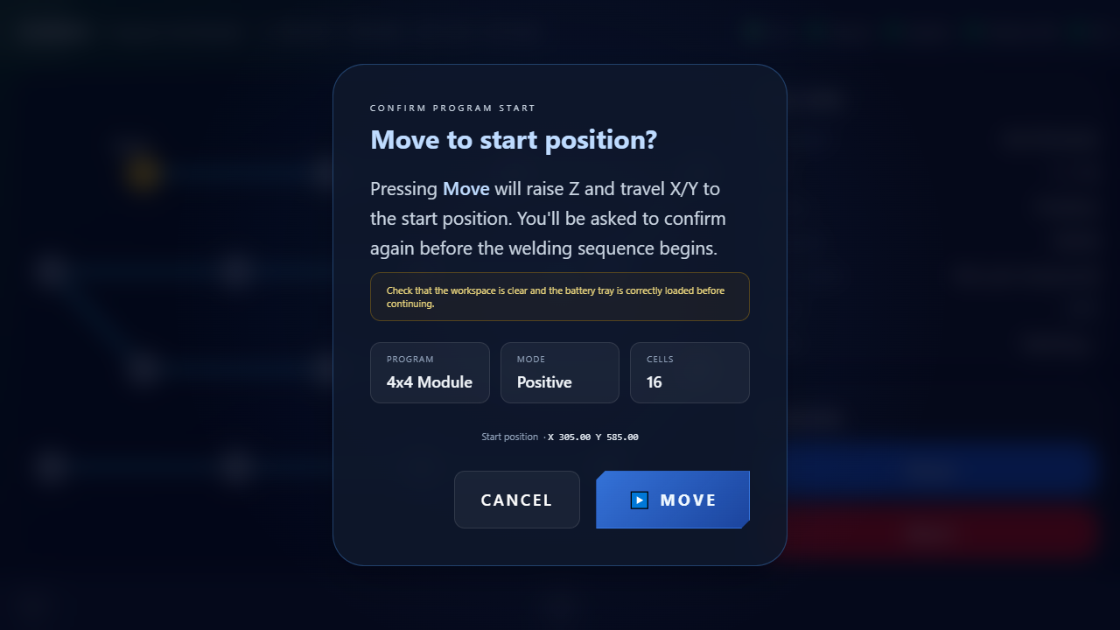
Pre-run confirmation — appears immediately after tapping ▶ Begin. The table will raise Z and travel to the program's start position once you tap Move. This is your check-the-workspace step before any motion happens.

4 — Confirm and run
1. Read the Move to start position? prompt. Verify the cell count and start coordinates look right.
2. Confirm the workspace is clear and the battery tray is correctly loaded.
3. Tap ▶ Move. The Z axis raises and the table travels to the start position. A full-screen overlay shows live X/Y motion.
4. When motion completes you'll see the At Start Position reticle. Tap ▶ Begin.
5. The machine welds each cell in sequence. The Home Screen progress arc fills in green. The Run Screen shows the current cell on a live diagram.
6. When the last cell completes you'll see the Program Complete green checkmark. Tap Back to Production.
TIP
If something looks wrong during a run, tap the red Abort button on the Run Screen. The machine pauses immediately and asks for confirmation before retracting Z and parking. You can resume from the aborted cell on the next launch — your progress is not lost.

SECTION 4

The GUI at a Glance
Every screen shares a common frame: a status bar at the top, a back/home navigation bar at the bottom, and the main work area in between. Knowing what each indicator means makes the rest of the manual much easier.

The top status bar
The bar across the top of every screen is always live. From left to right:
- Mode pill — the current screen mode (HOME / PRODUCTION / RUNNING / SETUP / DIAGNOSTICS).
- NOT HOMED warning — amber pill that appears whenever the machine has not been homed since power-on or E-Stop.
- Program name — the active program (during a run) or the last loaded program.
- Live X / Y / Z position — machine coordinates in millimetres, updated continuously.
- Air pressure — the shop-air reading in bar. Turns red below the configured threshold.
- Connection pill — OFFLINE if the GUI can't reach the backend; TEENSY OFFLINE if the backend can't reach the motion controller.
- E-STOP indicator — red, pulsing, only visible when E-Stop is engaged.
- Fault pill — appears red with a human-readable fault name when a fault is latched.
- Health dots — four small dots: Teensy, System, Drivers, Air. Green = OK, red = problem.
- Link pulse — a small animated indicator confirming the GUI is in contact with the backend.
Top status bar close-up — mode pill on the left (HOME / PRODUCTION / RUNNING etc.), program name, live X / Y / Z / air readout, and health dots on the right (Link, Teensy, System, Drivers, Air). All dots green means the machine is ready.

The bottom navigation bar
Below the work area:
- Back arrow (←) on the left — returns to the previous screen.
- Home button (⌂) in the centre — returns to the Home Screen at any time.

Numeric and text keypads
Tapping any number field — for example a step size, a dwell time, or a speed setting — opens a full-screen numeric keypad. Tap to enter digits, use ⌫ to backspace, Clear to start over, +/– to toggle sign, and the blue Enter to accept. Renaming a program opens a full QWERTY keyboard with the same flow.

Fault and E-Stop overlays
Whenever a fault latches or E-Stop engages, a full-screen red overlay takes over. Motion is blocked until the overlay is cleared. The overlay tells you the fault name and the recovery steps. See Section 9 for the full recovery flow.

SECTION 5

Production — Running a Program
The Production screen is the fastest way to launch a saved program. Pick a program, pick a mode, tap Begin. The screen is designed so that the most common operator workflow takes three taps.

The Production Screen
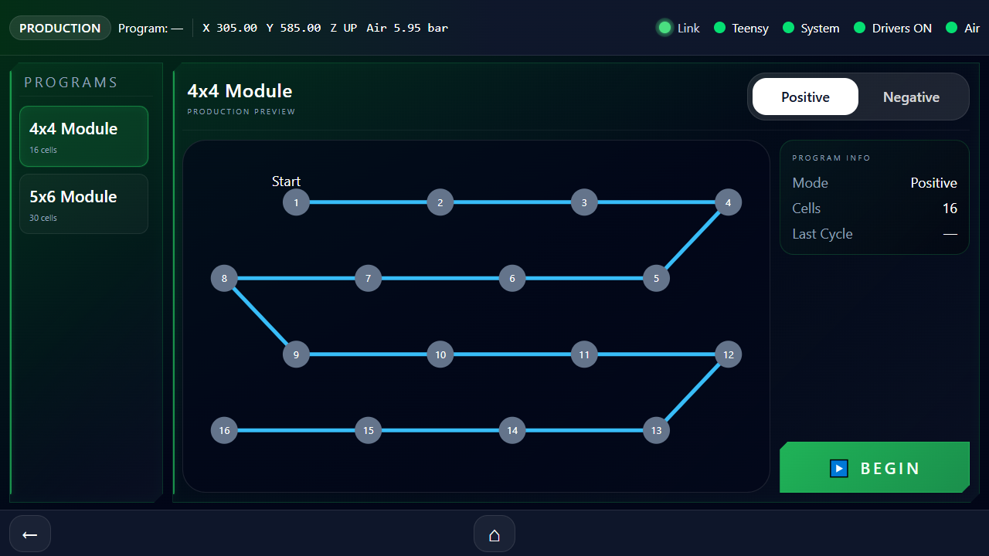
Production Screen — program list on left, preview and Begin button on right

- Program list on the left shows every saved program with its cell count. Tap to select.
- Production Preview on the right shows the cell pattern in grey.
- Mode switch at the top of the preview toggles Positive / Negative.
- Info box shows the selected mode, cell count, and the time of the last cycle.
- ▶ Begin button launches the Run sequence.
NOTE
Selecting a program here is local — it doesn't change the program file. Each side of a pack has its own start position saved per mode, so switching Positive/Negative automatically picks up the correct start coordinates.

The Run Screen
Once you tap ▶ Begin the screen transitions through four short stages before any motion happens — the machine never moves without giving you a chance to cancel.

Stage 1 — Confirm move to start
A modal appears: Move to start position? It shows the program name, mode, cell count, and the X/Y start coordinates. A warning box reminds you to check the workspace and battery tray. Tap ▶ Move to proceed or Cancel to back out.

Stage 2 — Moving to start
A full-screen overlay with a spinner shows live X/Y position as the table travels from wherever it was to the program's start point. Z is raised first for clearance.

Stage 3 — At Start Position
A full-screen green reticle confirms the machine is in position. Tap ▶ Begin to start welding, or tap Cancel to back out. This is your last chance to abort before the laser fires.

Stage 4 — Running
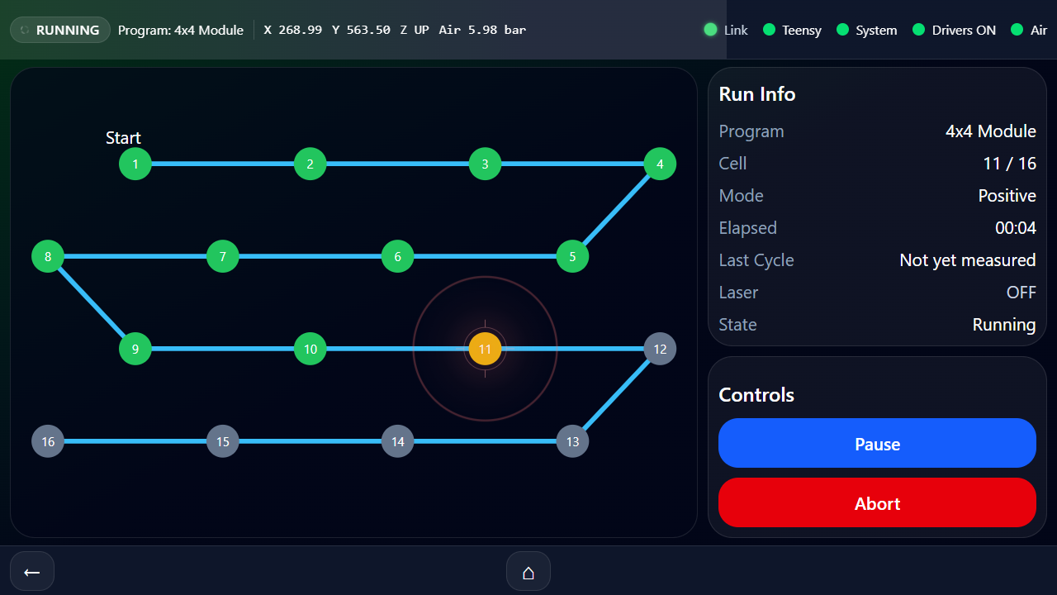
Run Screen mid-run — green dots are completed cells, the amber/orange dot is the active cell. Right panel shows live Run Info (program, cell N / total, mode, elapsed, last cycle, laser, state). Pause and Abort controls sit below.

During the run, the Run Screen shows:
- A live program diagram on the left. The currently active cell highlights green; a red glow shows when the laser is firing.
- An info panel on the right with program name, mode, current cell / total cells, elapsed time, and laser state (OFF / FIRING).
- Pause / Resume button — halts motion mid-cycle; the active cell turns amber when paused.
- Abort button (red) — opens the abort confirmation modal.

Pause and resume
Tapping Pause halts motion at the next safe point. The cell you were on stays highlighted in amber. Tap Resume to continue from the same cell — the firmware picks up exactly where it left off.
CAUTION
Pause does not retract Z. If you need to access the work area while paused, tap Abort instead — the abort flow raises Z and parks the table at the loading position.

Aborting a run
1. Tap the red Abort button. Motion pauses immediately.
2. The Abort Program? modal appears. Read it: the machine will raise Z and travel to the loading position.
3. Tap Yes, Abort to confirm, or Resume to back out.
4. Z raises. The table travels to the loading position. A red Run Aborted panel appears with the cell number where you stopped.
5. Tap Dismiss to return to the Production screen.
TIP
Resuming an aborted run. The next time you launch the same program, the GUI remembers where you aborted and asks Resume from cell N or Start from beginning. Resume picks up at the cell after the one that was interrupted — you do not have to re-weld cells that were already complete.

Completing a run
When the last cell finishes welding, the diagram highlights the final cell for two seconds, then a green checkmark overlay appears with the title Program Complete. It shows the cell count, elapsed time, and mode. Tap Back to Production to load the next part.

SECTION 6

Programs
The Programs screen is where you create, edit, test-run, import and export programs. Operators usually only need the Test Run and Manual Cell Select features here — creating and editing programs is normally a setup task.
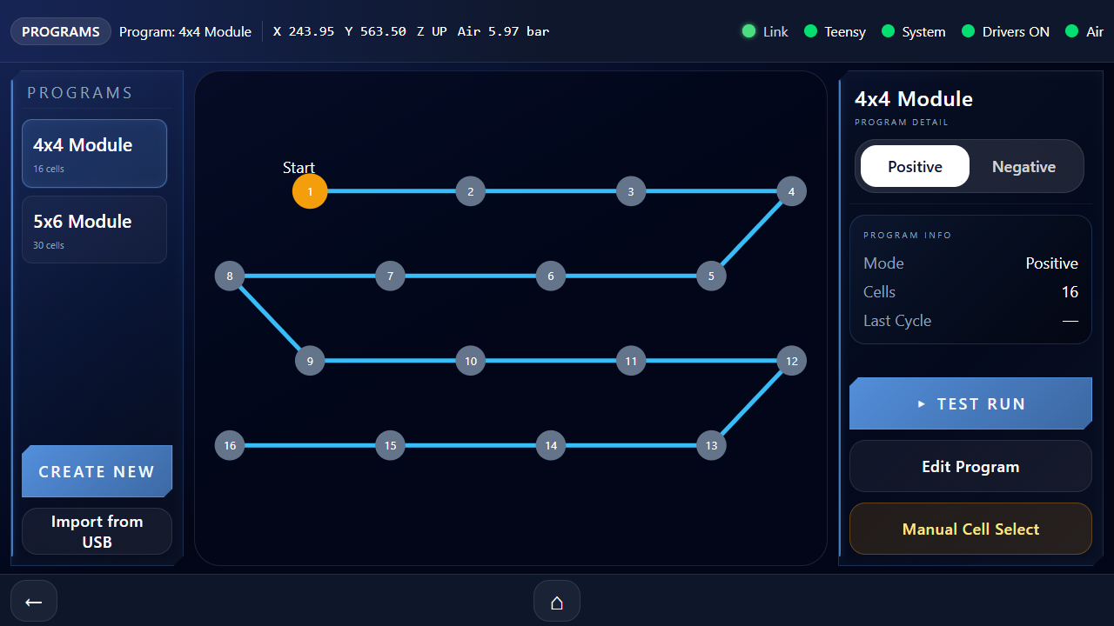
Programs Screen with a program selected

Layout
- Program list (left): every saved program. Two action buttons below — Create New and Import from USB.
- Program graphic (middle): preview of the selected program's cell layout.
- Program detail (right): info box plus the action buttons described below.

Test Run
Tap ▸ Test Run to launch the same Run sequence as Production, but with the laser firing disabled. The machine will travel through every cell, drop Z, hold for the pre-weld dwell, skip the laser fire, hold for the post-weld dwell, and raise Z. Use this to verify a new program's geometry without burning a part.
TIP
The Run Screen shows a blue Test Run badge throughout. The laser state in the info panel will stay on OFF for the entire cycle.

Edit Program
Tap Edit Program to open the parameter editor. You can adjust:
- Cell X Spacing and Cell Y Spacing in millimetres.
- Cells X and Cells Y counts.
- Row Offset Direction — Offset Left or Offset Right for staggered patterns.
- Laser Dwell — the time the laser fires on each cell, in milliseconds.
- Solenoid — pick A, B, or C. A is the primary head; B and C are spares on the same manifold.
Other buttons on the Edit screen:
- Rename Program — opens a QWERTY keyboard.
- Export to USB — saves the program as a name.gillis.json file on a connected FAT32 USB stick.
- Calibrate Start Position — opens the Calibration screen (see Section 7).
- Save Pattern — required to persist changes. Edits are lost if you leave without saving.
- Delete Program — asks for confirmation. Cannot be undone.

Create New
Same parameter set as Edit, but starting from defaults. You'll be asked for a program name first. The live preview updates as you adjust spacing and counts. Tap Create Program to save it and return to the Programs list.

Import from USB
1. Plug a FAT32-formatted USB stick into the Pi pendant's spare USB port.
2. Tap Import from USB. The pendant scans the root of the stick for *.gillis.json files.
3. Tap a file to import it. The new program appears in the list and is selected.
NOTE
If you see No programs on stick, check that the file name ends in .gillis.json and is in the root of the USB stick (not inside a folder). Programs exported from the same machine are always compatible.

Manual Cell Select
Tap Manual Cell Select to re-weld a specific cell — useful if a cell failed during a run and you want to retry it without re-running the whole program.
1. Tap a cell on the diagram. It highlights amber.
2. Tap Move to Cell — the machine travels to that cell's coordinates.
3. Use Z Down / Z Up to extend or retract the cylinder.
4. Tap Fire Laser to fire for the program's configured Laser Dwell time.
5. Tap Exit when finished — the machine returns to the Programs list.
WARNING
Manual Cell Select fires the laser. Keep enclosure interlocks intact and wear laser-safety glasses. The machine will not auto-retract Z when you exit — verify Z is up before leaving the screen.

SECTION 7

Calibration — Setting the Start Position
Each program/mode combination has its own start position — the X/Y/Z coordinates where the first cell sits. This is the value you teach by jogging the machine to the first cell and saving.

When to recalibrate
- After installing a new fixture or replacing the loading tray.
- If the first cell of a run lands off-target.
- When switching between battery pack variants with different cell-1 positions.
- After mechanical work on the gantry or table (re-square, then recalibrate).

Calibration workflow
1. From the Programs screen, select the program you want to calibrate.
2. Tap Edit Program, then Calibrate Start Position.
3. Pick the mode — Positive or Negative. (Run separate calibration passes for each side.)
4. Read the confirmation prompt — the machine will travel to the currently stored start position so you can fine-tune from there. Tap Move Table.
5. Use the 3×3 jog pad to drive the table. The arrow buttons move in the direction shown.
6. Adjust the Step Size slider as you get closer — coarse for travel, fine (0.1 mm) for the final touch-down.
7. Use Z Down to check alignment against the part. Use Z Up before any X/Y move.
8. When the welder head is centred over cell 1, tap Save Start Position.
9. The machine raises Z and travels to the loading position. The new start position is saved.
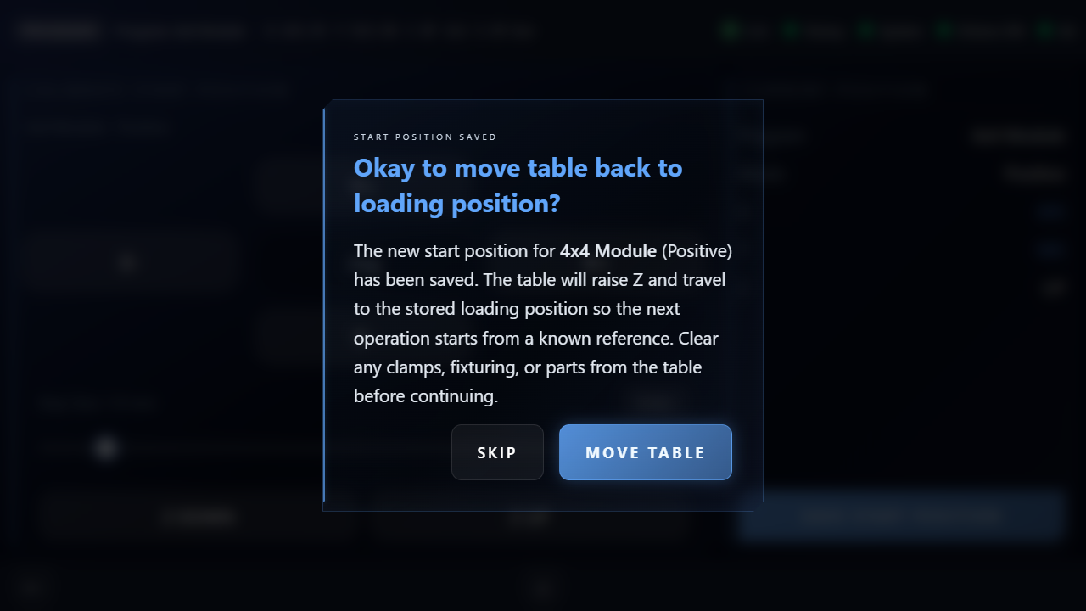
Post-save confirmation — appears after tapping Save Start Position. Confirms the new start position has been saved and asks whether to drive the table back to the loading position. Skip leaves the gantry where it is.

CAUTION
The jog pad moves the machine immediately when you tap. There is no second confirmation. Start with a small step size if you're unsure of your position.

SECTION 8

Machine Setup
The Machine Setup screen groups three tasks: homing the axes, setting the loading position, and tramming the X axis. Homing is a daily task. Loading Position and X-Axis Tramming are setup tasks you'll touch rarely.
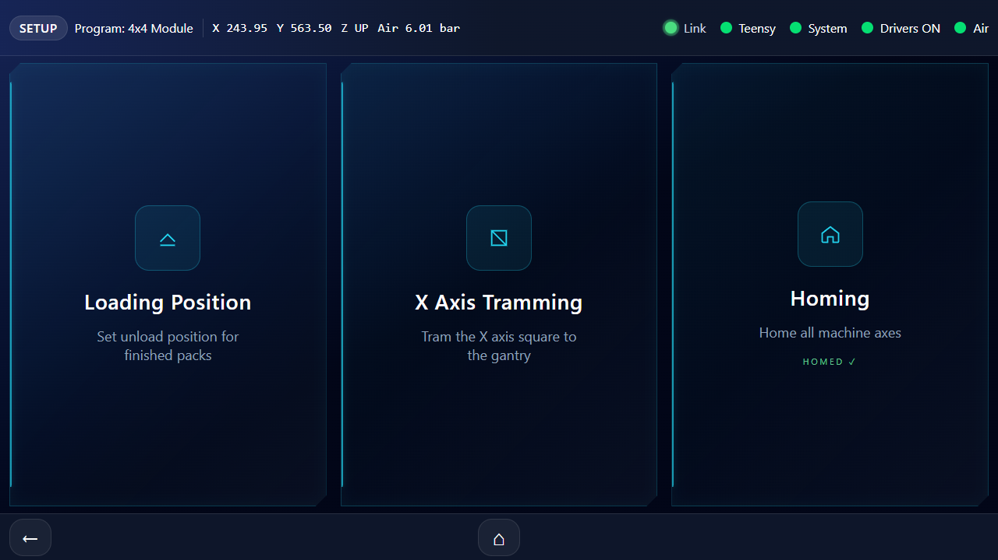
Setup Menu Screen — three tiles: Loading Position, X Axis Tramming, Homing

Homing
Homing establishes machine zero by driving each axis into its home switch. The Teensy backs off, slows down, and re-touches for precision. The whole sequence takes about 20 seconds.
1. Tap Machine Setup → Homing → Start Home.
2. Watch the live X/Y readouts during travel. Keep hands clear.
3. Wait for the overlay to dismiss. The NOT HOMED warning will disappear from the top bar.
NOTE
If homing fails — the machine stops without finding a switch, or a driver alarm fires — release E-Stop (if engaged), clear any fault on the Diagnostics screen, then retry. If it fails again, escalate to maintenance.

Loading Position
The loading position is where the table parks after every run, so the operator has clear access to load and unload battery trays.
1. Tap Machine Setup → Loading Position.
2. Confirm the move to the currently stored loading position.
3. Jog the table to where you want loading/unloading to happen.
4. Tap Save Loading Position. The machine raises Z and parks at the new position.
TIP
A well-chosen loading position has the welder head clear of the part envelope and the table accessible from the front. Sit at the pendant and verify reach before committing the position.

X-Axis Tramming
X-Axis tramming squares the gantry to the X-axis travel by adjusting the right-hand Y ballscrew's offset relative to the left. Out-of-square axes produce skewed cell patterns — the welder lays down parallelograms instead of rectangles. The procedure below uses a dial test indicator (DTI) to measure squareness directly: with the indicator mounted on the gantry and the on-screen tramming preview slewing the right ballscrew in real time, the adjustment loop is "tap arrow, watch needle, repeat" until the runout flattens.
You will need
• A dial test indicator (DTI) accurate to 0.01 mm or better.
• A rigid DTI mount — magnetic base on the gantry frame works well; keep the arm short and locked.
• A reference edge on the moving stage that's parallel to X travel. A precision-machined face of the stage works best; otherwise clamp a parallel block or 1-2-3 block to the stage, aligned with the X rails.
1. Home the machine first. Tramming offsets are applied during the homing cycle, so homing gives you a clean reference frame for the rest of the procedure.
2. Tap Setup → X Axis Tramming.
3. Mount the DTI on the gantry so the plunger rides on the reference edge of the moving stage with a slight pre-load. Aim the plunger perpendicular to the surface — angled contact reads as cosine error, not true displacement.
4. Jog X to one end of its travel using the on-screen X+/X- buttons. Zero the dial.
5. Jog X to the other end of travel. Read the runout on the DTI — that's the Y drift across the full X span, and it tells you how badly the gantry is racked.
6. Tap the ↑ or ↓ buttons in the offset panel to nudge the right ballscrew. Each tap physically slews the right-hand Y motor in real time, so the gantry visibly tilts. Use the Offset Step slider to set how much per tap — start at 0.1 mm or 0.5 mm while you are far off square, drop to 0.01 mm for the final fine-tune.
7. Jog X back across with the same step you used in step 5. Read the DTI again. If the runout shrank you have the sign right — keep nudging the same direction. If it grew, flip direction.
8. Iterate steps 6 and 7 until the runout is below your target. ≤ 0.05 mm over the full X travel is a sensible target for laser welding.
9. Tap Save to Teensy to persist the value to EEPROM.
10. Re-home the machine so the new offset is applied to both ballscrews from a clean start.
11. Optional sanity check: jog X across once more with the DTI still in place and confirm the saved offset held after the re-home.
If at any point you want to revert to the previously saved offset before tapping Save to Teensy, tap Restore Previous instead — the right ballscrew slews back to the saved position.
CAUTION
Tramming changes affect every program on the machine. Don't adjust unless you've measured the axes out of square with a DTI or precision square. If the DTI drifts between sweeps without you touching the offset arrows, suspect a mechanical issue — a loose Y motor coupling, ballscrew end bearing, or gantry-to-carriage bolt. Tighten everything before chasing the offset in software.
NOTE
This procedure squares the gantry to whatever reference edge the DTI is touching — not to the X rails themselves. Pick a reference that is parallel to the X rails, either by virtue of how the moving stage was machined, or by first checking your clamped parallel against the X rails with a separate sweep before tramming the gantry to it.

SECTION 9

Fault Recovery
Faults stop motion immediately and show a full-screen red overlay. The overlay tells you the fault, the cause, and the steps to recover. This section is a reference for the faults you are most likely to see.

The general fault flow
1. Motion stops. The red overlay appears with the fault name and recovery text.
2. Address the physical cause — restore air pressure, clear an obstruction, reset a driver.
3. Tap Clear Fault on the overlay.
4. If the fault was during a run, the abort point is saved. The next launch of the program will offer Resume from cell N.
5. If the fault required re-homing (E-Stop, driver alarm), the NOT HOMED warning will appear — home the machine before running again.

E-Stop
E-Stop is the most common fault and is technically not a fault at all — it's a safety state. The flow is described in Section 2.

Common faults
Fault | What it means | How to recover
Low Air Pressure | Shop air dropped below the configured threshold. The Z cylinder cannot operate reliably. | Check the air supply at the wall. Verify the regulator reads above 4 bar. Verify nothing else is drawing air. Tap Clear Fault once pressure is restored.
Z Up Timeout | The Z cylinder did not reach the up reed within the timeout. Cylinder is stuck or the reed has failed. | Manually verify Z is up. If not, isolate air, vent, and inspect the cylinder. If Z is up but the reed isn't reading, escalate to maintenance.
Z Down Timeout | Same as above, but for the down stroke. Cylinder did not reach the down reed. | Check for an obstruction under the weld head. Verify the down reed sensor is making contact (visible in Diagnostics → Test Motion).
Driver X / Y-L / Y-R Alarm | A servo driver flagged a fault — usually overcurrent, overheating, or position error from a stalled axis. | Power-cycle the servo (cycle the 48 V PSU). Re-home. If it recurs, escalate to maintenance — likely a stalled axis or driver replacement.
User Abort | Not a true fault — informational. The run was aborted by tapping Abort. | Tap Dismiss on the aborted-run panel. Relaunch the program to be offered Resume from cell N.

TIP
If you see a driver alarm immediately after an abort or E-Stop, it may be a transient caused by the abrupt motion stop. The GUI dismisses these automatically — if the red fault pill clears within a second of clearing E-Stop, you can ignore it.

SECTION 10

Diagnostics
The Diagnostics screen is a health snapshot — connection status, driver state, air, and runtime hours. Use it to verify the machine is healthy before a shift and to track service intervals.
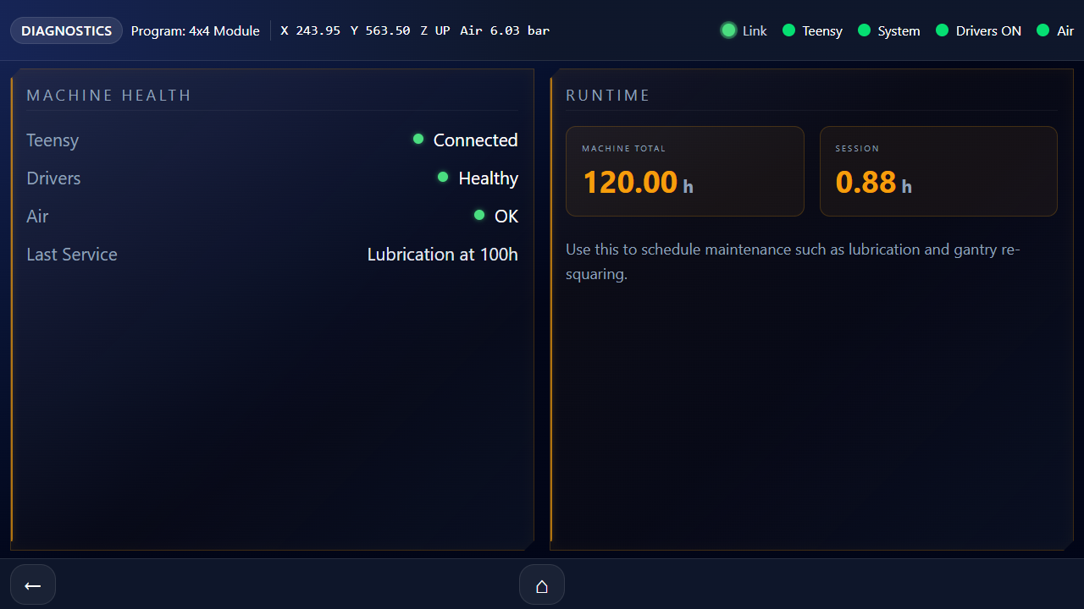
Diagnostics Screen with health indicators and runtime tiles

Health indicators
- Teensy — Connected (green) or Disconnected (red). If red, the motion controller is offline.
- Drivers — Healthy (green) or Fault (red). If red, drop to Test Motion to see which axis.
- Air — OK (green) or Low (red). Compares the live reading to the threshold in Settings.
- Last Service — Manually tracked text field. Used to remember when the machine was last serviced.

Runtime metrics
Two tiles show Machine Total hours and Session hours. Use these to schedule lubrication, gantry re-squaring, and other periodic maintenance.

SECTION 11

Settings
The Settings screen controls motion speeds, accelerations, weld timing, the air threshold, and boot behaviour. Operators typically don't change these — they are a setup task. The values are persisted to the Teensy's EEPROM and survive power cycles.
Reach the Settings screen by tapping the gear icon (⚙) in the top-left corner of the Home Screen.

Motion Speed and Acceleration — Fast Profile
Applies to jogging, the pre-move to start position, parking to loading, and the Test Motion screen.
X Speed | mm/s — table speed in X during fast moves. Default 120.
Y Speed | mm/s — table speed in Y during fast moves. Default 120.
X Accel | mm/s² — X-axis acceleration during fast moves. Default 500.
Y Accel | mm/s² — Y-axis acceleration during fast moves. Default 500.

Cell-to-Cell Profile — Running a Program
Applies only between cells during a welding run. These are usually slower than the Fast Profile to keep the welder head settled before firing.
Cell X Speed | mm/s — X-axis travel between cells. Default 60.
Cell Y Speed | mm/s — Y-axis travel between cells. Default 60.
Cell X Accel | mm/s² — X-axis accel between cells. Default 250.
Cell Y Accel | mm/s² — Y-axis accel between cells. Default 250.

Weld-Cycle Timing
These three values shape the dwell pattern for every cell. The cycle is: MOVE → Z DOWN → Pre-weld Hold → FIRE → Post-weld Hold → Z UP.
Laser On Time | ms — laser pulse duration. Also called Laser Dwell. Default 50.
Pre-Weld Hold | ms — delay between Z down and laser fire. Default 0.
Post-Weld Hold | ms — delay between laser fire and Z up. Default 0.

Air Pressure Threshold
Sets the minimum acceptable air pressure. Below this value, the machine refuses to run and flags a Low Air Pressure fault. Default is 1.5 bar — well below the regulator setting of 4 bar in normal use.

Home on Boot
When ON, the machine automatically homes itself on power-up. When OFF, you must home manually from the Setup screen before running anything. This toggle is locked until you've successfully homed the machine at least once.

Bench Mode
CAUTION
Engineering use only. Bench Mode bypasses the multi-touch homing refinement for use on a development rig. It should always be OFF on the production machine. Don't toggle this without explicit instruction.

Saving
Tap Save to Teensy EEPROM after any change. Settings are not active until saved. The button shows Saving… while the write is in flight; this takes less than a second.

SECTION 12

Test Motion
Test Motion is a hands-on diagnostic screen. It lets you jog the table without homing, disable the drivers to push the table by hand, and watch every limit switch and driver alarm live. It is mostly used by maintenance, but operators should know it exists.
Reach Test Motion via the Diagnostics screen. The pendant shows an amber warning across the top of the screen because the machine may not be homed.

Manual jog
The jog pad and Z buttons behave exactly like the calibration screen, with a wider step-size range (up to 50 mm). Use this to verify motors respond before homing, or to position the table after a failed home.

Drivers Enabled / Disabled
Tap the driver toggle to remove power from the motors. With drivers disabled you can push the table by hand. This is how you verify the home switches and driver alarms work — push slowly toward each switch and watch the lamps on the right of the screen.

Sensor lamps
The right panel groups every sensor:
- Home switches — X Home, Y-Left Home, Y-Right Home. Blue when active.
- Z cylinder reeds — Z Up, Z Down. Green when the cylinder reaches the corresponding reed.
- Driver alarms — X ALM, Y-L ALM, Y-R ALM. Red when active (a fault condition).
TIP
If a driver alarm lamp is red, that axis won't move. Resetting the driver typically means power-cycling the 48 V PSU (after E-Stopping for safety).

SECTION 13

End-of-Shift Shutdown
At the end of a shift, follow the sequence below. The pendant has a built-in Shut Down button that halts the Raspberry Pi cleanly before you flip the mains — this avoids the slow SD-card corruption that abrupt power-off can cause.
1. Finish or abort any active run. Wait for the table to park at the loading position.
2. Remove any battery pack from the fixture.
3. Press the E-Stop button. The red overlay confirms the safety state.
4. On the pendant, tap Settings (⚙) to open the Settings screen, then tap the red Shut Down button in the bottom-right corner of the screen. A confirmation modal will appear — tap Shut Down to proceed, or Cancel if you tapped it by mistake. If the button is greyed out, a run is still active — abort or finish it first.
5. Wait for the pendant screen to go dark. This takes about 20 seconds while the Pi flushes any in-flight writes and halts the operating system. A full-screen "Shutting down…" overlay tells you what is happening.
6. Only after the screen has gone dark, switch off the wall isolator. Flipping the mains while the screen is still on risks corrupting the pendant's SD card.
7. Close the air supply valve at the wall.
8. Wipe down the table and fixture. Note any unusual sounds or movements in the shift log.
CAUTION
Never flip the mains while the pendant screen is still showing the GUI. The Pi is mid-write to its SD card, and an abrupt power cut here is what slowly destroys flash storage. Wait for the screen to go dark first — that is the explicit signal from the Shut Down workflow that it is safe to cut power.
TIP
If the Shut Down button does nothing when tapped, the one-time Pi sudoers entry that lets the GUI run poweroff may not be installed yet. See docs/SHUTDOWN_SETUP.md for the one-line setup. Until that is in place, the pendant tolerates abrupt power loss — but get the setup done at the next service visit.

SECTION 14

Troubleshooting Quick Reference
First-stop guide for the symptoms operators see most often. If the suggested action doesn't resolve the issue, escalate to maintenance — don't keep retrying.
Fault | What it means | How to recover
Pendant is blank | Pi pendant didn't boot, or display cable is loose. | Wait 30 seconds after power-on. If still blank, check that the pendant's USB-C cable is seated. Power-cycle.
TEENSY OFFLINE pill | Backend can't talk to the motion controller — could be a USB disconnect or a Teensy crash. | Power-cycle the machine at the wall. Allow 30 seconds for full re-boot. If it recurs, escalate.
NOT HOMED warning | Machine hasn't been homed since the last power-on or E-Stop. | Setup → Homing → Start Home. Keep the work envelope clear.
Gillis is lost screen | Attempted to open a screen that needs known coordinates before homing. | Tap Home Now on the same screen, or back out and home from Setup.
Run won't start — Move button greyed out | A fault is latched, or air pressure is below threshold. | Look at the top status bar — a red fault pill, E-STOP, or air dot tells you what to clear first.
Cell pattern is skewed | X axis is out of square with the table. | Setup → X Axis Tramming. Adjust until square. Recalibrate affected programs.
First cell is offset from target | Start position has drifted — fixture moved or program needs recalibration. | Programs → select program → Edit → Calibrate Start Position. Jog to the new cell-1 location and save.
Laser fires but no weld | Either the head is not in contact with the part (Z stroke too short), or laser power has changed. | Check Z reaches the part — verify with Manual Cell Select → Z Down. If contact is good, escalate.
Random driver alarms during Z moves | Likely solenoid back-EMF — flyback diodes may be missing or failed. | Note the symptom and escalate. This is a wiring fix, not a parameter change.
Pendant disconnects briefly during runs | Pi power glitch caused by inductive noise on the 24 V rail. | Note when it happens (Z stroke direction matters). Escalate to maintenance — solenoid suppression is the fix.

APPENDIX A

Hidden System Info Panel
There is a hidden engineering panel that shows Pi vitals — CPU temperature, CPU and RAM usage, uptime, and GUI version. It is hidden by default to keep the operator UI clean. It's safe to look at but not usually needed.

How to open it
Tap the Ionetic logo on the Home Screen five times in quick succession (within about 1.5 seconds). The System Info panel will appear. Tap the back arrow to leave.

What it shows
- CPU Temp — green below 60 °C, yellow below 70 °C, orange below 80 °C, red above. Sustained red means the pendant needs better airflow.
- CPU Usage — % aggregate, sampled in real time.
- RAM — used / total in megabytes, plus a percentage.
- Uptime — how long the pendant has been running since the last boot.
- GUI Version — useful when reporting issues; quote this number.
TIP
If maintenance asks what version of the GUI are you running?, the answer is in the top-right corner of the System Info panel.

APPENDIX B

GUI Map
Every screen reachable from the pendant and the path to get there. Keep this page open during training.
Home Screen | Top-level navigation hub. Power-on lands here.
→ Production | Quick-launch a saved program.
→ Run Screen | Live cell-by-cell run with Pause / Abort.
→ Programs | Manage saved programs.
→ Edit Program | Adjust pattern parameters and rename.
→ Create Program | Build a new program from defaults.
→ Calibration | Jog and teach start position for a program/mode.
→ Manual Cell Select | Re-weld a single cell.
→ Import from USB | Load programs from a FAT32 stick.
→ Machine Setup | Setup tasks hub.
→ Homing | Drive axes to home switches.
→ Loading Position | Set the post-run park location.
→ X Axis Tramming | Square the gantry to the table.
→ Diagnostics | Health overview and runtime.
→ Test Motion | Hands-on motor and sensor diagnostic.
→ Settings | Speeds, dwells, air threshold (gear icon ⚙).
→ System Info | Hidden — 5-tap the logo.

Notes
Use the space below to log shift observations, calibration changes, or anything the next operator should know about.

