Özgür Öney
21101821
CS342 – 2
Assoc. Prof. Dr. Özcan Öztürk

Homework 1
Assigned: Sep 11, 2015, Friday
Due date: Sep 19, 2015, Saturday, 23:55pm.

Q2) Kernel executable is in the path lib/modules/3.19.0-28-generic/kernel
3.19.0-28-generic is the version of my running kernel. After given instructions are followed and root directory has been changed to source code's directory, following subdirectories were reached.

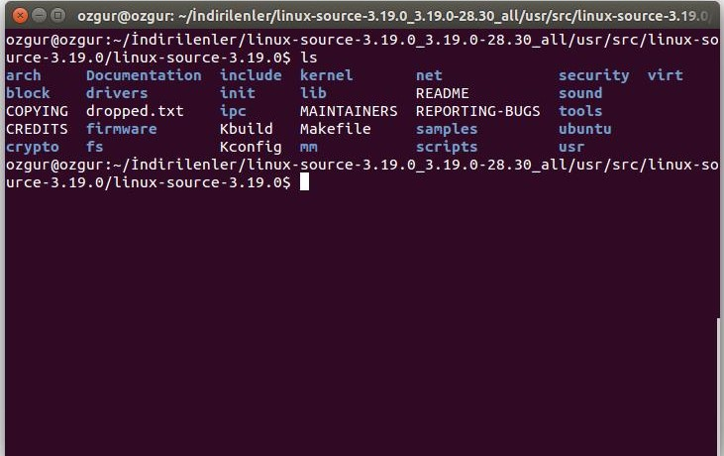

Q4) strace command in Linux is used to trace system calls. Since every user process has an interact with kernel by invoking system calls, strace utility logs these system calls respectively. Thanks to these, programs' interactions with the system could be monitored and tracked down. Following figure shows what Terminal did to show trace of executable after compilation.
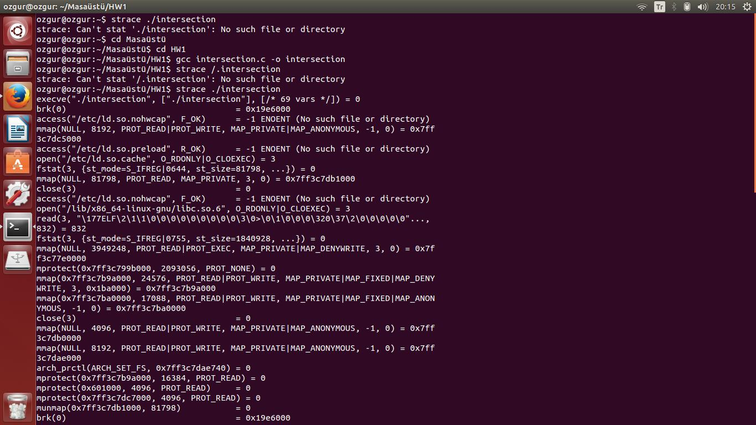

strace man command is used to display the man page of the “strace” command, whereby man is the default built user manual page under many Linux version.Just after strace man command is used in Terminal, following screen could be seen.

