### **Costrict & Gemini CLI User Guide**

**Configuration Steps**

1. **Google Gemini CLI Installation**

Refer to the official Google Gemini CLI documentation（<https://github.com/google-gemini/gemini-cli>）， install and log in first.

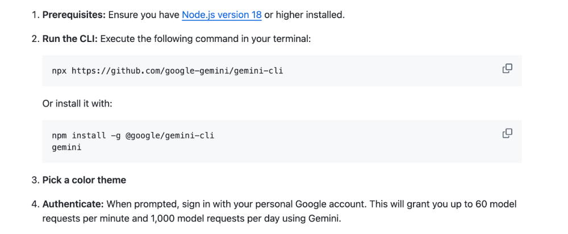

Video Tutorial：

<https://www.bilibili.com/video/BV1LhKfzZEsY?vd_source=e6f596d697180964811dd541f1b5fcc0&spm_id_from=333.788.videopod.sections>

1. **How to use the Gemini CLI with the Costrict**
   1. Open the VSCode, click the extension store, search for "costrict", install and log in.

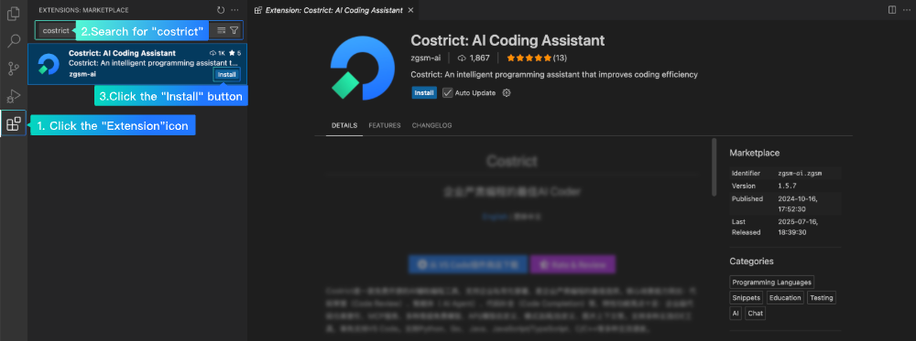

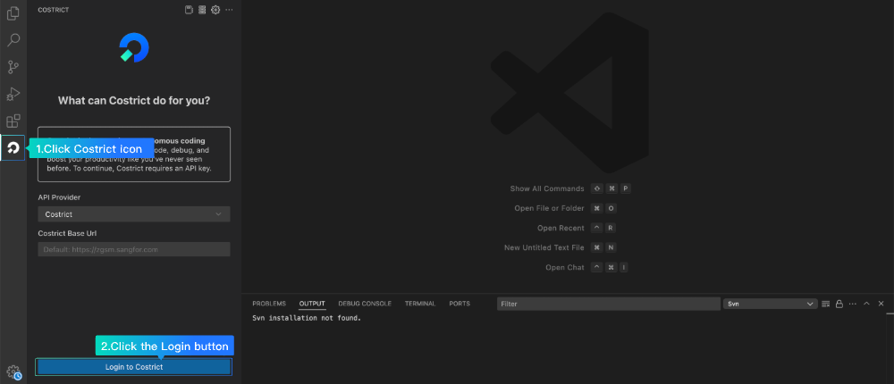

2.2 Open Settings > API Provider page, select Gemini CLI and click “Down” button.

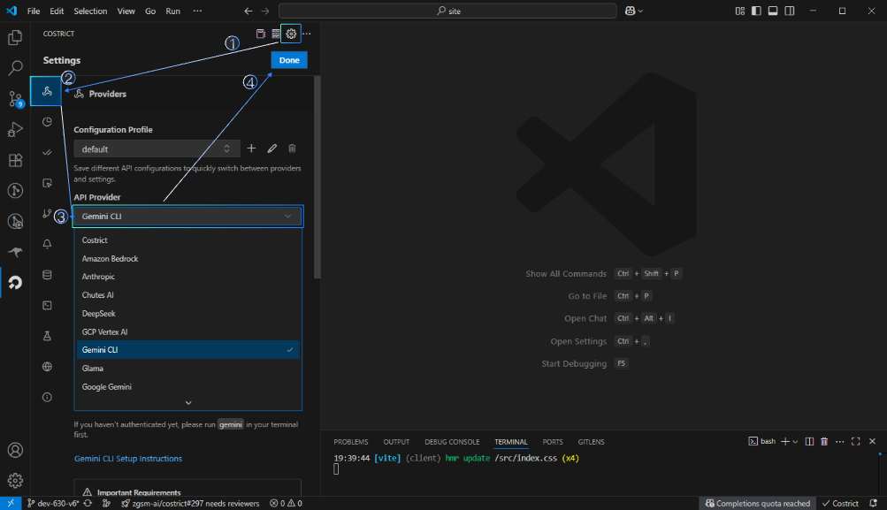

Video Tutorial：

<https://www.bilibili.com/video/BV1GFKBzbE7w?vd_source=e6f596d697180964811dd541f1b5fcc0&spm_id_from=333.788.videopod.sections>