ENGINEERING NOTE
Which J-Tube Pull-In Method Applies to Your Riser or Umbilical?
A quantitative test for choosing between Walker & Davies (1983) and Ronalds (1992), and why the two methods cannot validate one another.

1. Purpose
This note answers a question that comes up whenever a J-tube pull-in analysis is set up: two well-established closed-form design methods exist for predicting pull-in load, but they rest on opposite physical assumptions. This note states the difference precisely, gives a quantitative test for which method applies to a given riser or umbilical, and demonstrates it on a published worked example.
Bottom line
Walker & Davies (1983) and Ronalds (1992) are not two notations for the same theory. They model opposite contact behaviour at the J-tube wall, and each paper's formulas are only valid within its own regime. Using one paper's numbers to validate the other's method is not a meaningful check — it answers a different physical question. Section 4 gives a quantitative test (Ronalds’ own wrap-vs-bridge criterion) for which regime a given object actually falls into.

2. The Two Methods

2.1 Walker & Davies (1983) — rigid pipe, elastic-plastic bending
“A Design Basis for the J-Tube Method of Riser Installation,” ASME J. Energy Resources Technology, 105(3), 263–270. Models a steel riser as a rigid pipe that does NOT conform to the J-tube's curvature. Instead the riser touches the wall at three discrete points, deforming elastically and plastically between them as it is pulled through. The pull-in load is derived from the plastic bending work plus friction at those discrete contacts, in three stages (bending into the bend, elastic relaxation, straightening the residual curvature). Riser yield stress and elastic modulus are central inputs — they set how far the pipe deforms plastically. Explicitly stated to apply for stiff risers (diameter-to-thickness ratio below about 30).

2.2 Ronalds (1992) — flexible cable, friction only
“J-Tube Design for Flexible Umbilicals,” OTC 6875. Models a flexible umbilical as a cable that conforms continuously to the J-tube wall throughout the bend, with negligible bending resistance of its own. Load is carried entirely by axial tension, growing around each bend by the classical capstan (belt-friction) relation. Yield stress and elastic modulus barely enter the load calculation at all — they appear only in a secondary check of whether the umbilical is flexible enough to wrap the bend in the first place. The paper cites Walker & Davies directly and positions itself as addressing the case Walker & Davies does not: an object too flexible to hold a discrete-contact shape.

2.3 Side by side
 | Walker & Davies (1983) | Ronalds (1992)
Contact | Discrete — 3 points, straight between them | Continuous — hugs the wall throughout the bend
Load mechanism | Elastic-plastic bending (dominant) + friction (secondary, coupled) | Pure friction (capstan equation); bending assumed negligible
σ₀, E role | Central — sets how much the pipe plastically deforms | Peripheral — only used in a “can it wrap?” check
Valid for | Stiff risers (dₘ/t < 30), does not conform to the bend | Flexible umbilicals, bending stiffness negligible

3. Why the Two Methods Cannot Validate Each Other
Both methods produce a pull-in load from the same inputs — bend radius, J-tube diameter, object diameter, friction coefficient — which makes it tempting to run one geometry through both and compare. That comparison is not meaningful, because the two methods answer different physical questions:
- Walker & Davies computes the load to plastically bend a rigid pipe across three discrete contacts.
- Ronalds computes the friction load on a cable that is assumed to already be conforming continuously to the wall.
Feeding a stiff steel riser's geometry into Ronalds' formulas does not “validate” Walker & Davies — it computes the pull load for a hypothetical cable with no bending resistance, which the riser demonstrably is not. The reverse substitution has the same problem in the other direction. What genuinely IS shared between the two papers is the geometric input space (R/d, D/d, bend angle, friction coefficient carry the same physical meaning in both) and one theoretical limit: Ronalds' capstan equation is the correct asymptotic form of Walker's friction term as bending stiffness approaches zero — a genuine connection, but a limiting case, not an identity over the range either paper is meant to be used in.

4. A Quantitative Test: The Wrap-vs-Bridge Criterion
Ronalds’ own paper gives a closed-form test (his eq. 15) for whether a given object is flexible enough to conform continuously to a bend at all, rather than bridging across it at localised points. Restated as a threshold tension:
T_wrap = 2 × (EI) / (f × a²) where a = √(2rD − 2rd), f = 4
EI is the object's own bending stiffness, r the bend radius, and D, d the J-tube and object diameters. Below T_wrap, the object does not conform to the bend continuously — consistent with Walker & Davies’ discrete-contact picture. Above it, continuous wrap is the physically correct assumption, consistent with Ronalds. This test decides which paper's assumption actually applies, rather than assuming one or the other by habit.

5. Worked Example: Walker & Davies’ Own Appendix II Riser
Applying the wrap-vs-bridge test to the riser in Walker & Davies’ own worked example (300 mm OD, 20 mm wall, 200 GPa steel, pulled through a 30 m bend radius, 450 mm J-tube ID) checks whether that paper's own example is self-consistent with the assumption it depends on.
Riser bending stiffness, EI | 34.7 MN·m²
Tension needed to reach the wrap threshold | 1.93 MN
Actual Stage I pull-in load (paper's own result) | 167 kN
Margin | ~11.5×

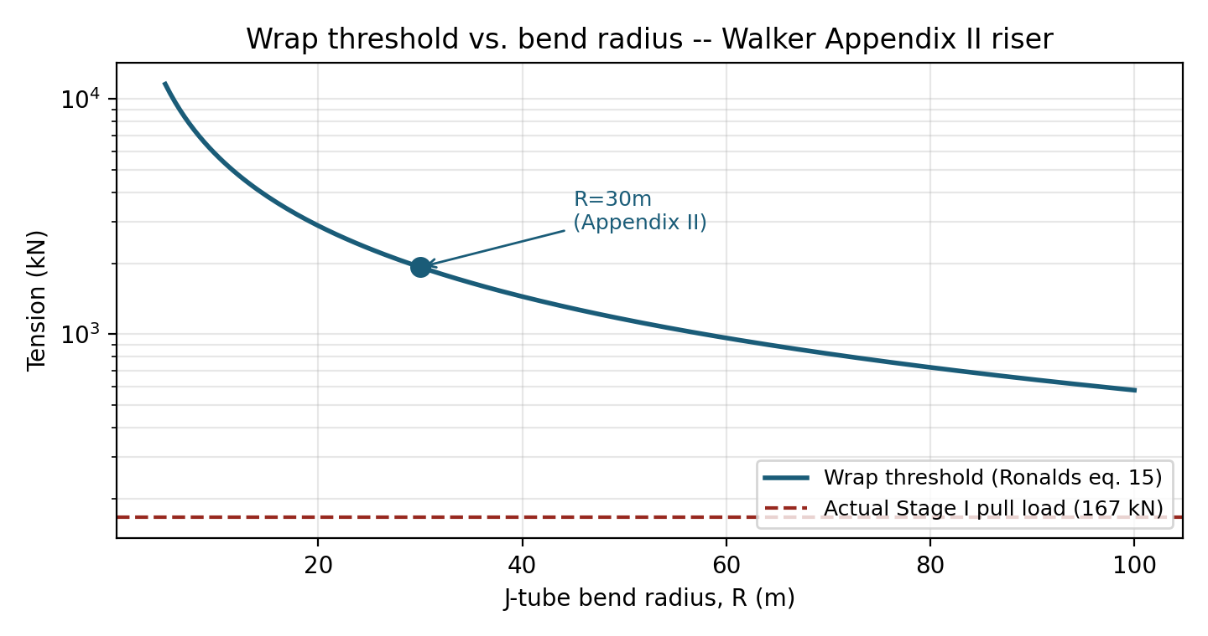
Figure 1 — Wrap threshold vs. bend radius for the Appendix II riser, against its actual pull-in load (log scale).
Conclusion
The riser would need roughly 11.5 times more tension than it is ever actually pulled with just to reach the point where Ronalds’ continuous-wrap assumption begins to apply. At its real operating loads, this riser sits firmly in Walker & Davies’ discrete-contact regime — confirming the paper's own example is self-consistent with the assumption it depends on, and demonstrating concretely why substituting Ronalds’ formulas here would not be a valid check.

6. Recommendation
- Before running either method, compute the wrap threshold for the actual object and compare it against the expected pull tension — do not assume the regime from the object's name alone (“riser” vs “umbilical” is a reasonable prior, not a substitute for the check).
- If the expected pull tension is well below the wrap threshold (margin ≳ 2× in this note's convention), use Walker & Davies (1983).
- If it is well above (margin ≲ 0.5×), use Ronalds (1992).
- Within a factor of 2 either side of the threshold, treat the case as marginal: compute both, and if the two disagree materially, escalate to a full finite-element contact analysis rather than picking one closed-form method by default.
This check, the two design methods, and a desktop calculator implementing all three are packaged together in the accompanying J_tube_2026/scripts/ folder (regime_classifier.py and combined_gui.py); see README.md for the full verification record of both methods.

References
Walker, A.C., Davies, P. (1983). “A Design Basis for the J-Tube Method of Riser Installation.” ASME Journal of Energy Resources Technology, 105(3), 263–270.
Ronalds, B.F. (1992). “J-Tube Design for Flexible Umbilicals.” OTC 6875, Offshore Technology Conference, Houston, TX.

