# Electrokinetics in gwaterFreakFoamEK

We use the formulation for EK given in RheoTool but combined with phreeqc The species are exchanged with phreeqcRM through getSpecies and linked other phreeqcRM functions. Phreeqc also provide the diffusion coefficient through getSpeciesD25. The specific fields for EK are included in createEKFields, and some data come from specific options of transportProperties file

The EKequations are solved in NernstPlanck in the EK folder.

All exchange with phreeqc is included in gwaterFoam3ek (3 is for dissolved species and phreeqc)

The equations :

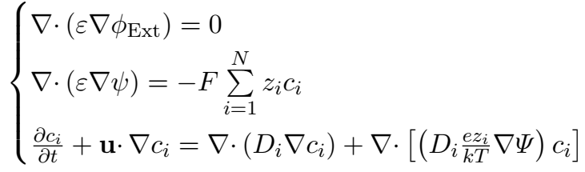

With F faraday nb : 99680 C.mol-1 or A.s.mol-1 [0,0,1,0-1,1,0] and  where  is the electric permittivity (epsilonK ("vacuumPermittivity",dimensionSet(-1, -3, 4, 0, 0, 2, 0),8.8541878176e-12 ) , $ε_{R}$ relative permittivity unitless.

We use slightly different symbols than rheoTool because in OpenFoam phi is dedicated to fluxes and it was puzzling to use for one potential phi and the other psi so we use psi with different letters after for both.

The 1st eqn is simply

fvm::laplacian(psiE)

For the 2nd eqn:

fvm::laplacian(psiI) == souE with souE += -z[i]*Cw[i]()*FK/(relPerm*epsilonK)

this is ok, but if we use relPerm=78 (as in one example, close to the one of water) this gives values of souE of 10^12..(find in the web for sand sigma~10^5 S/m)

Needed :

psiE,psiI field at time 0. psiE solver in fvSolutions (system)

Differences with rheoTool : our conc are in kg/m3 and not in mol/m3

In transportProperties add relPerm

Variables

Kbk : Boltzmann constant

Fk : Faraday constant

rhoE : charge density

AK Avogadro constant

psiE : externally applied electric potential in volts (note in rheoTool this is phiE)

psiI : intrinsic electric potential in volts (note in rheoTool this is psi)