Electricity Sector Data Streaming and Analysis
COMP5339 Project Assignment 2 Report

1. Introduction
This project performs a data processing pipeline for data retrieval, data Integration and materialisation, data publishing, data storing, data subscription and visualization for electricity generation and emissions data for the Australian National Electricity Market (NEM). The NEM scope includes the following states: New South Wales, Queensland, South Australia, Tasmania and Victoria. This system utilizes OpenElectricity data at 5 minute resolution spanning from 1 May 2026 to 8 May 2026, and the retrieved data is then converted into facility-level records, making it ideal for MQTT streaming and visualizing the data on a dashboard via a map interface.
The last implementation will get the OpenElectricity facility data with filters of facility_code, which is unlike an aggregate-only approach. The API return value includes the records for power usage and emissions at the unit level, and so units are run back to the facility and consolidated to one record per facility for every time period. This data is then inserted into a cache to store the data as CSV, minimizing repeated calls to the external API during subsequent stages of the streaming and dashboard processes. Any optional NEM market price and demand information is also retrieved and added to the published messages.

2. System Description
The system contains 4 primary parts: Data acquisition and preparation, database storage, MQTT streaming and map-based visualization. The first notebook and supporting electricity_pipeline.py module is in charge of data acquisition. It fetches the facility metadata, unit-level power and emissions data and the market price and demand from OpenElectricity. The cleaned data is stored in CSV files in the processed data directory.
In the third notebook, DuckDB is used to store data in the database. The schema is separated into the following sections: static facility information, Assignment 1 annual facility metrics, state-year demographic statistics, and Assignment 2 5-minute stream records. The mqtt_helpers.py module publishes composite power and emissions messages, and supports MQTT streaming, with the resulting events being published in event-time sequence. The dashboard notebook is a subscriber that decodes incoming messages, saves current value for each facility and generates an interactive map.
The implementation is organised into three notebooks and one final Streamlit dashboard. 01_data_retrieval_cleaning_final.ipynb retrieves, cleans, materialises and continuously publishes MQTT data. 02_mqtt_dashboard_final.ipynb subscribes to MQTT, demonstrates a notebook prototype dashboard from an empty live-message state, exports full-map HTML files, and launches the final Streamlit dashboard. 03_data_storage_final.ipynb implements the DuckDB schema and loads Assignment 1 data with the Assignment 2 stream. The Streamlit dashboard is used as the final user-facing interface and has been updated to launch reliably on both Windows and macOS using the active Python executable and a local log file.

3. Data Acquisition, Cleaning and Transformation

3.1 Data Acquisition
The main data source is the OpenElectricity v4 REST API. First, the facilities endpoint is used to retrieve NEM operating facility metadata, including facility codes, names, network regions, coordinates, units, fuel technology, dispatch type, and registered capacity. The facility codes are then used as filters when calling the facility data endpoint for the NEM network.
The pipeline requests two metrics, power and emissions, using a five-minute interval and the date range 2026-05-01T00:00:00 to 2026-05-08T00:00:00. To reduce API calls and stay within the OpenElectricity free-account request limit, facility codes are requested in batches of 25 rather than one request per facility. Power and emissions are requested together where possible, and the raw API responses are cached under data/raw/openelectricity for reproducibility.
The final facility-level CSV contains 710,406 records, 353 facilities with observed data, and 2,016 five-minute timestamps from 2026-05-01 00:00:00+10:00 to 2026-05-07 23:55:00+10:00. A separate market cache contains 2,016 timestamped NEM price and demand records for the same week.

3.2 Data Cleaning and Transformation
OpenElectricity provides data for facilities on a unit level. Therefore, every result is using the unit_code in the response metadata as its parser. Based on the metadata of the facilities, a unit-to-facility lookup table is created and all units with the same facility are grouped by the time stamp. This creates 1 record for each facility with a 5-minute interval.
Standardisation of data types is also performed during transformation. Timestamps are parsed as datetime data types. Power, emissions, latitude, longitude, and capacity fields are converted to numeric values. Missing power and emissions values are filled as 0 since the API indicates no output for a unit. Records with no valid facility identifiers or timestamps are deleted. Only a reliable match between a facility and its coordinates are kept, otherwise OpenElectricity coordinates are used as a fallback in order to ensure that all the location records on the dashboard are mappable.
Since the facility names in OpenElectricity do not always match to the names in Assignment 1, the facility name normalisation process is performed. It removes common suffixes such as ?Power Station?, ?Wind Farm?, and ?Solar Farm? compares names of facilities in the same state and stores the best Assignment 1 match as a1_facility_name with an a1_match_score. This helps to integrate with the Assignment 1 schema while keeping the original OpenElectricity facility name and code.

4. Data Integration
The data integration stage is where the dynamic 5-minute data from the stream that merged with the static and annual facility data from Assignment 1. The consolidated streaming dataset contains the facility_code, facility_name, state, network_region, facility_type, coordinates, power_mw, emissions_t_co2e, registered_capacity and the optional Assignment 1 match fields. The cached CSV is able to be used for publish, visualise and load into a database without having to call the API again.
The data for Assignment 1 and 2 are stored in related tables in the DuckDB schema contained in 03_data_storage_final.ipynb. Static Facility Information and Coordinates are stored in the facilities table. The facility_year_metrics table contains annual electricity production, emissions, and emissions intensity data for each facility from Assignment 1. The state_year_stats table contains demographic data at the state level. The facility_stream_records table contains 5-minute level Assignment 2 records and matches with facilities by facility_id.
For schema integration, the database-loading notebook now prefers the a1_facility_name produced during the retrieval stage. This increases the number of streaming records that can be matched to Assignment 1 facilities compared with direct name matching, while unmatched facilities are still retained in the streaming CSV for dashboard use.

5. MQTT Streaming and Continuous Execution
The data stream of electricity is simulated using MQTT. Each facility-time record is converted into a JSON message containing timestamp, facility code, facility name, state, network region, facility type, coordinates, power output, emissions, NEM price, and NEM demand. The messages are published on the public HiveMQ broker “broker.hivemq.com” on port 1883 to the topic comp5339/2026s1/team_xinyi/electricity.
Records are sorted by the "timestamp" and "facility_code" to ensure that the messages are delivered in chronological order of event-time.It uses QoS 1 and waits for publish acknowledgement before continuing. After every message is published, a 0.1 seconds delay is applied. Each message is hashed based on timestamp, facility code, power and emissions values and the hashes will be written to mqtt_published_state.json, in order to prevent duplicate publication. New and changed records are only published in later rounds.
Continuous execution is implemented by a loop that reloads the cached CSV, publishes new or changed records, and then waits 60 seconds before the next round. This design uses materialised data for stream replay rather than repeatedly calling OpenElectricity, by applying caching to reduce unnecessary external API traffic.

6. Data Visualisation Dashboard
The visualisation layer now has two roles. In 02_mqtt_dashboard_final.ipynb, the notebook prototype creates an MQTT subscriber for the same broker and topic used by the publisher. It starts from an empty live-message buffer, decodes incoming JSON messages, and gradually adds or updates facility markers as messages are received. This prototype is mainly used to demonstrate the subscription process from zero received records.
The final dashboard is implemented in streamlit_dashboard.py and launched from Notebook 02. It displays a map with facility markers placed by latitude and longitude. Marker colour and size respond to the selected metric, allowing the user to switch between power_mw and emissions_t_co2e. The dashboard also provides state and facility-type filters, automatic refresh, current NEM price and demand display, and marker pop-ups showing facility name, facility code, type, state or network region, timestamp, power, emissions, price, and demand.
The Streamlit dashboard uses the cached CSV as a fallback so the map is populated even before new live MQTT messages arrive. It also supports clearing the live message buffer and pausing or resuming live MQTT message ingestion during testing. During a full demonstration, Notebook 01 runs the continuous publisher, while Notebook 02 or the Streamlit app subscribes to the topic and visualises the latest facility state.

7. Challenges, Findings and Future Improvements

7.1 Challenges and Solutions
The first major challenge was retrieving true per-facility data rather than only NEM-level totals. This was solved by first retrieving facility metadata, then using facility_code filters in the OpenElectricity facility data endpoint. The second challenge was that the API response is unit-level, so a unit-to-facility mapping and aggregation step was required before MQTT publishing.
Another challenge was matching OpenElectricity facility names to Assignment 1 facility names. The naming conventions differ across datasets, so exact matching was insufficient. A normalisation and fuzzy-matching step was added to improve database integration while preserving the original API facility identifiers. Finally, the dashboard needed to support both a from-zero MQTT demonstration and a stable full-map user interface. This was handled by keeping the notebook dashboard as a prototype without CSV fallback and using Streamlit as the final dashboard with cached fallback, live MQTT controls, and cross-platform launch support.

7.2 Key Findings
The final pipeline demonstrates that high-frequency electricity data can be transformed into a reusable facility-level streaming dataset. The processed data covers 353 facilities, 2,016 five-minute timestamps, and 710,406 facility-time records across the NEM states. The dataset supports multiple downstream uses: MQTT publishing, database storage, and map-based dashboard visualisation.
Combining power, emissions, facility metadata, and market-level price and demand makes the dashboard more informative than a raw time-series table. Users can inspect where facilities are located, what type of generation they represent, and how their latest power and emissions values relate to broader NEM demand and price conditions. Caching the integrated dataset also made development and testing more reliable because later stages did not depend on repeated API calls.

7.3 Future Improvements
Future work could deploy the Streamlit dashboard as a hosted web application so it can be accessed without manually starting a local process. The fuzzy matching between OpenElectricity and Assignment 1 facilities could also be improved using a curated mapping table or additional identifiers. Another improvement would be persistent database storage of subscribed MQTT messages during live execution, allowing the dashboard to support time-series playback, replay by timestamp, and post-run analysis.
API resilience could also be improved through exponential backoff, retry logging, and automatic recovery from broker disconnections. Finally, future versions could add richer analytics, such as emissions intensity by facility type, state-level aggregation, or comparisons between market price, demand, power generation, and emissions.

8. Individual Contributions
Guowang Zhang is in charge of OpenElectricity API retrieval, data cleaning, and CSV materialisation.
Xinyi Li is in charge of developing MQTT publishing/subscription and the dynamic dashboard.
Jiayue Wu is in charge of implementing the DuckDB schema, Assignment 1 integration, report writing, and final testing.

9. Reference and AI Appendix
References: OpenElectricity API documentation, including the facility data endpoint, facilities metadata endpoint, market network endpoint, and API data limits documentation. HiveMQ public MQTT broker documentation was used for MQTT broker configuration. Python package documentation for pandas, paho-mqtt, Folium, ipywidgets, and DuckDB was used during implementation.
AI assistance statement: Generative ChatGPT AI was used to help review the assignment requirements, refactor the implementation, explain the code structure, and draft this report. The final implementation, outputs, and report content were reviewed and adapted for the project requirements.

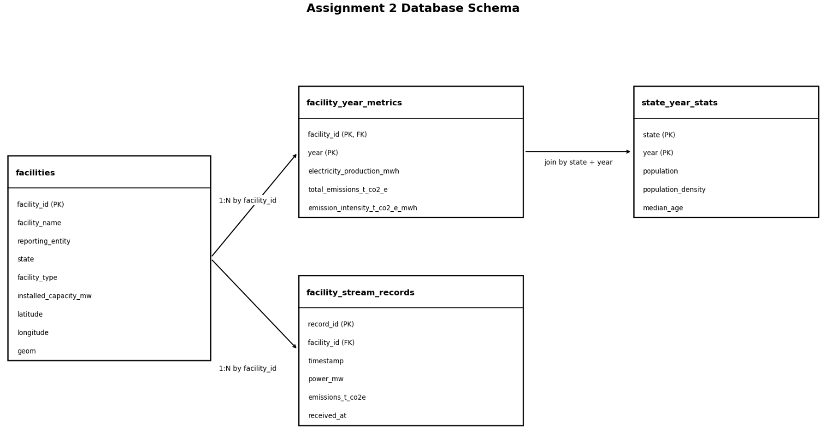
Appendix Figure 1. DuckDB database schema generated by 03_data_storage_final.ipynb.
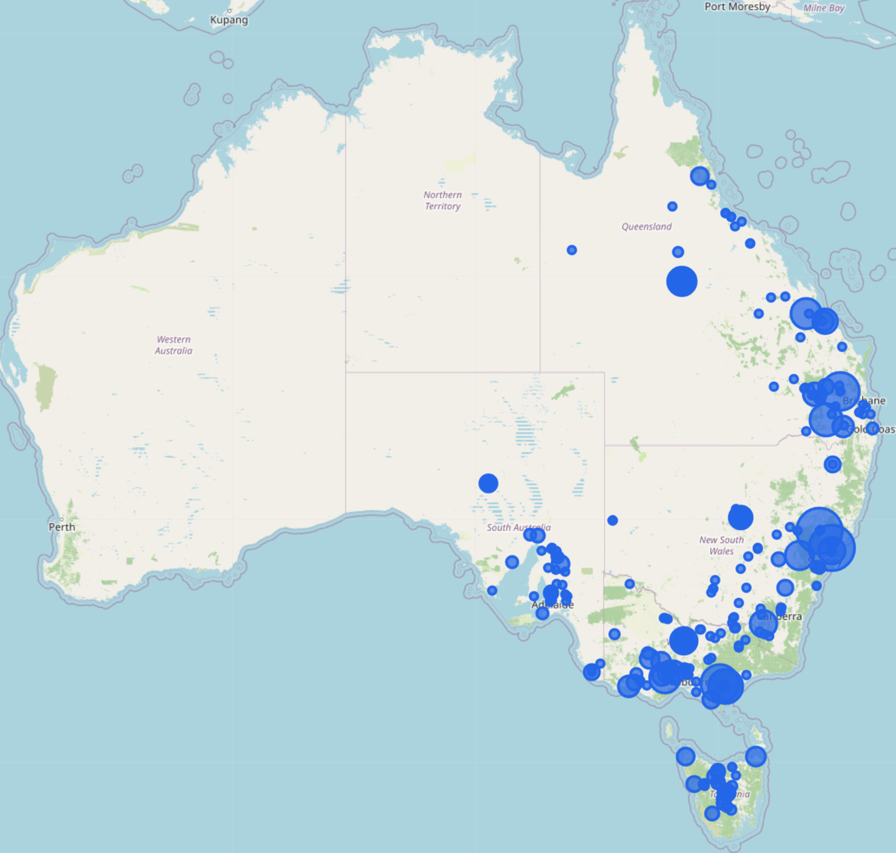
Appendix Figure 2. Map-based dashboard showing facility power markers across the NEM states.
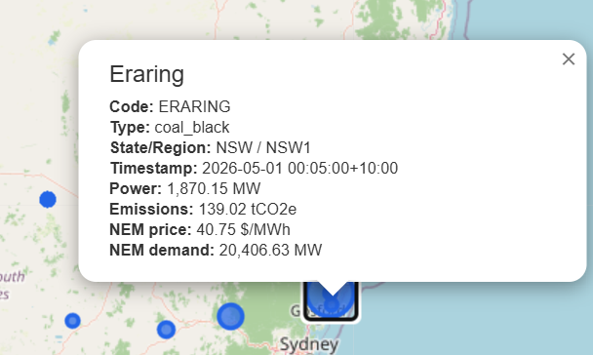
Appendix Figure 3. Example marker pop-up showing facility name, type, state, timestamp, power output, emissions, price, and demand.
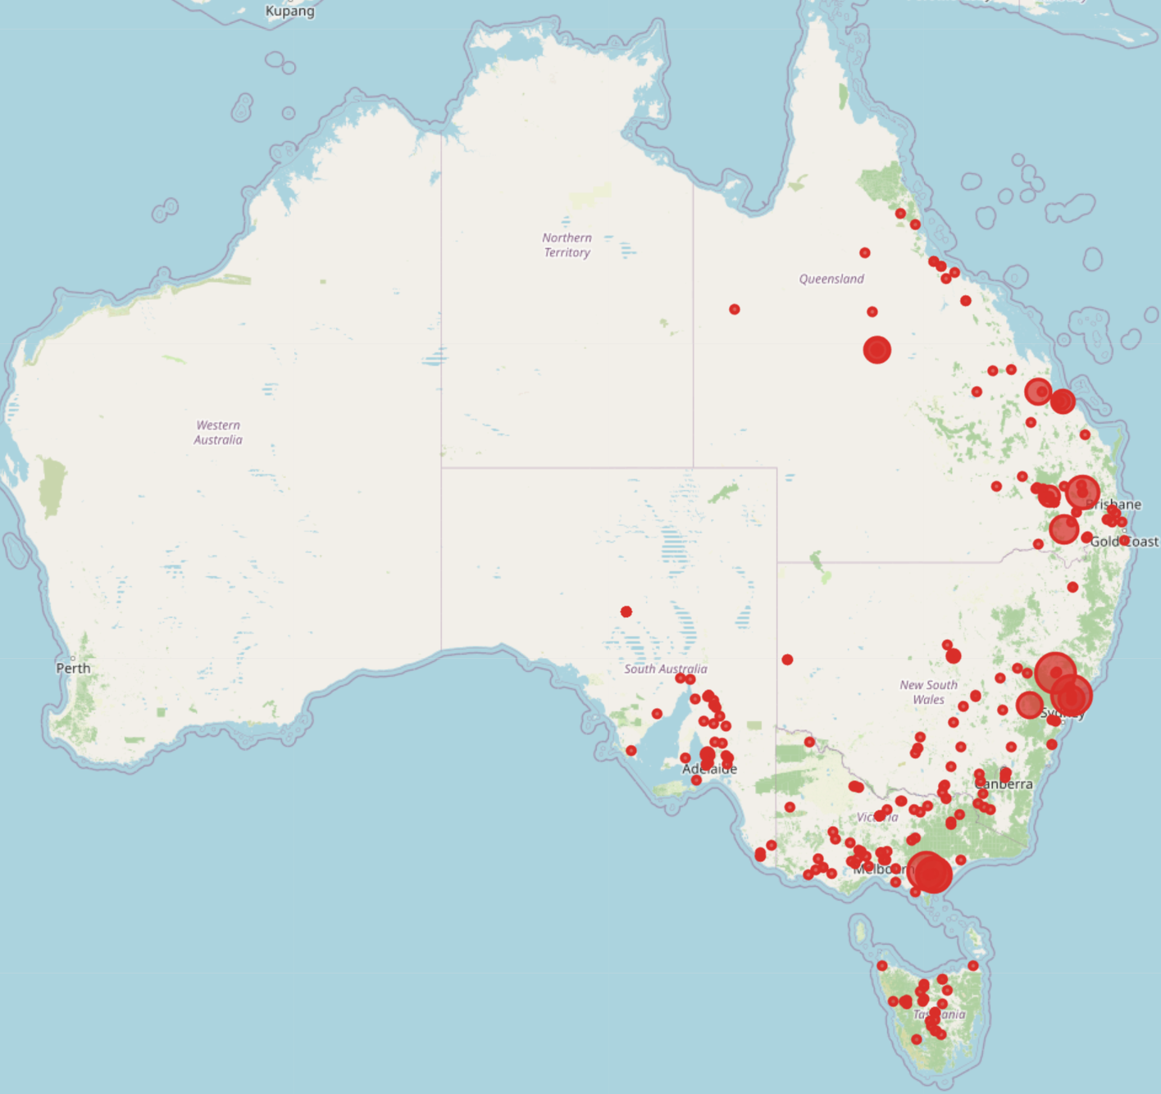
Appendix Figure 4. Map-based dashboard showing facility emission markers across the NEM states.

