|  |  |  |  |  |  |  |
| --- | --- | --- | --- | --- | --- | --- |
| max1 | max2 | deltapi | deltaQi **1** | deltaa | deltaQi **2** | deltaU |
|  |  | -3.7000  -2.0000  -1.6000  5.0000 |  |  |  |  |
| 5.0000e+00 |  | -0.0310  -1.1289  -0.0492  1.1568 |  | -0.0722  0.3083  -0.0698  0.3617 | -0.0362  2.8296  -1.0803 | -0.0092  0.0312  -0.1481 |
| 1.1568e+00 |  | -0.0231  0.0386  -0.0070  0.0222 |  | -0.0028  -0.0096  -0.0181  0.0063 | -0.0102  -0.0386  -0.1550 | -0.0027  -0.0024  -0.0299 |
| 3.8600e-02 |  | -0.0170  -0.0091  -0.0187  0.0227 |  | 0.0011  0.0128  0.0089  0.0128 | -0.0298  -0.0092  -0.0275 | -0.0013  -0.0005  -0.0059 |
| 2.2700e-02 |  | -0.0016  0.0049  0.0021  -0.0002 |  | -0.0009  -0.0013  -0.0054  -0.0009 | 0.0002  -0.0053  -0.0162 | -0.0003  -0.0003  -0.0033 |
| 4.9000e-03 |  | -0.0018  -0.0015  -0.0025  0.0026 |  | 0.0002  0.0016  0.0018  0.0015 | -0.0036  -0.0003  -0.0014 | -0.1247e-03  -0.0297e-03  -0.3334e-03 |
| 2.6000e-03 |  | 0.0014e-03  0.7920e-03  0.5613e-03  -0.3401e-03 |  | -0.1304e-03  -0.3415 e-03  -0.8736 e-03  -0.2982 e-03 | 0.0005  -0.0006  -0.0018 | -0.0170e-03  -0.0303e-03  -0.3646e-03 |
| 7.9202e-04 |  | -0.2175e-03  -0.2830e-03  -0.3829e-03  0.3655e-03 |  | 0.0410e-03  0.2338e-03  0.3219e-03  0.2239e-03 | -0.5027e-03  0.0320 e-03  0.0413e-03 | -0.1344e-04  -0.0007e-04  0.0193e-04 |
| 3.8294e-04 |  | 0.0259e-03  0.1322e-03  0.1154e-03  -0.0858e-03 |  | -0.0211e-03  -0.0702e-03  -0.1469e-03  -0.0637e-03 | 0.1179e-03  -0.0778e-03  -0.2336e-03 | -0.0052e-04  -0.0376e-04  -0.4561e-04 |
| 1.3220e-04 |  | -0.3015e-04  -0.5094e-04  -0.6139e-04  0.5569e-04 |  | 0.0760e-04  0.3744e-04  0.5754e-04  0.3544e-04 | -0.7658e-04  0.1325e-04  0.3292e-04 | -0.1611e-05  0.0439e-05  0.5665e-05 |
| 6.1394e-05 |  | 0.0681e-04  0.2252e-04  0.2167e-04  -0.1731e-04 |  | -0.0353e-04  -0.1320e-04  -0.2513e-04  -0.1214e-04 | 0.2378e-04  -0.1126e-04  -0.3299e-04 | 0.0127-05  -0.0520-05  -0.6351-05 |
| 2.2515e-05 |  | -0.0456e-04  -0.0902e-04  -0.1022e-04  0.0899e-04 |  | 0.0137e-04  0.0623e-04  0.1015e-04  0.0586e-04 | -0.1236e-04  0.0299e-04  0.0802e-04 | -0.0216e-05  0.0116e-05  0.1461e-05 |
| 1.0220e-05 |  | 0.1391e-05  0.3876e-05  0.3914e-05  -0.3224e-05 |  | -0.0601e-05  -0.2384e-05  -0.4336e-05  -0.2208e-05 | 0.4430e-05  -0.1758e-05  -0.5061e-05 | 0.0415e-06  -0.0786e-06  -0.9644e-06 |
| 3.9137e-06 | 8.5848e-07 |  | 0.0897e-06  -0.0066e-06  -0.8585e-06 |  |  |  |

deltapi：

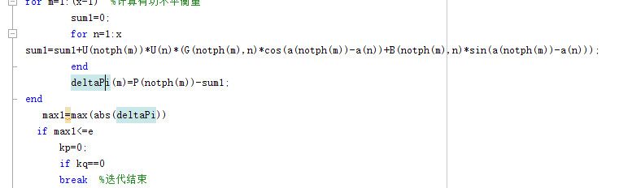

deltaQi **1:**

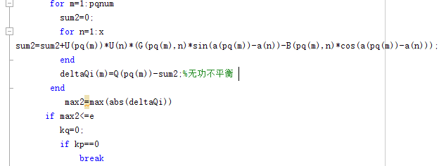

deltaQi **2**

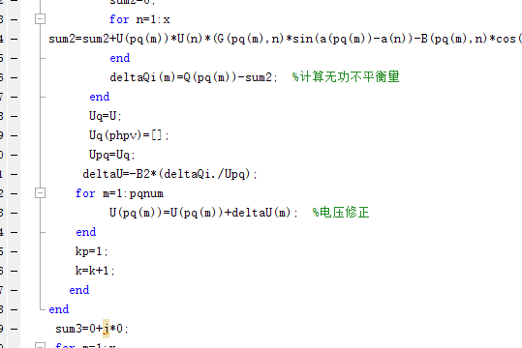

deltaa:

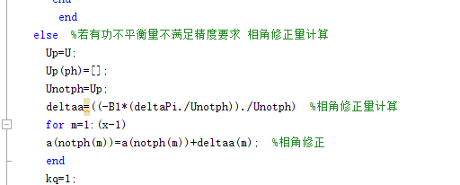

deltaU:

