学 号 21307185 姓 名 张礼贤
【实验题目】流水线CPU设计(3)
【实验目的】用FPGA芯片实现流水线CPU。
【实验工具】
BASYS3实验板，Vivado软件

【实验要求】
设计基于MIPS的流水线CPU，可以正确运行课本中的冒泡排序程序（未加任何nop指令）。

【实验要求】
1、（仿真）实现执行冒泡排序并仿真，仿真执行包含最后读取数据区数据的8条语句的WriteData的低8位和PC的低8位。
仿真图（要截图排序部分，并用红线标出）：
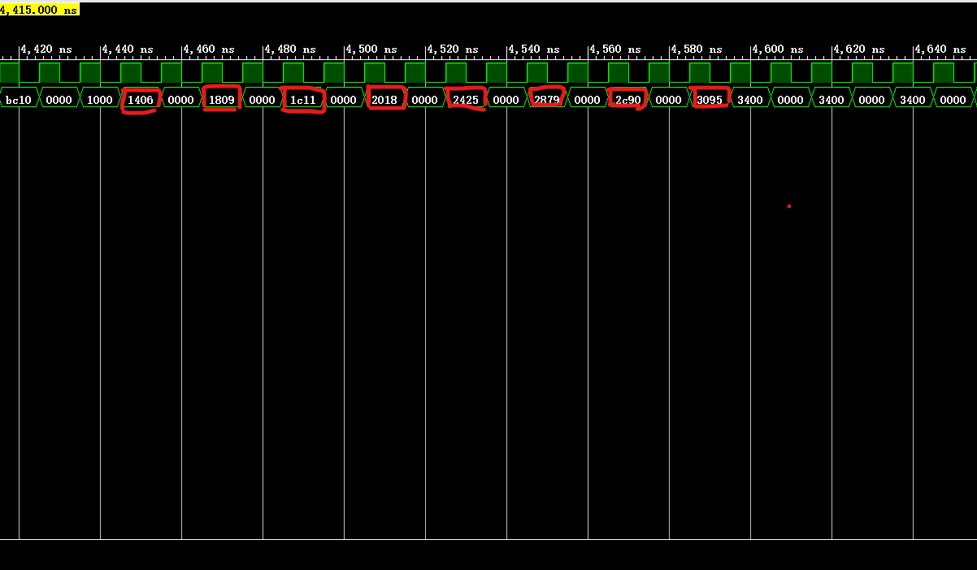
2、（写板）实现写板，每次按BtnL键在数码管上输出数据存储器中的内容，输出的第一个数字是序号，后三个数字是内容，循环输出。一开始没有排序，在按下按BtnC键后，才开始排序，然后按BtnL键可以看到排序结果。
完成后拍照8个数据排序前的结果，可以拼在一张图上(最好不要超过300KB)：
[1] [2] [3] [4]
[5] [6] [7] [8]
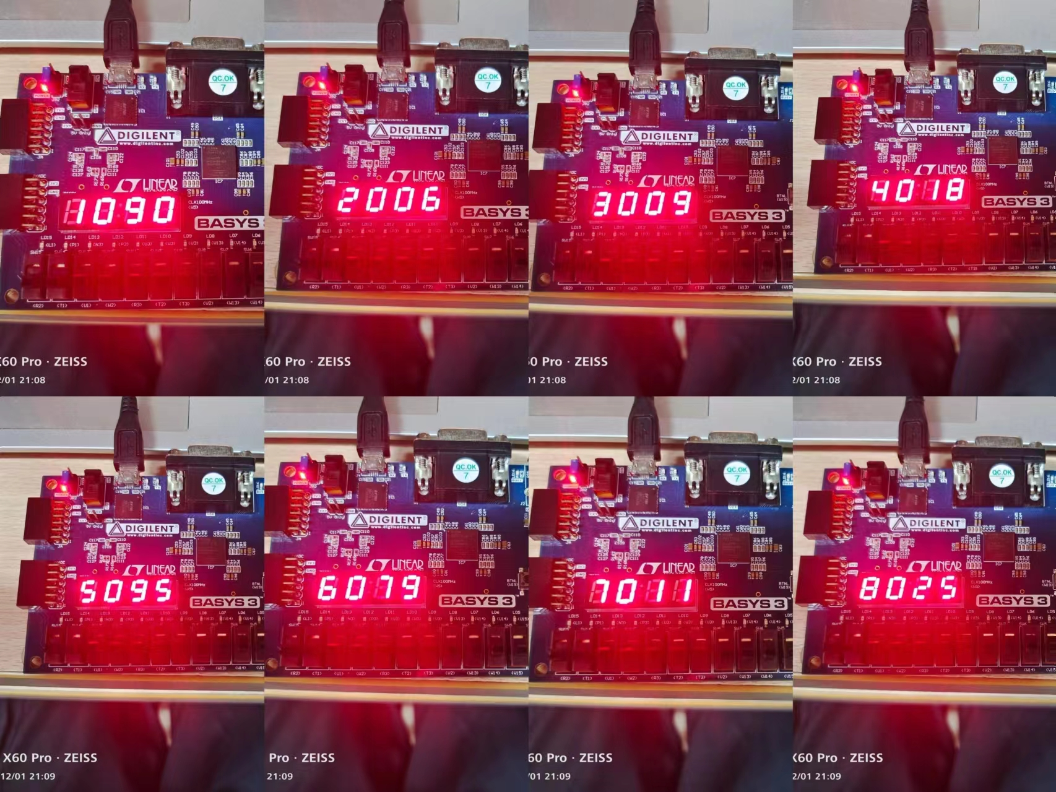
拍照8个数据排序后的结果，可以拼在一张图上(最好不要超过300KB)：
[1] [2] [3] [4]
[5] [6] [7] [8]
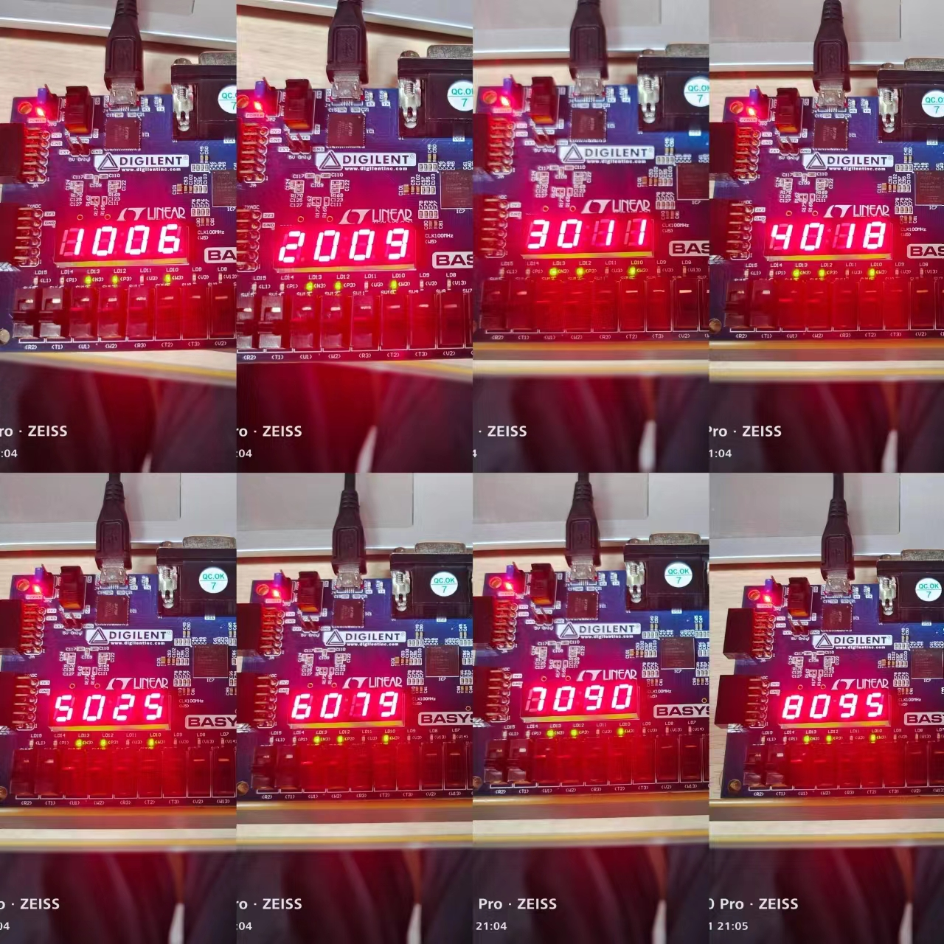
3、模块源码（名字可变，也可增减）：
如果是在 “流水线CPU设计(2)”的基础上修改的，只需要给出顶层模块(CPU)和列出增加的和修改过的模块。
module CPU(input clk,input enable,input BntL,output [15:0] q,output [7:0] y_l,output [3:0] select);
wire [31:0] expand;
wire [31:0] pc,pc_add;
wire [31:0] pcin;
wire [31:0] ins;
wire RegDst,ALUSrc,MemtoReg,RegWrite,MemRead,MemWrite,Branch,Jump,zero,BranchNot,Jalwrite,Jr;
wire [1:0] ALUOp;
wire sll;
wire [31:0] result,ALU_data1,ALU_data2,write_reg_back;
wire [4:0] write_register;
wire [31:0] reg_data1,reg_data2;
wire [31:0] memread;
wire [3:0] control;
wire And1,And2,Or;
wire [31:0] left;
wire [31:0] alu_result,Mux_4_result,Mux_5_result,MUX_6_result;
wire [31:0] jump_extend;
wire [31:0] num;
wire [7:0] y;

wire[31:0] pc_addm,pcm1,pcm2,pcm3,pcm4,insm;
wire mRegDst,mALUOp,mALUSrc;
wire [31:0] mreg_data1,mreg_data2,mexpand;
wire [4:0] mrs1,mrt1,mrd1,mr,exr,wbr;
wire [31:0] exresult,exreg_data2;
wire mMemRead,mMemWrite;
wire mMemtoReg,mRegWrite;
wire [31:0] wbmemread,wbresult,Jread;
wire [4:0] EX,EX1;
wire [1:0] M,WB,M1,M2,WB1,WB2,WB3;

wire [1:0] forwardA,forwardB,forwarda,forwardb;
wire [31:0] Mux_1_result,Mux_2_result,Mux3_result,Mux4_result;
wire stall,isJump,flush;

reg temp=0;
reg [2:0] i=0;
always @(posedge enable)begin
temp<=1;
end
always @(posedge BntL)begin
i=i+1;
end
smg s(clk,num,i,y,select);
assign y_l=y;

PC uPC(clk&temp,pcin,pc,stall);
Add add1(pc,4,pc_add);
InsMem uInsMem(pc,insm);
IDIF ifid(clk&temp,pc,pc_add,insm,pcm1,pc_addm,ins,stall,flush);

//pc_addm,ins

Control con(ins[31:26],ins[5:0],RegDst,ALUSrc,MemtoReg,RegWrite,MemRead,MemWrite,Branch,ALUOp,Jump,BranchNot,Jalwrite,Jr,sll);
assign isJump=Jump||Or||Jalwrite||Jr;
Hazard_Detection_Unit hdu(ins[25:21],ins[20:16],mr,M1[1],isJump,stall,flush);
assign EX={sll,RegDst,ALUOp,ALUSrc};
assign M={MemRead,MemWrite};
assign WB={RegWrite,MemtoReg};
Forward_Unit2 FU2(ins[25:21],ins[20:16],mr,exr,WB1,WB2,forwarda,forwardb);
Register r(ins[25:21],ins[20:16],write_register,write_reg_back,WB3[1],clk&temp,reg_data1,reg_data2,Jalwrite,Jread,pc_addm);//jal
Mux3 #(32) Mux3(reg_data1,memread,result,forwarda,Mux3_result);
Mux3 #(32) Mux4(reg_data2,memread,result,forwardb,Mux4_result);
assign expand ={{16{ins[15]}},ins[15:0]};
assign left=expand<<2;
Add add2(pc_addm,left,alu_result);
assign jump_extend={alu_result[31:28],ins[25:0],{2{1'b0}}};
assign And1=Branch & (Mux3_result==Mux4_result);//(Mux3_result==Mux4_result);
assign And2=BranchNot & (Mux3_result!=Mux4_result);
assign Or=And1 | And2;//beq and bne
MUX #(32) m4(MUX_6_result,alu_result,Or,pcin);
MUX #(32) m5(pc_add,jump_extend,Jump,Mux_5_result);
MUX #(32) m6(Mux_5_result,Jread,Jr,MUX_6_result);
IDEX idex(clk&temp,EX,M,WB,pcm1,Mux3_result,Mux4_result,expand,ins[25:21],ins[20:16],ins[15:11],
EX1,M1,WB1,pcm2,mreg_data1,mreg_data2,mexpand,mrs1,mrt1,mrd1,stall);

//mRegDst,mALUOp,mALUSrc,pcm2,mreg_data1,mreg_data2,mexpand,mrt1,mrd1
Forward_Unit FU(mrs1,mrt1,exr,write_register,WB2,WB3,forwardA,forwardB);
Mux3 #(32) Mux1(mreg_data1,write_reg_back,exresult,forwardA,Mux_1_result);
Mux3 #(32) Mux2(mreg_data2,write_reg_back,exresult,forwardB,Mux_2_result);
MUX #(32) m7(Mux_1_result,{{27{1'b0}},mexpand[10:6]},EX1[4],ALU_data1);
MUX #(32) m2(Mux_2_result,mexpand,EX1[0],ALU_data2);
MUX #(5) m1(mrt1,mrd1,EX1[3],mr);
ALU_Control c(EX1[2:1],mexpand[5:0],control);
ALU alu(ALU_data1,ALU_data2,control,zero,result);//jr的result
EXMEM exmem(clk&temp, M1,WB1,pcm2,result,Mux_2_result,mr,M2,WB2,pcm3,exresult,exreg_data2,exr);

//M2,WB2,pcm2,exresult,exreg_data2
DataMem d_m(clk&temp,M2[0],M2[1],exreg_data2,exresult,memread,BntL,i,num);//增加输入输出
MEMWB memwb(clk&temp,WB2,pcm3,memread,exresult,exr,WB3,pcm4,wbmemread,wbresult,write_register);
MUX #(32) m3(wbresult,wbmemread,WB3[0],write_reg_back);//

assign q[15:8]=pcm4[7:0];
assign q[7:0]=write_reg_back[7:0];
endmodule

[CPU_sim]
module CPU_sim();
reg clk=0;//enable=BntC
wire[15:0] q;
reg enable=1,BntL=0;
wire [7:0] y_l;
wire [3:0] select;
CPU uCPU(clk,enable,BntL,q,y_l,select);

initial
begin
enable=1;
BntL=0;
clk=0;
end
always #5 clk=~clk;
Endmodule

[smg]
module smg(clk,data,sequence,y_l,select);//y_l表示要显示的数,sequence表示序号
input clk;
input [2:0] sequence;
input [31:0] data;
output reg[3:0] select;
output reg[7:0] y_l;
reg[31:0] div_count=0;
reg [1:0]div_clk=0;
parameter
y0=8'b11000000,y1=8'b11111001,y2=8'b10100100,y3=8'b10110000,y4=8'b10011001,y5=8'b10010010,y6=8'b10000010,y7=8'b11111000,y8=8'b10000000,y9=8'b10010000;

always @(posedge clk)
begin
if(div_count==5000)begin
div_count=0;
div_clk=div_clk+1;
end
else div_count=div_count+1;
end
always @(*)
begin
if(div_clk==0)begin
select=4'b1110;
case(data[3:0])
4'b0000:y_l<=y0;
4'b0001:y_l<=y1;
4'b0010:y_l<=y2;
4'b0011:y_l<=y3;
4'b0100:y_l<=y4;
4'b0101:y_l<=y5;
4'b0110:y_l<=y6;
4'b0111:y_l<=y7;
4'b1000:y_l<=y8;
4'b1001:y_l<=y9;
default:y_l<=8'b11000000;
endcase
end
else if(div_clk==1)begin
select=4'b1101;
case(data[7:4])
4'b0000:y_l<=y0;
4'b0001:y_l<=y1;
4'b0010:y_l<=y2;
4'b0011:y_l<=y3;
4'b0100:y_l<=y4;
4'b0101:y_l<=y5;
4'b0110:y_l<=y6;
4'b0111:y_l<=y7;
4'b1000:y_l<=y8;
4'b1001:y_l<=y9;
default:y_l<=8'b11000000;
endcase
end
else if(div_clk==2)begin
select=4'b1011;
y_l<=8'b11000000;
end
else if(div_clk==3)begin
select=4'b0111;
case(sequence)
3'b000:y_l<=y1;
3'b001:y_l<=y2;
3'b010:y_l<=y3;
3'b011:y_l<=y4;
3'b100:y_l<=y5;
3'b101:y_l<=y6;
3'b110:y_l<=y7;
3'b111:y_l<=y8;
default:y_l<=8'b11000000;
endcase
end
end

Endmodule

[PC]
module PC(clk,pcin,pc,PCwrite);
input clk,PCwrite;
input [31:0]pcin;
output reg [31:0]pc;
reg start=0;
reg [31:0] temp;
initial begin
pc<=0;
end
always @(posedge clk)
begin
if(PCwrite==1'b1)pc<=pc;
else
begin
if(start==0)
begin
pc<=0;
start=1;
end
else begin
pc<=pcin;
end
end
end
Endmodule

[Add]
module Add(x,y,cout);
input [31:0]x;
input [31:0]y;
output [31:0]cout;
assign cout=x+y;
Endmodule

[InsMem]
module InsMem(pc, ins);
input wire[31:0] pc;
output reg[31:0] ins;
reg[31:0] mem[255:0];
initial begin
mem[0]=32'h241d00c8;
mem[1]=32'h24040000;
mem[2]=32'h24050008;
mem[3]=32'h0c00000e;
mem[4]=32'h24100000;
mem[5]=32'h8e110000;
mem[6]=32'h8e110004;
mem[7]=32'h8e110008;
mem[8]=32'h8e11000c;
mem[9]=32'h8e110010;
mem[10]=32'h8e110014;
mem[11]=32'h8e110018;
mem[12]=32'h8e11001c;
mem[13]=32'h0800000d;
mem[14]=32'h23bdffec;
mem[15]=32'hafbf0010;
mem[16]=32'hafb3000c;
mem[17]=32'hafb20008;
mem[18]=32'hafb10004;
mem[19]=32'hafb00000;
mem[20]=32'h00049021;
mem[21]=32'h00059821;
mem[22]=32'h00008021;
mem[23]=32'h0213402a;
mem[24]=32'h11000010;
mem[25]=32'h2211ffff;
mem[26]=32'h2a280000;
mem[27]=32'h1500000b;
mem[28]=32'h00114880;
mem[29]=32'h02495020;
mem[30]=32'h8d4b0000;
mem[31]=32'h8d4c0004;
mem[32]=32'h018b402a;
mem[33]=32'h11000005;
mem[34]=32'h00122021;
mem[35]=32'h00112821;
mem[36]=32'h0c000030;
mem[37]=32'h2231ffff;
mem[38]=32'h0800001a;
mem[39]=32'h22100001;
mem[40]=32'h08000017;
mem[41]=32'h8fbf0010;
mem[42]=32'h8fb00000;
mem[43]=32'h8fb10004;
mem[44]=32'h8fb20008;
mem[45]=32'h8fb3000c;
mem[46]=32'h23bd0014;
mem[47]=32'h03e00008;
mem[48]=32'h00054880;
mem[49]=32'h00894820;
mem[50]=32'h8d280000;
mem[51]=32'h8d2a0004;
mem[52]=32'had2a0000;
mem[53]=32'had280004;
mem[54]=32'h03e00008;
end
always@(pc)begin
ins = mem[pc>>2];
end
Endmodule

[IFID]
module IDIF(input clk,input[31:0] pcin,input[31:0] pc_add_in,input[31:0] insin,
output reg[31:0] pc,output reg [31:0] pc_add,output reg[31:0] ins ,input IFIDWrite,input reset);
initial
begin
{pc,pc_add,ins}<=0;
end
always@(posedge clk )
begin
if(reset){pc,pc_add,ins}<=0;
else begin
if(IFIDWrite==1'b1){pc,pc_add,ins}<={pc,pc_add,ins};
else{pc,pc_add,ins}<={pcin,pc_add_in,insin};
end
end
Endmodule

[Control]
module Control(special,funct,RegDst,ALUSrc,MemtoReg,RegWrite,MemRead,MemWrite,Branch,ALUOp,Jump,BranchNot,Jalwrite,Jr,sll);
input [5:0] special;
input [5:0] funct;
output RegDst,ALUSrc,MemtoReg,RegWrite,MemRead,MemWrite,Branch,Jump,BranchNot,Jalwrite,Jr,sll;
output[1:0] ALUOp;
function [13:0]select;
input [5:0]special;
input [5:0]funct;
case(special)
6'b000000:
case(funct)
6'b001000:select=14'b00000000000010;//jr
6'b000000:select=14'b10010001000001;//sll
default:select=14'b10010001000000;
endcase
6'b100011:select=14'b01111000000000;
6'b101011:select=14'b01000100000000;
6'b000100:select=14'b00000010100000;//beq
6'b000101:select=14'b00000000101000;//bne
6'b000010:select=14'b00000000010000;//jump
6'b001000:select=14'b01010000000000;//addi
6'b001001:select=14'b01010000000000;//addiu
6'b000011:select=14'b00010000010100;//jal
6'b001010:select=14'b01010001100000;//slti
default :select=14'b00000000000000;
endcase
endfunction
wire [13:0]temp;
assign temp=select(special,funct);
assign RegDst=temp[13];
assign ALUSrc=temp[12];
assign MemtoReg=temp[11];
assign RegWrite=temp[10];
assign MemRead=temp[9];
assign MemWrite=temp[8];
assign Branch=temp[7];
assign ALUOp=temp[6:5];
assign Jump=temp[4];
assign BranchNot=temp[3];
assign Jalwrite=temp[2];
assign Jr=temp[1];
assign sll=temp[0];
endmodule

[Hazard_Detection_Unit]
module Hazard_Detection_Unit(rs,rt,IDEXrt,ExRegWrite,J,stall,flush);
input [4:0] rs,rt,IDEXrt;
input ExRegWrite,J;
output reg stall;
output reg flush;
reg hold=0;
always @(*)
begin
if((ExRegWrite&&((rs==IDEXrt)||(rt==IDEXrt))))//load-use同时判断beq
begin
stall<=1'b1;
end
else stall<=0;
if(J==1)
begin
flush<=1;
end
else
begin
flush<=0;
end
end
Endmodule

[Forward_Unit2]
module Forward_Unit2(rs,rt,mrd,exrd,iewb,emwb,forwardA,forwardB);
input [4:0] rs,rt,mrd,exrd;
input [1:0] emwb,iewb;//memtoreg,regwrite
output reg[1:0] forwardA,forwardB;
always @(*)
begin
if(iewb[1] && mrd!=0 && mrd==rs)forwardA=2'b10;
else if(emwb[1]&&exrd!=0&&exrd==rs)forwardA=2'b01;
else forwardA=2'b00;

if(iewb[1] && mrd!=0 && mrd==rt)forwardB=2'b10;
else if(emwb[1]&&exrd!=0&&exrd==rt)forwardB=2'b01;
else forwardB=2'b00;
end
Endmodule

[Register]
module Register(read1,read2,write_r,write_data,regwrite,clk,data1,data2,Jalwrite,Jread,pc_addm);
input[4:0] read1,read2,write_r;
input[31:0] write_data,pc_addm;
input regwrite,Jalwrite;
input clk;
output [31:0]data1,data2;
output [31:0] Jread;
reg [31:0]ROM[31:0];integer i=0;
//reg [31:0] data1,data2;
initial
begin
for(i=0;i<32;i=i+1)
begin
ROM[i]=0;
end
end
always @(negedge clk)
begin
if(regwrite && write_r!=5'b0)begin
ROM[write_r]<=write_data;
end
if(Jalwrite)ROM[31]<=pc_addm;
end
assign data1=ROM[read1];
assign data2=ROM[read2];
assign Jread=ROM[31];
endmodule

[Mux3]
module Mux3 #(parameter width = 32)(A,B,C,state,Y);
input[width-1:0]A,B,C;
output reg[width-1:0]Y;
input [1:0]state;
always @(*)
begin
if(state==2'b00)Y<=A;
else if(state==2'b01)Y<=B;
else if(state==2'b10)Y<=C;
end
endmodule

[MUX]
module MUX #(parameter width = 32)(A,B,state,Y);
input[width-1:0]A,B;
output [width-1:0]Y;
input state;
assign Y=state?B:A;
Endmodule

[IDEX]
module IDEX(input clk,input [4:0]EX,input [1:0]M,input [1:0]WB,input [31:0]pc1,
input [31:0]read_data1,input [31:0]read_data2,input[31:0] extend,input [4:0] rs,input[4:0] rt,input [4:0]rd,
output reg [4:0]exEX,output reg[1:0]exM,output reg [1:0]exWB,output reg[31:0] expc1,
output reg [31:0]exread_data1,output reg [31:0]exread_data2,output reg[31:0] exextend,
output reg[4:0] exrs,output reg[4:0] exrt,output reg[4:0]exrd,input IDEXWrite);
initial
begin
{exEX,exM,exWB,expc1,exread_data1,exread_data2,exextend,exrs,exrt,exrd}<=0;
end
always@(posedge clk )
begin
if(IDEXWrite==1'b1)
{exEX,exM,exWB,exread_data1,exread_data2,exextend,exrs,exrt,exrd,expc1}<=0;
else {exEX,exM,exWB,expc1,exread_data1,exread_data2,exextend,exrs,exrt,exrd}<={EX,M,WB, pc1,
read_data1,read_data2,extend,rs,rt,rd};
end
endmodule

[Forward_Unit]
module Forward_Unit(IErs,IErt,EMrd,MWrd,emwb,mwwb,forwardA,forwardB);
input [4:0] IErs,IErt,EMrd,MWrd;
input [1:0] emwb,mwwb;//memtoreg,regwrite
output reg[1:0] forwardA,forwardB;
always @(*)
begin
if(emwb[1] && EMrd!=0 && EMrd==IErs)forwardA=2'b10;
else if(mwwb[1]&&MWrd!=0&&MWrd==IErs)forwardA=2'b01;
else forwardA=2'b00;

if(emwb[1]&&EMrd!=0&&EMrd==IErt)forwardB=2'b10;
else if(mwwb[1]&&MWrd!=0&&MWrd==IErt)forwardB=2'b01;
else forwardB=2'b00;
end
endmodule

[ALU_Control]
module ALU_Control(ALUOp,funct,control);
input[5:0]funct;
input[1:0]ALUOp;
output[3:0]control;
function [3:0] select;
input [1:0]ALUOp;
input [5:0]funct;
if(ALUOp<2'b10)
begin
case(ALUOp)
2'b00:select=4'b0010;
2'b01:select=4'b0110;
endcase
end
else if(ALUOp==2'b10)begin
case(funct)
6'b100000:select=4'b0010;//add
6'b100001:select=4'b0010;//addu
6'b000000:select=4'b0011;//sll
6'b100010:select=4'b0110;
6'b100100:select=4'b0000;
6'b100101:select=4'b0001;
6'b101010:select=4'b0111;
6'b001000:select=4'b0010;//jr
6'b101010:select=4'b0111;//slt
endcase
end
else select=4'b0111;
endfunction
assign control=select(ALUOp,funct);
endmodule

[ALU]
module ALU(x,y,control,zero,result);
input[31:0]x,y;
input[3:0] control;
output zero;
output reg [31:0] result;
reg [31:0] temp;
always@(*)begin
case(control)
4'b0000: result=x&y;
4'b0001: result=x|y;
4'b0010: result=x+y;
4'b0011: result=(y<<x);//逻辑左移
4'b0110: result=x-y;
4'b1100: result=~(x|y);
4'b0111: begin
temp=x-y;
if(temp[31]==1'b1)result=1;
else result=1'b0;
end//小于则置位
endcase
end
function eq;
input [31:0]x,y;
if(x-y==0)eq=1;
else eq=0;
endfunction
assign zero=eq(x,y);
endmodule

[EXEMEM]
module EXMEM(clk, M,WB, pc,aluResult,read_data2,select,exM,exWB,exmemPc,exmemAluResult,out_data2,exselect);
input clk;
input [1:0]M,WB;
input [31:0] pc,aluResult,read_data2;
input [4:0] select;
output reg [31:0] exmemPc,exmemAluResult,out_data2;
output reg [4:0] exselect;
output reg [1:0]exM,exWB;
initial
begin
{exM,exWB,exmemPc,exmemAluResult,out_data2,exselect}<=0;
end
always @(posedge clk ) begin
{exM,exWB,exmemPc,exmemAluResult,out_data2,exselect}
<= { M,WB,pc,aluResult,read_data2,select};
end
endmodule

[DataMem]
module DataMem(clk,WR,RE,data_in,address,read,BntL,j,num);
input WR;
input clk;
input RE;
input BntL;
input [2:0]j;
input [31:0] data_in;
input [31:0] address;
output [31:0] read;
output reg[31:0]num;
reg [31:0] RAM[255:0];
reg [31:0] read;
//reg [2:0] j=0;
integer i=9;
initial
begin
RAM[0]=32'h00000090;
RAM[1]=32'h00000006;
RAM[2]=32'h00000009;
RAM[3]=32'h00000018;
RAM[4]=32'h00000095;
RAM[5]=32'h00000079;
RAM[6]=32'h00000011;
RAM[7]=32'h00000025;
for(i=9;i<256;i=i+1)RAM[i]<=0;
end
always @(posedge clk)
begin
if(WR)
begin
RAM[address>>2] <= data_in;
end
end
always @(*)
begin
if(RE)
begin
read = RAM[address>>2];
end
end
always @(*) num=RAM[j];
endmodule

[MEMWB]
module MEMWB(input clk,input [1:0]WB,input [31:0]pc1,input [31:0]readdata,input [31:0]alu,input [4:0]select,
output reg [1:0] exWB, output reg[31:0] expc1,output reg[31:0] exreaddata,output reg[31:0]exalu,output reg[4:0] exselect);
initial begin
{exWB,expc1,exreaddata,exalu,exselect}<=0;
end
always @(posedge clk)
begin
{exWB,expc1,exreaddata,exalu,exselect}<={WB,pc1,readdata,alu,select};
end
endmodule

【完成情况】
是否完成以下步骤？(√完成 ×未做)
1 [] 2[]

【实验体会】
写出实验过程中遇到的问题，解决方法和自己的思考;并简述实验体会（如果有的话）。
在一开始运行排序的程序时，出现了一些错误，但是经过debug和仔细地思考，检查出了两个问题，一个是Jr在返回地址的时候出了问题，仍然停留在上一个调用函数的地址；另一个是CPU_sim中的clk的周期调的过于大，以至于延长时间都无法执行完程序。经过调整，以上两种问题的到顺利解决。

【交实验报告】
每位同学单独完成本实验内容并填写实验报告。
交作业地点：http://172.18.187.251/netdisk/default.aspx?vm=21org
FPGA实验/09、流水线CPU设计(3)
截止日期：2022年12月22日17:30（周四）
上传文件：学号_姓名_流水线CPU设计3.doc
学号_姓名_流水线CPU设计3.rar （包含源代码的工程）

