Gantt Chart Report
Generated on: 3/8/2026
Date Range: 1/1/2026 to 12/31/2026

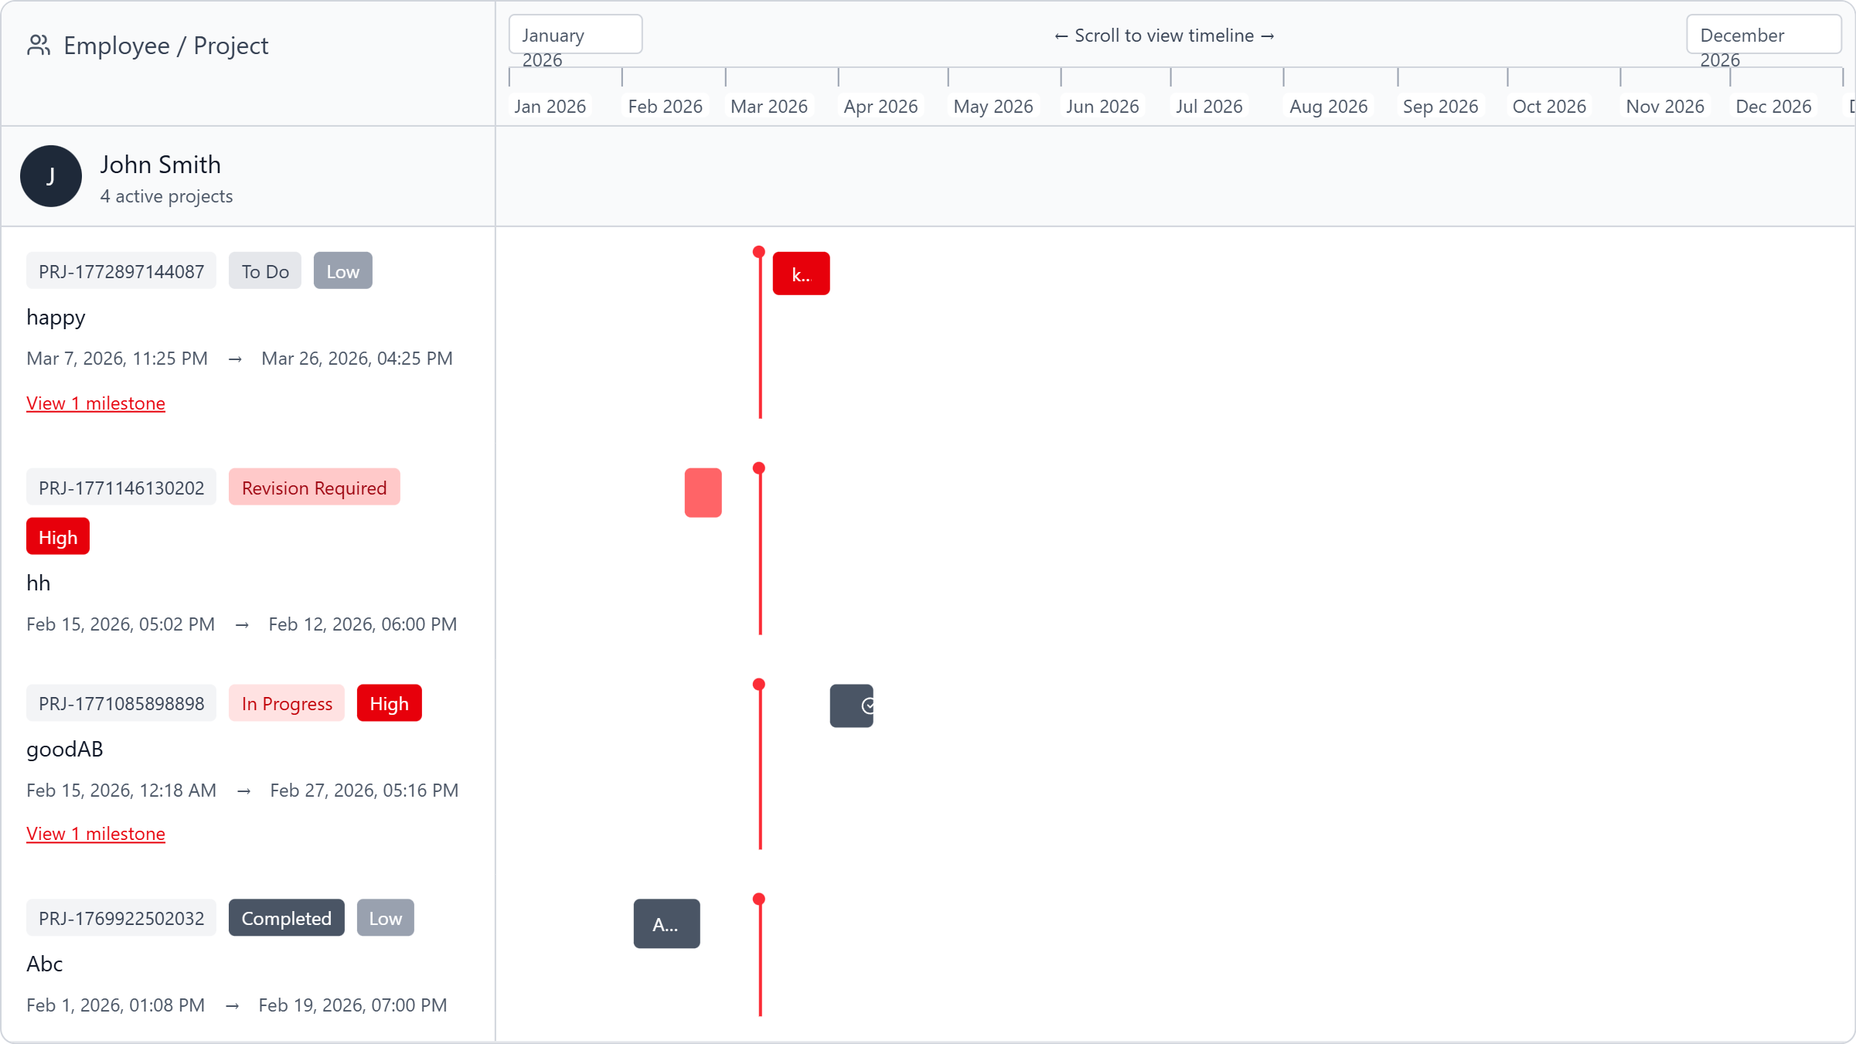

Project Details
Project ID | Title | Status | Priority | Start Date | Due Date
PRJ-1772897144087 | happy | To Do | Low | 2026-03-07T15:25:44.085Z | 2026-03-26T08:25:00.000Z
PRJ-1771146130202 | hh | Revision Required | High | 2026-02-15T09:02:10.199Z | 2026-02-12T10:00:00.000Z
PRJ-1771085898898 | goodAB | In Progress | High | 2026-02-14T16:18:18.899Z | 2026-02-27T09:16:00.000Z
PRJ-1769922502032 | Abc | Completed | Low | 2026-02-01T05:08:22.068Z | 2026-02-19T11:00:00.000Z

