**GameObj永远面对镜头效果**

Posted on 2013年04月06日 by U3d / [Unity3D脚本/插件](http://www.unitymanual.com/category/script)/被围观 240 次

GameObj永远面对镜头效果。

效果图：

[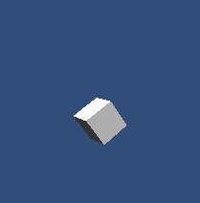](http://www.unitymanual.com/wp-content/uploads/2013/04/21.jpg)

GameObj永远面对镜头效果

绑定脚本到cube中。

[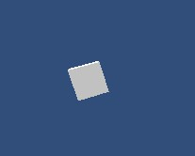](http://www.unitymanual.com/wp-content/uploads/2013/04/3.jpg)

GameObj永远面对镜头效果

[**Unity3D脚本**](http://www.unitymanual.com/category/script)如下：

using UnityEngine;  
using System.Collections;  
public class CameraFacingBillboard : MonoBehaviour  
{  
public Camera cameraToLookAt;  
void Start()  
{  
cameraToLookAt = Camera.main;  
}  
void Update()  
{  
Vector3 v = cameraToLookAt.transform.position - transform.position;  
v.x = v.z = 0.0f;  
transform.LookAt(cameraToLookAt.transform.position - v);  
}  
}