**Runtime切换摄像机**

Posted on 2013年04月22日 by U3d / [Unity3D 基础教程](http://www.unitymanual.com/category/manual/unity3d-%e5%9f%ba%e7%a1%80%e6%95%99%e7%a8%8b)/被围观 150 次

为了实现相机的切换，需要禁用一个、启用另一个。首先创建一个简单的场景：一个cube、3个相机。为了遍历这些摄像机，我们可以使用tag标记来实现。选取摄像机对象，放入一个列表中，然后使用for循环遍历，找到camera组件，然后禁用所有的。最后启用指定的摄像机。

第一创建一个函数接收整型数字为参数，来指定要激活某个摄像机。

|  |  |  |
| --- | --- | --- |
|  |  |  |

|  |  |
| --- | --- |
| 1 | function Update(){ |
| 2 | **if**(Input.GetKey("1")){ |
| 3 | Debug.Log("Using Camera One"); |
| 4 | camSwap(1); |
| 5 | } |
| 6 | } |
| 7 | function camSwap(currentCam : **int**){ |
| 8 |  |
| 9 | } |

[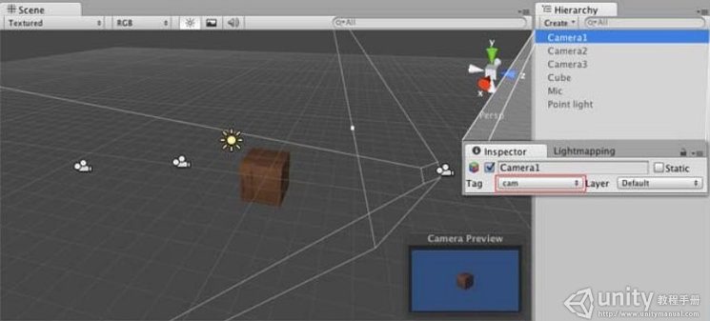](http://www.unitymanual.com/wp-content/uploads/2013/04/QQ截图20130422131320.png)

Unity3D教程：Runtime 切换摄像机

第二在camSwap函数内，创建一个for循环来查找所有含有cam标记的对象，cam标记被应用在场景中的所有三个摄像机上，使用GetComponent来禁用所有的摄像机。

|  |  |  |
| --- | --- | --- |
|  |  |  |

|  |  |
| --- | --- |
| 1 | function camSwap(currentCam : **int**){ |
| 2 | **var** cameras = GameObject.Fi ndGameObjectsWithTag("cam"); |
| 3 |  |
| 4 | **for** (**var** cams : GameObject **in** cameras){ |
| 5 | cams.GetComponent(Camera).enabled = **false**; |
| 6 | } |
| 7 | } |

第三.最后，选择到你想要摄像机，传入参数序号，并组成摄像机名称，然后使用Find和GetComponent函数找到它，然后启用Camera组件。

|  |  |  |
| --- | --- | --- |
|  |  |  |

|  |  |
| --- | --- |
| 1 | **var** oneToUse : **String** = "Camera"+currentCam; |
| 2 | gameObject.Find(oneToUse).GetC omponent(Camera).enabled = **true**; |

所有的摄像机都应该命名为：Camera1，Camera2，Camera3等等。

参考图片设置标记，脚本如下：

|  |  |  |
| --- | --- | --- |
|  |  |  |

|  |  |
| --- | --- |
| 01 | Javascript |
| 02 | function Update () { |
| 03 | **if**(Input.GetKey("1")){ |
| 04 | Debug.Log("Using Camera One"); |
| 05 | camSwap(1); |
| 06 | } |
| 07 | **if**(Input.GetKey("2")){ |
| 08 | Debug.Log("Using Camera Two"); |
| 09 | camSwap(2); |
| 10 | } |
| 11 | **if**(Input.GetKey("3")){ |
| 12 |  |
| 13 |  |
| 14 | Debug.Log("Using Camera Three"); |
| 15 | camSwap(3); |
| 16 | } |
| 17 | } |
| 18 |  |
| 19 | function camSwap(currentCam : **int**){ |
| 20 | **var** cameras = GameObject.Fi ndGameObjectsWithTag("cam"); |
| 21 |  |
| 22 | **for** (**var** cams : GameObject **in** cameras){ |
| 23 | cams.GetComponent(Camera).enabled = **false**; |
| 24 | } |
| 25 |  |
| 26 | **var** oneToUse : **String** = "Camera"+currentCam; |
| 27 |  |
| 28 |  |
| 29 | gameObject.Find(oneToUse).GetC omponent(Camera).enabled = **true**; |
| 30 | } |
| 31 | C# Equivalent |
| 32 | **using** UnityEngine; |
| 33 | **using** System.Collections; |
| 34 |  |
| 35 | **public** **class** camControl : MonoBehaviour { |
| 36 |  |
| 37 | **void** Update () { |
| 38 | **if**(Input.GetKey("1")){ |
| 39 | Debug.Log("Using Camera One"); |
| 40 | camSwap(1); |
| 41 |  |
| 42 |  |
| 43 | } |
| 44 | **if**(Input.GetKey("2")){ |
| 45 | Debug.Log("Using Camera Two"); |
| 46 | camSwap(2); |
| 47 | } |
| 48 | **if**(Input.GetKey("3")){ |
| 49 | Debug.Log("Using Camera Three"); |
| 50 | camSwap(3); |
| 51 | } |
| 52 | } |
| 53 |  |
| 54 | **void** camSwap(**int** currentCam){ |
| 55 | GameObject[] cameras = GameObj ect.FindGameObjectsWithTag("cam "); |
| 56 |  |
| 57 |  |
| 58 |  |
| 59 |  |
| 60 | **foreach** (GameObject cams **in** cameras){ |
| 61 | Camera theCam = cams.GetC omponent<Camera>() **as** Camera; |
| 62 | theCam.enabled = **false**; |
| 63 | } |
| 64 |  |
| 65 | **string** oneToUse = "Camera"+currentCam; |
| 66 | Camera usedCam = GameObject.F ind(oneToUse).GetComponent<Camer a>() **as** Camera; |
| 67 | usedCam.enabled = **true**; |
| 68 | } |
| 69 | } |