**Shader与Cube两张材质逐渐转换**

Posted on 2013年04月01日 by U3d / [Unity3D脚本/插件](http://www.unitymanual.com/category/script)/被围观 277 次

Shader与Cube两张材质逐渐转换，如下图：

[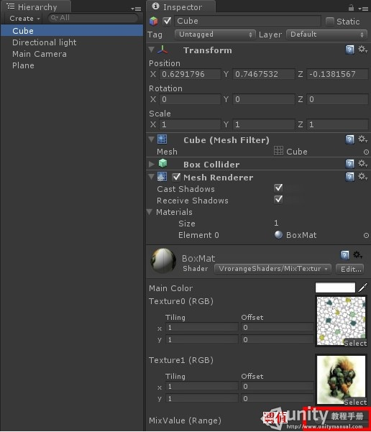](http://www.unitymanual.com/wp-content/uploads/2013/04/11.jpg)

Shader与Cube两张材质逐渐转换U

[**Unity3D**](http://www.unitymanual.com)脚本如下：

Shader "VrorangeShaders/MixTexture" {  
Properties {  
_Color ("Main Color", Color) = (1,1,1,1)  
_Texture0 ("Texture0 (RGB)", 2D) = "white" {}  
_Texture1 ("Texture1 (RGB)", 2D) = "white" {}  
_MixValue ("MixValue (Range)",Range(0,1)) = 0.5  
}  
SubShader {  
Cull Back  
ZWrite On  
ZTest LEqual  
Tags {"Queue"="Geometry+0" "IgnoreProjector"="False" "RenderType"="Opaque" }  
CGPROGRAM  
#pragma surface surf Lambert

float4 _Color;  
sampler2D _Texture0;  
sampler2D _Texture1;  
float _MixValue;

struct Input {  
float2 uv_Texture0;  
float2 uv_Texture1;  
};

void surf (Input IN, inout SurfaceOutput o){  
half4 c0=tex2D (_Texture0, IN.uv_Texture0);  
half4 c1=tex2D (_Texture1, IN.uv_Texture1);  
c0=c0*_MixValue;  
c1=c1*(1-_MixValue);  
o.Albedo=(c0+c1)*_Color;  
}

ENDCG  
}  
FallBack "Diffuse"  
}