**Unity3D中的Socket通信**

Posted on 2013年06月24日 by U3d / [Unity3D脚本/插件](http://www.unitymanual.com/category/script)/被围观 39 次

第一部分简单示例：连接服务器Ip 端口，发送请求，接收数据同理。

|  |  |  |
| --- | --- | --- |
|  |  |  |

|  |  |
| --- | --- |
| 01 | **public** **static** **void** SocketConnect(**string** serverIP, **int** serverPort) |
| 02 | { |
| 03 | clientSocket = new Socket(AddressFamily.InterNetwork, SocketType.Stream, ProtocolType.Tcp); |
| 04 | IPEndPoint ipe = new IPEndPoint(IPAddress.Parse(serverIP), serverPort); |
| 05 | **try** |
| 06 | { |
| 07 | clientSocket.Connect(ipe); |
| 08 | Debug.Log(" Connect Success IP: " + serverIP + " Port : " + serverPort.ToString()); |
| 09 | } |
| 10 | **catch** (Exception e) |
| 11 | { |
| 12 | Debug.LogError(e.ToString()); |
| 13 | } |
| 14 | } *//Unity3D教程手册：www.unitymanual.com* |
| 15 | *//发送数据* |
| 16 | **public** **static** **void** Send(**byte**[] bytes) |
| 17 | { |
| 18 | **if** (clientSocket == **null**) |
| 19 | **return**; |
| 20 | **if** (!clientSocket.Connected) |
| 21 | **return**; |
| 22 | **if** (clientSocket.Poll(0, SelectMode.SelectWrite)) |
| 23 | { |
| 24 | **try** |
| 25 | { |
| 26 | clientSocket.Send(bytes); |
| 27 | } |
| 28 | **catch** (Exception e) |
| 29 | { |
| 30 | Debug.LogError(e.ToString()); |
| 31 | } |
| 32 | } |
| 33 | } |

第二部分请求数据示例：

|  |  |  |
| --- | --- | --- |
|  |  |  |

|  |  |
| --- | --- |
| 01 | **public** **void** _MSG_ACCOUNT(**string** name, **string** pwd) |
| 02 | { |
| 03 | ACCOUNT account = new ACCOUNT(); |
| 04 | datas = new **byte**[account.length]; |
| 05 | **byte**[] bytesLength = BitConverter.GetBytes((System.Int16)account.length); |
| 06 | **int** length = 0; |
| 07 | bytesLength.CopyTo(datas, length); |
| 08 | length += 2; |
| 09 | **byte**[] bytesID = BitConverter.GetBytes((System.Int16)account.ID); |
| 10 | bytesID.CopyTo(datas, length); |
| 11 | length += 2; |
| 12 | **byte**[] bytesName = Encoding.**Default**.GetBytes(name); |
| 13 | bytesName.CopyTo(datas, length); |

第三部分接收数据示例：

|  |  |  |
| --- | --- | --- |
|  |  |  |

|  |  |
| --- | --- |
| 01 | **void** _MSG_CONNECT(**byte**[] datas) |
| 02 | { |
| 03 |  |
| 04 | connect = new CONNECT(); |
| 05 | **int** length = 4; |
| 06 | connect.idAccount = BitConverter.ToUInt32(datas, length); |
| 07 | Debug.LogError("账号ID " + connect.idAccount); |
| 08 | *//Unity3D教程手册：www.unitymanual.com* |
| 09 | length += System.Runtime.InteropServices.Marshal.SizeOf(connect.idAccount); |
| 10 | connect.dwData = BitConverter.ToUInt32(datas, length); |
| 11 | Debug.LogError("认证ID " + connect.dwData); |
| 12 |  |
| 13 | length += System.Runtime.InteropServices.Marshal.SizeOf(connect.dwData); |
| 14 | connect.nServerIndex = BitConverter.ToUInt32(datas, length); |
| 15 | Debug.LogError("游戏逻辑服务器索引 " + connect.nServerIndex); |

运行效果：

[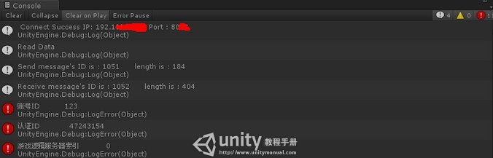](http://www.unitymanual.com/wp-content/uploads/2013/06/QQ截图20130624132358.jpg)

Unity3D中的Socket通信