**Unity3D中空引用错误的报错解答**

Posted on 2013年03月18日 by U3d / [Unity3D脚本/插件](http://www.unitymanual.com/category/script)/被围观 253 次

[**Unity3D**](http://www.unitymanual.com)中DaiMa1调用DaiMa2报错：NullReferenceException:Object referebce not set to an instance of an object DaiMa2.nihao ()(at Assets/maScript/DaiMa2.cs:14)

答：DaiMa2.cs14可以，报的是空引用错误。

[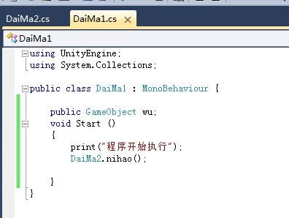](http://www.unitymanual.com/wp-content/uploads/2013/03/13.jpg)

Unity3D中DaiMa1调用DaiMa2报错解答

[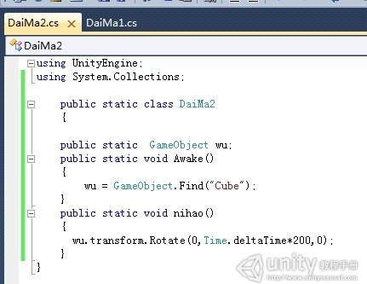](http://www.unitymanual.com/wp-content/uploads/2013/03/22.jpg)

Unity3D中DaiMa1调用DaiMa2报错解答

[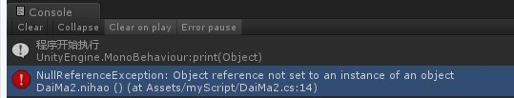](http://www.unitymanual.com/wp-content/uploads/2013/03/31.jpg)

Unity3D中DaiMa1调用DaiMa2报错解答