**Unity3D屏幕截图功能**

Posted on 2013年06月26日 by U3d / [Unity3D 基础教程](http://www.unitymanual.com/category/manual/unity3d-%e5%9f%ba%e7%a1%80%e6%95%99%e7%a8%8b)/被围观 48 次

|  |  |  |
| --- | --- | --- |
|  |  |  |

|  |  |
| --- | --- |
| 1 | function OnGUI(){ |
| 2 | **if**(GUI.Button(Rect(Screen.width*0.5-50,Screen.height*0.5-50,100,100),"screen")){ |
| 3 | Application.CaptureScreenshot("Screenshot.png"); |
| 4 | } |
| 5 | }<!--DVFMTSC--> |
| 6 |  |

这张Screenshot.png图片被存在了当前工程的子目录下了。在android上截取的图片存在Application.persistentDataPath上面，在pc上存在Application.dataPath。

|  |  |  |
| --- | --- | --- |
|  |  |  |

|  |  |
| --- | --- |
| 01 | **private** **var** www:WWW; |
| 02 | **private** **var** image:Texture; |
| 03 | **private** **var** path:**String**; |
| 04 | function Awake(){ |
| 05 | Application.CaptureScreenshot("Screenshot.png"); |
| 06 | } |
| 07 | function Start () { |
| 08 | **if**(Application.platform==RuntimePlatform.Android){ |
| 09 | path=Application.persistentDataPath; |
| 10 | }**else** **if**(Application.platform==RuntimePlatform.WindowsPlayer){ |
| 11 | path=Application.dataPath; |
| 12 | }**else** **if**(Application.platform==RuntimePlatform.WindowsEditor){ |
| 13 | path=Application.dataPath; |
| 14 | path=path.Replace("/Assets",**null**); |
| 15 | } |
| 16 | www=new WWW("file://"+path+"/Screenshot.png"); |
| 17 | **yield** www; |
| 18 | image=www.texture; |
| 19 | } |
| 20 | *//Unity3D教程手册：www.unitymanual.com* |
| 21 | function OnGUI(){ |
| 22 | GUI.Label(Rect(0,0,400,50),"1:"+Application.persistentDataPath); |
| 23 | GUI.Label(Rect(0,50,400,50),"2:"+Application.dataPath); |
| 24 | GUI.Label(Rect(0,100,400,50),"3:"+Application.temporaryCachePath); |
| 25 | GUI.Label(Rect(0,150,400,50),"4:"+Application.absoluteURL); |
| 26 | GUI.Label(Rect(0,200,400,50),"5:"+Application.streamingAssetsPath); |
| 27 | GUI.DrawTexture(Rect(0,250,300,200),image); |
| 28 | } |

在编辑器上各种路径：

[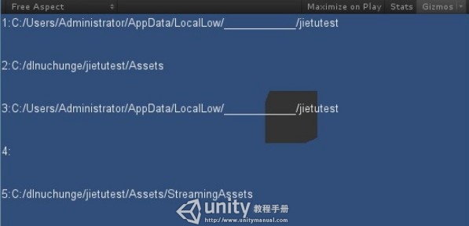](http://www.unitymanual.com/wp-content/uploads/2013/06/137.jpg)

Unity3D屏幕截图功能

在pc上各种路径：

[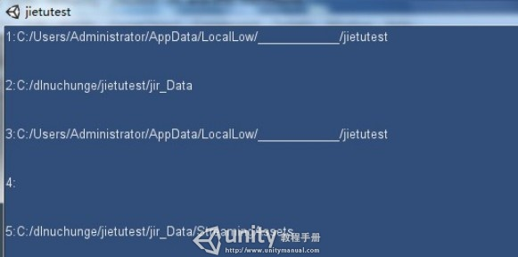](http://www.unitymanual.com/wp-content/uploads/2013/06/225.jpg)

Unity3D屏幕截图功能

在web上各种路径：

[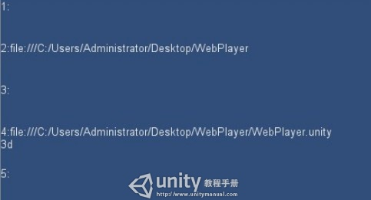](http://www.unitymanual.com/wp-content/uploads/2013/06/318.jpg)

Unity3D屏幕截图功能

在android上面各种路径：

[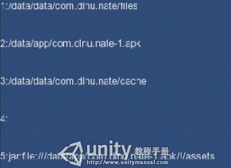](http://www.unitymanual.com/wp-content/uploads/2013/06/412.jpg)

Unity3D屏幕截图功能