**Unity3D教程：抓取物件脚本、变数、名称**

Posted on 2013年05月10日 by U3d / [Unity3D 基础教程](http://www.unitymanual.com/category/manual/unity3d-%e5%9f%ba%e7%a1%80%e6%95%99%e7%a8%8b)/被围观 21 次

游戏中相当常使用的功能GetComponent，经常用来Get(取得)物件上的Component(组件)资讯，若没有取得组件会回传null值。

|  |  |  |
| --- | --- | --- |
|  |  |  |

|  |  |
| --- | --- |
| 1 | gameObject.GetComponent(“ScriptName”); |

如果发现要抓取GetComponent上的值为大写可能就要注意一下原本的变数是否为小写如图1所示：

TextMesh是3D Text上原本就包含的Component，可以发现到他所有变数都为大写，但使用上并不是这样。

1.Unity会将开头的英文字元自动转换成大写。例如 text > Text。

2.而驼峰式的命名法TextMesh会变成Text Mesh会让人误认为中间有空白字元。

[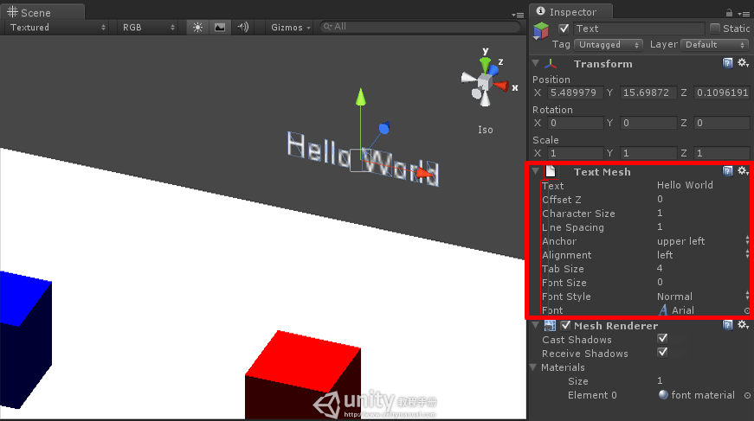](http://www.unitymanual.com/wp-content/uploads/2013/05/GetConponent1.png)

图1

[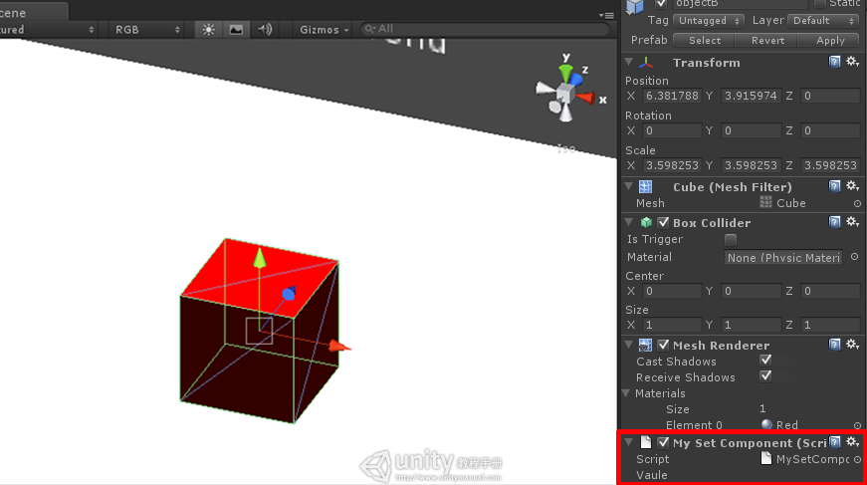](http://www.unitymanual.com/wp-content/uploads/2013/05/GetConponent2.png)

图2

|  |  |  |
| --- | --- | --- |
|  |  |  |

|  |  |  |  |  |
| --- | --- | --- | --- | --- |
| 01 | | | **var** vaule:**String**; | |
| 02 | | |  | |
| 03 | | | **var** scriptName; | |
| 04 | | |  | |
| 05 | | | **var** getVaule:**String**;Unity3D教程手册 | |
| 06 | | |  | |
| 07 | | | function Start(){ | |
| 08 | | |  | |
| 09 | | | vaule=“You See Me”; | |
| 10 | | |  | |
| 11 | | | } | |
| 12 | | |  | |
| 13 | | | function OnCollisionEnter(target : Collision){*//当进入碰撞* | |
| 14 | | |  | |
| 15 | | | Debug.Log(“OnCollisionEnter”); | |
| 16 | | |  | |
| 17 | | | *//取得target(撞到的目标)上的Script名称* | |
| 18 | | |  | |
| 19 | | | scriptName=target.gameObject.GetComponent(“MySetComponent”); | |
| 20 | | |  | |
| 21 | | | Debug.Log(“Script Name: ”+scriptName); | |
| 22 | | |  | |
| 23 | | | *//取得target(撞到的目标)上Script的值* | |
| 24 | | |  | |
| 25 | | | getVaule=target.gameObject.GetComponent(“MySetComponent”).vaule; | |
| 26 | | |  | |
| 27 | | | Debug.Log(“**Get** Vaule: ”+getVaule); | |
| 28 | | |  | |
| 29 | | | } | |
| 30 | | |  | |
| 31 | | | function Update(){ | |
| 32 | | |  | |
| 33 | | | **if**(transform.position.x<15) | |
| 34 | | |  | |
| 35 | | | transform.position+=Vector3.right*Time.deltaTime*5; | |
| 36 | | |  | |
| 37 | | | } | |
|  |  | |  |

|  |  |
| --- | --- |
| 01 | **var** vaule:**String**; |
| 02 |  |
| 03 | function Start(){ |
| 04 |  |
| 05 | vaule=“I Love EasyUnity !”; |
| 06 |  |
| 07 | } |
| 08 |  |
| 09 | function OnCollisionExit(target : Collision){ *//当离开碰撞* |
| 10 |  |
| 11 | Debug.Log(“OnCollisionExit”); |
| 12 |  |
| 13 | *//传送target(撞到的目标)上Script的值* |
| 14 |  |
| 15 | target.gameObject.GetComponent(“MyGetComponent”).vaule=“EasyUnity”; |
| 16 |  |
| 17 | Debug.Log(“Target Vaule: ”+target.gameObject.GetComponent(“MyGetComponent”).vaule); |
| 18 |  |
| 19 | } |

结果：

[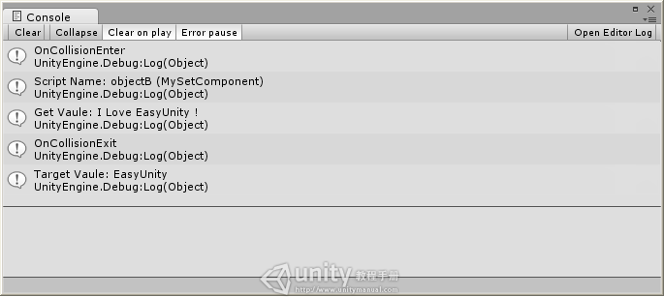](http://www.unitymanual.com/wp-content/uploads/2013/05/Result3.png)

结果

参考资料下载地址：http://vdisk.weibo.com/s/ASb4V