**Unity3D教程：连数据库方法**

Posted on 2013年07月01日 by U3d / [Unity3D 基础教程](http://www.unitymanual.com/category/manual/unity3d-%e5%9f%ba%e7%a1%80%e6%95%99%e7%a8%8b)/被围观 96 次

注：这里面的System.Data.dll 是Unity\Editor\Data\Mono\lib\mono\2.0\System.Data.dll;但是MySql.data.dll的版本我也不知道怎么来判断，我本来用的是1.0.6.15336这个版本的，但是一直报错“MySqlException: Character set 'gbk' is not supported”，报这个错误一般都是MySql.data.dll的版本太低了，后来我改成5.0的了，结果就ok了。

数据库创建如下：

|  |  |  |
| --- | --- | --- |
|  |  |  |

|  |  |
| --- | --- |
| 01 | **set** feedback off; |
| 02 | drop database db; |
| 03 | create database db; |
| 04 | USE DB; |
| 05 | drop table s; |
| 06 | create table s( |
| 07 | sno **Int**(10) not **null** primary key, |
| 08 | name varchar(10), |
| 09 | sex varchar(10) |
| 10 | ); |
| 11 | insert **into** s values('001','杨纯','男'); |
| 12 | insert **into** s values('002','yaya','女'); |
| 13 | insert **into** s values('003','dlnuchunge','男'); |
| 14 | **select** * **from** s; |

Unity3D里面的代码如下：

|  |  |  |
| --- | --- | --- |
|  |  |  |

|  |  |
| --- | --- |
| 001 | **using** UnityEngine; |
| 002 | **using** System; |
| 003 | **using** System.Collections; |
| 004 | **using** System.Data; |
| 005 | **using** MySql.Data.MySqlClient; |
| 006 | **public** **class** CMySql : MonoBehaviour { |
| 007 | *// Global variables* |
| 008 | **public** **static** MySqlConnection dbConnection;*//Just like MyConn.conn in StoryTools before* |
| 009 | **static** **string** host = "localhost"; |
| 010 | **static** **string** id = "root"; |
| 011 | **static** **string** pwd = "mysql"; |
| 012 | **static** **string** database = "db"; |
| 013 | **static** **string** result = ""; |
| 014 |  |
| 015 | **private** **string** strCommand = "Select sno from s ;"; |
| 016 | **public** **static** DataSet MyObj; |
| 017 | **void** OnGUI() |
| 018 | { |
| 019 | host = GUILayout.TextField( host, 200, GUILayout.Width(200)); |
| 020 | id = GUILayout.TextField( id, 200, GUILayout.Width(200)); |
| 021 | pwd = GUILayout.TextField( pwd, 200, GUILayout.Width(200)); |
| 022 | **if**(GUILayout.Button("Test")) |
| 023 | { |
| 024 | **string** connectionString = **string**.Format("Server = {0}; Database = {1}; User ID = {2}; Password = {3};",host,database,id,pwd); |
| 025 | openSqlConnection(connectionString); |
| 026 |  |
| 027 | MySqlCommand mySqlCommand = new MySqlCommand("Select * from s;", dbConnection); |
| 028 | MySqlDataReader reader = mySqlCommand.ExecuteReader(); |
| 029 | **try** |
| 030 | { *//Unity3D教程手册：www.unitymanual.com* |
| 031 | **while** (reader.Read()) |
| 032 | { |
| 033 | **if** (reader.HasRows) |
| 034 | { |
| 035 | print("编号:" + reader.GetInt32(0)+"|姓名："+reader.GetString(1)+"|性别："+reader.GetString(2)); |
| 036 | } |
| 037 | } |
| 038 | } |
| 039 | **catch** (Exception) |
| 040 | { |
| 041 | Console.WriteLine("查询失败了！"); |
| 042 | } |
| 043 | **finally** |
| 044 | { |
| 045 | reader.Close(); |
| 046 | } |
| 047 |  |
| 048 | MyObj = GetDataSet(strCommand); |
| 049 | } |
| 050 | GUILayout.Label(result); |
| 051 | } |
| 052 | *// On quit* |
| 053 | **public** **static** **void** OnApplicationQuit() { |
| 054 | closeSqlConnection(); |
| 055 | } |
| 056 |  |
| 057 | *// Connect to database* |
| 058 | **private** **static** **void** openSqlConnection(**string** connectionString) { |
| 059 | dbConnection = new MySqlConnection(connectionString); |
| 060 | dbConnection.Open(); |
| 061 | result = dbConnection.ServerVersion; |
| 062 | *//Debug.Log("Connected to database."+result);* |
| 063 | } |
| 064 |  |
| 065 | *// Disconnect from database* |
| 066 | **private** **static** **void** closeSqlConnection() { |
| 067 | dbConnection.Close(); |
| 068 | dbConnection = **null**; |
| 069 | *//Debug.Log("Disconnected from database."+result);* |
| 070 | } *//Unity3D教程手册：www.unitymanual.com* |
| 071 |  |
| 072 | *// MySQL Query* |
| 073 | **public** **static** **void** doQuery(**string** sqlQuery) { |
| 074 | IDbCommand dbCommand = dbConnection.CreateCommand(); |
| 075 | dbCommand.CommandText = sqlQuery; |
| 076 | IDataReader reader = dbCommand.ExecuteReader(); |
| 077 | reader.Close(); |
| 078 | reader = **null**; |
| 079 | dbCommand.Dispose(); |
| 080 | dbCommand = **null**; |
| 081 | } |
| 082 | #region Get DataSet |
| 083 | **public** DataSet GetDataSet(**string** sqlString) |
| 084 | { |
| 085 | *//string sql = UnicodeAndANSI.UnicodeAndANSI.UnicodeToUtf8(sqlString);* |
| 086 |  |
| 087 |  |
| 088 | DataSet ds = new DataSet(); |
| 089 | **try** |
| 090 | { |
| 091 | MySqlDataAdapter da = new MySqlDataAdapter(sqlString, dbConnection); |
| 092 | da.Fill(ds); |
| 093 |  |
| 094 | } |
| 095 | **catch** (Exception ee) |
| 096 | { |
| 097 |  |
| 098 | **throw** new Exception("SQL:" + sqlString + "**\n**" + ee.Message.ToString()); |
| 099 | } |
| 100 | **return** ds; |
| 101 |  |
| 102 | } |
| 103 | #endregion |
| 104 | } |

结果如下：

[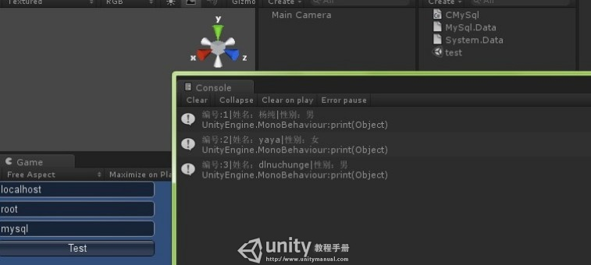](http://www.unitymanual.com/wp-content/uploads/2013/07/QQ截图20130701105440.jpg)

Unity3D教程：连数据库方法