**Unity3D的纹理贴图循环运动**

Posted on 2013年03月13日 by U3d / [Unity3D脚本/插件](http://www.unitymanual.com/category/script)/被围观 314 次

[**Unity3D**](http://www.unitymanual.com)的纹理贴图循环运动。

用法很简单，把以下脚本放在有贴图的gameobject上就可以了。贴图最好用psd格式的，jpg格式的不行。

[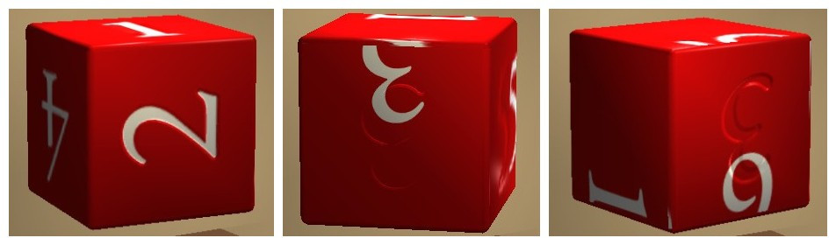](http://www.unitymanual.com/wp-content/uploads/2013/03/initpintu_副本.jpg)

Unity3D的纹理贴图循环运动

#pragma strict

// Scroll main texture based on time

var scrollSpeed = -0.5;

// This must be set to override a bug where Render Order

// of the tunnel objects is lost when SetTextureOffset is used

var queue = 0;

private var offset = 0.0;

function Update ()

{

offset = Time.time * scrollSpeed;

renderer.material.SetTextureOffset ("_MainTex", Vector2(offset,0));

renderer.material.renderQueue = queue;

}