**实现半透明效果**

Posted on 2013年04月18日 by U3d / [Unity3D脚本/插件](http://www.unitymanual.com/category/script)/被围观 249 次

绘制被遮挡部分 ZTest Off， ZTest Greater 绘制未被遮挡部分 ZTest On， ZTest LEqual 效果。

[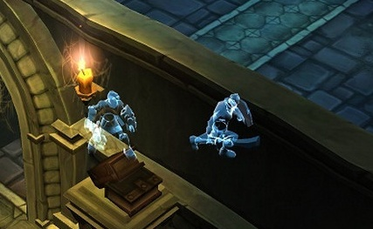](http://www.unitymanual.com/wp-content/uploads/2013/04/121.png)

实现半透明效果

|  |  |  |
| --- | --- | --- |
|  |  |  |

|  |  |
| --- | --- |
| 01 | **using** UnityEngine; |
| 02 |  |
| 03 | **using** System.Collections; |
| 04 |  |
| 05 |  |
| 06 |  |
| 07 | **public** **class** example : MonoBehaviour { |
| 08 |  |
| 09 | **void** Update() { |
| 10 |  |
| 11 | RaycastHit[] hits; |
| 12 |  |
| 13 | hits = Physics.RaycastAll(transform.position, transform.forward, 100.0F); |
| 14 |  |
| 15 | **int** i = 0; |
| 16 |  |
| 17 | **while** (i < hits.Length) { |
| 18 |  |
| 19 | RaycastHit hit = hits[i]; |
| 20 |  |
| 21 | Renderer renderer = hit.collider.renderer; |
| 22 |  |
| 23 | **if** (renderer) { |
| 24 |  |
| 25 | renderer.material.shader = Shader.Find("Transparent/Diffuse"); |
| 26 |  |
| 27 | renderer.material.color = new Color(renderer.material.color.r,renderer.material.color.g,renderer.material.color.b,0.3f); |
| 28 |  |
| 29 |  |
| 30 |  |
| 31 | } |
| 32 |  |
| 33 | i++; |
| 34 |  |
| 35 | } |
| 36 |  |
| 37 | } |
| 38 |  |
| 39 | } |
| 40 |  |