**播放器设置 Player Settings**

Date:2012-04-19 15:50

**Player Settings** is where you define various parameters (platform specific) for the final game that you will build in Unity. Some of these values for example are used in the **Resolution Dialog** that launches when you open a standalone game, others are used by XCode when building your game for the iOS devices, so it's important to fill them out correctly.

播放器设置是将在Unity中编译最终游戏时定义的各种参数（特定平台）的地方。当打开独立版游戏，启动时例如使用在分辨率对话框的这些值，当编译iOS设备游戏时，使用于Xcode的一些值，因此，正确地填写它们是十分重要的。

To see the Player Settings choose **Edit->Project Settings->Player** from the menu bar.

从菜单栏查看播放器设置，选择 **Edit->Project Settings->Player**

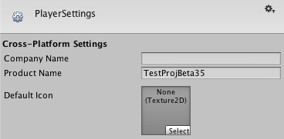  
*Global Settings that apply to any project you create.  
将应用于所有项目的全局设置*

* **Cross-Platform Properties**

跨平台特性

* **Company Name 公司名称**

The name of your company. This is used to locate the preferences file.  
您的公司名称， 这是用来设置参数文件。

* **Product Name 产品名称**

The name that will appear on the menu bar when your game is running and is used to locate the preferences file also.  
当游戏运行时，这个名字将出现在菜单栏。并且也被使用来设置参数文件。

* **Default Icon 默认图标**

Default icon the application will have on every platform (You can override this later for platform specific needs).  
将应用于每一个平台的默认图标（特定平台需要以后还可以覆盖这个）。

**Per-Platform Settings 各平台设置**

**Desktop**

**Web-Player Web播放器**

**Resolution And Presentation 分辨率和描述**

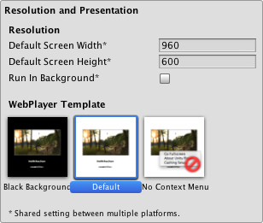

* **Resolution**

分辨率

* **Default Screen Width  
  默认屏幕宽度**

Screen Width the player will be generated with.  
播放器将生成的屏幕宽度。

* **Default Screen Height  
  默认屏幕高度**

Screen Height the player will be generated with.  
播放器将生成的屏幕高度。

* **Run in background  
  后台运行**

Check this if you dont want to stop executing your game if the player looses focus.  
如果不想在播放器失去焦点时停止运行游戏，请勾选此项。

* **WebPlayer Template  
  网络播放器模板**

For more information you should check the ["Using WebPlayer templates page"](http://game.ceeger.com/Components/Using_Web_Player_templates.html), note that for each built-in and custom template there will be an icon in this section.  
查看更多信息参阅["使用Web播放器模板页"](http://game.ceeger.com/Components/Using_Web_Player_templates.html)。注意，对于每一个内置和自定义模板将会对应一个图标在此处显示。

**Icon 图标**

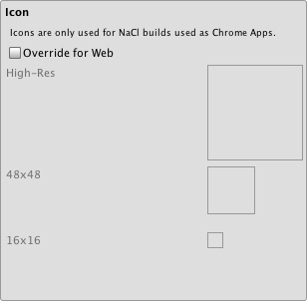

Icons don't have any meaning for most webplayer builds but they are needed for Native Client builds used as Chrome applications. You can set these icons here.

图标对于大多数Web播放器没有任何意义，但是在编译Chrome应用的本地客户端时需要使用，你可以在这里设置这些图标。

**Other Settings 其他设置**

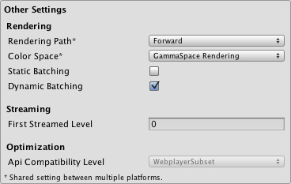

* **Rendering**

渲染

* **Rendering Path 渲染路径**

This property is shared between Standalone and WebPlayer content.  
此属性是在单机版和Web版两者共享的。

* **Vertex Lit 顶点光照**

Lowest lighting fidelity, no shadows support. Best used on old machines or limited mobile platforms.  
最低光照保真，不支持阴影，最好用于老机器或受限的手机平台。

* **Forward with Shaders   
  正向着色器**

Good support for lighting features; limited support for shadows.  
很好的支持光照特性，有限的支持阴影。

* **Deferred Lighting   
  延时光照**

Best support for lighting and shadowing features, but requires certain level of hardware support. Best used if you have many realtime lights. Unity Pro only.  
最好的支持光照和阴影特性，但需要一定程度的硬件支持。最好有许多实时光照时使用。Untiy专业版功能。

* **Color Space 色彩空间**

The color space to be used for rendering 用于渲染的色彩空间

* **GammaSpace Rendering  
  伽马空间渲染**

Rendering is gamma-corrected   
伽马校正渲染

* **Linear Rendering  
  线性渲染**

Rendering is done in linear space   
在线性空间渲染

* **Hardware Sampling**

硬件采样

* **Static Batching  
  静态批处理**

Set this to use Static batching on your build (Inactive by default in webplayers). Unity Pro only.  
编译时设置使用静态批处理（在Web播放器中默认无效）。 Unity 专业版功能 。

* **Dynamic Batching   
  动态批处理**

Set this to use Dynamic Batching on your build (Activated by default).  
编译时设置使用动态批处理（默认激活）。

* **Streaming**

流处理

* **First Streamed Level  
  首先流处理的关卡**

If you are publishing a Streamed Web Player, this is the index of the first level that will have access to all Resources.Load assets.  
如果你想发布流媒体网络播放器, 这是第一个关卡的索引，它将访问所有Resources.Load加载的资源。

**Standalone 单机**

**Resolution And Presentation 分辨率和描述**

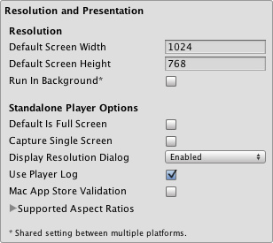

* **Resolution**

分辨率

* **Default Screen Width  
  默认屏幕宽度**

Screen Width the stand alone game will be using by default.  
单机游戏默认的屏幕宽度。

* **Default Screen Height  
  默认屏幕高度**

Screen Height the plater will be using by default.  
单机游戏默认的屏幕高度。

* **Run in background  
  后台运行**

Check this if you dont want to stop executing your game if it looses focus.  
如果你不想在游戏失去焦点时停止游戏，请勾选此项。

* **Standalone Player Options**

单机游戏播放器选项

* **Default is Full Screen  
  默认为全屏**

Check this if you want to start your game by default in full screen mode.  
如果你想开始游戏后默认全屏模式，勾选此项。

* **Capture Single Screen  
  捕获单屏**

If enabled, standalone games in fullscreen mode will not darken the secondary monitor in multi-monitor setups.  
如果开启，在全屏模式下单机游戏不会在多显示器设置的第二显示器变暗。

* **DisplayResolution Dialog**

显示分辨率对话框

* **Disabled 禁用**

No resolution dialog will appear when starting the game.  
在游戏开始时，不显示分辨率对话框。

* **Enabled 启用**

Resolution dialog will always appear when the game is launched.  
在游戏开始时，显示分辨率对话框。

* **Hidden by default 默认隐藏**

The resolution player is possible to be opened only if you have pressed the "alt" key when starting the game.  
在游戏开始时按“alt”键才能打开分辨率对话框。

* **Use Player Log 使用播放器日志**

Write a log file with debugging information.  
写入带有调试信息的日志。

* **Mac App Store Validation  
  Mac应用商店验证**

Enable receipt validation for the Mac App Store.  
开启Mac应用商店验证。

* **Supported Aspect Ratios  
  支持的长宽比**

Aspect Ratios selectable in the Resolution Dialog will be monitor-supported resolutions of enabled items from this list.  
可选长宽比，在分辨率对话框将提供显示器支持的分辨率。

**Icon 图标**

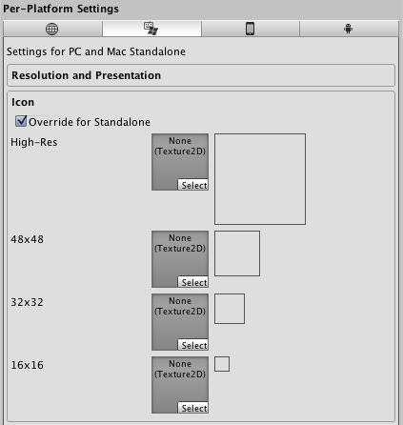

* **Override for Standalone  
  覆盖图标**

Check if you want to assign a custom icon you would like to be used for your standalone game. Different sizes of the icon should fill in the squares below.  
如果你想自定义单机游戏的图标，请勾选。对应不同大小的图标填入方框。

**Splash Image 开机画面**

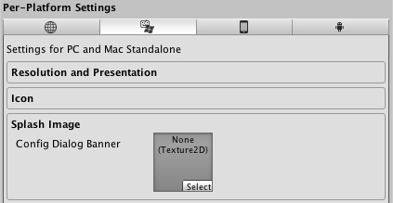

* **Config Dialog Banner  
  配置对话框横幅**

Add your custom splash image that will be displayed when the game is starting.  
添加自定义开机画面，将在游戏开始时显示。

**Other Settings 其他设置**

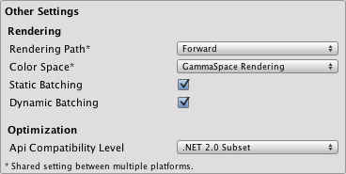

* **Rendering**

渲染

* **Rendering Path 渲染路径**

This property is shared between Standalone and WebPlayer content.  
此属性是在单机版和Web版两者共享的。

* **Vertex Lit 顶点光照**

Lowest lighting fidelity, no shadows support. Best used on old machines or limited mobile platforms.  
最低光照保真，不支持阴影，最好用于老机器或受限的手机平台。

* **Forward with Shaders  
  正向着色器**

Good support for lighting features; limited support for shadows.  
很好的支持光照特性，有限的支持阴影。

* **Deferred Lighting  
  延时光照**

Best support for lighting and shadowing features, but requires certain level of hardware support. Best used if you have many realtime lights. Unity Pro only.  
最好的支持光照和阴影特性，但需要一定程度的硬件支持。最好有许多实时光照时使用。Untiy专业版功能。

* **Color Space 色彩空间**

The color space to be used for rendering 用于渲染的色彩空间

* **GammaSpace Rendering  
  伽马空间渲染**

Rendering is gamma-corrected  
伽马校正渲染

* **Linear Rendering 线性渲染**

Rendering is done in linear space  
在线性空间渲染

* **Hardware Sampling**

硬件采样

* **Static Batching 静态批处理**

Set this to use Static batching on your build (Inactive by default in webplayers). Unity Pro only.  
编译时设置使用静态批处理（在Web播放器中默认无效）。 Unity 专业版功能 。

* **Dynamic Batching 动态批处理**

Set this to use Dynamic Batching on your build (Activated by default).  
编译时设置使用动态批处理（默认激活）。

* **API Compatibility Level**

API兼容性级别

* **.Net 2.0**

.Net 2.0 libraries. Maximum .net compatibility, biggest file sizes  
.Net 2.0 库。 最大.net 兼容性， 最大文件大小。

* **.Net 2.0 Subset  
  .Net 2.0 子集**

Subset of full .net compatibility, smaller file sizes  
完整的子集 .net 兼容性，较小的文件大小。

**iOS**

**Resolution And Presentation 分辨率和描述**

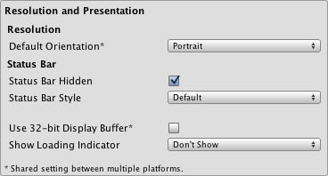

* **Resolution**

分辨率

* **Default Orientation 默认方向**

(This setting is shared between iOS and Android devices)  
（此项在IOS和Android设备共享)

* **Portrait 纵向**

The device is in portrait mode, with the device held upright and the home button at the bottom.  
设备为纵向模式，设备垂直手持并home键在底部。

* **Portrait Upside Down (iOS Only)  
  纵向倒置 （仅iOS）**

The device is in portrait mode but upside down, with the device held upright and the home button at the top.  
设备为纵向倒置模式，设备垂直手持并home键在顶部。

* **Landscape Right (iOS Only)  
  右横向 （仅iOS）**

The device is in landscape mode, with the device held upright and the home button on the **left** side.  
设备为横向模式，设备垂直手持并且home键在左边。

* **Landscape Left  
  左横向**

The device is in landscape mode, with the device held upright and the home button on the **right** side.  
设备为横向模式，设备垂直手持并且home键在右边。

* **Auto Rotation 自动旋转**

The screen orientation is automatically set based on the physical device orientation.  
基于设备物理设备方向，自动设置屏幕方向。

* **Auto Rotation settings**

自动旋转设置

* **Use Animated Autorotation  
  使用带动画的自动旋转**

When checked, orientation change is animated. This only applies when Default orientation is set to Auto Rotation.  
当勾选，改变方向将带有动画效果。这仅适用于默认方向设置为自动旋转时。

* **Allowed Orientations for Auto Rotation**

允许方向为自动旋转

* **Portrait 纵向**

When checked, portrait orientation is allowed. This only applies when Default orientation is set to Auto Rotation.  
当勾选，允许纵向，这仅适用于默认方向设置为自动旋转时。

* **Portrait Upside Down  
  纵向且上下颠倒**

When checked, portrait upside down orientation is allowed. This only applies when Default orientation is set to Auto Rotation.  
当勾选，允许纵向倒置，这仅适用于默认方向设置为自动旋转时。

* **Landscape Right  
  右横向**

When checked, landscape right (home button on the **left** side) orientation is allowed. This only applies when Default orientation is set to Auto Rotation.  
当勾选，右允许横向（home 键左边）这仅适用于默认方向设置为自动旋转时。

* **Landscape Left  
  左横向**

When checked, landscape left (home button is on the **right** side) orientation is allowed. This only applies when Default orientation is set to Auto Rotation.  
当勾选，允许左横向（home 键右边）这仅适用于默认方向设置为自动旋转时。

* **Status Bar**

状态栏

* **Status Bar Hidden 隐藏状态栏**

Specifies whether the status bar is initially hidden when the application launches.  
当应用启动时，指定状态条是否最初隐藏。

* **Status Bar Style 状态栏样式**

Specifies the style of the status bar as the application launches  
当应用启动时，指定状态条的样式。

* **Default**

默认

* **Black Translucent**

黑色半透明

* **Black Opaque**

黑色不透明

* **Use 32-bit Display Buffer  
  使用32位显示缓冲器**

Specifies if Display Buffer should be created to hold 32-bit color values (16-bit by default). Use it if you see banding, or need alpha in your ImageEffects, as they will create RTs in same format as Display Buffer.  
如果显示缓冲器被创建持有32位颜色值时指定（默认16位）。如果你看到条带或你的图像效果需要alpha时使用，将以相同的格式创建TRs作为显示缓冲器。在运行pre-Gingerbread操作系统的设备不支持（将强制为16位）。

* **Show Loading Indicator  
  显示加载条**

Options for the loading indicator   
加载条选项

* **Don't Show 不显示**

No indicator 无加载条

* **White Large 白色大**

Indicator shown large and in white 加载条较大，并且为白色

* **White 白色**

Indicator shown at normal size in white 加载条为正常大小，并且为白色

* **Gray 灰色**

Indicator shown at normal size in gray 加载条为正常大小，并且为灰色

**Icon 图标**

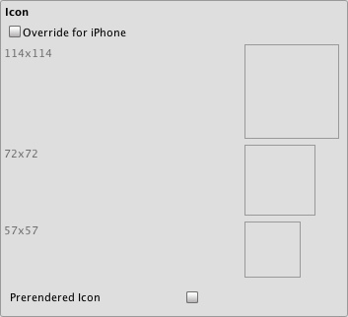

* **Override for iOS  
  覆盖图标**

Check if you want to assign a custom icon you would like to be used for your iPhone/iPad game. Different sizes of the icon should fill in the squares below.  
如果想为你的iPhone/iPad游戏只定义个图标，请选择。对应不同大小的图标填入方框中。

* **Prerendered icon 预渲染图标**

If unchecked iOS applies sheen and bevel effects to the application icon.  
如果不勾选，iOS应用光泽和斜角效果到应用程序的图标。

**Splash Image 开机画面**

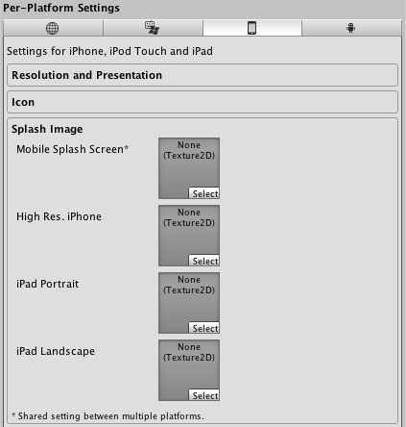

* **Mobile Splash Screen 手机开机画面  
  (Pro-only feature)（专业版功能）**

Specifies texture which should be used for iOS Splash Screen. Standard Splash Screen size is 320x480.(This is shared between Android and iOS)  
指定用于IOS开机画面纹理。 标准开机画面的尺寸为320x480。（此项与Android 和 iOS共享）

* **High Res. iPhone (Pro-only feature)  
  iphone高分辨率开机画面（专业版功能）**

Specifies texture which should be used for iOS 4th gen device Splash Screen. Splash Screen size is 640x960.  
指定用于IOS第四代设备的开机画面纹理。 开机画面的尺寸为640x960。

* **iPad Portrait (Pro-only feature)  
  iPad纵向（专业版功能）**

Specifies texture which should be used as iPad Portrait orientation Splash Screen. Standard Splash Screen size is 768x1024.  
指定用于iPad纵向的开机画面纹理。 标准开机画面的尺寸为768x1024。

* **iPad Landscape (Pro-only feature)  
  iPad横向（专业版功能）**

Specifies texture which should be used as iPad Landscape orientation Splash Screen. Standard Splash Screen size is 1024x768.  
指定用于iPad横向的开机画面纹理。 标准开机画面的尺寸为1024x768。

**Other Settings 其它设置**

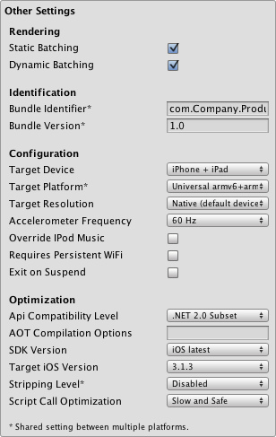

* **Rendering**

渲染

* **Static Batching 静态批处理**

Set this to use Static batching on your build (Activated by default). Pro-only feature.  
设置使用Static batching编译（默认激活的）。仅专业版功能

* **Dynamic Batching 动态批处理**

Set this to use Dynamic Batching on your build (Activated by default).  
设置使用Dynamic batching编译（默认激活的）。

* **Identification**

标识符

* **Bundle Identifier 包标识符**

The string used in your provisioning certificate from your Apple Developer Network account(This is shared between iOS and Android)  
从苹果开发者网络帐户在你的证书中使用的字符串。（此项与iOS 和 Android共享）

* **Bundle Version 包版本**

Specifies the build version number of the bundle, which identifies an iteration (released or unreleased) of the bundle. This is a monotonically increased string, comprised of one or more period-separated  
指定该包的版本号，包的迭代版本号（发布或未发布的）。这是单一性的增加字符串，由一个或多个句点分割。 （此项与iOS 和 Android共享）

* **Configuration**

配置

* **Target Device 目标设备**

Specifies application target device type. 指定应用程序目标设备类型。

* **iPhone Only**

Application is targeted for iPhone devices only.  
应用程序目标设备仅为iPhone。

* **iPad Only**

Application is targeted for iPad devices only.  
应用程序目标设备仅为iPad。

* **iPhone + iPad**

Application is targeted for both iPad and iPhone devices.  
应用程序目标为iPad and iPhone设备。

* **Target Platform 目标平台**

Specifies the target arquitecture you are going to build for.(This setting is shared between iOS and Android Platforms)  
指定你将要编译的目标架构（此项与Android 和 iOS平台共享)

* **armv6 (OpenGL ES1.1)**

Application is optimized for armv6 chipsets   
对于armv6芯片组优化的应用程序

* **Universal armv6+armv7  
  (OpenGL ES1.1+2.0)**

Application supports both armv6 and armv7 chipsets. *Note: increases application distribution size*  
应用程序支持armv6和armv7芯片组。 注意: 将会增加应用程序的大小

* **armv7**

Application is optimized for armv7 chipsets. 1st-2nd gen. devices are not supported. There might be additional requirements for this build target imposed by Apple App Store. Defaults to OpenGL ES 2.0.  
对于armv7芯片组优化的应用程序，不支持一代和二代设备。对于此编译目标苹果应用商店有可能额外强加要求，默认 OpenGL ES 2.0。

* **Target Resolution 目标分辨率**

Resolution you want to use on your deployed device.(This setting will not have any effect on devices with maximum resolution of 480x320)  
你要部署的设备上使用的分辨率。（此设置对设备的最大分辩率480x320不会有任何影响）

* **Native(Default Device Resolution)  
  本地(默认设备分辨率)**

Will use the device native resolution.   
将使用设备的本地分辨率。

* **Standard 标准（中低分辨率）  
  (Medium or Low Resolution)**

Use the lowest resolution possible (480x320).  
尽可能使用最低分辨率(480x320)。

* **HD 高清 （最高分辨率）  
  (Highest available resolution)**

Use the maximum resolution allowed on the device (960x640).  
使用设备允许最大的分辨率 (960x640)。

* **Accelerometer Frequency  
  加速计频率**

How often the accelerometer is sampled  
加速度计多长时间采样

* **Disabled 禁用**

Accelerometer is not sampled 加速计不采样

* **15Hz**

15 samples per second 每秒15次

* **30Hz**

30 samples per second 每秒30次

* **60Hz**

60 samples per second 每秒60次

* **100Hz**

100 samples per second 每秒100次

* **Override iPod Music  
  覆盖iPod音乐**

If selected application will silence user's iPod music. Otherwise user's iPod music will continue playing in the background.  
如果选择，应用程序将用户的iPod音乐静音。否则，用户的iPod音乐将会继续在后台播放。

* **UI Requires Persistent WiFi  
  用户界面需要持久WiFi链接**

Specifies whether the application requires a Wi-Fi connection. iOS maintains the active Wi-Fi connection open while the application is running.  
指定应用程序是否需要Wi-Fi连接，当应用程序运行，iOS提供可用Wi-Fi连接。

* **Exit on Suspend  
  退出后挂起**

Specifies whether the application should quit when suspended to background on iOS versions that support multitasking.  
指定应用程序是否应退出后在后台挂起，需IOS版本支持多任务。

* **Optimization**

优化

* **Api Compatibility Level   
  API兼容性级别**

Specifies active .NET API profile  
指定可用的 .NET API 设定档

* **.Net 2.0**

.Net 2.0 libraries. Maximum .net compatibility, biggest file sizes  
Net 2.0 库. 最大的.net 兼容性，最大文件大小

* **.Net 2.0 Subset   
  .Net 2.0子集**

Subset of full .net compatibility, smaller file sizes  
完整的子集 .net 兼容性，较小的文件大小

* **AOT compilation options  
  AOT编译器选项**

Additional AOT compiler options.  
额外的AOT编译器选项。

* **SDK Version  
  SDK版本**

Specifies iPhone OS SDK version to use for building in Xcode  
指定在Xcode中编译时所用的iPhone系统的SDK版本

* **iOS 4.0**

iOS SDK 4.0.

* **iOS Simulator 4.0**

iOS Simulator 4.0. Application built for this version of SDK will be able to run only on Simulator from the SDK 4.  
iOS 模拟器 4.0，对于这个SDK版本编译的应用程序，只能够从SDK4的模拟器上运行。

* **iOS 4.1**

iOS 4.1.

* **iOS Simulator 4.1**

iOS Simulator 4.1. Application built for this version of SDK will be able to run only on Simulator from the SDK 4.x.  
iOS 模拟器 4.1，对于这个SDK版本编译的应用程序，只能够从SDK 4.x的模拟器上运行。

* **iOS 4.2**

iOS 4.2.

* **iOS Simulator 4.2**

iOS Simulator 4.2. Application built for this version of SDK will be able to run only on Simulator from the SDK 4.x.  
iOS 模拟器 4.2，对于这个SDK版本编译的应用程序，只能够从SDK 4.x的模拟器上运行。

* **iOS 4.3**

iOS 4.3.

* **iOS Simulator 4.3**

iOS Simulator 4.3. Application built for this version of SDK will be able to run only on Simulator from the SDK 4.x.  
iOS 模拟器 4.3，对于这个SDK版本编译的应用程序，只能够从SDK 4.x的模拟器上运行。

* **iOS 5.0**

iOS 5.0

* **iOS Simulator 5.0**

iOS Simulator 5.0. Application built for this version of SDK will be able to run only on Simulator from the SDK 5.x.  
iOS 模拟器 5.0，对于这个SDK版本编译的应用程序，只能够从SDK 5.x的模拟器上运行。

* **iOS latest 最新的iOS**

Latest available iOS SDK. Available since iOS SDK 4.2. (default value)  
最新可用的iOS SDK， 自iOS SDK 4.2以后可用 （默认值）

* **iOS Simulator latest  
  最新的iOS模拟器**

Latest available iOS Simulator SDK. Available since iOS SDK 4.2.  
最新可用的iOS模拟器 SDK，自iOS SDK 4.2以后可用。

* **Unknown 未知**

iOS SDK version is not managed by Unity Editor.  
iOS SDK version 没有被Unity托管。

* **Target iOS Version  
  目标IOS版本**

Specifies lowest iOS version where final application will able to run  
指定最终应用程序将能运行的最低IOS版本。

* **3.0**

iPhone OS 3.0. (default value)

* **3.1**

iPhone OS 3.1.

* **3.1.2**

iPhone OS 3.1.2.

* **3.1.3**

iPhone OS 3.1.3.

* **3.2**

iPhone OS 3.2.

* **4.0**

iPhone OS 4.0.

* **4.1**

iPhone OS 4.1.

* **4.2**

iPhone OS 4.2.

* **4.3**

iPhone OS 4.3.

* **5.0**

iPhone OS 5.0

* **Unknown 未知**

iPhone OS SDK version is not managed by Unity Editor.  
iPhone系统的SDK版本，未被Unity编辑器托管。

* **Stripping Level (Pro-only feature)  
  剥离级别（专业版功能）**

Options to strip out scripting features to reduce built player size(This setting is shared between iOS and Android Platforms)  
可选剥离脚本功能，来减少构建播放器大小（此设置与iOS和Andriod平台共享）

* **Disabled 禁用**

No reduction is done. 不减少。

* **Strip Assemblies 剥离程序集**

Level 1 size reduction. 1级大小减少。

* **Strip ByteCode 剥离字符集**

Level 2 size reduction (includes reductions from Level 1).  
2级大小减少。（包含1级大小减少。）

* **Use micro mscorlib**

Level 3 size reduction (includes reductions from Levels 1 and 2).  
3级大小减少。（包含1级和2级大小减少。）

* **Script Call Optimization  
  脚本调用优化**

Optionally disable exception handling for a speed boost at runtime  
可选择禁用异常处理，用于运行时的速度提升。

* **Slow and Safe 缓慢而安全**

Full exception handling will occur with some performance impact on the device  
处理全部异常将发生一些对设备性能的影响。

* **Fast but no Exceptions  
  快但无异常处理**

No data provided for exceptions on the device, but the game will run faster  
对于设备异常不提供数据，但是游戏运行会更快。

**Note:** If you build for example for iPhone OS 3.2, and then select Simulator 3.2 in Xcode you will get a ton of errors. So you **MUST** be sure to select a proper Target SDK in Unity Editor.

**注意:** 例如，如果编译目标为iPhone OS 3.2，那么在Xcode选择3.2模拟器，将得到很多错误。所以你**必须** 确保在unity中选择一个恰当的目标 SDK。

**Android**

**Resolution And Presentation 分辨率和描述**

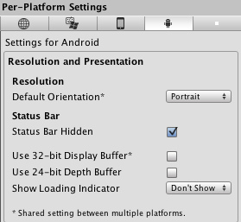  
*Resolution and presentation为你的Android编译项目.*

* **Resolution**

分辨率

* **Default Orientation 默认方向**

(This setting is shared between iOS and Android devices)   
（此设置在IOS和Android设备中共享）

* **Portrait 纵向**

The device is in portrait mode, with the device held upright and the home button at the bottom.  
设备为纵向模式，设备垂直手持并home键在底部。

* **Portrait Upside Down 纵向倒置**

The device is in portrait mode but upside down, with the device held upright and the home button at the top (only available with Android OS 2.3 and later).  
设备为纵向倒置模式，设备垂直手持并home键在顶部。 （仅Android OS 2.3和以后可用）

* **Landscape Right 右横向**

The device is in landscape mode, with the device held upright and the home button on the **left** side (only available with Android OS 2.3 and later).  
设备为横向模式，设备垂直手持并且home键在左边。（仅Android OS 2.3和以后可用）

* **Landscape Left 左横向**

The device is in landscape mode, with the device held upright and the home button on the **right** side.  
设备为横向模式，设备垂直手持并且home键在右边。

* **Use 32-bit Display Buffer  
  使用32位显示缓冲器**

Specifies if Display Buffer should be created to hold 32-bit color values (16-bit by default). Use it if you see banding, or need alpha in your ImageEffects, as they will create RTs in same format as Display Buffer. Not supported on devices running pre-Gingerbread OS (will be forced to 16-bit).  
如果显示缓冲器被创建持有32位颜色值时指定（默认16位）。如果你看到条带或你的图像效果需要alpha时使用，将以相同的格式创建TRs作为显示缓冲器。在运行pre-Gingerbread操作系统的设备不支持（将强制为16位）。

* **Use 24-bit Depth Buffer  
  使用24位深度缓冲器**

If set Depth Buffer will be created to hold (at least) 24-bit depth values. Use it only if you see 'z-fighting' or other artifacts, as it may have performance implications.  
如果深度缓冲器被创建持有24位深度值时设置。仅在你看到z-fighting或其他斑迹时使用，因为它可能影响性能。

**Icon 图标**

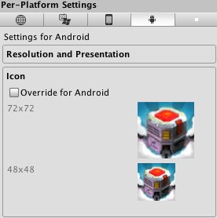  
*Different icons that your project will have when built 你的项目编译时的默认图标.*

* **Override for Android  
  覆盖图标**

Check if you want to assign a custom icon you would like to be used for your Android game. Different sizes of the icon should fill in the squares below.  
如果你想为你的Andriod游戏自定义一个图标，请勾选。对应不同尺寸的图片填入方框中。

**SplashImage 开机画面**

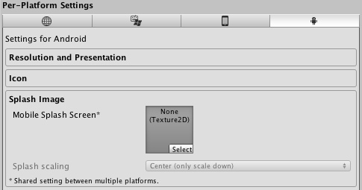  
*Splash image that is going to be displayed when your project is launched 你的项目运行时显示的开启画面.*

* **Mobile Splash Screen 手机开机画面  
  (Pro-only feature)**

Specifies texture which should be used by the iOS Splash Screen. Standard Splash Screen size is 320x480.(This is shared between Android and iOS)  
指定用于iOS开机画面的纹理，标准开机画面的尺寸为320x480。（该项与Android 和 iOS共享）

* **Splash Scaling 开机画面缩放**

Specifies how will be the splash image scaling on the device.  
指定开机画面将如何缩放。

**Other Settings 其他设置**

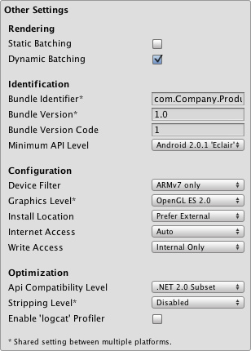

* **Rendering**

渲染

* **Static Batching 静态批处理**

Set this to use Static batching on your build (Activated by default). Pro-only feature.  
设置使用Static batching编译（默认激活的）。仅专业版功能

* **Dynamic Batching 动态批处理**

Set this to use Dynamic Batching on your build (Activated by default).  
设置使用Dynamic batching编译（默认激活的）。

* **Identification**

标识符

* **Bundle Identifier 包标识符**

The string used in your provisioning certificate from your Apple Developer Network account(This is shared between iOS and Android)  
从苹果开发者网络帐户在你的证书中使用的字符串。（这个与iOS 和 Android共享）

* **Bundle Version 包版本**

Specifies the build version number of the bundle, which identifies an iteration (released or unreleased) of the bundle. This is a monotonically increased string, comprised of one or more period-separated(This is shared between iOS and Android)  
指定该包的版本号，包的迭代版本号（发布或未发布的）。这是单一性的增加字符串，由一个或多个句点分割。 （这个与iOS 和 Android共享）

* **Bundle Version Code 包版本代码**

An internal version number. This number is used only to determine whether one version is more recent than another, with higher numbers indicating more recent versions. This is not the version number shown to users; that number is set by the versionName attribute. The value must be set as an integer, such as "100". You can define it however you want, as long as each successive version has a higher number. For example, it could be a build number. Or you could translate a version number in "x.y" format to an integer by encoding the "x" and "y" separately in the lower and upper 16 bits. Or you could simply increase the number by one each time a new version is released.  
内部版本号。这个数字仅用于确定一个版本比另外的版本是否最新，较高的数字表示是更新的版本。这不是显示给用户的版本号;此数字是由versionName属性设置。该值必须设置为一个整数，例如100。你可以自定义，只要每个后续版本有更大的数字。例如，它可以是内部版本号。或者你可以转换在"X.Y"格式的版本号为整数，通过编码的"X"和"Y"分别上下限为16位。或者在每次新版本发布时，简单的增加数值。

* **Configuration**

配置

* **Device Filter 设备筛选器**

Specifies the target architecture you are going to build for.  
指定你要建立的目标架构。

* **ARMv7 only**

Application optimized for ARMv7 CPU architecture. It will also enable correct Android Market device filtering, thus recommended for publishing to the Android Market (only devices supporting Unity Android will list the application on the Android Market).  
对于ARMv7 CPU 架构优化的应用程序。 这样将启用Android Market的设备过滤，因此，建议发布到Android Market（仅设备支持Unity Android 在Android Market列出的应用程序）。

* **ARMv6 with VFP**

Application optimized for ARMv6 CPU architecture (requires VFP support). Use runtime detection of hardware capabilities rather than relying on the Android Market filtering mechanism. It means the application when published to the Android Market will be visible also to devices not supporting Unity Android. Obviously this is not recommended, especially for paid applications (though can be combined with other means of filtering instead, like OpenGLES version).  
对于ARMv6 CPU 架构优化的应用程序（需要VFP支持）。 使用硬件功能的运行检测而不是依靠Android电子市场的过滤机制。这意味着发布到Android电子市场的也将可见，但不支持Unity Andriod设备，显然这是不推荐的，特别是对于支付应用（但可以结合其他手段过滤，像OpenGLES版本）。

* **x86**

Application compiled for the Intel x86 CPU architecture  
对于Intel x86 CPU架构编译的应用程序。

* **Graphics Level 图形级别**

Select either ES 1.1 ('fixed function') or ES 2.0 ('shader based') Open GL level. When using the AVD (emulator) only ES 1.x is supported.  
选择ES 1.1 ('fixed function') 或 ES 2.0 ('shader based') Open GL级别。当使用AVD（模拟器）仅支持ES 1.x。

* **Install Location  
  安装位置**

Specifies application install location on the device (for detailed information, please refer to <http://developer.android.com/guide/appendix/install-location.html>).  
指定设备上的应用程序的安装位置更多信息参考[这里](http://developer.android.com/guide/appendix/install-location.html)。

* **Automatic 自动**

Let OS decide. User will be able to move the app back and forth.  
让操作系统决定。用户将能够来回移动应用程序。

* **Prefer External 偏好外部**

Install app to external storage (SD-Card) if possible. OS does not guarantee that will be possible; if not, the app will be installed to internal memory.  
如果可能，应用程序安装到外部储存（SD卡）。操作系统不保证可能，如果不，应用程序将被安装到内部储存器。

* **Force Internal 强制内部**

Force app to be installed into internal memory. User will be unable to move the app to external storage.  
强制应用程序安装到内部存储器。 用户将不能移动应用程序到外部储存器。

* **Internet Access 因特网访问**

When set to Require, will enable networking permissions even if your scripts are not using this. Automatically enabled for development builds.  
如果设置所需，将启用网络权限，即使你的脚本没有使用这个。开发版自动启用。

* **Write Access 写入访问**

When set to External (SDCard), will enable write access to external storage such as the SD-Card. Automatically enabled for development builds.  
当设置为外部（SD卡）,将启用写入访问到外部储存器，如SD卡。开发版自动启用。

* **Optimization**

优化

* **Api Compatibility Level  
  Api 兼容级别**

Specifies active .NET API profile   
指定可用的.NE API 设定档

* **.Net 2.0**

.Net 2.0 libraries. Maximum .net compatibility, biggest file sizes  
.NET 2.0库， 最大.net兼容性，最大的文件大小。

* **.Net 2.0 Subset 子集**

Subset of full .net compatibility, smaller file sizes  
完整的子集 .net 兼容性，较小的文件大小

* **Stripping Level (Pro-only feature)  
  剥离级别（仅专业版功能）**

Options to strip out scripting features to reduce built player size(This setting is shared between iOS and Android Platforms)  
可选剥离脚本功能，来减少构建播放器大小（此设置与iOS和Andriod平台共享）

* **Disabled 禁用**

No reduction is done. 不减少

* **Strip Assemblies 剥离程序集**

Level 1 size reduction. 1级大小减少。

* **Strip ByteCode (iOS only)  
  剥离字节码（iOS）**

Level 2 size reduction (includes reductions from Level 1).  
2级大小减少。（包含1级大小减少。）

* **Use micro mscorlib**

Level 3 size reduction (includes reductions from Levels 1 and 2).  
3级大小减少。（包含1级和2级大小减少。）

* **Enable "logcat" profiler  
  启用logcat分析器**

Enable this if you want to get feedback from your device while testing your projects. So adb logcat prints logs from the device to the console (only available in development builds).  
如果你想从设备获得反馈同时测试项目，启用此项。因此从设备adb logcat打印日志到控制台（仅在开发版可用）。

**Publishing Settings 发布设置**

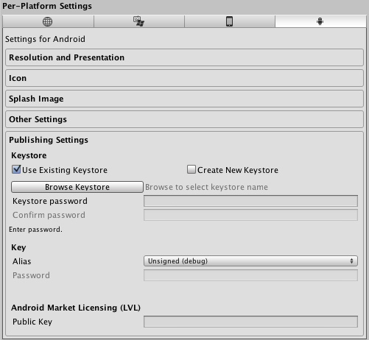  
*Publishing settings for Android Market*  
Andriod电子市场的发布设置

* **Keystore**

密钥库

* **Use Existing Keystore 使用现有密钥库  
  Create New Keystore 创建新密钥库**

Use this to choose whether to create a new Keystore or use an existing one.  
选择是否创建新的密钥库或是使用现有的。

* **Browse Keystore 浏览密钥**

Lets you select an existing Keystore. 选择已有的密钥库

* **Keystore password 密钥库密码**

Password for the Keystore. 密钥库密码

* **Confirm password 确认密码**

Password confirmation, only enabled if the Create New Keystore option is chosen.  
确认密码，仅当Create New Keystore选项被选择时启用

* **Key**

密钥

* **Alias 别名**

Key alias 密钥别名

* **Password 密码**

Password for key alias 密钥别名密码

* **Android Market Licensing (LVL)**

Android电子市场的授权

* **Public Key 公共密钥**

The public key provided by the [Android developer site](http://developer.android.com/guide/publishing/licensing.html" \l "account).  
[Android开发网站](http://developer.android.com/guide/publishing/licensing.html" \l "account)所提供的公共密钥。

Note that for security reasons, Unity will save neither the keystore password nor the key password. Also, note that the signing must be done from Unity's player settings - using jarsigner will not work.

注意：出于安全原因，Unity既不保存keystore密码也不保存key密码。此外也请注意，数字签名必须从PlayerSettings中来完成 - 使用Jarsigner将无法正常工作。

**Flash**

**Resolution And Presentation 分辨率和外观**

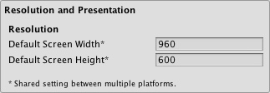

* **Resolution**

分辨率

* **Default Screen Width  
  默认屏幕宽度**

Screen Width the player will be generated with.  
播放器将生成的屏幕宽度

* **Default Screen Height  
  默认屏幕高度**

Screen Height the plater will be generated with.  
播放器将生成的屏幕高度

**Other Settings 其他设置**

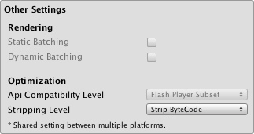

* **Optimization**

优化

* **Stripping 剥离**

Bytecode can optionally be stripped during the build.   
在编译期间可选字节码剥离。

**Details**

**Desktop**

The Player Settings window is where many technical preference defaults are set. See also [Quality Settings](http://game.ceeger.com/Components/class-QualitySettings.html) where the different graphics quality levels can be set up.

播放器设置窗口其中有许多技术性首选项默认设置。参见[质量设置](http://game.ceeger.com/Components/class-QualitySettings.html)那里可设置不同的图形质量等级。

**Publishing a web player 发布网络播放器**

**Default Web Screen Width** and **Default Web Screen Height** determine the size used in the html file. You can modify the size in the html file later.

默认Web屏幕宽度和默认Web屏幕高度定义在html文件的大小。你也可以后在html文件中来修改这个大小。

**Default Screen Width** and **Default Screen Height** are used by the Web Player when entering fullscreen mode through the context menu in the Web Player at runtime.

默认屏幕宽度和默认屏幕高度，当网络播放器运行是通过右键菜单进入全屏模式时使用。

**Customizing your Resolution Dialog 自定义分辨率对话框**

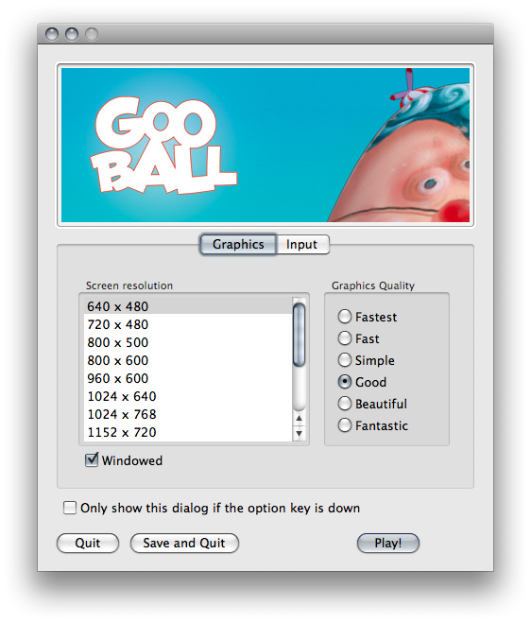  
*The Resolution Dialog, presented to end-users* 分辨率对话框，呈现给终端用户

You have the option of adding a custom banner image to the Screen Resolution Dialog in the Standalone Player. The maximum image size is 432 x 163 pixels. The image will not be scaled up to fit the screen selector. Instead it will be centered and cropped.

在独立版播放器有一个添加自定义横幅图像到分辨率对话框的选项。最大的图像尺寸是432 x 163像素。图像不能被缩放来适应容器。相反，它将会中心放置或裁剪。

**Publishing to Mac App Store 发布到苹果应用商店**

**Use Player Log** enables writing a log file with debugging information. This is useful to find out what happened if there are problems with your game. When publishing games for Apple's Mac App Store, it is recommended to turn this off, because Apple may reject your submission otherwise. See [this manual page](http://game.ceeger.com/Components/Log_Files.html) for further information about log files.

开启**Use Player Log**将写入一个带有调试信息的日志文件。如果游戏有问题，找出发生了什么事情，这是非常有用的。当发布游戏到苹果应用商店，建议关掉此选项，否则苹果公司可能会拒绝你的提交。参见[日志文件](http://game.ceeger.com/Components/Log_Files.html)页面来进一步了解日志文件。

**Use Mac App Store Validation** enables receipt validation for the Mac App Store. If this is enabled, your game will only run when it contains a valid receipt from the Mac App Store. Use this when submitting games to Apple for publishing on the App Store. This prevents people from running the game on any computer then the one it was purchased on. Note that this feature does not implement any strong copy protection. In particular, any potential crack against one Unity game would work against any other Unity content. For this reason, it is recommended that you implement your own receipt validation code on top of this using Unity's plugin feature. However, since Apple requires plugin validation to initially happen before showing the screen setup dialog, you should still enable this check, or Apple might reject your submission.

开启**Use Mac App Store Validation**接收苹果应用商店验证。如果启用，游戏仅在包含苹果应用商店的有效认证时运行。当提交游戏到苹果应用商店时使用此项。这可以防止从任何一台计算机上运行游戏然后购买人。请注意，此功能不执行任何强大的拷贝保护。尤其是，针对一个Unity游戏的任何可能的破解，可以运行针对任何Unity内容。出于这个原因，建议您使用Unity的插件功能来实现自己接收验证码。然而在显示屏幕设置对话框之前，由于苹果公司需要插件验证来初始发生。你还是应该启用此项检查，否则苹果可能会拒绝你的提交。

**iOS**

**Bundle Identifier 包标识符**

The **Bundle Identifier** string must match the provisioning profile of the game you are building. The basic structure of the identifier is **com.CompanyName.GameName**. This structure may vary internationally based on where you live, so always default to the string provided to you by Apple for your Developer Account. Your GameName is set up in your provisioning certificates, that are manageable from the Apple iPhone Developer Center website. Please refer to the [Apple iPhone Developer Center website](http://developer.apple.com/iphone/) for more information on how this is performed.

**Bundle Identifier**必须匹配构建游戏时的配置文件。标识符的基本结构是**com.CompanyName.GameName**。该结构不同的地方可能有所不同，所以总是默认字符串由苹果提供给您的开发者帐户。游戏名称在你的配置证书中设置，从苹果的iPhone开发人员中心网站的管理。请参考[苹果的iPhone开发人员中心网站](http://developer.apple.com/iphone/)了解更新信息。

**Stripping Level (Pro-only) 剥离级别（仅专业版）**

Most games don't use all necessary dlls. With this option, you can strip out unused parts to reduce the size of the built player on iOS devices. If your game is using classes that would normally be stripped out by the option you currently have selected, you'll be presented with a Debug message when you make a build.

大多数游戏并不使用dll的全部功能，有了这个选项，你可以去掉未使用的部分，以减少iOS设备上的内置播放器的大小。如果你的游戏使用通过当前选择的选项被剥离的类，当编译游戏时会看到一个调试信息。

**Script Call Optimization 脚本调用优化**

A good development practice on iOS is to never rely on exception handling (either internally or through the use of try/catch blocks). When using the default **Slow and Safe** option, any exceptions that occur on the device will be caught and a stack trace will be provided. When using the **Fast but no Exceptions** option, any exceptions that occur will crash the game, and no stack trace will be provided. However, the game will run faster since the processor is not diverting power to handle exceptions. When releasing your game to the world, it's best to publish with the **Fast but no Exceptions** option.

在iOS一个良好的开发习惯是从不依赖异常处理（无论是内部或通过使用try/catch块）。当使用默认的**Slow and Safe**选项，设备上发生的任何异常将被捕获，将提供一个堆栈跟踪。当使用**Fast but no Exceptions**选项，发生的任何异常将导致游戏崩溃，不提供堆栈跟踪信息；然而游戏将运行的更快，因为处理器不分配运算来处理异常。当正式发布游戏时，最好带有**Fast but no Exceptions**选项。

**Android**

**Bundle Identifier 包标识符**

The **Bundle Identifier** string is the unique name of your application when published to the Android Market and installed on the device. The basic structure of the identifier is **com.CompanyName.GameName**, and can be chosen arbitrarily. In Unity this field is shared with the iOS Player Settings for convenience.

当发布到Android Market和在设备上安装，包标识符字符串是应用程序唯一的名称。标识符的基本结构是**com.CompanyName.GameName**。在Unity为方便起见，该字段与iOS Player Settings共享。

**Stripping Level (Pro-only) 剥离级别（仅专业版）**

Most games don't use all the functionality of the provided dlls. With this option, you can strip out unused parts to reduce the size of the built player on Android devices.

大多数游戏不使用所提供dll的所有功能。使用此选项，你可以去掉未使用的部分，以减少在Android设备上播放器的大小。