**控制播放动画片段**

Posted on 2013年07月04日 by U3d / [Unity3D脚本/插件](http://www.unitymanual.com/category/script) /被围观 66 次

[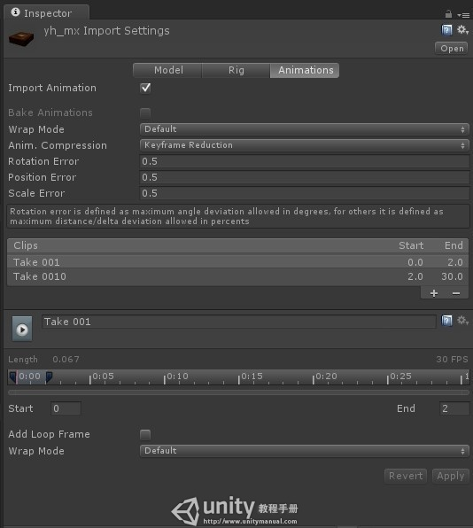](http://www.unitymanual.com/wp-content/uploads/2013/07/112.jpg)

控制播放动画片段

这里查看物体自带动画，并可以进行切割。

[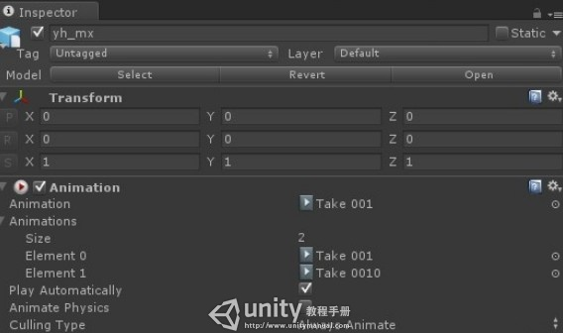](http://www.unitymanual.com/wp-content/uploads/2013/07/221.jpg)

控制播放动画片段

Animation组件就是控制播放动画。

|  |  |  |
| --- | --- | --- |
|  |  |  |

|  |  |
| --- | --- |
| 01 | **public** **const** **string** ANIM_NAME0 = "Take 001"; |
| 02 | **public** **const** **string** ANIN_NAME1 = "Take 0010"; |
| 03 | **private** GameObject obj = **null**; |
| 04 | **void** Start () { |
| 05 | *//Unity3D教程手册：www.unitymanual.com* |
| 06 | obj = GameObject.Find("yh_mx"); |
| 07 | obj.animation.wrapMode = WrapMode.**Default**; |
| 08 |  |
| 09 | } |
| 10 |  |
| 11 | *// Update is called once per frame* |
| 12 | **void** Update () { |
| 13 | **if**(Input.GetKeyDown(KeyCode.A)) |
| 14 | { |
| 15 | obj.animation.Play(ANIM_NAME0); |
| 16 |  |
| 17 | } |
| 18 | **if**(Input.GetKeyDown(KeyCode.B)) |
| 19 | { |
| 20 | obj.animation.Play(ANIN_NAME1); |
| 21 | } |