**获取网络时间、解析xml、截取string**

Posted on 2013年06月24日 by U3d / [Unity3D脚本/插件](http://www.unitymanual.com/category/script)/被围观 34 次

很多游戏具有每日登陆奖励功能，为防止玩家修改本地时间，需要读取服务器时间。下面分两部分介绍获取网络时间的两种方法，第一部分解析xml，第二部分截取string。

第一部分：通过国家授时中心链接获得的数据如下:

[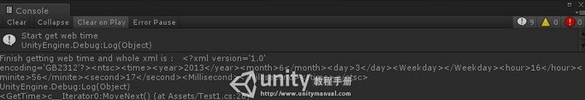](http://www.unitymanual.com/wp-content/uploads/2013/06/130.jpg)

获取网络时间、解析xml、截取string

|  |  |  |
| --- | --- | --- |
|  |  |  |

|  |  |
| --- | --- |
| 01 | <?xml version="1.0" encoding="GB2312" ?> |
| 02 | - <ntsc> |
| 03 | - <time> |
| 04 | <year>2011</year> |
| 05 | <month>7</month> |
| 06 | <day>10</day> |
| 07 | <Weekday ></Weekday> |
| 08 | <hour>19</hour> |
| 09 | <minite>45</minite> |
| 10 | <second>37</second> |
| 11 | <Millisecond ></Millisecond> |
| 12 | </time> |
| 13 | </ntsc>` |

然后解析xml获得当前时间,完整代码如下：

|  |  |  |
| --- | --- | --- |
|  |  |  |

|  |  |
| --- | --- |
| 01 | **using** UnityEngine; |
| 02 | **using** System.Collections; |
| 03 | **using** System.Xml; |
| 04 |  |
| 05 | */// <summary>* |
| 06 | */// Get web time and parse xml* |
| 07 | */// 获取网络时间/解析xml* |
| 08 | */// </summary>* |
| 09 | **public** **class** Test1 : MonoBehaviour |
| 10 | { |
| 11 | **public** **string** timeURL = "http://www.time.ac.cn/timeflash.asp?user=flash";*//授时中心地址* |
| 12 | *// Use this for initialization* |
| 13 | **void** Start() |
| 14 | { |
| 15 | StartCoroutine(GetTime()); |
| 16 | } |
| 17 |  |
| 18 | IEnumerator GetTime() |
| 19 | { |
| 20 | Debug.Log("Start get web time"); |
| 21 | WWW www = new WWW(timeURL); |
| 22 | **while** (!www.isDone) |
| 23 | { |
| 24 | Debug.Log("Getting web time"); |
| 25 | **yield** **return** www; |
| 26 | Debug.Log("Finish getting web time and whole xml is : " + www.text); |
| 27 | ParseXml(www); |
| 28 | } |
| 29 | } |
| 30 |  |
| 31 | **public** **void** ParseXml(WWW www) |
| 32 | { |
| 33 | XmlDocument xmlDoc = new XmlDocument(); |
| 34 | xmlDoc.LoadXml(www.text); |
| 35 | XmlElement root = xmlDoc.DocumentElement; |
| 36 | XmlNodeList nodeList = root.SelectNodes("/ntsc/time"); |
| 37 | **foreach** (XmlElement xe **in** nodeList) |
| 38 | { *//Unity3D教程手册：www.unitymanual.com* |
| 39 | **foreach** (XmlElement x1 **in** xe.ChildNodes) |
| 40 | { |
| 41 | **if** (x1.Name == "year") |
| 42 | Debug.Log("Current year: " + x1.InnerText); |
| 43 | **if** (x1.Name == "month") |
| 44 | Debug.Log("Current month: " + x1.InnerText); |
| 45 | **if** (x1.Name == "day") |
| 46 | Debug.Log("Current day: " + x1.InnerText); |
| 47 | **if** (x1.Name == "hour") |
| 48 | Debug.Log("Current hour: " + x1.InnerText); |
| 49 | **if** (x1.Name == "minite") |
| 50 | Debug.Log("Current minite: " + x1.InnerText); |
| 51 | **if** (x1.Name == "second") |
| 52 | Debug.Log("Current second: " + x1.InnerText); |
| 53 | } |
| 54 | } |
| 55 | } |
| 56 | } |

获得的网络时间如下:

[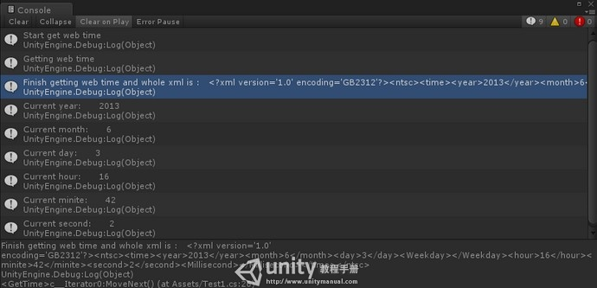](http://www.unitymanual.com/wp-content/uploads/2013/06/219.jpg)

获取网络时间、解析xml、截取string

第二部分:通过北京时间链接地址获得的数据如下:

|  |  |  |
| --- | --- | --- |
|  |  |  |

|  |  |
| --- | --- |
| 1 | t0=new Date().getTime(); nyear=2013; nmonth=6; nday=3; nwday=1; nhrs=16; nmin=57; nsec=29; |

然后截取string获得网络时间,具体方法是截取“;”获得年月日...然后截取“=”获得对应的时间.

完整代码如下:

|  |  |  |
| --- | --- | --- |
|  |  |  |

|  |  |
| --- | --- |
| 01 | **using** UnityEngine; |
| 02 | **using** System.Collections; |
| 03 |  |
| 04 | */// <summary>* |
| 05 | */// Get web time and split string* |
| 06 | */// 获取网络时间/截取string* |
| 07 | */// </summary>* |
| 08 | **public** **class** Test2 : MonoBehaviour |
| 09 | { |
| 10 | **public** **string** timeURL = "http://www.beijing-time.org/time.asp";*//北京时间地址* |
| 11 | *// Use this for initialization* |
| 12 | **void** Start() |
| 13 | { |
| 14 | StartCoroutine(GetTime()); |
| 15 | } |
| 16 |  |
| 17 | IEnumerator GetTime() |
| 18 | { |
| 19 | Debug.Log("Start get web time"); |
| 20 | WWW www = new WWW(timeURL); |
| 21 | **while** (!www.isDone) |
| 22 | { *//Unity3D教程手册：www.unitymanual.com* |
| 23 | Debug.Log("Getting web time"); |
| 24 | **yield** **return** www; |
| 25 | Debug.Log("Finish getting web time and whole xml is : " + www.text); |
| 26 | SplitString(www); |
| 27 | } |
| 28 | } |
| 29 |  |
| 30 | **public** **void** SplitString(WWW www) |
| 31 | { |
| 32 | **string**[] timeData = www.text.Split(';'); |
| 33 | **for** (**int** i = 0; i < timeData.Length; i++) |
| 34 | { |
| 35 | **string**[] exactTime = timeData[i].Split('='); |
| 36 | **foreach** (**string** temp **in** exactTime) |
| 37 | Debug.Log(temp); |
| 38 | } |
| 39 | } |
| 40 | } |

获得的网络时间如下：

[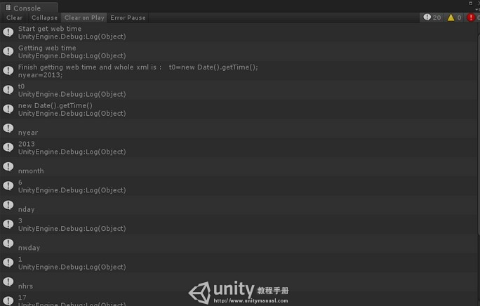](http://www.unitymanual.com/wp-content/uploads/2013/06/313.jpg)

获取网络时间、解析xml、截取string