Narrative Feature Extraction — Project Summary
Naturalistic neuroimaging increasingly uses rich, dynamic stimuli — movies and spoken stories — that engage perception, language, emotion, and social cognition as they unfold in time. Making sense of brain responses to such stimuli requires quantitative, second-by-second descriptions of what is on the screen and in the soundtrack. We built infrastructure to produce these descriptions automatically and reproducibly. We first performed a broad scoping review of computational models for visual, auditory, and language annotation, surveying roughly 146 tools across 15 feature subclasses — from interpretable features built with classical machine learning and signal processing to large ‘foundation’ and multimodal transformer models. We preferred models with large, well-documented training sets, open weights (so annotations can be inspected, shared, and reproduced), and best-in-class validated performance. From these we selected 24 feature extractors — about half interpretable classical-ML / signal-processing features (e.g., low-level image statistics, acoustic descriptors, psycholinguistic word norms, GPT-2 word surprisal, optical flow, event segmentation) and about half large open-weight models with expressive learned feature spaces (e.g., the DINOv2 and SigLIP2 vision transformers, CLAP audio–language embeddings, VideoMAE action recognition, EmoNet visual-emotion schemas, a Qwen2.5 vision–language model, and — for a rich representation of what is said — Qwen3 sentence embeddings and Llama-3.1-8B autoregressive hidden states of the dialogue and narration). The features are organized into 6 broad domains — visual, auditory, language, social, emotional (affect), and situational/schema-level — each spanning low-, mid-, and high-level descriptions (Table 1).
Applying these models, we extracted about 7,899 feature-variable time series (from 103 annotation channels) across 106 movie clips and stories (76 audiovisual, 29 spoken-audio, 1 text), yielding roughly 35,809 seconds (~9.9 h) of annotations sampled once per second on a common time grid. Features that do not apply to a stimulus (e.g., visual features for an audio-only story) are stored as explicit nulls, so the whole corpus stacks into a single rectangular matrix; embedding the full set of variables shows that this annotation space is organized primarily by modality, with the dense LLM language embeddings forming its largest, cleanly separated cluster (Figure 4). An interactive browser lets users visualize and manually check each feature’s distribution and quality. To characterize the structure of the annotation space, we performed exploratory factor analysis within each domain/model. Some feature sets proved essentially irreducible — the first principal factor of the Qwen3 language embedding (3%); the 527-way AudioSet sound tags (4%); the 400-way action posteriors (5%); the DINOv2 image embedding (5%); the SigLIP2 image embedding (5%) each explained only a small share of the variance, indicating genuinely high-dimensional, distributed representations that cannot be collapsed without losing information. Others were highly compressible — a single component captured most of the variance for musical pitch-class (chroma) (63%); situation_scalars (54%). Reducing each model to its leading factors yields 176 compact, labeled regressors (Figures 1–3) suited to encoding models that relate stimulus content to brain activity.

Table 1. Feature groups by class (rows) and level of abstraction (columns).
Numbers in parentheses are the count of variables in each group (a scalar/flag = 1; a vector = its dimensionality). Low-level = raw physical/perceptual signal; mid-level = perceptual organization; high-level = semantic/conceptual.
Feature class | Low-level | Mid-level | High-level
Visual | image statistics (12); optical-flow motion (3); shot cuts (2) | saliency & depth (8); faces & bodies (7) | SigLIP semantics — embedding + scene probes (784); DINOv2 embedding (384); action recognition (400)
Audio | acoustics — loudness / pitch / timbre / MFCC / chroma (34) | speech presence & rate (2) | AudioSet sound tags (527); CLAP semantics — embedding + probes (524); vocal affect V/A/D (3)
Language | word frequency & length (2) | lexical norms — valence / arousal / dominance, concreteness, AoA (5); syntactic complexity (5) | word surprisal & next-word entropy (2); LLM embeddings — Qwen3 sentence + Llama-3.1 autoregressive (5120); semantic coherence / drift / novelty / surprise (4); narrative expectedness / surprise (LLM-rated) (2)
Social | — | agent count & closest-pair distance (2) | interaction type & social dominance (2)
Situation | — | — | scene description / setting / indoor–outdoor (3); event structure — boundaries & event id (2)
Affect | — | facial affect — 8 expressions + valence + arousal (10) | EmoNet image emotion (20); text emotion & sentiment (32); VLM depicted emotion (3)

Figures
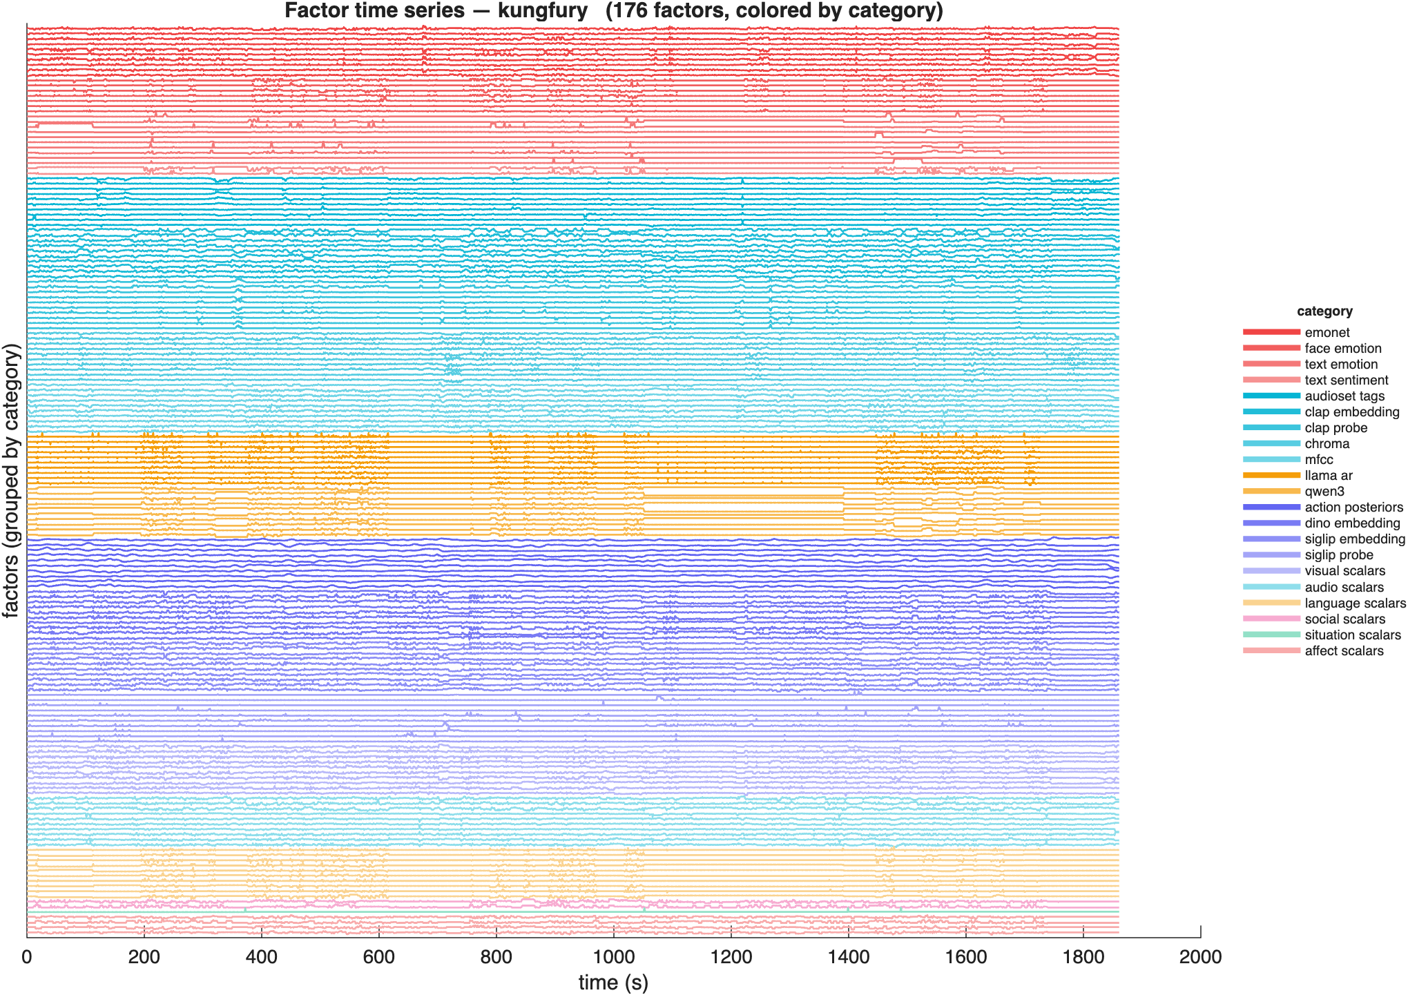
Figure 1. Second-by-second factor time courses for one audiovisual clip (Kung Fury). Each horizontal trace is one of the 176 per-model factors, colored by feature domain (reds = emotion/affect, cyans = auditory, blues/purples = visual, orange = language, pink = social, green = situational). The annotations vary continuously and coherently as the scene unfolds, which is the raw material for relating stimulus content to brain responses.
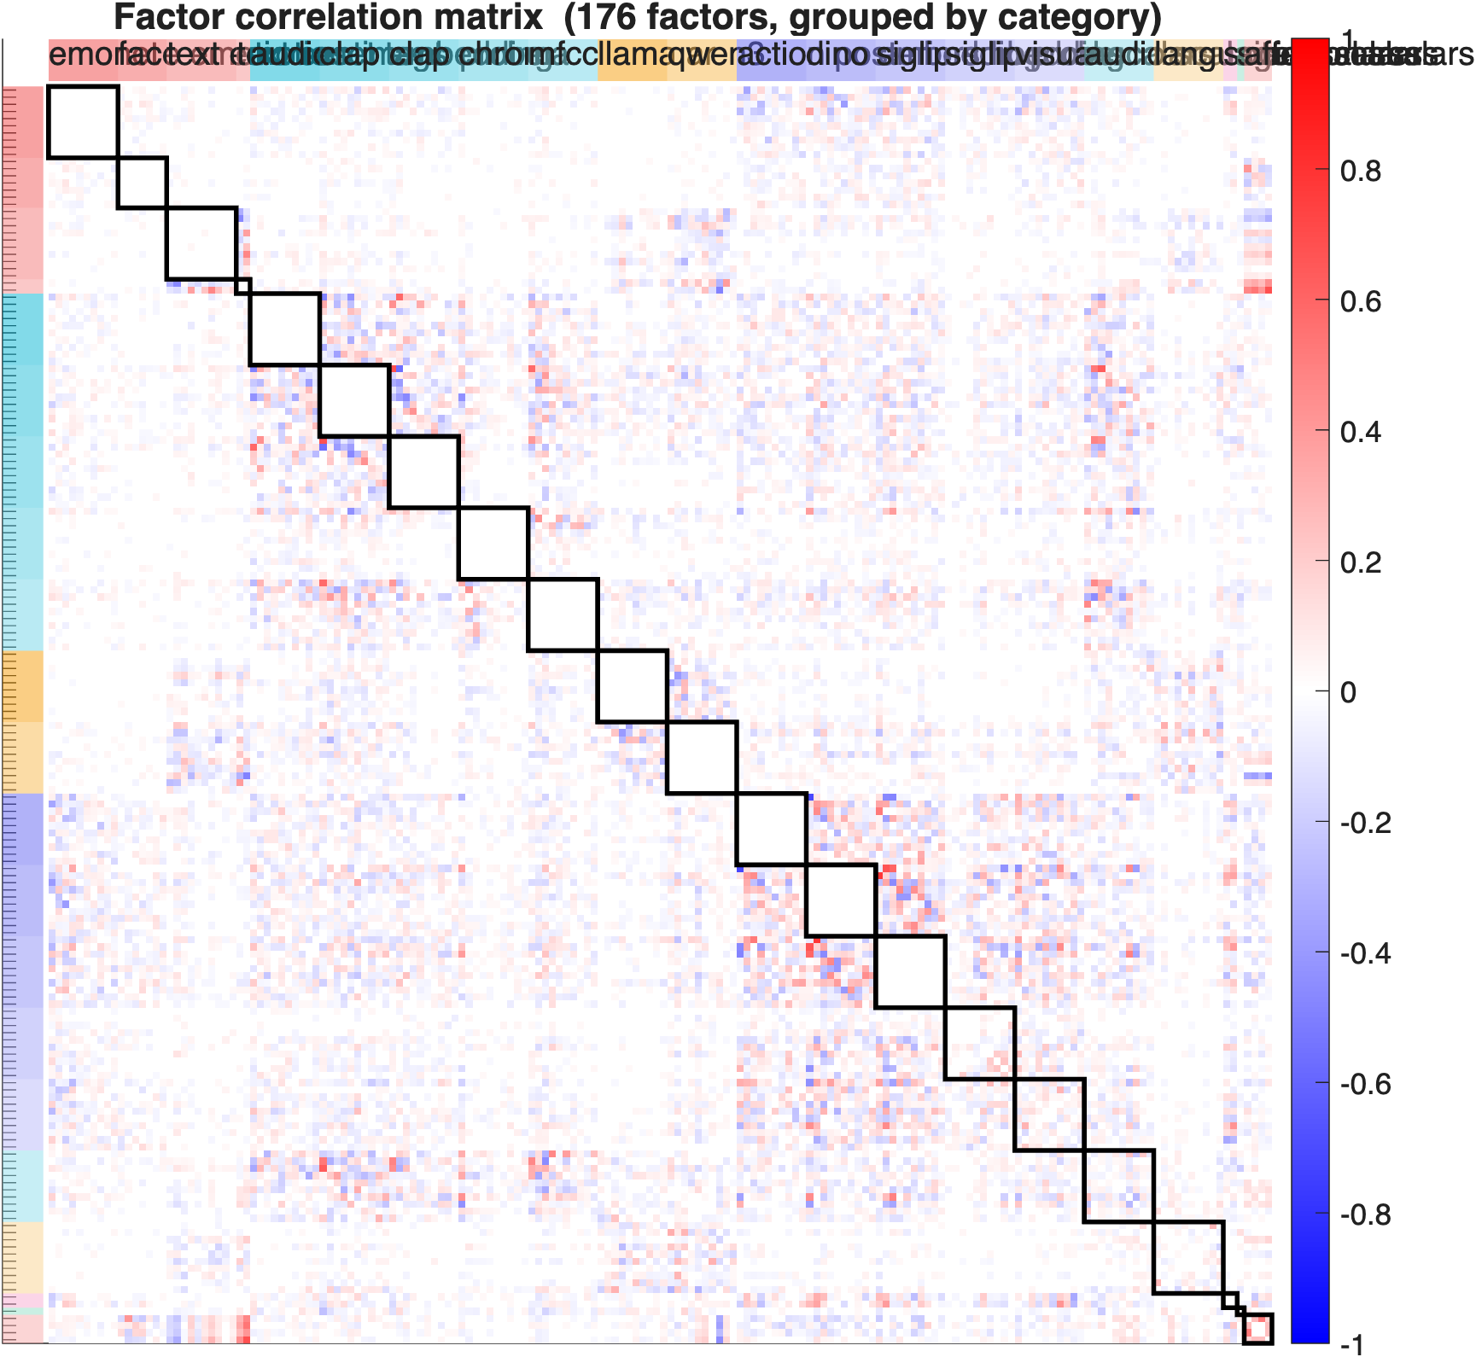
Figure 2. Correlation matrix of all 176 factors across the entire corpus (35,809 s), ordered and color-labeled by category. Near-zero correlations inside each outlined diagonal block show that the factors within a model are largely non-redundant; off-diagonal structure reveals genuine cross-modal coupling (e.g., among the visual embedding, action, and depth factors).
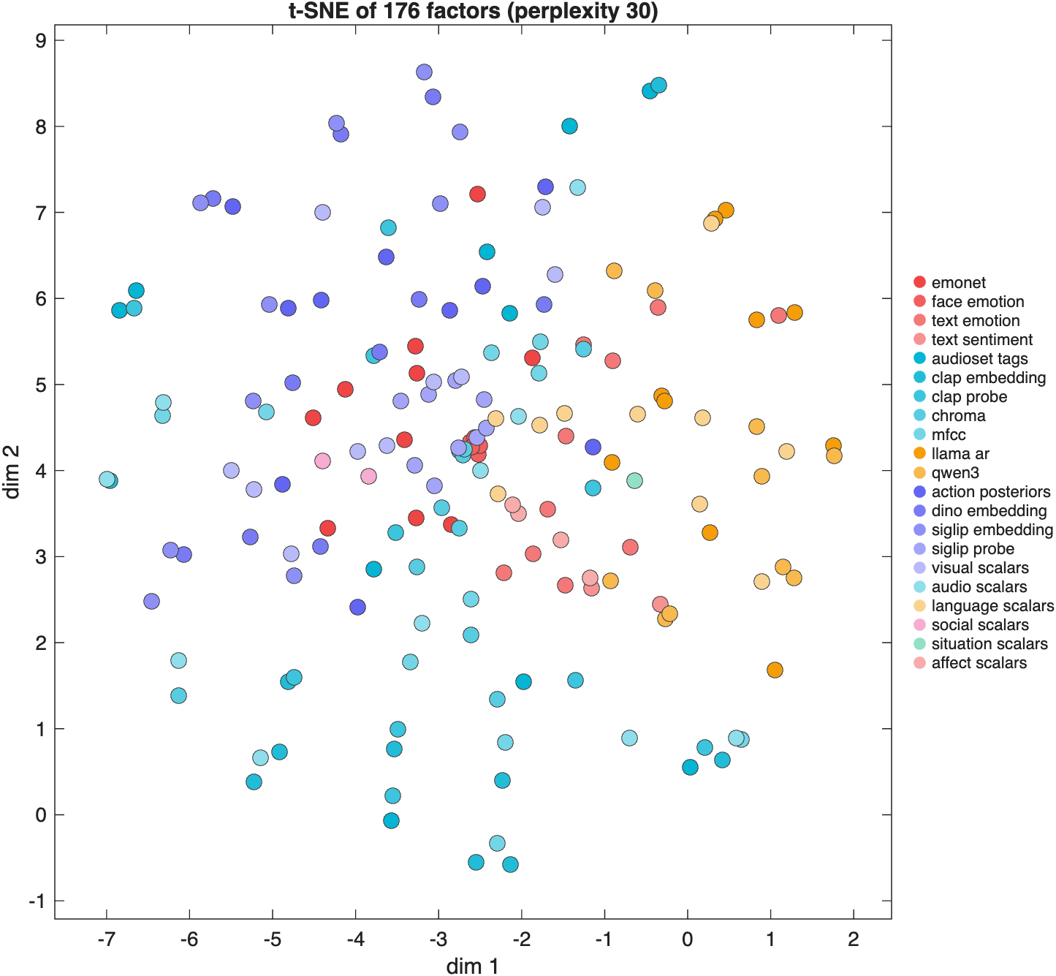
Figure 3. Two-dimensional t-SNE layout of the 176 factors, each point one factor colored by category. Factors from the same model or sensory domain tend to group together, while emotion and interpretable factors spread across the space, reflecting variance they share with several modalities.
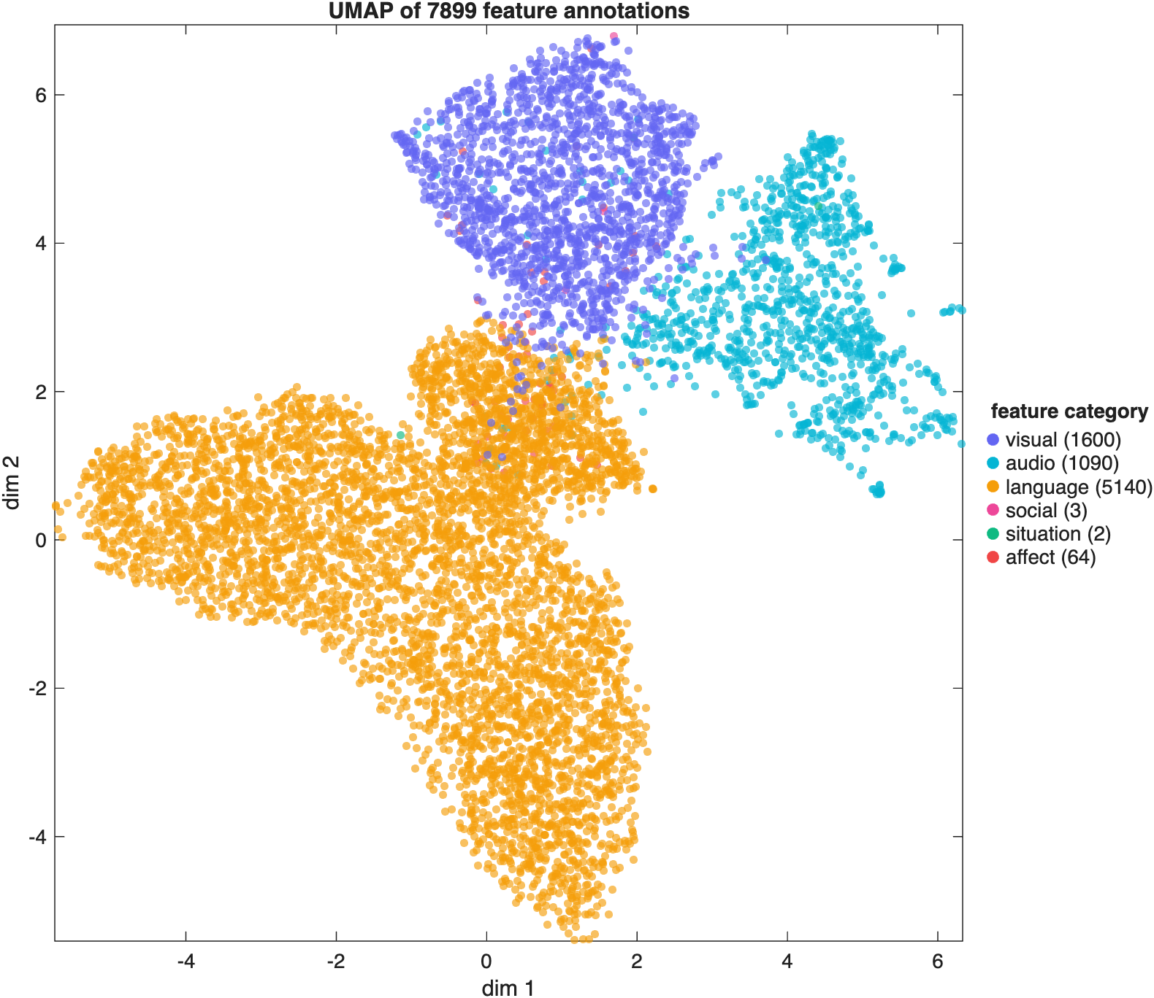
Figure 4. UMAP embedding of all 7,899 individual feature-variable annotations (not the factors), each point one variable colored by feature domain (legend). The variables separate cleanly into three modality masses — visual, auditory, and language (now the largest, dominated by the Qwen3 and Llama-3.1 language embeddings) — with the smaller social, situational, and affective feature sets between them, showing that the annotation space is organized primarily by modality.

