
Group Assignment (Group 18)
Module Code | : AAPP012-4-2-RWDD
Module Name | : RESPONSIVE WEB DESIGN & DEVELOPMENT
Lecturer | : JEFFERY JESELEE SIJORE
Project Title | : EcoRewards (Theme - Green Points & Rewards)
Date Assigned | : Week 2
Date Completed | : 30th March 2026

Name | TP Number | Intake Code
BONG ZIHAO | TP083121 | UCDF2409ICT
GAN SHAO CHENG | TP083588 | UCDF2409ICT(ITR)
LIM SIN YUE | TP083837 | UCDF2409ICT

Table of Contents
1.0 Introduction 4
1.1 Project Overview 4
1.2 Project Objectives 5
1.3 Project Scope 6
1.4 Intended Users 8
2.0 Project Management 9
2.1 Project Plan 9
2.2 Gantt Chart 11
3.0 System Design 12
3.1 System Flowchart 12
3.2 Entity Relationship Diagram (ERD) 15
3.3 Data Dictionary 16
3.4 Wireframes 17
3.4.1 Student 18
3.4.2 Moderator 21
3.4.3 Administrator 24
3.5 Navigation Map 29
4.0 Implementation 31
4.1 Development Steps 31
4.1.1 Student 31
4.1.2 Moderator 34
4.1.3 Administrator 36
4.2 Code Snippets 38
4.2.1 General 38
4.2.2 Student 41
4.2.3 Moderator 50
4.2.4 Administrator 52
4.3 Screenshots of Major Pages 60
4.3.1 General 60
4.3.2 Student 62
4.3.3 Moderator 66
4.3.4 Administrator 70
5.0 Conclusion 80
5.1 Review of Work 80
5.2 Validation of Project Objectives 82
5.3 Limitations and Challenges 84
5.4 Recommendations for Future Improvements 85
6.0 References 86
7.0 Workload Matrix 87

1.0 Introduction

1.1 Project Overview
The EcoRewards system is an online system that aims to encourage people to adopt eco-friendly behaviour through a reward system. The main concept of this system is that it allows people to interact with eco-friendly activities and earn points by submitting evidence in photo format.

Users of this system can upload proof of their eco-friendly behaviour, such as plant a tree, public transport, and reduction of plastic. These activities will then be reviewed and approved by the moderators after proof is submitted.

The accumulated points can be redeemed for rewards like discount vouchers, or exclusive deals. Moreover, to motivate individuals to lead more environmentally friendly lifestyles, the community awareness of the environmental sustainability is also increased with the help of such an approach.

Overall, this platform combines reward redemption, content verification and user interaction into a single system, making eco-friendly behaviour both engaging and beneficial.

1.2 Project Objectives
EcoRewards system is designed with the following main objectives to encourage sustainable behaviour and promote environmental awareness among APU students.

- To encourage environmentally friendly behaviour
The objective of this system is to inspire and motivate people to adopt environmentally friendly behaviour in their day-to-day lives. This includes reducing waste and using alternatives that are environmentally friendly.

- To provide a reward-based motivation system
The goal of the platform is to motivate and inspire people to take up environmentally friendly practices in their day-to-day life through the accumulation of points and points that can be redeemed.

- To ensure authenticity through activity verification
The system has a review process by moderators to ensure that all activities are verified.

- To increase awareness of environmental sustainability
The platform is helpful in educating people about the importance of environmental sustainability through active participation and engagement.

- To create a community-driven eco platform
The system is to create a community through user interaction and engagement. It promotes a sense of community among users by incorporating collaborative features. In order to accomplish environmental sustainability goals, this community-driven strategy encourages users to remain involved and collaborate.

1.3 Project Scope
The system comprises of modules that are broad and include:
User Authentication and Profile Management
The system supports secure access to the system by simulated APU TP account credentials. All the users have individual dashboards which show their total points earned, badges, history of their submissions and their ranking in the leaderboard. The users can also update their profile information and see their sustainability progress.

Sustainability Challenge Module
Available sustainability challenges include the use of reusable bags, the use of the public transport, and recycling of the activities that the students can explore. Every challenge consists of descriptions of challenges and points. The students must provide the evidence of the performed actions by uploading pictures or videos.

Submission Verification System
Moderators will review all submissions that are uploaded to facilitate fairness and credibility. The moderators have the right to approve or disapprove the submissions and give feedback wherever necessary. Duplicate or suspicious submissions are also identified using the system on misuse.

Gamification and Reward Features
There is gamification features used to make the user more motivated and interested. Upon the approval of the submissions, students get green points and achievement badges. It has a leaderboard ranking system to promote friendly user competitiveness.

As well, a Virtual Tree represents every student which visually grows depending on the number of points made. The fact that the tree is growing is symbolic of the contribution made by the user to the environmental sustainability.

For social connectivity, the users can socialize with other users by visiting their friends on eco-homes. This functionality will enable users to see Virtual Trees of their friends and their progress, which would make them feel included in the community and have healthy competition.
The system includes a Daily Check-in feature to make daily habits a regular occurrence; it will provide a “Daily Eco - Check-in” system to users where they receive increasing bonus points every time they use the platform.

Reward Redemption System
The students can redeem the points they have earned in them in terms of discount vouchers or special offerings. The system will document the redemption after which the corresponding points will be automatically deducted against the user account.

Administrative Management
The administrators will deal with system set up, creating sustainability challenges and allocating point values, administering rewards, tracking system use and making announcements. The system provides an appropriate integration of databases with the ERD and data dictionary.

Badge System
The system has achievement badges system delivers digital titles when attainment of specific milestones by the user. These badges are earned in respect of requirements (such as Recycling Pro when 5 recycling activities are done or just Commuter Hero at 10 logs using devices). These are badges that can be seen at the profile of the user. These elements of gamification make the process of user interaction more dynamic and enjoyable as well as promote further interaction with the user.

1.4 Intended Users
EcoRewards system exhibits three major user functionalities, and each user has a particular responsibility and permission to access the system.
APU Students (Primary Users)
The system is mostly used by students. They are the ones that are actively involved in problems related to sustainability. They also post on its photo evidence of environment-friendly actions like the reusable product usage, using public transports, and minimizing the use of plastic. With the help of their personal dashboard, students can monitor the points earned, badges, rank in a leaderboard, and their progress in a Virtual Tree. The system also encourages students to constantly make environmentally friendly habits because their participation attracts points and other redeemable items.

Moderator
The moderators are supposed to make the system fair and credible. Their priority is to look and check in the submissions downloaded by students to assure that the activities are sustainable as per the requirement. The role of moderators is to ensure the integrity of the system which includes approving and rejecting the valid submissions, detection of duplicate or suspicious activities. This verification method will guarantee and make sure that only real eco-friendly behaviour is rewarded.

Administrator
Administrators oversee general administration and setup of the platform. They have the responsibility of upkeeping content in the systems like sustainability challenges, reward catalogue, and user roles. Administrators also keep track of the participation information and make announcements concerning sustainability campaigns. Their position will make sure that the system is efficient and remains in the process of environmental awareness in the APU community.

2.0 Project Management

2.1 Project Plan
EcoRewards project is developed under the logic of life-cycle development where all the functionalities are meticulously developed. The project schedule is presented between December 2025 and April 2026 which is handled using a Gantt chart. Our project schedule is directly related to the workflow, as it consists of seven major phases:
Phase 1: Project Initiation & Theme Selection (Week 1 - Week 2)
The initiating point of the project was the team building. At this time, the team completed the theme of Green Points and Rewards, defined the three user types and the distinguishing functionality of the platform which includes the logic of the photo-based proof submission and calculation of points.
Phase 2: Preliminary Design & Proposal & Submission (Week 3 - Week 5)
This step was the one oriented at the development of the technical scheme. The team wrote the system flowcharts and the navigation map, wrote the database architecture (ERD and Data Dictionary) and wrote the wireframes to provide the description of the user interface on the dashboard and submission pages.
Phase 3: Database & Backend Setup (Week 6 - Week 7)
It started with configuration of the backend as the starting point of development. This comprised developing the MySQL database framework in accordance with the ERD and development of a prototype PHP server-side connection and security code.
Phase 4: Core Feature Implementation (Week 7 - Week 9)
The most intensive period was this period of development. The team applied user login, registration and access control of the three roles. The CRUD system of managing challenges was also created together with theme-related logic such as the moderator verification system and voucher redemption systems.

Phase 5: Frontend & Interactivity (Week 10 - Week 11)
In order to respond to the requirements of the responsive design without relying on the frameworks, the process of manual CSS styling was conducted on all the web pages. There was also the use of JavaScript to make a user even more interactive with it by offering form checks and dynamic elements of the UI.
Phase 6: Documentation & Testing (Week 11 - Week 13)
During last few weeks of development, the team did the system testing, wrote the required code snippets and created a detailed User Manual. The project report was also designed following the academic norms.
Phase 7: Final Submission & Demo (Week 13 - Week 14)
The project is seen to end with the exporting of the SQL database as well as the ZIP packaging of the source code of Moodle to be submitted. Lastly, the team will undergo a physical presentation and questions and answer session to showcase the capabilities of the system.

2.2 Gantt Chart
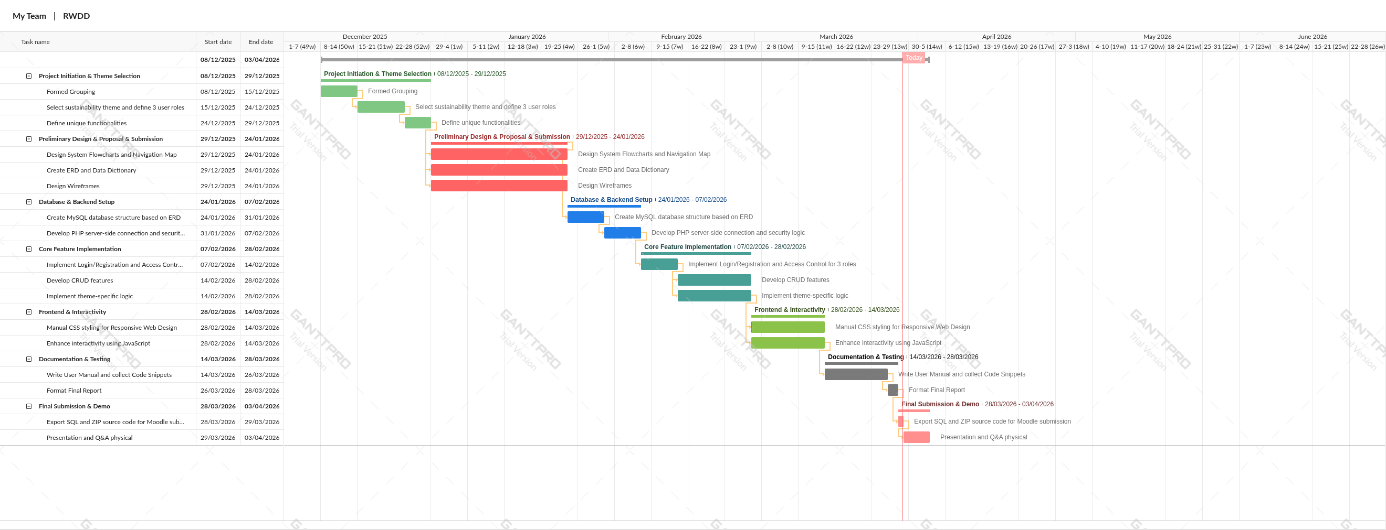


3.0 System Design

3.1 System Flowchart
Student
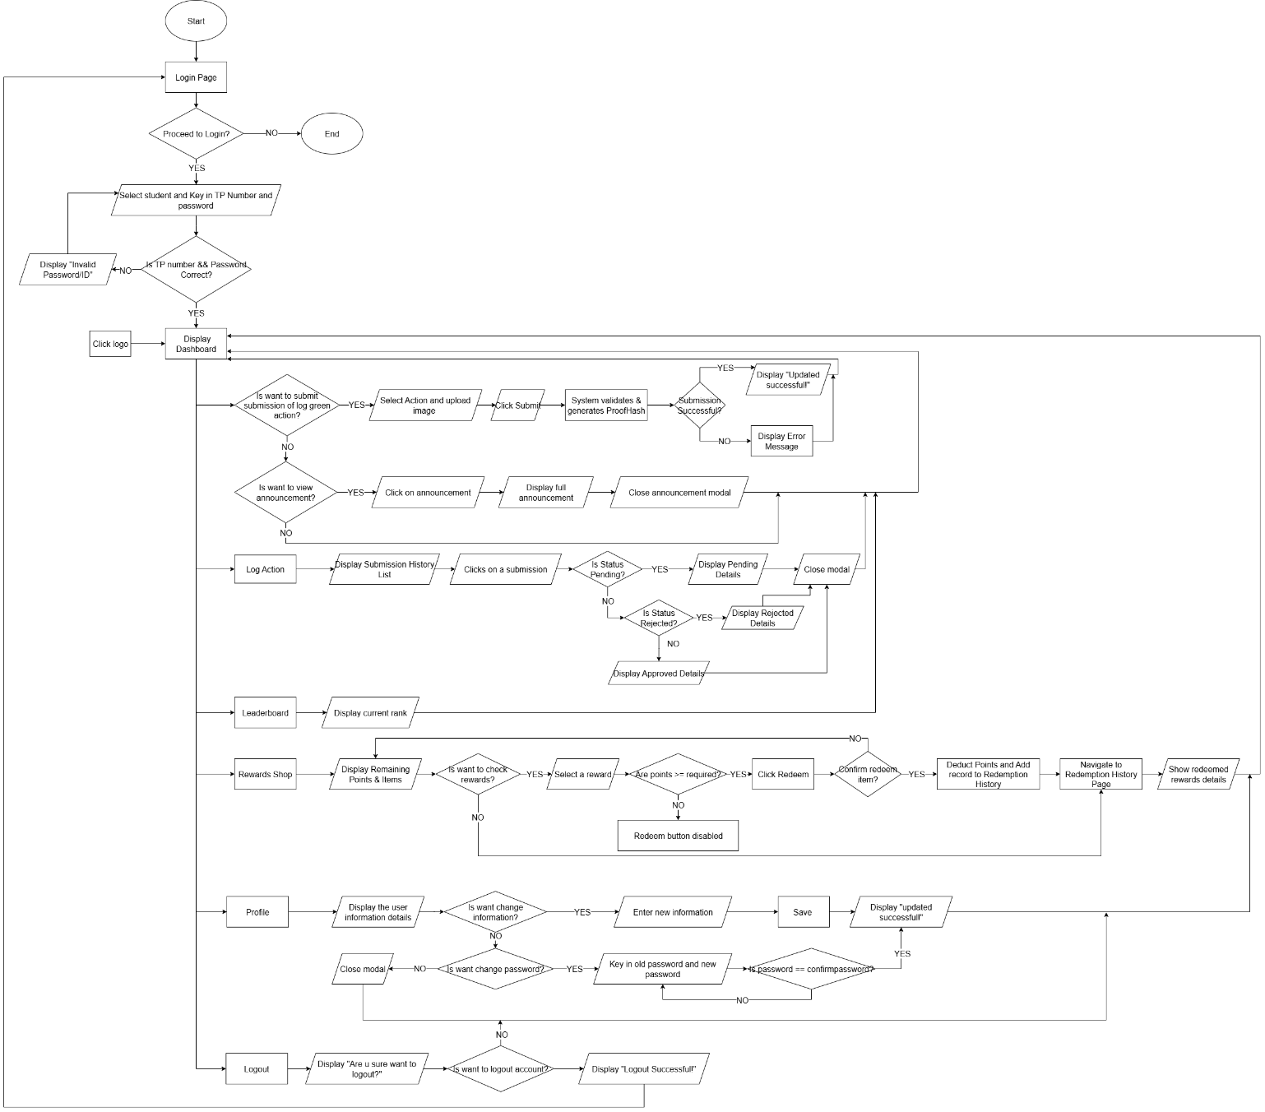

Moderator
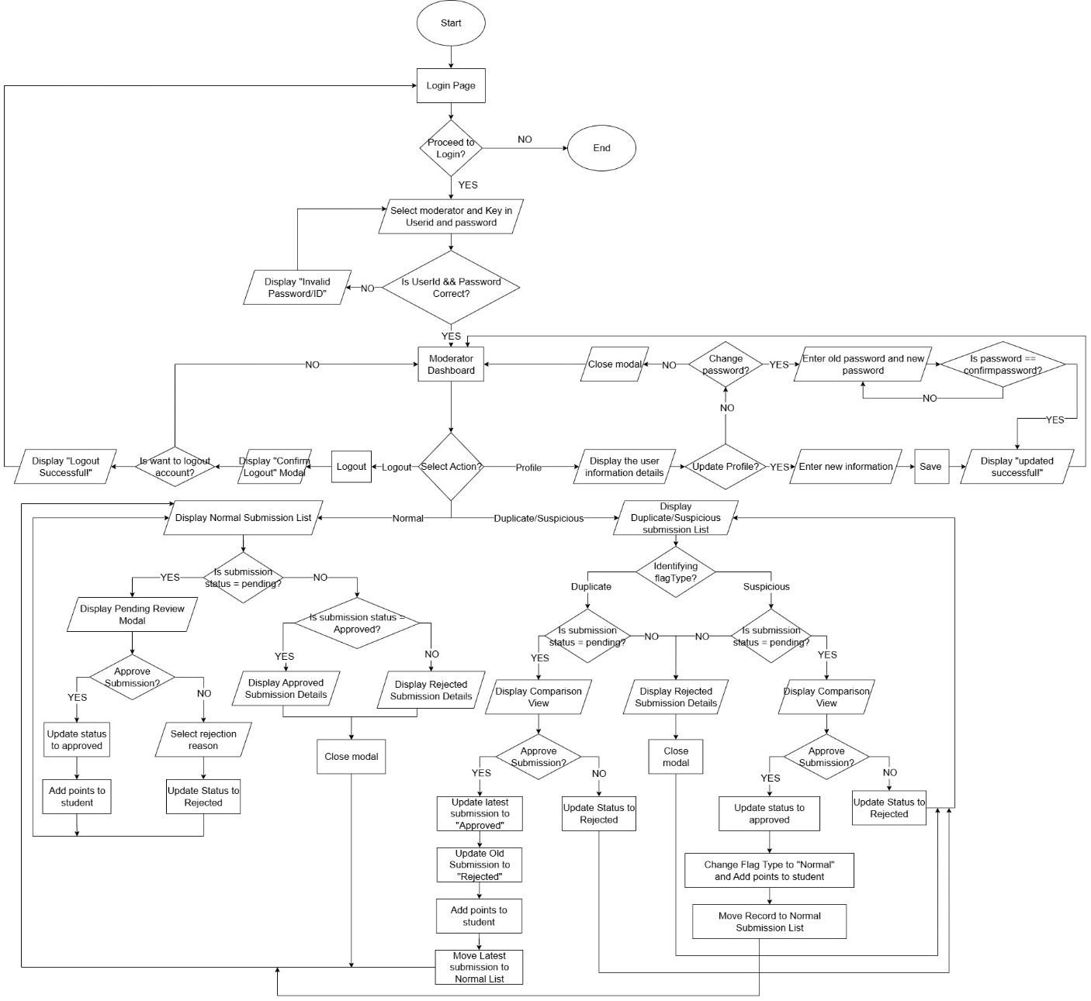

Adminstrator
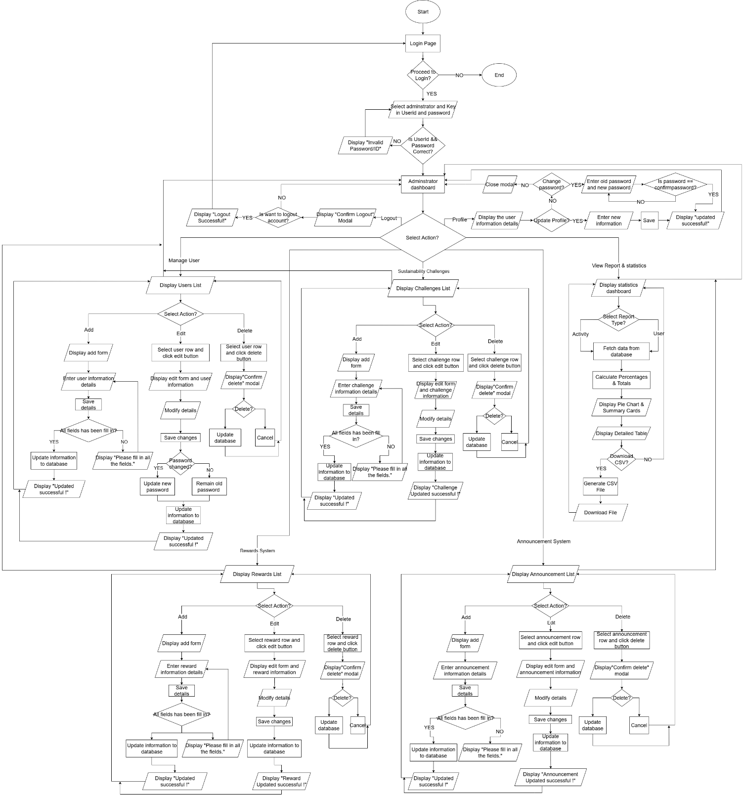

3.2 Entity Relationship Diagram (ERD)
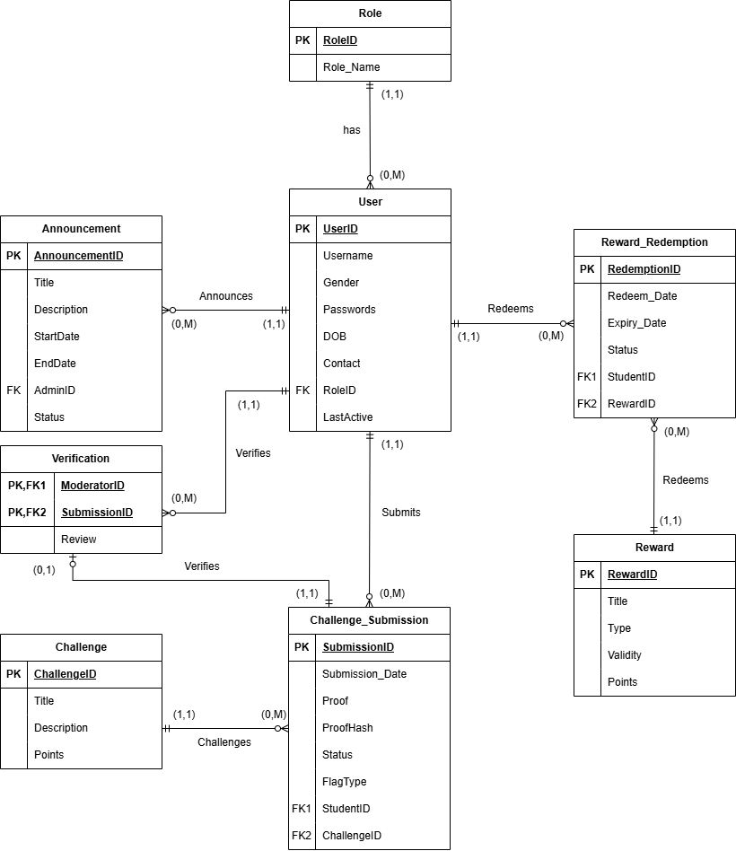

3.3 Data Dictionary

3.4 Wireframes
Login
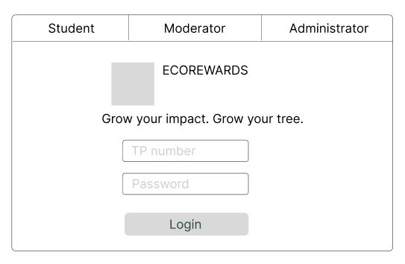 | 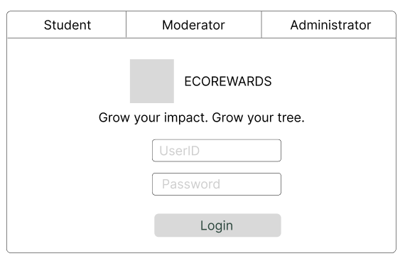
When the user wants to login need enter their TP number or UserID and password.

Profile & Change Password
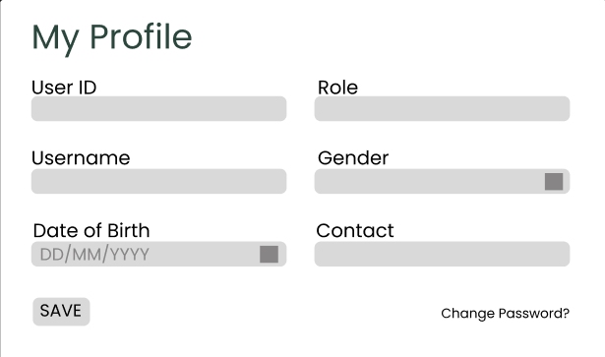 | 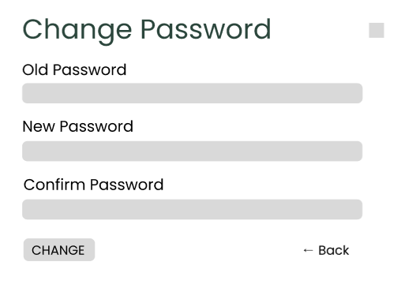

When user click on the profile avatar will prompt profile details. When user click on the Change Password? will be direct to this page and user can change their password.

Logout
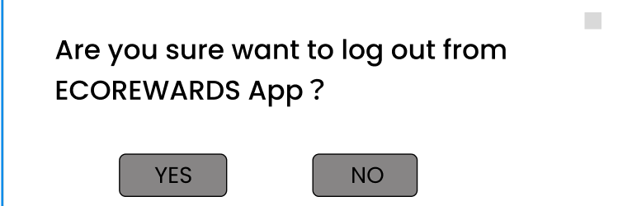
Users want to log out just need to click on Logout button.

3.4.1 Student
Dashboard
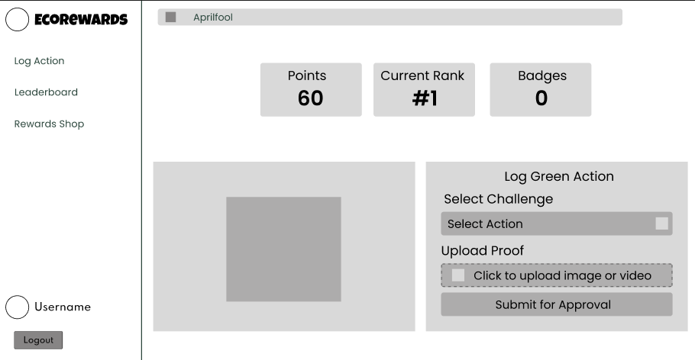
When student click the logo will prompt student dashboard. There is a dynamic announcement display at the top. When students click it, full announcement will appear. Student can check their points, current rank and badges at here. Beside the Log Green Action is a forest which display rank progress. Student need submit their submission at here and select which challenge they want to attend and upload the proof before submitting.

Log Action
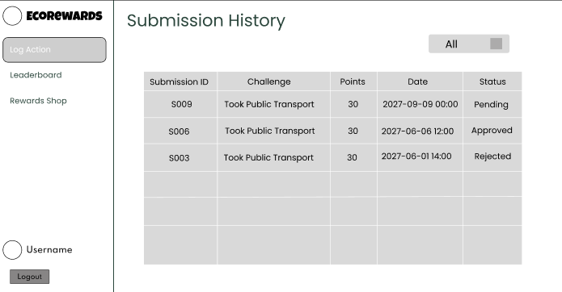
When student click on Log Action, student can saw their submission history. There also has a filter can help student check the status for pending, approved and rejected easily.

Log Action – Pending & Approved & Rejected
If student want to check back their submission, just need to click on the row.
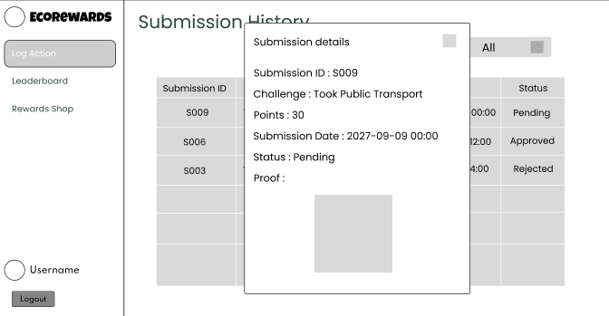 | 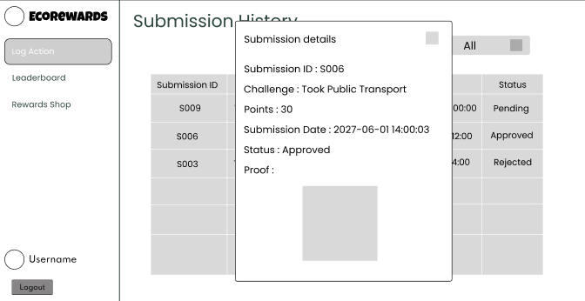
This is the pending and approved submission details.

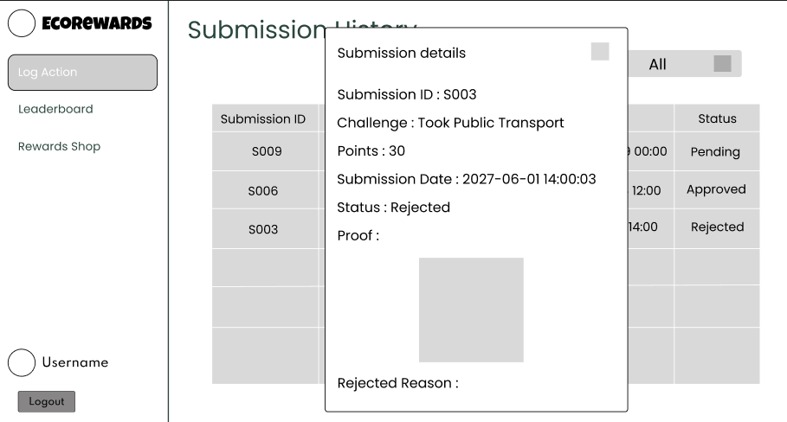
This is the rejected submission details.

Leaderboard
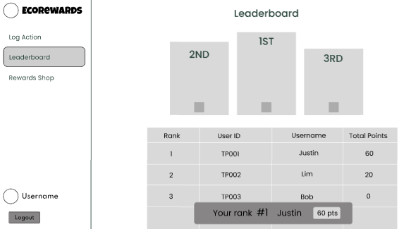
When student click on Leaderboard can check the current rank.

Rewards Shop
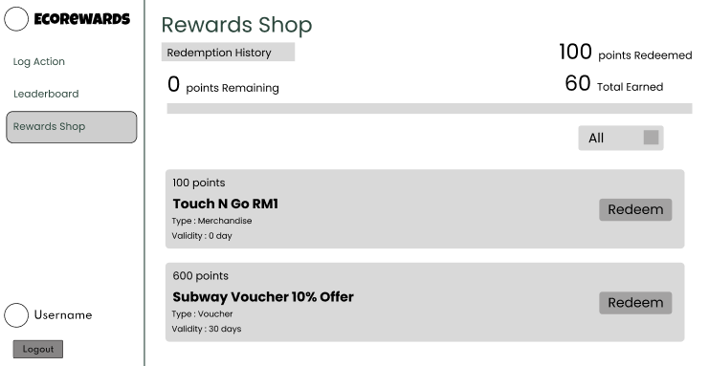
For the rewards shop, student can redeem rewards such as voucher or merchandise. There has a filter box allows student find voucher or merchandise easily. There will prompt student totally earned how many points, points redeemed and remaining.

Rewards Shop – Redemption History
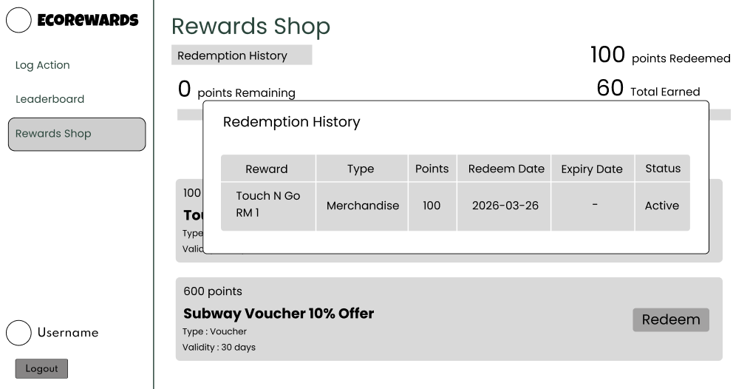
Click on the Redemption History can check the redemption before, and it will show the redeem date and expiry date to prevent student forget use it before expired.

3.4.2 Moderator
Normal Submission
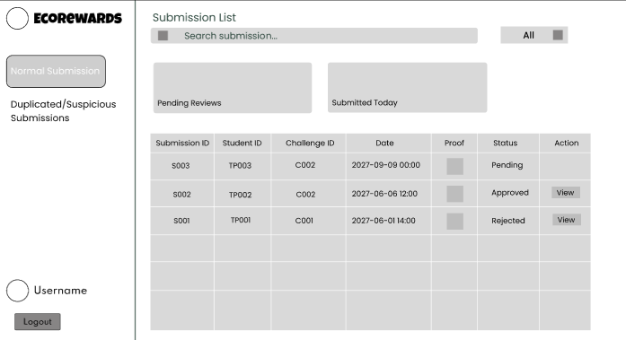
This is the page of normal submission, it shows the table of normal submission. It has search bar and filter to check the submission easily. For the Pending Reviews and Submitted Today will display quantity of submissions.

Normal Submission – Pending Reject & Pending Approved
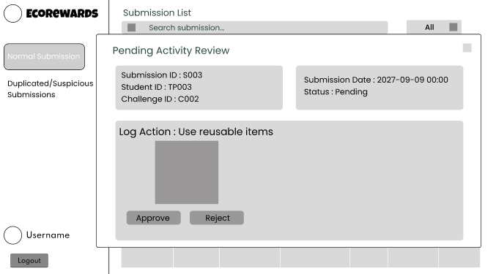  Status = Pending | 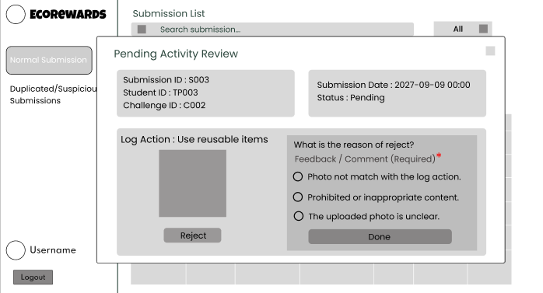  Pending Reject
When moderator click the pending submission, it will display the page of Status: Pending. The page of Status: Pending show the details of the submission and the photo which are student uploaded. If moderator choose the approve, the activity will become approved. If choose the reject, moderator need choose the reason of reject and done it.

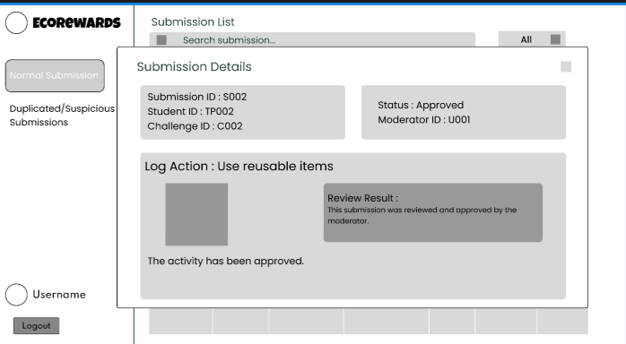  Approved | 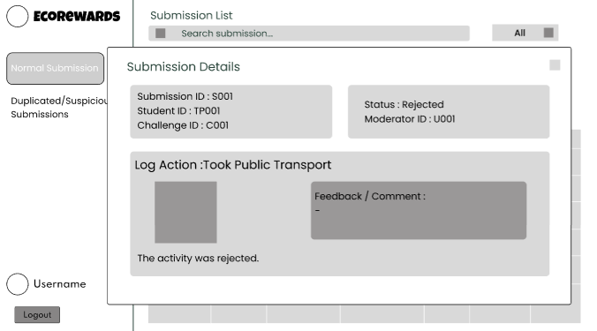  Rejected
Normal Submission – Review Approved & Rejected
When moderator click on the submission has been approved or rejected before, it will show the submission details. It will show the SubmissionID, StudentID, ChallengeID, Status and ModeratorID. For the approved, it will show the review result; Rejected will show the feedback/comment. Both can only be reviewed and cannot be edited.

Duplicate/Suspicious Submission
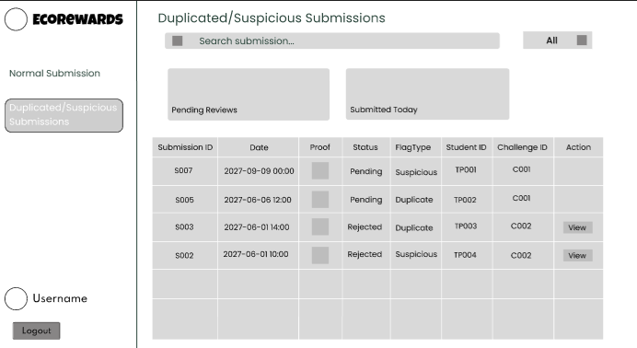
This is the page of duplicate/suspicious submission, there have table of submission, search bar and filter to check the submission easily. For the Pending Reviews and Submitted Today will display quantity of submissions.

Duplicate/Suspicious Submission - Approved
Approved activities of Duplicate/Suspicious Submission, the flagType of latest submission will change to normal and will be show at normal submission; for the old submission will remain at flag Type = duplicated / suspicious.
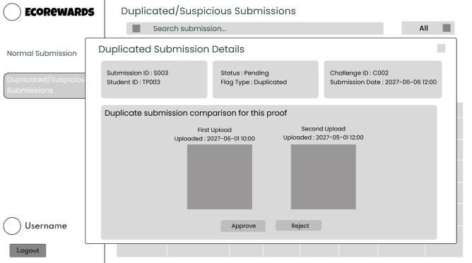  Duplicated Submission | 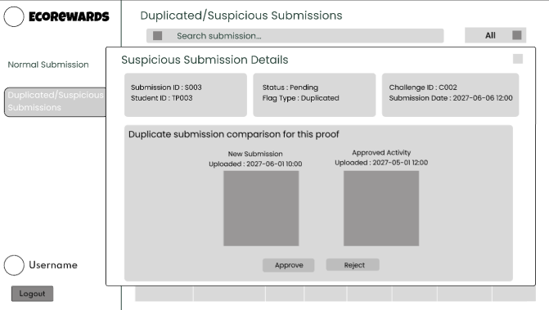  Suspicious Submission
Duplicate/Suspicious Submission – Pending

For the Duplicate/Suspicious Submission status = Pending, moderator can make decisions after checking the photo. The duplicate occurs when the same student submitted same photo and challenge within a short period, and both activity status is in pending have not approve or reject by moderator. The suspicious occurs when a different student submits a photo and challenge that matches an activity that has already been approved in the past.

Duplicate/Suspicious Submission – Rejected
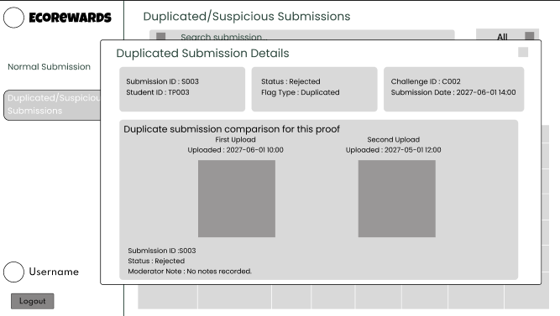  Duplicated Submission | 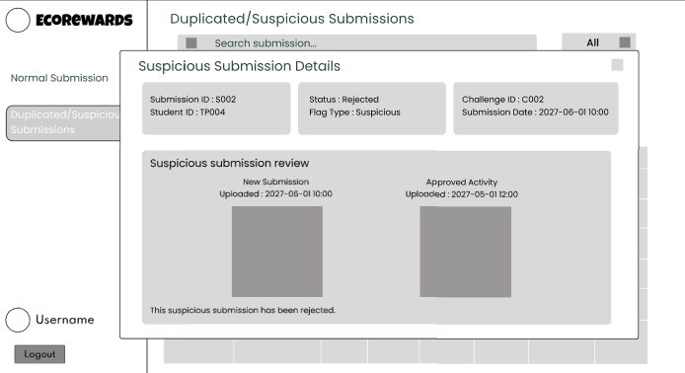  Suspicious Submission

After moderator decide approved or rejected, they can review the submissions. These are the rejected submissions details. Duplicate submission will show the first uploaded and second uploaded proof and submitted time. It also shows the submissionID, Status and moderator note. Suspicious submission shows the new submission, approved activity, uploaded time and proof for both submissions.

3.4.3 Administrator
Delete for all function
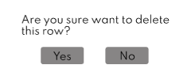
When admin select the row and click the delete, it will prompt a confirmation dialog to confirm the deletion.

Manage Users
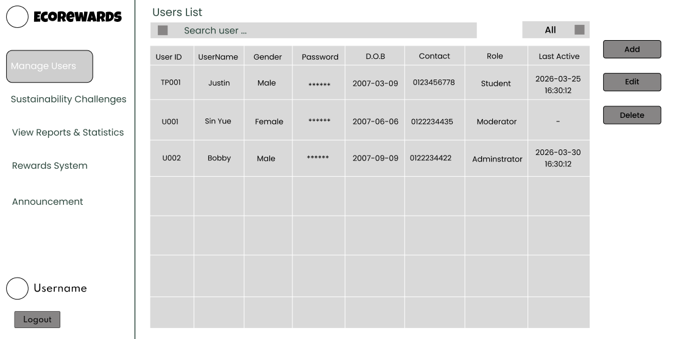
This is the table of Users list. It has a search bar and a filter box to convenient admin search the user.

Manage Users – Add & Edit
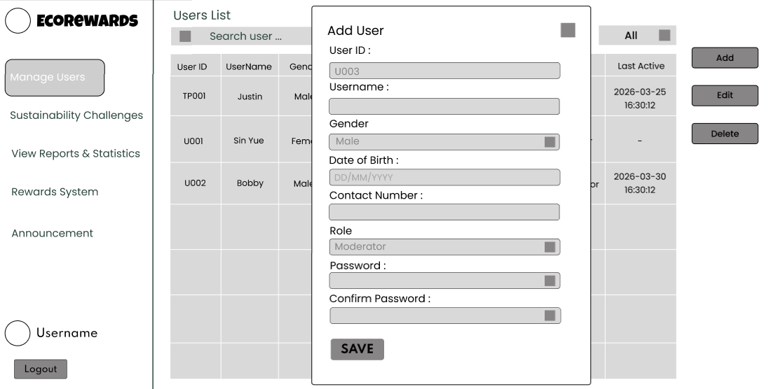
Admin click on the add button to add new user. After filling up the user information and clicking the save, the information will be save in database and display at table.

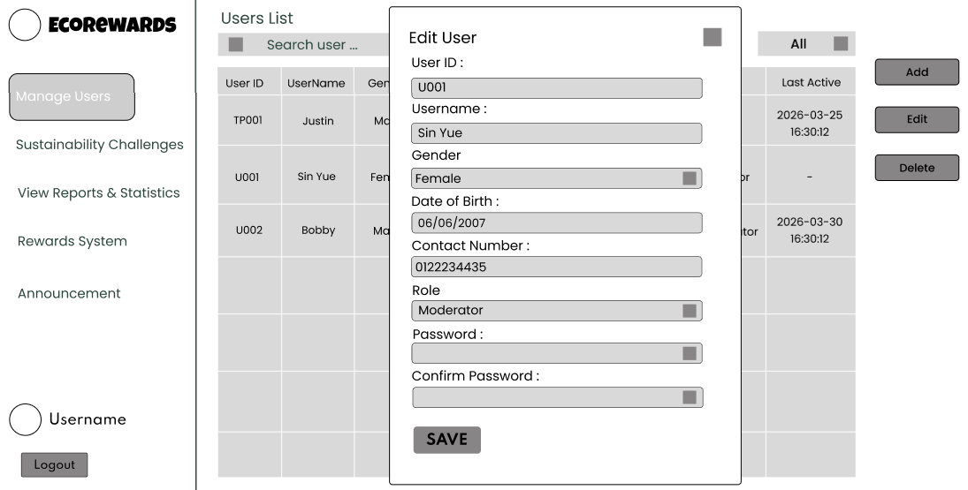
Admin selects a row and clicks edit button to modify user information. The UserID and Role cannot be changed. If there is no need to update the password, the password field can be left blank. However, if the admin wishes to change the password, they can enter a new password, which will then be saved in the database.

Sustainability Challenge
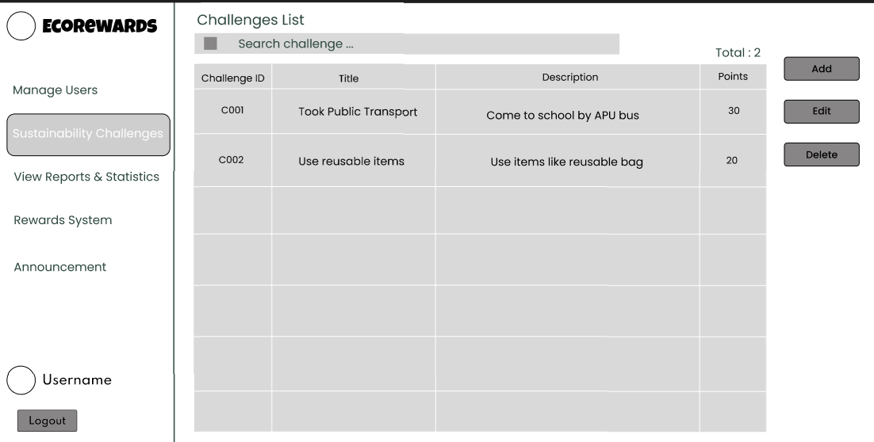
This is the table of Challenges list. It has a search bar to convenient admin search the challenges. Table content includes ChallengeID, Title, Description and points.

Sustainability challenge – Add & Edit
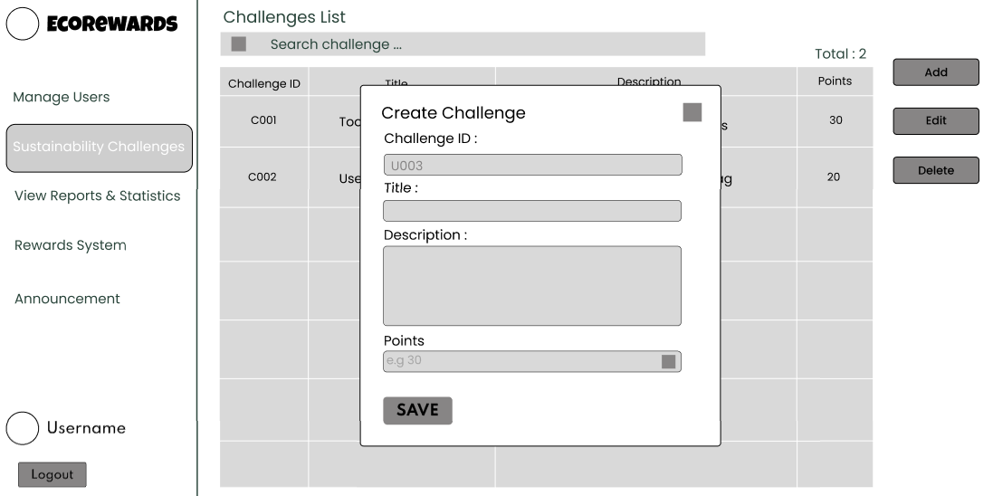  Add Challenge | 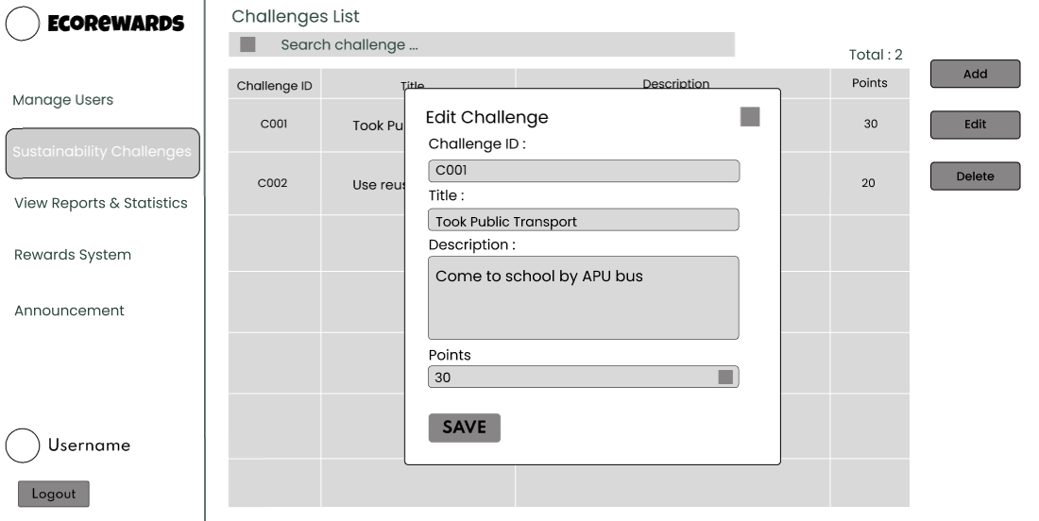  Edit Challenge
Admin can click on add button to insert a new challenge. Select a row which want to be edit and click on edit button and change the information before saving it.

View Reports & Statistics – User & Badge & Activity
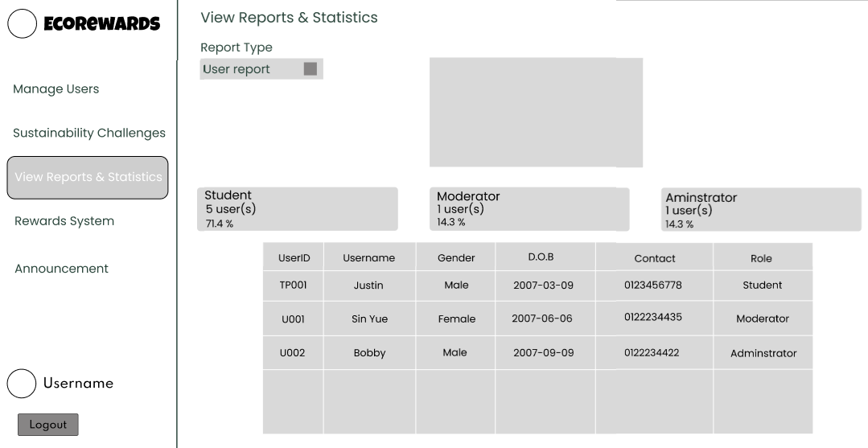
This is the report and statistics for user report. It shows the total number of users of EcoRewards.

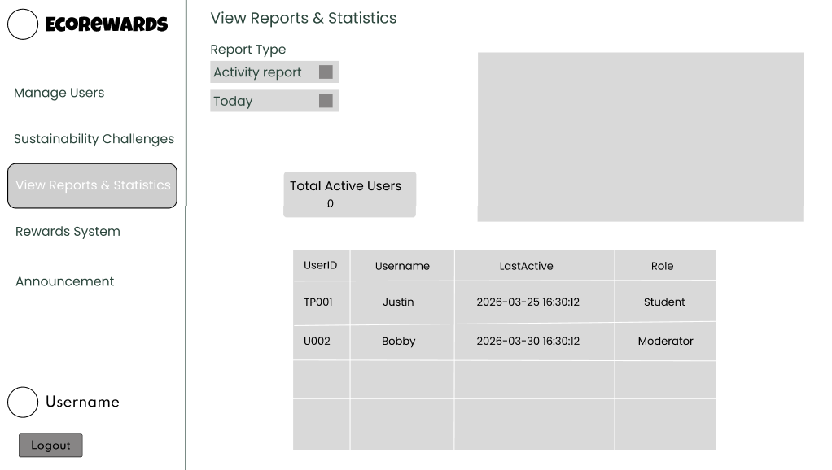
The activity report shows the active users for daily, monthly and yearly.

Rewards System
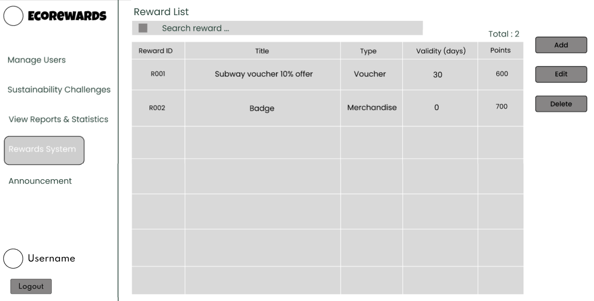
Reward system has a search bar to convenient admin search reward. The table include RewardID, Title, Type, Validity(days) and points.

Rewards System – Add & Edit
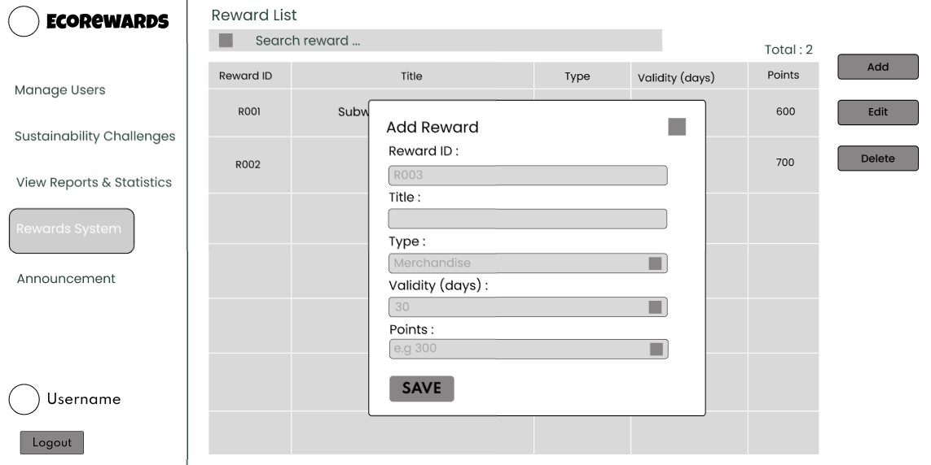
Admin can click on add button for add a new reward.

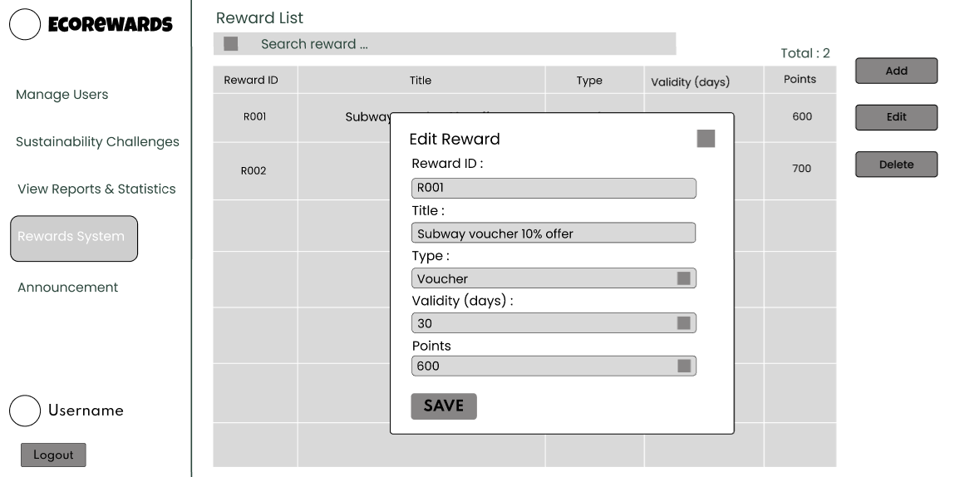
Select a row which want to be edit and click on edit button and change the information before saving it.

Announcement
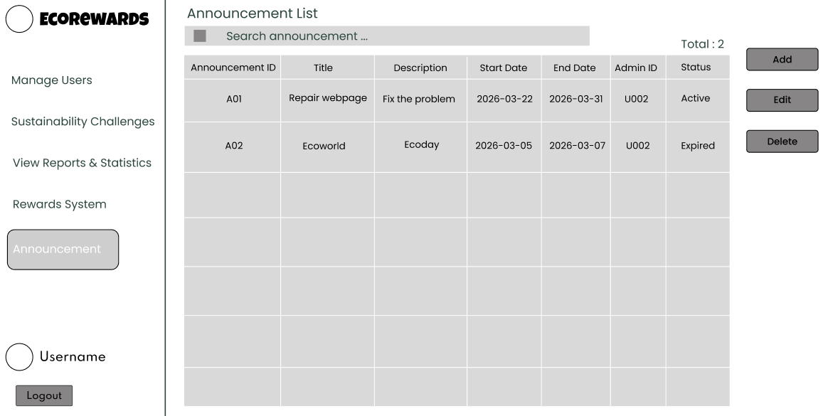
Announcement interface has a search bar to convenient admin search announcement and has a summary total announcement have been posted. The table include AnnouncementID, Title, Description, Start Date, End Date, AdminID and status.

Announcement – Add & Edit
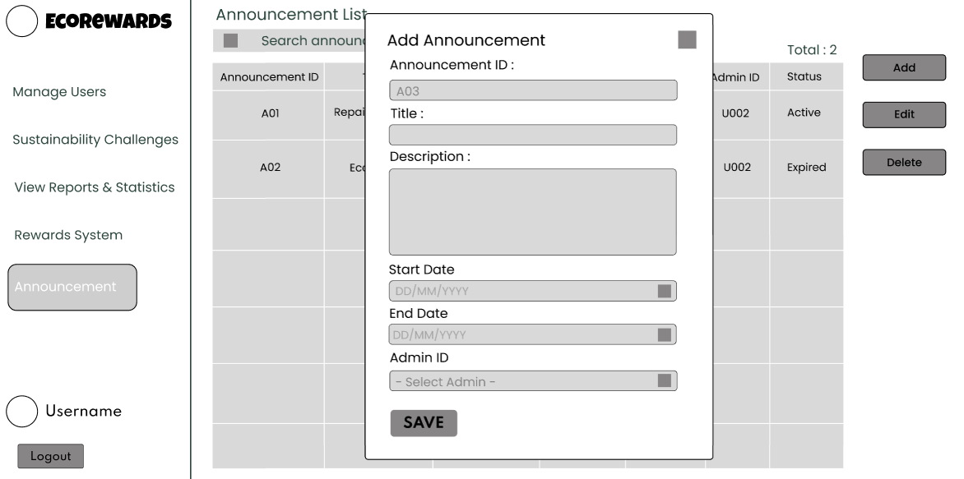
Admin can click on add button to insert a new announcement.
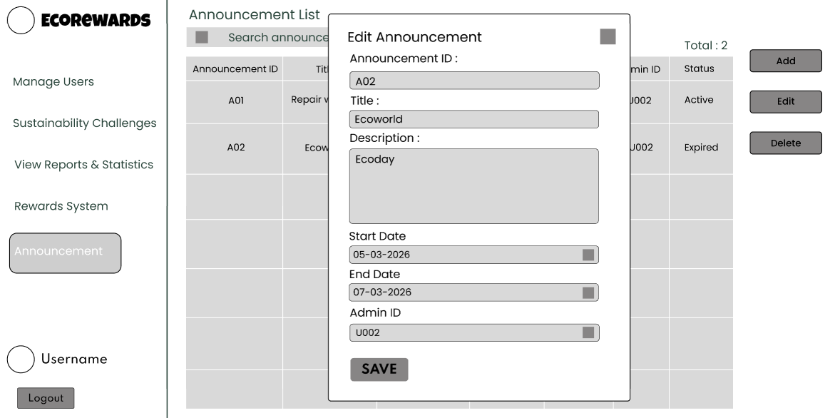
Select a row which want to be edited and click on edit button and change the information before saving it.

3.5 Navigation Map
Student
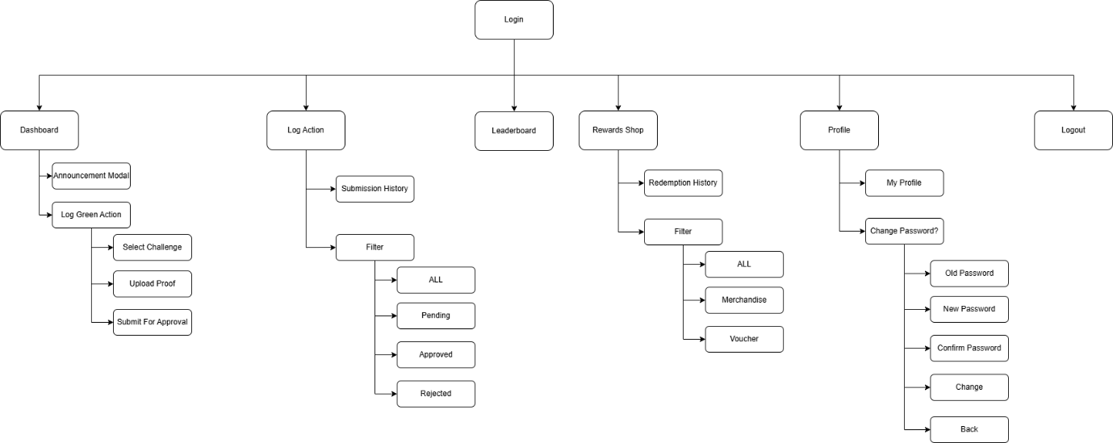

Moderator
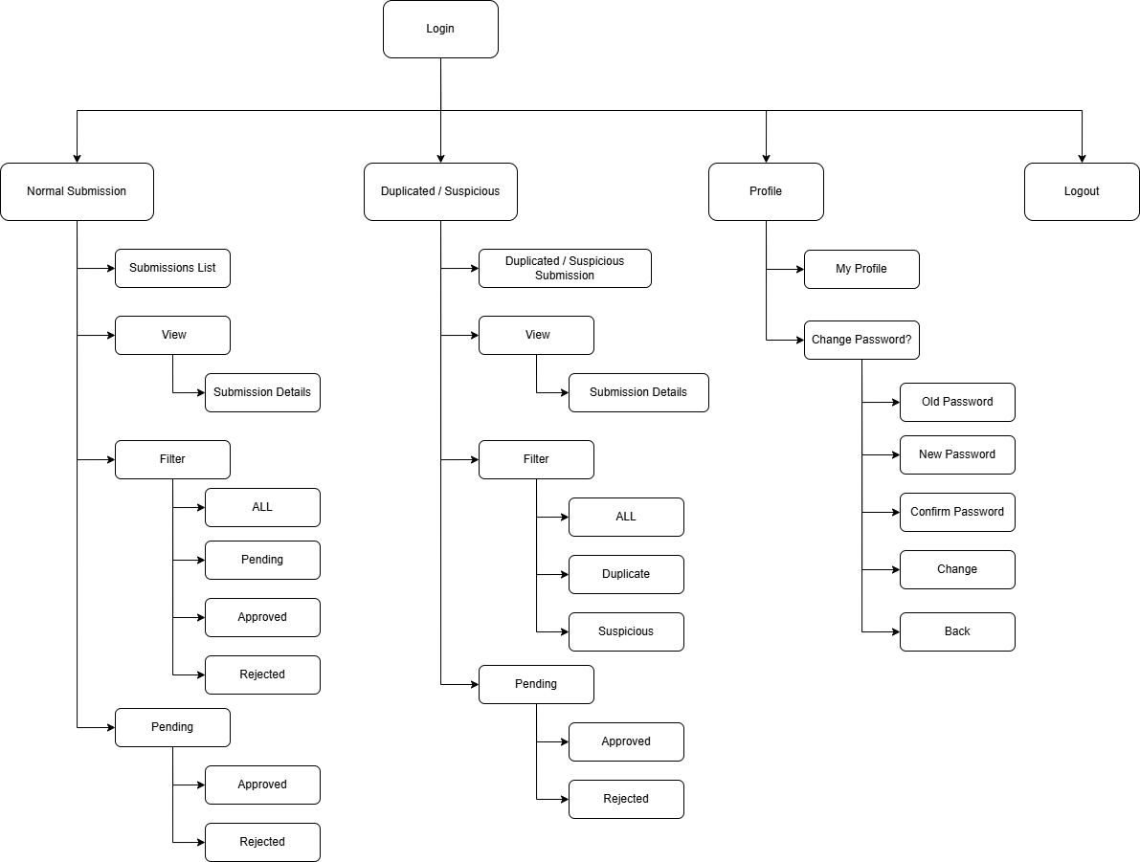

Administrator
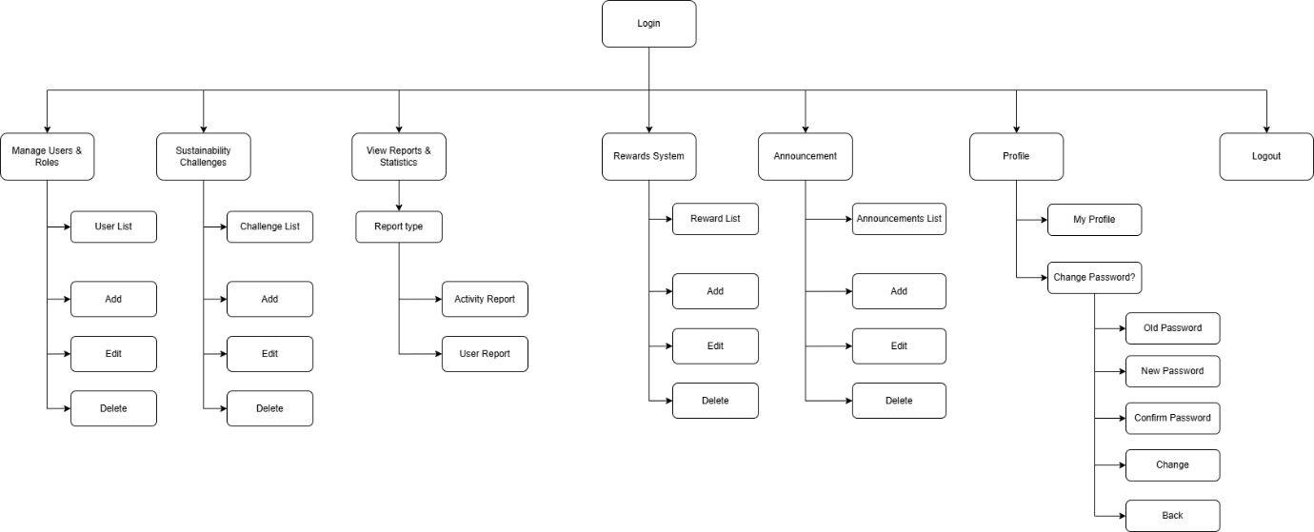

4.0 Implementation

4.1 Development Steps

4.1.1 Student
As the primary user component of the EcoRewards system, the student module enables users to participate in sustainability challenges, track their progress and interact with the platform. The development of the student module consists of five key steps:

Step 1: Student Dashboard and Performance Visualization
Dashboard interface was developed to provide students with an overview of their activity and progress. The system retrieves user information, total earned points and current ranking using SQL aggregation queries such as SUM() and DENSE_RANK().

The dashboard integrates multiple elements including announcements display, points summary and ranking. A tree growth system is implemented to enhance user motivation. In addition, a progress bar updates in real-time to reflect the user’s progress towards the next milestone.

Step 2: Log Green Action and Submission System
A submission module was developed to allow students to participate in sustainability challenges. Students can select a challenge and upload image as evidence of completion through a structured form.

The backend PHP script processes file uploads securely. Each submission is stored with a unique Submission ID and marked as “Pending” status for verification. To detect duplicate and suspicious submissions, advanced logic was implemented by using file hashing. This ensures data integrity by identifying:
- Duplicate Submissions: Same user uploaded same file
- Suspicious Submissions: Different user uploaded same file

Step 3: Submission History
A submission history interface was implemented to allow students to track all their previous submissions. The system retrieves submission records using SQL joins across different tables. Student can view detailed information such as submission date, challenge title, points earned and approval status in a modal window.

Step 4: Leaderboard and Ranking System
A leaderboard module is developed to foster engagement among students. The system calculates total points for each students using SQL aggregation and ranks them. The leaderboard displays:
- Top three users using a podium-style
- Full ranking table
- Individual user rank and total points

Step 5: Rewards Redemption System
Reward management interface was implemented for students to redeem earned points. In the interface, students can browse available rewards and redeem them if have required points. Additionally, the system automatically updates reward status based on expiry dates using SQL logic. A redemption history feature allows students to review past transactions and reward usage.

Step 6: Announcement and Notification System
An announcement feature was implemented to keep students informed about system updates, campaigns and events. A scrolling ticker element was introduced to show active announcements and a modal interface allows users to view full details when clicked. This ensures that important information is shown to all users in real time.

4.1.2 Moderator
The moderator module is to be part of the EcoRewards system, where it is responsible for verifying and validating user-submitted eco-friendly activities prior to the awarding of rewards. The process of creating the Moderator module involves the following steps:
Step 1: Moderator Dashboard and Submission Overview
A dashboard interface is created to enable moderators to effectively monitor and manage user-submitted activities. This is achieved through the following steps:
A table is created to retrieve data from the challenge_submission table, with two sections: Normal Submission and Duplicated/Suspicious Submission.
Normal Submission is a page with all normal submissions, whereas Duplicated/Suspicious Submission is a page with all duplicated or suspicious submissions. Other options are added to the system to provide better user experience. This is done by adding other features such as the filtering options, which are very helpful for the moderator.
Step 2: Submission Review and Modal Interface
The detailed review interface is another feature that is included. This is achieved by creating an interface where the moderator can view each submission. A modal window is included, which shows the necessary information once the submission is clicked. This information includes the submission ID, student ID, challenge ID, submission date, and uploaded proof images. This is an essential feature, which helps improve user experience. This is achieved by creating an interface where the moderator can view the information without having to change the original dashboard.
Step 3: Approve and Reject Mechanism
An approval system is developed where the moderator can make decisions on each submission. The moderator is allowed to either Approve or Reject the submissions. If the moderator approves the submission, the status is set to “Approved” with the flag type being “normal”. If the moderator rejects the submission, the status is set to “Rejected” with the flag type being either “duplicate” or “suspicious”. In addition, all moderation activities are recorded in the verification table.
Step 4: Duplicate and Suspicious Detection System
Advanced validation logic is included in this system to detect duplicate and suspicious submissions. The system includes proof image hashing (ProofHash) to compare the uploaded images by the user. The system is able to detect:
Duplicate Submissions: The user submits duplicate proof images.
Suspicious Submissions: Other users also submit duplicate proof images.

In addition, in case a valid submission is approved, all other related pending submissions from the same user on the same challenge will be rejected as duplicates. This ensures that the user is not rewarded for doing the same thing and data integrity is maintained in the system.
Step 5: System Efficiency and Data Integrity
The Moderator module is included in this system to emphasize efficiency, accuracy, and usability. Through a structured workflow system, validation processes, and live data updates, the system guarantees that only true eco-friendly activities will be accepted and rewarded.

4.1.3 Administrator
As the key point of control in the EcoRewards system, the Administrator module allows administrators to control the system, edit the platform, and oversee operations using data-driven insights. PHP and MySQL have been used to provide high level database interactions and complex aggregation logic. There were five crucial steps that the development took:

Step 1: User & Role Management
CRUD interface was done to operate the users table and this table consists of User ID, Username, Gender, Password (hashed), Date of Birth (D.O.B), Contact details, Role, and Last Active. The PHP scripts were designed in such a way that they would enable the administrators to Add, edit or delete user accounts. The strong PHP session validation and role-based access control (RBAC) will ensure that unauthorized administrators are unable to carry out such administrative functions, and to this end, data integrity and security are ensured.

Step 2: Manage Sustainability Challenges
It has created a dynamic hosting module in order to enable the administrator to Add, Edit, or Delete eco-friendly challenges. The table of challenges was designed to host the Challenge ID, Title, Description, category and points. Real-time SQL queries ensure that any updates to challenge descriptions or point values are immediately reflected in the Student’s ‘Select Action’ interface.

Step 3: View Reports and Statistics
Users Report: Use SQL COUNT() with Group By role, to calculate total number of users census and also percentage distribution of students, moderators and administrators.
Activity Report: Utilizes MySQL date functions (DATE(), MONTH(), YEAR()) to find out the number of active users daily, monthly and annually with regards to navigation data and timing of last activity. These metrics are dynamically generated using PHP scripts so that the administration can view them.

Step 4: Reward Management
The system based on incentives on the platform was maintained with the help of a special system of rewards management. Items could be Added/Edited/Deleted by the Administrators in the rewards table, that monitors the Reward ID of/and Title, Type (Voucher/Merchandise), the Validity (days), and the number of Points required. The backend logic will ensure that catalogue of rewards is kept in time with the system of points redemption and creating a motivating environment for users.

Step 5: System Announcements
In order to ensure smooth operation of communication, a global announcement system was formulated and had Add, Edit, and Delete applications. Notifications are kept in a specific table that holds the following Announcement ID, Title, description, start date, end date, administrator ID and status (Active/ Inactive). PHP scripts dynamically render active announcements on all dashboards based on their validity period, ensuring timely delivery of eco-friendly tips and campaign updates.

These steps in development will give an administrator the control interface, which is robust, based on data, and enables to have an efficient control over users, challenges, rewards, and announcements besides some valuable statistical insights.

4.2 Code Snippets

4.2.1 General
Login Page
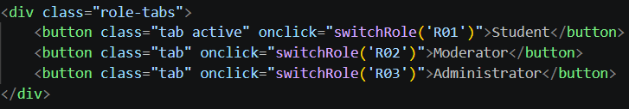
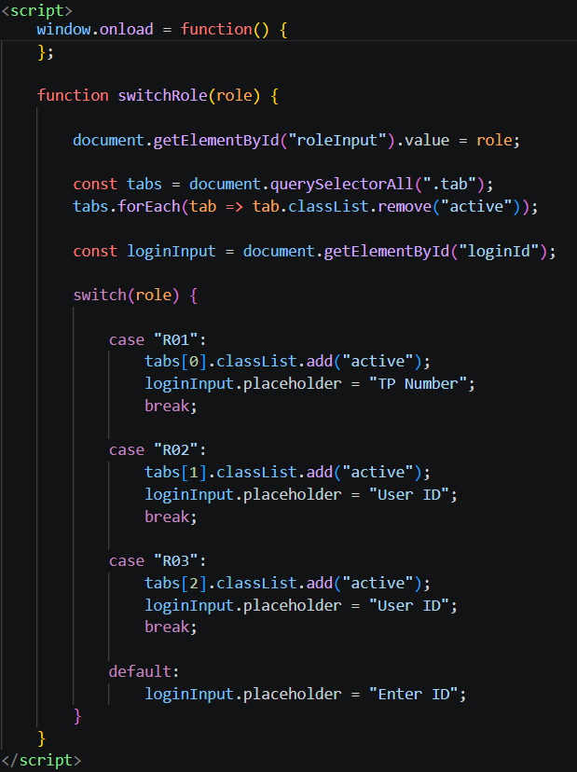
These codes create a switch tab UI that allows the user to access different system roles such as student, moderator and administrator. When a tab is clicked, the switchRole(role) function is triggered which stores the selected role in a hidden input field for the form submission. If the users enter valid credentials, the system will redirect them to the respective interface.

Sidebar and Hamburger Menu
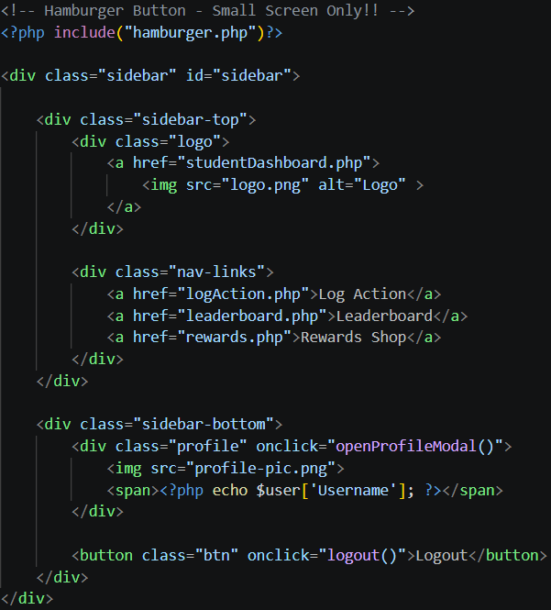
The sidebar is designed as the main navigation component of the system. It contains the website icon, role-specific features, the user’s profile and a logout button. When a user clicks on different features, the sidebar toggles an active class to indicate the current features being used.

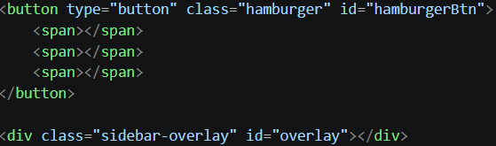
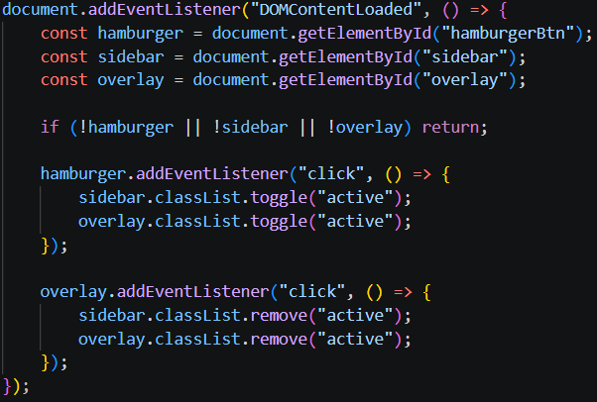
The sidebar remains visible on larger screens, ensuring an easy and eccessible navigation experience. On smaller screens, the sidebar is hidden by default and can be accessed by clicking the hamburger button.
Profile Modal and Change Password Modal
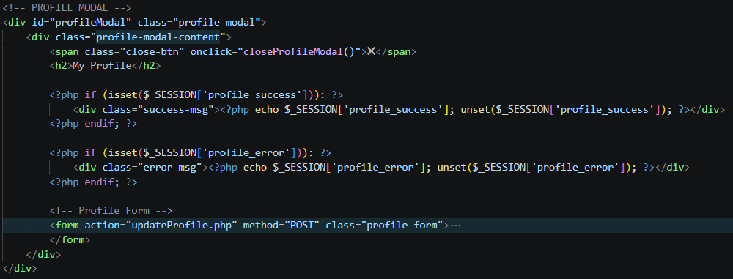
When the users click the profile section in the sidebar, the system will load the profile modal into the current page. It allows users to view and update their personal information.
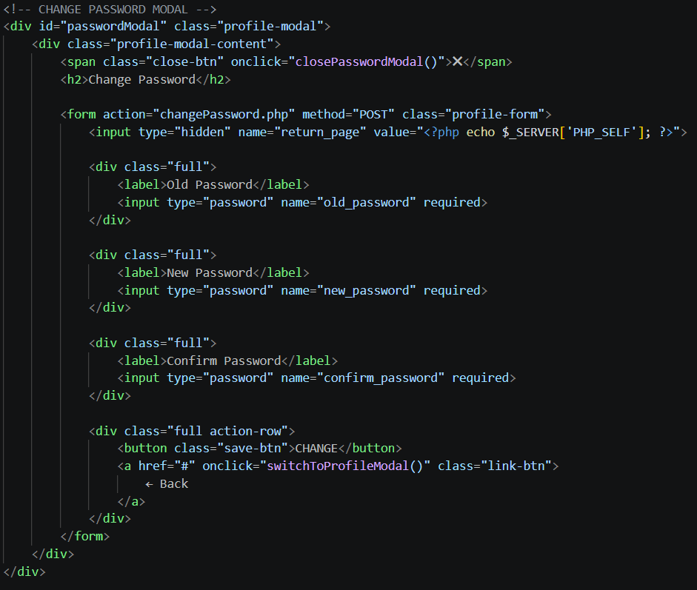
From the Profile modal, users can also navigate to the Change Password modal. Users are required to enter their current password, new password and confirm password. If the current password does not match the passwordstored in the database or if the new password and the confirm password do not match, the system will not allowed the password to be changed.

4.2.2 Student
Student Dashboard - Announcement Feature
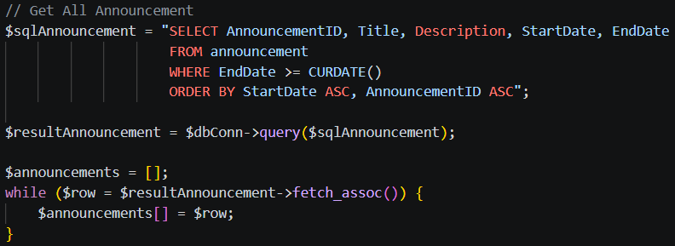
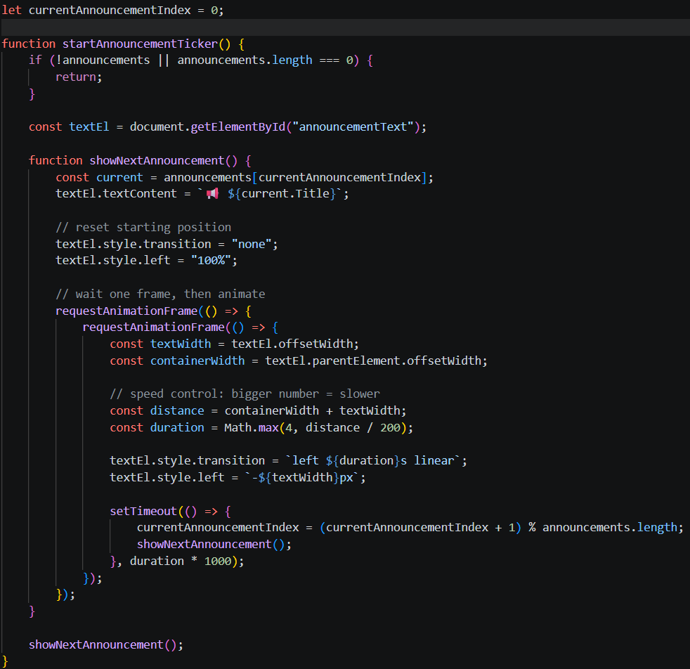
In the Student Dashboard, an announcement feature is implemented to display important updates or event notices to users. The startAnnouncementTicker() function retrieves the current announcement title from the announcements array and display it inside the announcementText element. After one announcement finishes scrolling from right to left, the system automatically updates the index and displays the next announcement in sequence. This feature presents announcements in an engaging and space-efficient way while ensuring that multiple updates can be displayed continuously.
Student Dashboard - Forest Growth Feature
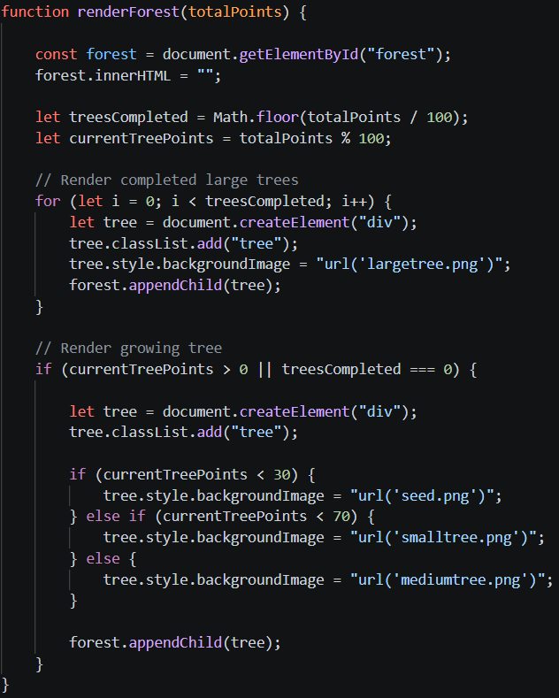
The renderForest(totalPoints) function is used to visually represent the user’s accumulated points as a forest growth feature. The function retrieves the forest container element and clears any existing content to ensure the display is updated dynamicaly. It calculates the number of fully completed trees by dividing the total points by 100 and determines the remaining points for the current growing tree. The growth stages are defined as follows:
- Below 30 points: Seed
- Below 70 points: Small Tree
- Below 100 points: Medium Tree
- 100 points: Large Tree
This feature provides a visual representation of user progress, making the system more engaging and motivating by allowing users to view their achievements in the form of growing trees.

Student Dashboard - Log Green Action Feature
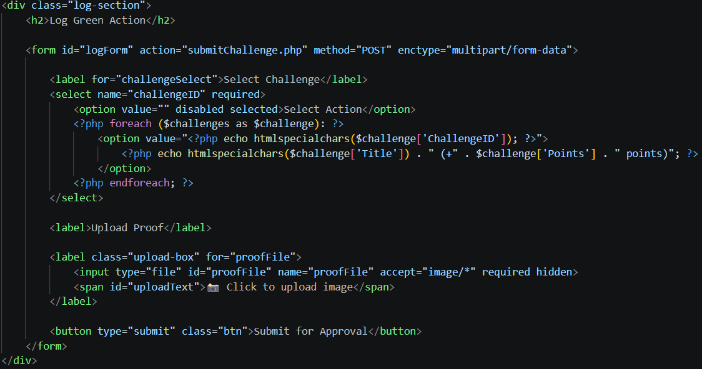
The Log Green Action feature allows students to submit sustainability activities through a form that includes selecting a challenge and uploading proof in the form of an image. The system load avaiable challenges from the database and displays them in a dropdown list.
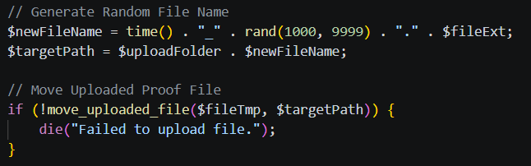
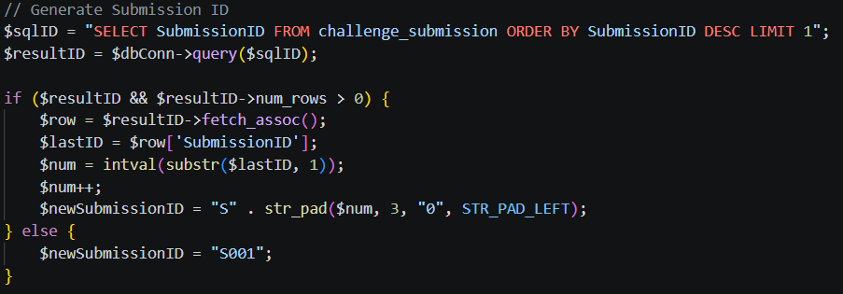
After submitting, the backend processes the uploaded file by generating a unique file name to prevent duplication and stores the file in desired folder. Besides that, a unique submission ID is generated by retrieving the latest existing ID from the database. This ensures that each submission is uniquely identified and securely stored in the database.

Log Action - Submission History Table
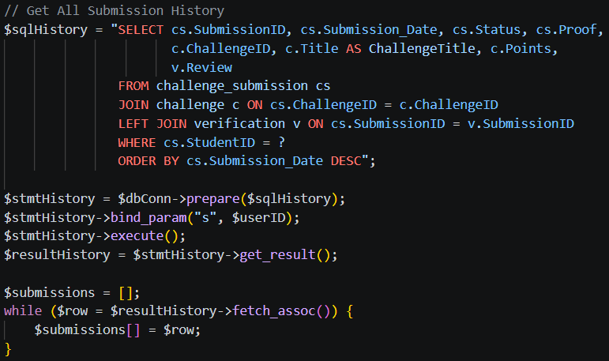
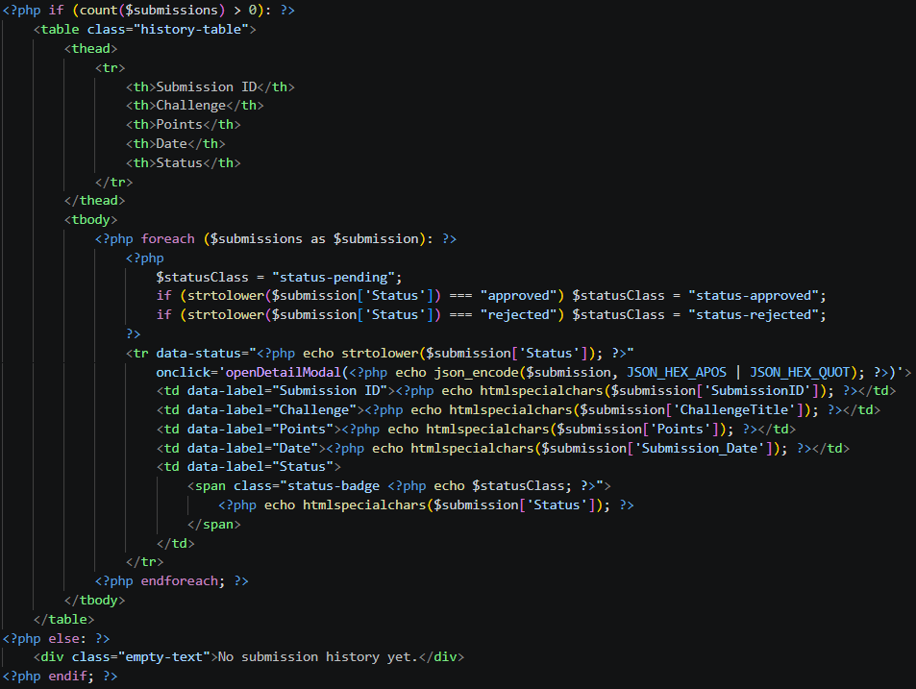
The Submission History Table in the Log Action page is designed to display all activities submitted by the user. The system retrieves records from the database and dynamically generates a table that includes details such as Submission ID, Challenge, Points, Date and Status. Users can view more detailed information about each submissions by clicking on a table row.

Log Action - Submission Details Modal
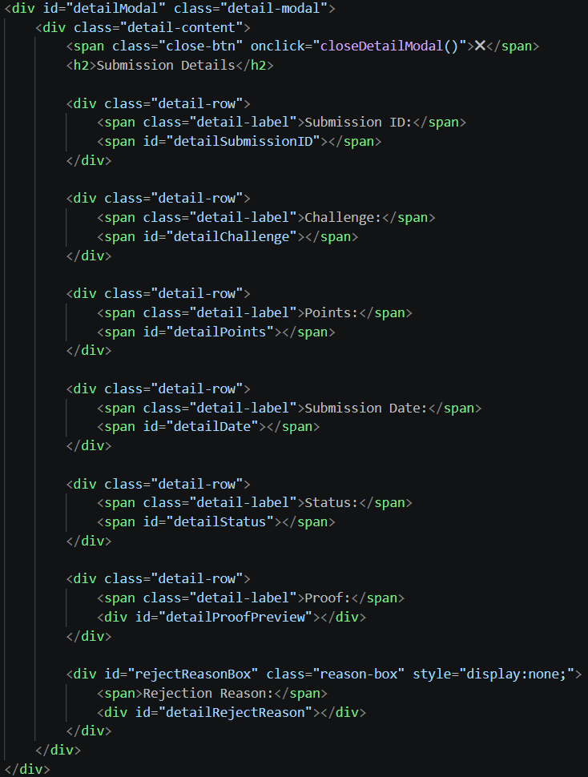
The Submission Details modal is implemented to provide detailed information about a selected submission. When a user clicks on a submission in the table, the modal is displayed and dynamically shows all relavant information. If the selected submission is rejected by a moderator, a rejection reason is also displayed to provide feedback to the user. This feature enhances usability by allowing users to quickly access detailed information.

Log Action - Filter Feature
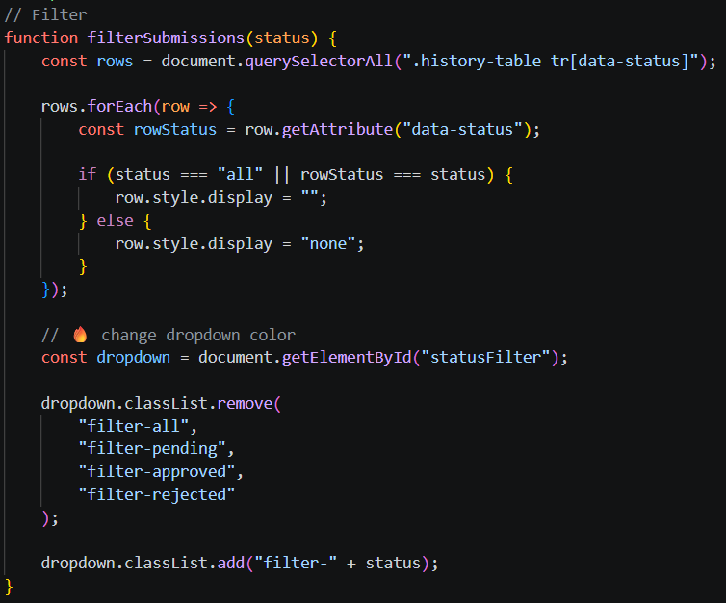
The submission filter feature is implemented to allow users to view their submission history based on different statuses such as pending, approved and rejected. The filterSubmissions(status) function dynamically filters table rows by checking each submission status and displays those that match the selected status.

Leaderboard - Podium Section
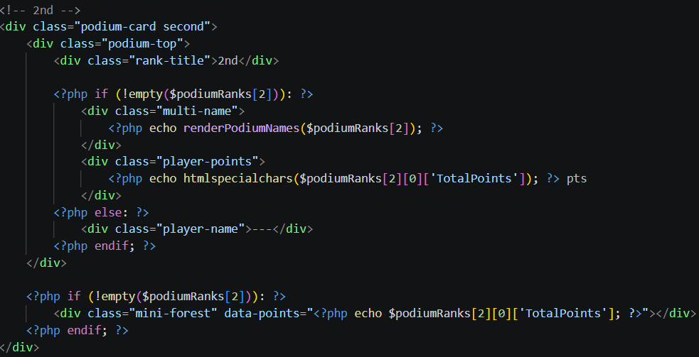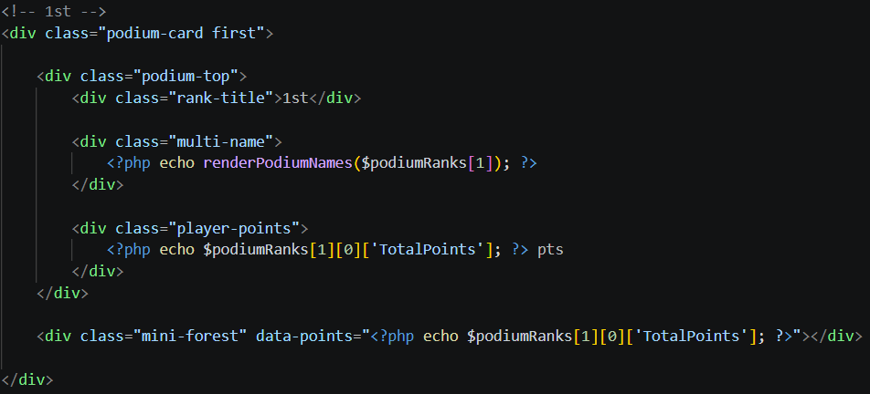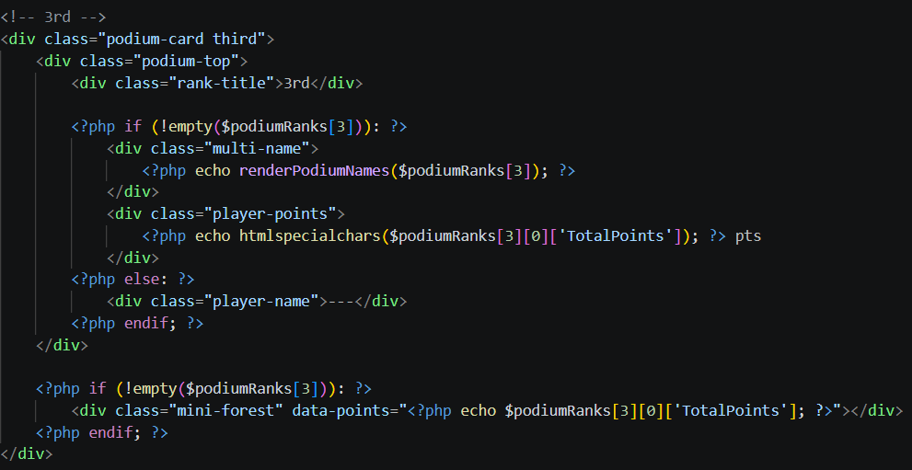
The Podium section in the leaderboard is designed to spotlight the top three students based on their total points. The system dynamically retrieves ranking data and displays the first, second and third positions using separate podium cards. This feature enhances user motivation by visually recognizing top performers and encouraging healthy competition among users.

Leaderboard - Table Section
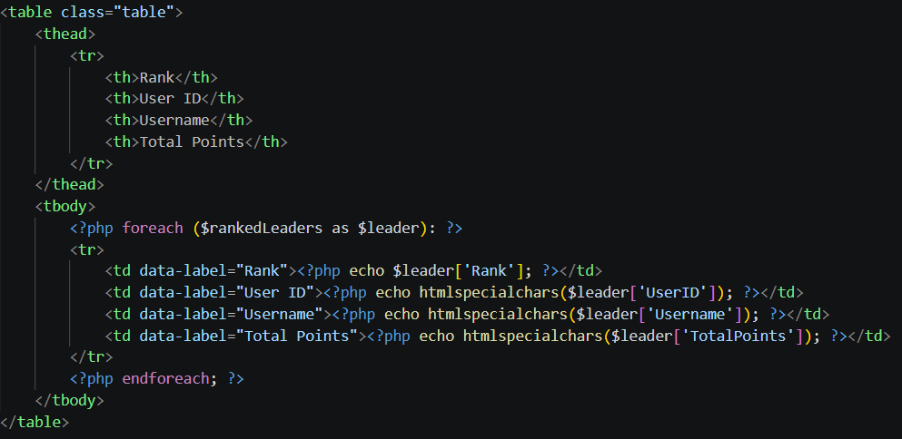The Table section in leaderboard is used to display a ranked list of users based on their total points, It will shows each record with details such as rank, user ID, username and total points. This structured table provides a clear overview of user performance, allowing users to compare rankings and track their progress within the system.

Leaderboard - Current Rank Tab
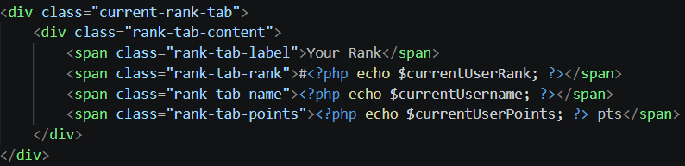
The Current Rank Tab is implemented to ensure that users can easily view their own ranking information even when they are positioned at the bottom og the leaderboard. This feature displats the user’s rank, username and total points in a fixed section separate from the leaderboard table.
Rewards Shop - Points Summary Section
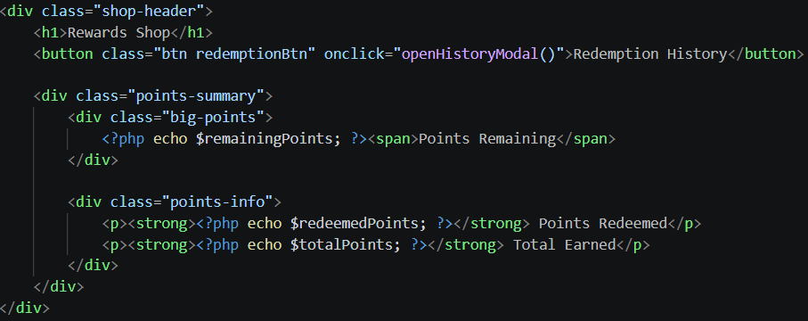
The Points Summary section in the Rewards Shop page is designed to provide users with a clear overview of their points status. It displays the remaining points for redemption, as well as the total points redeemed and total points earned.

Rewards Shop - Redemption History Modal
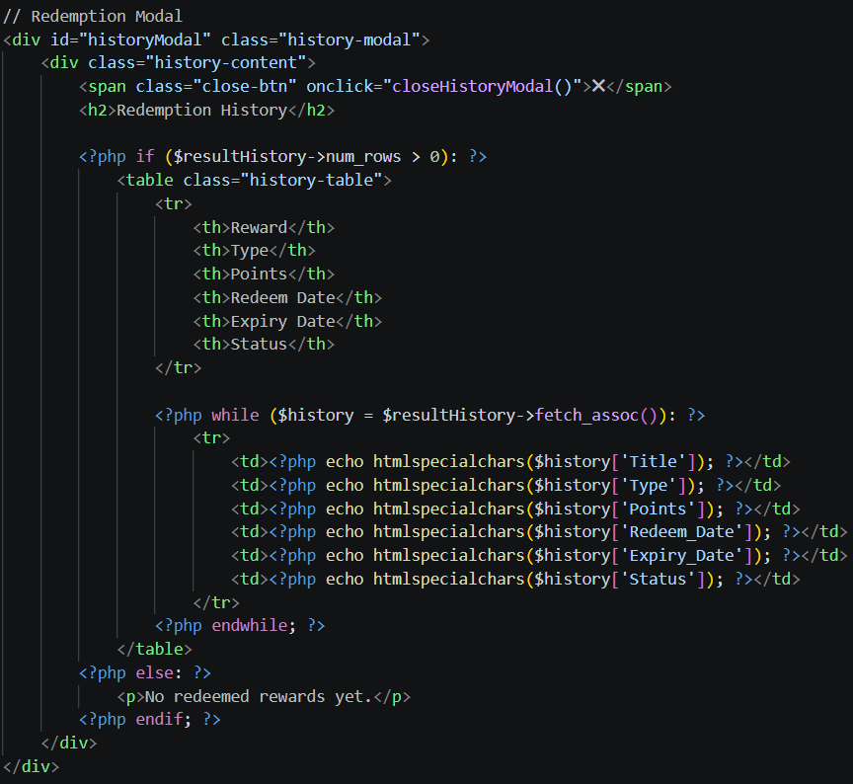
Furthermore, a redemption history button is implemented to allow users to view their past reward transactions. When click on the button, the redemption history modal will appear and display a table containing details such as reward title, type, points used, redemption date, expiry date and status. This feature enhances user experience by providing transparency reward transaction history.

4.2.3 Moderator
Moderator Dashboad Filtering
This retrieves only normal submission for display in the moderator dashboar. It ensure that standard submission and flagged submissions are separated.

Retrieve Submission Data
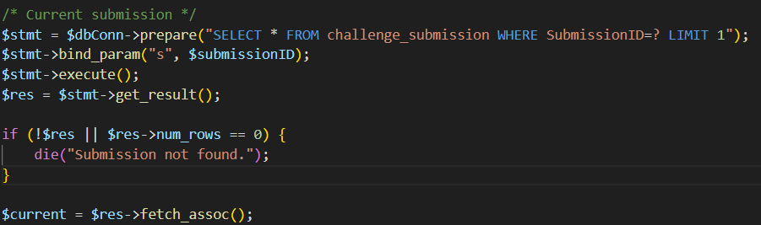
This code retrieves a specific submission from the challenge_submission table using the Submission ID. The use of prepared statements ensures secure database access, avoiding SQL injection attacks. The retrieved data is used to display submission details such as student ID, challenge ID, and uploaded proof, within the moderator review interfrace.

Approve / Reject Normal Submission
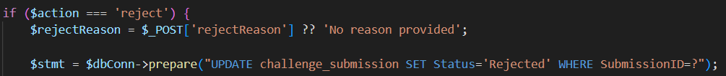
This is allow the moderator to approve or reject a normal submission. When is approved, it will update the status to “Approved”. When is rejected, then it is “Rejected”. This is to ensure only verified activities proceed to the reward stage.

Store Moderator Verification Record
This code records the moderators decision into the verification table. It stores the moderator ID, submission ID, and review comments. This is to provides a history of all moderation actions.

Suspicious Detection (ProofHash)
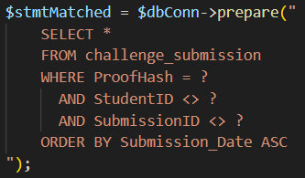
This is to detect suspicious submission by comparing the ProofHash value of uploaded images. If mutiple submission are sharing the same hash, but belong to different users, then it is flagged as suspicious. It help preventing user from using the same image for proof.

Duplicate Handling Logic (Auto Reject)
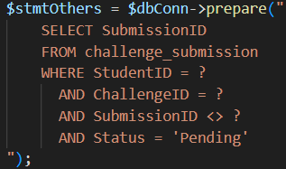 | 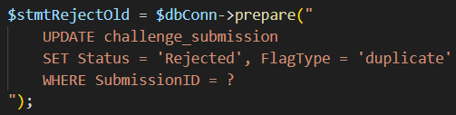

This is to identifies duplicate submissions made by the same student for the same challenge. Once the submission is been approve, all other related pending submission will be automatically rejected and flagged as “duplicate”. This prevents mutiple rewards from being granted for the same activity.

4.2.4 Administrator
Frontend UI/UX Enhancements
Real-time Filter & Search
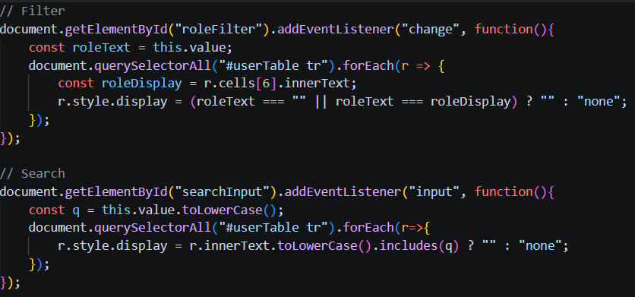

Call attention to the fact that the search bar and the dropdown of the word "Role" manipulates the JavaScript DOM and filters the results immediately, without having to reload the page.

AJAX Integration
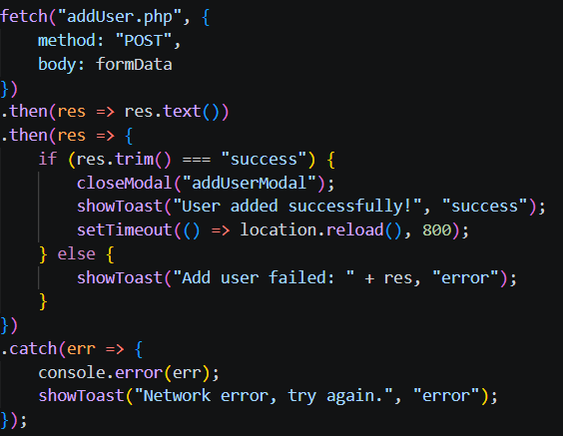 | 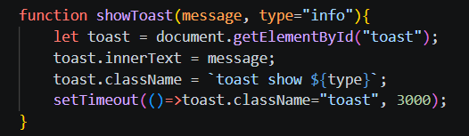

Add, Edit, and Delete buttons are implemented with the use of the JavaScript Fetch API to transfer information to the PHP back-end without interrupting the design of the page, but with a success notification in the form of the Toast instead of a distractive page reload.

Automatically generated userID
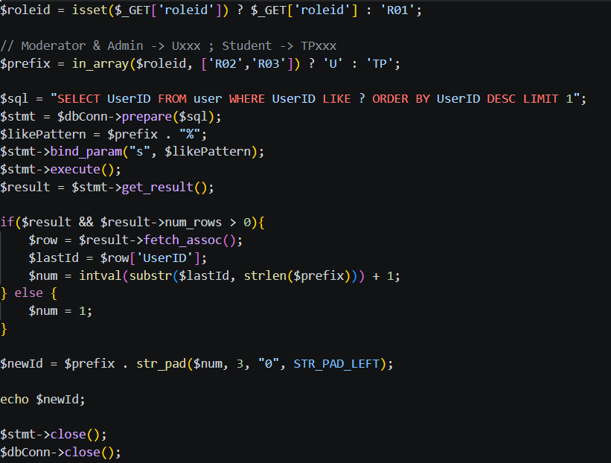
Unlike standard SQL AUTO_INCREMENT, this logic provides a meaningful ID structure (TP vs U). It also relies on the str pad to maintain a steady 5 character string format (e.g., TP001) that is critical to indexing into the database and an easy way of visual representation.

Manage User
Add
Data Security and Database Integrity
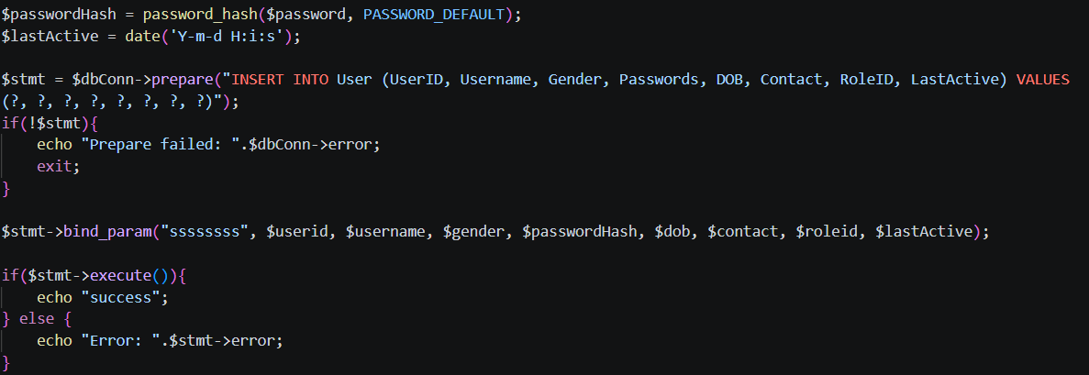
- password_hash() function used with PASSWORD_DEFAULT make password are encrypted using the hash passwords password, thus the user passwords are never stored as plain-text passwords in the database.
- SQL Prepared Statements ($stmt->bind_param) are realized. Such strict division of the query structure and the data values effectively removes SQL injection threats.

Edit
Conditional Query Execution
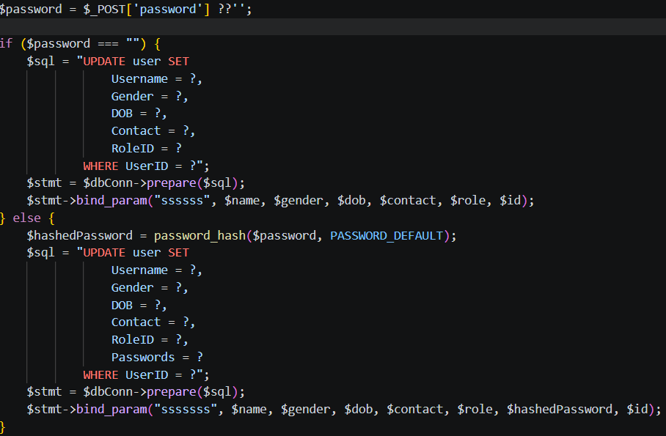
The script confirms whether or not the field of password is empty. In case it does not contain any value, then it will create an UPDATE dynamically but void of the password column. A logic of this nature makes sure that the old password of the user does not change unless he/she specifically requests a password change to enhance data security and ease of use.
Sustainability Challenges
A powerful sorting algorithm with JavaScript helped admin to make the administration process very fast in finding or sorting the challenges based on the merit of rewards or titles. This enables the re-ordination of a table without overhead to a server.
DOM Manipulation & Data-Type Awareness
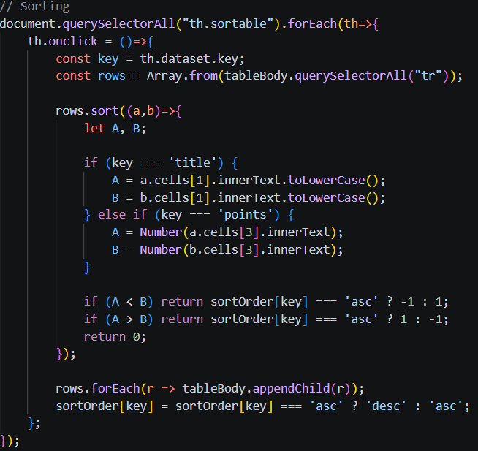
- This system is able to manipulate the rows of a table into an Array which allows the high-speed classification of the table within the browser memory instead of the server which saves on requests to the server and gives an immediate response.
- The script intelligently distinguishes between String sorting (for Titles) and Numerical sorting (for Points), ensuring logical ordering.

Server-Side Duplicate Validation
The backend has a validation layer that ensures the data is not shared among various challenges since it is required to be of the same title to be considered intact. This will make each eco- challenge distinctive and recognizable.
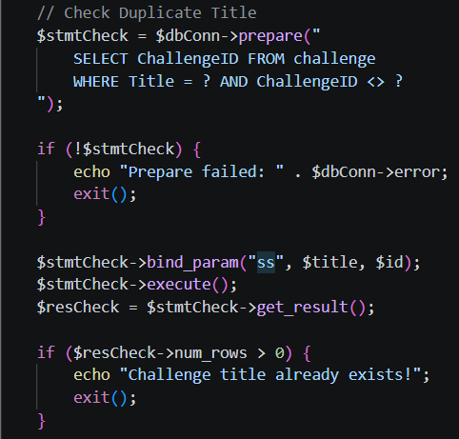
Integrity Guard & Robust Error Handling
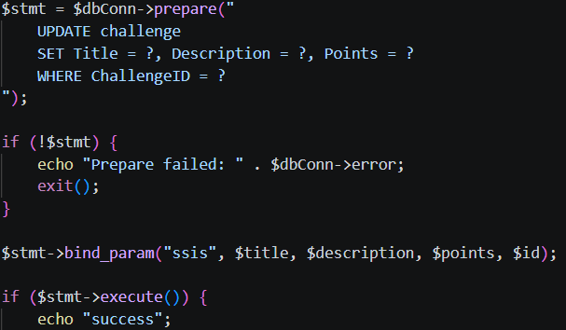
- SQL logic WHERE Title = ? AND ChallengeID <> ? is an advanced method of duplicate check; it examines whether there are other records with the same title whereas current record is allowed to retain its name in case it has not been altered.
- It terminates the script once a duplicate is detected so that the database does not get in an incoherent state.
Rewards System
Conditional UI Logic (Type-Based Input Control)
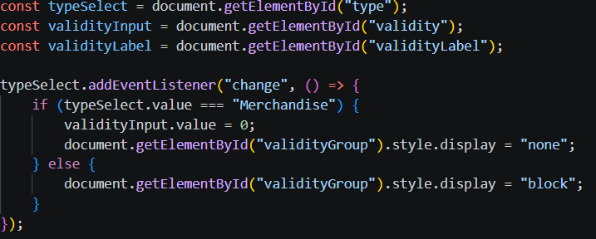
- In order to preserve the integrity of data and enhance User Experience (UX), installed a listener tracking the Reward Type. As far as there was no need to provide a Merchandise period (physical items), the system would hide and reset the field of validity automatically to 0 when the option is chosen.
- This eliminates "Logic errors" in the database (e.g. a physical mug with expiration length of 30 days) and simplifies the process of entering data into the database as an administrator.

View Report & Statistics
Integrated the Chart.js library to render dynamic pie charts. The system gets the data stored on MySQL backend and converts it into a format of a JSON and displays it.
User Report & Activity Report
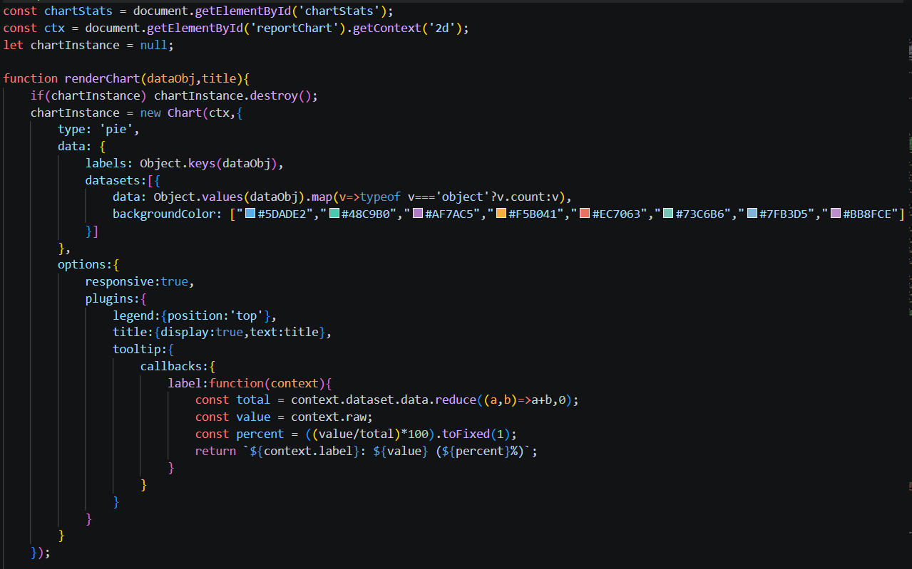
It presents the proportion of Students, Moderators and Administrators. It also shows an overview of the peaks of user engagement according to the time filters (Hourly today, daily monthly or yearly).
Server-Side Data Export (CSV Generation)
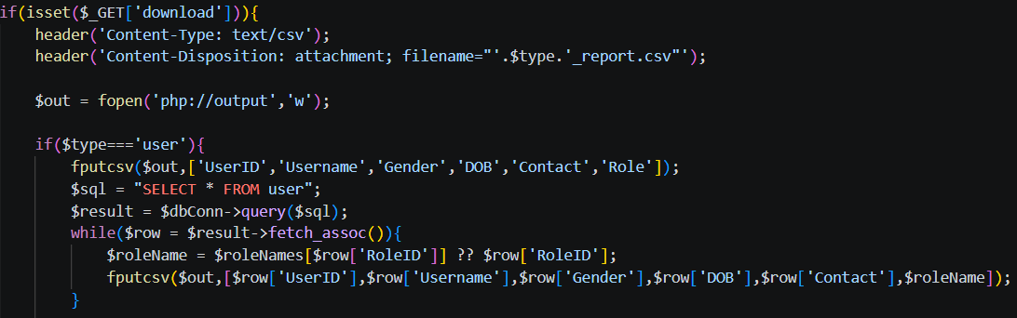
A special PHP function that causes a downloading of a file by alteration of the HTTP headers. This will enable the administrator to export the existing view (User list, Badges or Activity logs) to a.csv file.

4.3 Screenshots of Major Pages

4.3.1 General
Login Page
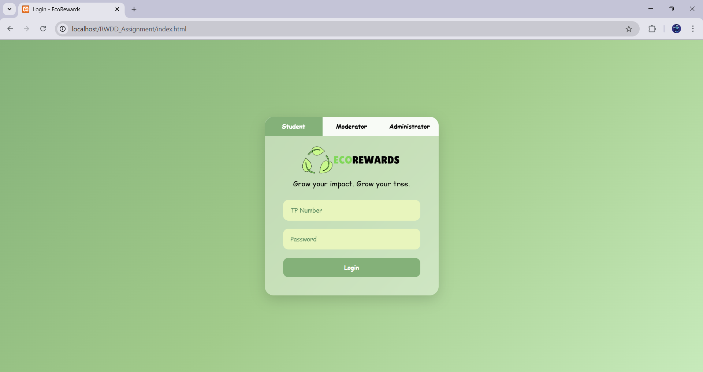

Sidebar and Hamburger Menu
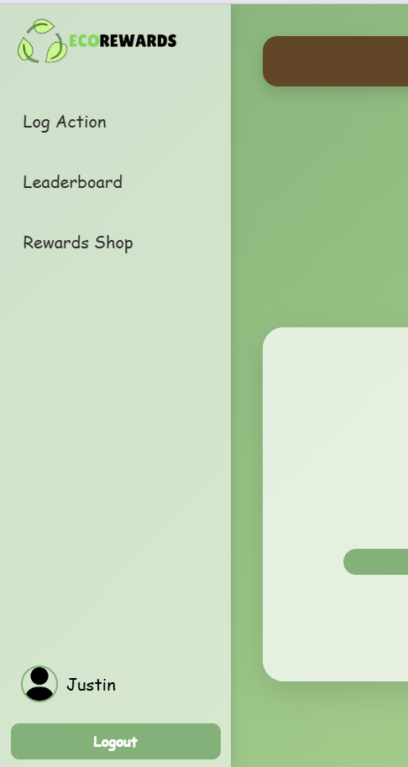 | 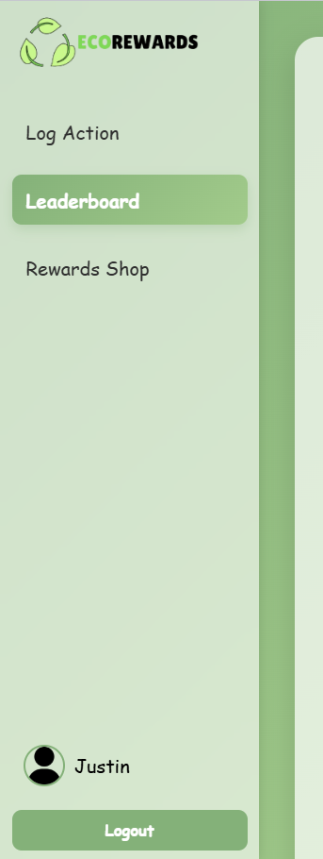 | 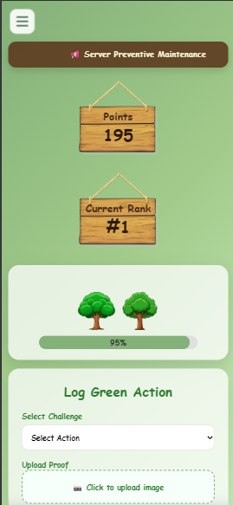 | 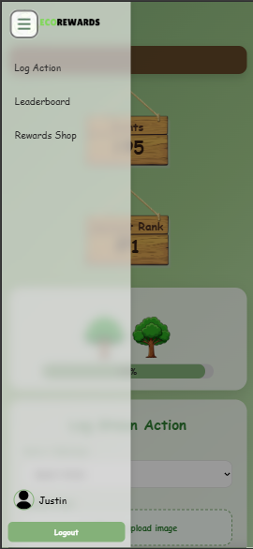

Profile Modal and Change Password Modal
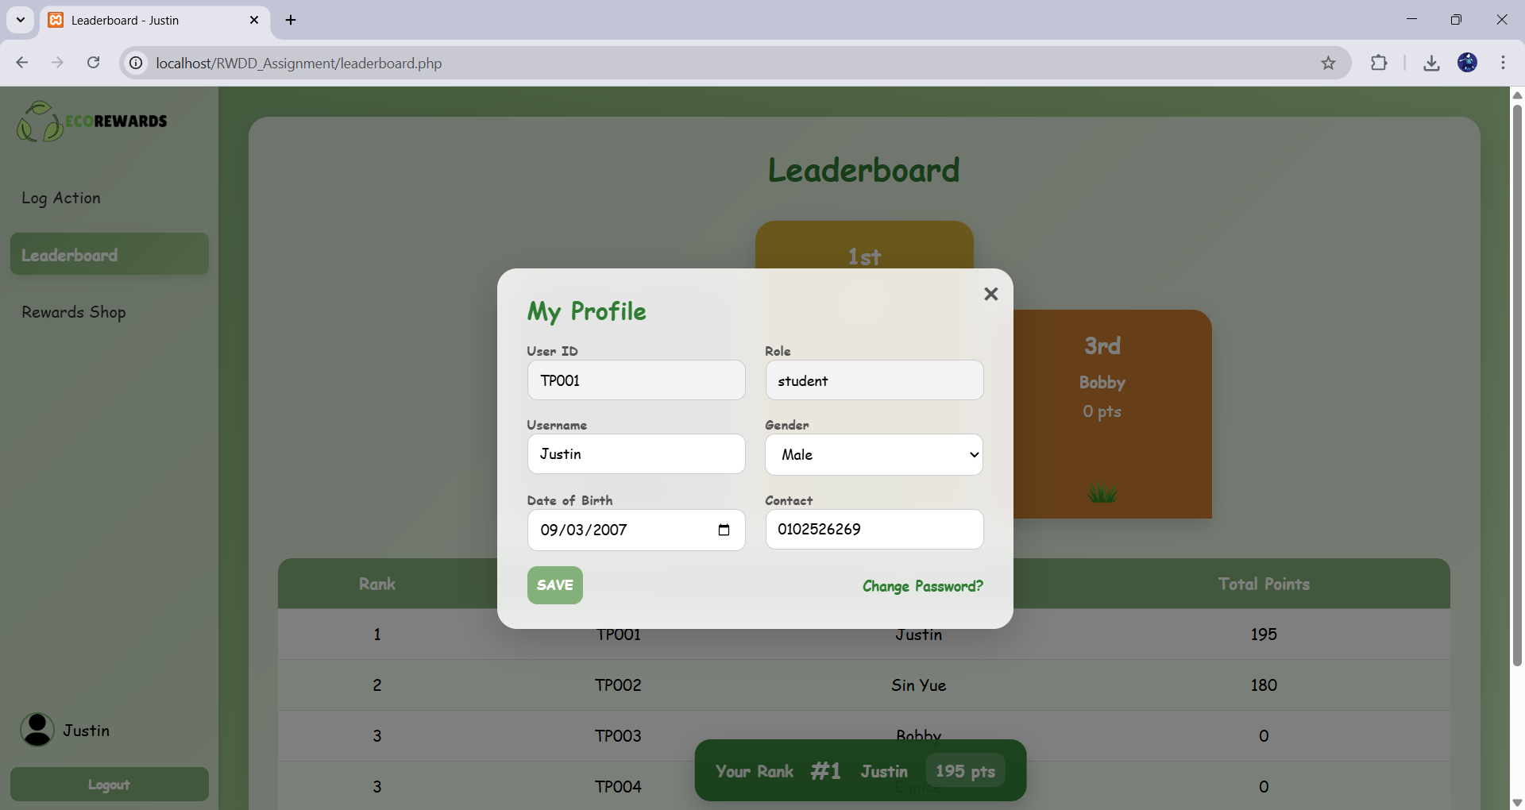
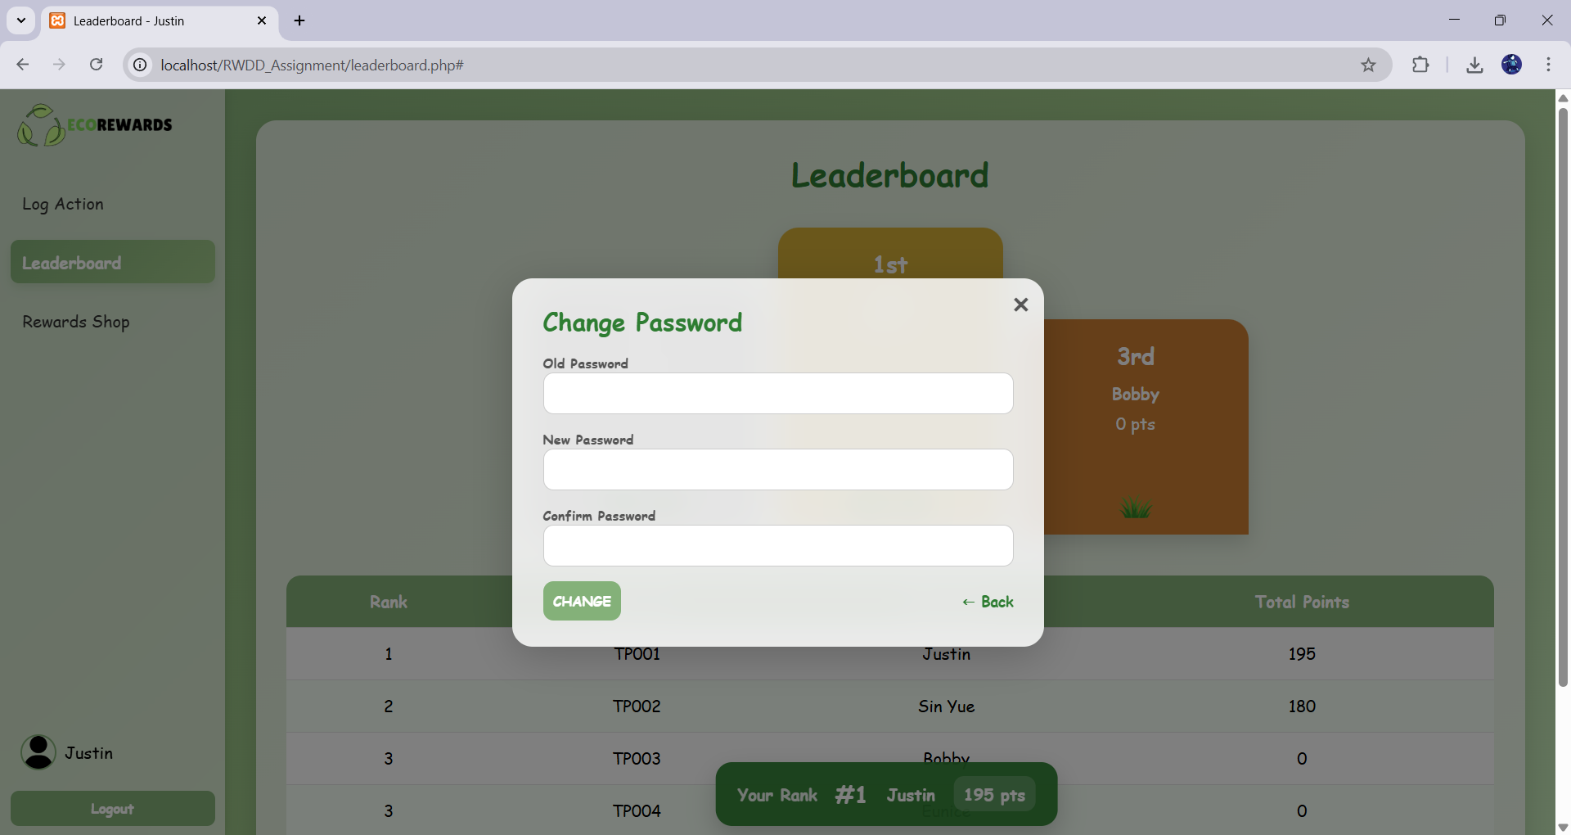

4.3.2 Student
Student Dashboard
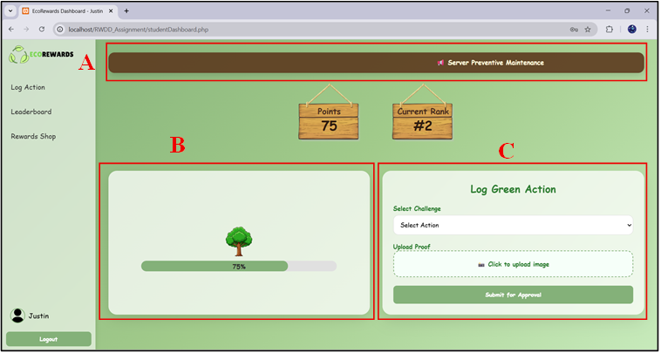
Section A: Announcement feature
Display system announcements.
Section B: Forest Growth feature
Represent user progress visually.
Section C: Log Green Action feature
Allow user to submit sustainability activities.

Student Dashboard - Announcement Modal
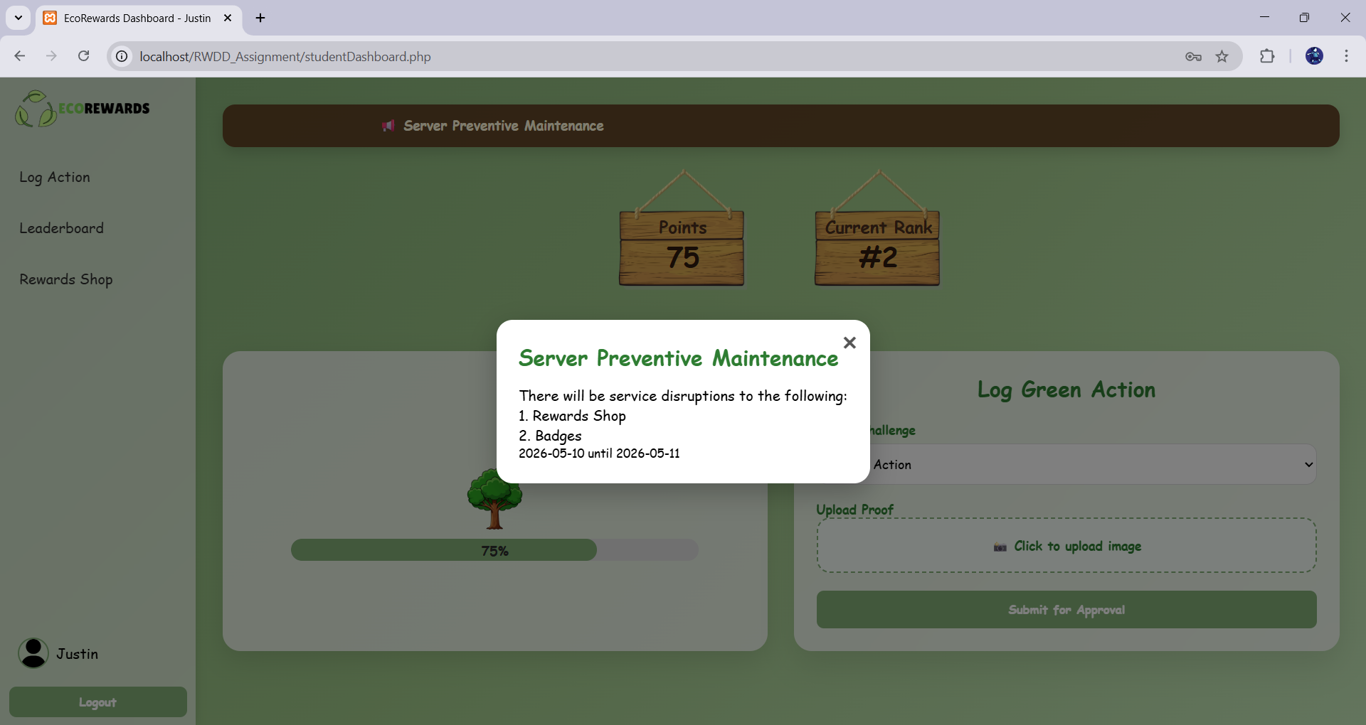
Log Action - Submission History Table
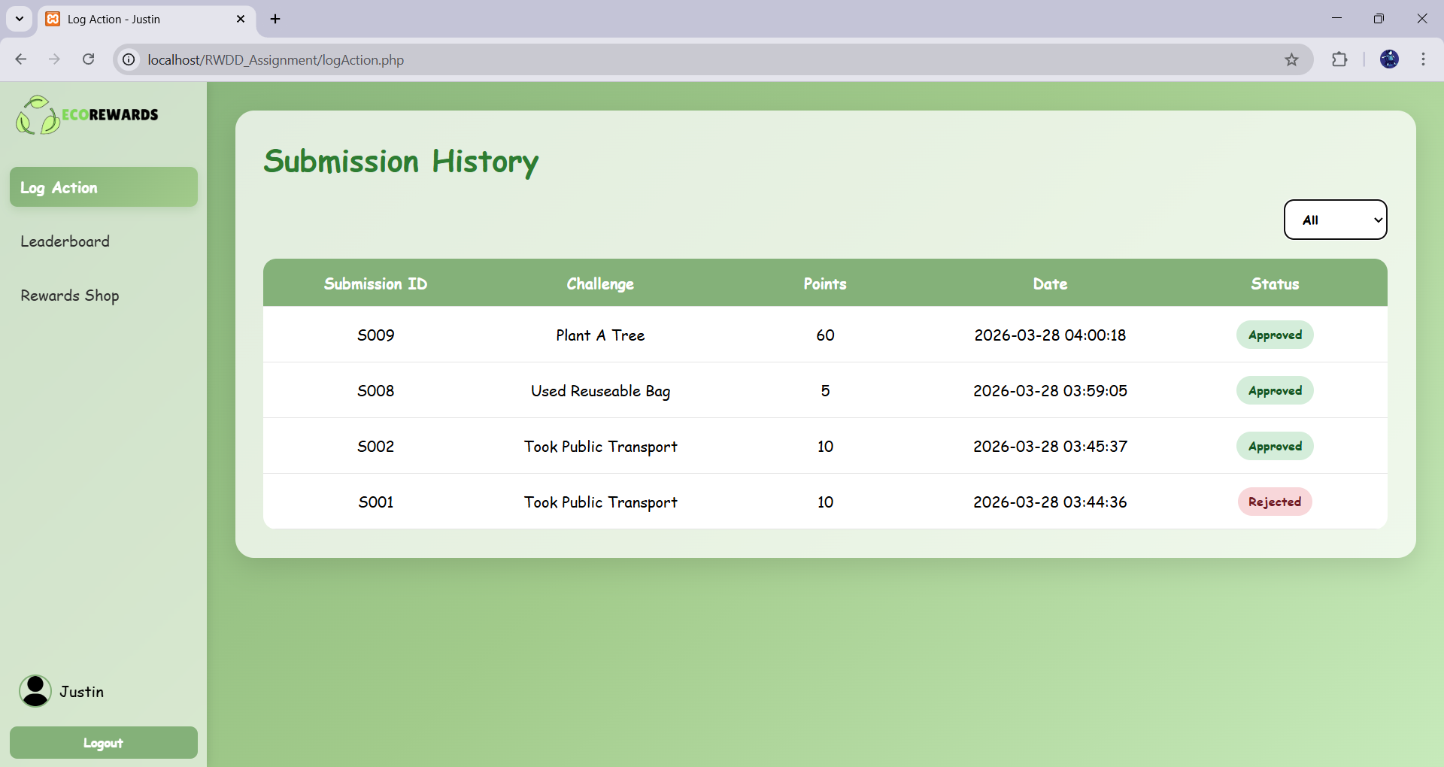

Log Action - Submission Details Modal
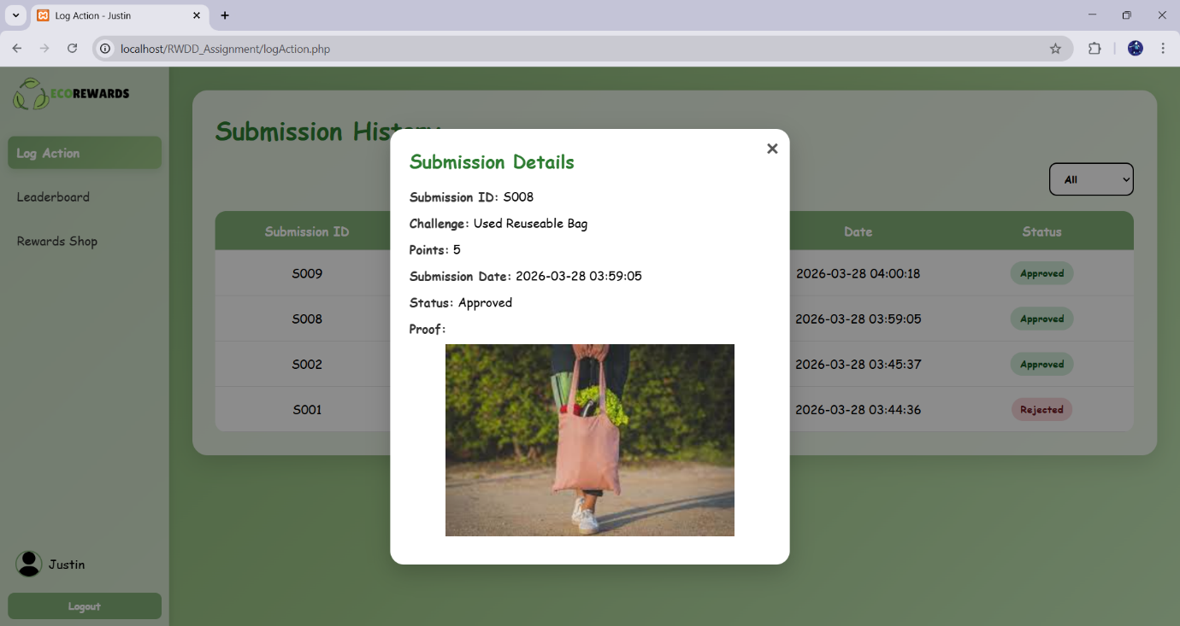

Log Action - Filter Feature
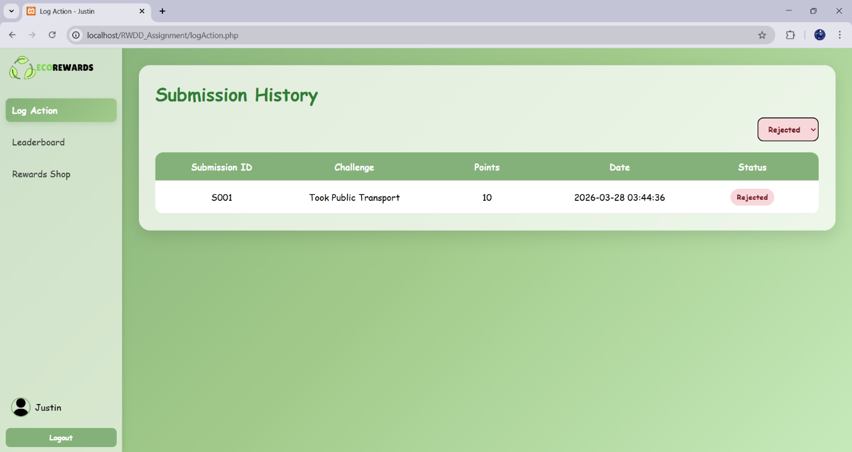

Leaderboard
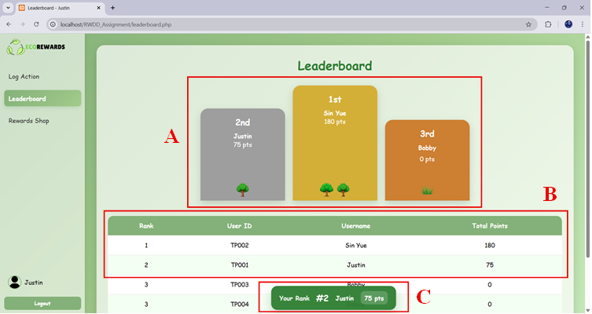
Section A: Podium Section
Highlights the top three students.
Section B: Leaderboard Table
Shows all student ranking
Section C: Current Rank Tab
Shows current user ranking
Rewards Shop
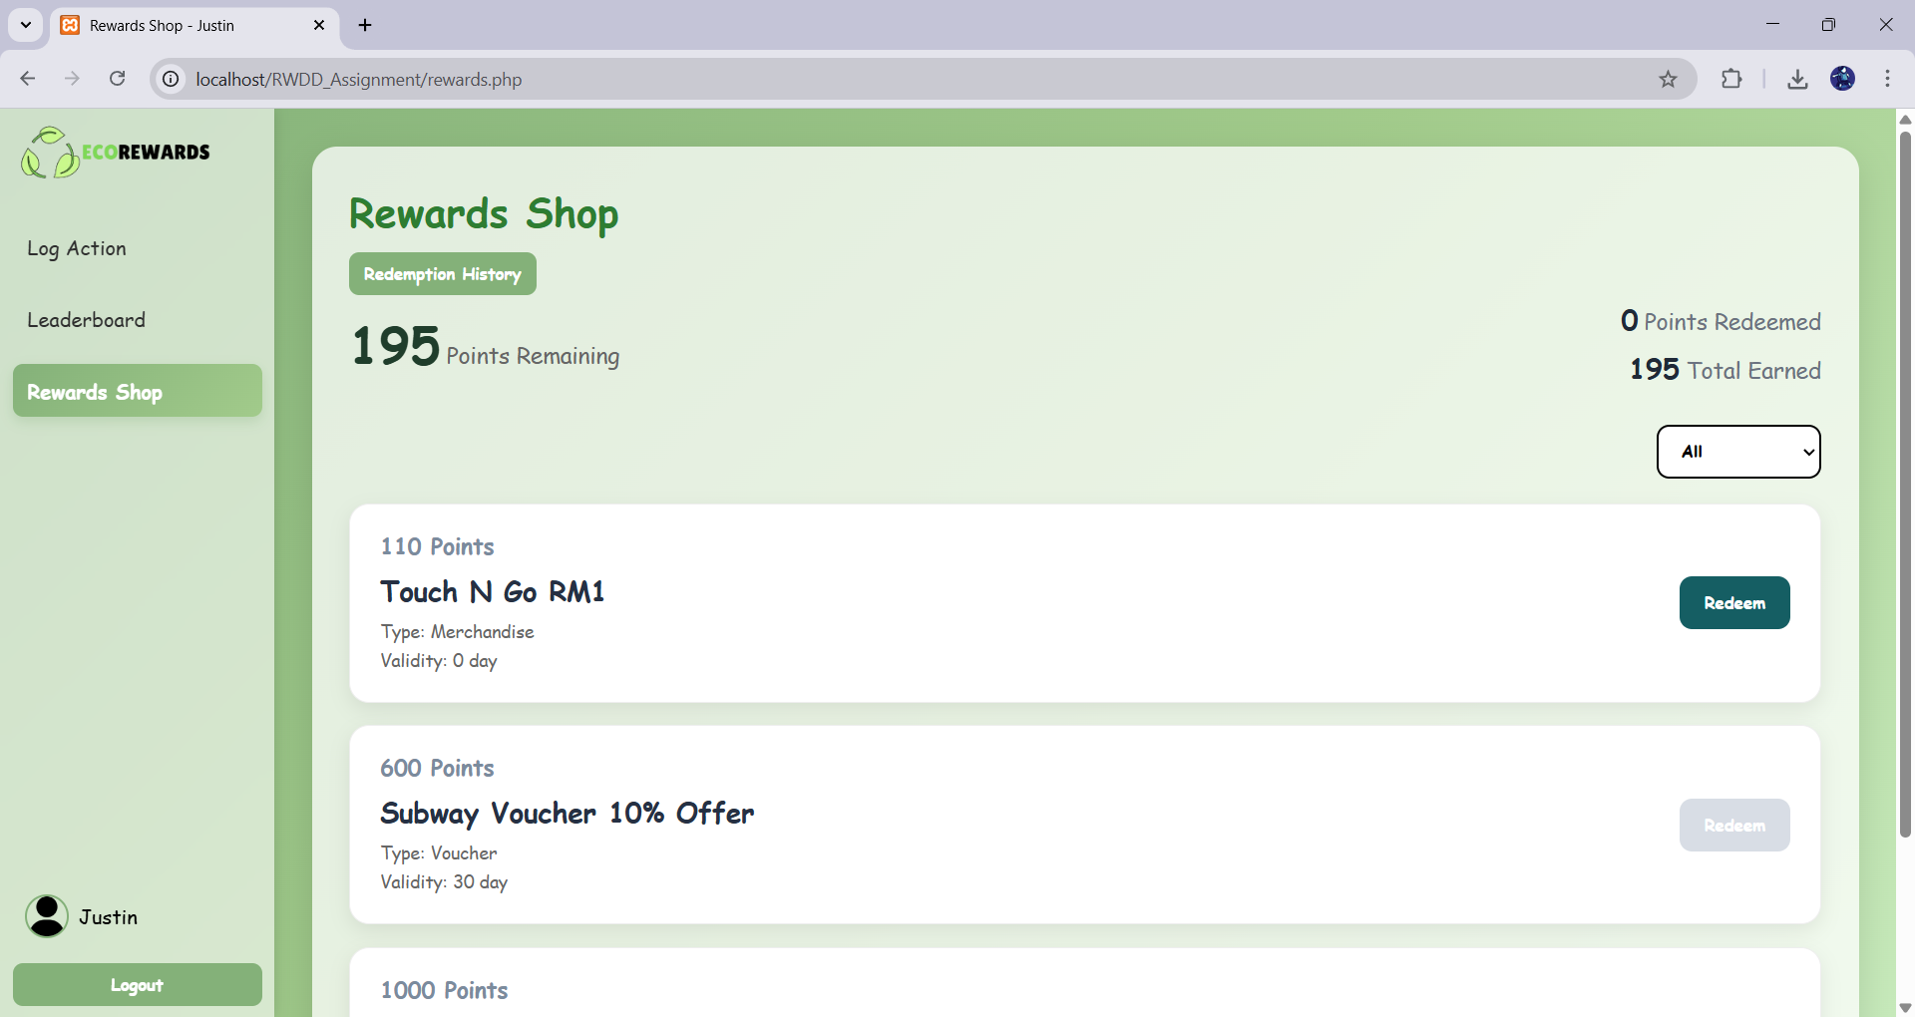

Rewards Shop - Redemption History Modal
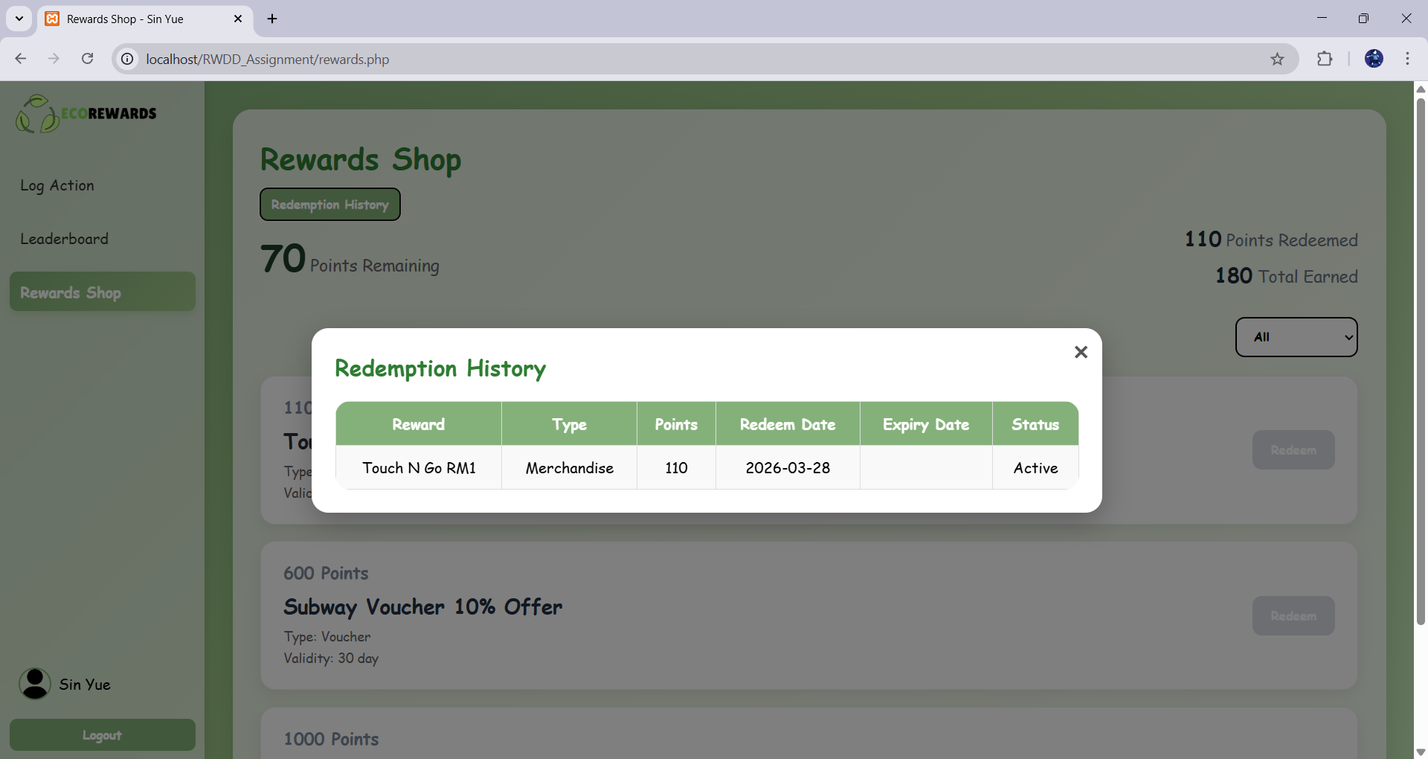

4.3.3 Moderator
Normal Submission – Table & Pending & Approved & Rejected
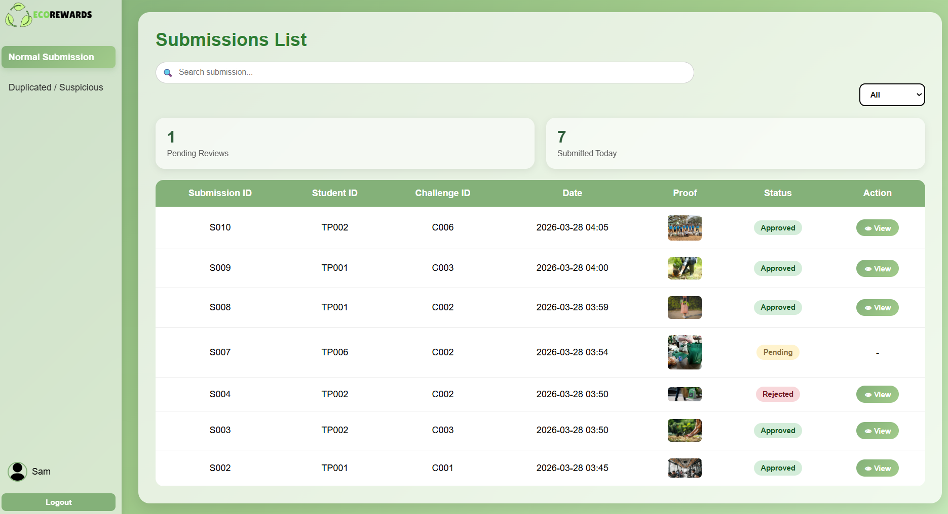
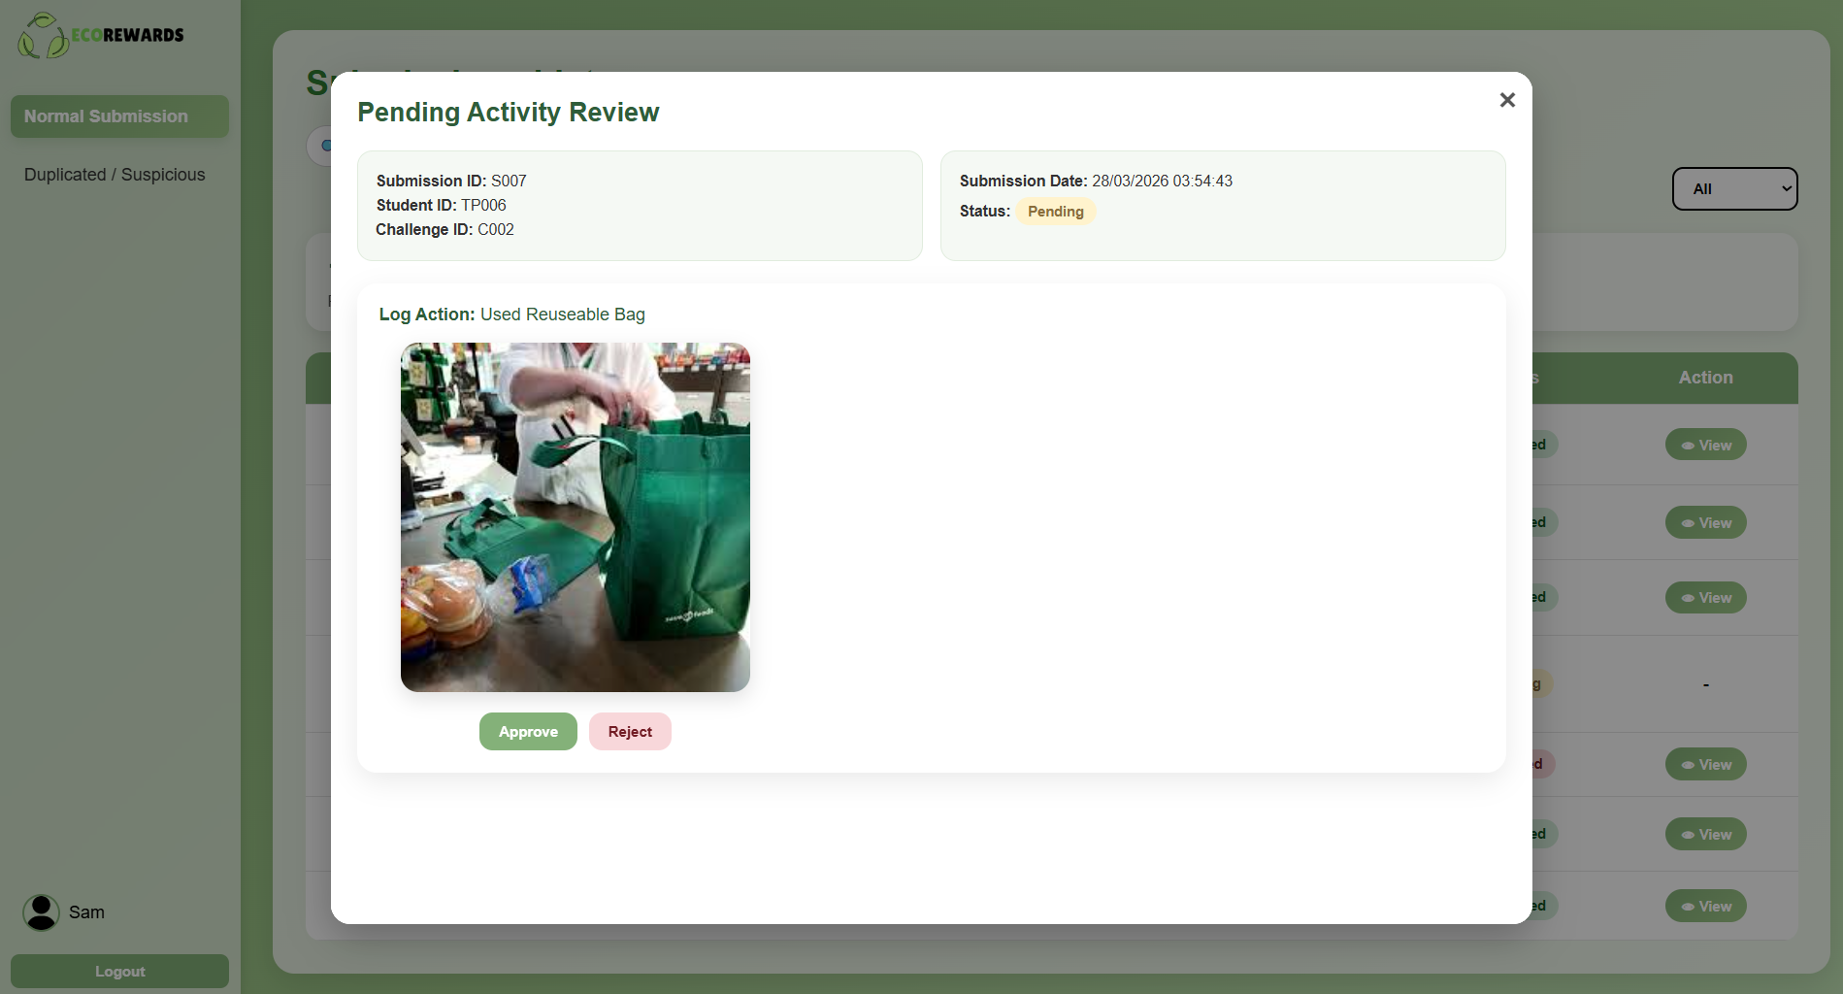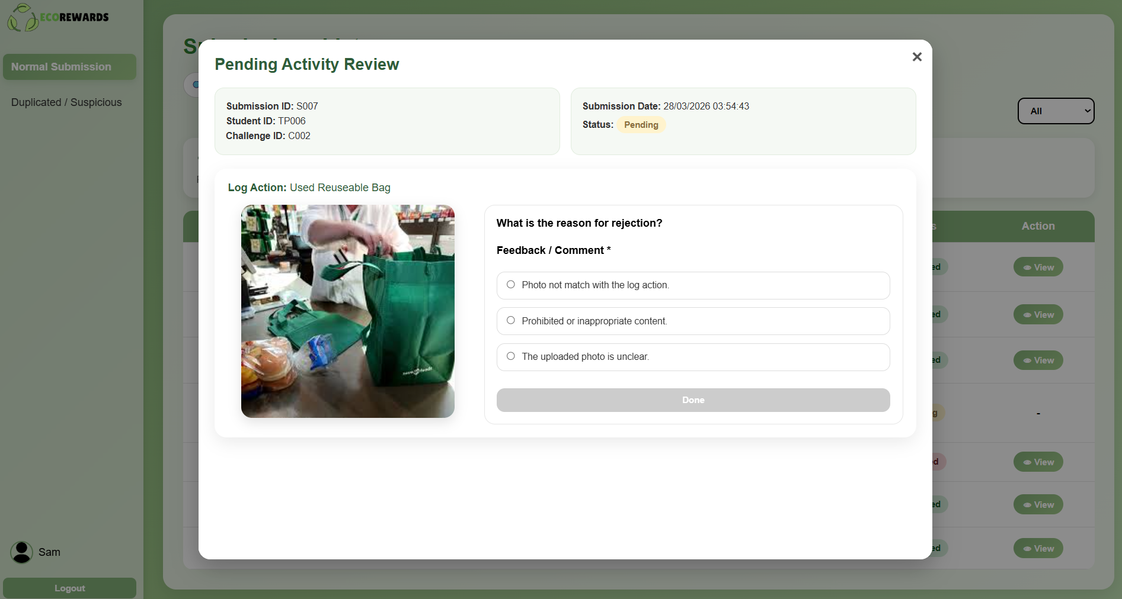
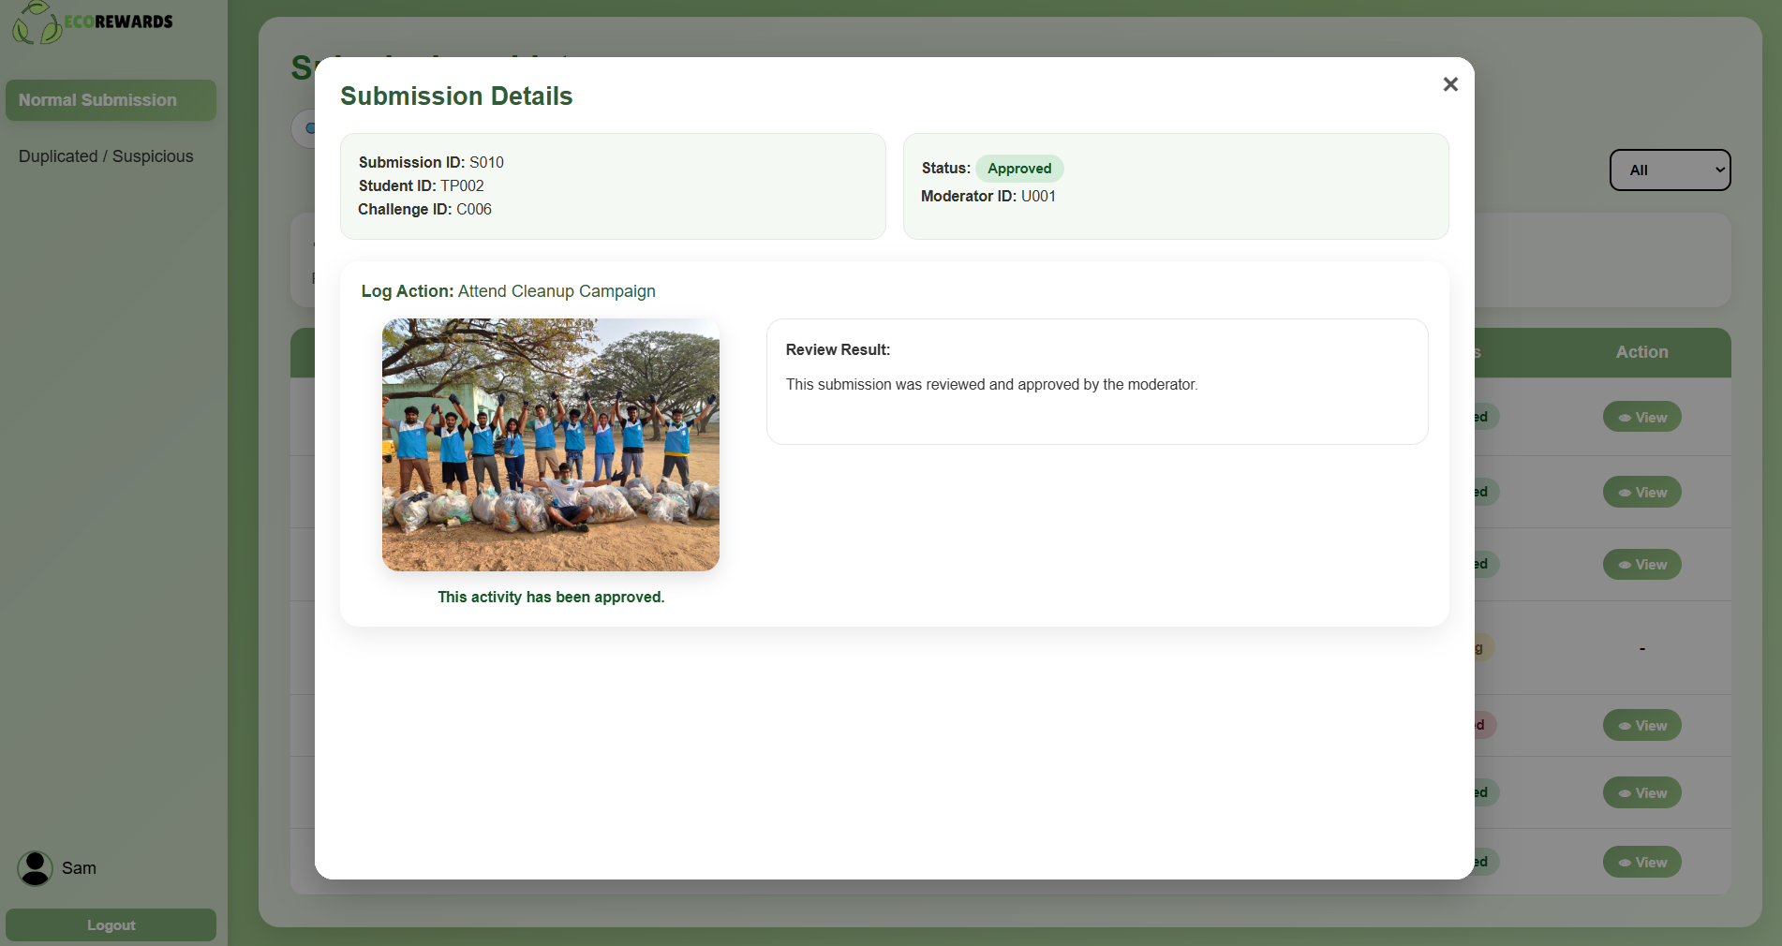
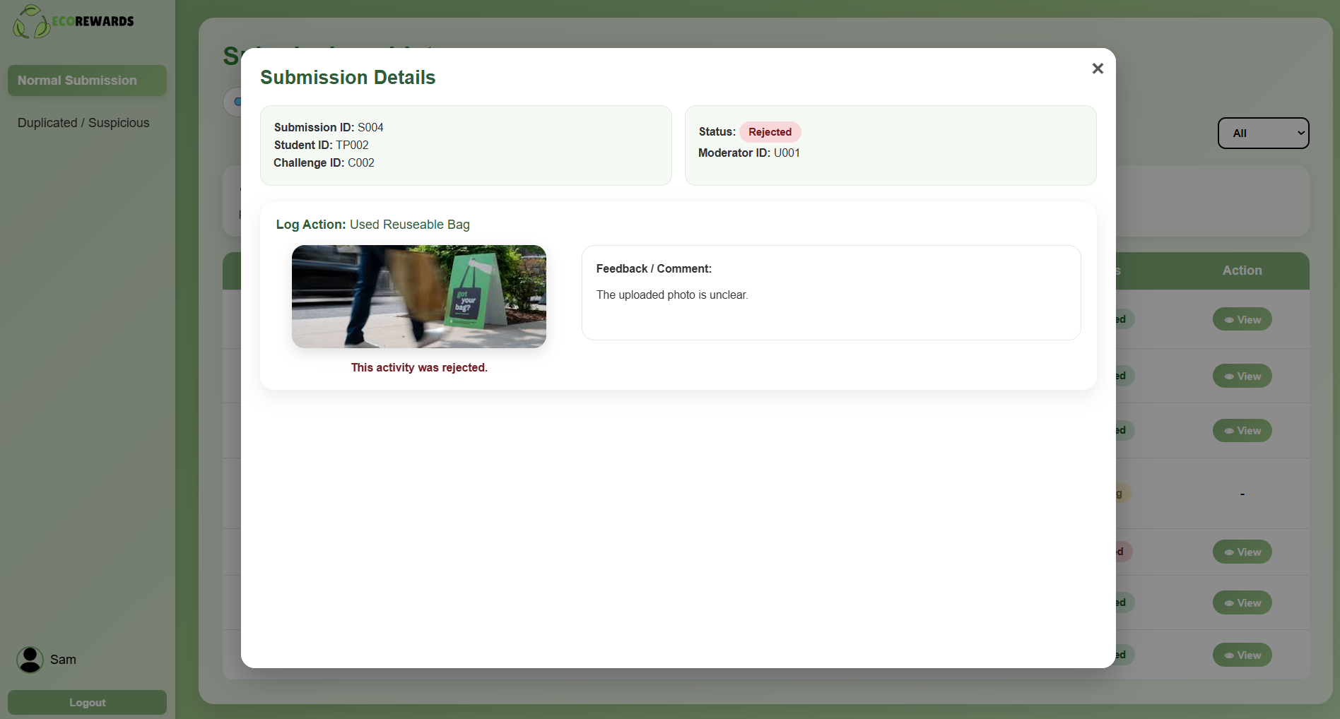

Duplicate/Suspicious Submission – Table
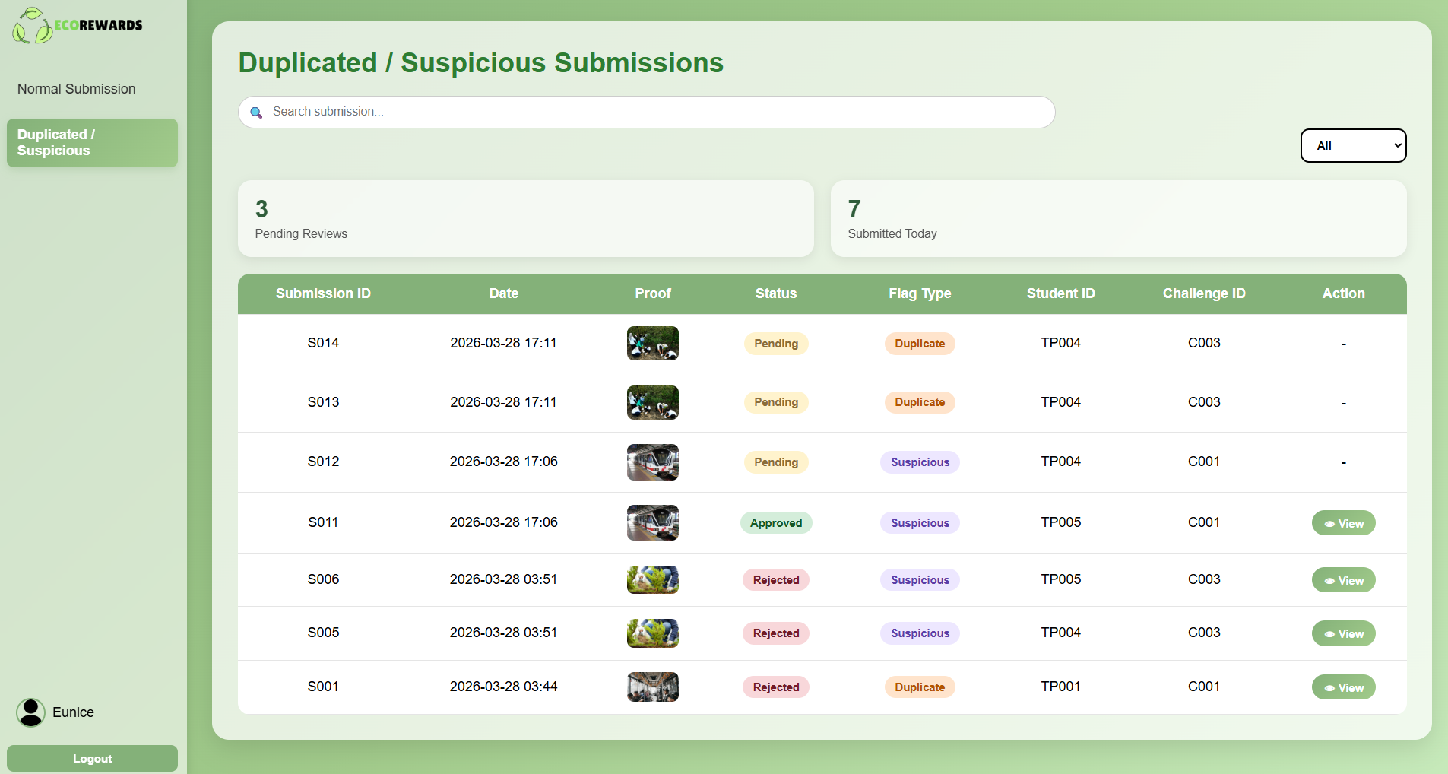
Duplicate - Pending & Rejected
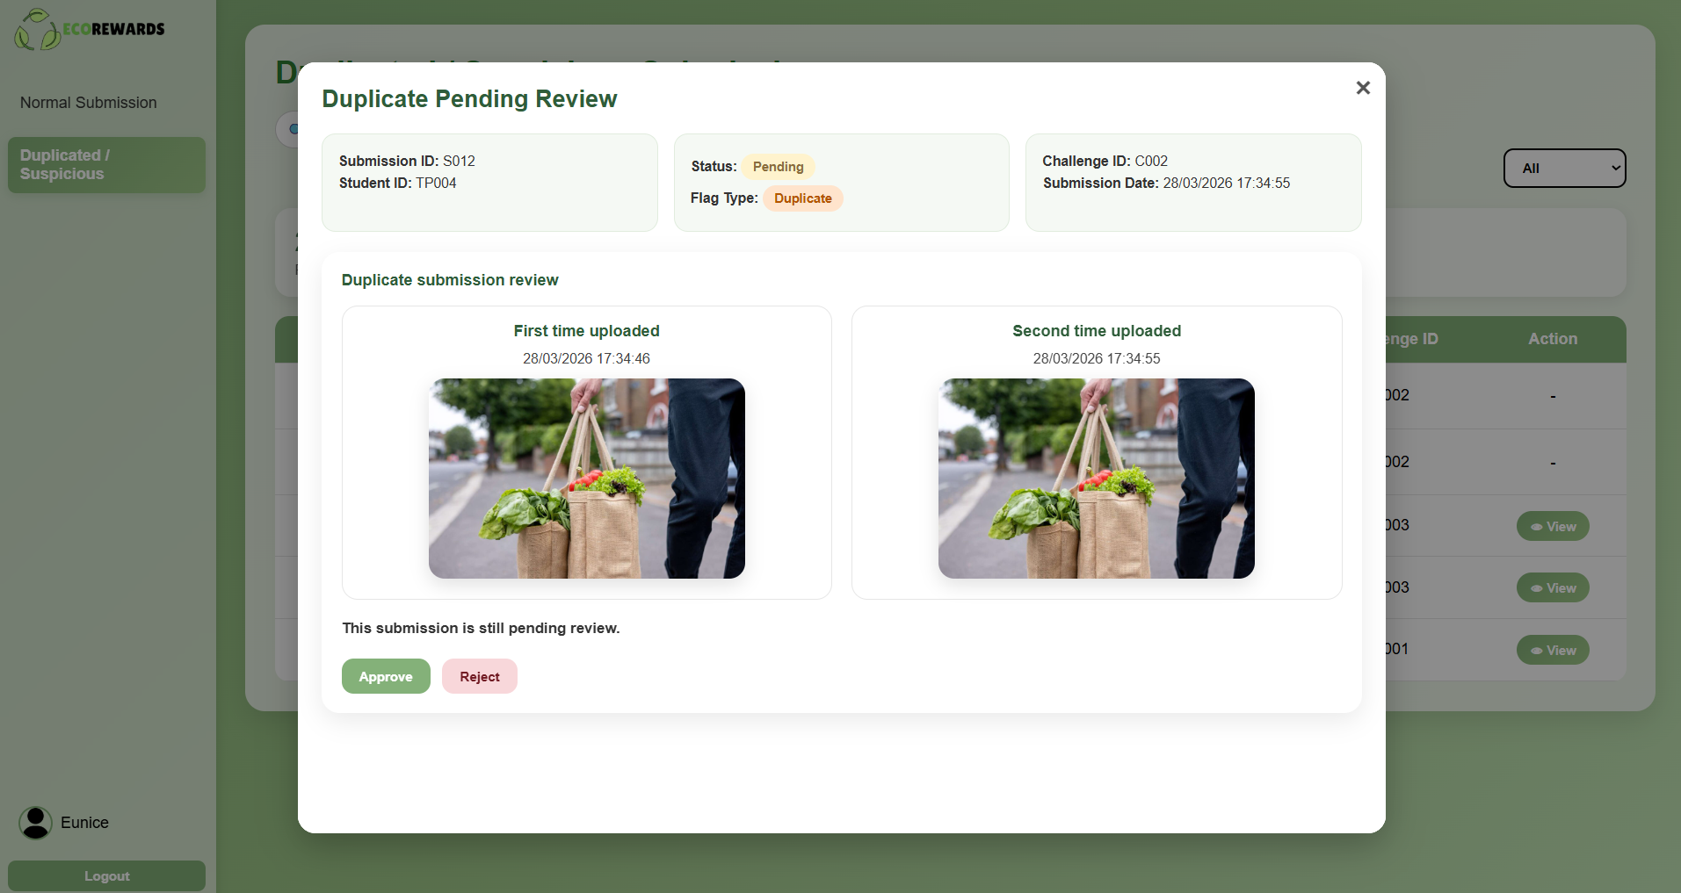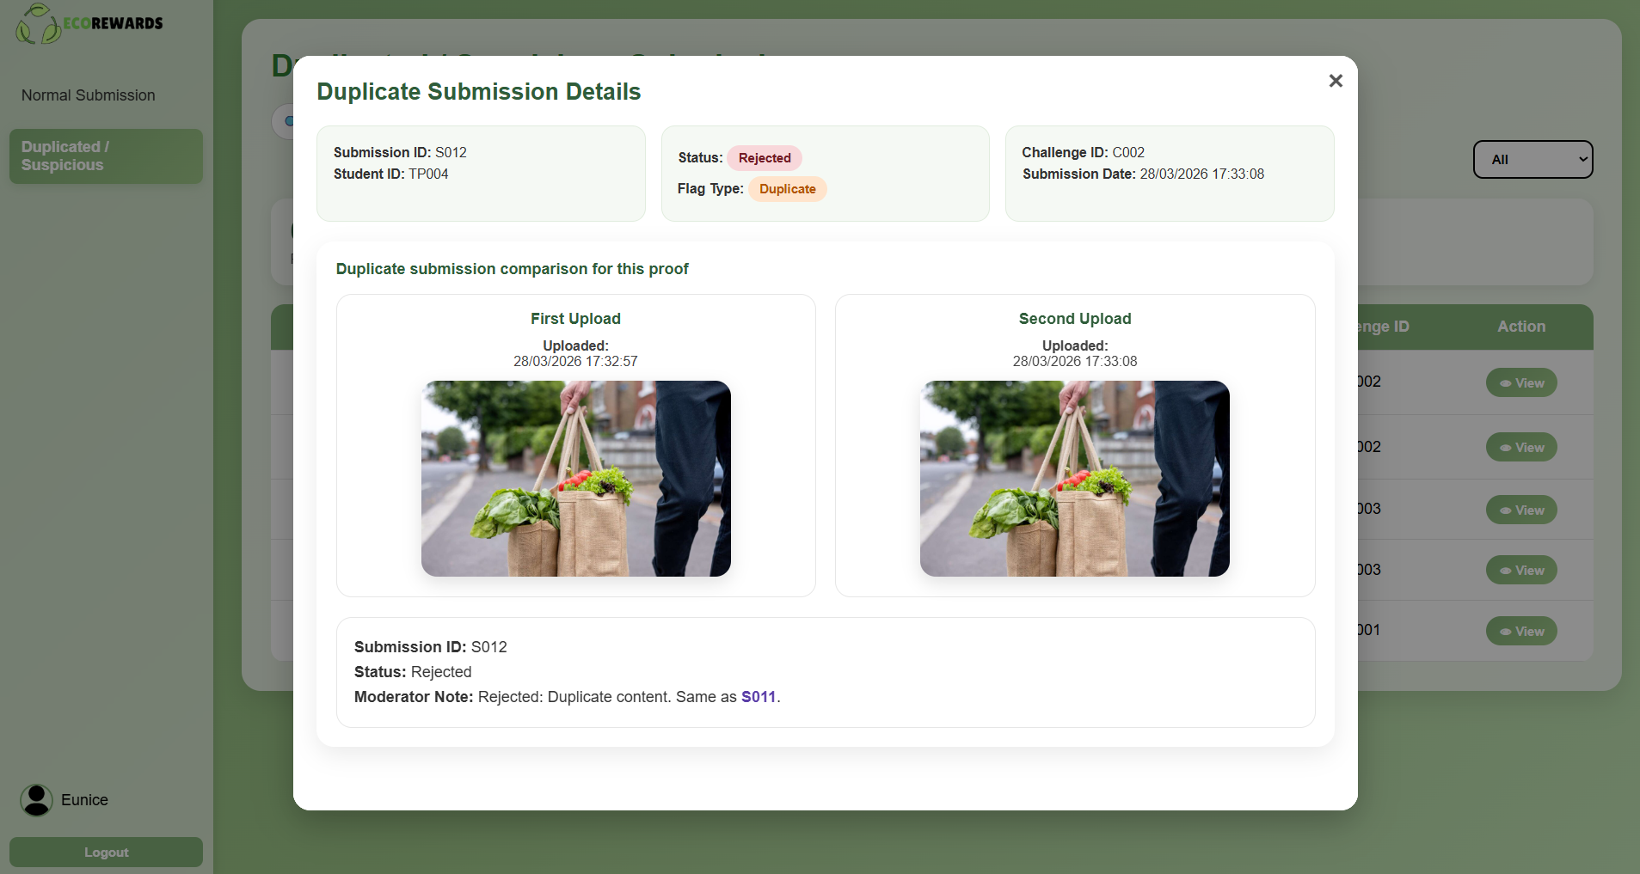

Suspicious submission – Pending & Rejected
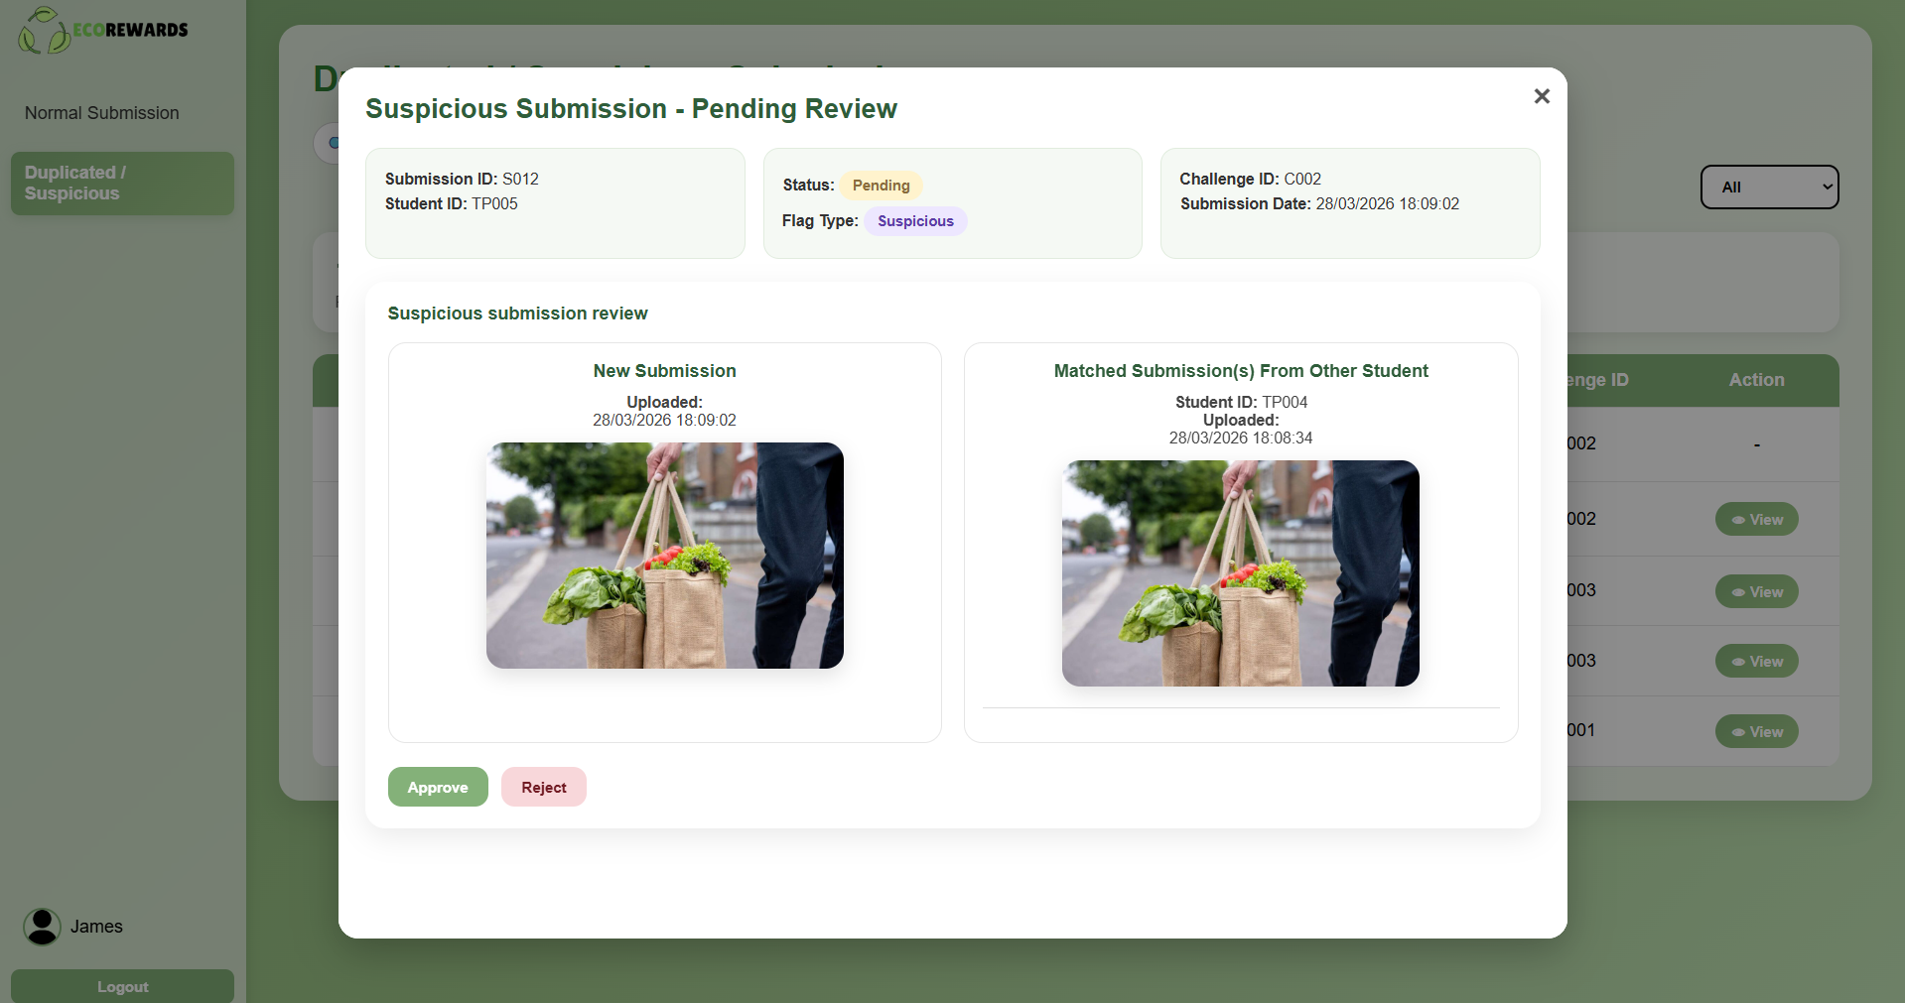
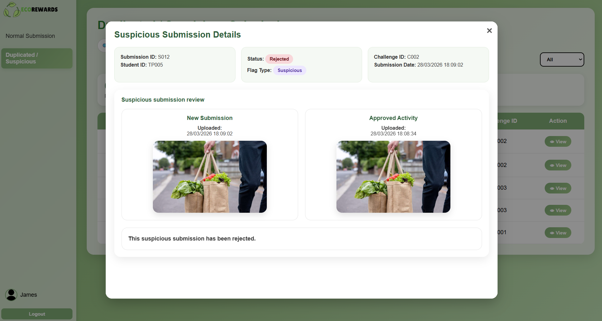

4.3.4 Administrator
Manage Users – Table & Add & Edit & Delete
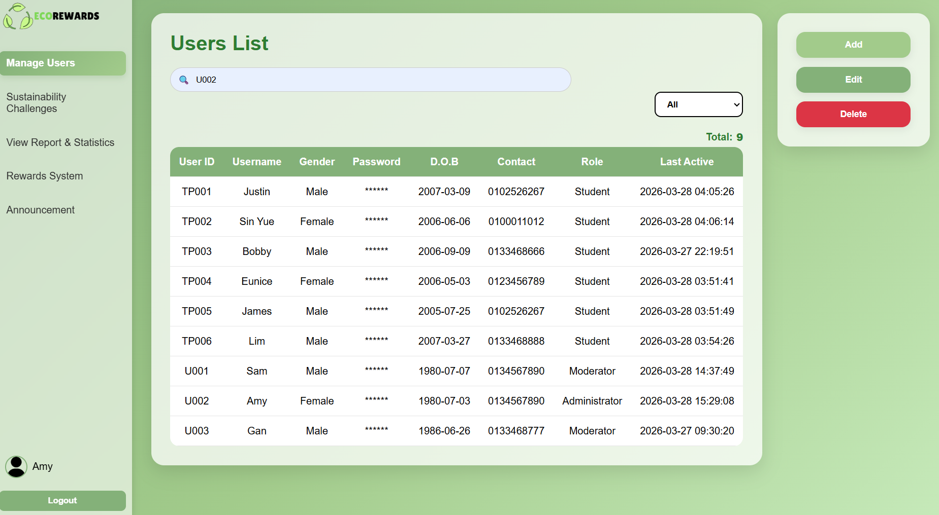

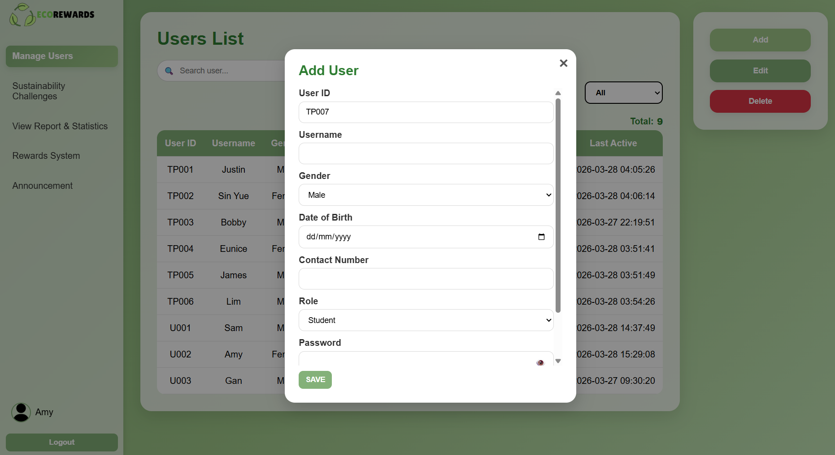
Add User – add the new user information. The User ID is automatically generate.

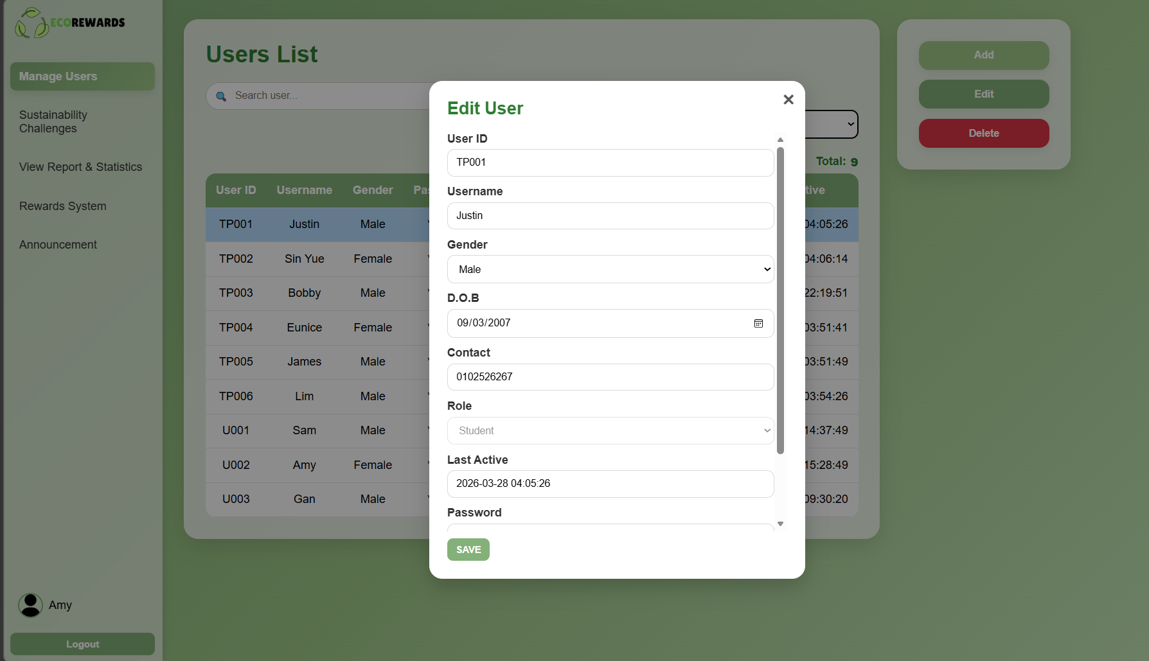
Edit User
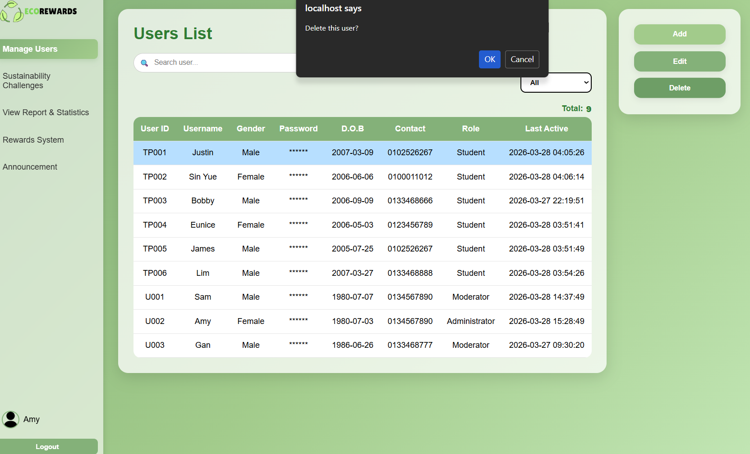
Delete User

Sustainability Challenges – Table & Add & Edit & Delete
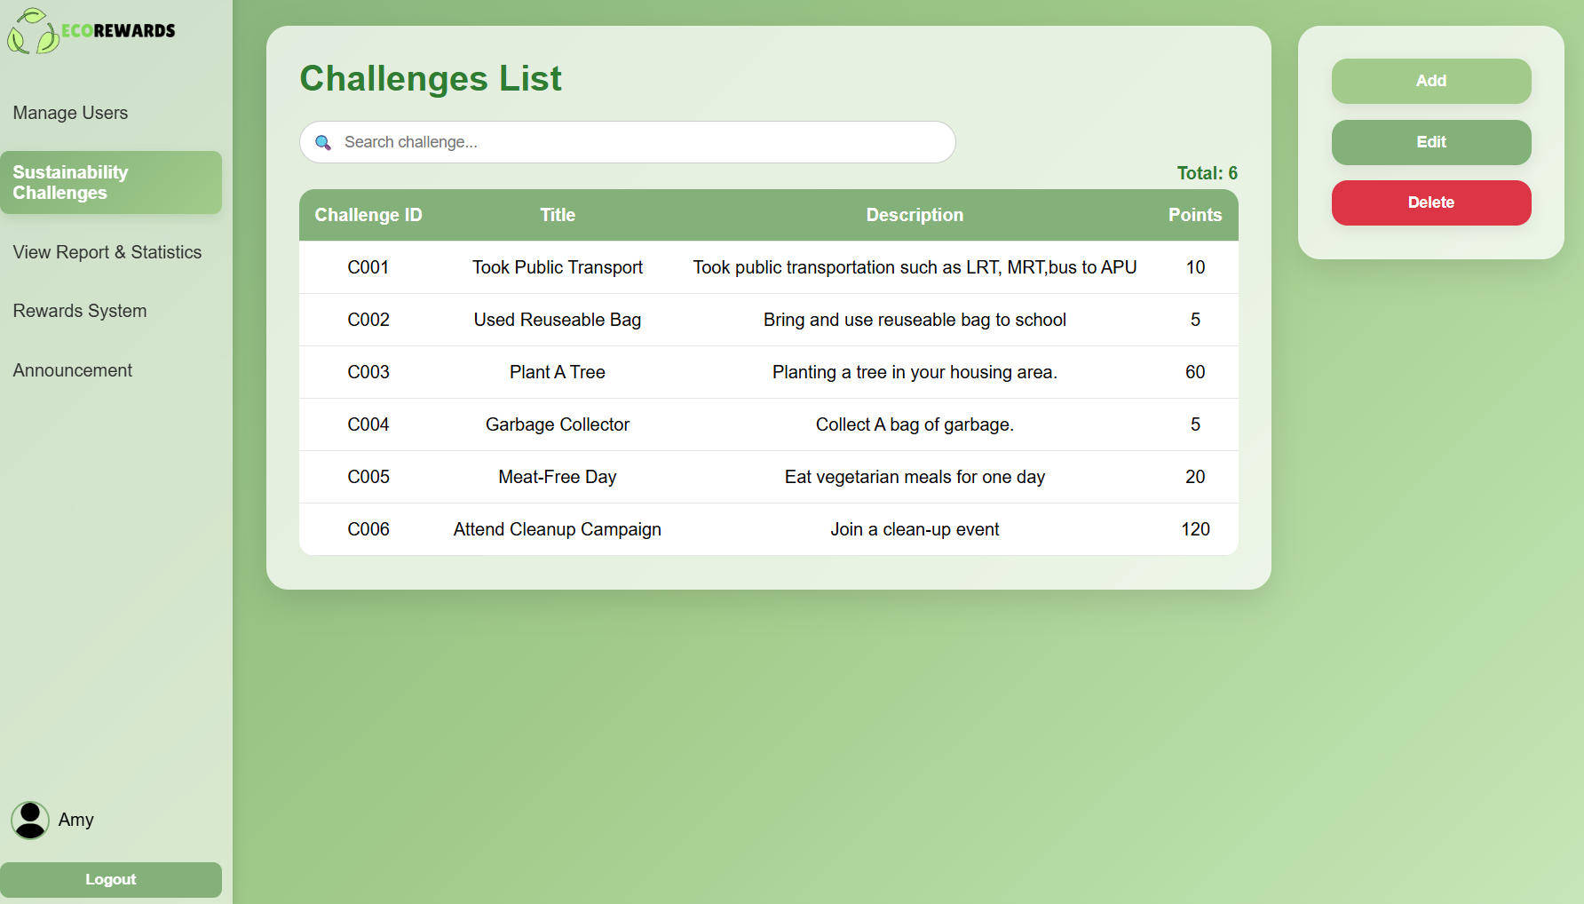

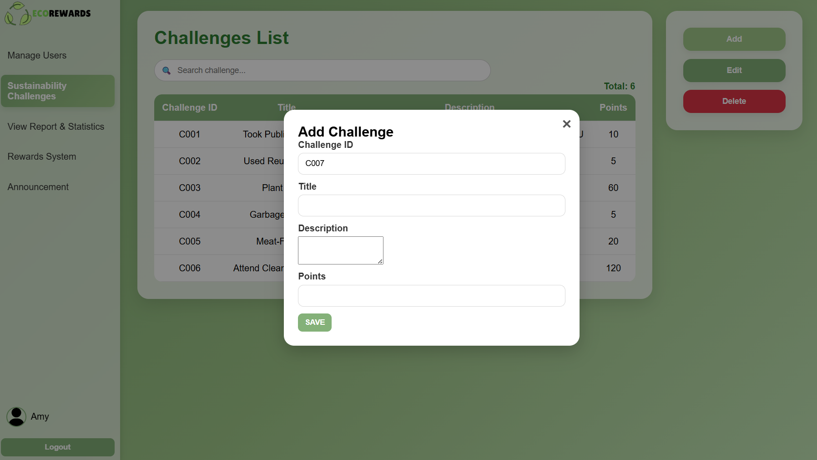

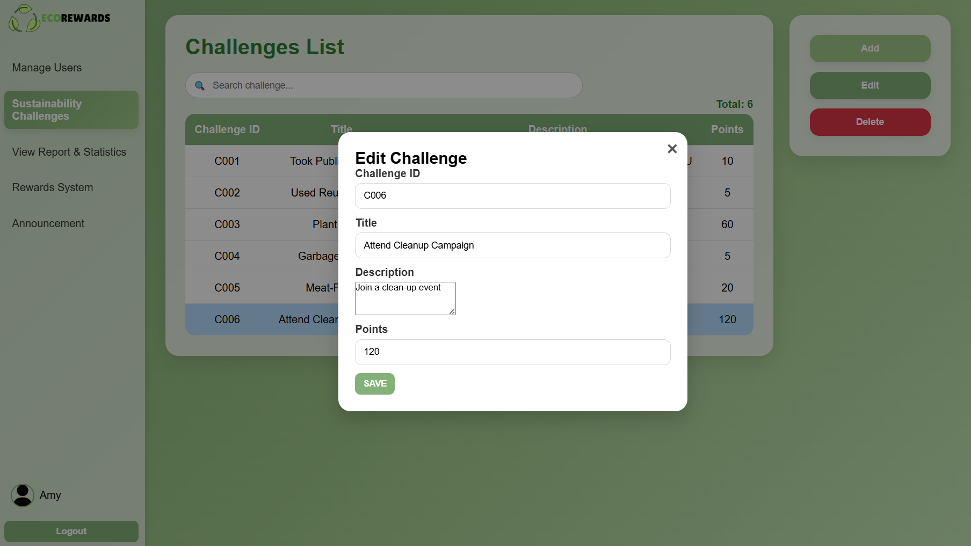

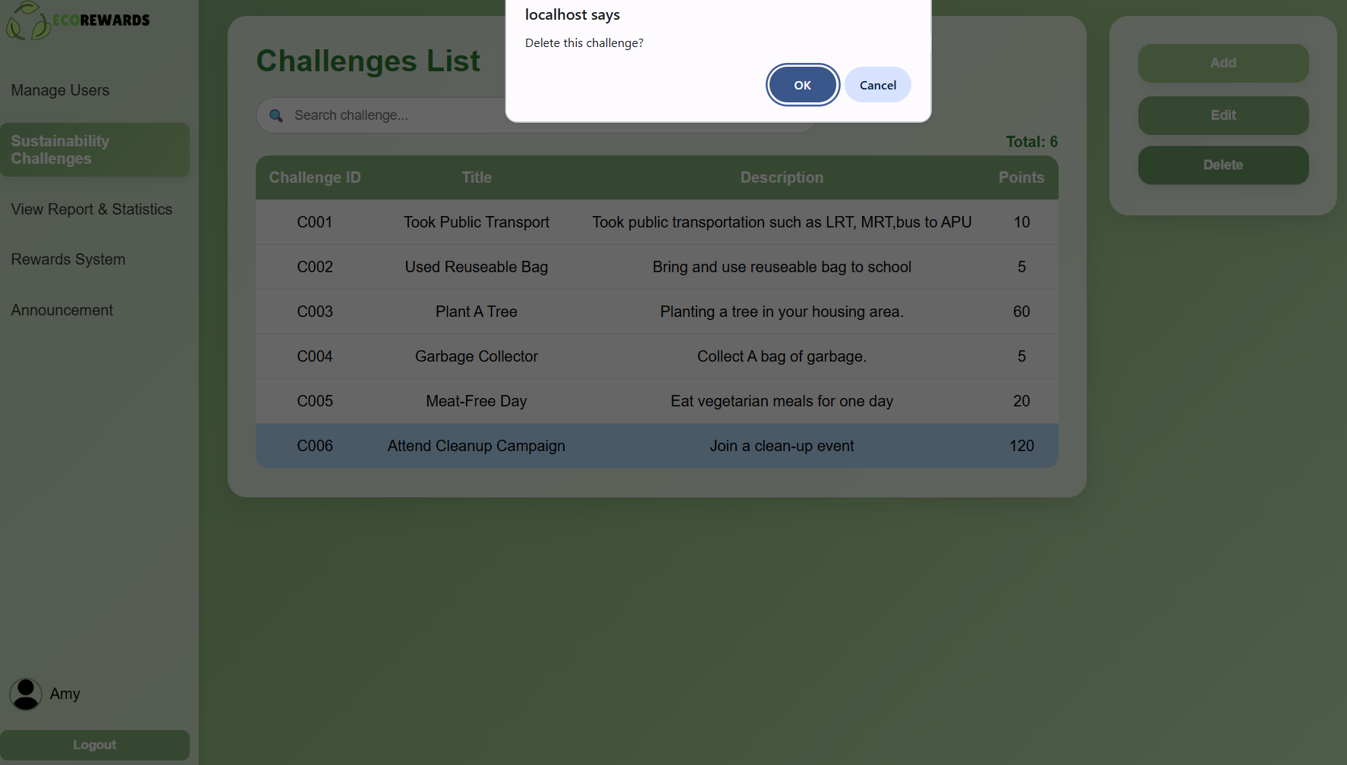

View Report & Statistics – User Report & Activity Report
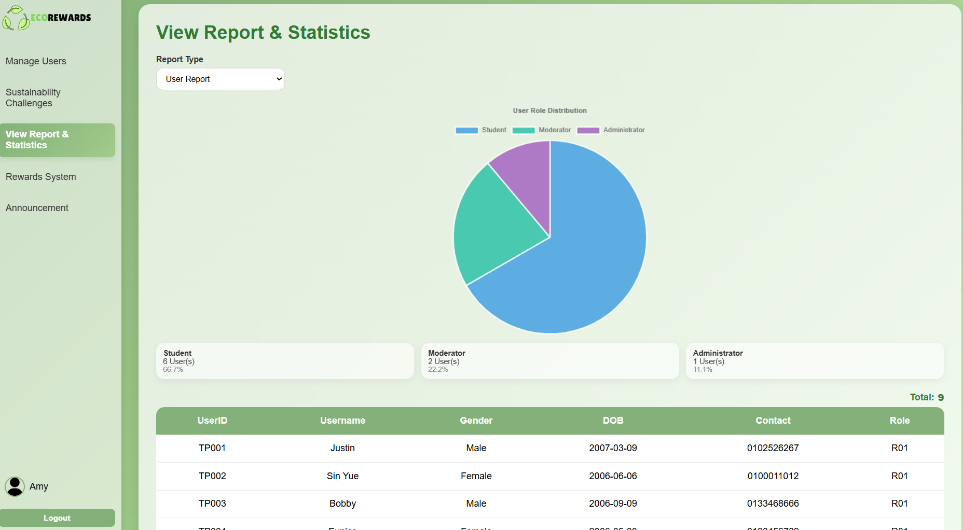
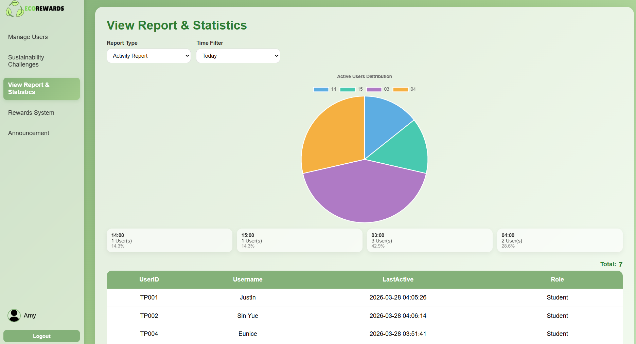
Today – Display the time for user LastActive. Data is grouped by Hour in 24:00 format.

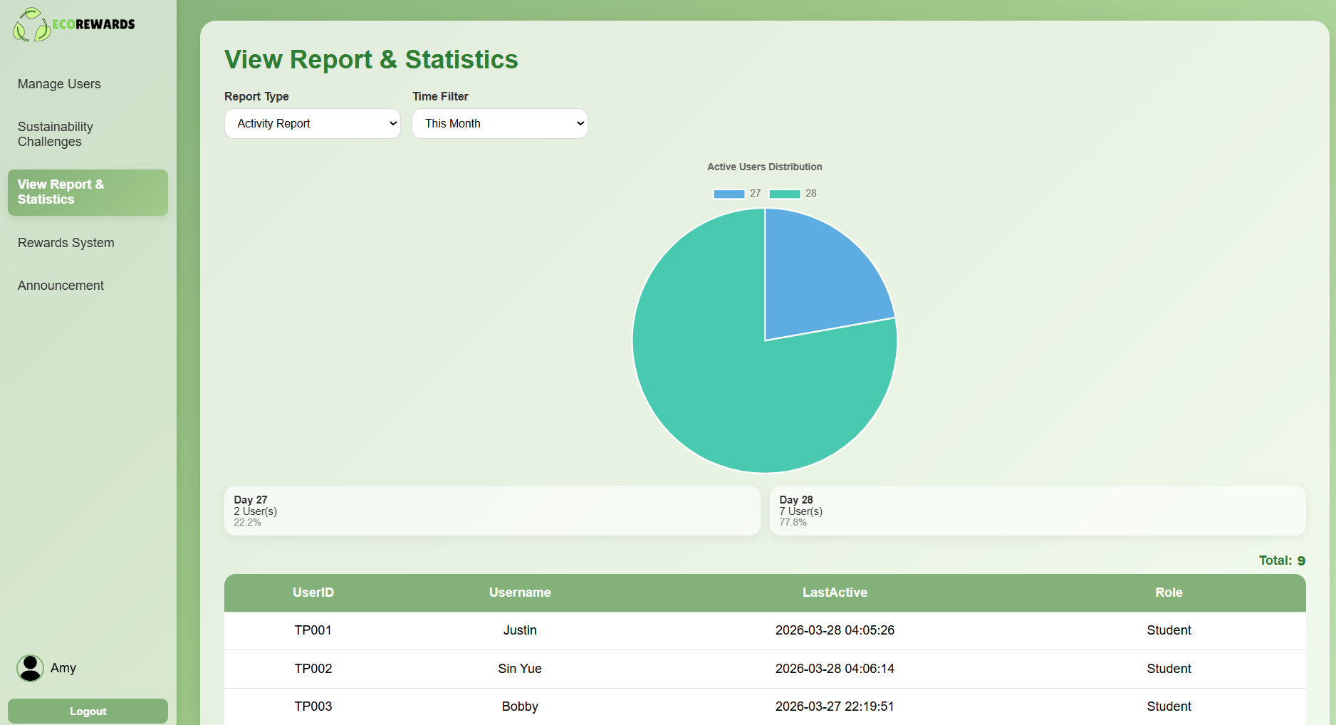
Month - Data is grouped by Day of the month in format day xx

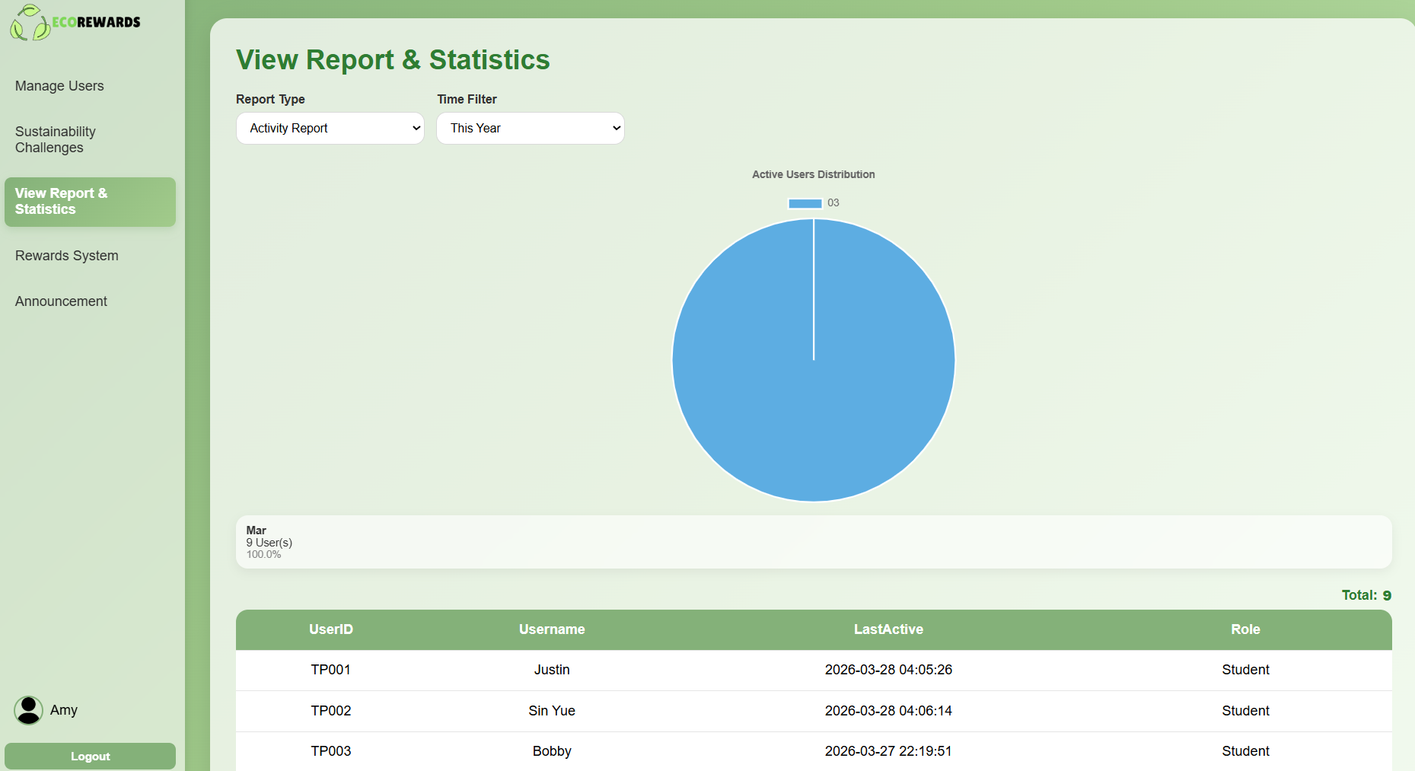
Year - Data is grouped by Month in format Jan/Feb etc... instead of 0-12

Rewards System – Table & Add & Edit & Delete
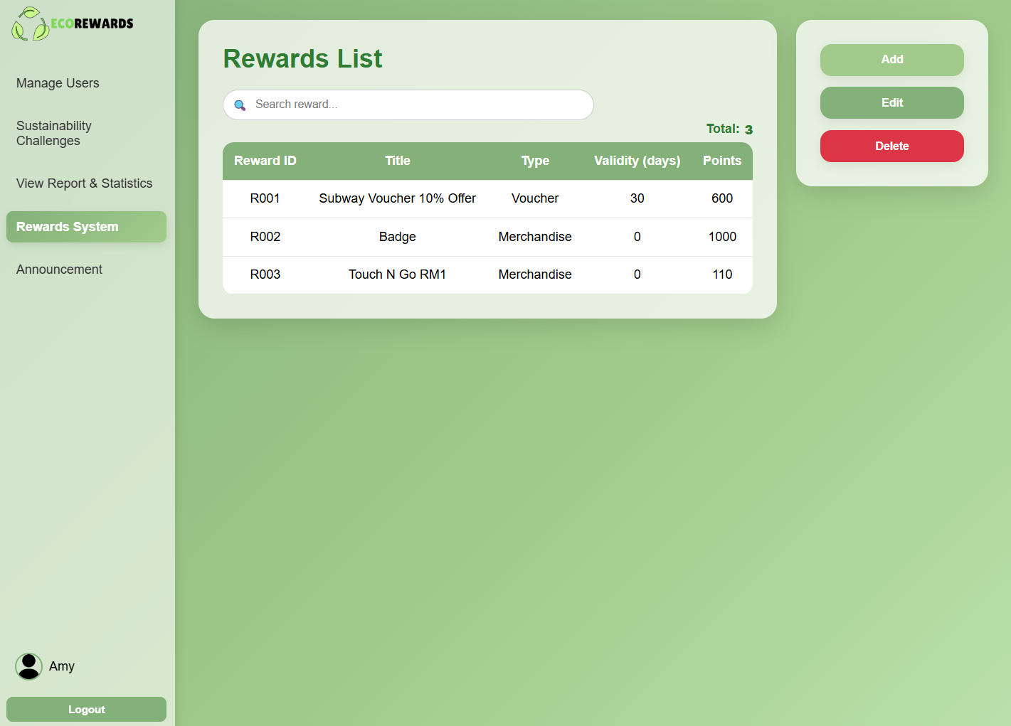

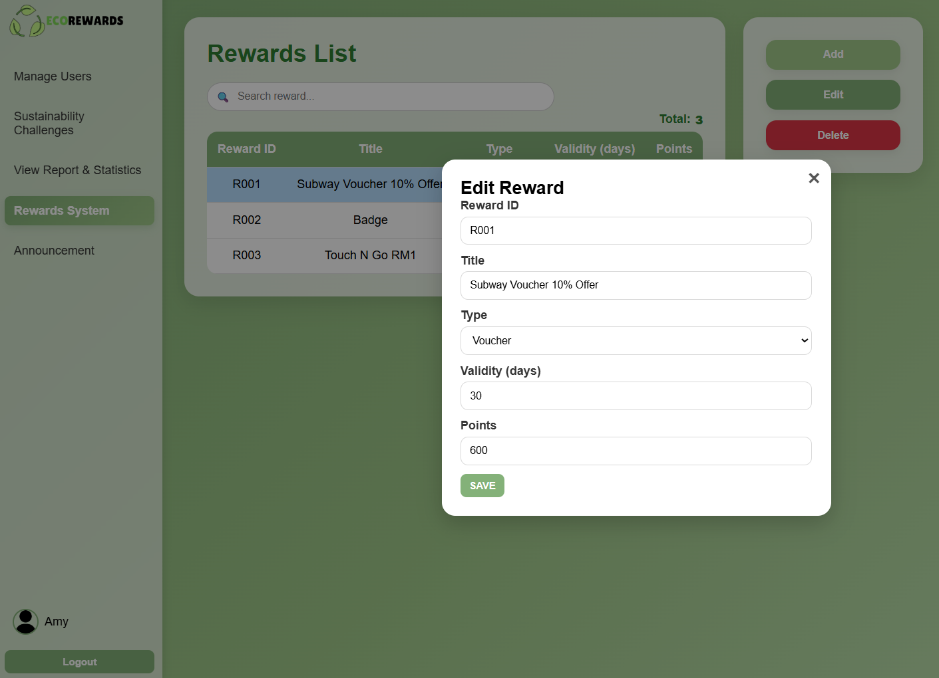
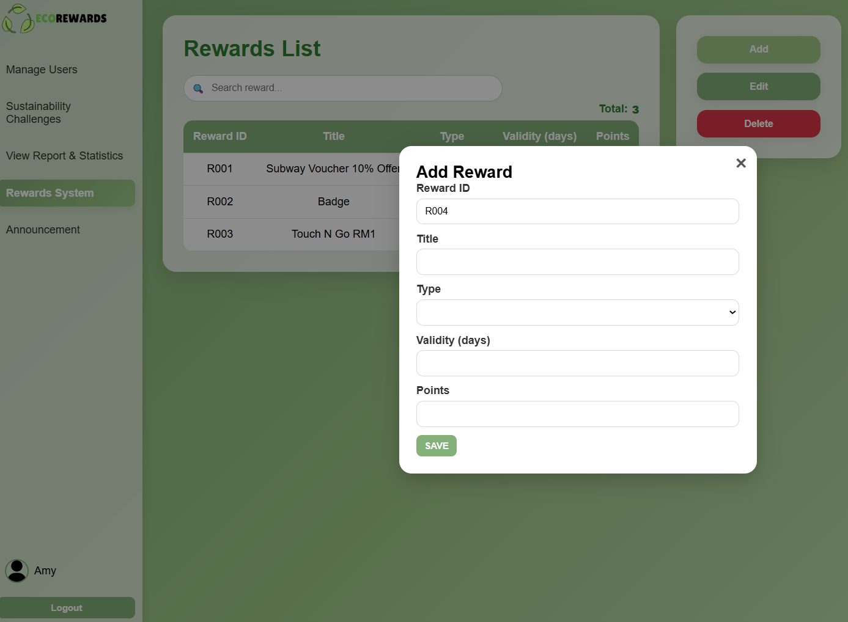

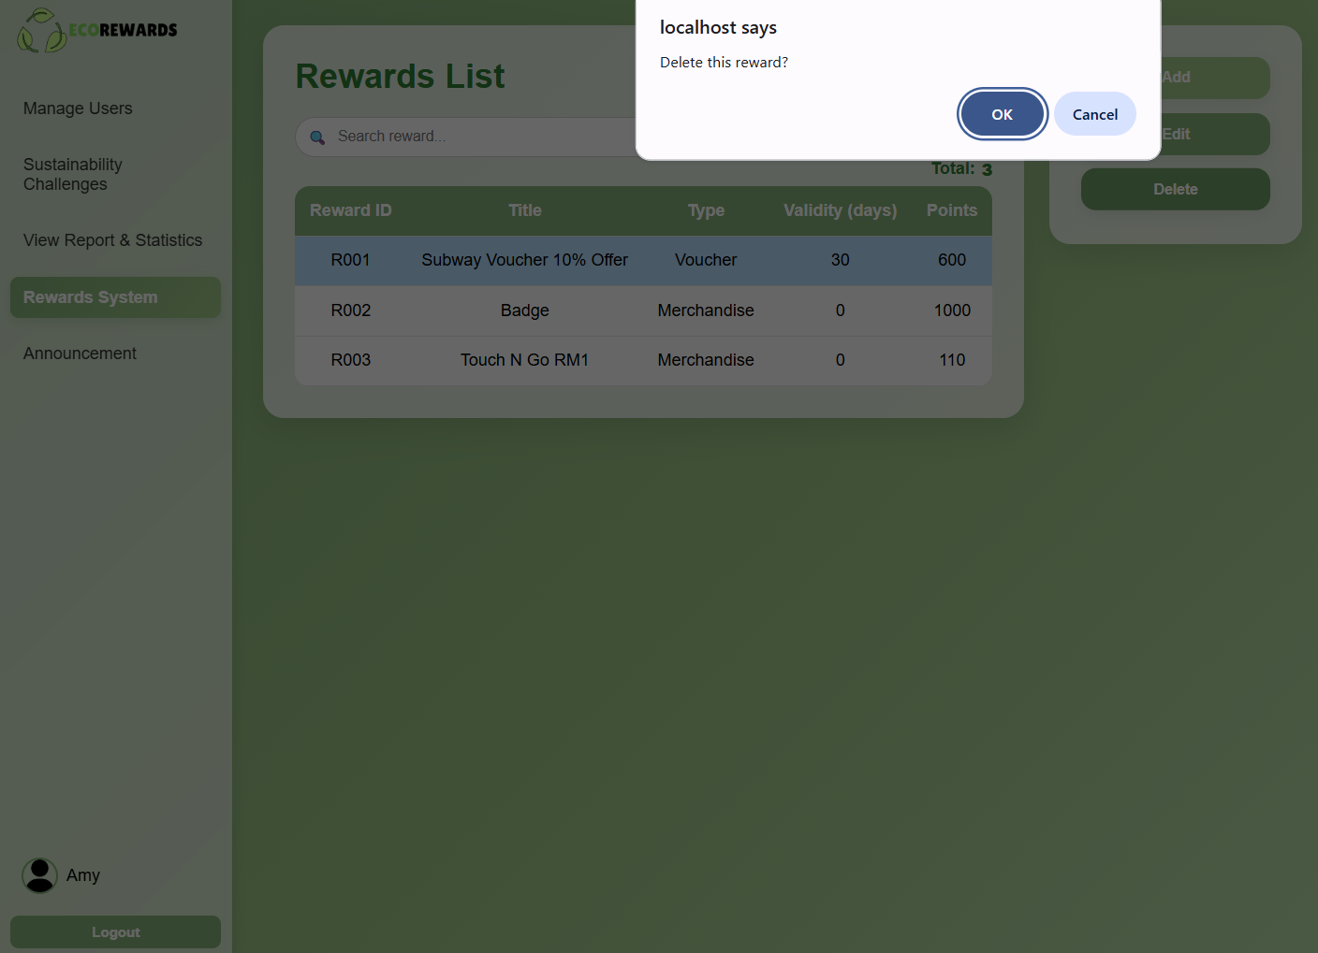

Announcement – Table & Add & Edit & Delete
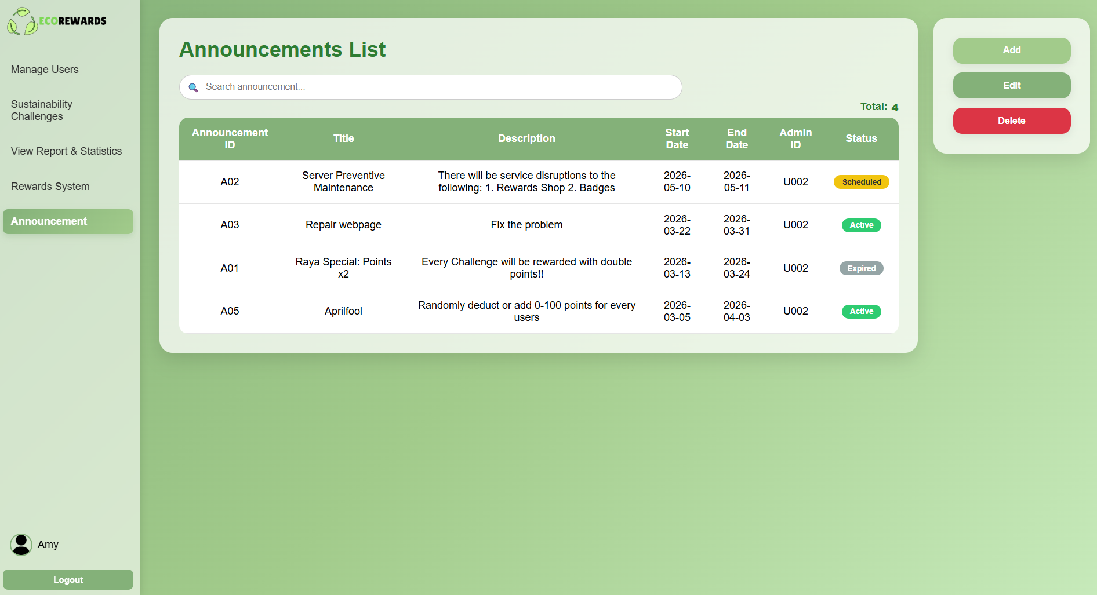

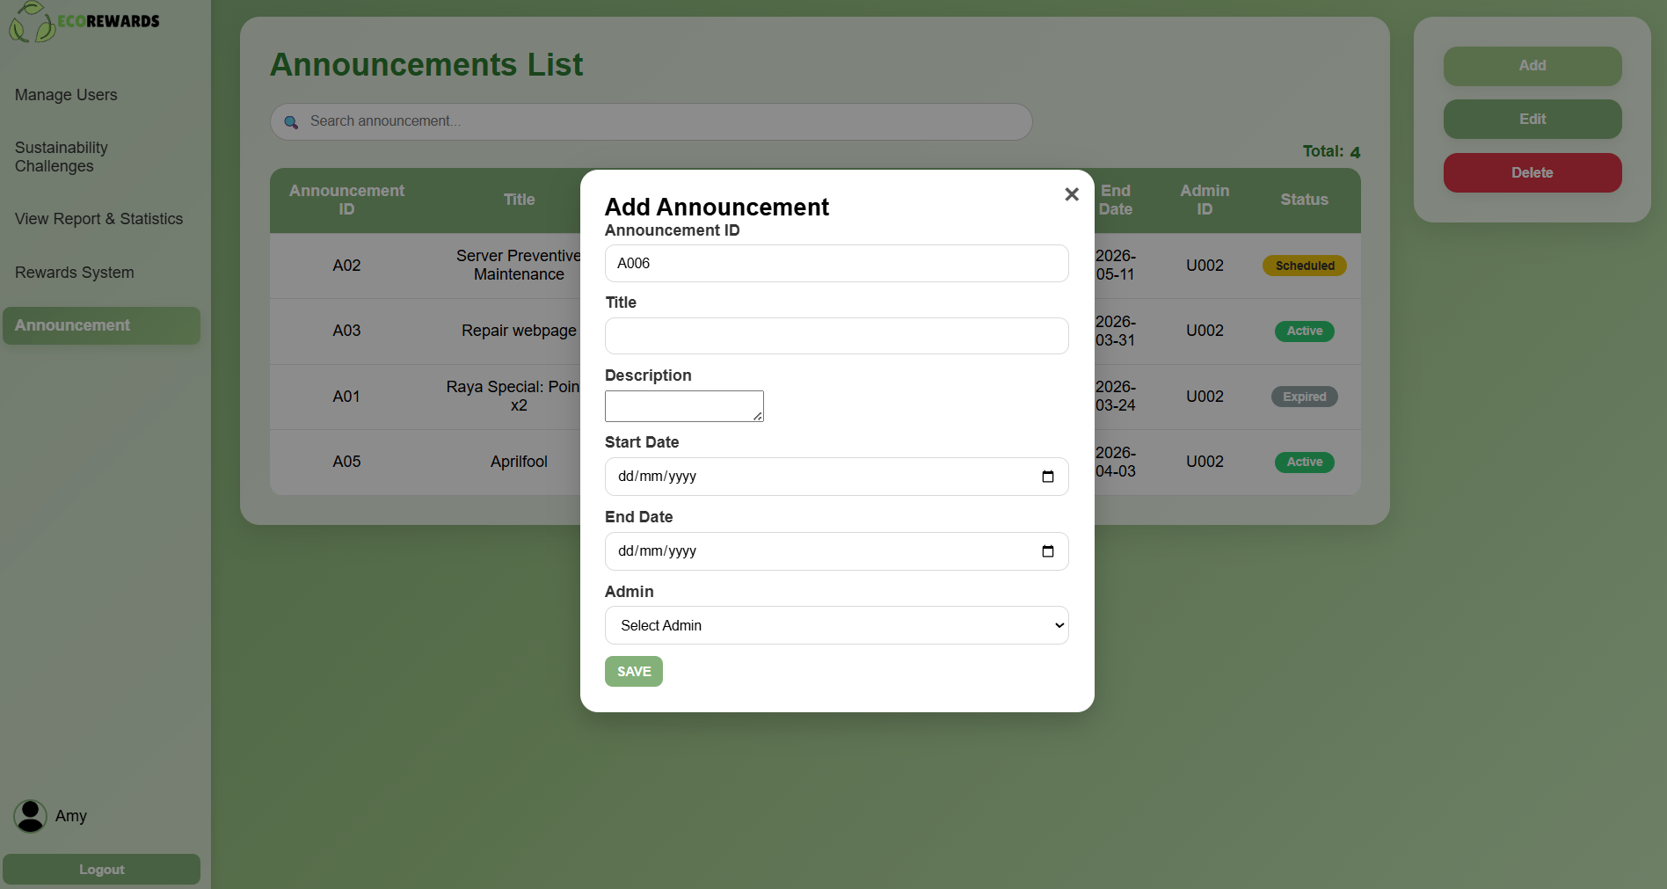

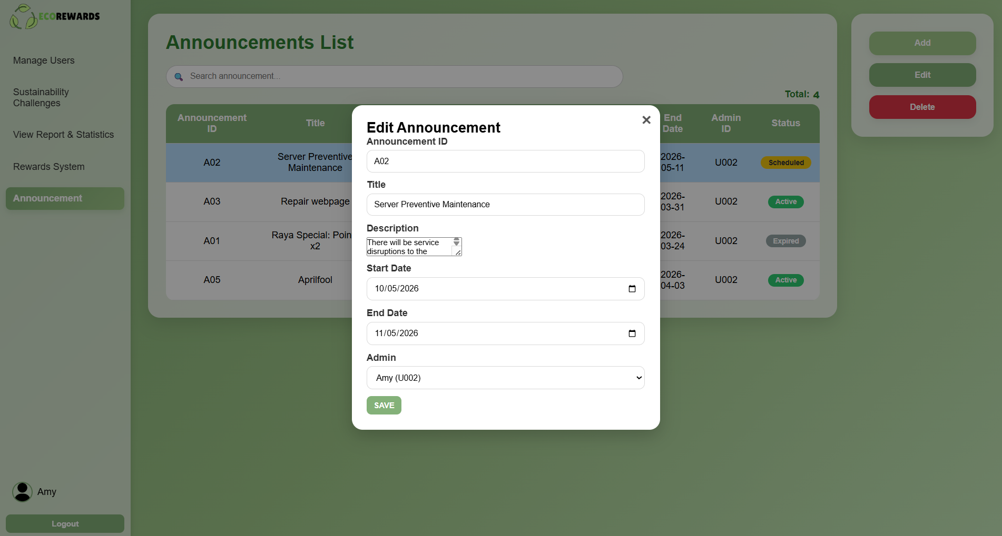

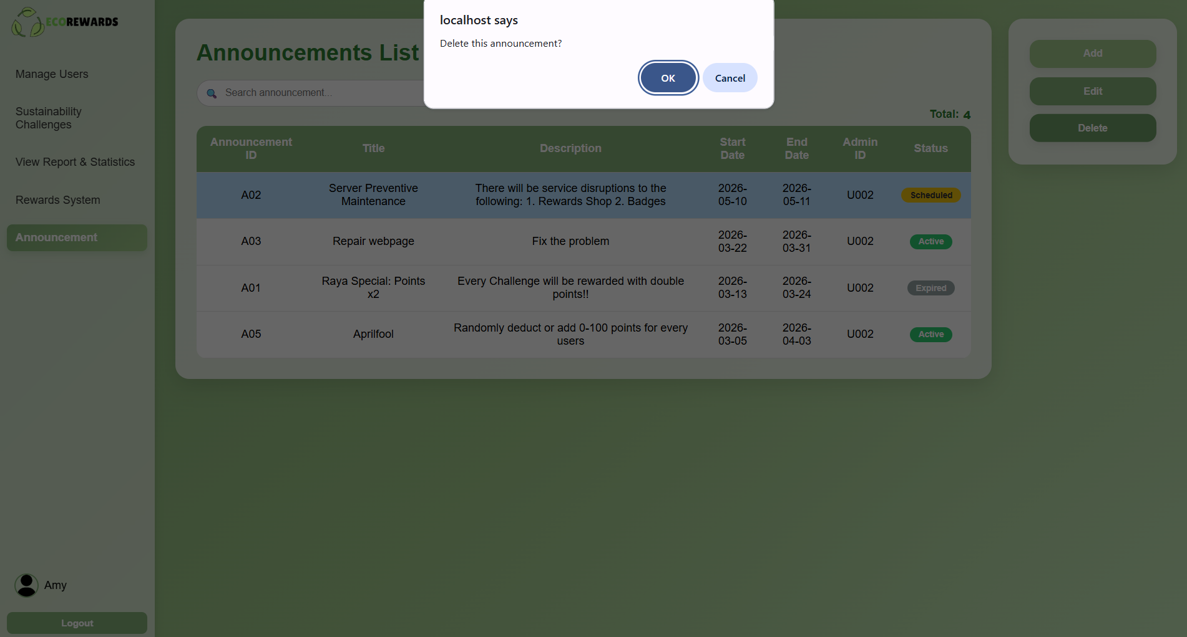

5.0 Conclusion

5.1 Review of Work
In conclusion, our team has successfully implemented several key features outlined in the project scope within the EcoRewards system. The main features developed are as below:
- User Authentication and Profile Management
Users can securely log in, manage their profiles and view their points, submission history and leaderboard ranking.

- Sustainability Challenge Module
This is the core module of the EcoRewards system. It allows students to select challenges and upload proof of their activities.

- Submission Verification System
Moderators can review, approve or reject submissions submitted by the students. Feedback is provided to students whose submissions are rejected.

- Reward Redemption System
Students can redeem vouchers or merchandise using their points. Besides that, a redemption history modal is implemented to allow users to view their previous redemption history.

- Basic Gamification Features
Features such as points accumulation, leaderboard ranking and a virtual tree growth system are implemented to enhance user engagement.

- Administrative Management
In this module, administrators can manage announcements, challenges and rewards within the system. Furthermore, system analytics and monitoring features are included to allow administrators to view the system performance reports.

However, there is some modules were not fully developed such as:

- Advanced Gamification Features
Features such as daily check-in system and social interaction through eco-homes were not developed due to time constraints and the complexity of implementing real-time user interaction.

- Badge System
Currently, students are not able to earn badges or achievements in the EcoRewards system. This feature requires additional logic for automatic milestone detection and integration with user achievements, which was beyond the current development scope.

Overall, the system successfully delivers its core features, while undeveloped components identified as potential future improvements.

5.2 Validation of Project Objectives
The objectives of the EcoRewards system were evaluated based on the implemented features and system functionalities.

Objective 1: To encourage environmentally friendly behaviour
This objective was achieved through the Sustainability Challenge module where users are required to perform eco-friendly activities such as using public transport and participating in clean-up campaigns. As shown in Figure 1, users submit proof of their actions which encourages consistent participation in sustainable practices.
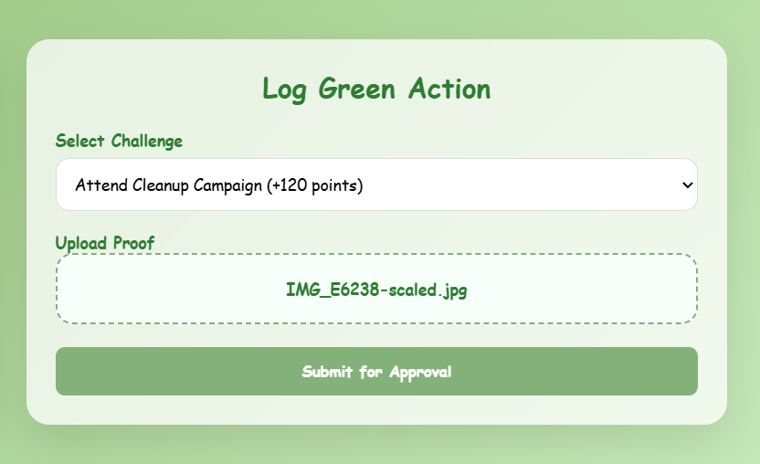
Figure 1. User Submitting the Activities in Log Green Action Section

Objective 2: To provide a reward-based motivation system
EcoRewards successfully implements a reward feature where users earn points after their submissions are approved. These points can be redeemed in the Rewards Shop for vouchers or merchandise. It motivates users to actively engage in environmentally friendly practices.
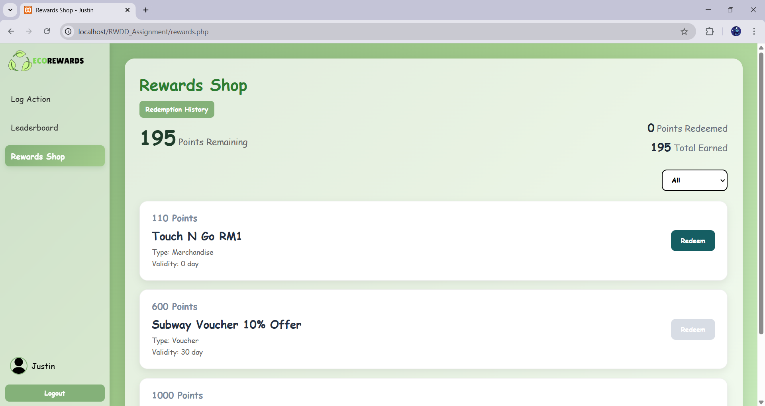
Figure 2. Rewards Shop

Objective 3: To ensure authenticity through activity verification
This objective is achieved through the Submission Verification system where moderators review each submission before approval. The system also detects duplicate and suspicious submissions automatically to maintain fairness.
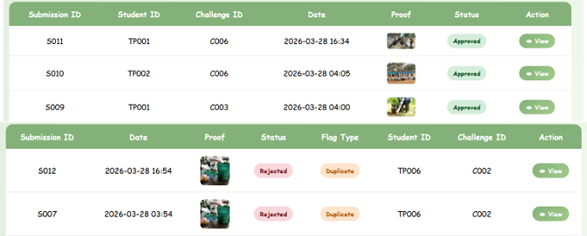
Figure 3. Moderator Review Interface for Submission Verification

Objective 4: To increase awareness of environmental sustainability
This objective was only partially achieved. While EcoRewards includes sustainability challenges features, it does not provide sufficient educational content to actively increase users’ awareness of environmental sustainability. The system currently focuses more on participation rather than education and lacks features such as tips, article or learning materials.

Objective 5: To create a community-driven eco platform
This objective was partially achieved through the leaderboard feature which promotes interaction and friendly competition among users. However, advanced community features such as eco-home visits and direct user interaction were not implemented due to system complexity.
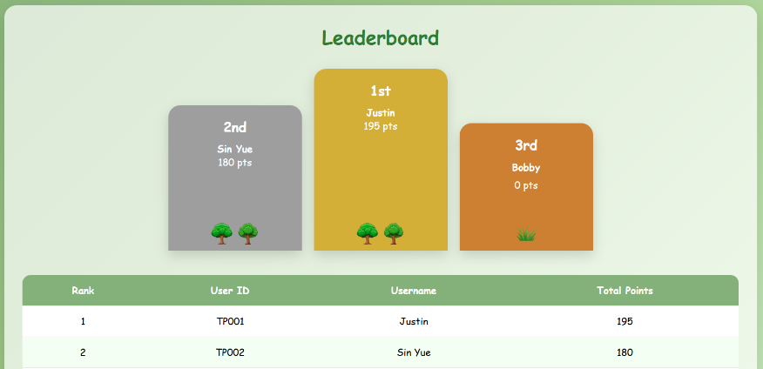
Figure 4. Leaderboard

5.3 Limitations and Challenges
Despite achieving the main objectives, several limitations and challenges were identified during the development of the system. Firstly, the system currently does not include a badge or achievement feature. While users can earn points, the absence of milestone-based rewards may limit long-term user motivation and engagement. Users may feel less encouraged to consistently participate in sustainability challenges, especially after reaching higher points level.

Moreover, the gamification elements in the system are relatively basic. The system relies on points and leaderboard rankings, without implementing advanced features such as levels or streaks system. As a result, the user experience may become repetitive over time and users may feel boring to interact with the system.

Furthermore, the EcoRewards system relies heavily on manual moderation for submission verification. All user submissions require approval by moderators. It may reduce system scalability as the number of users increases and significantly increase the moderators’ workload.

Last but not least, the system only partially achieves the objective of increasing environmental awareness. While users are encouraged to participate in sustainability activities, EcoRewards platform does not provide sufficient educational content such as tips, articles or learning materials. This limits the system’s ability to actively educate users beyond participation-based engagement.

5.4 Recommendations for Future Improvements
The EcoRewards website should be implemented some enhancements in the future to improve user engagement and system efficiency. First and foremost, a badge or achievement system should be introduced to enhance the existing points system. Users can be awarded badges for reaching specific achievements, such as completing a certain number of challenges or achieving target point level. This feature will motivate users to remain actively engaged with the system.

In addition, the gamification features can be further enhanced by introducing more interactive elements such as levels, streak and dynamic challenges. For example, daily or weekly challenges and bonus points events can be implemented to maintain user interest. These features can help reduce repetitive user experiences and encourage continuous user engagement (Archi Gupta, 2024).

Furthermore, an automated verification mechanism can be implemented. Technologies such as image recognition or basic validation algorithms can be used to analyse user-submitted proof and detect duplicates (Mucci, 2025). This will improve system efficiency, reduce moderator workload and enhance scalability when handling a larger number of users.

Besides that, educational content related to environmental sustainability should be integrated into EcoRewards system. Features such as eco-tips, article and learning resources can be incorporated to increase user awareness and knowledge. This will better support the objective of promoting environmental education among students.

6.0 References
Archi Gupta. (2024, September 9). Gamification Techniques for increasing customer
engagement and Loyalty :: UXMatters. UXmatters. https://www.uxmatters.com/mt/archives/2024/09/gamification-techniques-for-increasing-customer-engagement-and-loyalty.php

Mucci, T. (2025, November 17). Image Recognition. IBM.
https://www.ibm.com/think/topics/image-recognition

7.0 Workload Matrix
Name | Tasks
BONG ZIHAO | 3.2 Entity relationship Diagram (ERD)  3.3 Data Dictionary  4.1.1 Student  4.2.1 General  4.2.2 Student  4.3.1 General  4.3.2 Student  5.0 Conclusion
GAN SHAO CHENG | 1.1 Project Overview  1.2 Project Objectives  3.1 System Flowchart  3.5 Navigation Map  4.1.2 Moderator  4.2.3 Moderator  4.3.3 Moderator
LIM SIN YUE | 1.3 Project Scope  1.4 Intended Users  2.0 Project Management  3.4 Wireframes  4.1.3 Administrator  4.2.4 Administrator  4.3.4 Administrator

