**Title**

“**Battery Level Indicator Circuit”**

**Group Details:**

**1-2020-CS-125** **2**-**2019-CS-133**

**3-2020-CS-134** **4**-**2020-CS-157**

**Significance:**

A battery level indicator is with electronic appliances to arrange as to display, on an indicator, a real time voltage detected by voltage indicator. Indicator indicates how much power the battery will be able to supply to electronic apparatus. It is used to check the battery level with the help of LED’s for example if three LED’s, indicates battery capacity of 30 percent. And if 10 LED’s glow then it is 100 percent. Easily indicate the battery level. Enhanced version of this circuitry is the present mobile phone battery level indication system. This circuit can be used in household applications like INVERTER. This circuit connected to inverter can help the users to know when to charge and when to leave the inverter idle. Minimized version of this circuit can be also used for automobiles to indicate the battery level and low cost.

**Description:**

Battery level indicator is a circuit that is used to check the battery life. We can easily recognize the battery level with the help of LED’s. It uses a **LM3914** driver IC use to drive **10 LEDs** by passing sufficient amount of current through it. Brightness of LEDs are controlled by reference adjustable pin and reference out pin. A **variable resistor** is also deployed in the circuit to have variable input voltage at pin 5 of the driver IC. Since the driver IC has two modes of operation which is bar graph mode and dot mode, it enables us to have indication of the battery life either in bar form or in dot form. We can have colored LEDs to indicate state of the batteries like first three LEDs will indicate low battery. And the last LED will show that the battery is at its maximum level.

**Components:**

Circuit contains components:

* **BreadBoard**
* **LM3914**
* **Resistors (18k, 4.7k, 56k)**
* **Variable Resistor as Potentiometer**
* **10 LED’s**
* **12V Battery (To Test)**
* **Connecting Wires**

**1-BreadBoard:**

A breadboard is a solderless device for temporary prototype with electronics and test circuit designs. Most electronic components in electronic circuits can be interconnected by inserting their leads or terminals into the holes and then making connections through wires where appropriate. Breadboards are designed to work with through-hole electronic components.

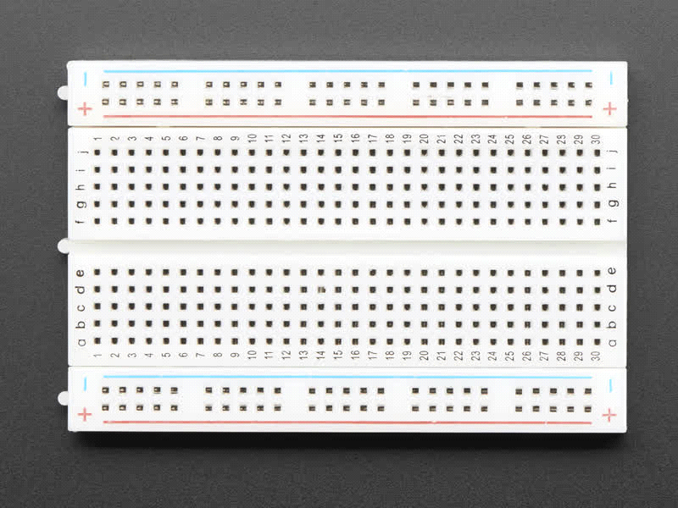

**2-LM3914:**

The heart of this battery level indicator circuit is LM3914 IC. This IC takes input analog voltage and drives 10 LED’s linearly according to the input analog voltage.

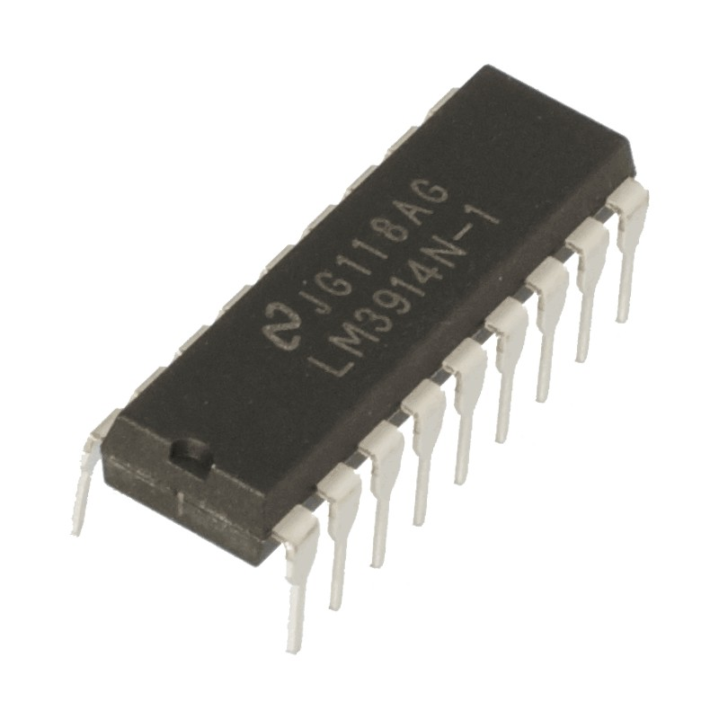

**3- Resistors (18k, 4.7k, 56k):**

Resistors are used in the circuit with LM3914 IC. One resistor is used in common with 56k resistor which will act as switch if we remove that resistor circuit will show dot graph and connecting this circuit will show bar graph.

**4- Potentiometer as a Potential Divider:**

Potentiometer is used in the circuit so that we can control the current in the circuit. It acts same as potential divider.

**5- 10 LED’s:**

In this circuit LED’s (D1-D10) displays the capacity of the battery in either dot mode or display mode. This mode is selected by the external switch sw1 which is connected to 9th pin of IC.

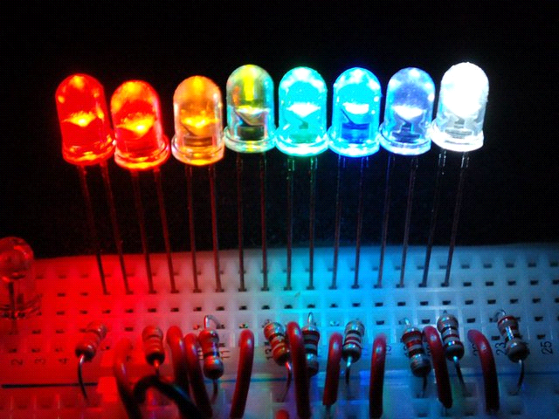

**6-12V Battery (To Test):**

This circuit is most suitable for indicating 12V battery level. In this circuit each led indicates 10 percent battery level.

**7-Connecting Wires:**

Connecting wires are used in the circuit to connect the components with their source and with each other.

**Working:**

The circuit will work when the battery will be connected to it. The main important part of circuit is IC LM3914. The heart of this battery level indicator circuit is LM3914 IC. This IC takes input analog voltage and drives 10 LED’s linearly according to the input analog voltage. In this circuit, there is no need of resistors in series with LEDs because the current is regulated by the IC. It drives the LEDs after it. Resistors are connected with the circuit to control the voltage/current. One resistor is used in common with 56k resistor which will act as switch if we remove that resistor circuit will show dot graph and connecting this circuit will show bar graph.

There is a variable resistor which acts same like the potentiometer it can control the current in the circuit. There is a resistor which can open and close the circuit by taking it off or on the circuit. When the 1st LED will glow it means that the battery level is 10% and when all lights will glow it shows that the battery is at its maximum level 100%. The circuit is designed to monitor 10V to 15V DC. The circuit will work even if the battery voltage is 3V. The operating voltage of this IC is 3v to 25v DC. Lm3914 drives LEDs , LCDs and vacuum fluorescents.

The lowest reading of the circuit is measured at 8.8V at which the 1st LED of the circuit glows, the 2nd LED glows at 9.1V, the 3rd LED glows at 9.5V, the 4th LED glows at 10.0V, the 5th LED glows at 10.4V, the 6th LED glows at 10.7V, the 7th LED glows at 11.2V, the 8th LED glows at 11.6V, the 9th LED glows at 12V and the 10th and last LED will glow at 12.3V and this will be its final reading.

**Circuit:**