[Tsinghua Online Judge](http://dsa.cs.tsinghua.edu.cn/oj/foyer.shtml)

* [Foyer](http://dsa.cs.tsinghua.edu.cn/oj/foyer.shtml)
* [Profile](http://dsa.cs.tsinghua.edu.cn/oj/problem.shtml?id=1145)
* [Courses](http://dsa.cs.tsinghua.edu.cn/oj/problem.shtml?id=1145)
* [Guide](http://dsa.cs.tsinghua.edu.cn/oj/guide.shtml)
* [Logout](http://dsa.cs.tsinghua.edu.cn/oj/problem.shtml?id=1145)
* My Courses

列车调度(Train)

**Description**

Figure 1 shows the structure of a station for train dispatching.

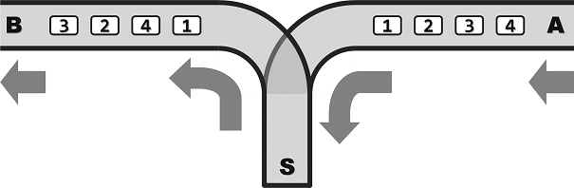

Figure 1

In this station, A is the entrance for each train and B is the exit. S is the transfer end. All single tracks are one-way, which means that the train can enter the station from A to S, and pull out from S to B. Note that the overtaking is not allowed. Because the compartments can reside in S, the order that they pull out at B may differ from that they enter at A. However, because of the limited capacity of S, no more that m compartments can reside at S simultaneously.

Assume that a train consist of n compartments labeled {1, 2, …, n}. A dispatcher wants to know whether these compartments can pull out at B in the order of {a1, a2, …, an} (a sequence). If can, in what order he should operate it?

**Input**

Two lines:

1st line: two integers n and m;

2nd line: n integers separated by spaces, which is a permutation of {1, 2, …, n}. This is a compartment sequence that is to be judged regarding the feasibility.

**Output**

If the sequence is feasible, output the sequence. “Push” means one compartment goes from A to S, while “pop” means one compartment goes from S to B. Each operation takes up one line.

If the sequence is infeasible, output a “no”.

**Example 1**

Input

5 2

1 2 3 5 4

Output

push

pop

push

pop

push

pop

push

push

pop

pop

**Example 2**

Input

5 5

3 1 2 4 5

Output

No

**Restrictions**

1 <= n <= 1,600,000

0 <= m <= 1,600,000

Time: 2 sec

Memory: 256 MB

**描述**

某列车调度站的铁道联接结构如Figure 1所示。

其中，A为入口，B为出口，S为中转盲端。所有铁道均为单轨单向式：列车行驶的方向只能是从A到S，再从S到B；另外，**不允许超车**。因为车厢可在S中驻留，所以它们从B端驶出的次序，可能与从A端驶入的次序不同。不过S的容量有限，同时驻留的车厢不得超过m节。

设某列车由编号依次为{1, 2, ..., n}的n节车厢组成。调度员希望知道，按照以上交通规则，这些车厢能否以{a1, a2, ..., an}的次序，重新排列后从B端驶出。如果可行，应该以怎样

的次序操作?

**输入**

共两行。

第一行为两个整数n，m。

第二行为以空格分隔的n个整数，保证为{1, 2, ..., n}的一个排列，表示待判断可行性的驶出序列{a1，a2，...，an}。

**输出**

若驶出序列可行，则输出操作序列，其中push表示车厢从A进入S，pop表示车厢从S进入B，每个操作占一行。

若不可行，则输出No。

**样例**

见英文题面

**限制**

1 ≤ n ≤ 1,600,000

0 ≤ m ≤ 1,600,000

时间：2 sec

空间：256 MB

UI powered by [Twitter Bootstrap](http://getbootstrap.com/).

Tsinghua Online Judge is designed and coded by Li Ruizhe.

For all suggestions and bug reports, contact oj[at]liruizhe[dot]org.