**Experiment Design and Purchase Form**

1. Carbon capture reactor based on solid-state electrolyte

基于固态电解质的碳捕集反应器

Reappearance复现文献：*Nature*, 2023, **618**, 959-966

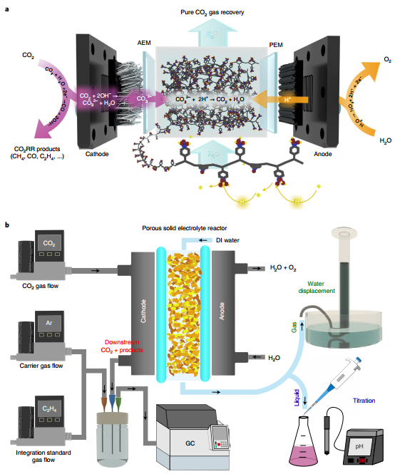

**Chemicals & Electrochemical materials 化学试剂及电化学配件:**

|  |  |  |
| --- | --- | --- |
| Materials 所需材料 | Purpose目的 | Standard 规格/厂家 |
| Pt/C catalyst  Pt/C商用催化剂 | ORR rxn.  阴极氧还原反应产OH- | 苏州晟尔诺20% Pt  1.0 cm² |
| IrO2碳纸 | OER rxn.  阳极产H+ | 1.0 cm² |
| GDL  GDL气体扩散层 | Load catalyst  负载催化剂 | Sigracet 28 BC |
| Isopropanol  异丙醇 | 电极制备 | AR |
| Nafion  Nafion粘接剂 | 电极制备 | 5% |
| Sustainion AEM  Sustainion 阴离子交换膜 | Exchange anion at Cathode |  |
| Nafion 117 CEM  Nafion 117 阳离子交换膜 | Exchange proton at Anode |  |
| Amberlite 732 (H)  Amberlite 732 离子交换树脂 | Solid electrode | 罗恩 |
| PTFE  聚四氟乙烯垫片 | Set SER | 0.015 英寸厚，1 cm² 窗口 |
| Delrin plastic  聚甲醛塑料模具 | Set SER | 2.5mm (1.5mm inner) |
| Mass flow  气体流量控制计 |  |  |
| CO2 Meter  CO2检测计 |  |  |
| pH Meter  pH计 | Titration  滴定 |  |

**Key experiments：**

1. 电极喷涂 Electrode spraying

40 mg 催化剂 + 4 mL 异丙醇 + 160 μL Nafion 溶液，超声 30 min 🡪10 mg/mL 墨水

喷雾涂布于 GDL（1 cm² 面积），负载量≈10 mg cm⁻²，干燥后作为阴极；IrO₂电极直接作为阳极。

1. 核心测试

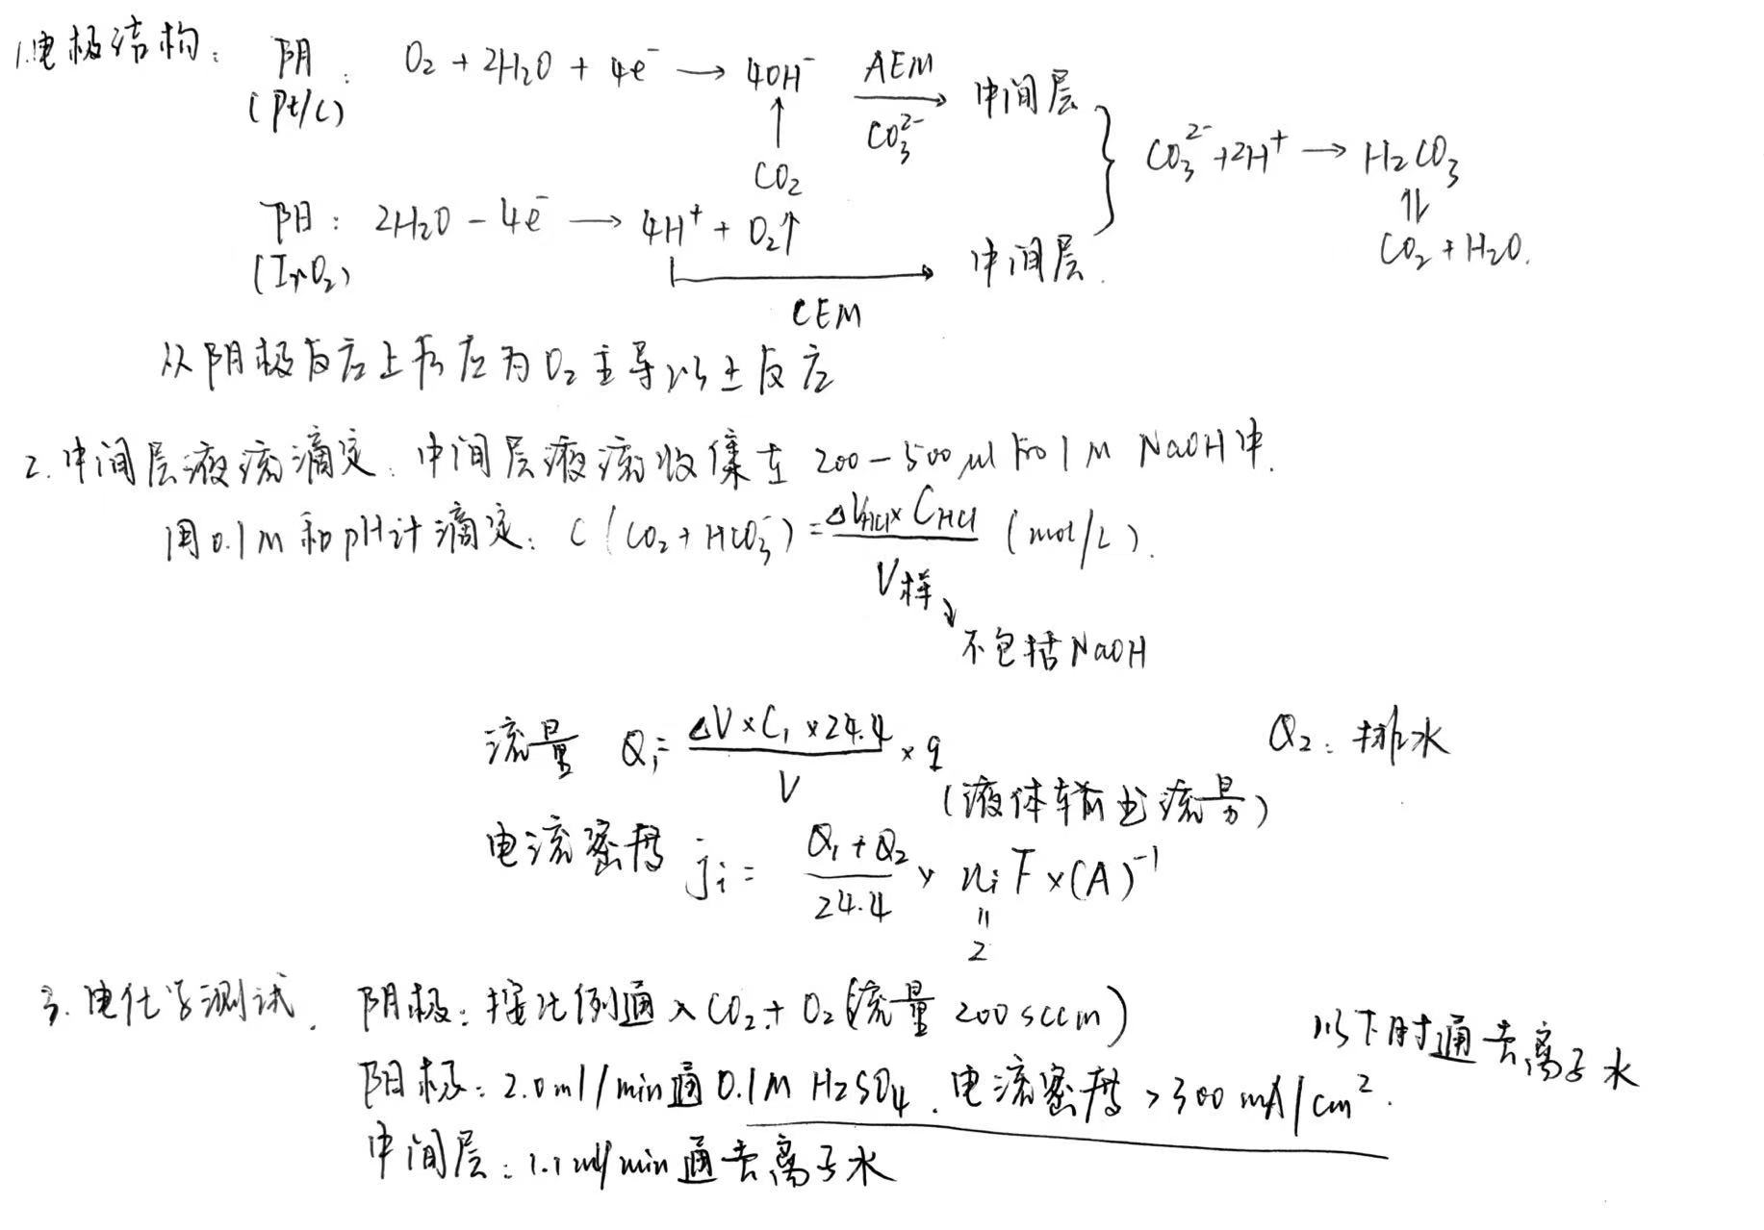

1. 电化学测试
2. LSV：初步判断催化剂活性；
3. I-V
4. 法拉第效率
5. 碳捕集能耗

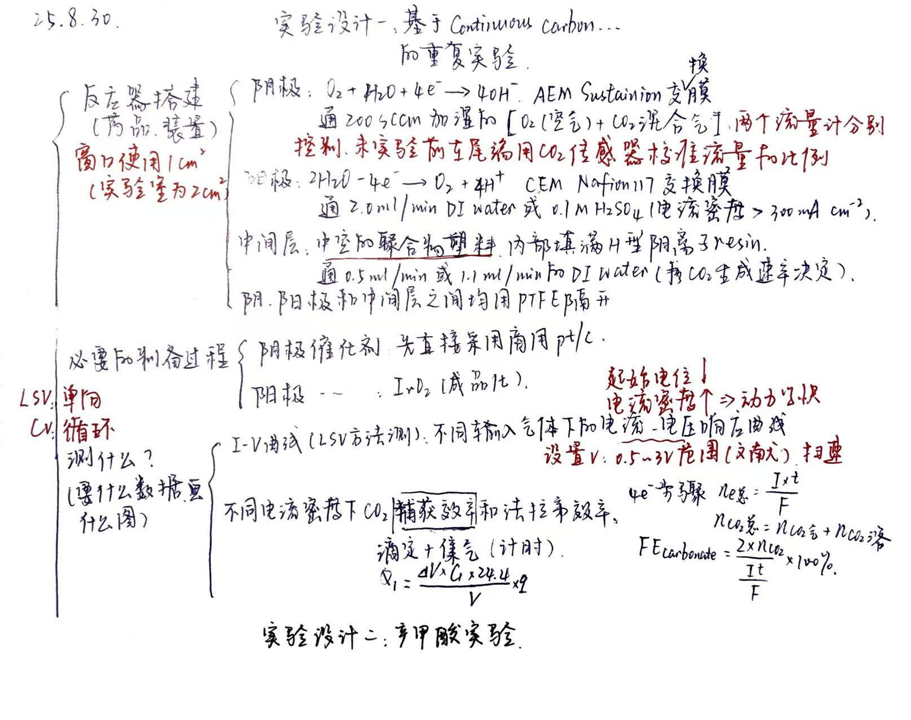

CO2传感器：[SprintIR英国GSS高速响应红外二氧化碳传感器NDIR SprintIR-WF-60-淘宝网](https://item.taobao.com/item.htm?abbucket=8&id=709457066926&mi_id=0000iH3f-MXAPlHqGNxKdXww6LWkDJfMX3WzVe-l4E-gT1M&ns=1&skuId=5146859814582&spm=a21n57.1.hoverItem.4&utparam=%7B%22aplus_abtest%22%3A%229fcb41f546778eea92a31b95914ac345%22%7D&xxc=taobaoSearch)

[红外二氧化碳传感器金属进口CO2探头大量程红外防护型气体变送器-tmall.com天猫](https://detail.tmall.com/item.htm?abbucket=8&id=798878546845&mi_id=0000sRezk_P_XwJ1vdlU9e1jk_eC6gdw4XRgjBlhyc6VyfU&ns=1&priceTId=2100c80117566517670655682e0a28&skuId=5628345746601&spm=a21n57.1.hoverItem.22&utparam=%7B%22aplus_abtest%22%3A%222d323205589dc852e96878a2f4fc2eb4%22%7D&xxc=taobaoSearch)

SprintIR 传感器本身通常只提供一个**数字串口输出**（通常是 TTL 电平的 UART，如 **Tx**, **Rx**, **GND**, **+5V**），**需要一个额外的****USB 转 TTL 串口模块**。

[正点原子USB转串口模块ATK-MO340P USB转TTL模块 USB转RS485模块 TTL转RS485三合一转换器 485 通信串口线-tmall.com天猫](https://detail.tmall.com/item.htm?abbucket=8&id=669365802975&mi_id=0000JFjm1pcpD42cpDzfoejuP4uIRiCJ7KRnFAzdSEX1OCM&ns=1&priceTId=2100c80117566518341567209e0a28&skuId=4812852560130&spm=a21n57.1.hoverItem.16&utparam=%7B%22aplus_abtest%22%3A%22c179a79fb665d0cdf86e9ff9a815c2a8%22%7D&xxc=taobaoSearch)

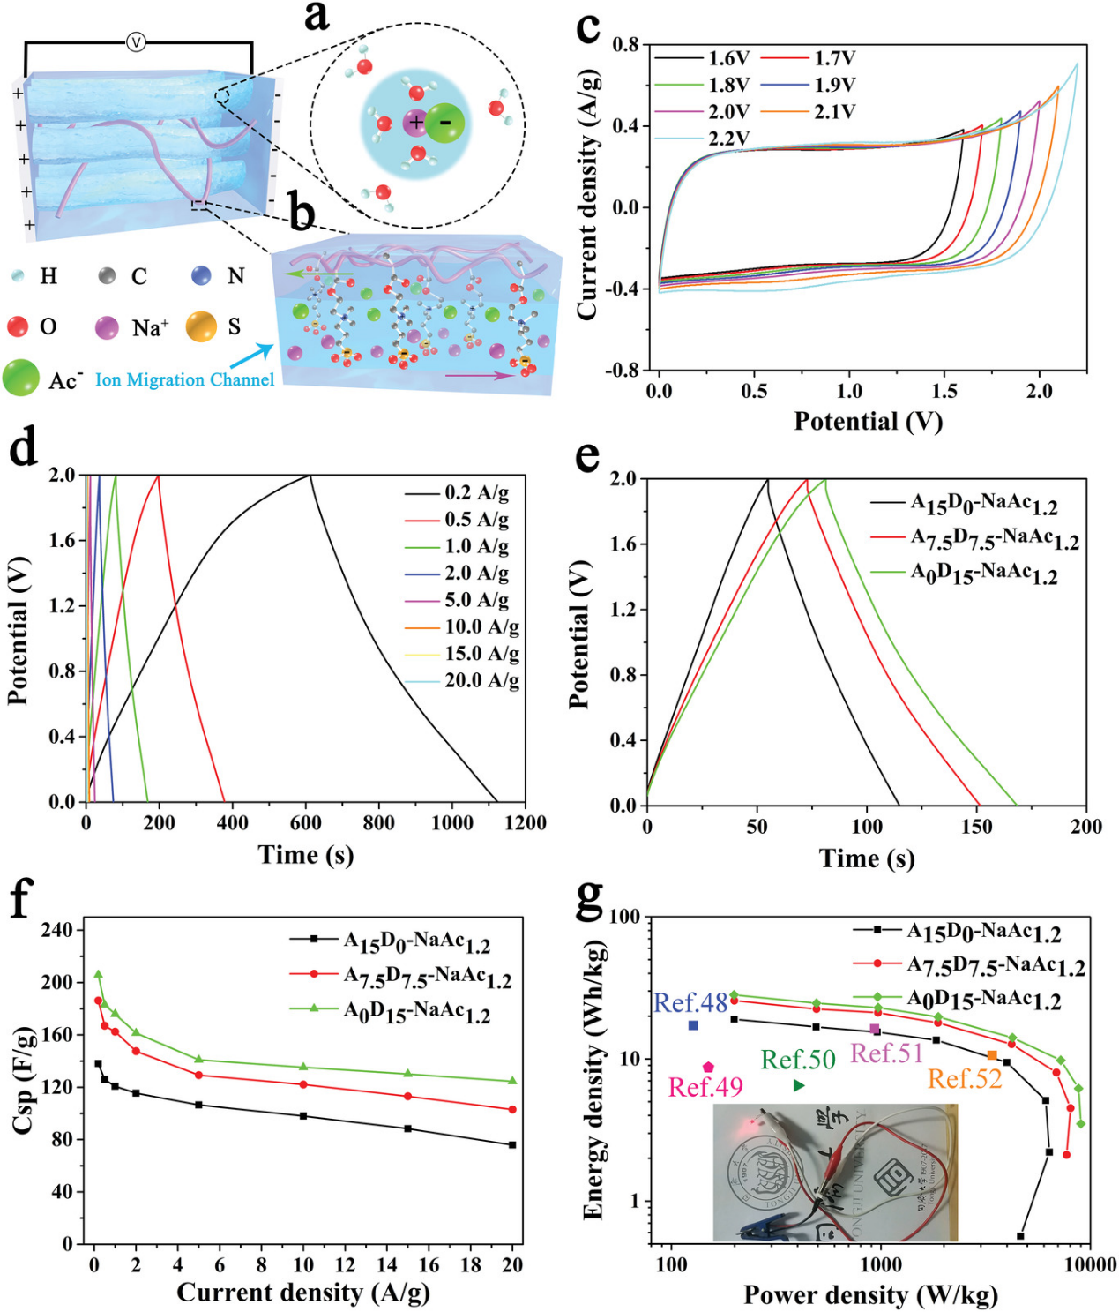

Junjie Wei, Gumi Wei, Yinghui Shang, Jie Zhou, Chu Wu, and Qigang Wang，Dissolution–CrystallizationTransition within a Polymer Hydrogel for a Processable Ultratough Electrolyte，Adv. Mater. 2019, 1900248.DOI: 10.1002/adma.201900248

[同济大学王启刚教授课题组《Adv. Mater. 》：聚合物凝胶中过饱和析晶造就的新型固态电解质_中国聚合物网科教新闻](http://www.polymer.cn/sci/kjxw15672.html)

1. Reappearance 复现: *Nature Energy*, **2025**, 10, 55–65 (2025)

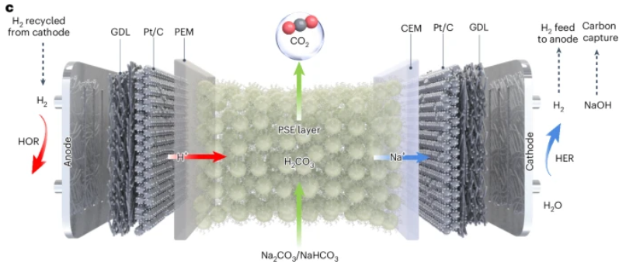

**Chemicals & Electrochemical materials 化学试剂及电化学配件:**