Extension User Stories - Review Copy

Newly added stories only: A.9-A.11, B.7-B.9, C.6-C.8, D.7-D.9 and E.6-E.8.

A. Farmer (3 Extension User Stories)

A.9 Bilingual Leaf Screening
User Story: As a farmer, I want to screen a maize leaf photo in English or Chinese, so that I can understand visible disease-like signs and decide what to do next.

Detailed Description

Name: Bilingual Leaf Screening
Stakeholder & Objectives:
The Farmer needs a clear, cautious and human-centred screening assistant that explains visible signs, uncertainty, photo quality and safe next steps in the selected language without claiming a laboratory diagnosis.
Actors: Farmer, Leaf Assistant, Disease Screening Model, Advice Engine
Triggers: The Farmer selects or photographs a maize leaf, chooses a language, optionally adds field context and submits the screening request.
Pre-Condition:
The Farmer is authenticated; the API and approved disease model are available; the selected file is a supported JPG or PNG within configured size and pixel limits.
Post-Condition: The system returns a bilingual screening response or retake request and stores the validated image, technical evidence, context and farmer-facing guidance when persistence succeeds.
Normal Flow:
1. The Farmer selects English or Chinese and supplies a leaf image.
2. The Leaf Assistant uploads the image and optional crop stage, weather and symptom-spread context.
3. The server validates the image and assesses brightness, blur, size and contrast.
4. The disease model produces calibrated class probabilities and uncertainty evidence.
5. The Advice Engine converts the evidence into observations, a possible condition, questions and safe next steps.
6. The interface displays the response in the selected language with a safety note.
7. The system persists the evidence and response without changing the original model output.
Sub-Flow: If the Farmer adds field context, it enriches the explanation but remains stored separately from model probabilities and quality measurements.
Alternative Flow:
1. If photo quality is insufficient, the system stops before classification and asks for a clearer retake.
2. If confidence is below the calibrated threshold, the result is marked unsupported or needs confirmation.
3. If the disease model is unavailable, the API returns a controlled service-unavailable response and never fabricates a condition.

Diagrams
BCE Class Diagram
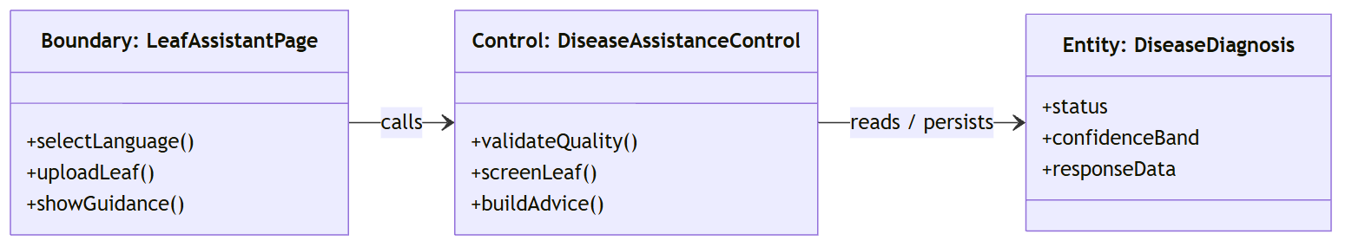

Sequence Diagram
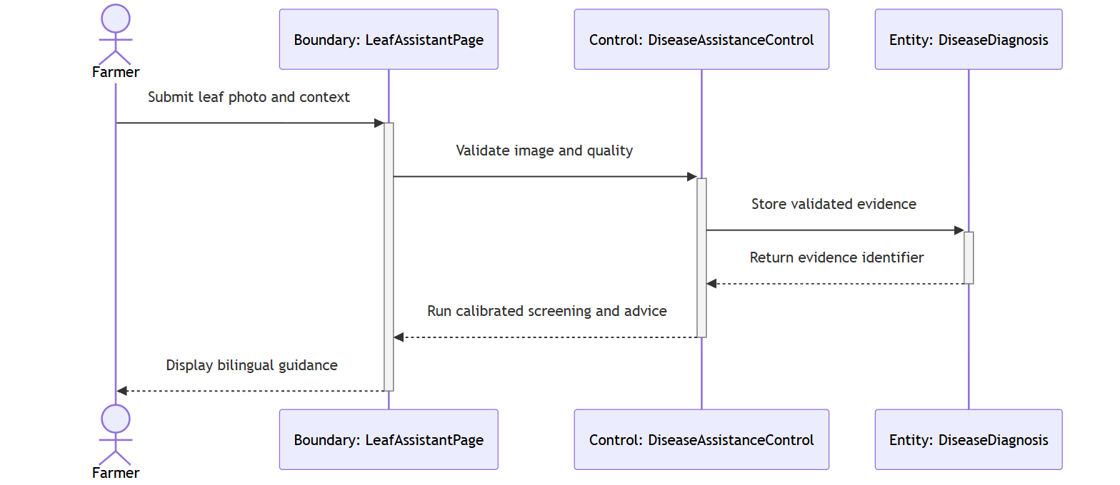

Test case:

Test Case ID: TC1_9 | User Stories: #31 (A.9)
Name: As a farmer, I want to screen a maize leaf photo in English or Chinese, so that I can understand visible disease-like signs and decide what to do next.
Test Scenario: Verify that a Farmer receives safe bilingual leaf-screening guidance and that poor-quality evidence produces a retake request.
Actions:
1. Log in as an active Farmer.
2. Open the Leaf Assistant and select English.
3. Upload a valid close-up maize leaf image and optional field context.
4. Submit the screening request.
5. Review quality, observations, possible condition, confidence language, next steps and safety note.
6. Repeat with a deliberately dark or undersized image.
7. Confirm that the second request asks for a retake instead of naming a condition.
Prerequisites:
- Active Farmer account
- Disease model is deployment-ready
- One valid leaf image and one poor-quality image
Test Data:
- language=en
- crop_stage=before tasseling
- valid_leaf.jpg and dark_leaf.jpg
Expected Results: A valid image returns a complete English screening response with uncertainty and safety wording; a poor-quality image returns retake guidance and no fabricated diagnosis.
Actual Result: As expected. Verified by the current automated regression suite.
Pass

Wireframe:
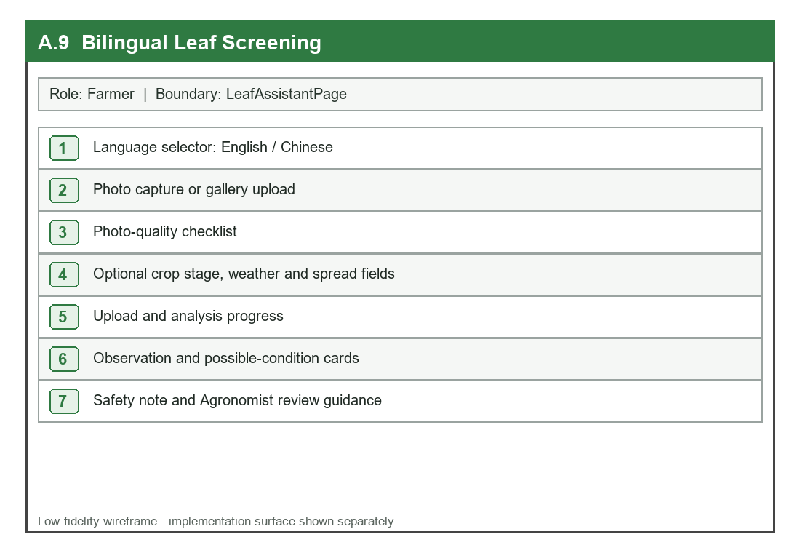

UI:
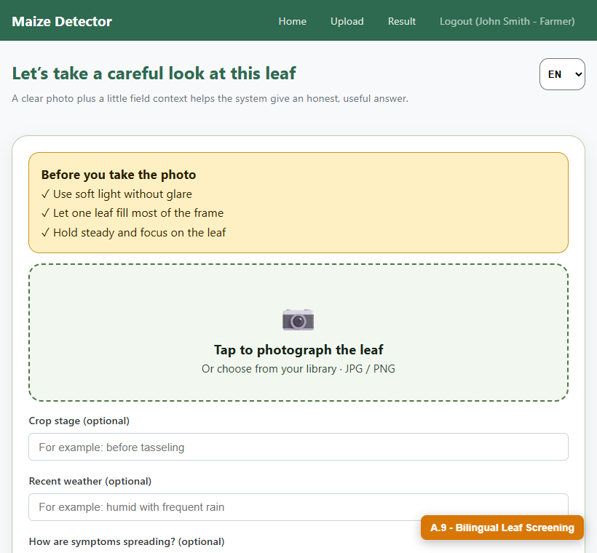

A.10 Secure Account Maintenance
User Story: As a farmer, I want to change my email address or password securely, so that I can keep access when my contact details change.

Detailed Description

Name: Secure Account Maintenance
Stakeholder & Objectives:
The Farmer needs a simple account page that uses email as the only contact identifier, confirms sensitive changes with the current password and immediately revokes older sessions.
Actors: Farmer, Account Page, Authentication Service
Triggers: The authenticated Farmer opens My Account and submits an email/profile change or password change.
Pre-Condition:
The Farmer account is active, the current password is known and the requested email is not already assigned to another user.
Post-Condition: Validated profile data or password hash is updated, session_version is incremented, the current session receives a fresh token where appropriate and all previous tokens become invalid.
Normal Flow:
1. The Farmer opens My Account and chooses Edit profile or Change password.
2. The interface collects the requested values and current password.
3. The server reloads the current account and verifies the password.
4. The server validates email uniqueness or password policy and confirmation.
5. The account record is updated and session_version is incremented.
6. The action is written to the system log.
7. The interface confirms the change and uses the new session state.
Sub-Flow: A name and email may be changed together; an unchanged email is accepted when only the name is being updated.
Alternative Flow:
1. A malformed or duplicate email is rejected without changing the account.
2. A weak, mismatched or unchanged password is rejected with a clear validation message.
3. An incorrect current password returns an authorization error and no session is changed.

Diagrams
BCE Class Diagram
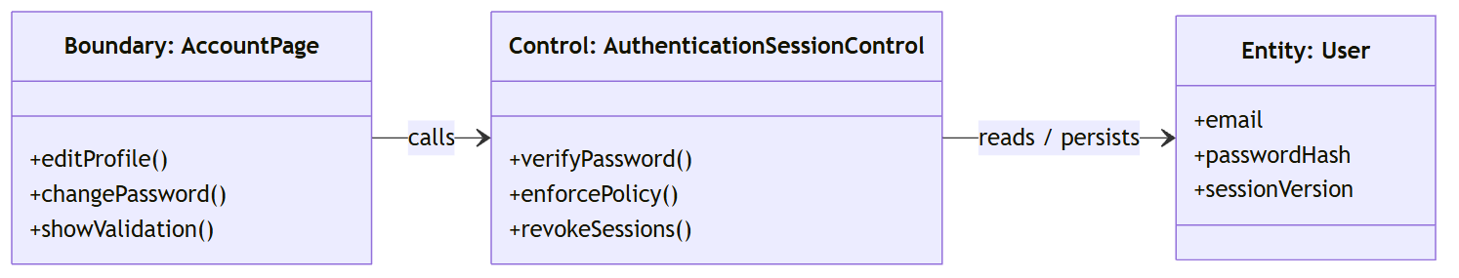

Sequence Diagram
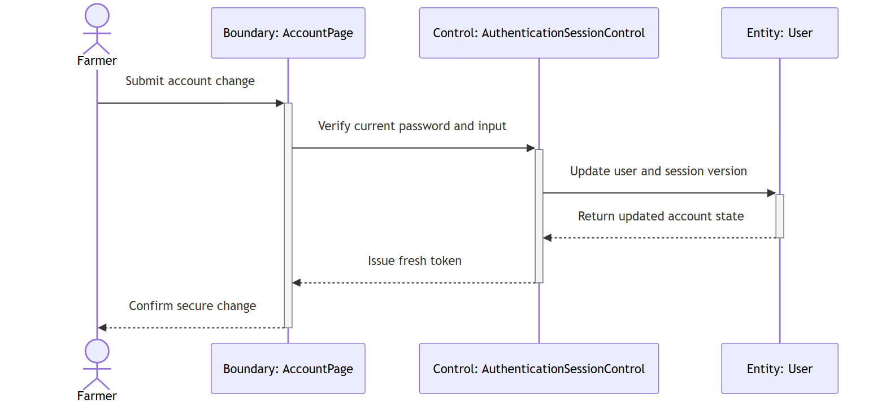

Test case:

Test Case ID: TC1_10 | User Stories: #32 (A.10)
Name: As a farmer, I want to change my email address or password securely, so that I can keep access when my contact details change.
Test Scenario: Verify secure email and password maintenance and immediate rejection of a token issued before the change.
Actions:
1. Log in as an active Farmer and retain the issued token.
2. Open My Account and submit a new unique email with the current password.
3. Confirm that the profile is updated and a fresh token is returned.
4. Call a protected endpoint with the retained old token.
5. Change the password using the correct current password and a policy-compliant replacement.
6. Attempt to sign in with the old password, then with the new password.
Prerequisites:
- Active Farmer account
- Current password is available
- A unique replacement email
Test Data:
- new email: farmer.updated@example.com
- strong replacement password
- old access token
Expected Results: Valid changes persist, prior tokens are rejected, the old password stops working and the new password succeeds; invalid inputs do not alter the account.
Actual Result: As expected. Verified by the current automated regression suite.
Pass

Wireframe:
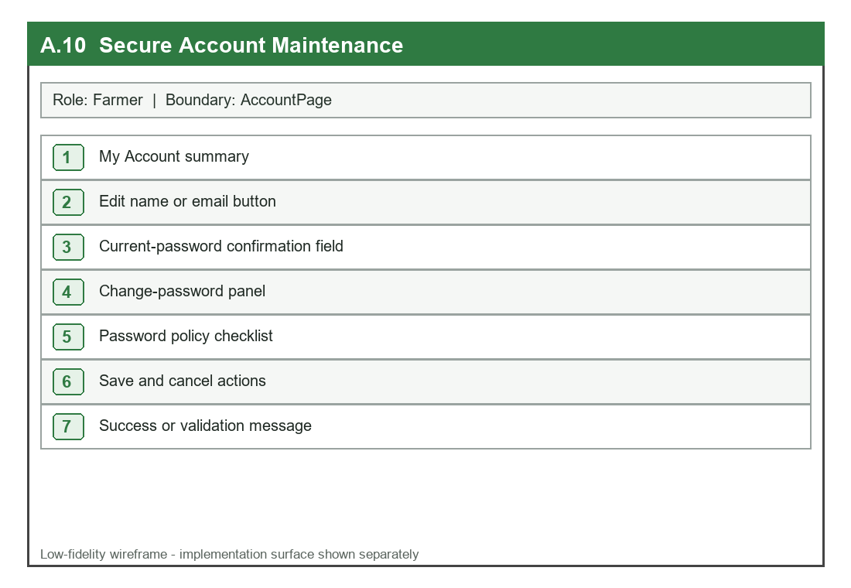

UI:
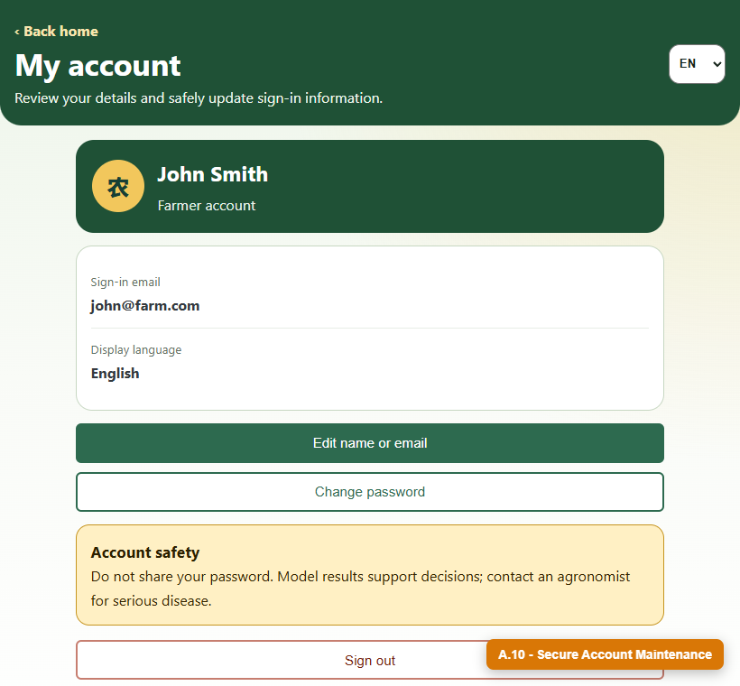

A.11 Resilient Field Upload
User Story: As a farmer using mobile data, I want clear upload progress and recoverable errors, so that an interrupted 4G/5G connection does not make me lose track of my work.

Detailed Description

Name: Resilient Field Upload
Stakeholder & Objectives:
The Farmer needs a mobile upload experience that reduces data usage, makes compression and transfer progress visible, survives temporary network failure and avoids duplicate or colliding storage records.
Actors: Farmer, Mobile Upload Page, Upload API
Triggers: The Farmer captures or selects a field image and starts an upload over a mobile connection.
Pre-Condition:
The Farmer is authenticated, the browser can read the selected image and the file is a supported image format.
Post-Condition: A successful upload creates one validated encrypted Image/Image File pair with a UUID storage name and digest; a failed transfer leaves the page and selected-photo context available for deliberate retry.
Normal Flow:
1. The Farmer selects or captures a field image.
2. The mobile client reads orientation and dimensions and compresses the image when appropriate.
3. The interface displays original size, prepared size and compression status.
4. The upload client sends multipart bytes with an Authorization header and progress callback.
5. The server validates actual content, assigns a UUID name and computes SHA-256.
6. The validated bytes are encrypted and stored with metadata.
7. The interface confirms completion and proceeds to analysis.
Sub-Flow: If compression is unnecessary or unsupported, the original valid image is uploaded while the interface still reports its size and progress.
Alternative Flow:
1. If the network disconnects, the current page is preserved and a human-readable reconnect-and-retry message is shown.
2. If the file is too large or not a real image, the server rejects it before persistence.
3. If the original filename is reused, the UUID and content digest keep the records isolated.

Diagrams
BCE Class Diagram
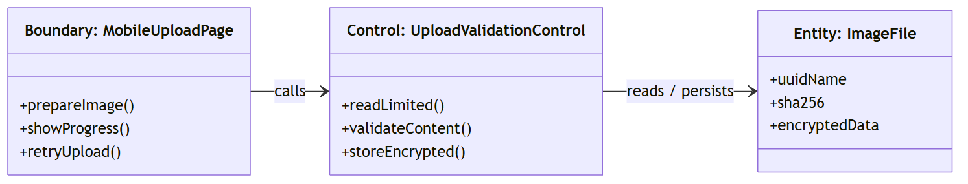

Sequence Diagram
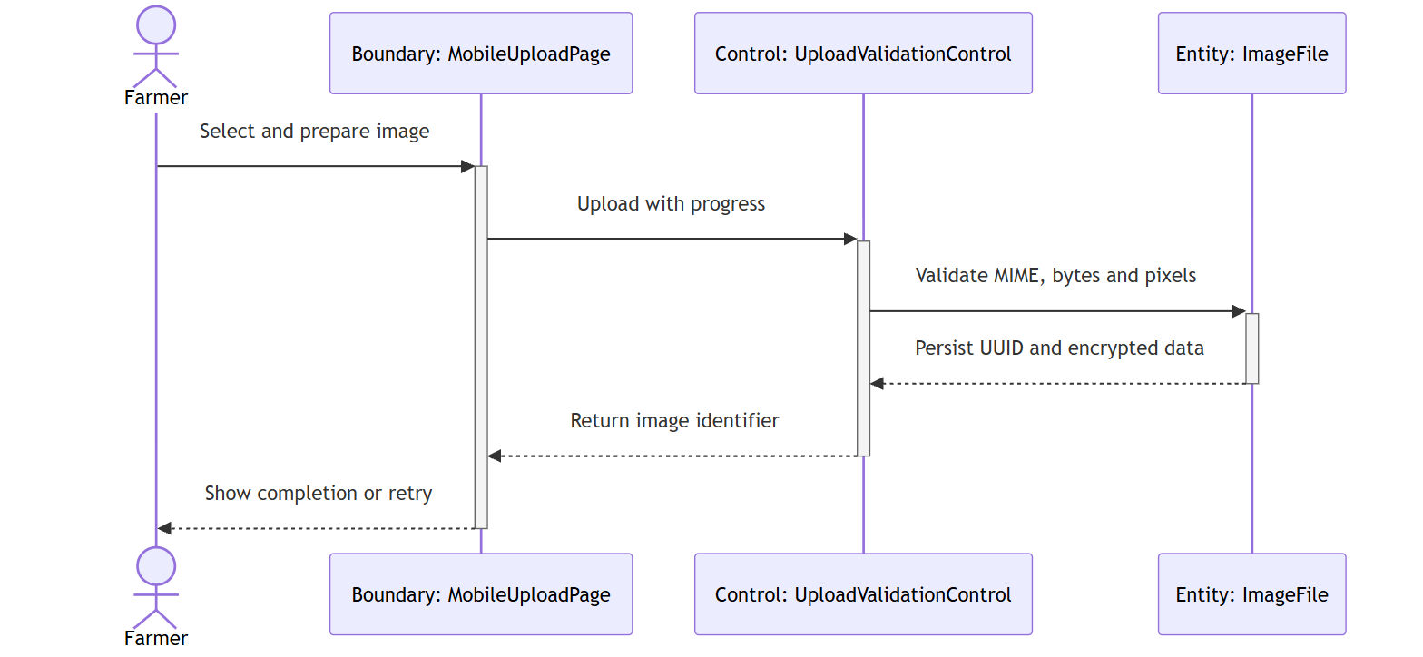

Test case:

Test Case ID: TC1_11 | User Stories: #33 (A.11)
Name: As a farmer using mobile data, I want clear upload progress and recoverable errors, so that an interrupted 4G/5G connection does not make me lose track of my work.
Test Scenario: Verify visible mobile upload preparation and recovery from an interrupted connection without logout or duplicate data.
Actions:
1. Log in as a Farmer on a mobile viewport.
2. Select a large valid field image.
3. Observe original and prepared sizes before upload.
4. Start the upload and observe transfer progress.
5. Simulate an offline or interrupted connection.
6. Confirm that the current screen and selected image remain available.
7. Reconnect, retry once and verify that only one successful record is created.
Prerequisites:
- Active Farmer account
- Mobile-capable browser
- Valid multi-megabyte field image
Test Data:
- field_photo.jpg
- simulated offline network state
- repeated original filename
Expected Results: Preparation and progress are visible; interruption does not log out the Farmer; retry succeeds deliberately; validated storage uses a unique UUID and digest.
Actual Result: As expected. Verified by the current automated regression suite.
Pass

Wireframe:
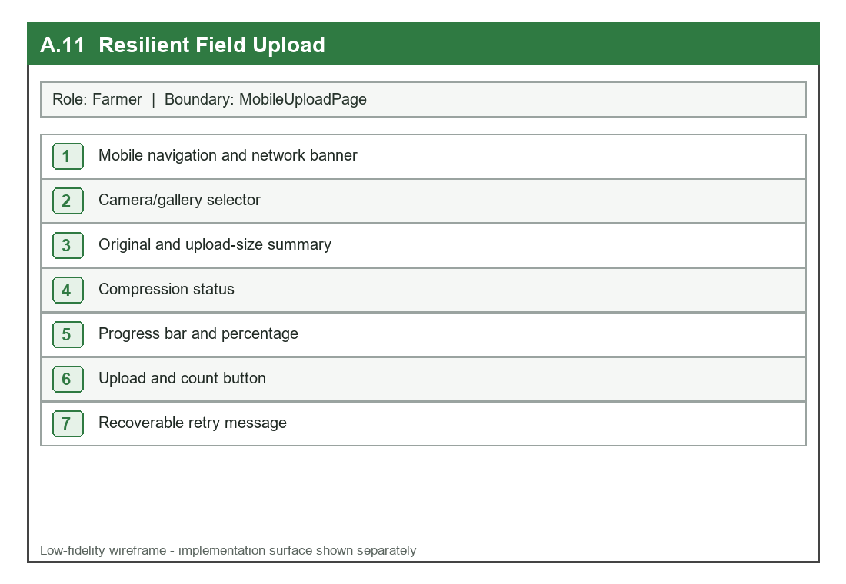

UI:
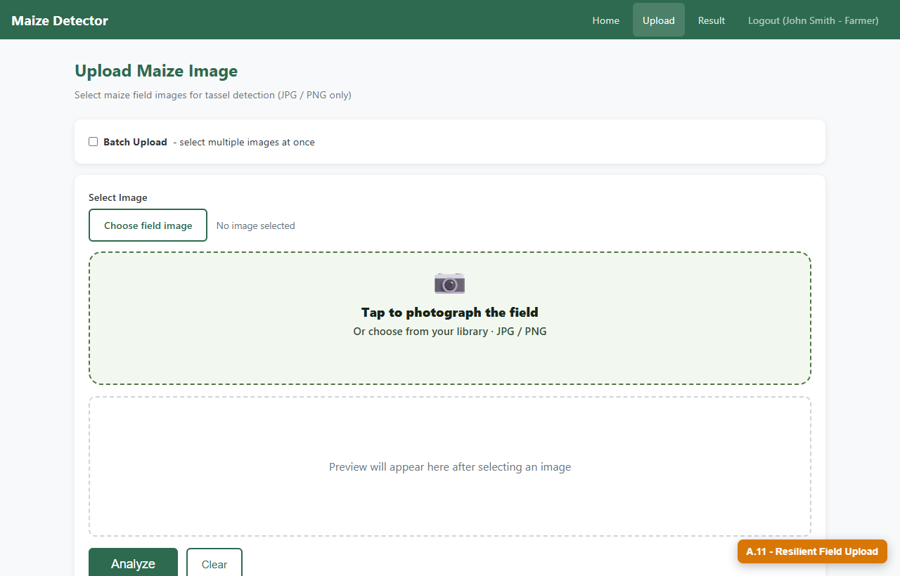

B. Researcher (3 Extension User Stories)

B.7 Review Uncertainty and Provenance
User Story: As a researcher, I want model identity, confidence, uncertainty, and quality metadata with each result, so that I can judge whether a record is suitable for analysis.

Detailed Description

Name: Review Uncertainty and Provenance
Stakeholder & Objectives:
The Researcher needs reproducible scientific evidence for every result, including model version, inference mode, confidence, quality and human-review state, while internal server paths remain private.
Actors: Researcher, Research Dashboard, Result Service
Triggers: The Researcher opens recent results, history or a filtered research dataset.
Pre-Condition:
The Researcher is authenticated with result-read permission and the database contains detection or disease-screening records.
Post-Condition: The interface returns stable provenance and uncertainty metadata suitable for inclusion/exclusion decisions without exposing filesystem paths or secret configuration.
Normal Flow:
1. The Researcher requests result records through the dashboard.
2. The API verifies the Researcher role and reloads current account permissions.
3. The service joins result evidence with registered model metadata and review state.
4. Internal paths and sensitive configuration are removed from the response.
5. The API returns model version, inference mode, confidence, quality and review status.
6. The dashboard presents the evidence next to the result.
7. The Researcher decides whether the record is suitable for analysis.
Sub-Flow: The Researcher may filter by field, date, model, quality or review state before exporting a research subset.
Alternative Flow:
1. A record with missing provenance is labelled incomplete and is not silently treated as validated.
2. A stale or disabled session is rejected before any result is returned.
3. An unauthorized role receives a forbidden response.

Diagrams
BCE Class Diagram
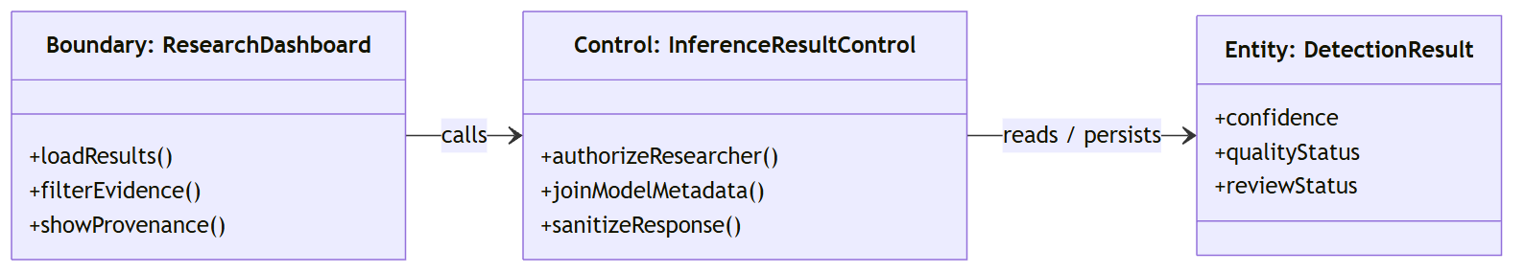

Sequence Diagram
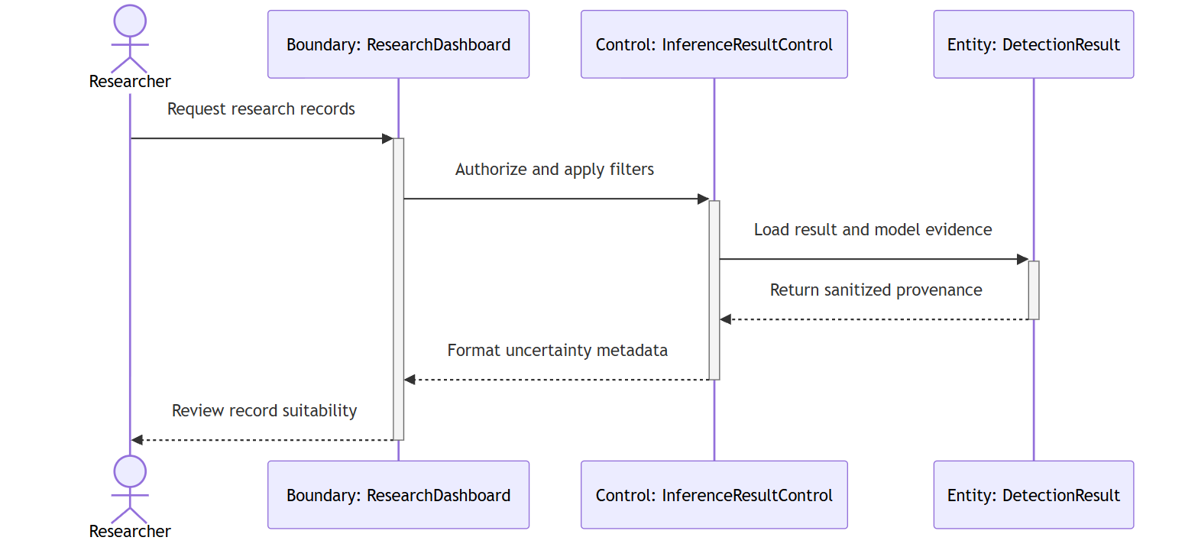

Test case:

Test Case ID: TC2_7 | User Stories: #34 (B.7)
Name: As a researcher, I want model identity, confidence, uncertainty, and quality metadata with each result, so that I can judge whether a record is suitable for analysis.
Test Scenario: Verify that research records expose complete provenance and uncertainty while hiding internal server paths.
Actions:
1. Log in as a Researcher.
2. Open Recent Research Records.
3. Request records containing both detection and screening outcomes.
4. Inspect model version, inference mode, confidence, quality and review state.
5. Inspect the raw API response for internal absolute paths.
6. Apply an uncertainty or quality filter.
Prerequisites:
- Active Researcher account
- Registered model metadata
- Stored result records
Test Data:
- Detection result with model version
- Disease diagnosis needing confirmation
- Reviewed and unreviewed records
Expected Results: Every returned record contains stable provenance and uncertainty fields; no internal absolute path is exposed; filters preserve the evidence.
Actual Result: As expected. Verified by the current automated regression suite.
Pass

Wireframe:
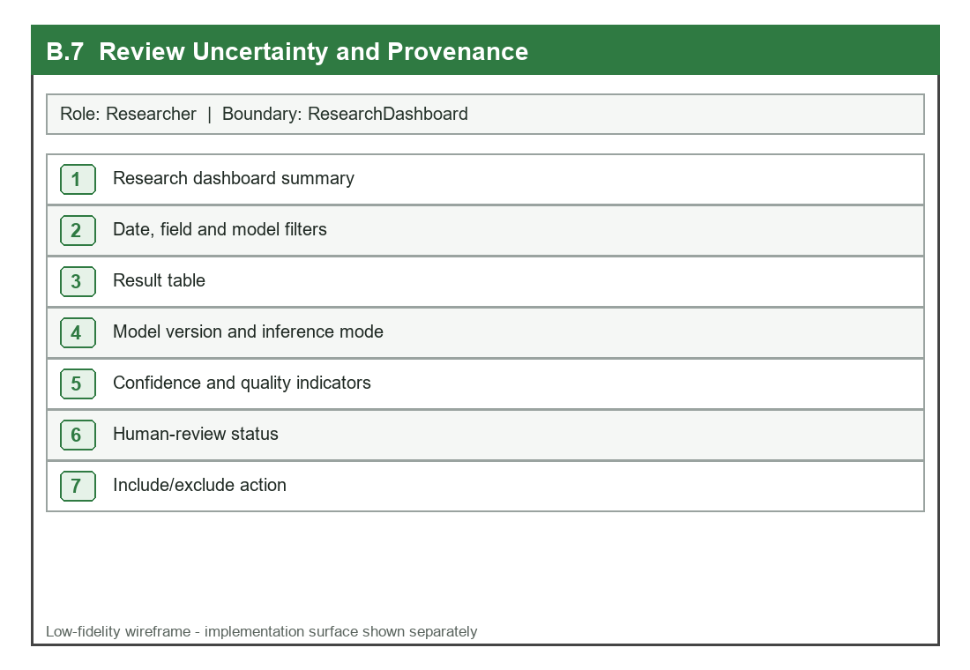

UI:
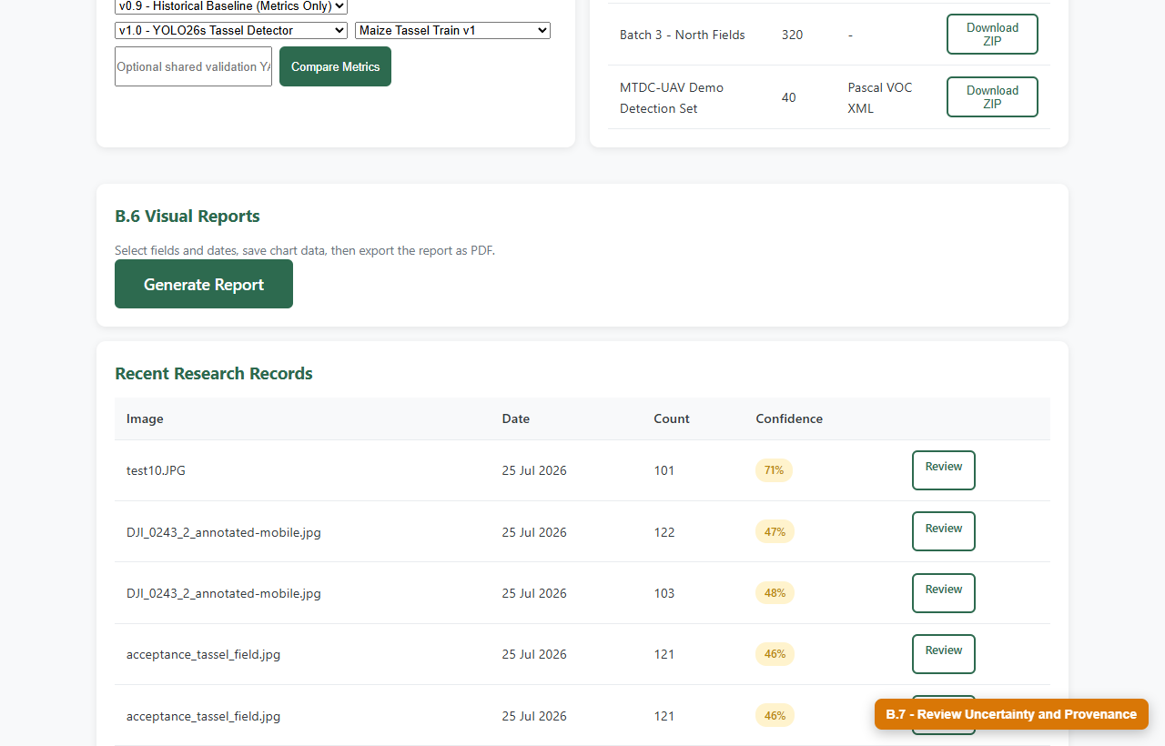

B.8 Controlled Dataset Retrieval
User Story: As a researcher, I want approved datasets exported with a manifest, so that I can reproduce analysis without accessing arbitrary server files.

Detailed Description

Name: Controlled Dataset Retrieval
Stakeholder & Objectives:
The Researcher needs a permission-controlled archive of an approved dataset and manifest, while configured storage roots prevent arbitrary filesystem access and unsafe oversized content.
Actors: Researcher, Dataset Page, Dataset Export Service
Triggers: The Researcher selects an approved dataset and requests a ZIP or TAR download.
Pre-Condition:
The account has datasets:download permission; the dataset record is active; its source path is inside a configured dataset root.
Post-Condition: The system returns an archive containing approved files and a manifest describing dataset identity, format and export metadata; the action is audited.
Normal Flow:
1. The Researcher opens Dataset Access and selects a registered dataset.
2. The API verifies role and datasets:download permission.
3. The export control resolves the stored path against configured dataset roots.
4. The service enumerates allowed files and excludes oversized entries.
5. A manifest is generated with dataset metadata and included files.
6. The archive is streamed without revealing the server path.
7. The system records the controlled download action.
Sub-Flow: The Researcher may select a supported archive format when the same approved source and manifest rules are retained.
Alternative Flow:
1. A path outside configured roots is rejected before any file is opened.
2. A missing or inactive dataset returns a not-found or unavailable response.
3. A user without datasets:download permission receives a forbidden response.

Diagrams
BCE Class Diagram
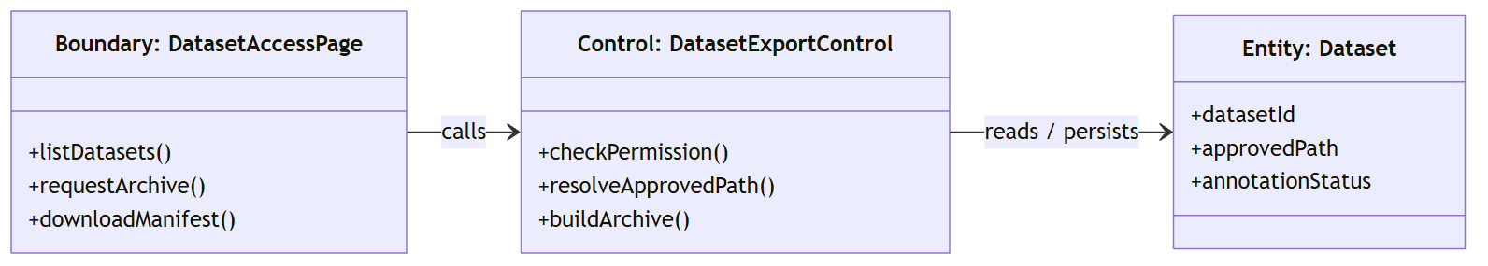

Sequence Diagram
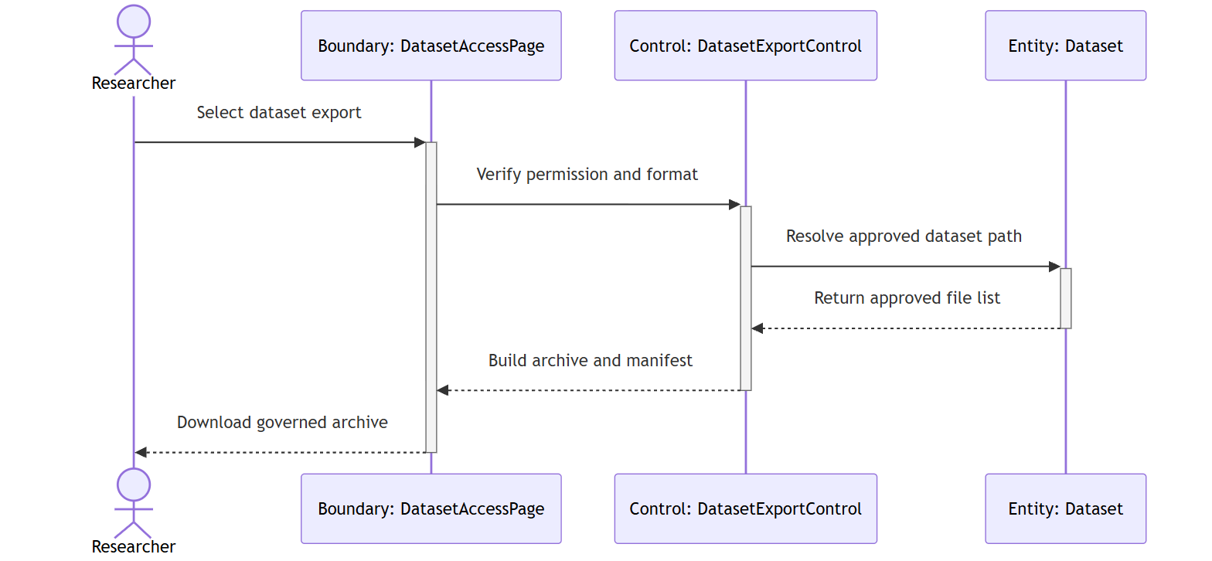

Test case:

Test Case ID: TC2_8 | User Stories: #35 (B.8)
Name: As a researcher, I want approved datasets exported with a manifest, so that I can reproduce analysis without accessing arbitrary server files.
Test Scenario: Verify successful manifest-based export from an approved root and rejection of an out-of-root dataset path.
Actions:
1. Log in as a Researcher with datasets:download permission.
2. Select an approved dataset and request download.
3. Open the returned archive and inspect the manifest.
4. Confirm that the response does not expose an absolute server path.
5. Change the test dataset path to an out-of-root location.
6. Repeat the request and verify rejection.
Prerequisites:
- Authorized Researcher
- Approved dataset root
- Registered dataset with sample files
Test Data:
- approved dataset directory
- out-of-root test path
- one oversized source file
Expected Results: The approved archive contains a manifest and allowed files only; out-of-root access is rejected; oversized content is excluded; the action is logged.
Actual Result: As expected. Verified by the current automated regression suite.
Pass

Wireframe:
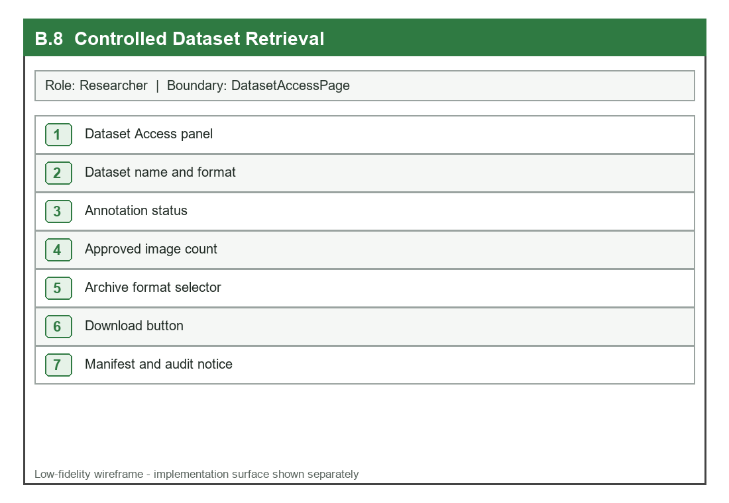

UI:
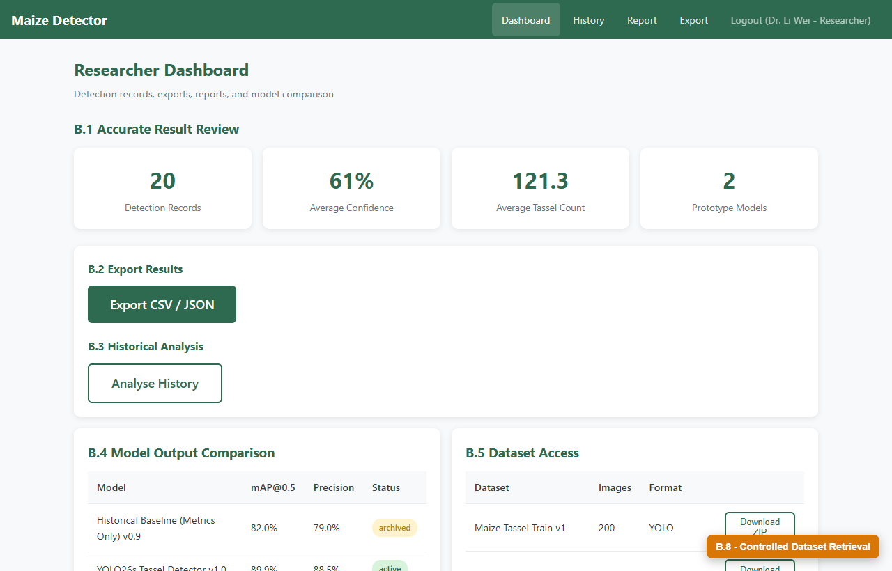

B.9 Reproducible Model Evaluation
User Story: As a researcher, I want evaluation to use an integrity-checked model and approved dataset YAML, so that reported metrics are tied to a reproducible artifact.

Detailed Description

Name: Reproducible Model Evaluation
Stakeholder & Objectives:
The Researcher needs mAP, precision and recall values that are traceable to one registered model digest and one approved dataset definition rather than an arbitrary local file.
Actors: Researcher, Model Evaluation Page, Model Governance Service
Triggers: The Researcher selects a registered model and approved dataset configuration and starts evaluation, or requests stored metrics.
Pre-Condition:
The model is registered with a materialized supported artifact; the dataset YAML is inside an approved root; the Researcher has model-evaluation permission.
Post-Condition: Validated metrics are returned and persisted against the registered model with a source indicating stored evidence or a validation run.
Normal Flow:
1. The Researcher selects a model and dataset definition.
2. The API verifies the Researcher role and requested identifiers.
3. Model Governance resolves the artifact inside the approved model root.
4. The recorded SHA-256 is compared with the materialized artifact.
5. The dataset YAML is resolved inside an approved dataset root.
6. Evaluation calculates mAP, precision and recall or retrieves stored validated values.
7. Metrics and source are returned and associated with the registered model.
Sub-Flow: When no dataset YAML is supplied, the service returns stored evaluation metrics without starting an expensive validation run.
Alternative Flow:
1. A missing, Git LFS pointer-only, altered or out-of-root model is rejected.
2. An out-of-root or invalid dataset YAML is rejected.
3. An unavailable evaluation runtime returns a controlled error without changing stored metrics.

Diagrams
BCE Class Diagram
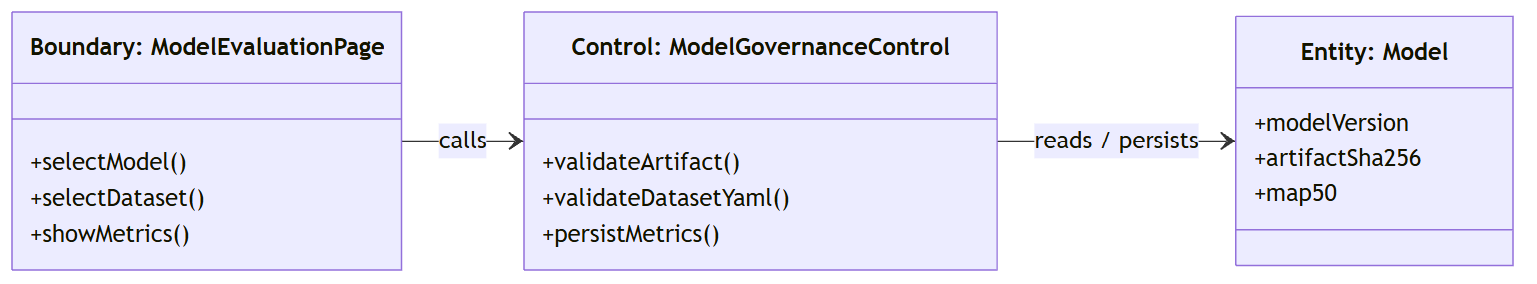

Sequence Diagram
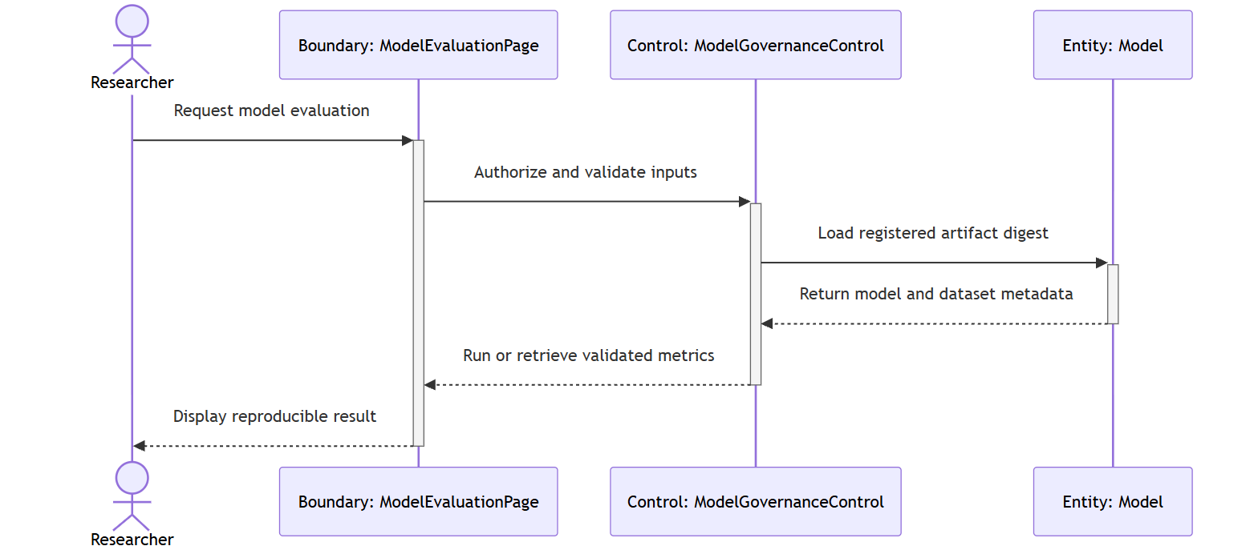

Test case:

Test Case ID: TC2_9 | User Stories: #36 (B.9)
Name: As a researcher, I want evaluation to use an integrity-checked model and approved dataset YAML, so that reported metrics are tied to a reproducible artifact.
Test Scenario: Verify integrity-checked stored metrics and rejection of a model artifact whose digest does not match its registry entry.
Actions:
1. Log in as a Researcher.
2. Select a registered model and request stored evaluation metrics.
3. Confirm model identifier, metric values and source.
4. Configure an approved dataset YAML and request validation.
5. Alter a temporary model artifact or expected digest.
6. Repeat validation and verify that evaluation is rejected before execution.
Prerequisites:
- Authorized Researcher
- Registered materialized model
- Approved dataset YAML
Test Data:
- model_id
- artifact SHA-256
- dataset.yaml
Expected Results: Stored or newly evaluated metrics remain tied to a validated model and approved dataset; a path or digest violation is rejected before evaluation.
Actual Result: As expected. Verified by the current automated regression suite.
Pass

Wireframe:
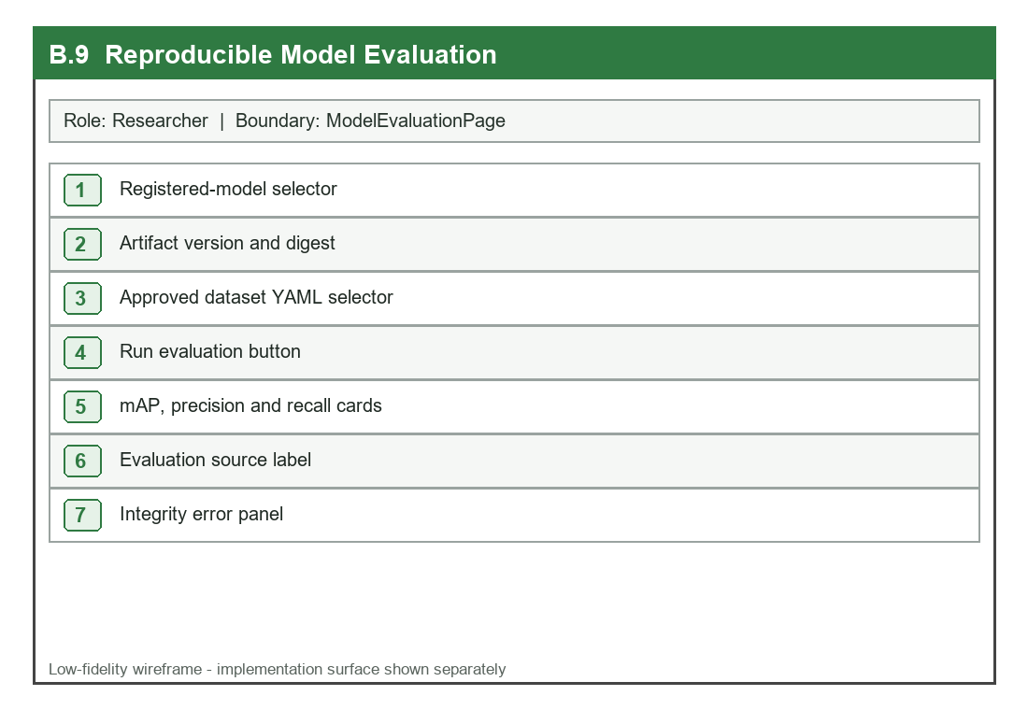

UI:
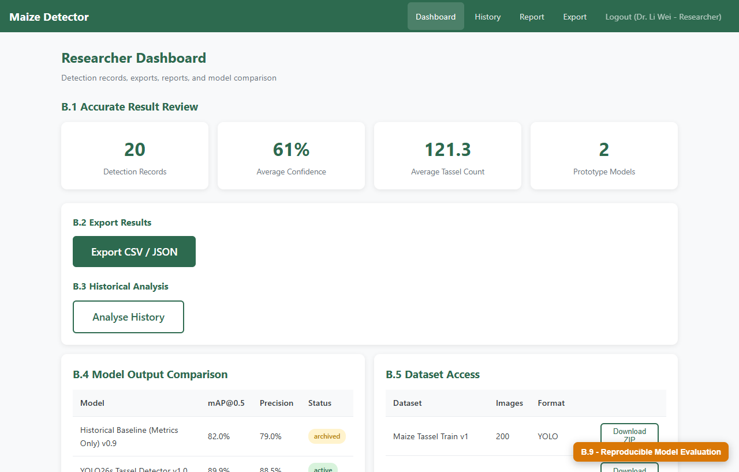

C. Agronomist (3 Extension User Stories)

C.6 Review Assigned Field Evidence
User Story: As an agronomist, I want to view leaf-screening evidence only for fields assigned to me, so that I can support farmers without seeing unrelated private images.

Detailed Description

Name: Review Assigned Field Evidence
Stakeholder & Objectives:
The Agronomist needs a field-scoped dashboard that shows only operationally assigned fields, diagnoses, summaries and protected images, enforcing the same boundary on every route.
Actors: Agronomist, Agronomist Dashboard, Field Authorization Service
Triggers: The Agronomist opens field lists, multi-field summaries, diagnosis history or protected evidence.
Pre-Condition:
The Agronomist account is active and at least one Field Assignment links the user to a field; requested evidence belongs to a known field.
Post-Condition: Only assigned field evidence is returned and displayed; attempted access to an unassigned field is denied and may be audited.
Normal Flow:
1. The Agronomist signs in and opens the dashboard.
2. Each protected request reloads the current account and role.
3. The Field Authorization Service resolves active Field Assignments for the Agronomist.
4. Field lists, insights, diagnoses and image queries apply the assignment filter.
5. The database returns evidence only for assigned field identifiers.
6. The dashboard displays scoped multi-field and diagnosis information.
7. The Agronomist opens permitted evidence for review.
Sub-Flow: An Admin may access all fields for governance, but the response still records the requesting identity and action.
Alternative Flow:
1. An unassigned field identifier returns HTTP 403 without disclosing its private evidence.
2. A removed assignment takes effect on the next protected request.
3. A stale or disabled Agronomist session is rejected before field lookup.

Diagrams
BCE Class Diagram
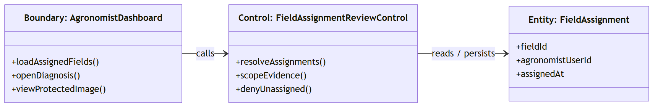

Sequence Diagram
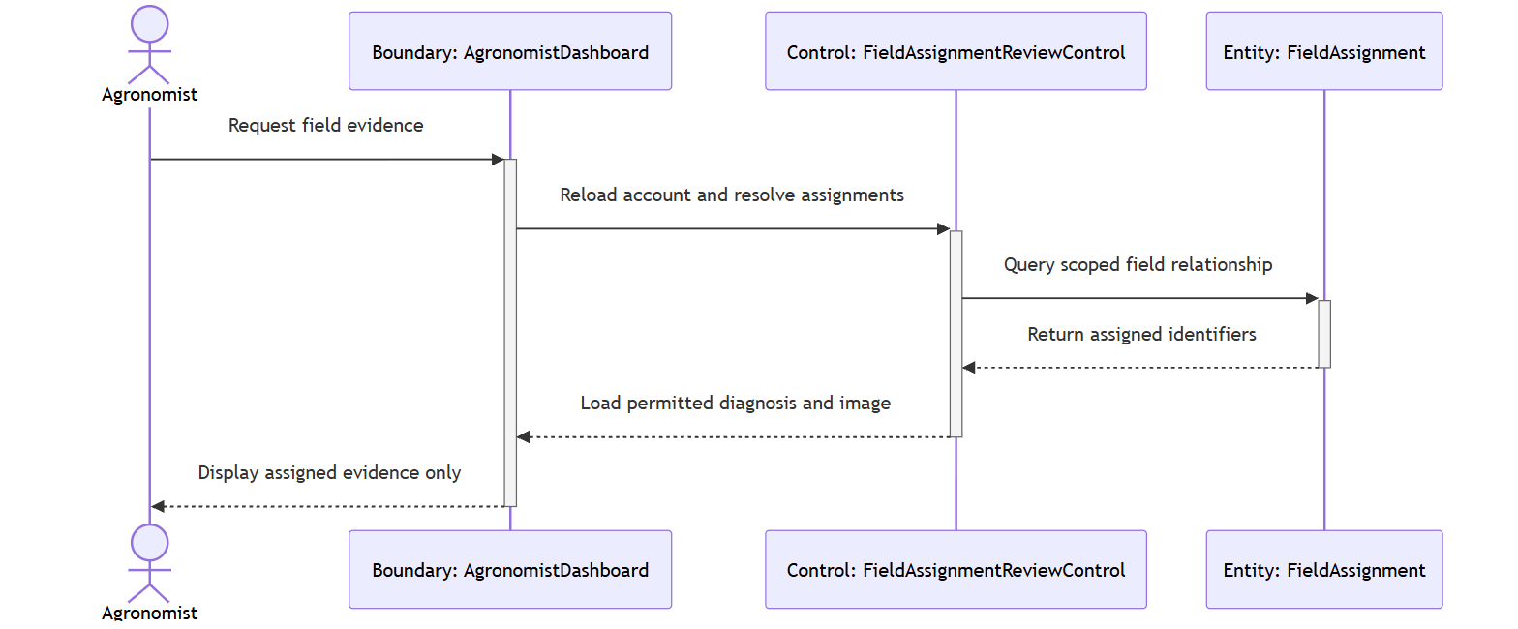

Test case:

Test Case ID: TC3_6 | User Stories: #37 (C.6)
Name: As an agronomist, I want to view leaf-screening evidence only for fields assigned to me, so that I can support farmers without seeing unrelated private images.
Test Scenario: Verify that an Agronomist can open assigned field evidence and receives a forbidden response for an unassigned field and image.
Actions:
1. Create one assigned and one unassigned field for an Agronomist.
2. Log in as that Agronomist.
3. Request the field list and confirm only assigned records appear.
4. Open diagnosis history and protected image evidence for the assigned field.
5. Request the same routes with the unassigned field identifier.
6. Remove the assignment and repeat the assigned-field request.
Prerequisites:
- Active Agronomist
- One Field Assignment
- Assigned and unassigned diagnosis/image records
Test Data:
- assigned field_id
- unassigned field_id
- protected image_id
Expected Results: Assigned evidence is available; unassigned or removed assignments return forbidden responses; no unrelated image or diagnosis metadata is leaked.
Actual Result: As expected. Verified by the current automated regression suite.
Pass

Wireframe:
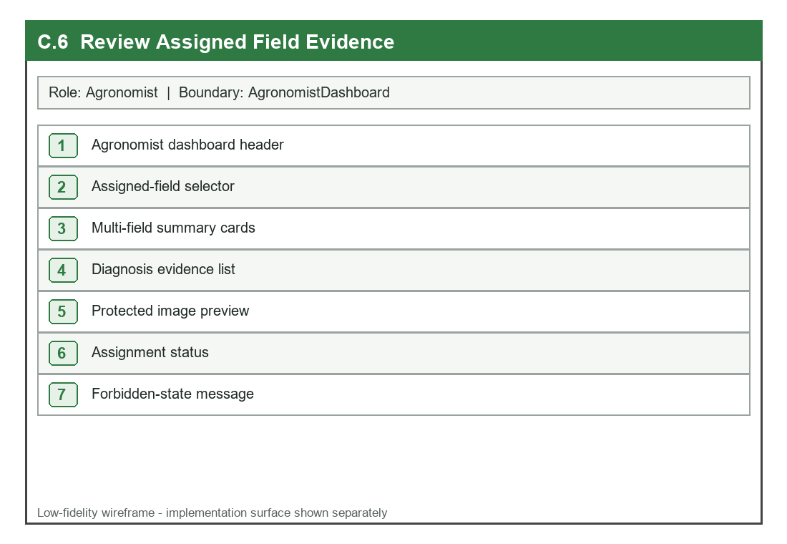

UI:
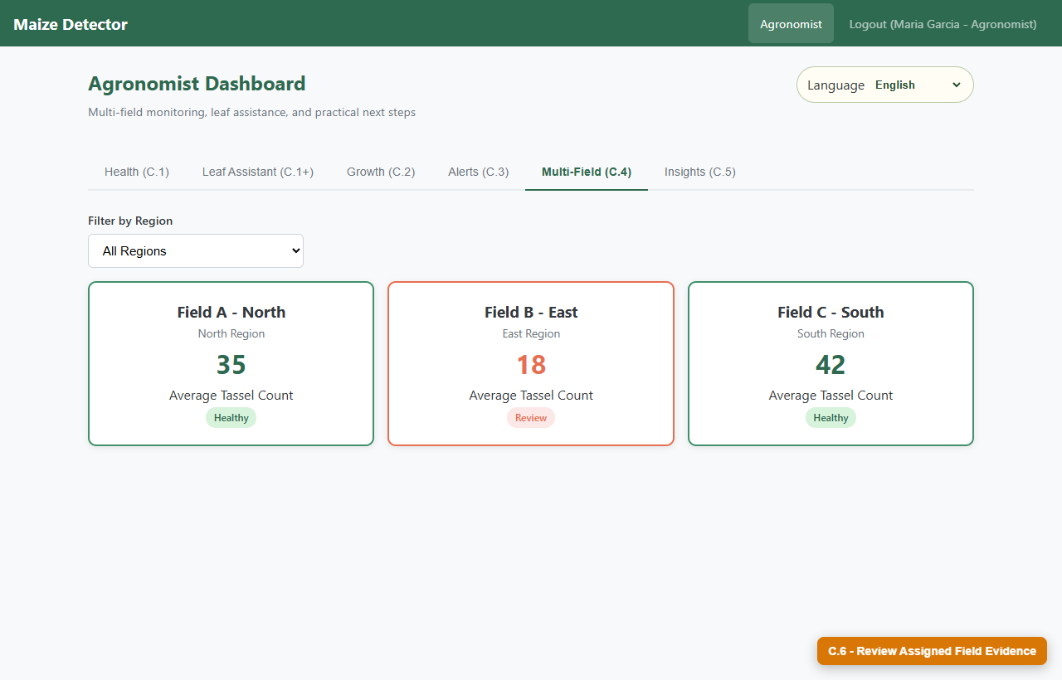

C.7 Confirm or Correct Screening
User Story: As an agronomist, I want to confirm, correct, or mark a disease screening inconclusive, so that the farmer-facing record includes accountable expert review.

Detailed Description

Name: Confirm or Correct Screening
Stakeholder & Objectives:
The Agronomist needs an accountable review panel that preserves original model evidence while adding a reviewer decision, reviewed condition, note and timestamp.
Actors: Agronomist, Diagnosis Review Panel, Review Service
Triggers: The Agronomist opens an assigned, unreviewed disease-screening record and submits a review decision.
Pre-Condition:
The diagnosis exists, belongs to an assigned field and the Agronomist is authenticated; the record retains original model and quality evidence.
Post-Condition: The original automated evidence remains unchanged and the diagnosis stores reviewer identity, decision, reviewed condition where applicable, note and reviewed timestamp; an audit log is written.
Normal Flow:
1. The Agronomist opens an assigned diagnosis and reviews the photo, quality and model evidence.
2. The Review Panel offers Confirm, Correct and Inconclusive decisions.
3. The Agronomist selects a decision and enters a professional note.
4. For Correct, the Agronomist selects a supported condition or Other.
5. The Review Service validates assignment, decision and required fields.
6. Review metadata is added without overwriting the original prediction.
7. The updated record and audit confirmation are displayed.
Sub-Flow: A confirmed review may retain the model's possible condition while adding clarification or a follow-up recommendation in the note.
Alternative Flow:
1. An unsupported decision or blank note is rejected before persistence.
2. A correction without a reviewed condition is rejected.
3. An Agronomist who is not assigned to the field receives a forbidden response.

Diagrams
BCE Class Diagram
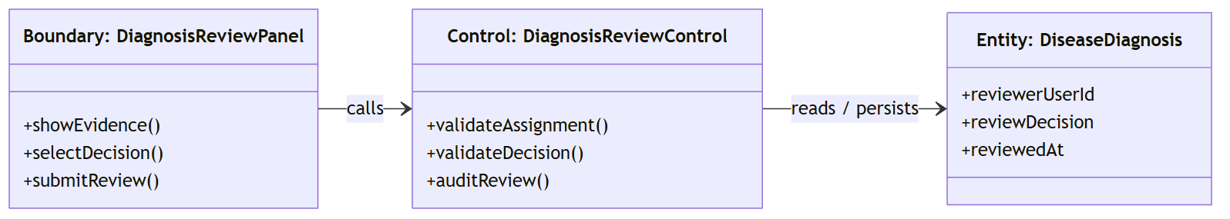

Sequence Diagram
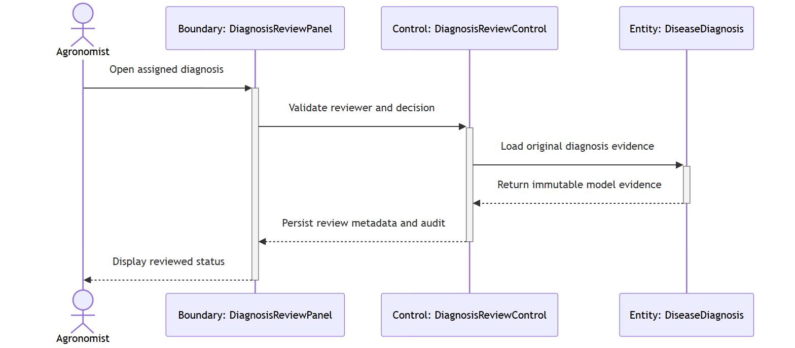

Test case:

Test Case ID: TC3_7 | User Stories: #38 (C.7)
Name: As an agronomist, I want to confirm, correct, or mark a disease screening inconclusive, so that the farmer-facing record includes accountable expert review.
Test Scenario: Verify successful confirmation/correction and validation of an invalid review decision without alteration of original model evidence.
Actions:
1. Log in as an assigned Agronomist.
2. Open an unreviewed diagnosis.
3. Record the original predicted condition and probabilities.
4. Submit Confirm with a review note.
5. Verify reviewer identity, decision and timestamp.
6. Submit an invalid decision against another test record.
7. Confirm HTTP 400 and no persisted invalid review.
Prerequisites:
- Assigned Agronomist
- Unreviewed disease diagnosis
- Original model evidence
Test Data:
- decision=confirmed
- review note
- invalid decision value
Expected Results: A valid review is persisted and audited while original evidence remains unchanged; invalid or unassigned reviews are rejected.
Actual Result: As expected. Verified by the current automated regression suite.
Pass

Wireframe:
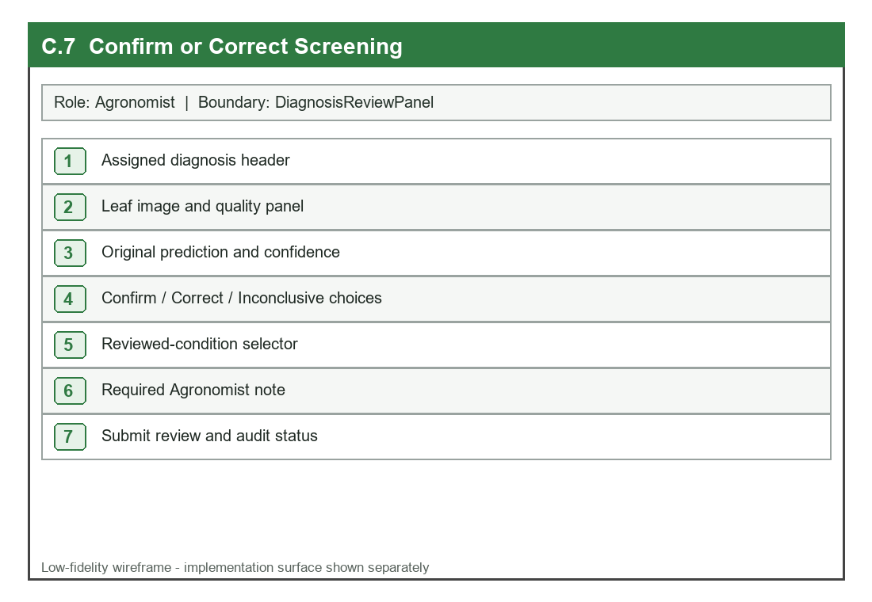

UI:
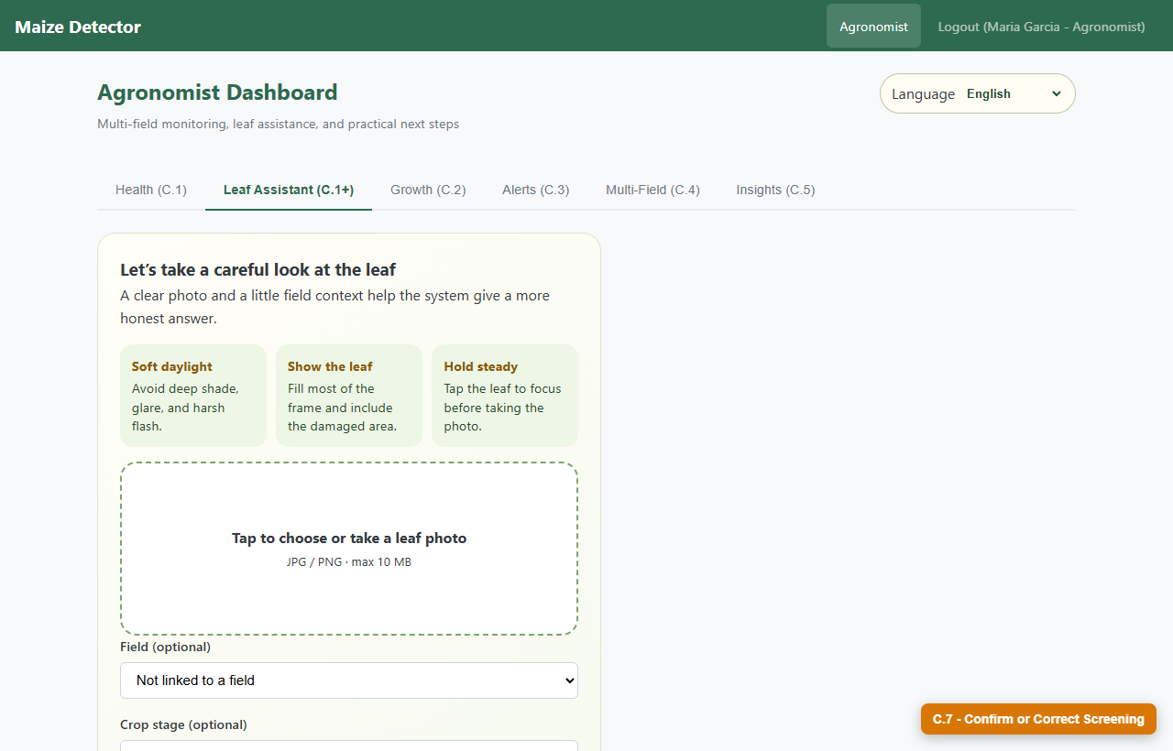

C.8 Context-Aware Human Guidance
User Story: As an agronomist, I want the system to keep field context separate from model evidence, so that advice is useful without overstating diagnostic certainty.

Detailed Description

Name: Context-Aware Human Guidance
Stakeholder & Objectives:
The Agronomist needs advice that incorporates crop stage, recent weather and symptom spread while explicitly separating those human observations from image-model probabilities and quality measurements.
Actors: Agronomist, Leaf Assistant, Advice Engine
Triggers: A leaf-screening request includes one or more optional field-context values and produces screenable model evidence.
Pre-Condition:
The image passes the quality gate; context values are bounded plain text; the Advice Engine receives a fresh request-specific evidence object.
Post-Condition: The response presents context-aware questions and next steps, labels screening as unconfirmed, stores context separately and does not contaminate another request.
Normal Flow:
1. The user supplies a leaf image and optional crop stage, weather and spread context.
2. The server validates and stores context as separate request data.
3. The disease model evaluates only image-derived evidence.
4. The Advice Engine receives model evidence and the current request context.
5. The engine builds observations, clarifying questions and safe next steps.
6. The response explicitly distinguishes possible condition from confirmed diagnosis.
7. The diagnosis record retains both technical evidence and separate context fields.
Sub-Flow: If no context is supplied, the system still returns image-based guidance and asks concise follow-up questions rather than inventing field facts.
Alternative Flow:
1. Excessively long or malformed context is rejected or safely bounded.
2. Low-quality images return retake guidance before contextual disease advice.
3. Parallel requests with different context values remain isolated in their responses.

Diagrams
BCE Class Diagram
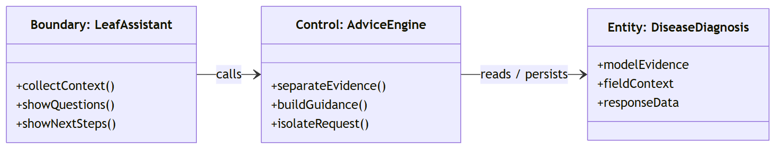

Sequence Diagram
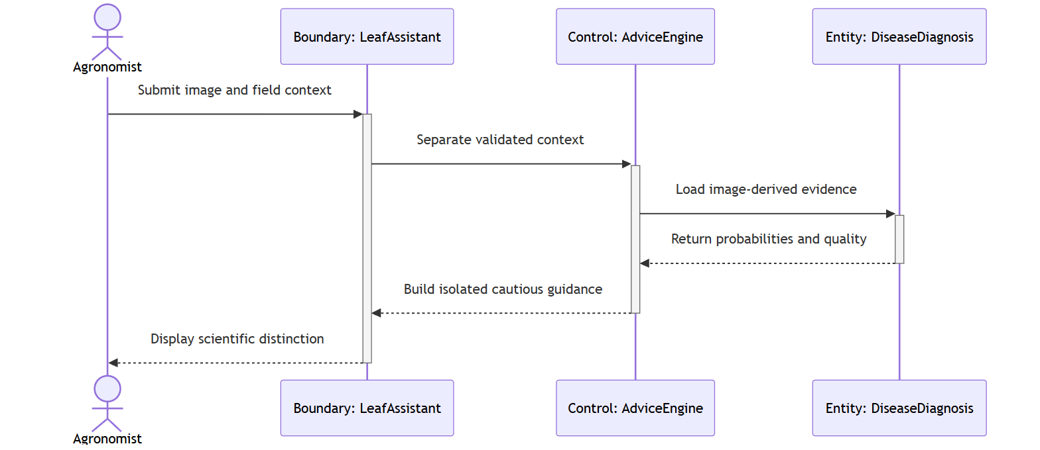

Test case:

Test Case ID: TC3_8 | User Stories: #39 (C.8)
Name: As an agronomist, I want the system to keep field context separate from model evidence, so that advice is useful without overstating diagnostic certainty.
Test Scenario: Verify context-aware guidance, scientific separation of evidence and isolation between two requests carrying different field context.
Actions:
1. Prepare two valid leaf-screening requests with different crop stage and weather values.
2. Submit both requests independently.
3. Compare raw model probabilities with farmer-facing guidance.
4. Confirm that probabilities do not change because of narrative context.
5. Confirm that each response mentions only its own context.
6. Inspect the safety wording and stored response_data.
Prerequisites:
- Screenable leaf image
- Two distinct context payloads
- Advice Engine available
Test Data:
- crop_stage=vegetative / tasseling
- weather=dry / humid
- symptom_spread=one leaf / across field
Expected Results: Advice uses only the current request's context, technical probabilities remain separate, and the wording never presents screening as a confirmed diagnosis.
Actual Result: As expected. Verified by the current automated regression suite.
Pass

Wireframe:
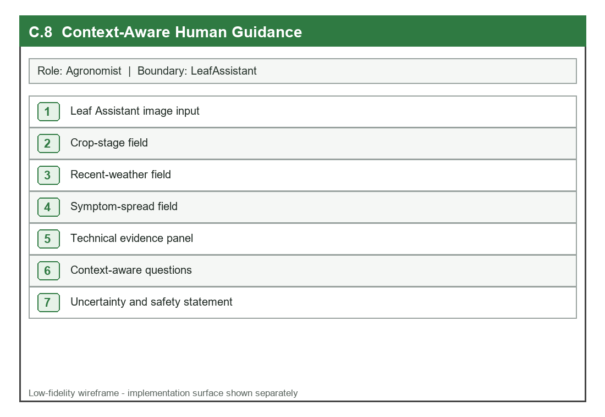

UI:
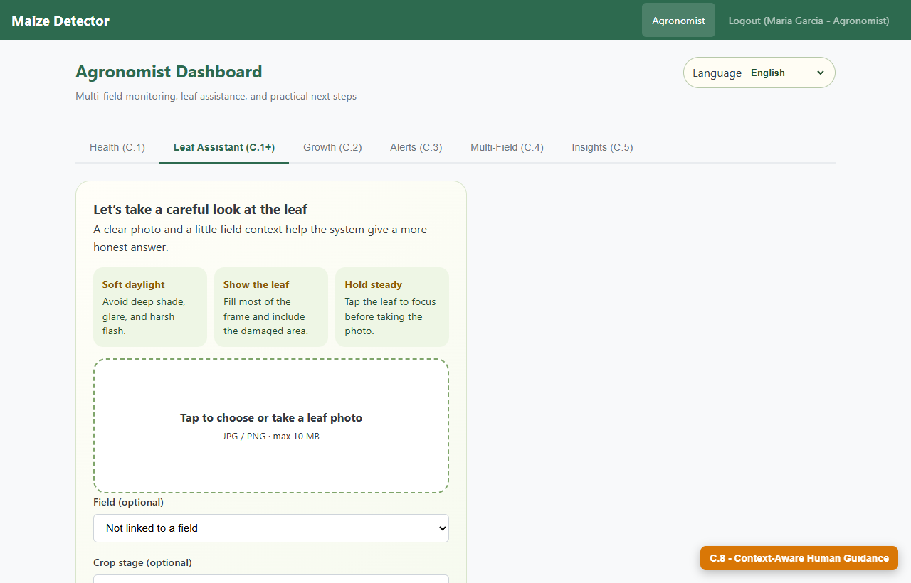

D. Admin (3 Extension User Stories)

D.7 Assign Agronomists to Fields
User Story: As an admin, I want to assign or remove Agronomists from fields, so that evidence access follows operational responsibility.

Detailed Description

Name: Assign Agronomists to Fields
Stakeholder & Objectives:
The Admin needs an auditable assignment control that links active Agronomists to fields, prevents duplicate pairs and makes authorization changes effective immediately.
Actors: Admin, Admin Console, Field Assignment Service
Triggers: The Admin selects a field and active Agronomist and chooses Assign, Replace or Remove.
Pre-Condition:
The Admin session is active; the field exists; the selected user has the active Agronomist role.
Post-Condition: A unique Field Assignment is created or removed, the action is logged and subsequent Agronomist evidence requests use the new authorization state.
Normal Flow:
1. The Admin opens field access management.
2. The console loads fields, active Agronomists and existing assignments.
3. The Admin selects a field and Agronomist.
4. The Field Assignment Service validates Admin role, field existence and active Agronomist status.
5. The unique field/user assignment is inserted or updated idempotently.
6. An audit log records actor, action and assignment identifiers.
7. The console refreshes and the authorization change takes effect immediately.
Sub-Flow: The Admin may remove an existing assignment; repeating the same desired state remains safe and does not create duplicates.
Alternative Flow:
1. A non-Admin request receives a forbidden response.
2. An inactive or non-Agronomist user cannot be assigned.
3. A missing field or malformed identifier is rejected without changing existing assignments.

Diagrams
BCE Class Diagram
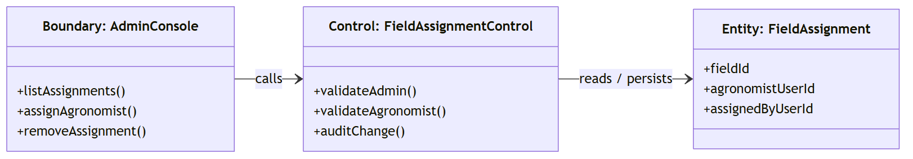

Sequence Diagram
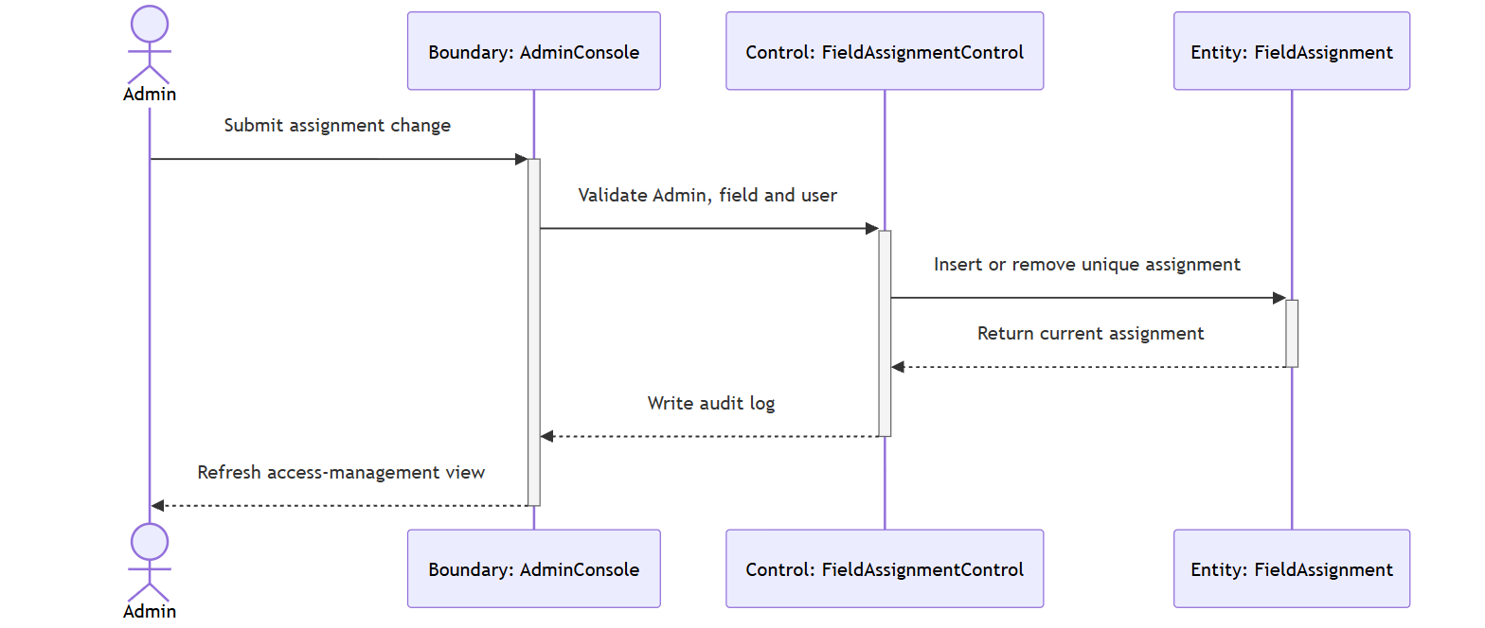

Test case:

Test Case ID: TC4_7 | User Stories: #40 (D.7)
Name: As an admin, I want to assign or remove Agronomists from fields, so that evidence access follows operational responsibility.
Test Scenario: Verify Admin assignment creation/removal, uniqueness and immediate impact on Agronomist field access.
Actions:
1. Log in as Admin.
2. Select an existing field and active Agronomist.
3. Create the assignment and repeat the same request.
4. Confirm that only one assignment exists.
5. Log in as the Agronomist and open the assigned field.
6. Remove the assignment as Admin.
7. Repeat the Agronomist request and verify forbidden access.
Prerequisites:
- Active Admin
- Existing field
- Active Agronomist account
Test Data:
- field_id
- agronomist_user_id
- duplicate assignment request
Expected Results: Assignment is unique and auditable, repeated creation is idempotent, removal is immediate and only Admin may change the relationship.
Actual Result: As expected. Verified by the current automated regression suite.
Pass

Wireframe:
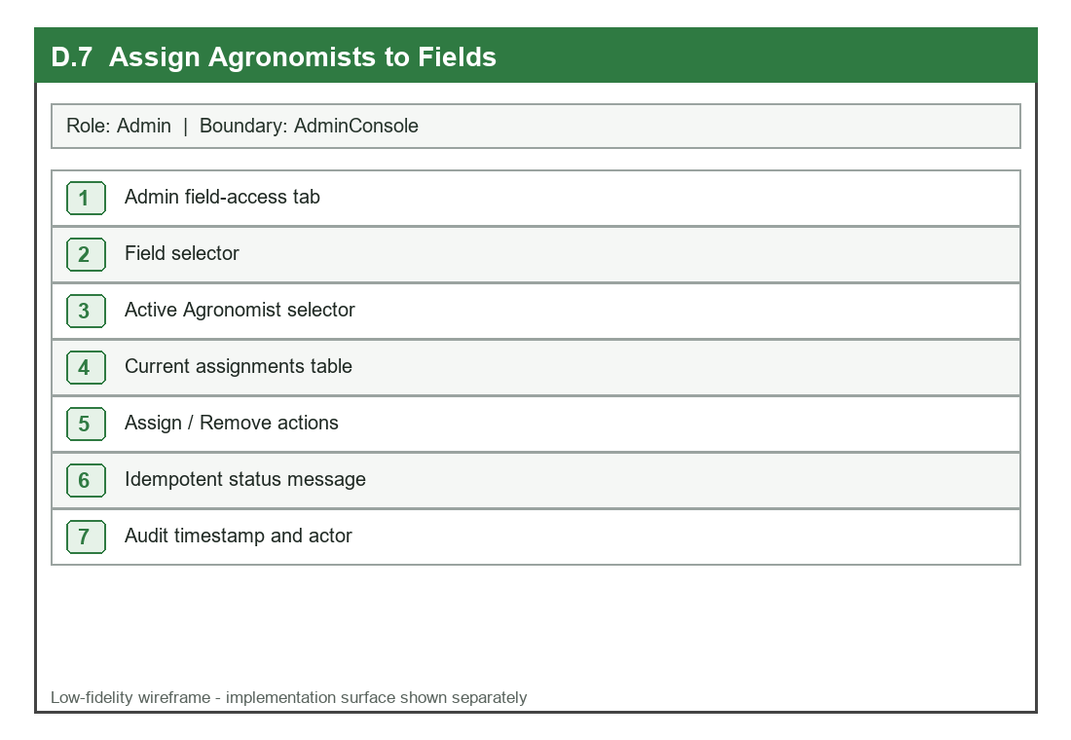

UI:
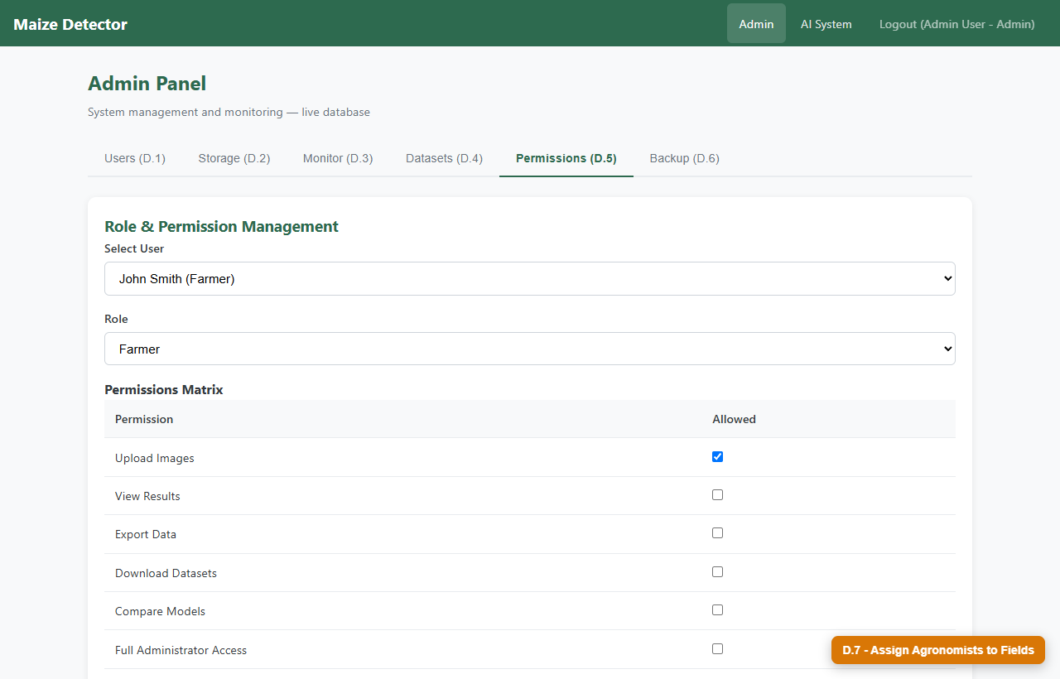

D.8 Revoke Stale Sessions
User Story: As an admin, I want role, status, permission, email, and password changes to invalidate old sessions, so that revoked access cannot continue until token expiry.

Detailed Description

Name: Revoke Stale Sessions
Stakeholder & Objectives:
The Admin needs account and permission changes to take effect on the next protected request, using live database state and a session version instead of trusting stale token claims.
Actors: Admin, User Management Page, Authentication Service
Triggers: The Admin changes a user's role, status or permissions, or a user changes email/password and thereby increments session_version.
Pre-Condition:
A user has an issued access token and the Admin is authorized to change the account's role, status or permission state.
Post-Condition: The account change is stored with a new session version; every older token is rejected; subsequent access requires a new valid login/token.
Normal Flow:
1. The Admin opens User Management and selects an account.
2. The Admin changes role, status or permissions and saves.
3. The API reloads and validates the Admin account.
4. The target user record is updated and session_version is incremented.
5. The action is written to the audit log.
6. On the target user's next request, Authentication reloads current database state.
7. The old token version is rejected and the client returns to login.
Sub-Flow: The same revocation behavior is applied when the user securely changes email or password through My Account.
Alternative Flow:
1. A query-string token is rejected because Authorization header transport is required by default.
2. A disabled account is rejected even if its token has not reached its age limit.
3. An invalid Admin change is rejected without incrementing session_version.

Diagrams
BCE Class Diagram
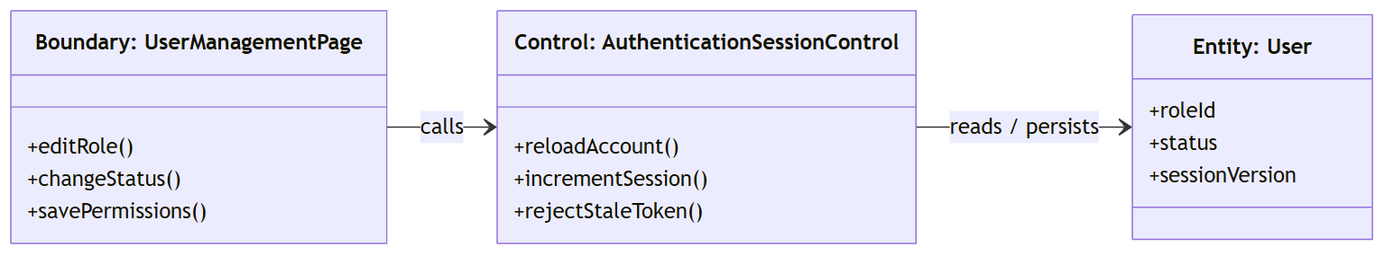

Sequence Diagram
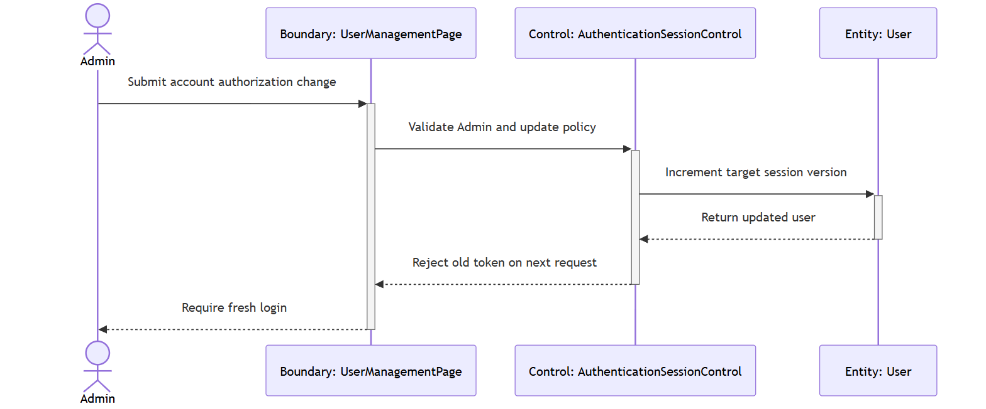

Test case:

Test Case ID: TC4_8 | User Stories: #41 (D.8)
Name: As an admin, I want role, status, permission, email, and password changes to invalidate old sessions, so that revoked access cannot continue until token expiry.
Test Scenario: Verify that disabling or changing a user invalidates an already-issued token on the next protected request.
Actions:
1. Log in as a target user and retain the access token.
2. Log in as Admin and disable the target account or change its permissions.
3. Call a protected endpoint with the retained token.
4. Confirm HTTP 401 and no protected data.
5. Re-enable the account and attempt query-string token transport.
6. Confirm rejection until a fresh Authorization-header token is issued.
Prerequisites:
- Active Admin
- Active target user
- Previously issued target-user token
Test Data:
- target user_id
- old session_version token
- disabled status or permission change
Expected Results: Old tokens fail immediately after account change; disabled accounts and query tokens are rejected; only a fresh valid session may continue.
Actual Result: As expected. Verified by the current automated regression suite.
Pass

Wireframe:
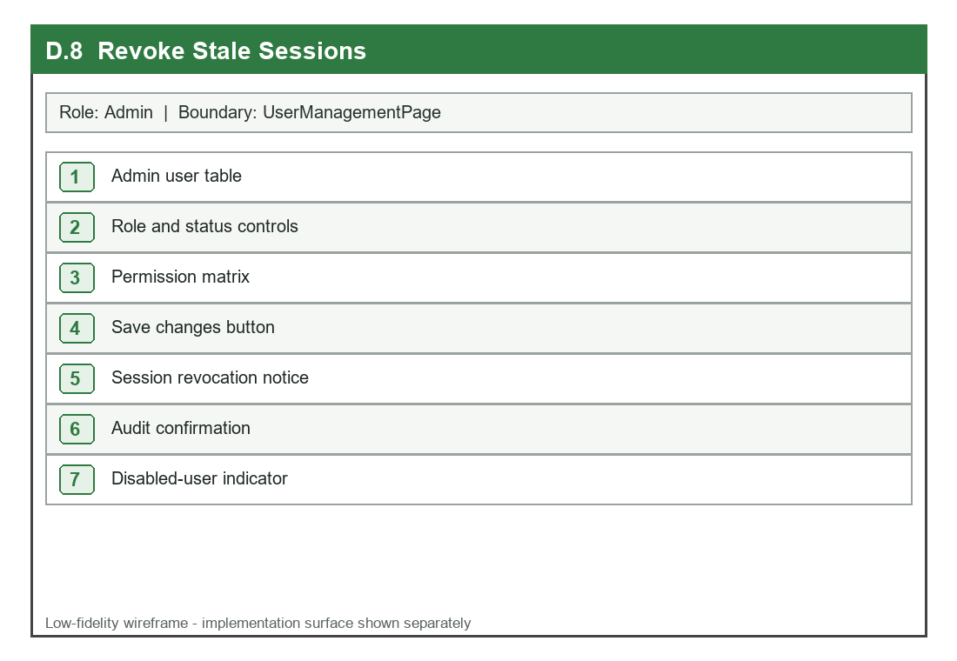

UI:
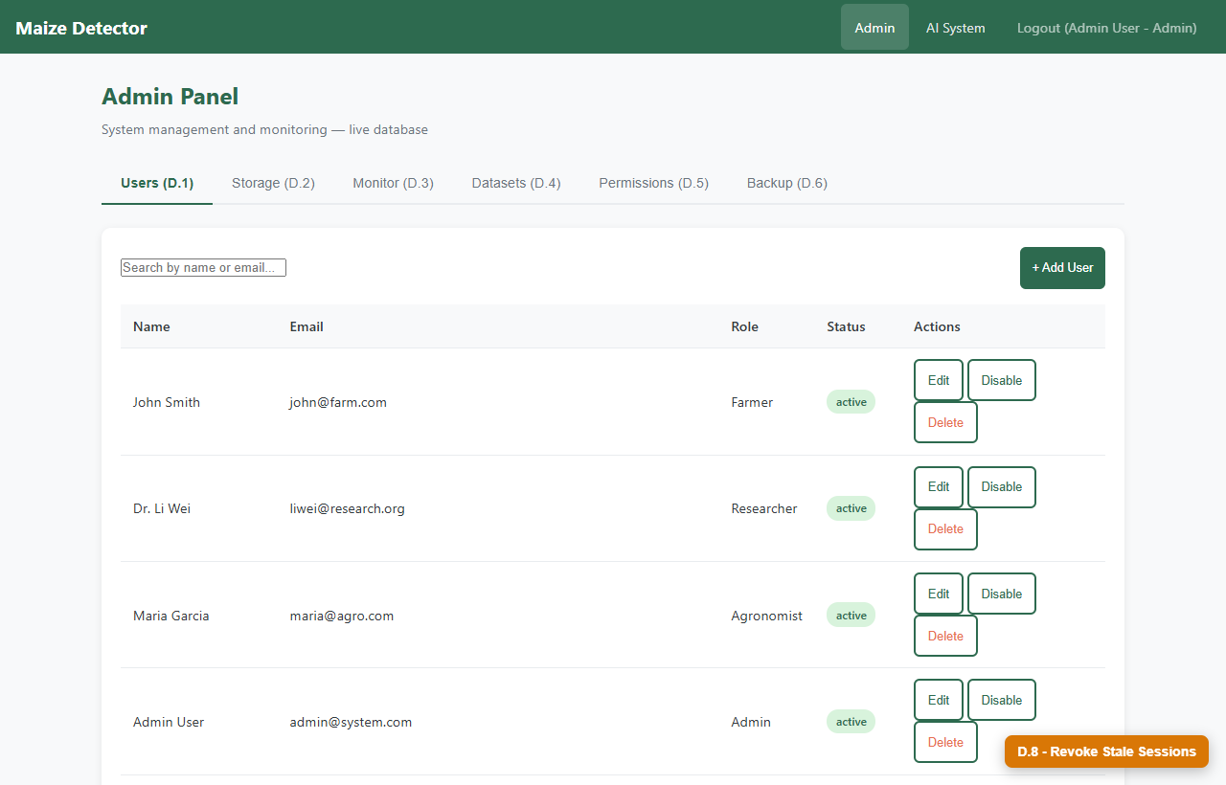

D.9 Govern Storage and Deployment
User Story: As an admin, I want uploaded images, model artifacts, migrations, and background workloads governed by explicit limits, so that the service remains auditable and stable.

Detailed Description

Name: Govern Storage and Deployment
Stakeholder & Objectives:
The Admin needs operational visibility and enforced trust boundaries across image storage, model artifacts, database schema changes, rate limits and bounded background work.
Actors: Admin, Admin/System Console, Governance Services
Triggers: The service starts, an upload/model/migration/background request is submitted, or the Admin reviews system health and audit evidence.
Pre-Condition:
Secrets, database access, approved storage roots, models and operational limits are configured; the Admin account is active.
Post-Condition: Only validated governed work proceeds; checksums, digests, limits and audit records remain inspectable; public errors reveal no internal exception detail.
Normal Flow:
1. The Admin opens System Monitor or governance evidence.
2. Startup verifies secrets, database connectivity and model materialization.
3. Uploads enforce byte, MIME, decode, dimension and encryption controls.
4. Model and dataset operations enforce approved roots and recorded digests.
5. Migration runner serializes numbered SQL files and records SHA-256 checksums.
6. Rate limits, bounded cache and bounded workers constrain expensive requests.
7. Health and audit views report safe operational status without secret paths.
Sub-Flow: The Admin may inspect stored metrics and logs or initiate approved work, but the same validation and capacity controls remain active.
Alternative Flow:
1. A failed startup control prevents unsafe production launch.
2. A digest/checksum/path violation is rejected before artifact or schema use.
3. An excess request or full work queue receives a controlled retry/capacity response.

Diagrams
BCE Class Diagram
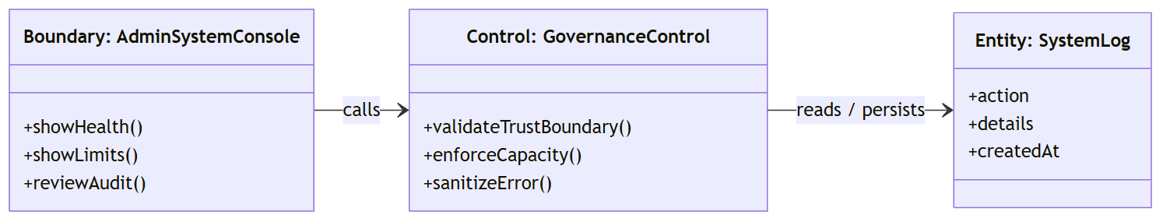

Sequence Diagram
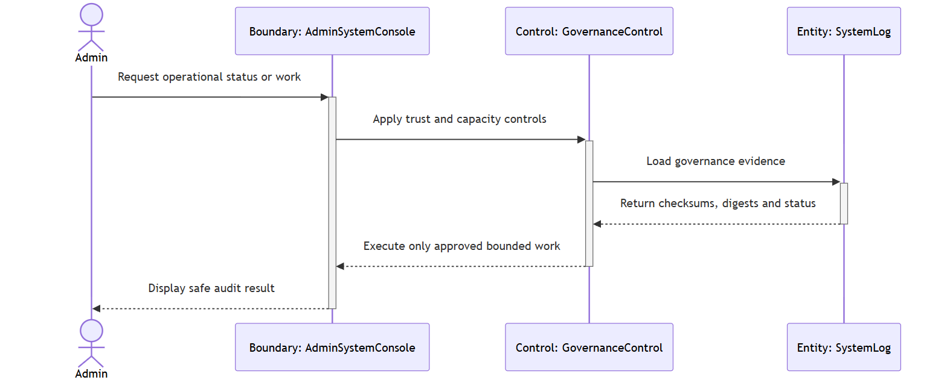

Test case:

Test Case ID: TC4_9 | User Stories: #42 (D.9)
Name: As an admin, I want uploaded images, model artifacts, migrations, and background workloads governed by explicit limits, so that the service remains auditable and stable.
Test Scenario: Verify governance controls for invalid image content, altered model/migration evidence and bounded request capacity.
Actions:
1. Log in as Admin and open System Monitor.
2. Submit disguised non-image bytes and confirm rejection.
3. Validate a model with an incorrect digest and confirm rejection.
4. Run migration status and verify recorded checksums.
5. Exceed a configured rate or pending-work limit.
6. Inspect public error responses and system logs.
Prerequisites:
- Active Admin
- Configured security limits
- Applied migrations and registered model
Test Data:
- disguised image payload
- mismatched artifact digest
- requests exceeding configured limit
Expected Results: Invalid or excessive work is safely rejected, valid governed work remains available, checksums/digests are traceable and public errors contain no internal exception details.
Actual Result: As expected. Verified by the current automated regression suite.
Pass

Wireframe:
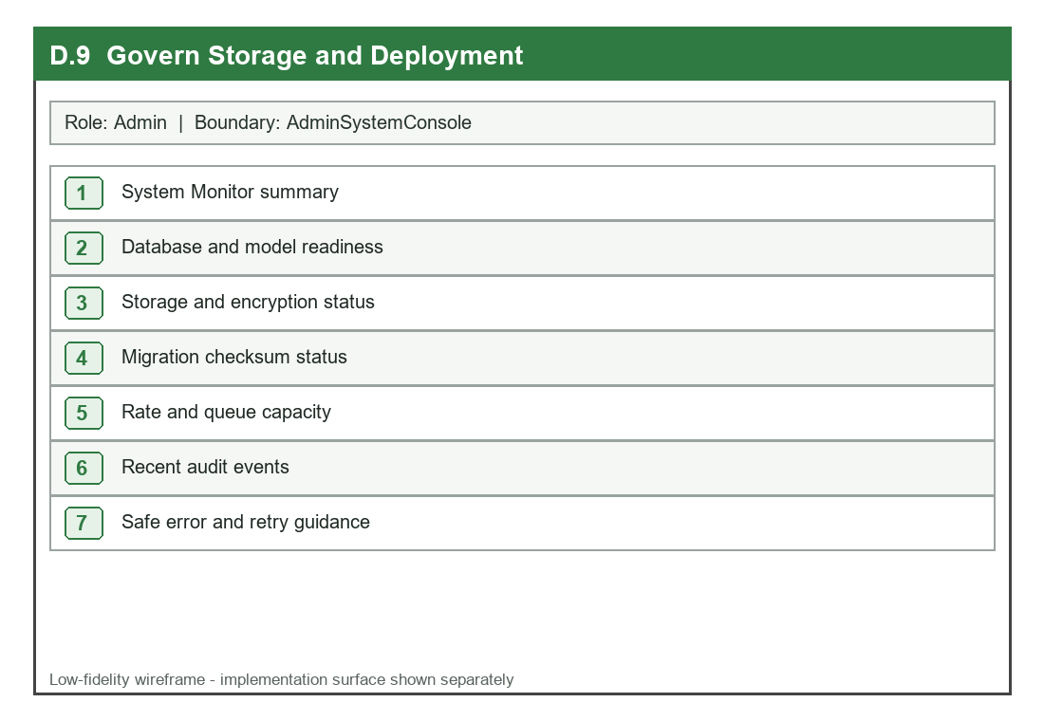

UI:
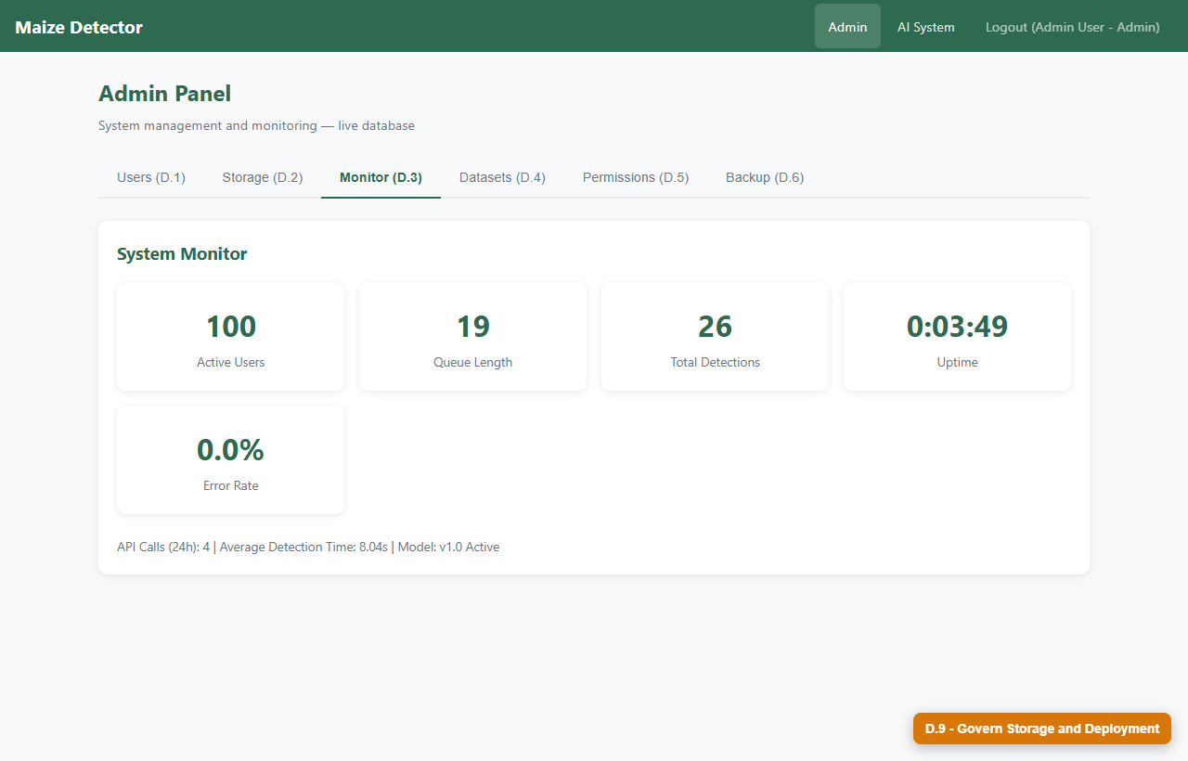

E. System (3 Extension User Stories)

E.6 Validate and Isolate Every Upload
User Story: As a system, I want to validate actual image content and assign collision-resistant storage names, so that unsafe or duplicate filenames cannot corrupt another user's data.

Detailed Description

Name: Validate and Isolate Every Upload
Stakeholder & Objectives:
The System must distrust client filenames and MIME declarations, enforce byte and decoded-pixel limits, isolate names with UUIDs, record SHA-256 and encrypt only validated original bytes.
Actors: System, Upload API, Image Validation Service
Triggers: An authenticated multipart upload reaches the Upload API.
Pre-Condition:
Upload limits and encryption key are configured; the request contains a candidate image and an authorized user identity.
Post-Condition: A valid upload creates isolated Image metadata and encrypted Image File bytes; invalid content creates no persistent image record.
Normal Flow:
1. The Upload API reads the request body through a configured byte limit.
2. The validator checks magic bytes, declared MIME, supported format and successful image decode.
3. Decoded width, height and total pixel count are checked.
4. EXIF orientation is normalized and a SHA-256 digest is calculated.
5. A collision-resistant UUID storage name is generated while the original name is retained as metadata.
6. Validated bytes are encrypted and persisted separately from queryable metadata.
7. The API returns a trusted image identifier and safe metadata.
Sub-Flow: Two uploads with the same original filename are accepted as separate records when their UUID identities remain unique.
Alternative Flow:
1. Disguised non-image content or MIME mismatch is rejected.
2. Oversized byte or pixel dimensions return a controlled validation error.
3. Encryption or persistence failure rolls back metadata so no partial trusted record remains.

Diagrams
BCE Class Diagram
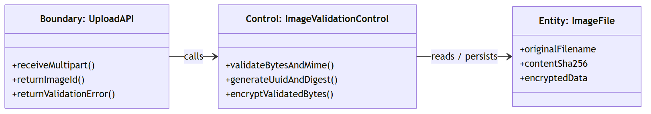

Sequence Diagram
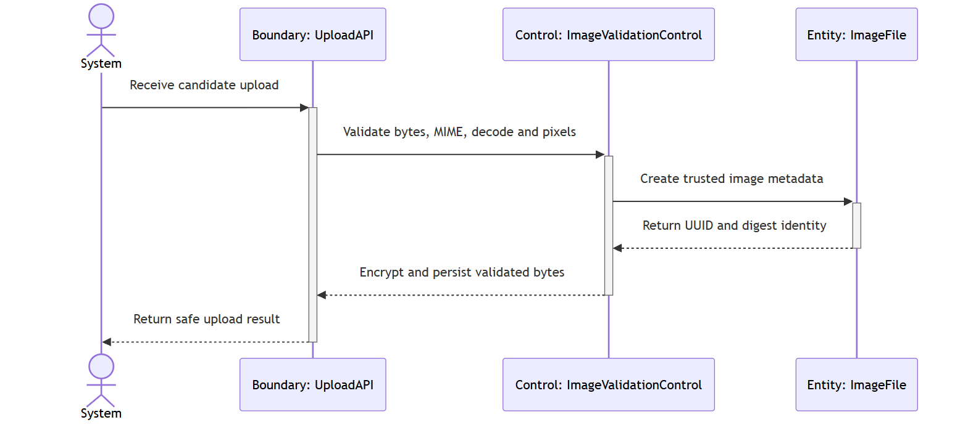

Test case:

Test Case ID: TC5_6 | User Stories: #43 (E.6)
Name: As a system, I want to validate actual image content and assign collision-resistant storage names, so that unsafe or duplicate filenames cannot corrupt another user's data.
Test Scenario: Verify rejection of disguised/MIME-mismatched files and isolation of two valid uploads sharing the same original filename.
Actions:
1. Prepare disguised non-image bytes named sample.jpg.
2. Submit the file and verify rejection with no database row.
3. Prepare valid PNG bytes declared as JPEG and verify MIME mismatch rejection.
4. Upload two valid PNGs with the same original filename.
5. Compare their server UUID names and SHA-256 values.
6. Read encrypted storage and verify round-trip decryption to validated originals.
Prerequisites:
- Configured encryption key
- Authenticated upload identity
- Database transaction available
Test Data:
- disguised sample.jpg
- PNG declared image/jpeg
- two valid same-name PNGs
Expected Results: Invalid content creates no record; valid same-name uploads receive unique UUID identities; digest and original name are retained; encrypted bytes decrypt correctly.
Actual Result: As expected. Verified by the current automated regression suite.
Pass

Wireframe:
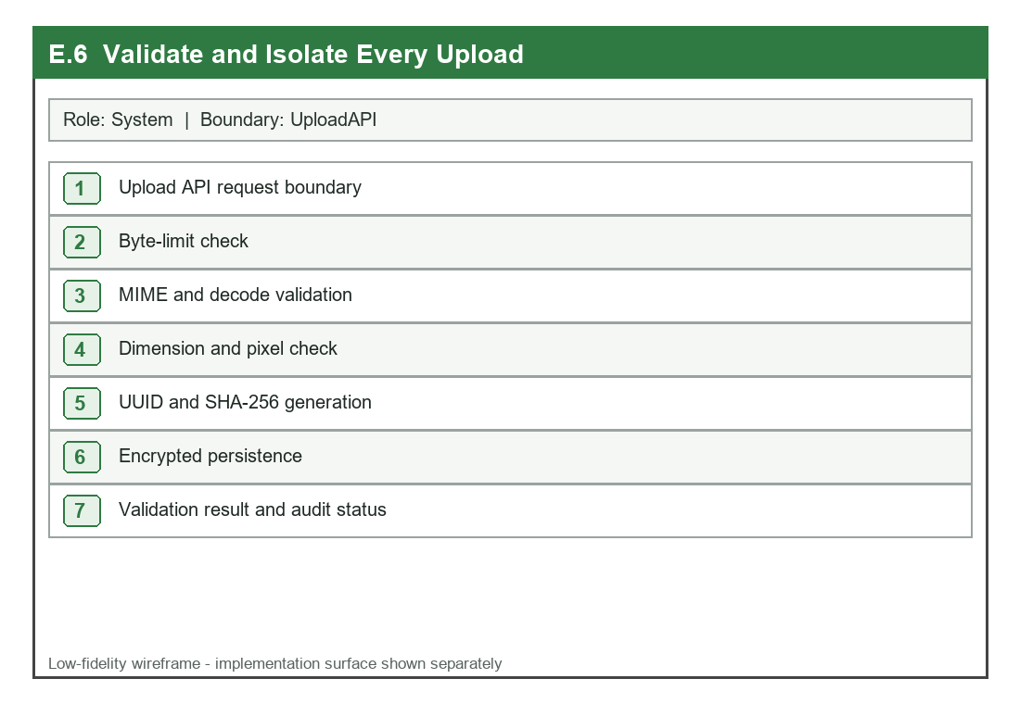

UI:
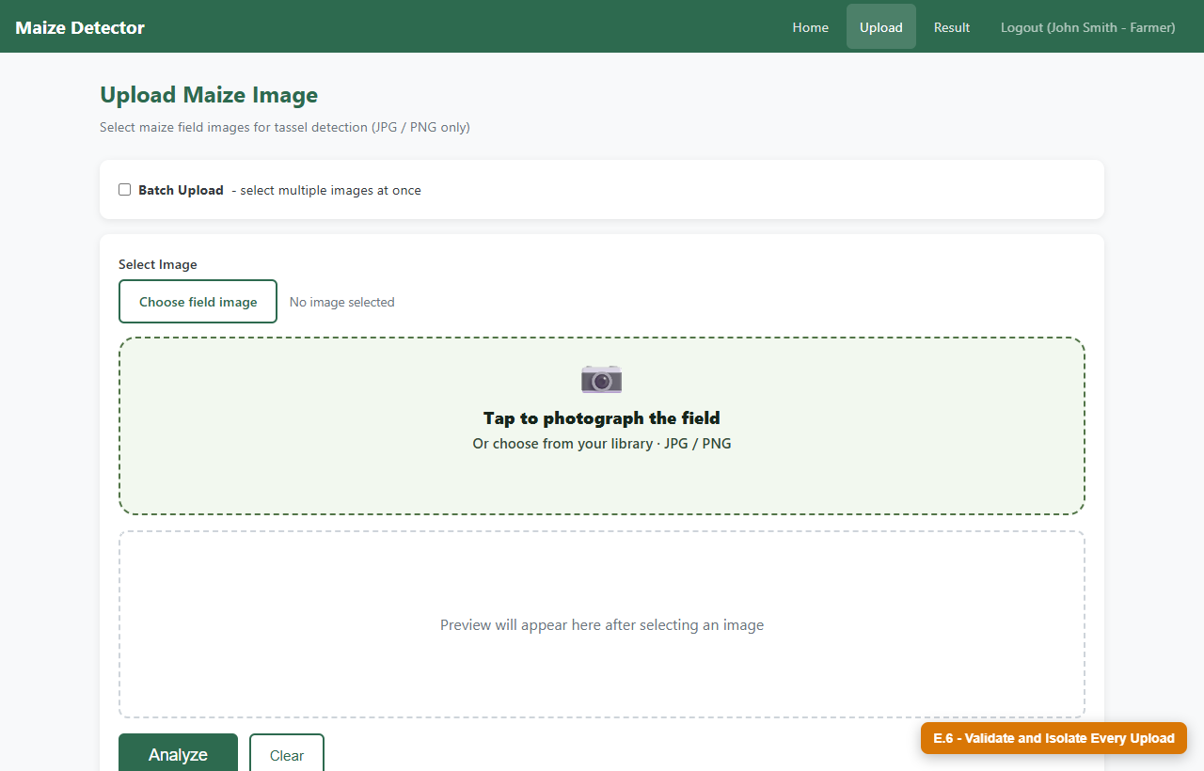

E.7 Operate Dual AI Pipelines Safely
User Story: As a system, I want tassel counting and leaf screening to run as separate governed pipelines, so that each task returns appropriate evidence and neither silently substitutes fabricated output.

Detailed Description

Name: Operate Dual AI Pipelines Safely
Stakeholder & Objectives:
The System must keep tassel detection and leaf screening contracts separate, load only validated task-specific artifacts and return a controlled unavailable state instead of mock or fabricated output.
Actors: System, Prediction APIs, Tassel and Disease Inference Services
Triggers: A validated tassel-count request or maize-leaf screening request reaches its task-specific prediction endpoint.
Pre-Condition:
The request contains a persisted validated image identifier; the relevant model artifact is materialized, inside its approved root and compatible with its contract.
Post-Condition: Tassel requests return count/boxes/timing and disease requests return quality/status/probabilities/uncertainty; the correct entity is persisted or a controlled unavailable response is returned.
Normal Flow:
1. The API identifies whether the request is tassel counting or leaf screening.
2. The request is routed to the task-specific validation and inference control.
3. The active model identity and content digest form the inference cache key.
4. Model access is lock-protected while the task-specific predictor executes.
5. Tassel inference produces count and boxes; disease inference produces calibrated quality and uncertainty evidence.
6. The result is persisted in Detection Result or Disease Diagnosis respectively.
7. The API returns the task-specific contract and source/model identity.
Sub-Flow: A repeated valid request may use the bounded content/model-aware cache, but the response contract and model identity remain unchanged.
Alternative Flow:
1. A missing, pointer-only or invalid artifact returns controlled service unavailable.
2. A leaf image failing quality checks returns retake guidance without disease classification.
3. Production code never returns mock count or disease evidence as a fallback.

Diagrams
BCE Class Diagram
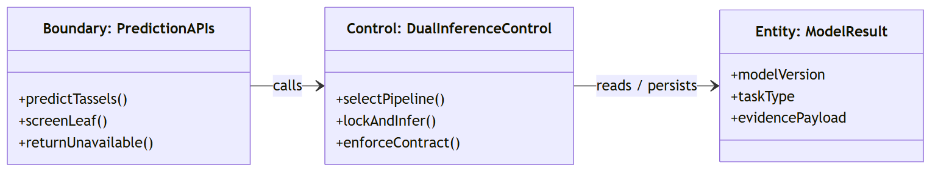

Sequence Diagram
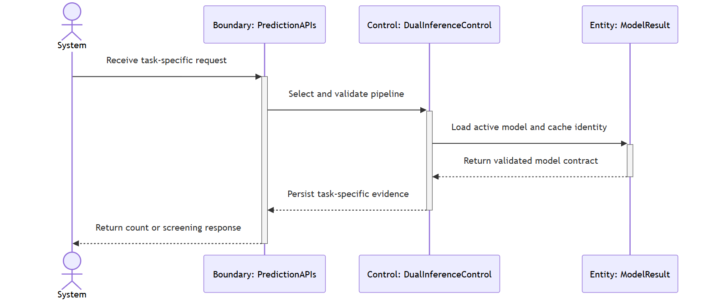

Test case:

Test Case ID: TC5_7 | User Stories: #44 (E.7)
Name: As a system, I want tassel counting and leaf screening to run as separate governed pipelines, so that each task returns appropriate evidence and neither silently substitutes fabricated output.
Test Scenario: Verify distinct tassel/disease response contracts and controlled unavailability when a task-specific artifact cannot be activated.
Actions:
1. Submit a validated field image to tassel prediction.
2. Verify count, bounding boxes, confidence and timing.
3. Submit a validated close-up leaf image to disease screening.
4. Verify quality, status, probabilities and uncertainty fields.
5. Temporarily configure a missing task artifact.
6. Repeat the corresponding request and inspect the controlled error.
7. Search the production response for mock fallback markers.
Prerequisites:
- Validated tassel and leaf images
- Approved tassel and disease artifacts
- Task-specific prediction endpoints
Test Data:
- persisted field image_id
- valid leaf image
- missing artifact path
Expected Results: Each task returns only its documented evidence contract; missing artifacts are explicit; no production mock or fabricated result is substituted.
Actual Result: As expected. Verified by the current automated regression suite.
Pass

Wireframe:
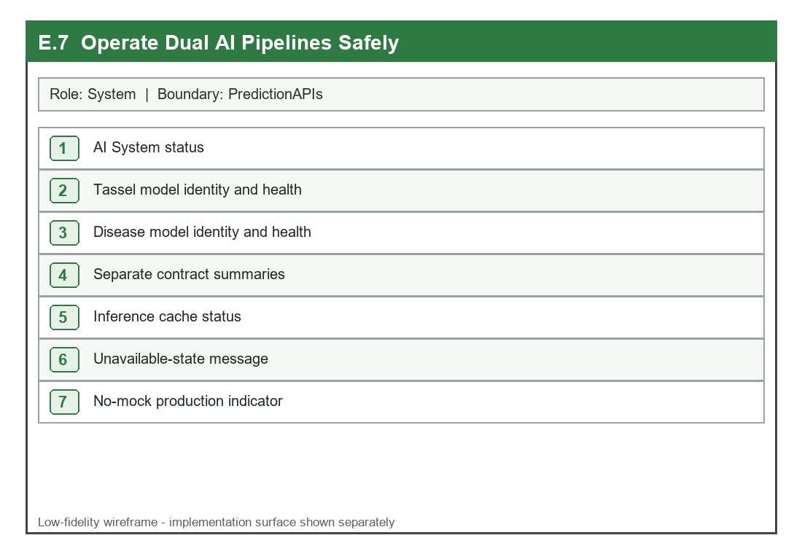

UI:
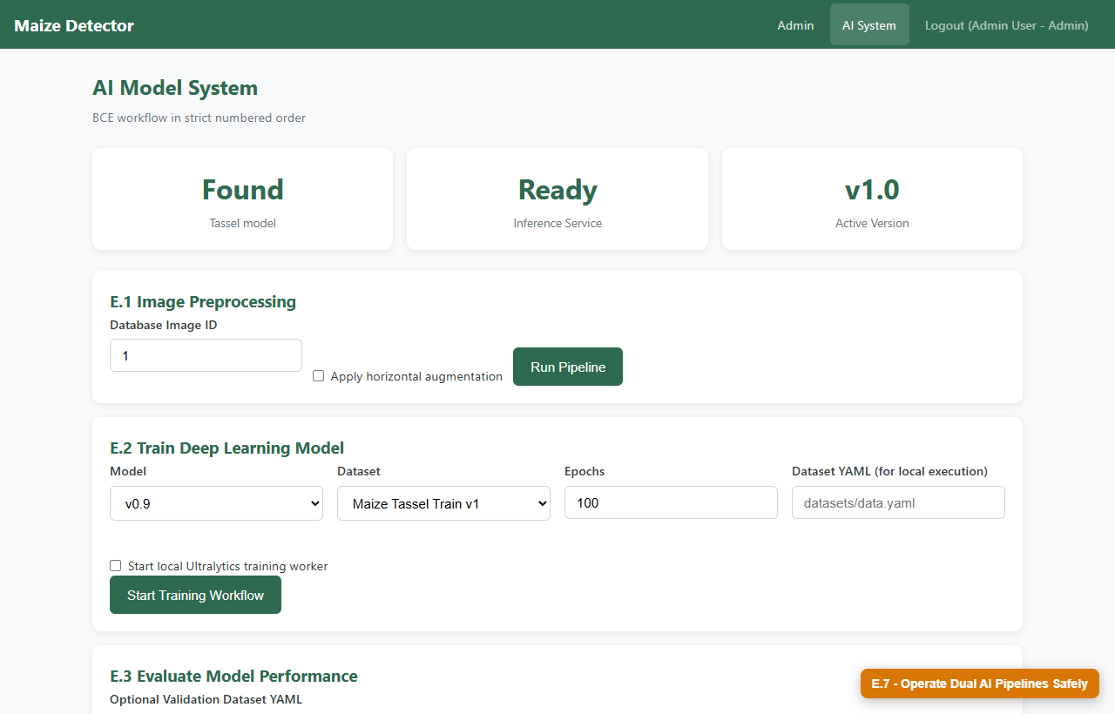

E.8 Bound Resources and Apply Reproducible Migrations
User Story: As a system, I want bounded caches, bounded training queues, rate limits, and tracked database migrations, so that load and schema changes remain controlled.

Detailed Description

Name: Bound Resources and Apply Reproducible Migrations
Stakeholder & Objectives:
The System must place explicit capacity and concurrency limits around expensive work and apply numbered, checksummed migrations under a lock so repeated startup is safe and reproducible.
Actors: System, Health/Startup Interface, Workload and Migration Services
Triggers: The service starts, a protected request enters a rate-limited route, inference uses the cache, or a local training job is submitted.
Pre-Condition:
Capacity settings, database connection, migration directory and production server thread limits are configured.
Post-Condition: Applied migration names/checksums are recorded; altered applied files are rejected; caches and queues remain within capacity; excess work receives a controlled response.
Normal Flow:
1. Startup discovers numerically ordered SQL migration files.
2. The migration runner acquires a PostgreSQL advisory lock.
3. Each file SHA-256 is compared with the schema_migrations record.
4. Pending migrations are applied transactionally and recorded.
5. Waitress starts with a configured bounded thread pool.
6. Rate limiter, LRU inference cache and training executor enforce configured capacity.
7. Health/status interfaces report readiness without leaking secrets.
Sub-Flow: A repeated startup finds matching applied checksums, performs no duplicate schema work and starts normally.
Alternative Flow:
1. An altered previously applied migration blocks startup/check with a checksum error.
2. A full training queue rejects additional pending work without spawning an unbounded thread.
3. A rate-limit breach returns retry guidance; a bounded cache evicts the least-recently-used entry.

Diagrams
BCE Class Diagram
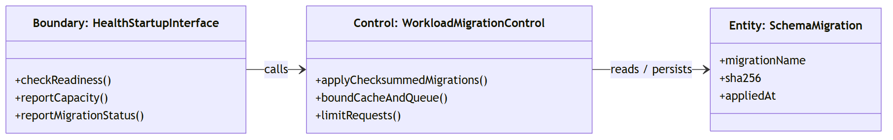

Sequence Diagram
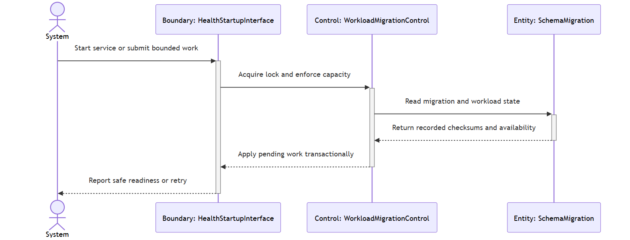

Test case:

Test Case ID: TC5_8 | User Stories: #45 (E.8)
Name: As a system, I want bounded caches, bounded training queues, rate limits, and tracked database migrations, so that load and schema changes remain controlled.
Test Scenario: Verify idempotent checksummed migrations, bounded inference cache and rejection of excess queued training work.
Actions:
1. Run migration application against a prepared PostgreSQL database.
2. Run the command again and confirm no duplicate changes.
3. Alter a temporary applied migration and run check mode.
4. Infer more content variants than the configured cache capacity.
5. Submit more local training jobs than worker plus pending capacity.
6. Inspect health and retry responses.
Prerequisites:
- PostgreSQL database
- Migrations 001-004
- Small configured cache and executor limits
Test Data:
- ordered SQL files
- altered migration copy
- three content variants and excess training requests
Expected Results: Repeated migration is safe, checksum drift is detected, cache size never exceeds capacity, excess training is rejected and operational responses remain controlled.
Actual Result: As expected. Verified by the current automated regression suite.
Pass

Wireframe:
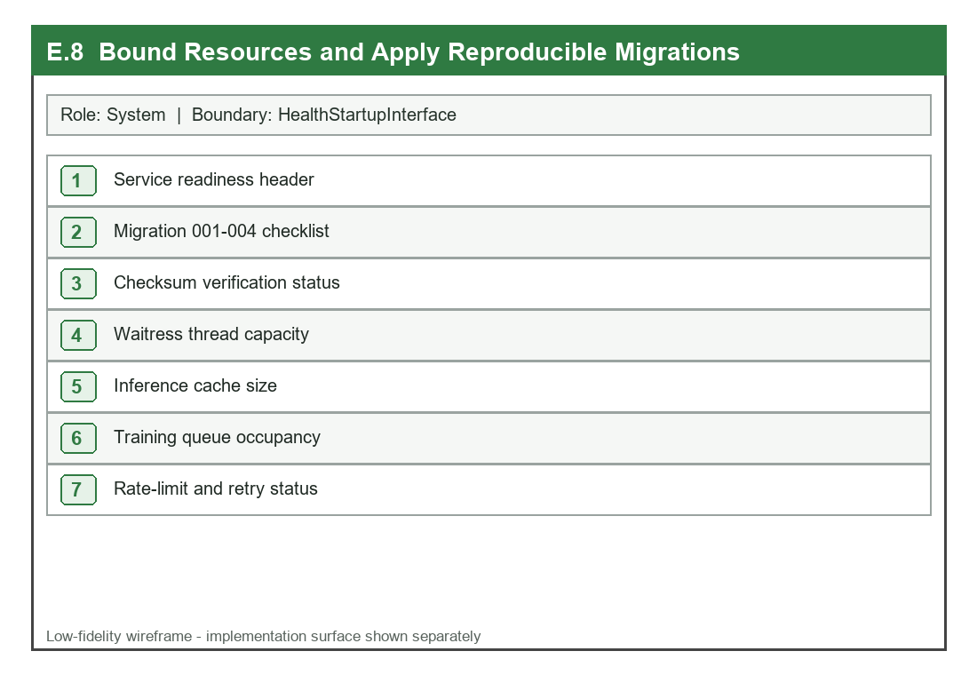

UI:
