Counting Maize Tassels in the Wild
via Deep Neural Network
Final Requirements, System Design, BCE, UML, ERD, and Testing Documentation

Project Reference: FYP-26-S2-7
Document Version: 1.0
Date: 4 August 2026
Language: English

Privacy note: This copy intentionally contains no student, supervisor, assessor, email, telephone, or other personal information.

Contents
1. Executive Summary and Project Description
2. Requirements Baseline - Original 30 User Stories
3. Extension User Stories and Descriptions
4. Extended System Description and Architecture
5. Use Case Model and Descriptions
6. BCE Model and Descriptions
7. Sequence Models
8. ERD and Data Dictionary
9. Security, Privacy, and Operational Controls
10. Testing Strategy and Historical Baseline
11. Current Regression Test Cases
12. Traceability and Completion Evidence
13. Limitations and Deployment Readiness
Page numbers are provided in the footer. Headings are Word-native and appear in the Navigation Pane.

1. Executive Summary and Project Description
This project delivers a role-based web and mobile system that reads maize images, counts and highlights tassels, and provides cautious bilingual maize leaf-condition screening. The primary objective remains the reduction of labour-intensive manual tassel counting for large-scale agricultural monitoring. The implemented extension adds image-quality feedback, uncertainty-aware guidance, field-scoped Agronomist review, secure account maintenance, encrypted storage, model integrity checks, controlled migrations, and bounded service workloads.

1.1 Purpose
The document baselines requirements, explains the current system, records Use Case, BCE, sequence, and ERD designs, and presents historical plus current test evidence. It follows the supplied preliminary technical-report page system while omitting all personal information.

1.2 Human-Centred Product Position
A photograph has value when the system converts visible evidence into a clear next action. For tassel counting, the image produces a count, confidence, and visual boxes. For leaf screening, the image produces a quality decision, a cautious similarity statement, uncertainty, follow-up questions, and safe next steps. The platform never presents a leaf-screening output as a confirmed diagnosis.

1.3 Roles
Role | Primary responsibility
Farmer | Capture/upload field images, receive counts and bilingual guidance, maintain the account.
Researcher | Analyse governed results, datasets, provenance, comparisons, and evaluation metrics.
Agronomist | Review only assigned fields, interpret evidence, and record accountable decisions.
Admin | Manage users, assignments, datasets, models, permissions, storage, backups, and logs.
System | Validate content, run separate AI pipelines, encrypt data, bound work, migrate schema, and audit actions.

2. Requirements Baseline - Original 30 User Stories
The 30 User Story sentences in this section are preserved verbatim from the preliminary technical documentation. They are not rewritten, renumbered, or replaced.

2.1 Farmer
ID | Original User Story
A.1 | As a farmer, I want to upload maize images, so that I can analyse crop conditions.
A.2 | As a farmer, I want the system to automatically count maize tassels, so that I do not need to perform manual counting.
A.3 | As a farmer, I want to view counting results clearly, so that I can understand plant growth.
A.4 | As a farmer, I want to see highlighted tassels on images, so that I can visually verify the results.
A.5 | As a farmer, I want to upload multiple images at once, so that I can save time.
A.6 | As a farmer, I want to receive results within a short response time, so that I can make timely decisions.
A.7 | As a farmer, I want to access the system via mobile devices, so that I can use it in the field.
A.8 | As a farmer, I want an intuitive and user-friendly interface, so that I can use the system easily.

2.2 Researcher
ID | Original User Story
B.1 | As a researcher, I want accurate tassel counting results, so that I can conduct reliable analysis.
B.2 | As a researcher, I want to export results in standard formats, so that I can use them for further research.
B.3 | As a researcher, I want to analyse historical data, so that I can study trends over time.
B.4 | As a researcher, I want to compare outputs from different models, so that I can evaluate performance.
B.5 | As a researcher, I want access to raw datasets, so that I can preprocess and analyse data.
B.6 | As a researcher, I want to generate visual reports, so that I can present findings effectively.

2.3 Agronomist
ID | Original User Story
C.1 | As an agronomist, I want to evaluate plant health based on tassel count, so that I can provide recommendations.
C.2 | As an agronomist, I want to monitor crop growth over time, so that I can track development stages.
C.3 | As an agronomist, I want to detect abnormal patterns in tassel counts, so that I can identify potential issues early.
C.4 | As an agronomist, I want a dashboard view of multiple fields, so that I can analyse large-scale crop conditions.
C.5 | As an agronomist, I want summarized insights, so that I can make decisions efficiently.

2.4 Admin
ID | Original User Story
D.1 | As an admin, I want to manage user accounts, so that I can control system access.
D.2 | As an admin, I want to store uploaded images securely, so that data is protected.
D.3 | As an admin, I want to monitor system usage, so that I can ensure system performance.
D.4 | As an admin, I want to manage datasets, so that the system maintains high-quality training data.
D.5 | As an admin, I want to control user permissions, so that different roles have appropriate access levels.
D.6 | As an admin, I want to back up data regularly, so that data loss is prevented.

2.5 System
ID | Original User Story
E.1 | As a system, I want to preprocess image data, so that the model can achieve better performance.
E.2 | As a system, I want to train deep learning models, so that tassel counting accuracy can be improved.
E.3 | As a system, I want to evaluate model performance using appropriate metrics, so that accuracy can be measured and improved.
E.4 | As a system, I want to deploy the trained model as a service, so that users can access it online.
E.5 | As a system, I want to support system updates and model improvements, so that new features and enhancements can be integrated.

3. Extension User Stories and Descriptions
The following 15 stories are additions. Their identifiers continue each role's baseline sequence and make the implemented bilingual, security, review, and operational behavior explicit.

3.1 Farmer Extensions

A.9 Bilingual Leaf Screening
User Story: As a farmer, I want to screen a maize leaf photo in English or Chinese, so that I can understand visible disease-like signs and decide what to do next.
Description: The Farmer may upload a validated maize leaf image and optional field context. The system must communicate observations, uncertainty, retake guidance, and safe next steps without presenting the output as a confirmed diagnosis.
Acceptance Criteria
- Given an authenticated Farmer and a valid leaf image, when screening succeeds, then the response contains a status, headline, observations, possible condition, confidence band, next steps, safety note, and selected language.
- Given a dark, blurred, or undersized image, when the quality gate fails, then the system asks for a better photo instead of inventing a condition.
- Given Chinese is selected, when the result is displayed, then all farmer-facing guidance is returned in Simplified Chinese while technical codes remain stable.
BCE Mapping: Boundary - Mobile/Web Leaf Assistant; Control - Disease Assistance and Advice Controls; Entity - Image and Disease Diagnosis.

A.10 Secure Account Maintenance
User Story: As a farmer, I want to change my email address or password securely, so that I can keep access when my contact details change.
Description: Email is the only account contact identifier. Profile and password changes require the current password and invalidate previously issued sessions.
Acceptance Criteria
- A duplicate or malformed email is rejected without changing the account.
- A new password must satisfy policy, match its confirmation, and differ from the current password.
- After a successful email or password change, the old access token is rejected.
BCE Mapping: Boundary - Account Page; Control - Authentication and Session Control; Entity - User.

A.11 Resilient Field Upload
User Story: As a farmer using mobile data, I want clear upload progress and recoverable errors, so that an interrupted 4G/5G connection does not make me lose track of my work.
Description: The interface shows compression/upload progress, preserves the current screen after network failure, and supports a deliberate retry without silently creating duplicate records.
Acceptance Criteria
- Upload progress and compressed size are visible before analysis begins.
- A network interruption produces a human-readable retry message and does not log the Farmer out.
- Repeated original filenames are isolated by UUID and content digest.
BCE Mapping: Boundary - Mobile Upload Page; Control - Upload Validation Control; Entity - Image and Image File.

3.2 Researcher Extensions

B.7 Review Uncertainty and Provenance
User Story: As a researcher, I want model identity, confidence, uncertainty, and quality metadata with each result, so that I can judge whether a record is suitable for analysis.
Description: Each result exposes stable scientific provenance without revealing internal server paths. Researchers can distinguish model evidence, quality findings, inference mode, and human review state before including a record in analysis.
Acceptance Criteria
- Results identify the model version, inference mode, confidence, quality state, and review status; internal server paths are never exposed.
BCE Mapping: Boundary - Research Dashboard; Control - Inference Control; Entity - Detection Result, Disease Diagnosis, and Model.

B.8 Controlled Dataset Retrieval
User Story: As a researcher, I want approved datasets exported with a manifest, so that I can reproduce analysis without accessing arbitrary server files.
Description: Dataset retrieval is permission-controlled and restricted to configured storage roots. Each generated archive includes metadata that identifies the selected dataset and supports reproducible downstream work.
Acceptance Criteria
- Only authorized roles with datasets:download may export; source paths must remain inside configured dataset roots; ZIP/TAR output includes a dataset manifest; oversized source files are excluded.
BCE Mapping: Boundary - Dataset Page; Control - Dataset Export Control; Entity - Dataset and System Log.

B.9 Reproducible Model Evaluation
User Story: As a researcher, I want evaluation to use an integrity-checked model and approved dataset YAML, so that reported metrics are tied to a reproducible artifact.
Description: Evaluation is allowed only when both the registered model artifact and dataset configuration remain inside their approved trust boundaries. Stored metrics therefore remain connected to a validated model version and input definition.
Acceptance Criteria
- Model paths are allowlisted, artifact SHA-256 is checked when recorded, dataset YAML must be inside approved roots, and mAP/precision/recall are persisted with the registered model.
BCE Mapping: Boundary - Model Evaluation Page; Control - Model Governance; Entity - Model, Dataset, and Training Run.

3.3 Agronomist Extensions

C.6 Review Assigned Field Evidence
User Story: As an agronomist, I want to view leaf-screening evidence only for fields assigned to me, so that I can support farmers without seeing unrelated private images.
Description: Field Assignment is the explicit authorization link between an Agronomist and agricultural evidence. The same scope is applied to field lists, summaries, diagnoses, review actions, and protected image retrieval.
Acceptance Criteria
- The field list, diagnosis history, aggregate insight, and image access are filtered through Field Assignment; an unassigned field returns a forbidden response; Admin retains full access.
BCE Mapping: Boundary - Agronomist Dashboard; Control - Field Assignment and Review Control; Entity - Field Assignment, Image, and Disease Diagnosis.

C.7 Confirm or Correct Screening
User Story: As an agronomist, I want to confirm, correct, or mark a disease screening inconclusive, so that the farmer-facing record includes accountable expert review.
Description: Expert review never overwrites the original model evidence. It adds a named reviewer decision, reviewed condition where applicable, note, and timestamp so the automated and human interpretations remain traceable.
Acceptance Criteria
- A review requires an allowed decision and note; corrections require a supported condition or other; reviewer identity and time are persisted; the action is audited.
BCE Mapping: Boundary - Diagnosis Review Panel; Control - Review Control; Entity - Disease Diagnosis and System Log.

C.8 Context-Aware Human Guidance
User Story: As an agronomist, I want the system to keep field context separate from model evidence, so that advice is useful without overstating diagnostic certainty.
Description: Farmer-provided crop stage, weather, and spread information enriches the explanation but is stored separately from raw probabilities and quality measurements. This preserves scientific clarity and prevents context from leaking between requests.
Acceptance Criteria
- Crop stage, recent weather, and symptom spread are stored as context; model probabilities remain technical evidence; wording explicitly states that screening is not a confirmed diagnosis; request context never leaks into another user's response.
BCE Mapping: Boundary - Leaf Assistant; Control - Advice Engine; Entity - Disease Diagnosis.

3.4 Admin Extensions

D.7 Assign Agronomists to Fields
User Story: As an admin, I want to assign or remove Agronomists from fields, so that evidence access follows operational responsibility.
Description: The Admin maintains a many-to-many assignment boundary between active Agronomists and fields. Assignment changes are idempotent, auditable, and immediately reflected by server-side authorization.
Acceptance Criteria
- Only Admin can manage assignments; only active Agronomist accounts can be assigned; assignments are unique per field/user pair; changes are audited.
BCE Mapping: Boundary - Admin Console; Control - Field Assignment Control; Entity - User, Field, Field Assignment, and System Log.

D.8 Revoke Stale Sessions
User Story: As an admin, I want role, status, permission, email, and password changes to invalidate old sessions, so that revoked access cannot continue until token expiry.
Description: Tokens carry only stable identity and a session version. Every protected request reloads current account state and rejects a token when the database version, role, permission, or active status no longer authorizes access.
Acceptance Criteria
- Every protected request reloads current account state; disabled accounts and session-version mismatches are rejected; tokens are accepted only from the Authorization header by default.
BCE Mapping: Boundary - Admin/User Account Pages; Control - Authentication and Session Control; Entity - User and Role.

D.9 Govern Storage and Deployment
User Story: As an admin, I want uploaded images, model artifacts, migrations, and background workloads governed by explicit limits, so that the service remains auditable and stable.
Description: Administrative governance covers the complete evidence and model lifecycle: validated encrypted storage, allowlisted artifacts, checksum-tracked schema changes, bounded workers, rate limits, safe errors, and operational audit logs.
Acceptance Criteria
- Image content is validated and encrypted; model paths and digests are verified; migrations are checksummed; rate limits and bounded workers are active; public errors do not expose internal exception details.
BCE Mapping: Boundary - Admin/System Console; Control - Upload, Model, Migration, and Rate Controls; Entity - Image File, Model, Schema Migration, and System Log.

3.5 System Extensions

E.6 Validate and Isolate Every Upload
User Story: As a system, I want to validate actual image content and assign collision-resistant storage names, so that unsafe or duplicate filenames cannot corrupt another user's data.
Description: The server distrusts filenames and client content types. It decodes supported formats, enforces byte and pixel limits, generates a UUID storage name, records the original name and digest, and encrypts the validated bytes.
Acceptance Criteria
- Byte, MIME, decode, dimension, and pixel limits are enforced; server names use UUIDs; SHA-256 and original names are recorded; encrypted database bytes decrypt to the validated original.
BCE Mapping: Boundary - Upload API; Control - Image Validation Control; Entity - Image and Image File.

E.7 Operate Dual AI Pipelines Safely
User Story: As a system, I want tassel counting and leaf screening to run as separate governed pipelines, so that each task returns appropriate evidence and neither silently substitutes fabricated output.
Description: Each AI task has its own model contract, output schema, quality controls, and persistence entity. A missing or invalid model produces a controlled unavailable state instead of a fabricated result.
Acceptance Criteria
- Tassel inference returns count/boxes; disease inference returns calibrated status/quality/uncertainty; missing artifacts return a controlled unavailable response; no production mock fallback is permitted.
BCE Mapping: Boundary - Prediction APIs; Control - Tassel and Disease Inference Controls; Entity - Model, Detection Result, and Disease Diagnosis.

E.8 Bound Resources and Apply Reproducible Migrations
User Story: As a system, I want bounded caches, bounded training queues, rate limits, and tracked database migrations, so that load and schema changes remain controlled.
Description: Expensive work has explicit capacity and concurrency boundaries. Database migrations are numbered, checksummed, and serialized under an advisory lock so repeated startup is safe and altered applied files are detected.
Acceptance Criteria
- Inference cache size is configurable and uses content/model identity; model access is lock-protected; local training rejects excess pending work; migration names/checksums are recorded and altered applied files are rejected; Waitress uses a bounded thread pool.
BCE Mapping: Boundary - Health/Startup Interfaces; Control - Workload and Migration Controls; Entity - Training Run, Model, Schema Migration, and System Log.

4. Extended System Description and Architecture
The system uses a same-origin responsive PWA and Flask API, PostgreSQL persistence, encrypted image storage, two separate AI inference pipelines, and role-aware review controls. Protected requests reload current account state so that role, status, permission, email, and password changes take effect immediately through session-version revocation.

4.1 Logical Layers
Layer | Components | Responsibility
Boundary | Mobile PWA, desktop pages, Admin console | Collect images and context; present progress, results, uncertainty, and actions.
Control | Auth, upload, inference, advice, assignment, model, migration | Validate, authorize, orchestrate, bound, and audit every use case.
Entity | PostgreSQL and encrypted image payloads | Persist identities, evidence, results, reviews, models, datasets, and logs.
Operations | Waitress, health, backups, migrations | Start safely, expose readiness, preserve data, and control schema change.

4.2 Dual AI Responsibility
Tassel detection and leaf screening are intentionally separated. The tassel pipeline returns object locations and count evidence. The disease pipeline applies an image-quality gate, calibrated class thresholds, uncertainty states, and a bilingual advice engine. Neither pipeline substitutes mock output when an artifact is unavailable.

5. Use Case Model and Descriptions
Figure 1. Extended role-based Use Case model.
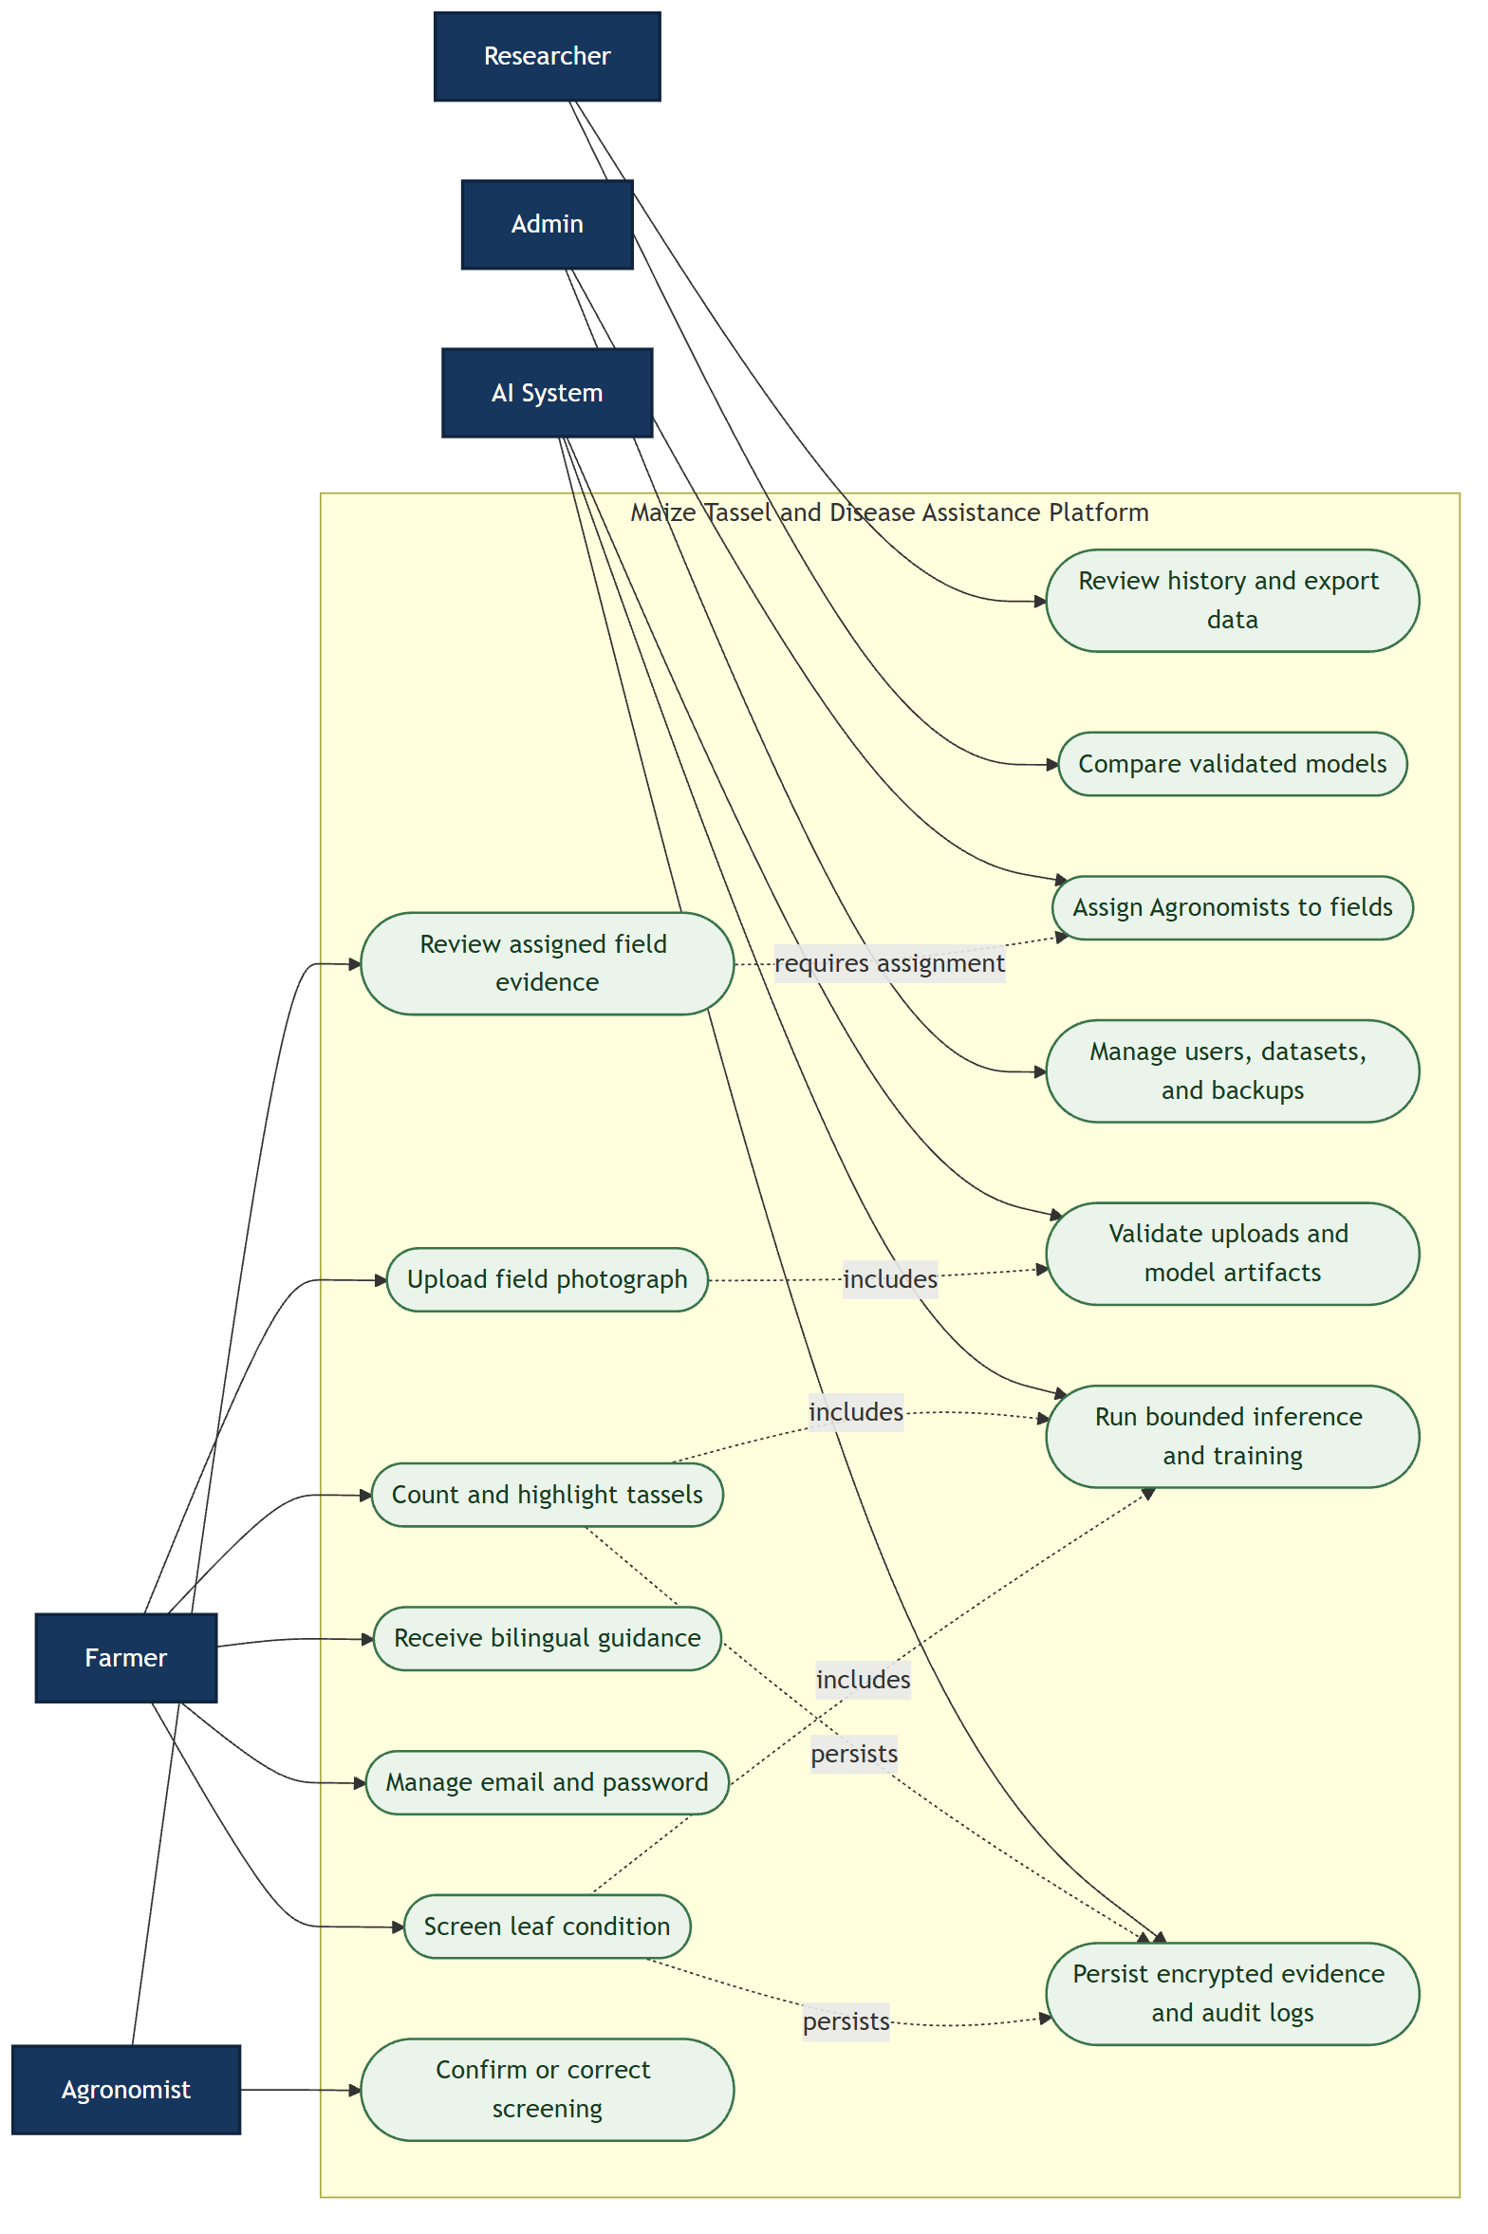

5.1 UC-01 - Upload and count tassels
Item | Description
Primary actor | Farmer
Precondition | Authenticated active account
Main flow | Validate and encrypt image; run active tassel model; save count, boxes, confidence, and timing.
Alternate/exception | Invalid/oversized image is rejected; unavailable model returns a controlled service error.
Postcondition | Authorized state changes are persisted and an appropriate response is returned.

5.2 UC-02 - Screen a maize leaf
Item | Description
Primary actor | Farmer
Precondition | Authenticated account and valid JPG/PNG
Main flow | Run quality gate and calibrated classifier; format the selected language; persist evidence and response.
Alternate/exception | Poor image requests a retake; uncertain evidence is labelled for confirmation.
Postcondition | Authorized state changes are persisted and an appropriate response is returned.

5.3 UC-03 - Maintain account
Item | Description
Primary actor | Any signed-in user
Precondition | Current password is known
Main flow | Update email or password; increment session version; issue a fresh token when appropriate.
Alternate/exception | Wrong password, duplicate email, weak password, and stale token are rejected.
Postcondition | Authorized state changes are persisted and an appropriate response is returned.

5.4 UC-04 - Retrieve governed research data
Item | Description
Primary actor | Researcher
Precondition | Required permission
Main flow | Filter history or export an approved dataset with manifest.
Alternate/exception | A path outside configured dataset roots is rejected.
Postcondition | Authorized state changes are persisted and an appropriate response is returned.

5.5 UC-05 - Evaluate a registered model
Item | Description
Primary actor | Researcher/Admin
Precondition | Registered artifact and dataset YAML
Main flow | Validate path and digest; run evaluation; persist metrics.
Alternate/exception | Missing, altered, pointer-only, or out-of-root artifacts are rejected.
Postcondition | Authorized state changes are persisted and an appropriate response is returned.

5.6 UC-06 - Review assigned diagnosis
Item | Description
Primary actor | Agronomist
Precondition | Field assignment exists
Main flow | Load permitted evidence; confirm, correct, or mark inconclusive; audit the review.
Alternate/exception | Unassigned field or invalid review decision is rejected.
Postcondition | Authorized state changes are persisted and an appropriate response is returned.

5.7 UC-07 - Assign Agronomist
Item | Description
Primary actor | Admin
Precondition | Active Agronomist and existing field
Main flow | Create, update, list, or remove Field Assignment; write audit log.
Alternate/exception | Inactive/non-Agronomist user is rejected.
Postcondition | Authorized state changes are persisted and an appropriate response is returned.

5.8 UC-08 - Operate and migrate service
Item | Description
Primary actor | System/Admin
Precondition | Configured secrets, database, and model
Main flow | Apply checksum-tracked migrations; start bounded Waitress service; expose safe health state.
Alternate/exception | Checksum mismatch, missing secret, database failure, or invalid model prevents unsafe startup.
Postcondition | Authorized state changes are persisted and an appropriate response is returned.

6. BCE Model and Descriptions
Figure 2. Consolidated Boundary-Control-Entity model.
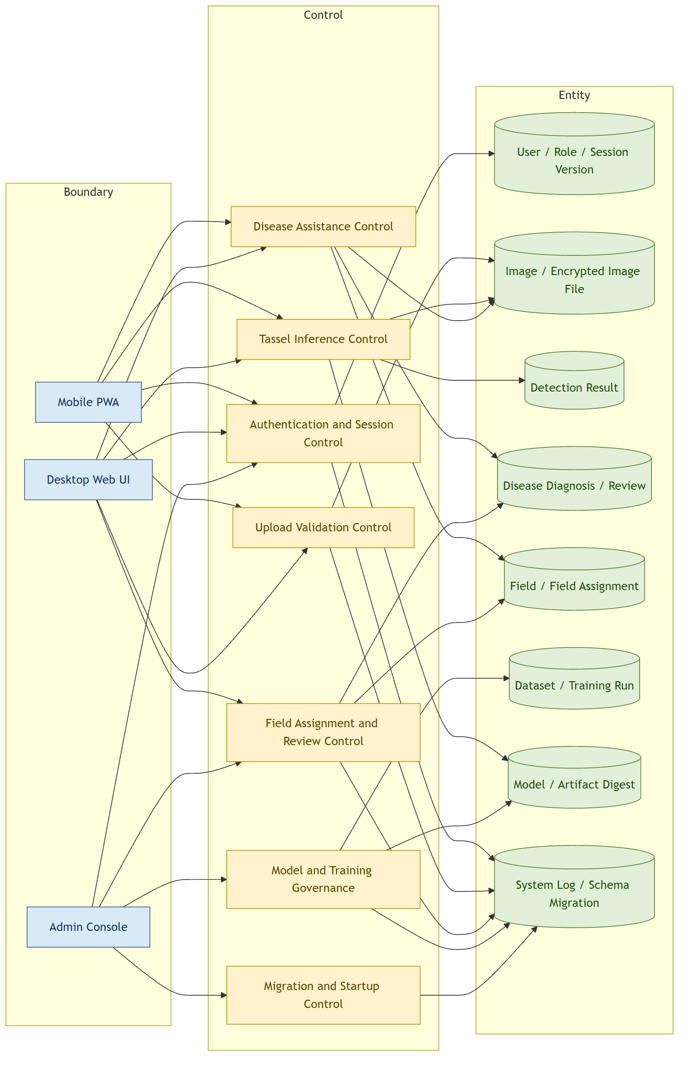

6.1 Boundary Objects
Mobile PWA and Desktop Web UI serve Farmers, Researchers, and Agronomists. The Admin Console exposes governance functions. Boundaries collect input and present output but do not decide authorization or model trust.

6.2 Control Objects
Control | Key behavior
Authentication and Session | Reload account state; enforce role/permission; reject stale or disabled sessions.
Upload Validation | Limit bytes/pixels; verify decode and MIME; generate UUID and digest; encrypt storage.
Tassel Inference | Lock model access; use content/model/mode cache key; return boxes and count.
Disease Assistance | Gate quality; classify with uncertainty; format bilingual human guidance.
Field Assignment and Review | Restrict Agronomist field/evidence access and persist accountable reviews.
Model and Training Governance | Allowlist paths, verify digest, bound local work, persist metrics.
Migration and Startup | Checksum migrations and refuse unsafe service startup.

6.3 Entity Objects
Entities retain durable system truth. The ERD in Section 8 defines identifiers and relationships; encrypted Image File data is separated from queryable Image metadata.

7. Sequence Models
Figure 3. Secure mobile upload and tassel-count sequence.
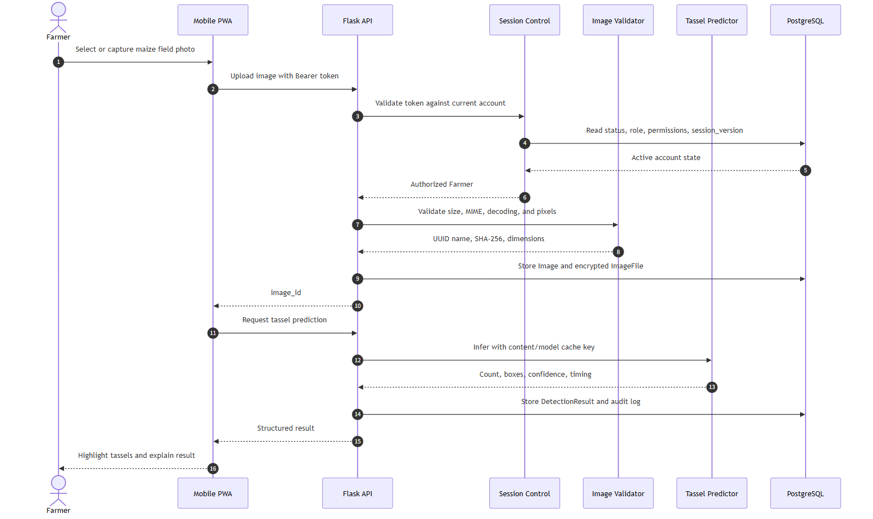

The API authenticates against live database state before image validation. Only validated encrypted evidence receives an image identifier. Inference then uses the active model and persists a Detection Result.
Figure 4. Bilingual disease screening and assigned Agronomist review.
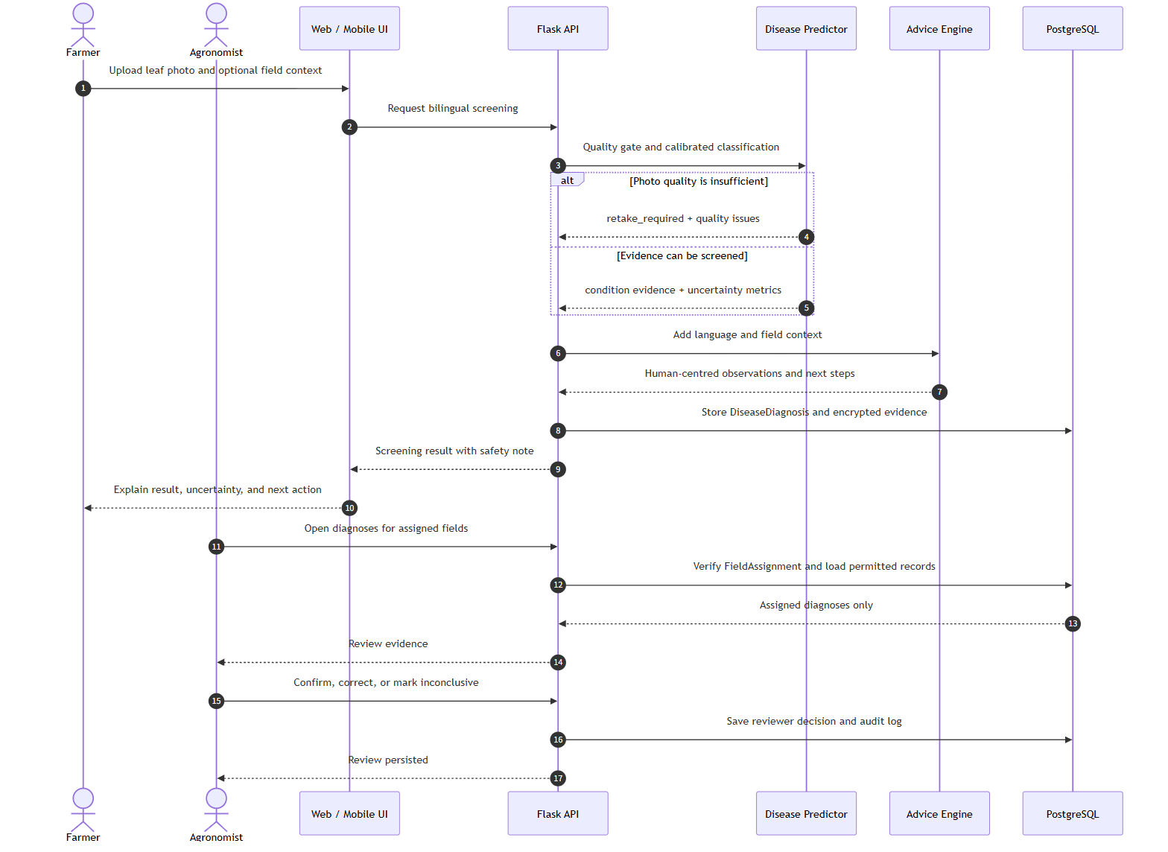

The quality gate can terminate the model flow with retake guidance. When evidence is screenable, model output and user context remain distinct. An Agronomist sees and reviews a diagnosis only through an explicit Field Assignment.

8. ERD and Data Dictionary
Figure 5. Extended PostgreSQL entity-relationship model.
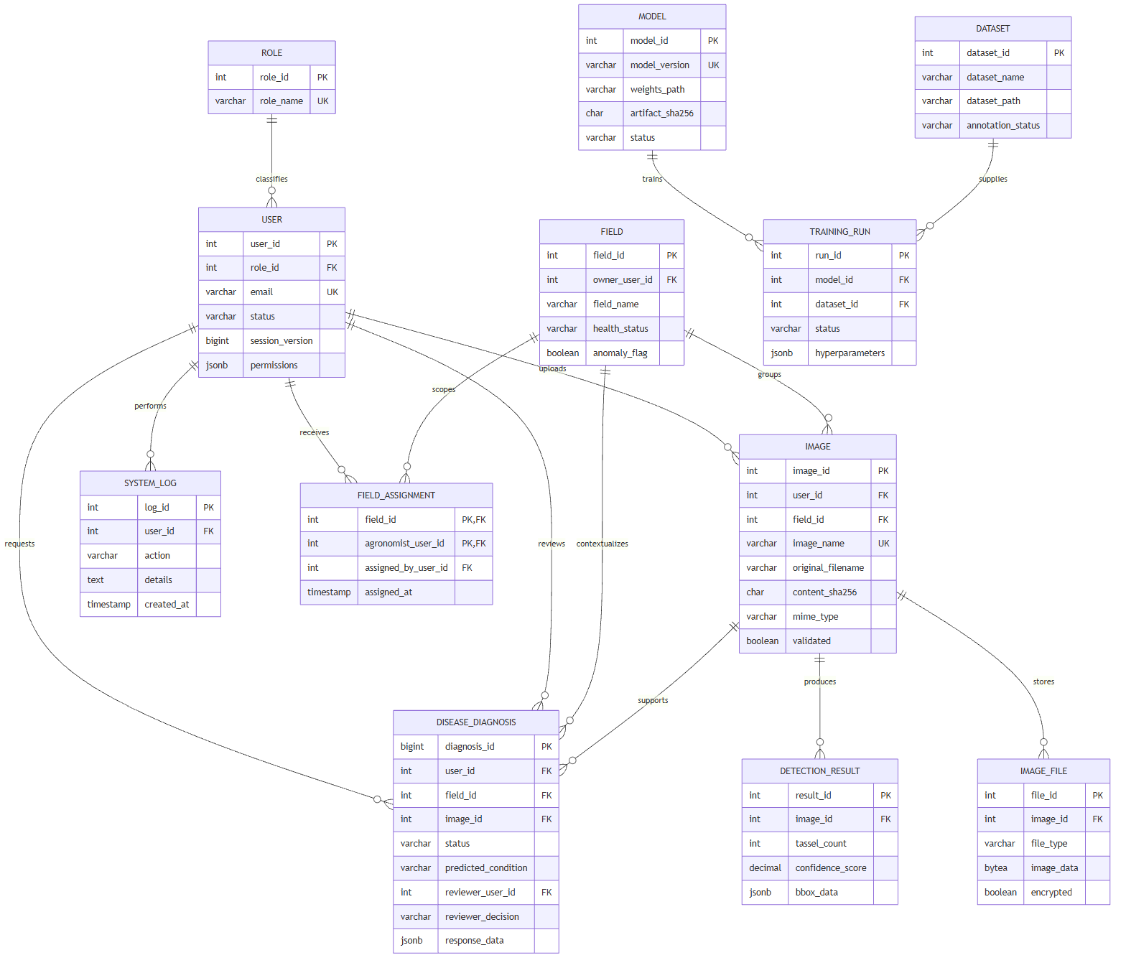

8.1 Data Dictionary
Entity | Purpose | Primary key | Principal relationships
roles | Role catalogue used by server-side authorization. | role_id | users
users | Account, status, permission overrides, and session revocation counter. | user_id | roles, images, diagnoses, logs, assignments
fields | Field identity, owner, thresholds, health, and anomaly state. | field_id | images, diagnoses, assignments
field_assignments | Explicit many-to-many Agronomist responsibility boundary. | field_id + agronomist_user_id | fields, users
images | Validated image metadata with original name, UUID name, digest, dimensions, and owner. | image_id | users, fields, image_files, results, diagnoses
image_files | Encrypted original or annotated binary image payload. | file_id | images
detection_results | Tassel count, confidence, timing, boxes, and review state. | result_id | images
disease_diagnoses | Leaf-screening evidence, uncertainty, context, advice, and expert review. | diagnosis_id | users, fields, images
datasets | Governed dataset metadata and approved path. | dataset_id | training_runs
models | Versioned model metadata, metrics, path, digest, parent, and lifecycle status. | model_id | training_runs
training_runs | Bounded local or external training configuration and outcome. | run_id | models, datasets
system_logs | Actor, action, details, and timestamp for auditable operations. | log_id | users
schema_migrations | Applied SQL filename, SHA-256 checksum, and timestamp. | migration_name | none

8.2 Integrity Rules
- A User belongs to one Role; account email is unique and session_version revokes stale sessions.
- A Field Assignment is unique for one Field/Agronomist pair and is deleted when either parent is removed.
- An Image stores metadata and ownership; Image File stores encrypted binary data with one type per image.
- Detection Result and Disease Diagnosis are separate outputs because their evidence and review semantics differ.
- Model artifact digest and migration checksum make operational changes detectable.

9. Security, Privacy, and Operational Controls
Risk | Implemented control | Verification
Filename collision / disguised image | UUID name, SHA-256, MIME/decode/pixel validation, request limits | Image-security and PostgreSQL upload tests
Stale privilege token | Live user reload and session_version; no query token by default | Farmer-account authentication tests
Unrelated field evidence | Explicit Field Assignment on fields, diagnoses, reviews, and image access | Field-authorization tests
Untrusted model/dataset path | Configured roots, suffix/type checks, Git LFS pointer rejection, digest verification | Security-control tests
Resource exhaustion | Rate limits, bounded LRU cache, locked inference, bounded training queue, Waitress threads | Rate/cache/executor tests
Schema drift | Numbered checksum-tracked migrations under PostgreSQL advisory lock | Migration discovery and live check
Sensitive data disclosure | Fernet encrypted bytes, controlled file endpoints, generic public errors, audit logs | Secure round-trip and response tests

9.1 Privacy Boundary
Farmers access their own evidence. Agronomists access only explicitly assigned fields. Researchers receive role-approved research records and datasets. Admin access is broad but authenticated, permission-controlled, and audited. Tokens are transported in the Authorization header and are not embedded in protected image URLs.

9.2 Scale Boundary
The in-memory limiter and cache are appropriate to a single-process academic deployment. A horizontally scaled public deployment must use a shared external rate limiter/cache, managed object storage, centralized monitoring, secret rotation, and automated backup verification.

10. Testing Strategy and Historical Baseline
The following material is reproduced from the prior Testing Plan as a historical baseline. Its test-case wording is intentionally unchanged. Statements about Week 10 prototype or mock behavior describe that earlier submission and are superseded by the current regression evidence in Section 11.

10.1 Historical Overview and Environment

1. Testing Plan Overview
Purpose: Verify that all prototype functions work correctly, APIs return expected responses, and the system handles edge cases gracefully. This document contains two complementary test suites: (a) a 17-case summary table covering UI, API, edge, and mobile tests per the Task 18 checklist; and (b) 30 per-story detailed test tables mapping every fixed user story to acceptance criteria and step-by-step verification. All tests were executed and verified against the running prototype on 28 May 2026.

2. Test Environment
Frontend: Vanilla HTML/CSS/JS, Playwright browser automation (v1.60)
Backend: Flask 3.x + Flask-CORS, psycopg3 PostgreSQL, Python 3.14
Browser: Chromium headless, viewport 1440x900 (desktop) / 375x812 (mobile)
API Base URL: http://localhost:5000
Database: PostgreSQL 18, database: maize_detector
Test Artifacts: Playwright script (test_e2e.py), curl API tests

3. Test Case Results — Summary Table
All 17 test cases (TC01-TC17) were executed against the running prototype. This table follows the Week 10 Task 18 checklist format. Results: 17/17 Passed.
Table 1: Week 10 Prototype Test Results — 17/17 Passed, 100% Pass Rate

4. Test Summary
Overall Results
Summary table (Section 3): 17 test cases — 17 Passed
User story tables (Section 5): 30 test cases — 23 Pass / 6 Partial / 1 Planned
Summary Pass Rate: 100% (17/17 for prototype functions)
Coverage Breakdown:
UI Functionality: 10 test cases (TC01-TC10) — All pages respond correctly, forms validate input, navigation flows work end-to-end.
API Endpoints: 4 test cases (TC11-TC14) — All 7 backend endpoints return valid JSON with consistent snake_case field names. CORS configured correctly.
Edge Conditions: 2 test cases (TC15-TC16) — System handles empty/unknown input gracefully using mock data fallback. No 500 errors or crashes.
Mobile Responsiveness: 1 test case (TC17) — Layout meets 375px touch target requirements. Buttons at 47px exceed the 44px WCAG minimum.

4.1 Observations and Notes
TC17 (Mobile): Button height measured at 47px, exceeding the 44px minimum touch target per WCAG accessibility guidelines. Tab buttons at 40px minimum height. No horizontal overflow detected at 375px width.
TC04 (Oversized file): The 11MB oversize file triggered a JavaScript-side size check (max 10MB) before reaching the server, providing fast client-side feedback.
TC06 (History): History page shows growing record count from database entries created during sequential test runs (58 records observed during final verification run).
TC11-TC14 (API): All endpoints return snake_case JSON field names matching the PostgreSQL database schema (tassel_count, confidence_score, created_at).

10.2 Historical 17-Case Summary
ID | Cat. | Function | Input | Expected Result | Status
TC01 | UI | Login valid credentials | john@farm.com / 123456 | Redirect to Farmer dashboard | Pass
TC02 | UI | Upload valid JPG image | JPG file (2KB) | Preview displayed, Analyze enabled | Pass
TC03 | UI | Upload invalid file | PDF file | Error message shown in red alert | Pass
TC04 | UI | Upload oversized file | JPG > 10MB (11MB) | Error shown, button disabled | Pass
TC05 | UI | Analyze image | Valid JPG via Upload page | Redirect to Result page with count | Pass
TC06 | UI | View detection history | Researcher clicks History tab | Table with >=3 records (58 loaded) | Pass
TC07 | UI | Daily report | Click Daily tab | Total uploads: 24, detections: 22 | Pass
TC08 | UI | Weekly report | Click Weekly tab | Total uploads: 148, active day shown | Pass
TC09 | UI | Monthly report | Click Monthly tab | Total uploads: 520, accuracy shown | Pass
TC10 | UI | Export CSV | Select all, click Download | Blob-triggered CSV download | Pass
TC11 | API | Health check | GET /api/health | HTTP 200, JSON { status: ok } | Pass
TC12 | API | Predict endpoint | POST /api/predict | JSON with tassel_count + confidence_score | Pass
TC13 | API | History endpoint | GET /api/history?limit=3 | JSON array with records + total | Pass
TC14 | API | Report endpoints | GET /api/report/{type} | JSON with uploads + detections | Pass
TC15 | Edge | Empty field detection | POST /api/predict empty image | Valid count returned, no crash | Pass
TC16 | Edge | Invalid credentials | baduser@no.com / wrong | Error message visible in alert | Pass
TC17 | Mobile | 375px viewport | Login page at 375x812 | Buttons >=44px (47px), no overflow | Pass

10.3 Historical Per-Story Test Cases

10.3.1 Farmer

TC-FARMER-01
Field | Historical text
User Story ID | TC-FARMER-01
Taiga / BCE Ref | A.1
User Story | As a farmer, I want to upload maize images, so that I can analyse crop conditions.
Pre-condition | Farmer is logged in and Upload page is accessible.
Test Data | john@farm.com / 123456; valid JPG/PNG image (test_maize.jpg, 2KB)
Implementation | frontend/pages/upload.html; apiUpload(); POST /api/upload; images table
Step | Test Action | Expected / Actual Result | Status / Remarks
1 | Open Upload page and select a valid maize JPG image. | Expected: Image preview appears and Analyze button becomes enabled.  Actual: Preview rendered; Analyze button enabled. | Pass  Core upload flow works.
2 | Attempt to upload a PDF file. | Expected: Error message shown in red alert.  Actual: Error alert visible; file rejected. | Pass  Input validation handles non-image.
3 | Attempt to upload JPG > 10MB. | Expected: Error shown, Analyze button disabled.  Actual: Client-side size check triggers error alert. | Pass  Size limit enforced in JS.
Overall Status: Pass

TC-FARMER-02
Field | Historical text
User Story ID | TC-FARMER-02
Taiga / BCE Ref | A.2
User Story | As a farmer, I want the system to automatically count maize tassels, so that I do not need to perform manual counting.
Pre-condition | A valid image has been uploaded and image_id exists.
Test Data | Uploaded image_id and image_name from TC-FARMER-01
Implementation | POST /api/predict; create_mock_detection(); detection_results table
Step | Test Action | Expected / Actual Result | Status / Remarks
1 | Click Analyze on a valid uploaded image. | Expected: System returns tassel_count, confidence_score, processing_time, and bbox_data.  Actual: /api/predict returns normalized mock/database detection data. | Pass  AI is prototype/mock for Week 10.
Overall Status: Pass

TC-FARMER-03
Field | Historical text
User Story ID | TC-FARMER-03
Taiga / BCE Ref | A.3
User Story | As a farmer, I want to view counting results clearly, so that I can understand plant growth.
Pre-condition | Prediction result exists in sessionStorage or API history.
Test Data | Mock prediction result from /api/predict
Implementation | frontend/pages/result.html; normalizeResult(); displayResult()
Step | Test Action | Expected / Actual Result | Status / Remarks
1 | Open Result page after upload and prediction. | Expected: Count, confidence, processing time, and date clearly visible.  Actual: result.html renders key detection fields and role-specific actions. | Pass  Readable result page exists.
Overall Status: Pass

TC-FARMER-04
Field | Historical text
User Story ID | TC-FARMER-04
Taiga / BCE Ref | A.4
User Story | As a farmer, I want to see highlighted tassels on images, so that I can visually verify the results.
Pre-condition | Prediction returns bbox_data or annotated image path.
Test Data | bbox_data boxes from mockPredict()
Implementation | result.html annotated image panel; bbox rendering; annotated_image_path fallback
Step | Test Action | Expected / Actual Result | Status / Remarks
1 | Open Result page with a prediction containing bounding boxes. | Expected: Highlighted tassel boxes or annotated image area displayed.  Actual: Result page displays annotation visual area from bbox data or fallback image. | Pass  Supports visual verification in prototype.
Overall Status: Pass

TC-FARMER-05
Field | Historical text
User Story ID | TC-FARMER-05
Taiga / BCE Ref | A.5
User Story | As a farmer, I want to upload multiple images at once, so that I can save time.
Pre-condition | Farmer is on Upload page.
Test Data | Multiple JPG/PNG files
Implementation | Current upload.html single-file flow; batch upload planned
Step | Test Action | Expected / Actual Result | Status / Remarks
1 | Attempt to select multiple maize images and process them. | Expected: System should support batch upload or clearly limit current behavior.  Actual: Current prototype supports single image; batch not yet implemented. | Partial  Future enhancement: multi-file input.
Overall Status: Partial

TC-FARMER-06
Field | Historical text
User Story ID | TC-FARMER-06
Taiga / BCE Ref | A.6
User Story | As a farmer, I want to receive results within a short response time, so that I can make timely decisions.
Pre-condition | Backend API is running.
Test Data | Valid uploaded image; timing measurement
Implementation | /api/predict processing_time field; mock response under 1s
Step | Test Action | Expected / Actual Result | Status / Remarks
1 | Upload an image and submit prediction; measure response time. | Expected: Result returns quickly with processing_time displayed.  Actual: Mock prediction returns immediate JSON (<1s); processing_time field in response. | Pass  Prototype fast; real model timing TBD.
Overall Status: Pass

TC-FARMER-07
Field | Historical text
User Story ID | TC-FARMER-07
Taiga / BCE Ref | A.7
User Story | As a farmer, I want to access the system via mobile devices, so that I can use it in the field.
Pre-condition | Mobile viewport (375x812) is available.
Test Data | 375px viewport; Farmer account session
Implementation | Responsive CSS (style.css); login/dashboard/upload/result pages
Step | Test Action | Expected / Actual Result | Status / Remarks
1 | Open login and dashboard pages in 375px mobile viewport. | Expected: Pages fit mobile width; buttons >= 44px; no horizontal overflow.  Actual: Buttons at 47px; tabs at 40px min-height; body scrollWidth <= 375px. | Pass  Field-use path covered by responsive UI.
Overall Status: Pass

TC-FARMER-08
Field | Historical text
User Story ID | TC-FARMER-08
Taiga / BCE Ref | A.8
User Story | As a farmer, I want an intuitive and user-friendly interface, so that I can use the system easily.
Pre-condition | Farmer is logged in.
Test Data | Farmer role session (john@farm.com)
Implementation | Farmer dashboard quick actions; role-limited nav; consistent green theme
Step | Test Action | Expected / Actual Result | Status / Remarks
1 | Open Farmer Dashboard and use visible action buttons. | Expected: User can find Upload Image and Latest Result without instruction.  Actual: Dashboard uses role-specific nav and clear quick-action buttons. | Pass  UI matches Week 10 prototype needs.
Overall Status: Pass

10.3.2 Researcher

TC-RESEARCHER-01
Field | Historical text
User Story ID | TC-RESEARCHER-01
Taiga / BCE Ref | B.1
User Story | As a researcher, I want accurate tassel counting results, so that I can conduct reliable analysis.
Pre-condition | Researcher can access detection outputs.
Test Data | History records with confidence_score; /api/history?limit=10
Implementation | /api/history; result confidence fields; model_accuracy_estimate in reports
Step | Test Action | Expected / Actual Result | Status / Remarks
1 | Open Researcher Dashboard and review confidence/count metrics. | Expected: Detection results include tassel_count and confidence_score for analysis.  Actual: Dashboard and history expose both fields from database. | Pass  Accuracy via prototype confidence; final model metrics pending.
Overall Status: Pass

TC-RESEARCHER-02
Field | Historical text
User Story ID | TC-RESEARCHER-02
Taiga / BCE Ref | B.2
User Story | As a researcher, I want to export results in standard formats, so that I can use them for further research.
Pre-condition | Researcher is logged in and history records exist.
Test Data | Selected history records (58 available in DB)
Implementation | frontend/pages/export.html; exportData(); CSV Blob download via URL.createObjectURL
Step | Test Action | Expected / Actual Result | Status / Remarks
1 | Open Export page; click Select All; click Download CSV. | Expected: CSV file download triggered with selected result data.  Actual: export.html builds and downloads CSV through Blob API. | Pass  Researcher-only export flow implemented.
Overall Status: Pass

TC-RESEARCHER-03
Field | Historical text
User Story ID | TC-RESEARCHER-03
Taiga / BCE Ref | B.3
User Story | As a researcher, I want to analyse historical data, so that I can study trends over time.
Pre-condition | History data exists in detection_results table.
Test Data | /api/history?limit=100; 58+ database records
Implementation | frontend/pages/history.html; GET /api/history; trend indicator
Step | Test Action | Expected / Actual Result | Status / Remarks
1 | Open History page; filter and sort records. | Expected: Filtered records and trend indicator update.  Actual: History table renders >=3 records (58 observed); trend text updates. | Pass  Trend analysis is basic but functional.
Overall Status: Pass

TC-RESEARCHER-04
Field | Historical text
User Story ID | TC-RESEARCHER-04
Taiga / BCE Ref | B.4
User Story | As a researcher, I want to compare outputs from different models, so that I can evaluate performance.
Pre-condition | Researcher Dashboard is available.
Test Data | Prototype YOLOv8n and planned YOLOv8s model rows
Implementation | frontend/pages/researcher.html model comparison table
Step | Test Action | Expected / Actual Result | Status / Remarks
1 | Open Researcher Dashboard and inspect model comparison section. | Expected: System shows model comparison status and metric placeholders.  Actual: Dashboard shows prototype comparison table; no live multi-model inference yet. | Partial  Multi-model comparison requires AI pipeline.
Overall Status: Partial

TC-RESEARCHER-05
Field | Historical text
User Story ID | TC-RESEARCHER-05
Taiga / BCE Ref | B.5
User Story | As a researcher, I want access to raw datasets, so that I can preprocess and analyse data.
Pre-condition | Dataset metadata exists in datasets table.
Test Data | /api/datasets; 3 seeded datasets (YOLO, COCO, none)
Implementation | researcher.html dataset access table; admin dataset CRUD
Step | Test Action | Expected / Actual Result | Status / Remarks
1 | Open Researcher Dashboard and review Dataset Access table. | Expected: Dataset names, annotation status, and formats visible.  Actual: researcher.html loads /api/datasets and displays metadata. | Pass  Raw binary download not yet included.
Overall Status: Pass

TC-RESEARCHER-06
Field | Historical text
User Story ID | TC-RESEARCHER-06
Taiga / BCE Ref | B.6
User Story | As a researcher, I want to generate visual reports, so that I can present findings effectively.
Pre-condition | Report endpoints are available.
Test Data | /api/report/daily (24u/22d), weekly (148u/139d), monthly (520u/496d)
Implementation | frontend/pages/report.html; SVG chart area; report cards
Step | Test Action | Expected / Actual Result | Status / Remarks
1 | Open Report page; click Daily tab. | Expected: Report displays total uploads and detections.  Actual: Daily report shows 24 uploads, 22 detections. | Pass  Daily report renders correctly.
2 | Click Weekly tab. | Expected: Weekly aggregated data displayed.  Actual: Weekly report shows 148 uploads. | Pass  Weekly tab switches correctly.
3 | Click Monthly tab. | Expected: Monthly aggregated data displayed.  Actual: Monthly report shows 520 uploads, accuracy. | Pass  Monthly tab switches correctly.
Overall Status: Pass

10.3.3 Agronomist

TC-AGRONOMIST-01
Field | Historical text
User Story ID | TC-AGRONOMIST-01
Taiga / BCE Ref | C.1
User Story | As an agronomist, I want to evaluate plant health based on tassel count, so that I can provide recommendations.
Pre-condition | Agronomist is logged in (maria@agro.com).
Test Data | MockData.fields latestAvgCount and healthStatus
Implementation | frontend/pages/agronomist.html field health cards
Step | Test Action | Expected / Actual Result | Status / Remarks
1 | Open Agronomist Dashboard and review field health indicators. | Expected: Plant health cards displayed using tassel count summaries.  Actual: agronomist.html renders field health cards from MockData.fields. | Pass  Recommendation is prototype-level.
Overall Status: Pass

TC-AGRONOMIST-02
Field | Historical text
User Story ID | TC-AGRONOMIST-02
Taiga / BCE Ref | C.2
User Story | As an agronomist, I want to monitor crop growth over time, so that I can track development stages.
Pre-condition | Historical data and field summaries exist.
Test Data | History/report records from detection_results and reports tables
Implementation | history.html; report.html; agronomist dashboard summaries
Step | Test Action | Expected / Actual Result | Status / Remarks
1 | Review trend/history data and agronomist field summaries. | Expected: System supports growth monitoring through records and summary cards.  Actual: History/report data available; agronomist page shows field-level summaries. | Pass  Longitudinal model can be expanded later.
Overall Status: Pass

TC-AGRONOMIST-03
Field | Historical text
User Story ID | TC-AGRONOMIST-03
Taiga / BCE Ref | C.3
User Story | As an agronomist, I want to detect abnormal patterns in tassel counts, so that I can identify potential issues early.
Pre-condition | Agronomist Dashboard has field baseline data.
Test Data | Field B warning sample from MockData
Implementation | agronomist.html warning/at-risk field cards
Step | Test Action | Expected / Actual Result | Status / Remarks
1 | Open Agronomist Dashboard; inspect abnormal/at-risk messages. | Expected: Abnormal low tassel count should be highlighted.  Actual: Dashboard highlights at-risk field with recommendation text. | Pass  Prototype uses rule-based field mock data.
Overall Status: Pass

TC-AGRONOMIST-04
Field | Historical text
User Story ID | TC-AGRONOMIST-04
Taiga / BCE Ref | C.4
User Story | As an agronomist, I want a dashboard view of multiple fields, so that I can analyse large-scale crop conditions.
Pre-condition | Agronomist is logged in.
Test Data | MockData.fields (10 field records)
Implementation | frontend/pages/agronomist.html multi-field dashboard grid
Step | Test Action | Expected / Actual Result | Status / Remarks
1 | Open Agronomist Dashboard. | Expected: Multiple field cards visible in one dashboard view.  Actual: Field cards render in responsive grid layout from MockData.fields. | Pass  Covers large-scale view in prototype.
Overall Status: Pass

TC-AGRONOMIST-05
Field | Historical text
User Story ID | TC-AGRONOMIST-05
Taiga / BCE Ref | C.5
User Story | As an agronomist, I want summarized insights, so that I can make decisions efficiently.
Pre-condition | Agronomist Dashboard is loaded.
Test Data | Key Takeaways section and Export Summary button
Implementation | agronomist.html insight cards; Export Summary button
Step | Test Action | Expected / Actual Result | Status / Remarks
1 | Review Key Takeaways section. | Expected: Concise insights displayed prominently.  Actual: Insight cards rendered with field summary data. | Pass  Insight display works.
2 | Click Export Summary button. | Expected: Export confirmation or download triggered.  Actual: Export triggers alert; not a full file export yet. | Partial  Export is prototype alert, not file download.
Overall Status: Partial

10.3.4 Admin

TC-ADMIN-01
Field | Historical text
User Story ID | TC-ADMIN-01
Taiga / BCE Ref | D.1
User Story | As an admin, I want to manage user accounts, so that I can control system access.
Pre-condition | Admin is logged in (admin@system.com).
Test Data | /api/users; 100 seeded users (5 fixed demo + 95 generated)
Implementation | admin.html Users tab; /api/users CRUD endpoints
Step | Test Action | Expected / Actual Result | Status / Remarks
1 | Open Admin Users tab; create a new user. | Expected: New user appears in table after creation.  Actual: API call succeeds; table refreshes with new row. | Pass  Create works.
2 | Edit an existing user's role. | Expected: Role updated and reflected in table.  Actual: PUT /api/users/:id updates role; table refreshes. | Pass  Edit works.
3 | Disable a user account. | Expected: User status changes to disabled; login blocked.  Actual: Status toggle calls API; disabled user cannot log in. | Pass  Disable/enable works.
4 | Delete a user. | Expected: User removed from active list.  Actual: DELETE /api/users/:id removes user; safe soft-delete pattern. | Pass  CRUD complete for Week 10.
Overall Status: Pass

TC-ADMIN-02
Field | Historical text
User Story ID | TC-ADMIN-02
Taiga / BCE Ref | D.2
User Story | As an admin, I want to store uploaded images securely, so that data is protected.
Pre-condition | Upload endpoint is configured; database running.
Test Data | JPG/PNG upload file
Implementation | /api/upload; backend/uploads/; images.access_level; image_files table
Step | Test Action | Expected / Actual Result | Status / Remarks
1 | Upload an image and verify record in images table. | Expected: Image stored with controlled path and access_level metadata.  Actual: /api/upload creates images record; file saved under backend/uploads/. | Partial  File storage exists; full security hardening is future work.
Overall Status: Partial

TC-ADMIN-03
Field | Historical text
User Story ID | TC-ADMIN-03
Taiga / BCE Ref | D.3
User Story | As an admin, I want to monitor system usage, so that I can ensure system performance.
Pre-condition | Admin is logged in; system_logs table populated.
Test Data | system_logs with 4 seeded entries; report statistics
Implementation | admin.html logs/stats sections; /api/admin/stats; system_logs table
Step | Test Action | Expected / Actual Result | Status / Remarks
1 | Open Admin page; review logs and system statistics. | Expected: System usage and log summary visible.  Actual: Admin page shows log entries (create_user, backup_created, access_policy, role_changed). | Pass  Monitoring is prototype-level.
Overall Status: Pass

TC-ADMIN-04
Field | Historical text
User Story ID | TC-ADMIN-04
Taiga / BCE Ref | D.4
User Story | As an admin, I want to manage datasets, so that the system maintains high-quality training data.
Pre-condition | Admin is logged in; datasets table exists.
Test Data | /api/datasets; 3 seeded datasets
Implementation | admin.html Datasets tab; /api/datasets CRUD
Step | Test Action | Expected / Actual Result | Status / Remarks
1 | Open Datasets tab; review dataset list. | Expected: Dataset names, counts, annotation status, format visible.  Actual: Table shows 3 datasets (YOLO/completed, COCO/in_progress, none/not_started). | Pass  Metadata list works.
2 | Create a new dataset entry. | Expected: New dataset appears with annotation_status and format.  Actual: POST /api/datasets creates record; table refreshes. | Pass  Create works.
3 | Edit dataset metadata. | Expected: Fields update and persist.  Actual: PUT /api/datasets/:id updates metadata. | Pass  Dataset metadata management complete.
Overall Status: Pass

TC-ADMIN-05
Field | Historical text
User Story ID | TC-ADMIN-05
Taiga / BCE Ref | D.5
User Story | As an admin, I want to control user permissions, so that different roles have appropriate access levels.
Pre-condition | Admin is logged in; users have varied roles.
Test Data | 4 roles: Farmer, Researcher, Agronomist, Admin
Implementation | auth.js ROLE_PAGES mapping; admin permissions tab; requireRole() guard
Step | Test Action | Expected / Actual Result | Status / Remarks
1 | Open Permissions tab; review role-page access matrix. | Expected: Each role shows correct page access mapping.  Actual: Permissions matrix renders ROLE_PAGES config from auth.js. | Pass  Role mapping visible.
2 | Attempt cross-role page access (e.g., Farmer tries Admin page). | Expected: Unauthorized page redirects to dashboard.  Actual: requireRole() guard blocks access and redirects. | Pass  Frontend role enforcement works.
Overall Status: Pass

TC-ADMIN-06
Field | Historical text
User Story ID | TC-ADMIN-06
Taiga / BCE Ref | D.6
User Story | As an admin, I want to back up data regularly, so that data loss is prevented.
Pre-condition | Admin is logged in; PostgreSQL tools available or fallback shown.
Test Data | /api/admin/backup; /api/admin/backups
Implementation | admin.html Backup tab; backend backup endpoint
Step | Test Action | Expected / Actual Result | Status / Remarks
1 | Open Backup tab; click Create Backup. | Expected: System creates backup or shows clear status message.  Actual: Backend exposes backup endpoints; Admin page lists backup records. | Pass  Requires pg_dump on PATH for real backup.
Overall Status: Pass

10.3.5 System

TC-SYSTEM-01
Field | Historical text
User Story ID | TC-SYSTEM-01
Taiga / BCE Ref | E.1
User Story | As a system, I want to preprocess image data, so that the model can achieve better performance.
Pre-condition | MTDC-UAV dataset zip is available for import.
Test Data | MTDC-UAV.zip; limit parameter for demo import
Implementation | backend/scripts/import_mtdc_demo.py; image_files/images/detection_results inserts
Step | Test Action | Expected / Actual Result | Status / Remarks
1 | Run import_mtdc_demo.py with a small limit; verify database rows. | Expected: Images and demo detection metadata imported.  Actual: Importer script exists and supports preparing local demo dataset. | Pass  Preprocessing is data import/demo preparation; not full training pipeline.
Overall Status: Pass

TC-SYSTEM-02
Field | Historical text
User Story ID | TC-SYSTEM-02
Taiga / BCE Ref | E.2
User Story | As a system, I want to train deep learning models, so that tassel counting accuracy can be improved.
Pre-condition | AI dataset and YOLO-format annotations are prepared.
Test Data | YOLO-format annotations; planned YOLOv8 model checkpoint
Implementation | AI model progress documentation; training script not yet committed
Step | Test Action | Expected / Actual Result | Status / Remarks
1 | Check for training script/artifact and AI progress documentation. | Expected: Training pipeline should start model training and save weights.  Actual: No full training code or model artifact present in repository yet. | Planned  AI training remains next-stage work (Weeks 11-14).
Overall Status: Planned

TC-SYSTEM-03
Field | Historical text
User Story ID | TC-SYSTEM-03
Taiga / BCE Ref | E.3
User Story | As a system, I want to evaluate model performance using appropriate metrics, so that accuracy can be measured and improved.
Pre-condition | Trained or prototype model output exists.
Test Data | mAP@0.5, Precision, Recall - currently placeholders
Implementation | Report model_accuracy_estimate field; AI progress documentation
Step | Test Action | Expected / Actual Result | Status / Remarks
1 | Review reports and AI progress material for evaluation metrics. | Expected: System should provide mAP, precision, recall for model quality.  Actual: Prototype exposes model_accuracy_estimate placeholder; full evaluation not yet implemented. | Partial  Final model evaluation needs real training output.
Overall Status: Partial

TC-SYSTEM-04
Field | Historical text
User Story ID | TC-SYSTEM-04
Taiga / BCE Ref | E.4
User Story | As a system, I want to deploy the trained model as a service, so that users can access it online.
Pre-condition | Backend Flask API is running on localhost:5000.
Test Data | POST /api/predict with valid image_id and image_name
Implementation | backend/app.py; /api/predict endpoint; mock detection service
Step | Test Action | Expected / Actual Result | Status / Remarks
1 | Call POST /api/predict with valid image data. | Expected: HTTP 200 with tassel_count, confidence_score, bbox_data, processing_time.  Actual: /api/predict returns JSON response with all expected fields. | Pass  Service deployed as prototype mock; final model pending.
Overall Status: Pass

TC-SYSTEM-05
Field | Historical text
User Story ID | TC-SYSTEM-05
Taiga / BCE Ref | E.5
User Story | As a system, I want to support system updates and model improvements, so that new features and enhancements can be integrated.
Pre-condition | Repository and versioned prototype code exist.
Test Data | Git commit history; model comparison placeholder in researcher dashboard
Implementation | GitHub workflow; researcher model comparison UI; version tracking
Step | Test Action | Expected / Actual Result | Status / Remarks
1 | Review version control history and model comparison placeholder. | Expected: System should support future model/version improvements.  Actual: GitHub commits and comparison UI support update planning; no model registry yet. | Partial  Model registry/version workflow is future work.
Overall Status: Partial

11. Current Regression Test Cases
The current suite was executed after the implementation changes. Result: 78 tests passed in 11.695 seconds on 4 August 2026. The handled persistence-failure test intentionally writes one error log while returning the completed assessment with a failed-persistence status.
ID | Story | Level | Preconditions | Test action | Expected result | Evidence
TC-EXT-A09-01 | A.9 | API/AI | Authenticated user; valid leaf PNG; controlled predictor | Submit Chinese screening request | 200; bilingual supported/uncertain/retake response with safety note | test_disease_assistant.py
TC-EXT-A09-02 | A.9 | Unit | Dark or undersized image | Run quality assessment | retake with explicit quality issues | test_disease_assistant.py
TC-EXT-A10-01 | A.10 | DB/API | Active Farmer | Change email with correct password | Email persists; new token works; old token is rejected | test_farmer_account.py
TC-EXT-A10-02 | A.10 | DB/API | Active Farmer | Change password | Old login fails; new login succeeds; session revoked | test_farmer_account.py
TC-EXT-A11-01 | A.11 | PWA/static | Mobile frontend | Inspect protected asset and upload clients | Authorization header used; URL token absent; retry copy retained | test_mobile_pwa.py
TC-EXT-A11-02 | A.11 | DB/API | Two PNGs with same original name | Upload both images | Unique UUID names, different hashes, isolated encrypted records | test_farmer_account.py
TC-EXT-B08-01 | B.8 | Security/unit | Approved dataset root and an outside file | Resolve both paths | Inside path accepted; outside path rejected | test_security_controls.py
TC-EXT-B09-01 | B.9 | Security/unit | Model artifact and expected digest | Validate artifact | Approved path/digest accepted; mismatch rejected | test_security_controls.py
TC-EXT-C06-01 | C.6 | Authorization/unit | Assigned and unassigned field states | Check Agronomist field access | Assigned field allowed; unassigned field denied | test_field_authorization.py
TC-EXT-C07-01 | C.7 | API | Agronomist token | Submit invalid review decision | 400 before persistence access | test_disease_assistant.py
TC-EXT-C08-01 | C.8 | Unit | Two advice requests with different context | Build both responses | Context from request one is absent from request two | test_disease_assistant.py
TC-EXT-D08-01 | D.8 | DB/API | Active account and issued token | Disable account, reuse old token | 401; stale token cannot access protected route | test_farmer_account.py
TC-EXT-D08-02 | D.8 | API | Valid token in query string only | Call protected route | 401 because query tokens are disabled | test_farmer_account.py
TC-EXT-D09-01 | D.9 | Security/unit | Rate limit of two requests | Make three requests in the window | Third request rejected with retry delay; later request allowed | test_security_controls.py
TC-EXT-D09-02 | D.9 | Security/unit | One-worker, one-pending training executor | Submit two pending jobs | Second pending job is rejected; capacity is bounded | test_security_controls.py
TC-EXT-E06-01 | E.6 | Unit | Disguised non-image bytes | Validate as JPG | Upload rejected | test_image_security.py
TC-EXT-E06-02 | E.6 | Unit | PNG bytes declared as JPEG | Validate content/MIME | MIME mismatch rejected | test_image_security.py
TC-EXT-E07-01 | E.7 | AI contract | Temporary TorchScript disease artifact | Run inference | Stable condition/status/technical contract returned | test_disease_assistant.py
TC-EXT-E08-01 | E.8 | Unit | Inference cache capacity two | Infer three content variants | Cache remains at capacity two; oldest entry evicted | test_image_security.py
TC-EXT-E08-02 | E.8 | Migration/unit | Ordered SQL files | Discover and strip transaction markers | Numeric order and SHA-256 records are stable | test_migrations.py
TC-EXT-E08-03 | E.8 | Integration | PostgreSQL with migration table | Run migration command twice | First run applies; second run reports applied without re-executing | python -m backend.migrations --check

11.1 Test Levels
Level | Purpose | Representative coverage
Unit | Validate deterministic policy and transformation logic. | Image validation, advice isolation, path controls, caches, rate limits.
API contract | Verify role, request, status-code, and response-shape behavior. | Authentication, disease screening/review, model and report controls.
Database integration | Verify constraints, encryption metadata, session revocation, and cleanup. | PostgreSQL upload and Farmer account suites.
AI artifact | Verify a real loadable artifact follows the backend contract. | Temporary TorchScript disease model and configured tassel predictor.
PWA/static | Prevent mobile regression and insecure token transport. | Responsive assets, protected fetch, bilingual interface markers.
Migration/operation | Verify reproducible schema and bounded execution. | Migrations 001-004, training executor, Waitress configuration.

12. Traceability and Completion Evidence
Story | Role | Capability | Code/test evidence | Status
A.9 | Farmer | Bilingual Leaf Screening | Disease API, advice engine, disease tests | Implemented and tested
A.10 | Farmer | Secure Account Maintenance | Profile/password APIs, session tests | Implemented and tested
A.11 | Farmer | Resilient Field Upload | PWA upload client, image isolation tests | Implemented and tested
B.7 | Researcher | Review Uncertainty and Provenance | Result/model metadata and contract tests | Implemented and tested
B.8 | Researcher | Controlled Dataset Retrieval | Dataset path control and export API | Implemented and tested
B.9 | Researcher | Reproducible Model Evaluation | Model path/digest validation and evaluation API | Implemented and tested
C.6 | Agronomist | Review Assigned Field Evidence | Field Assignment migration, scoped routes, auth tests | Implemented and tested
C.7 | Agronomist | Confirm or Correct Screening | Diagnosis review API and review contract tests | Implemented and tested
C.8 | Agronomist | Context-Aware Human Guidance | Advice context isolation and safety wording tests | Implemented and tested
D.7 | Admin | Assign Agronomists to Fields | Field assignment Admin API and audit log | Implemented and tested
D.8 | Admin | Revoke Stale Sessions | Live session validation and stale-token tests | Implemented and tested
D.9 | Admin | Govern Storage and Deployment | Storage/model/migration/workload security suite | Implemented and tested
E.6 | System | Validate and Isolate Every Upload | Image-security module and validation tests | Implemented and tested
E.7 | System | Operate Dual AI Pipelines Safely | Separate tassel/disease predictors and AI tests | Implemented and tested
E.8 | System | Bound Resources and Apply Reproducible Migrations | Bounded cache/executor, migration runner, Waitress | Implemented and tested

12.1 Git Evidence
Core implementation commits: 98d34af (secure data/model flows) and 9b38155 (safe startup controls). Diagram PNGs and editable Mermaid sources are versioned together. The original 30 BCE and sequence sources remain in place.

13. Limitations and Deployment Readiness

13.1 Scientific Limitations
Leaf screening is limited to configured classes and available training data. It is not a laboratory diagnosis and must be validated across geography, crop stage, imaging conditions, devices, and disease prevalence. Treatment decisions require qualified Agronomist review and locally approved guidance.

13.2 Public Deployment Requirements
- Managed HTTPS and domain with secure reverse-proxy headers.
- Strong SECRET_KEY and FILE_ENCRYPTION_KEY stored in a managed secret service.
- Managed PostgreSQL with automated encrypted backups and restoration drills.
- Durable object storage for image payloads and a shared rate limiter/cache for multiple instances.
- Monitoring for latency, queue capacity, storage growth, model availability, and failed reviews.
- Versioned model approval with artifact digest, validation report, rollback plan, and Agronomist sign-off.

13.3 Conclusion
The codebase now supports both core maize tassel counting and human-centred maize leaf screening through explicit role and data boundaries. The original requirements remain traceable, while the extension stories document implemented behavior that is secure, bilingual, testable, and aligned with practical field use.

