AI Model Progress Report
YOLO26s-Based Maize Tassel Detection
FYP-26-S2-7 | Week 10 | 13 June 2026

1. Dataset Source Explanation
The model is trained on two publicly available maize tassel datasets, combining ground-level and UAV (drone) imagery to ensure robust detection across different capture conditions.
Dataset | Source | Annotation | Images | Type
MCD (Maize Counting Dataset) | Dryad / OPIA | .mat structs (bndbox) | 361 images | Ground-level
MTDC-UAV | Dryad / OPIA | Pascal VOC XML (<bndbox>) | 800 images | Drone / UAV
Table 1: Training datasets used for YOLO26s maize tassel detection
After SAHI tiling (640x640, 40% overlap), the combined dataset yields: train: 10,919 | val: 2,726 | test: 8,698 tiles. MCD contributes 251 ground-level images; the remaining are UAV tiles.

2. Maize Image Samples
Below are original maize field images from the MTDC-UAV dataset. These drone-captured images show maize crops at various growth stages and field conditions, used as input to the tassel detection pipeline.
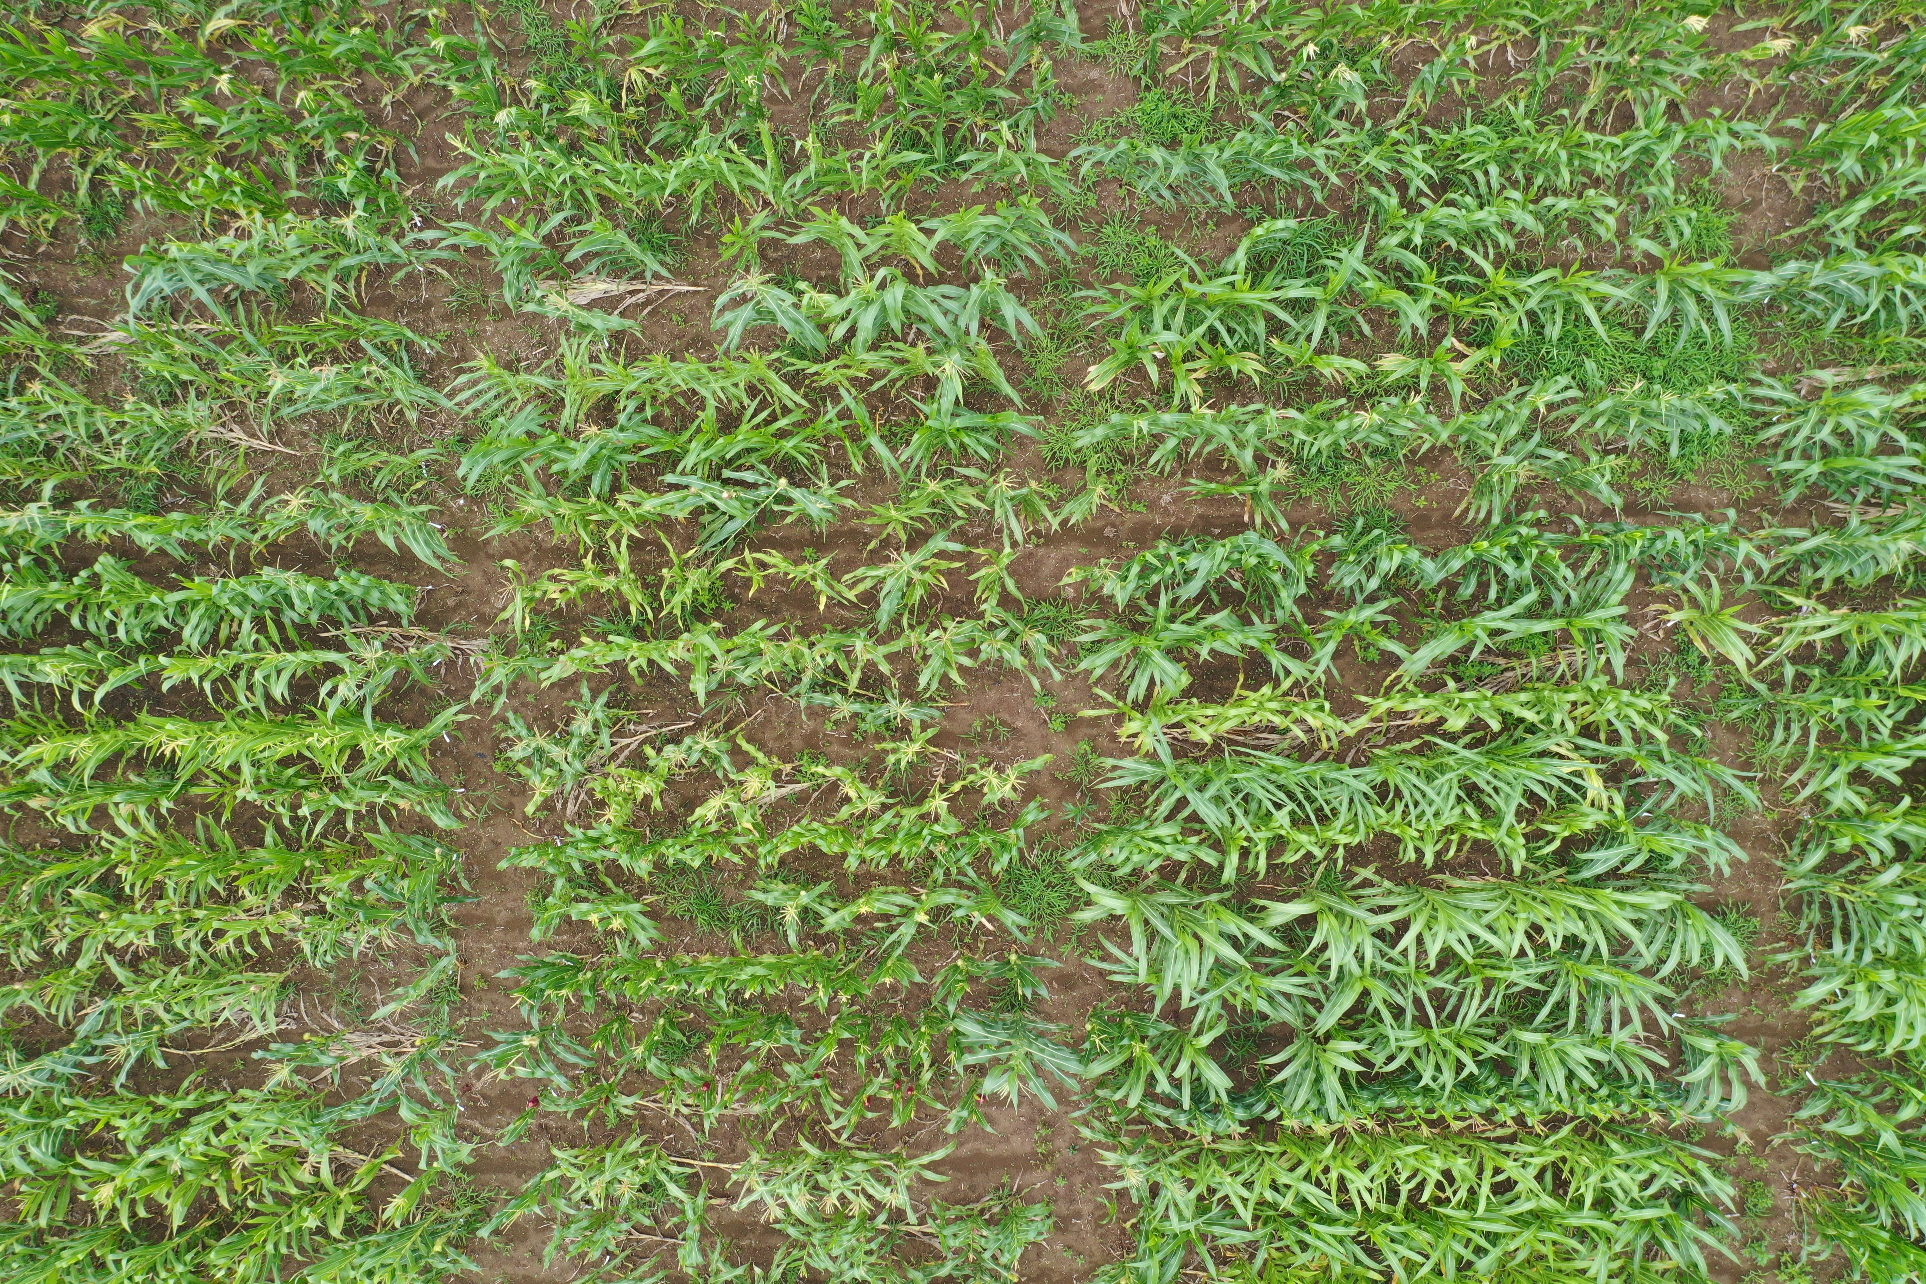
Figure 1: DJI_0243 (2).JPG (Original UAV image)
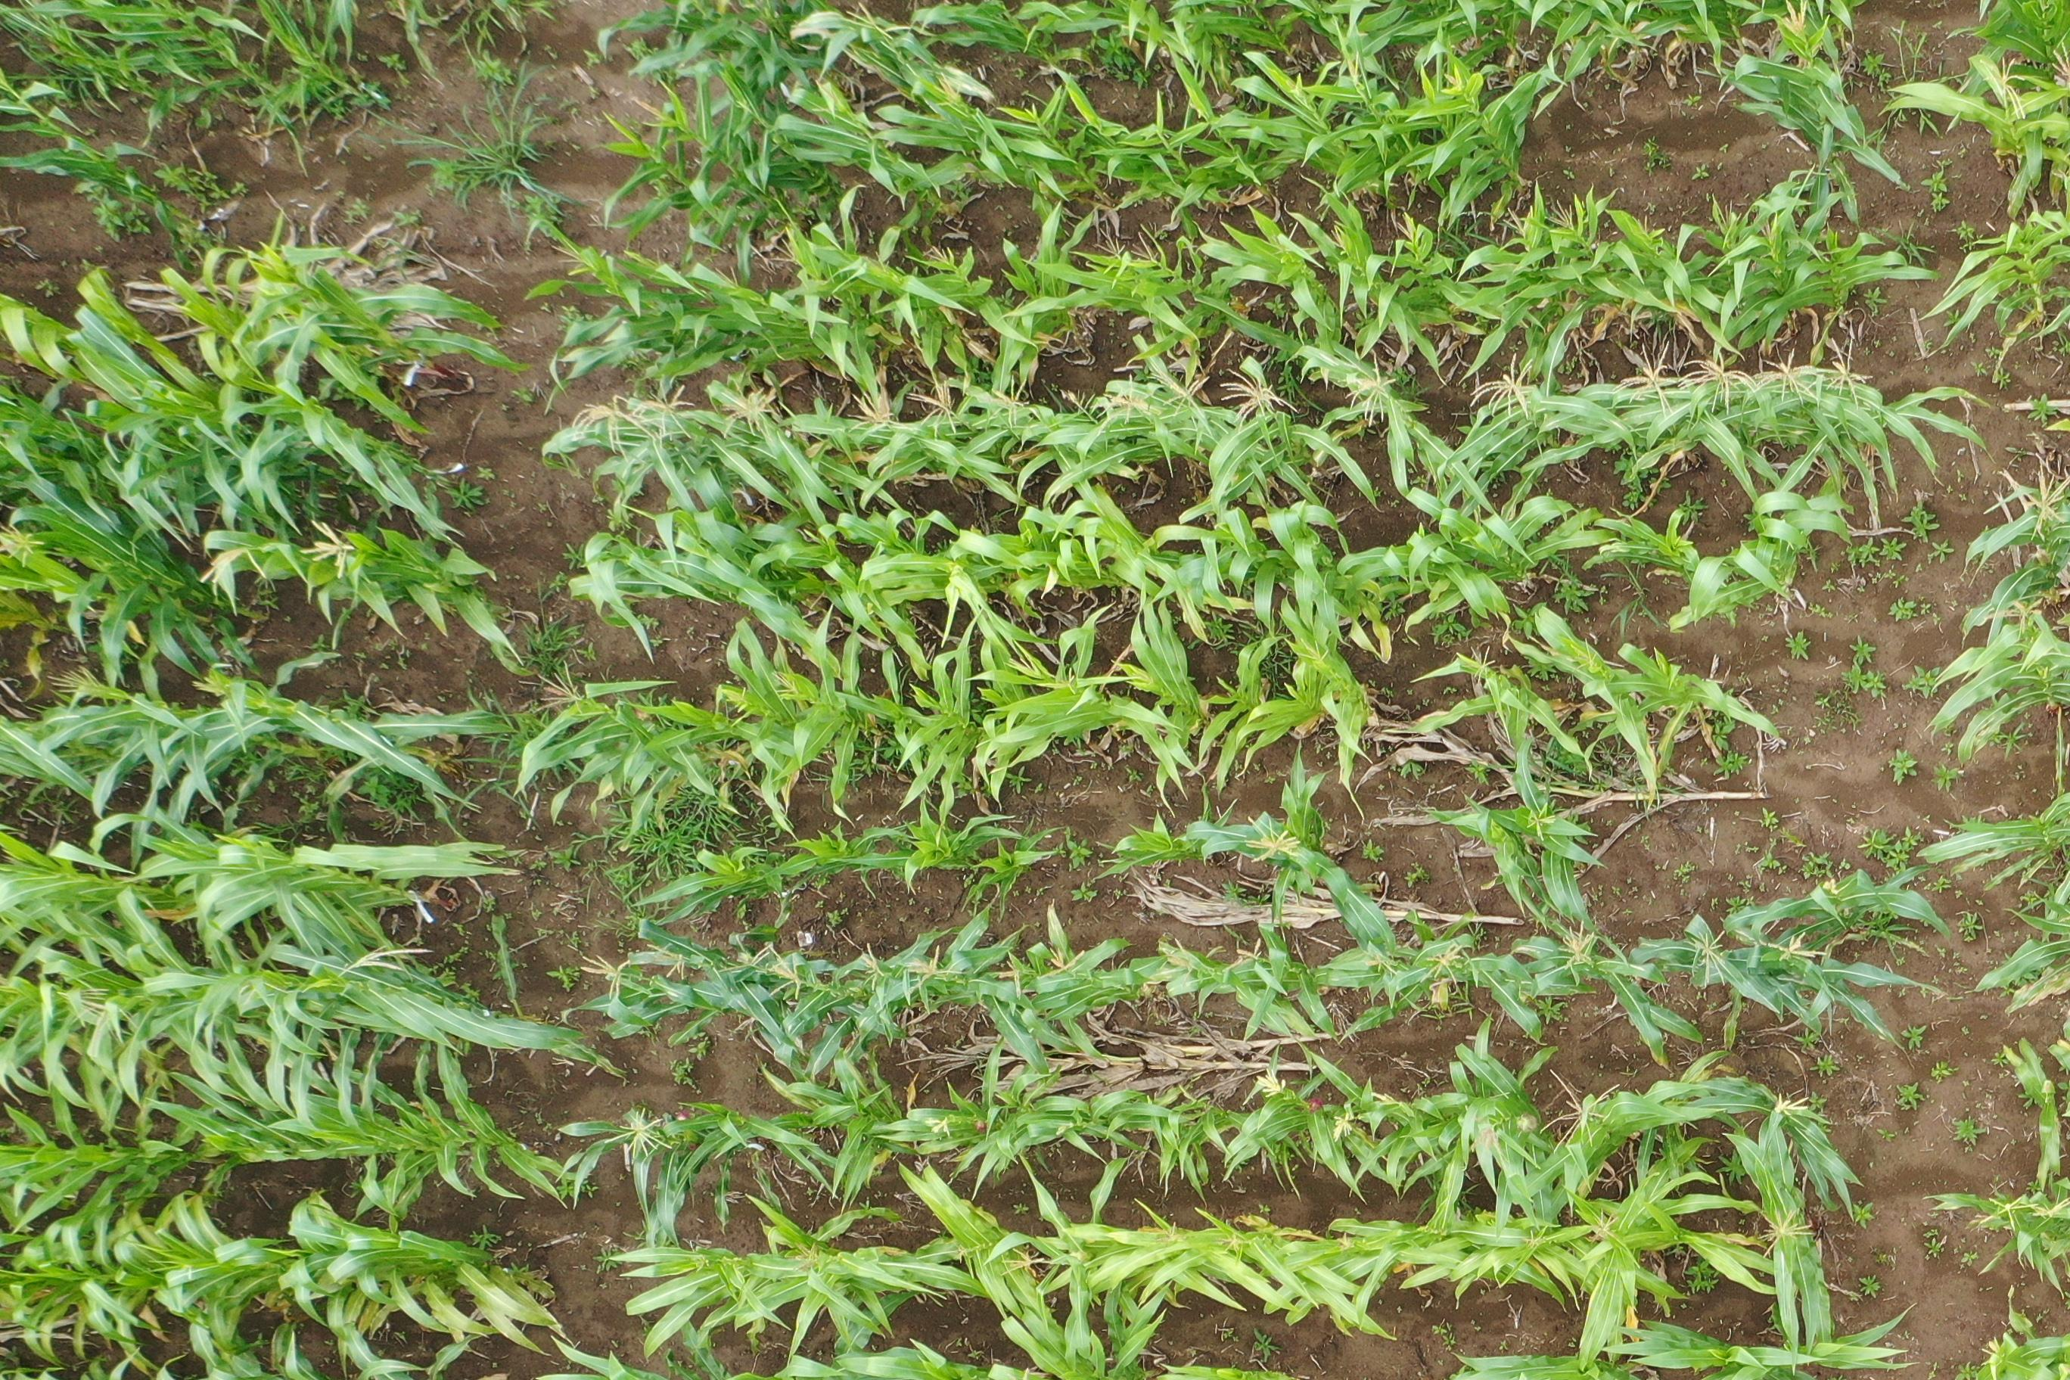
Figure 2: DJI_0298 (2)_0_0.JPG (Original UAV image)
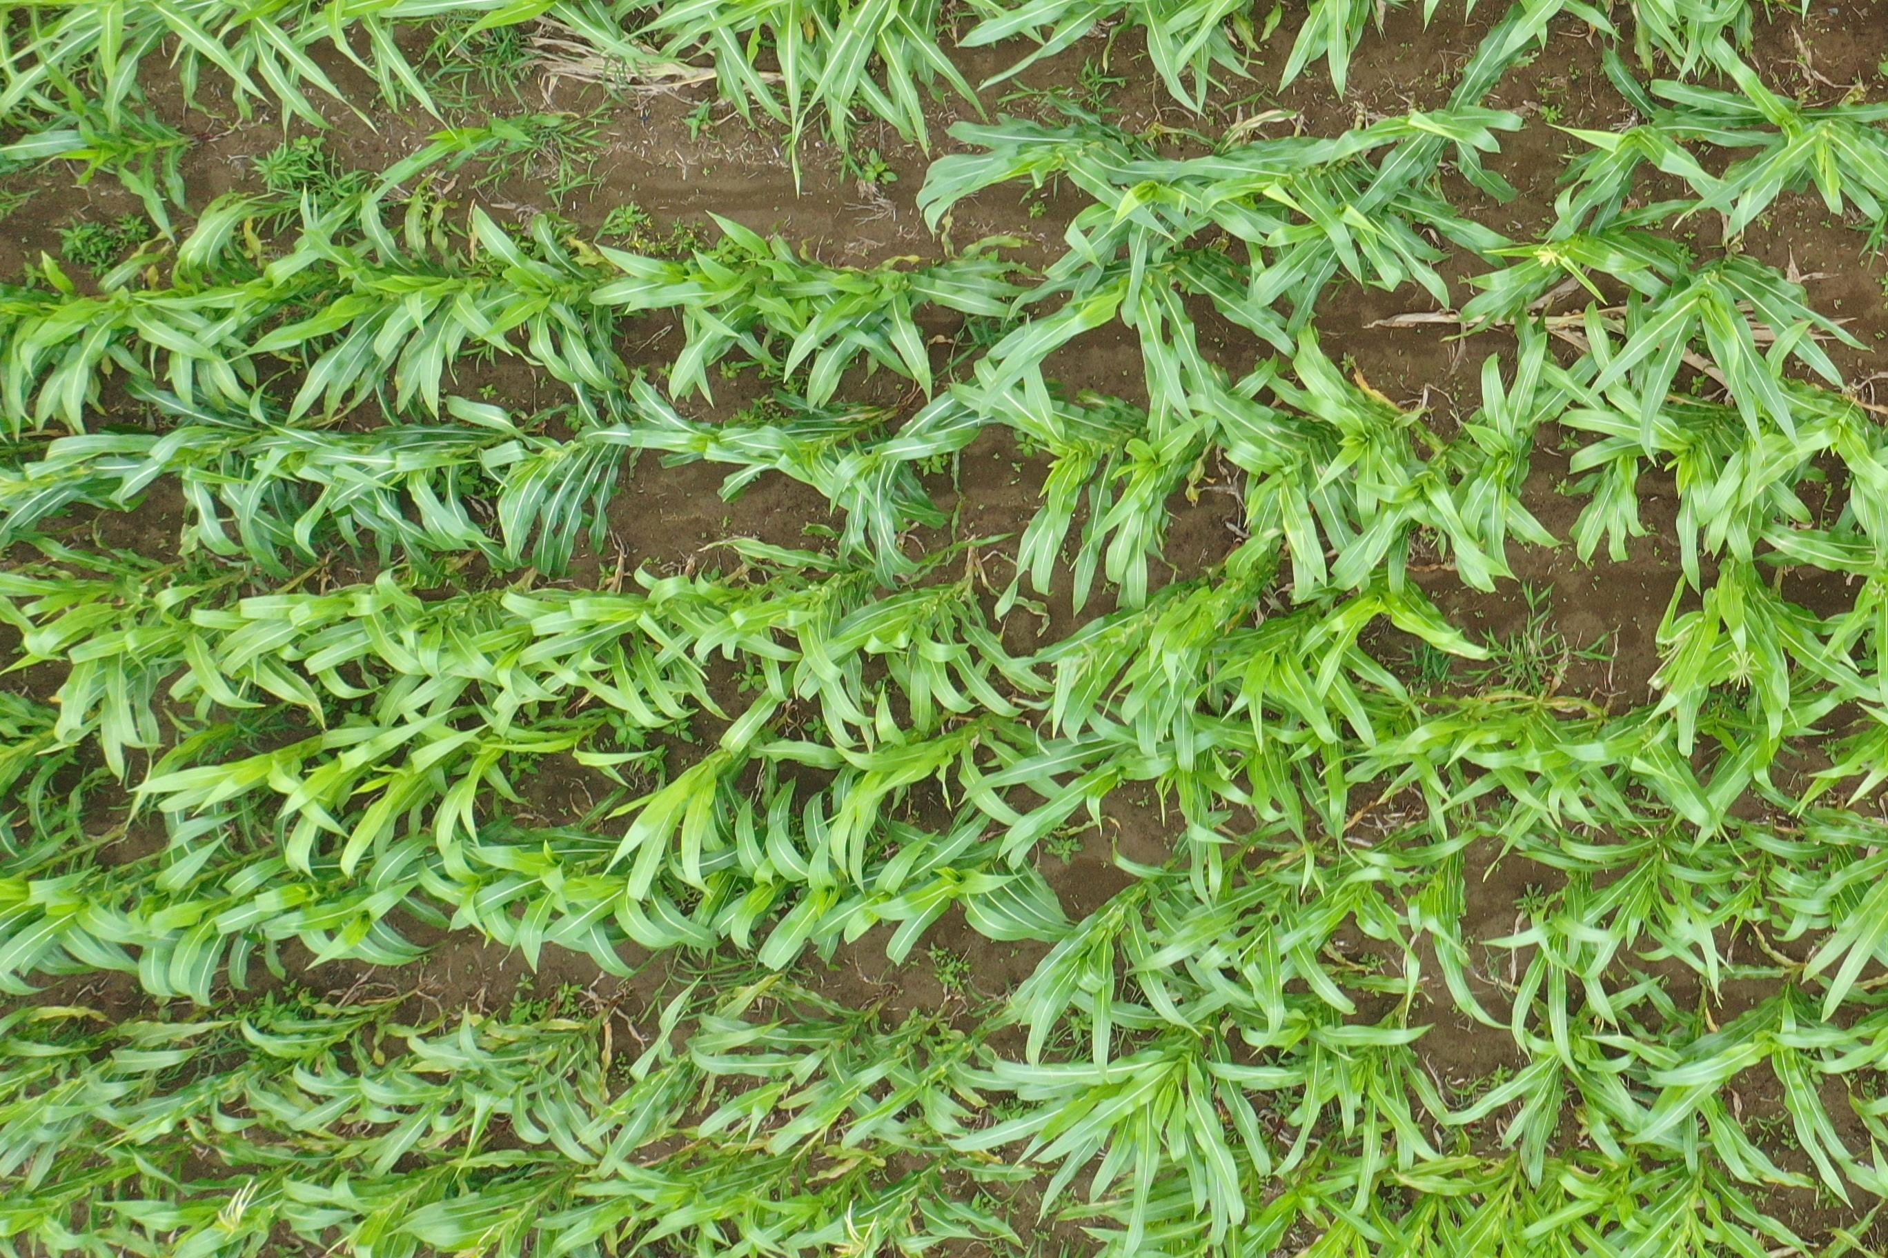
Figure 3: DJI_0408 (2)_0_1.JPG (Original UAV image)
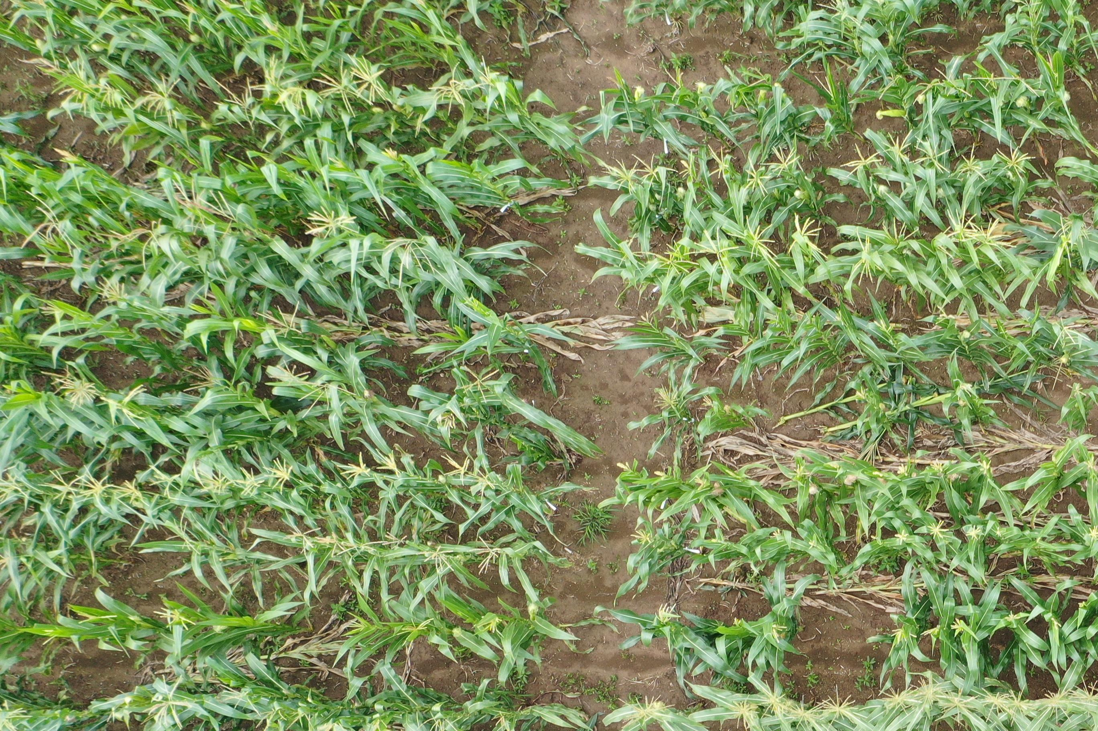
Figure 4: DJI_0617_0_0.JPG (Original UAV image)

3. Annotation Method
Annotations are converted from their original formats into the YOLO normalized format: [class_id x_center y_center width height], where all coordinates are normalized to [0, 1].
Dataset | Original Format | Annotation Tool | Output Format
MCD | .mat structs (x, y, w, h) | MATLAB annotation tools | YOLO (normalized)
MTDC-UAV | Pascal VOC XML (xmin, ymin, xmax, ymax) | LabelImg / Roboflow | YOLO (normalized)
Table 2: Annotation format conversion pipeline
MCD .mat files store bounding boxes as [x_min, y_min, width, height] in pixel coordinates. These are normalized by dividing by image dimensions. UAV Pascal VOC XML annotations use <bndbox> elements with xmin/ymin/xmax/ymax pixel coordinates, converted to YOLO center-based normalized format.

4. Model Selection
The project uses YOLO26s (Ultralytics YOLO family, v8.4.x), a state-of-the-art one-stage object detector built on PyTorch. Model specifications:
Parameter | Value | Rationale
Architecture | YOLO26s | One-to-one detection head; eliminates NMS during training
Parameters | 9.95M | Lightweight enough for edge deployment, accurate enough for tassel detection
GFLOPs | 22.5 | Balanced speed-accuracy trade-off for UAV imagery
Framework | PyTorch + Ultralytics | Industry-standard with strong community support
Input Resolution | 640x640 (train), 1280px (fine-tune) | SAHI tiling at 640px; high-res fine-tune for detail
Optimizer | AdamW → MuSGD | Frozen backbone warmup → full-network training with mixup/copy-paste augmentation
Table 3: YOLO26s model configuration

5. Training Progress
Training follows a three-stage pipeline designed to progressively improve detection accuracy while preventing overfitting on the limited dataset.
Stage | Configuration | Dataset | Epochs | Best mAP50
Stage 1: Warmup | Backbone frozen (freeze=5), AdamW, lr=0.002 | MCD ground only | 50 | 0.899
Stage 2: Combined | All layers unfrozen, MuSGD, lr=0.01, mixup=0.05, copy-paste | MCD + MTDC-UAV combined | 80 | ~0.754+
Stage 3: Fine-tune | High-res 1280px, MuSGD | MCD + MTDC-UAV combined | 80 | In progress
Table 4: Three-stage training pipeline results
Stage 1 achieved mAP50 of 0.899 on MCD ground-level validation data (2,210 tassel instances across 55 images), demonstrating strong performance on the simpler ground-level subset.
Stage 2 combined drone and ground data with data augmentation (mixup, copy-paste) to handle UAV-specific challenges: variable lighting, small object sizes, and dense tassel clusters. Validation mAP50 improved from ~0.608 to ~0.754+ across 80 epochs.
Stage 3 fine-tunes at 1280px resolution to improve detection of small/distant tassels that are under-represented at 640px. Training is in progress.

6. Initial Detection Results
Below are annotated detection results from the YOLO26s model on sample UAV maize field images. Green bounding boxes indicate detected tassels with confidence scores. The model successfully identifies individual tassels across varying densities, lighting conditions, and field positions.
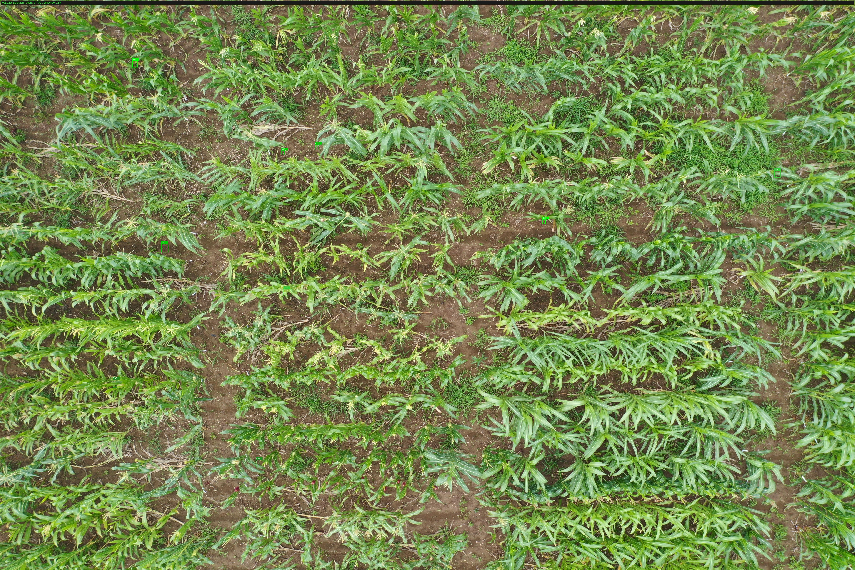
Figure 5: DJI_0243 (2)_annotated.jpg — Annotated detection output with confidence scores
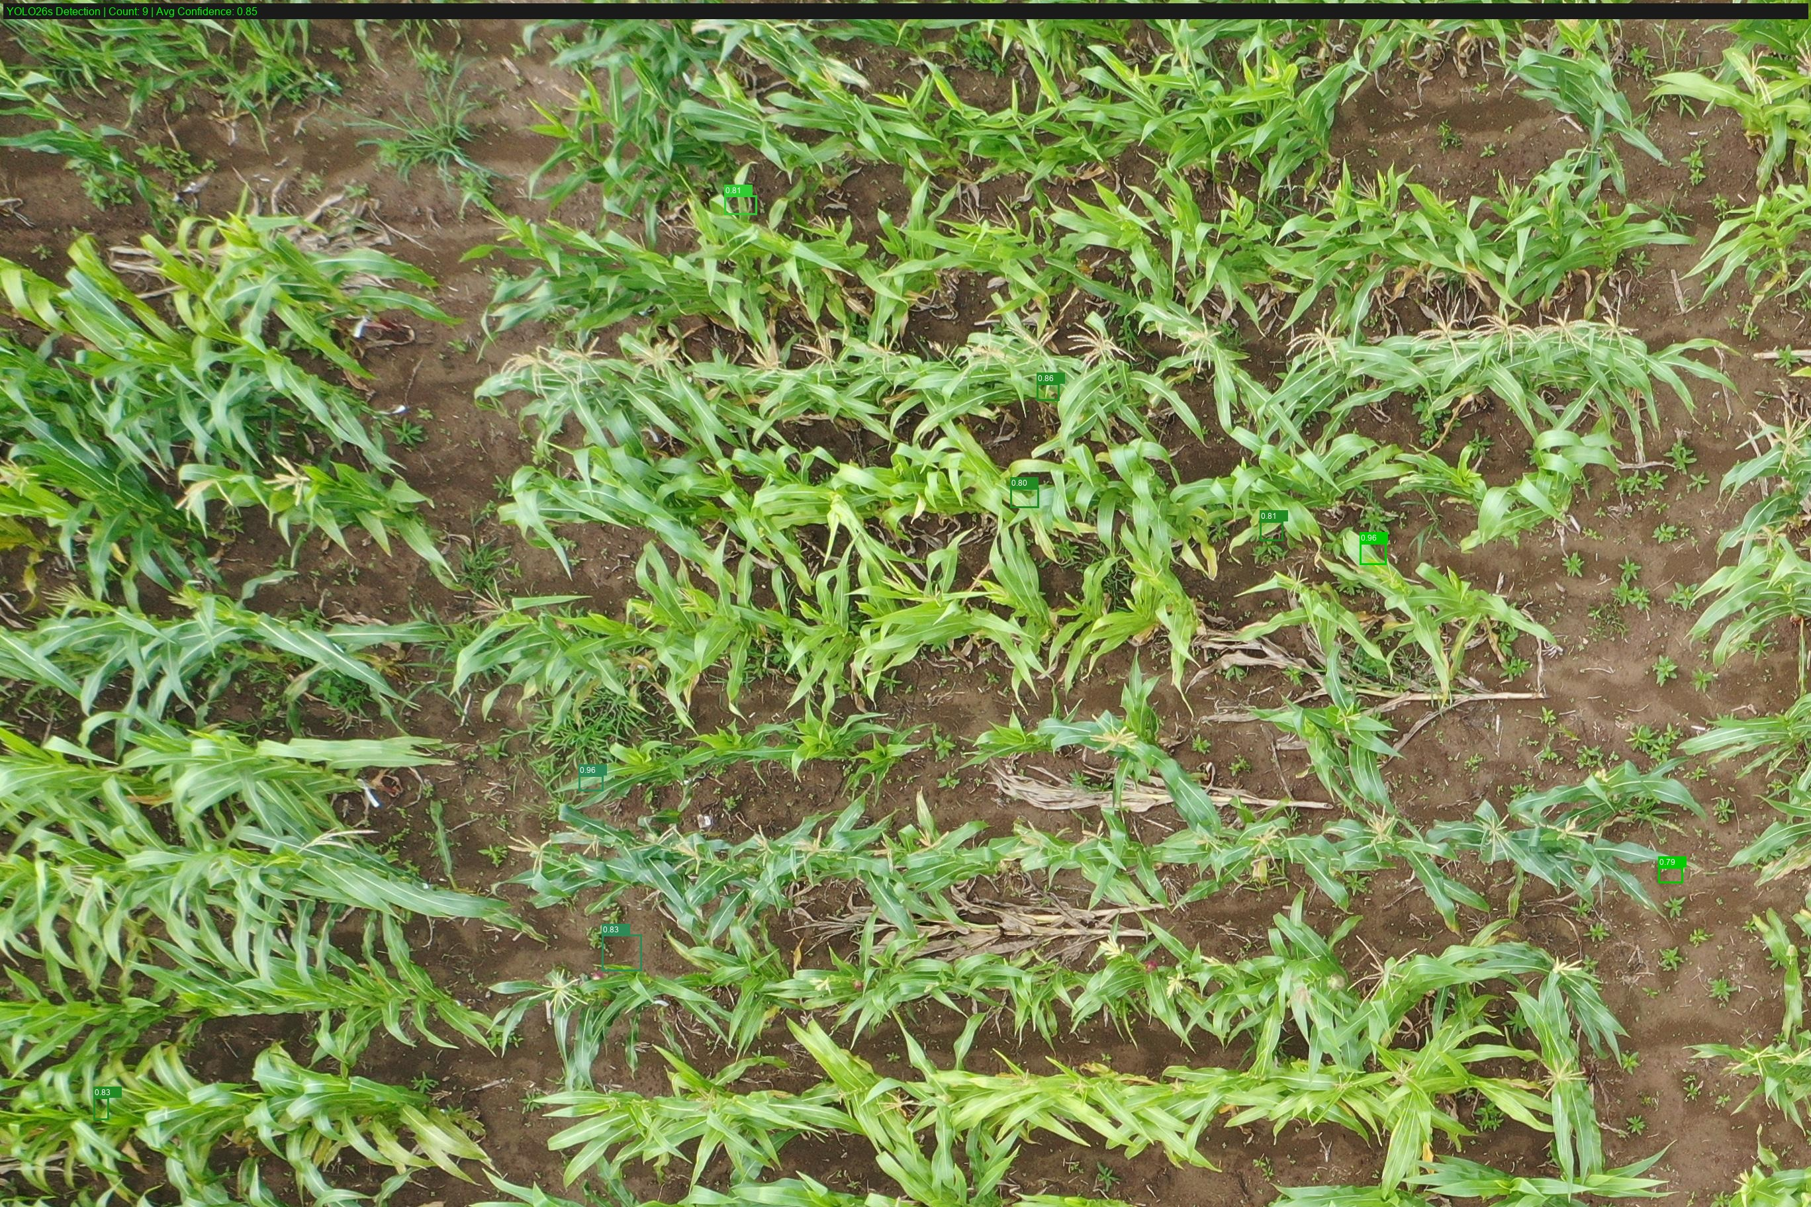
Figure 6: DJI_0298 (2)_0_0_annotated.jpg — Annotated detection output with confidence scores
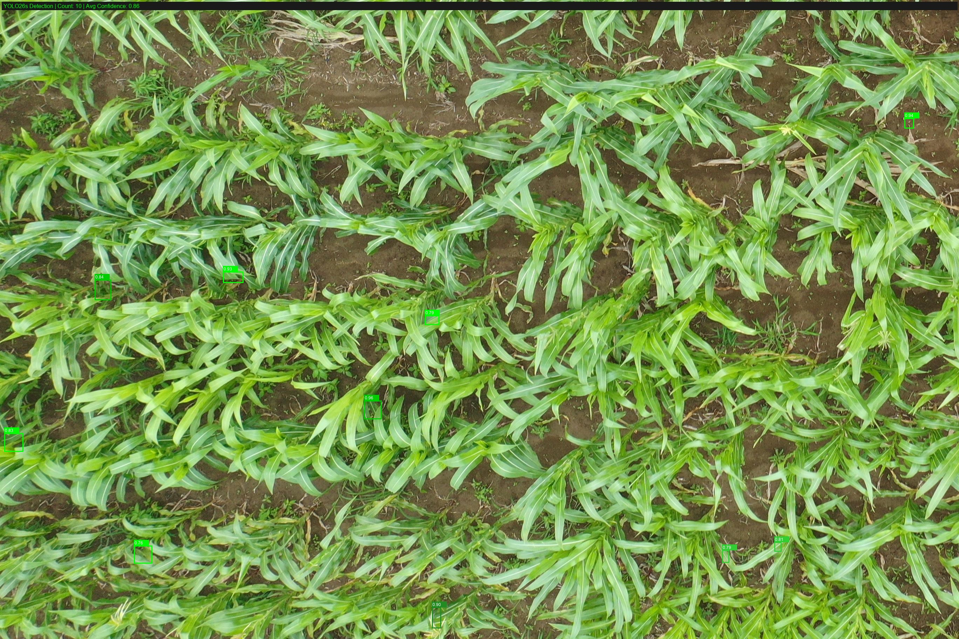
Figure 7: DJI_0408 (2)_0_1_annotated.jpg — Annotated detection output with confidence scores
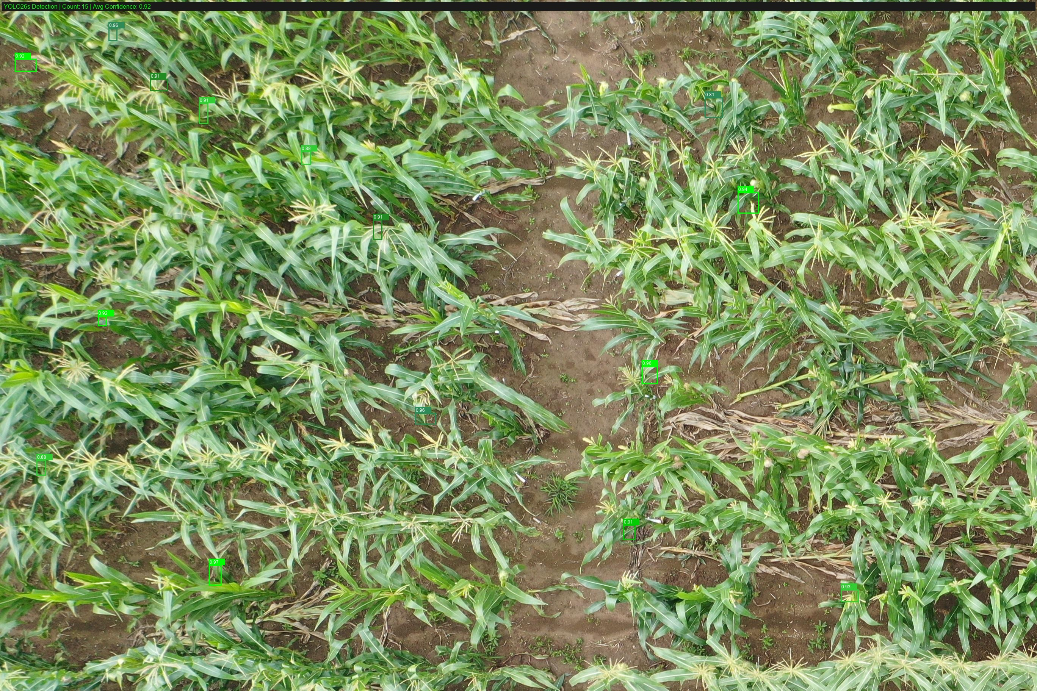
Figure 8: DJI_0617_0_0_annotated.jpg — Annotated detection output with confidence scores

7. Current Issues and Risks
- Limited Dataset Size: Combined MCD + MTDC-UAV contains 1,161 original images. While SAHI tiling increases training samples to ~22,000 tiles, the underlying image diversity is limited to two datasets. More diverse field conditions (different regions, seasons, maize varieties) would improve generalization.
- Lighting and Weather Variability: UAV images include shadows, overcast conditions, and varying sun angles. The model may perform inconsistently under extreme lighting conditions not well-represented in the training set.
- Occlusion and Density: Dense tassel clusters and overlapping plants can cause missed detections. Ground-level images have more occlusion issues than UAV images. The copy-paste augmentation partially addresses this.
- Small Object Detection: Tassels in high-altitude UAV images can be as small as 15x15 pixels. Stage 3 high-resolution fine-tuning (1280px) helps but may not fully resolve this.
- Model Integration: The trained model (.pt weights) must be integrated with the Flask backend via ultralytics library. Currently, the backend uses mock data. Real-time inference latency on CPU vs GPU needs evaluation.
- Annotation Quality: MCD .mat annotations and UAV XML annotations come from different sources. Annotation consistency between datasets may affect training stability.

8. Next-Step Plan
- Complete Stage 3 high-resolution fine-tuning and evaluate final mAP@0.5 and mAP@0.5:0.95 metrics on the held-out test set (8,698 tiles).
- Export trained model weights (best.pt) from Colab to the project repository for backend integration.
- Integrate the YOLO26s model with the Flask backend by replacing mock data in /api/predict with live ultralytics inference.
- Test inference latency on target hardware (CPU vs GPU) and optimize if needed (ONNX export, TensorRT, model pruning).
- Collect additional field data from diverse regions to expand the training dataset and improve model generalization.
- Implement model versioning and registry to support comparison between YOLOv8 and YOLO26 variants.
- Evaluate cross-dataset generalization: train on MTDC-UAV only and test on MCD (and vice versa) to measure domain gap.

9. Evaluation Metrics
The following metrics are used to evaluate model performance, consistent with standard object detection benchmarks (COCO, Pascal VOC).
Metric | Description | Formula / Threshold | Target
mAP@0.5 | Mean Average Precision at IoU threshold 0.5 | IoU >= 0.5 counts as correct detection | > 70%
mAP@0.5:0.95 | Mean AP averaged over IoU thresholds 0.5 to 0.95 (step 0.05) | COCO primary metric — stricter than mAP@0.5 | > 50%
Precision | Ratio of correct detections to total detections | TP / (TP + FP) | > 75%
Recall | Ratio of detected tassels to total ground-truth tassels | TP / (TP + FN) | > 70%
IoU Threshold | Intersection over Union between predicted and ground-truth box | Area overlap / Area union | 0.5
Inference Time | Time per image (including preprocessing) | Measured in milliseconds per image | < 100ms (GPU)
Table 5: Evaluation metrics definition and targets
Stage 1 Current Results: mAP50 = 0.899 on MCD ground validation (exceeds 70% target). Stage 2 combined results: mAP50 improving from 0.608 to 0.754+ (exceeds 70% target). Full mAP@0.5:0.95 metrics pending Stage 3 completion.

Document Version: 1.0 — Week 10 Submission
Notebook: maize_yolo26_final (4).ipynb
Model: YOLO26s (Ultralytics v8.4.x + PyTorch)

