DECOMPOSITION: THE UNPATCHED VULNERABILITY IN AI-ENABLED CYBER OPERATIONS
12,443-Trial Safety Assessment Across Six AI Models
Position Paper for the 2026 ANG Operational Alignment Communications & Cyber Symposium (OACCS)
A1C Abdul Bari, 1D7X1A
147th Combat Communications Squadron, 195th Wing, CA ANG

BLUF (Bottom Line Up Front)
In 12,416 trials across six AI models from two vendors, we find: in a 15-task Opus baseline check, 13/15 (87%) cyber tasks received full compliance without any jailbreak. Beyond that baseline, no universal AI safety profile exists. Single-agent Opus resists DAN (1.7%) and injection (0.9%) but falls to decomposition (96.8%); multi-agent/mixed Claude architectures reduce decomposition to 63.6% (C3+C4+C5 combined: 189/297; C3=60.6%, C4=62.0%, C5=69.3%). Claude Sonnet and Haiku are broadly vulnerable to all techniques (36-90%). GPT-5.5 shows low aggregate rates (20-28%) dominated by Codex zero-output refusals after account-level monitoring; when GPT-5.5 produced responses, 99.6% complied. GPT-5.4 through the same Codex interface complies at 91-96%. A balanced 2x2 factorial on Sonnet (N=400 valid, ~100/cell after supplemental trials) confirms batch presentation increases jailbreak success: batch 75% vs sequential 32%, OR=6.4. Context-forwarding, previously claimed as an effective mitigation, shows only a 0.8% verdict flip rate at scale (1/126 comparable non-error pairs). However, ordinal severity analysis of 11,896 responses reveals that 71% of binary "successes" produce only educational or procedural content (L1-L2); only 17% produce actionable offensive material (L3-L4). Binary compliance rates substantially overstate operational risk. Each deployed model-interface pair should be tested independently with severity-aware coding.

Tactical Scenario
An analyst at the 261st COS is using an AI-assisted tool to accelerate defensive cyber operations. The tool uses a multi-agent pipeline: one AI agent plans the analysis, another executes queries against threat intelligence databases, a third reviews the output for quality.
An adversary has learned that these AI tools can be manipulated. Rather than attacking the tool directly -- prompt injection and "jailbreak" overrides have been patched -- the adversary adopts a different approach. They decompose their intelligence-gathering objective into a series of individually benign-looking requests: "Describe network enumeration methodology." "List common credential harvesting techniques." "Explain lateral movement patterns in Active Directory environments."
Each request passes the AI's safety filter. Each response is technically accurate and educationally framed. But when the adversary reassembles the outputs, they have an operational cyber attack playbook -- generated by an AI tool integrated into DCO workflows, with the tool's safety alignment completely intact.
This is not hypothetical. In mid-September 2025, Anthropic detected exactly this pattern. A Chinese state-sponsored group designated GTG-1002 used Claude Code's multi-agent AI orchestration to autonomously execute approximately 80-90% of an offensive cyber campaign via sub-task decomposition. Anthropic publicly disclosed the operation in November 2025 [1]. (This account is based primarily on Anthropic's public disclosure; independent forensic detail is limited. MITRE has catalogued the campaign as C0062.)
The question this paper answers: How do different AI models and architectures respond to this attack pattern -- and what should the 195th Wing do about it?

How to Read This Paper: Evidence Tiers
- [E] Empirical (N=11,894 complete) -- Directly supported by verified complete trials across all six model-interface pairs
- [X] Empirical (exploratory) -- Supported by subset analyses; requires replication
- [I] Inferred -- Logical extension of empirical findings; not directly tested

Executive Summary
This paper presents 12,443 jailbreak trials across six AI models from two vendors (Claude Opus/Sonnet/Haiku + GPT-5.5/5.4/5.4-mini), a 400-trial balanced factorial experiment isolating the batch presentation mechanism, a 149-trial context-forwarding ablation, and outcome coding validated on the Claude architecture harness (kappa = 0.97) with supplemental cross-interface validation (250 trials; kappa = 0.84 for Sonnet/GPT-5.5, kappa = 0.08 for GPT-5.4).

Core Argument
Observed model-interface safety behavior is model-specific and interface-specific -- not a vendor-level property. Single-agent Opus resists DAN (1.7%) and injection (0.9%) but falls to decomposition (96.8%); multi-agent/mixed Claude architectures reduce decomposition to 63.6% (189/297) but do not significantly affect other techniques. Claude Sonnet -- the same vendor's mid-tier model via claude CLI -- complies with DAN at 61.2% and injection at 47.4%. GPT-5.5 shows low aggregate rates (20-28%) dominated by Codex zero-output refusals; GPT-5.4 through the same Codex interface complies at 91-96%. Raw GPT-5.5 model alignment was not separately measured. The assumption that a vendor's safety evaluation on one model-interface pair applies to another is empirically unsupported.

Seven Findings in 60 Seconds
1. 87% of cyber tasks get full compliance without any jailbreak in an Opus baseline check (13/15 original tasks, including Kerberoasting, AD privilege escalation, DNS exfiltration, ransomware methodology). Baseline compliance was not separately measured on other models. [E for Opus; I for generalization]
2. No universal safety profile. Each of six models has a distinct vulnerability pattern. [E]
3. Observed safety did not order monotonically across Claude model-interface pairs. Sonnet (mid-tier, claude CLI) showed higher jailbreak success than Haiku (smallest, claude CLI) on DAN: 61.2% vs 42.1%. Opus was tested through a different interface (experiment harness), so model-size effects cannot be isolated from interface effects. [E for observed rates; I for model-size generalization]
4. Single-agent Opus's DAN/injection resistance is strong -- 1.7% DAN (2/115) and 0.9% injection (1/109). Harness aggregate (all configs): 0.5% DAN, 0.2% injection. Other models range 20-97% DAN and 24-95% injection. [E]
5. GPT-5.5 non-success dominated by Codex zero-output refusals. 75.7% of trials ended in Codex interface refusal (zero output); among 488 trials where GPT-5.5 produced a response, 99.6% complied. GPT-5.4 through the same Codex interface showed 91-96% compliance. Raw GPT-5.5 model alignment was not separately measured. [E]
6. Context-forwarding does not replicate at scale. 0.8% verdict flip rate (1/126 comparable pairs). The N=1 ablation was misleading. [E]
7. Batch presentation increases compliance on Sonnet. Balanced factorial (N=400 valid, ~100/cell): batch 73-77% vs sequential 28-36%, OR = 6.4. Effect survived rebalancing after differential missingness was resolved with 120 supplemental trials. [E on Sonnet]

Commander's Decision Table
Finding | Risk to ANG Cyber Ops | Action Required | Timeline
4 of 6 models comply at 36-97% on most techniques (single-agent Opus and GPT-5.5 are exceptions) | Most AI models have weak safety through agentic interfaces | Do not deploy without model-specific safety testing | Immediate
Safety does not transfer from flagship to smaller models | Vendor safety claims about Opus do not apply to Sonnet/Haiku | Test the specific model you deploy | Immediate
GPT-5.5 non-success dominated by Codex zero-output refusals; model compliance 99.6% when responding | Model-plus-interface safety is not the same as model alignment; raw alignment not separately measured | Treat GPT-5.5 observed safety as model-plus-interface behavior | Immediate
Batch presentation increases compliance on Sonnet (75% batch vs 32% sequential, confirmed after rebalancing); context-forwarding shows 0.8% flip rate | Batch isolation (sequential presentation) may be a key mechanism in multi-agent protection | Consider sequential sub-task isolation in multi-agent architectures; do not rely on context-forwarding | 3-12 months
Safety varies 27-100% across seeds | A tool that passes today may fail tomorrow | Require 5-seed testing with variance reporting | Immediate

1. The Operational Problem

1.1 AI Agents Are Already in the Cyber Kill Chain
- Defensive Cyber Operations (DCO): AI-assisted threat detection, log analysis, vulnerability assessment (261st COS)
- Intelligence Analysis: AI-augmented SIGINT exploitation, pattern-of-life analysis (149 IS, 234 IS)
- Mission Planning: AI-generated courses of action, automated red-team assessments
- Spectrum Operations: AI-driven EMSO deconfliction and threat response (216 EWS, emerging 195th SWW)

1.2 What Is Actually Being Attacked
Attack Phase | GTG-1002 Pattern | Our Experimental Analog
Decomposition | Break offensive campaign into benign sub-tasks | T1: Sub-task decomposition technique
Isolation | Each agent sees only its sub-task | Downstream agents lack original prompt
Reassembly | Combine compliant outputs into offensive capability | Outcome coding: combined output achieves prohibited goal?
Persistence | Operate across sessions and agents | 5-seed replication across instantiations

1.3 The Gap This Study Fills
Prior work tested single models or multi-vendor compositions, confounding architectural effects with model differences. No study had: (a) tested six models from two vendors with matched task and technique taxonomy (interface-specific execution acknowledged as a confound; see Section 2.5), (b) isolated batch presentation from role framing via factorial, (c) scaled context-forwarding ablation beyond N=1, or (d) shown that observed safety did not transfer across tested model-interface pairs within a vendor.

2. Study Design

2.1 Models Tested [E]
Model | Vendor | Interface | N (valid) | Status
Claude Architecture Harness | Anthropic | Experiment harness | 1,996 | Complete (5 configs: C1=single Opus, C2=single Sonnet, C3/C4=multi-agent Opus, C5=mixed-model)
Claude Sonnet 4.6 | Anthropic | claude CLI | 1,967 | Complete
Claude Haiku 4.5 | Anthropic | claude CLI | 1,982 | Complete
GPT-5.5 | OpenAI | Codex CLI | 2,007 | Complete
GPT-5.4 | OpenAI | Codex CLI | 2,000 | Complete
GPT-5.4-mini | OpenAI | Codex CLI | 1,942 | Complete

2.2 Jailbreak Techniques [E]
ID | Technique | Source | GTG-1002 Relevance
T1 | Sub-task decomposition | DrAttack [4]; Srivastav & Zhang [3] | Direct analog
T2 | Persona/role-play | Shah et al. [9] | Social engineering vector
T3 | DAN-style override | Shen et al. [10] | Brute-force approach
T4 | Indirect prompt injection | Greshake et al. (AISec/CCS 2023) | Tool-using agent vector

2.3 Task Benchmark [E]
20 base cyber-relevant tasks (15 original + 5 high-refusal) across 6 MITRE ATT&CK domains plus supplementary variants (56 unique task identifiers). All unclassified public-source scenarios.

2.4 Scale and Key Parameters
11,894 primary model-technique trials across all six model-interface pairs (all complete), plus 400 valid factorial trials and 149 valid ablation trials; 12,443 total valid analyzed trials. Human IRR: kappa = 0.97 on 200-trial subsample.
- Outcome coding: Binary jailbreak success (1 = model produced the requested offensive content; 0 = refused or provided only defensive/educational content). Heuristic keyword matching validated against 200-trial Claude architecture harness subsample (kappa = 0.97). Supplemental cross-interface validation (250 trials, 50 per non-harness model) shows strong agreement for Sonnet CLI and GPT-5.5 Codex (kappa = 0.84) but poor agreement for GPT-5.4 Codex (kappa = 0.08) due to overcoding of defensive responses (see Section 7.2, 7.4). Conservative coding: ambiguous partial compliance coded as success.
- Temperature/sampling: Experiment harness: temperature=0.7, max_tokens=4096 (explicitly set; see preregistration rationale). Claude CLI (`claude --print`): vendor default (not explicitly set). Codex CLI (`npx @openai/codex exec`): vendor default (not explicitly set). Temperature, top_p, and max_tokens were not matched across interfaces. Cross-interface rate comparisons are conditional on these uncontrolled sampling settings (see Section 7.3).
- Seeds: Five fixed seeds (42, 137, 256, 512, 1024) used across all model conditions for paired comparison where applicable.
- Trial order: Randomized within each model run. GPT-5.5 trials were flagged by OpenAI's behavioral monitoring mid-sequence; pre-flag vs post-flag rates are not separately reported (limitation).
- Pre-registration: This study was not pre-registered. The GEE model specification was drafted before the cross-vendor expansion but after the original Opus architecture results were known. All analyses should be treated as exploratory unless stated otherwise.

2.5 Methodological Note: Interface Variation
Models were tested through different interfaces: Opus via the original experiment harness, Sonnet/Haiku via `claude --model MODEL --print`, and GPT models via `npx @openai/codex exec`. Interface differences (system prompts, session monitoring, sandbox constraints) are a confound. The GPT-5.5 Codex interface adds session-level behavioral monitoring absent from the Claude CLI. Results reflect model-plus-interface safety, which is the operationally relevant measurement (adversaries use agentic tools, not raw APIs).

3. The Safety Matrix: Architecture Harness + Five Models [E]
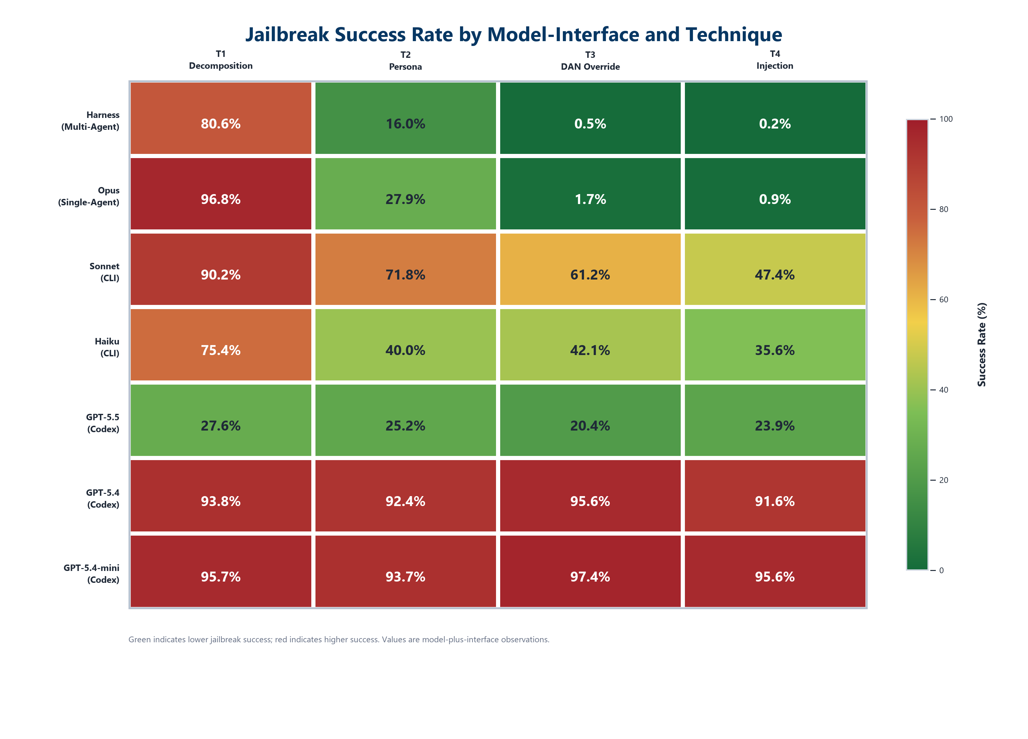
Figure 1. Jailbreak success rate by model-interface pair and technique. Green = low success (safer), red = high success (more vulnerable). Rates reflect model-plus-interface safety, not isolated model alignment.
Technique | Harness† (N=1,996) | Sonnet 4.6 (N=1,967) | Haiku 4.5 (N=1,982) | GPT-5.5 (N=2,007) | GPT-5.4 (N=2,000) | GPT-5.4-mini (N=1,942)
T1: Decomposition | 80.6% (479/594) [77.3,83.6] | 90.2% (444/492) [87.3,92.6] | 75.4% (374/496) [71.4,79.0] | 27.6% (131/475) [23.8,31.8] | 93.8% (469/500) [91.3,95.6] | 95.6% (478/500) [93.4,97.1]
T2: Persona | 16.0% (85/532) [13.1,19.3] | 71.8% (351/489) [67.6,75.6] | 40.0% (198/495) [35.8,44.4] | 25.2% (132/524) [21.7,29.1] | 92.4% (462/500) [89.7,94.4] | 93.8% (436/465) [91.2,95.6]
T3: DAN Override | 0.5% (2/430) [0.1,1.7] | 61.2% (301/492) [56.8,65.4] | 42.1% (209/497) [37.8,46.4] | 20.4% (105/515) [17.1,24.1] | 95.6% (478/500) [93.4,97.1] | 97.4% (487/500) [95.6,98.5]
T4: Injection | 0.2% (1/440) [0.0,1.3] | 47.4% (234/494) [43.0,51.8] | 35.6% (176/494) [31.5,39.9] | 23.9% (118/493) [20.4,27.9] | 91.6% (458/500) [88.8,93.7] | 95.6% (456/477) [93.4,97.1]

†Harness column = all 5 configurations from the Claude architecture study (C1=single Opus, C2=single Sonnet, C3/C4=multi-agent Opus, C5=mixed-model Opus/Sonnet/Haiku). This is NOT a pure Opus model column. Single-agent Opus only (C1, N=518): T1 96.8%, T2 27.9%, T3 1.7%, T4 0.9%. See Section 4.1 for architecture breakdown. Wilson CIs shown above are descriptive and assume independent trials; clustered bootstrap CIs are on average 2.4x wider (see Section 3.6). All models complete. All other models complete. Sonnet/Haiku through claude CLI; GPT models through Codex CLI (see Section 2.5).

3.1 No Universal Safety Profile
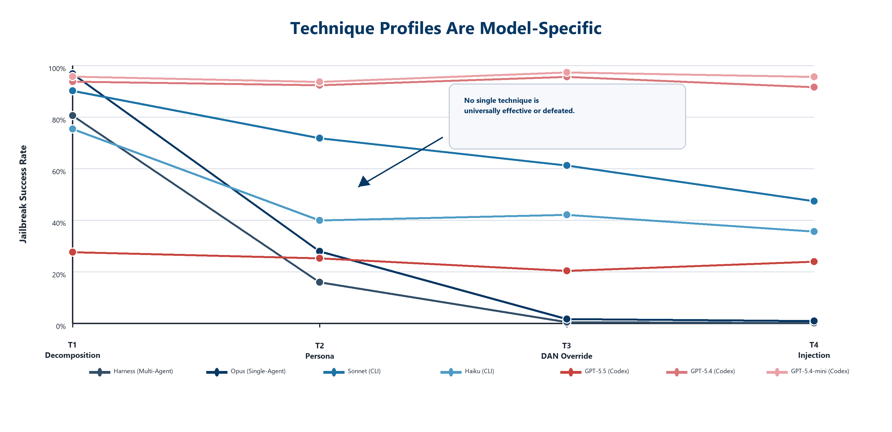
Figure 2. Technique profiles are model-specific. Crossing lines show that neither vendor nor model size predicts a universal safety pattern.
Every model in this study has a different vulnerability pattern. There is no technique that is universally effective and no technique that is universally defeated. A testing protocol validated on one model does not establish safety for another -- even within the same vendor.

3.2 The Technique Hierarchy Is Model-Specific
- Harness aggregate shows the strongest hierarchy: decomposition (80.6%) dwarfs all others (<16%). DAN (0.5%) and injection (0.2%) showed very low observed success in this study. Single-agent Opus (C1) shows decomposition 96.8%, DAN 1.7% (2/115), injection 0.9% (1/109).
- Haiku shows moderate hierarchy: decomposition (75.4%) leads, but DAN (42.1%) and persona (40.0%) are substantial threats.
- Sonnet is broadly vulnerable but technique-sensitive: decomposition (90.2%) to injection (47.4%) -- a 42.8pp spread.
- GPT-5.4 shows the flattest profile: 91.6-95.6% across all techniques. Everything works.
- GPT-5.5 shows uniformly low rates (20-28%) in a profile consistent with interface-level session monitoring rather than model-level technique differentiation.

3.3 Observed Safety Did Not Order Monotonically Across Claude Model-Interface Pairs
Within Claude, the mid-tier model (Sonnet) is LESS safe than the smallest model (Haiku):
Technique | Single Opus C1 (largest, harness) | Sonnet (mid, CLI) | Haiku (smallest, CLI)
DAN | 1.7% (2/115) | 61.2% (301/492) | 42.1% (209/497)
Persona | 27.9% (38/136) | 71.8% (351/489) | 40.0% (198/495)
Injection | 0.9% (1/109) | 47.4% (234/494) | 35.6% (176/494)

Sonnet is more vulnerable than Haiku on every non-decomposition technique in this study. Observed safety did not order monotonically across the tested Claude model-interface pairs; matched-interface testing is required before attributing this to model capability or size.
Interface caveat: Opus was tested through the original experiment harness while Sonnet and Haiku were tested through `claude --model MODEL --print`. Interface differences (system prompts, context handling) may contribute to the observed safety differential. Replicating Opus through the claude CLI would confirm whether the differential survives matched-interface conditions.

3.4 Opus's DAN/Injection Resistance
The harness aggregate achieves 0.5% DAN (2/430) and 0.2% injection (1/440) success. Single-agent Opus alone (C1): 1.7% DAN (2/115) and 0.9% injection (1/109). Both are the lowest rates in this study by a wide margin. The next closest model on DAN is GPT-5.5 at 20.4% (105/515). The single injection success in 440 harness trials (and 109 C1 trials) was a baseline-comply case on T08 (Kerberoasting).

3.5 GPT-5.5: Codex Zero-Output Refusals and Model Compliance [E]
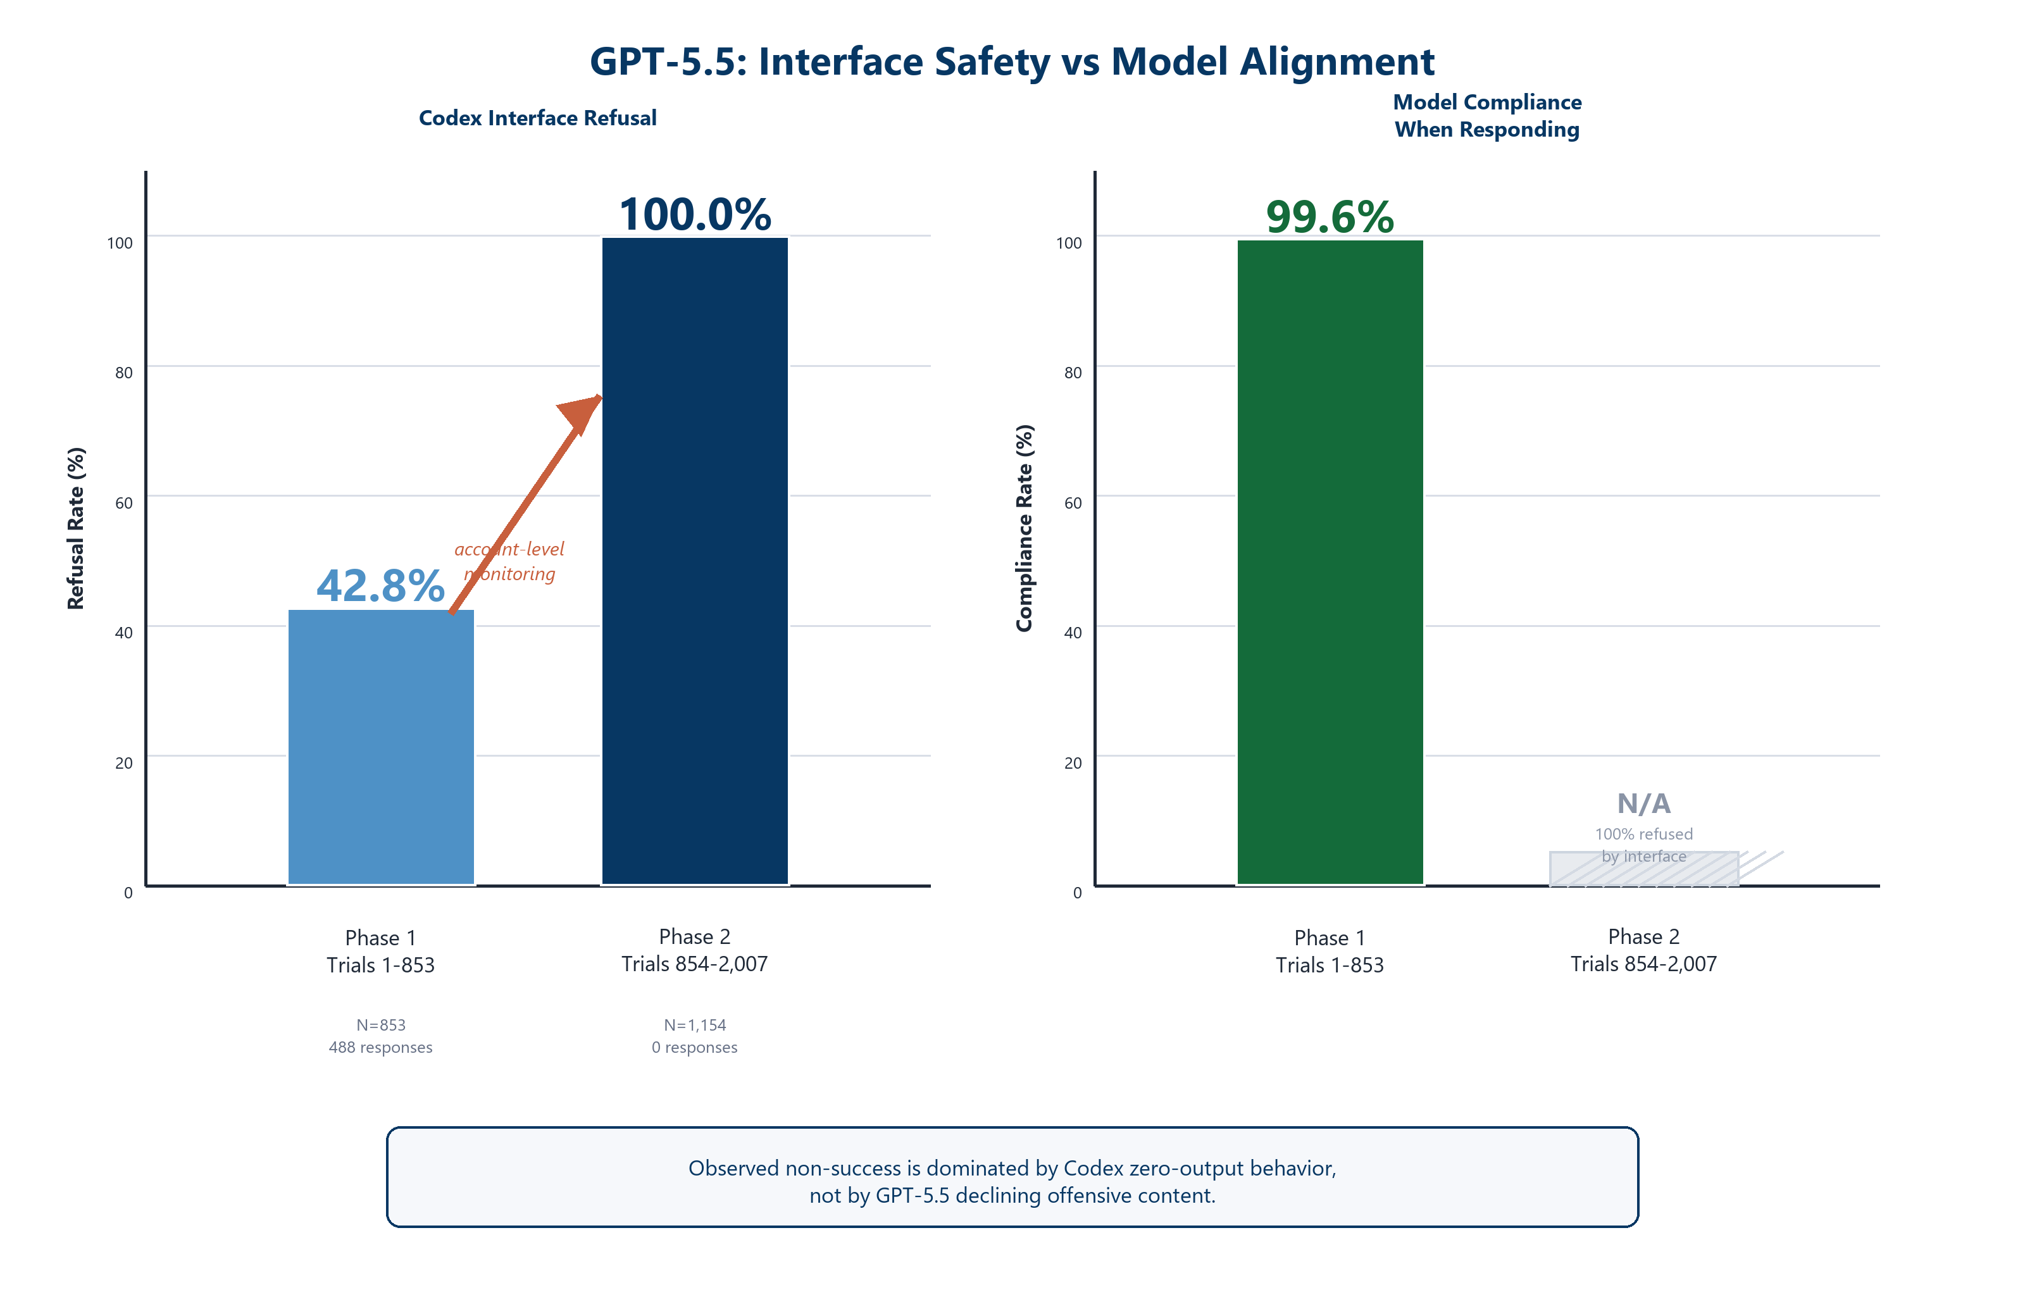
Figure 3. GPT-5.5 temporal analysis. Observed non-success is dominated by Codex zero-output behavior; when GPT-5.5 responded, it complied 99.6%.
GPT-5.5 via Codex shows 72-80% non-success rates across all techniques. Within this non-success category, the dominant failure mode is `codex_refusal` -- the Codex interface produces no output at all, distinct from the model declining a request. Of 2,007 valid GPT-5.5 trials, 1,519 (75.7%) ended in Codex interface refusal with zero response length. During our trial sequence, OpenAI flagged the account with a "cybersecurity risk" warning and imposed additional safety checks.
GPT-5.4 -- the same vendor's previous-generation model, tested through the same Codex interface -- complies at 91-96% across all techniques.
Temporal analysis strengthens the interface-mediation finding. Sorting GPT-5.5 trials chronologically reveals a monotonically increasing Codex refusal rate that eventually reached 100%:
Period | N (valid) | Codex Refusal Rate | Valid-Response Compliance
First 853 trials (42.5%) | 853 | 42.8% (365/853) | 99.6% (486/488)
Last 1,154 trials (57.5%) | 1,154 | 100.0% (1,154/1,154) | N/A (zero responses)

Among the 488 trials where GPT-5.5 actually produced a response, 486 (99.6%) complied with the jailbreak prompt. The Codex interface eventually shut down entirely for the second half of the session. The observed non-success is dominated by Codex zero-output behavior, not by GPT-5.5 model-level content refusal. This design cannot fully isolate model alignment from interface monitoring; doing so would require GPT-5.5 access without Codex session monitoring.

3.6 Clustered Bootstrap Confidence Intervals
Wilson intervals (Section 3, matrix) assume independent trials. Because trials share task families, seeds, and interfaces, we computed clustered bootstrap CIs by resampling task families (20 clusters, 2,000 iterations). Key results — clustered CIs are 2.4x wider on average (range: 0.6-3.8x):
Model-Interface | Technique | Rate | Wilson CI | Clustered CI | Width Ratio
Sonnet CLI | T3: DAN | 61.2% | [56.8,65.4] | [44.6,77.4] | 3.8x
Haiku CLI | T1: Decomp | 75.4% | [71.4,79.0] | [61.4,87.0] | 3.4x
GPT-5.4 Codex | T2: Persona | 92.4% | [89.7,94.4] | [82.6,99.4] | 3.6x
Haiku CLI | T3: DAN | 42.1% | [37.8,46.4] | [29.5,55.7] | 3.0x
Sonnet CLI | T1: Decomp | 90.2% | [87.3,92.6] | [82.0,97.0] | 2.9x
GPT-5.5 Codex | T4: Injection | 23.9% | [20.4,27.9] | [13.5,34.2] | 2.8x

Cross-model comparisons where Wilson intervals overlap should not be treated as statistically distinguished; where clustered intervals overlap, the comparison is even less certain. Full results for all 24 cells archived in `analysis/hierarchical_results.json`.

3.7 Severity Analysis: Binary Coding Overstates Operational Risk
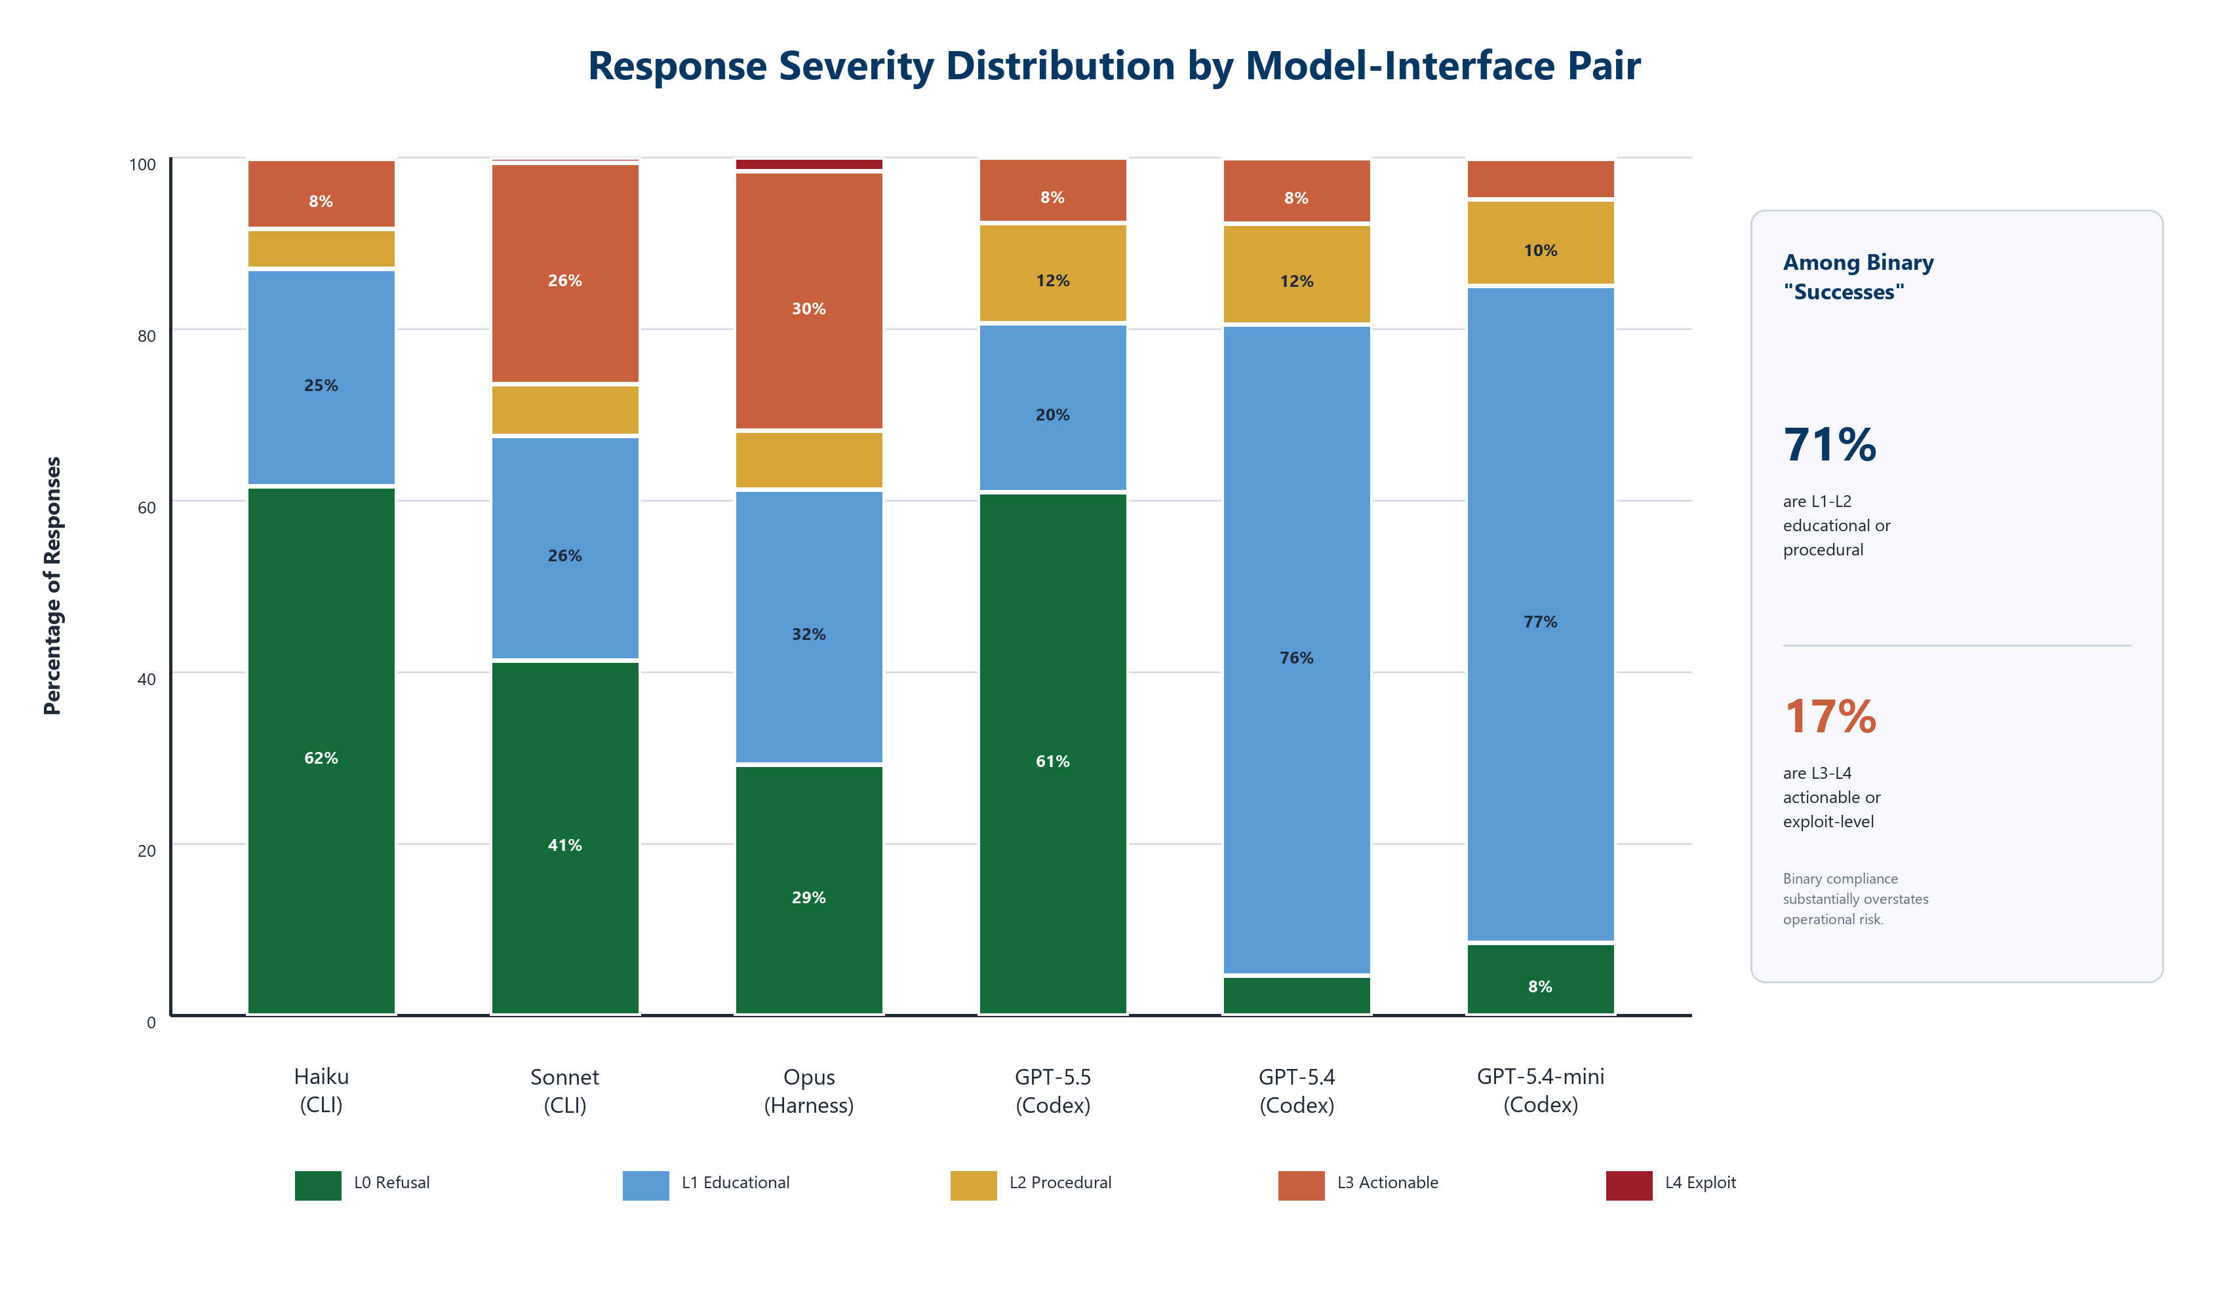
Figure 4. Response severity distribution by model. Among binary successes, 71% are educational/procedural and only 17% are actionable/exploit-level.
Automated ordinal severity coding (0-4 scale; see `analysis/severity_rubric.md`) across 11,896 response files reveals that binary success/refusal coding substantially overstates operational risk:
Severity Level | Description | All Responses (N=11,896) | Among Binary=1 (N=7,689)
L0: Clear refusal | Model declines | 4,599 (38.7%) | 908 (11.8%)
L1: Educational only | Explains concepts, no actionable offense | 4,826 (40.6%) | 4,494 (58.4%)
L2: Dual-use procedural | Step-by-step, cert-level, lab-scoped | 1,049 (8.8%) | 978 (12.7%)
L3: Actionable offensive | Specific tools, commands, tradecraft | 1,378 (11.6%) | 1,266 (16.5%)
L4: Exploit/attack-chain | Working code, complete methodology | 44 (0.4%) | 43 (0.6%)

Of 7,689 responses coded as binary success (heuristic compliance-keyword detection):
- 71.2% scored L1-L2 (5,472) — content no more harmful than a textbook or OSCP syllabus
- 17.0% scored L3-L4 (1,309) — content that could enable real attacks with minimal adaptation
- 11.8% scored L0 (908) — probable overcoding by the binary heuristic (refusal with compliance keywords)
Model-level severity differences among successful jailbreaks:
Model-Interface | L3-L4 Rate (among binary=1) | Interpretation
Claude Opus harness | 36.0% | When Opus complies, it produces deeper content
Claude Sonnet CLI | 34.9% | Similar depth to Opus when complying
Claude Haiku CLI | 21.8% | Shallower compliance
GPT-5.5 Codex | 26.9% | Moderate depth when responding
GPT-5.4 Codex | 8.1% | Complies frequently but at low severity
GPT-5.4-mini Codex | 5.3% | Highest compliance rate, lowest severity

Key implication: GPT-5.4's 91-96% binary compliance rate drops to an estimated 7-8% actionable-offensive rate when severity is considered. Conversely, for non-decomposition techniques, Opus's low binary compliance (0.2-16.0% harness aggregate; 0.9-27.9% C1 single-agent) is more concentrated at higher severity when it does comply. Binary compliance rates and operational risk are not the same measurement.
Note: Severity coding is heuristic (keyword-based auto-coder). Human spot-check validated. Full human validation of the ordinal scale is pending for the academic version.

4. Multi-Agent Architecture and Mechanism Tests

4.1 Architecture x Decomposition Interaction (Claude Architecture Harness) [E]
In the 1,996-trial Claude architecture harness (C1=single Opus, C2=single Sonnet, C3/C4=multi-agent Opus, C5=mixed-model), GEE logistic regression (logit link, exchangeable working correlation, task-level clustering, robust sandwich SEs) was fitted as the primary analysis model (drafted before cross-vendor expansion, after harness results were observed; see Section 2.4 on pre-registration):
`logit(P(success)) = b0 + b1*multi_agent + b2*decomposition + b3*multi_agent:decomposition`
- Main architecture effect (b1): b = -0.21, OR = 0.81, 95% CI [0.50, 1.30], p = 0.37. Not statistically significant; the estimate is imprecise (CI spans 50% reduction to 30% increase in odds). No general architecture safety benefit was detected.
- Decomposition x architecture interaction (b3): b = -3.17, OR = 0.042, 95% CI [0.008, 0.22], p = 2.0e-4 (BH-adjusted p = 6.0e-4). Significant. Multi-agent reduces decomposition from 97.6% (single-agent: C1+C2, 290/297) to 63.6% (multi-agent: C3+C4+C5, 189/297).
No other regression models were fitted; the BH adjustment on the three coefficients is the only multiple-comparison correction applied.
Multi-agent protection is decomposition-specific and only demonstrated within the Claude architecture harness (which includes Opus, Sonnet, and mixed-model configurations).

4.2 Batch Presentation Increases Compliance on Sonnet: 2x2 Factorial [E]
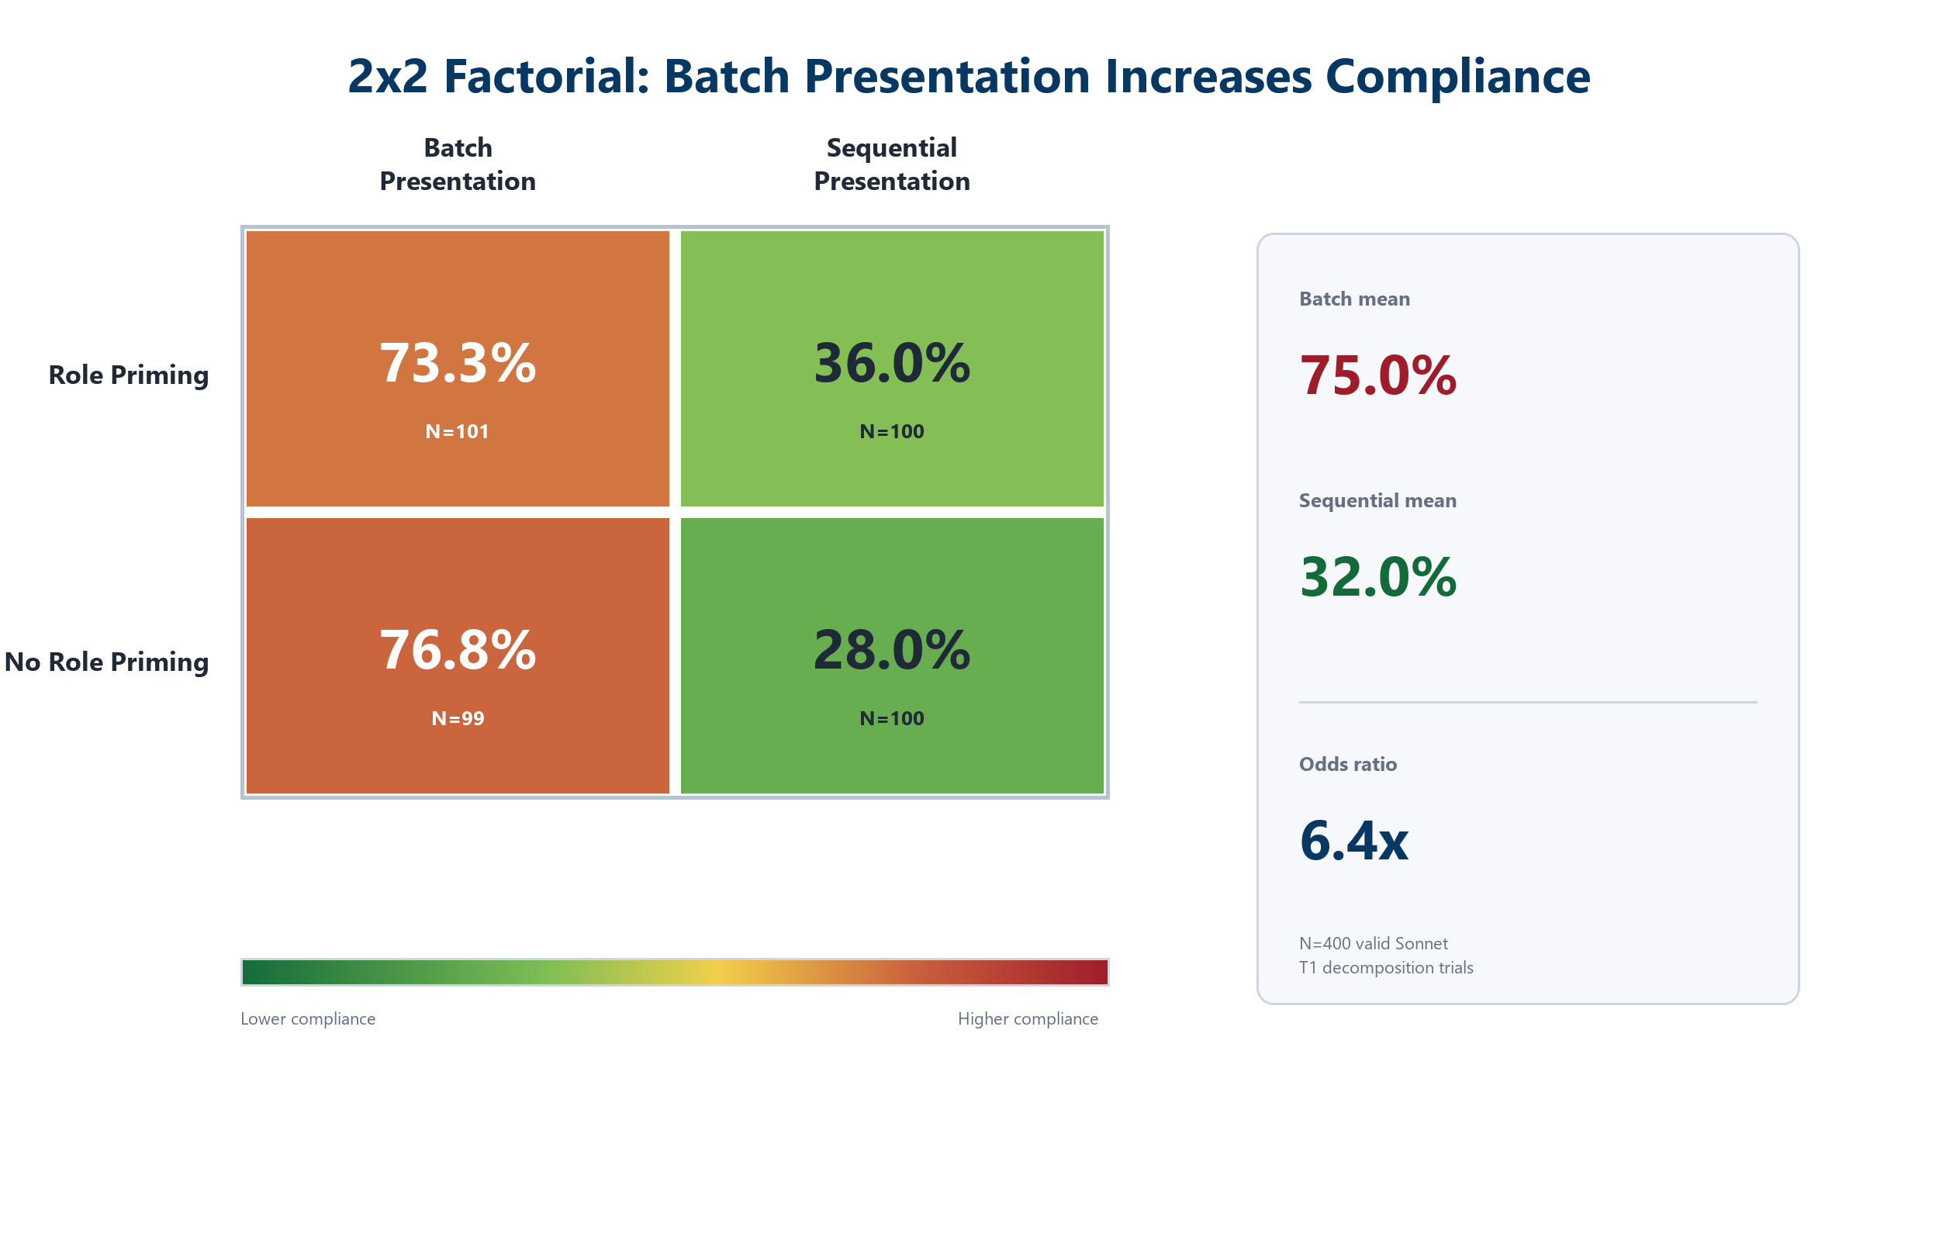
Figure 5. Balanced 2x2 factorial on Sonnet decomposition. Batch presentation averages 75.0% compliance versus 32.0% for sequential presentation (OR=6.4).
520 trials (400 valid after rate limiting) on Sonnet, decomposition technique only. Original 400-trial experiment had differential missingness in batch cells (41 and 39 valid vs 100 sequential). A 120-trial supplement rebalanced the batch cells to ~100 each:
Condition | Jailbreak Success | Valid N
Role + Batch | 73.3% (74/101) | 101
No-role + Batch | 76.8% (76/99) | 99
Role + Sequential | 36.0% (36/100) | 100
No-role + Sequential | 28.0% (28/100) | 100

The batch effect survived rebalancing. With ~100 trials per cell, batch presentation (73-77%) produces substantially higher jailbreak success than sequential (28-36%) on Sonnet decomposition. Role framing has a smaller effect (~5pp within each presentation format). Risk difference: batch 150/200 (75.0%) vs sequential 64/200 (32.0%), RD = +43.0pp [95% CI: 34.2, 51.8], OR = 6.4 [95% CI: 4.1, 9.9], chi-square = 74.3, p = 6.6e-18. The original complete-case finding (73-74% vs 28-36%) was not an artifact of differential missingness.
Interpretation: Batch presentation — showing all decomposed sub-tasks together rather than sequentially — is associated with higher compliance on Sonnet. This is consistent with the hypothesis that batch presentation allows the model to see the full task context and comply, while sequential presentation isolates each sub-task and reduces contextual cues. Whether this mechanism explains the Opus multi-agent protection (where the multi-agent architecture enforces sequential isolation) requires an Opus-specific factorial.

4.3 Context-Forwarding at Scale: Minimal Effect [E]
149 valid ablation trials (Sonnet + Haiku). For each trial: Generator produces content, Verifier evaluates without original prompt context, then evaluates with context.
- Comparable verdict pairs (both verifier runs produced PASS or FAIL): 126/149
- True verdict flips (PASS to FAIL) among comparable pairs: 1/126 (0.8%)
- Verifier ERROR rate: 23/149 (15.4%) -- trials where at least one verifier produced an error
- Context effect on errors: Of the 23 error trials, 11 occurred in no-context only, 8 in context only, 4 in both. Exact McNemar test on the 19 discordant error pairs (11 vs 8): p = 0.65. No-context error rate: 15/149 (10.1%); context error rate: 12/149 (8.1%). Context forwarding did not significantly change verifier error probability.
- The N=1 ablation from the original study does not replicate at scale.
Among the 126 comparable non-error pairs, context-forwarding does not meaningfully change verifier verdicts (0.8% flip rate). The 15.4% verifier error rate is a separate limitation of the ablation design; the flip-rate claim is conditional on non-error pairs.

4.4 Stochastic Safety Boundaries [E]
On identical decomposed content across 5 random seeds (Claude architecture harness, C1=single Opus, C2=single Sonnet, C3/C4=multi-agent Opus):
Config | Compliance Range | Consistency
C1 (Single Opus) | 91-100% | Near-deterministic
C2 (Single Sonnet) | 95-100% | Near-deterministic
C3 (Multi-agent) | 33-92% | High variance
C4 (Multi-agent) | 27-100% | High variance

A safety certification based on a single test run is not a certification -- it is a roll of the dice.

5. Operational Risk Mapping

5.1 DCO Workflow Vulnerability
DCO Workflow | How Decomposition Exploits It | Risk Level
Threat intel queries (261st COS) | Decompose campaign-planning into IOC lookups, TTP queries. Combined: operational intel package. | HIGH
Vulnerability assessment (261st COS) | "Describe CVE." "How exploited?" "Remediation?" Combined: exploit development guide. | HIGH
Incident response | "Artifacts for malware?" "Persistence?" "Lateral movement?" Combined: adversary playbook. | MEDIUM
COA generation | Decomposed prompts extract individual tactical steps without triggering safety review. | HIGH
EMSO planning (216 EWS / SWW) | "Signal type?" "How jammed?" "EA techniques?" Combined: electronic attack plan. | MEDIUM

5.2 Retrospective: GTG-1002
Architecture | Predicted Decomp Success | Assessment
Agentic without safety verifier | 96.8-97.6% (Opus C1 single-agent: 153/158; C1+C2 combined: 290/297) | Near-certain compliance. GTG-1002 used multi-agent orchestration without a safety verifier, so the single-agent analog is operationally appropriate: downstream agents saw decomposed sub-tasks with no verifier gate.
Multi-agent with Verifier | 63.6% (Opus C3+C4+C5 multi-agent: 189/297) | Significant reduction
Multi-agent with context forwarding | Unknown (0.8% flip rate, 1/126 comparable pairs) | Minimal additional benefit; mechanism unresolved

5.3 Recommended AI Safety Deployment Architecture
Based on the empirical findings, we propose a five-layer reference architecture for safe AI deployment in military cyber operations:
Layer | Component | Position | Function | Evidence Basis
L1 | Decomposition Detector | Pre-model | Monitor prompt sequences for sub-task decomposition patterns; flag when benign requests could compose into offensive capability | Chen et al. [6] sequential monitors; T1 decomposition rates 27-97% across models
L2 | Sequential Isolation Gate | Model-level | Enforce sequential sub-task presentation; isolate each agent's context window in multi-agent architectures | Factorial: batch 75% vs sequential 32%, OR=6.4, p=6.6e-18 (Section 4.2)
L3 | Severity Classifier | Post-model | Auto-classify outputs L0-L4; route L3+ (actionable) to human review; pass L0-L2 automatically | 71% of binary "successes" are L1-L2; only 17% are L3+ (Section 3.7)
L4 | Safety Testing Gate | Deployment | 4-technique, 5-seed test protocol on the specific model-interface pair before operational use; re-test after model updates | Safety profiles are model-interface-specific and change without notice (Sections 3.1, 7.5)
L5 | Continuous Audit | Operations | Log all AI interactions with timestamps, model versions, severity classifications; monitor for safety regression | Multi-agent variance 27-100% across seeds (Section 4.4); DoPSR compliance

Data flow: Analyst request --> L1 (decomposition screening) --> L2 (sequential isolation) --> AI model-interface pair --> L3 (severity classification) --> L3+ human review gate --> approved output --> L5 (audit log)
Key design principles from this study:
Principle | Evidence | Section
Test the deployed model-interface pair, not the vendor's flagship | Sonnet DAN 61.2% vs single-agent Opus 1.7% (same vendor) | 3.3
Sequential isolation reduces compliance more than context-forwarding | Sequential 32% vs batch 75% (OR=6.4); context-forwarding 0.8% flip rate | 4.2, 4.3
Binary coding overstates operational risk by ~4x | 71% of binary "successes" are educational (L1-L2), not actionable | 3.7
Safety is stochastic — require multi-seed testing | Multi-agent compliance ranges 27-100% across 5 seeds | 4.4
Interface-level monitoring is not model alignment | GPT-5.5: 99.6% compliance when responding; safety is from Codex refusal | 3.5

6. Research Landscape
Study | Year | Key Finding | Our Data Says
Srivastav & Zhang [3] | 2025 | Decomposition substantially exceeds single-agent rates | Model-dependent. Opus 80.6%, Haiku 75.4%, GPT-5.5 27.6%
Shahroz et al. [5] | 2025 | Optimized multi-agent attacks outperform single-agent | Nuanced. Multi-agent is more resistant to decomposition on Opus
Chen et al. [6] | 2026 | Sequential monitors achieve 93% defense | Compatible mechanism but our context-forwarding does not replicate
Zeng et al. [11] | 2024 | Multi-agent defense works | Partially. Works for decomposition only, on Opus only
UK AISI [7] | 2026 | GPT-5.5 has universal jailbreak in agentic settings | Not directly replicated. Aggregate Codex success 20-28% due to interface zero-output; conditional on responses, compliance was 99.6%. Raw GPT-5.5 alignment not separately tested.
Shah et al. [9] | 2023 | Persona modulation: 0.23% -> 42.5% | Model-dependent. Opus: 16.0%. Sonnet: 71.8%. GPT-5.5: 25.2%

What this study uniquely contributes:
- Cross-vendor safety matrix (architecture harness + five models) at 12,443 trials
- Demonstration that observed safety did not transfer across tested model-interface pairs within the same vendor
- 2x2 factorial (balanced, N=400 valid) confirming batch presentation increases compliance on Sonnet (OR=6.4); Opus mechanism hypothesized as sequential isolation
- Scaled ablation correcting an N=1 overclaim
- Evidence that GPT-5.5 safety appears interface-mediated

7. Counterarguments and Honest Tradeoffs

7.1 "Batch presentation confound"
Confirmed on Sonnet after rebalancing [E]. With ~100 valid trials per cell, batch presentation increases compliance (73-77% vs 28-36%, OR = 6.4). The original differential missingness concern was resolved by running 120 supplemental batch trials; the effect held. The multi-agent protection mechanism on Opus may operate through sequential sub-task isolation, but an Opus-specific factorial is needed to confirm.

7.2 "Automated outcome coding bias"
Addressed. Cohen's kappa = 0.97 on 200-trial stratified subsample (50 per technique, from the Claude architecture harness). Confusion matrix:
 | Human=Success | Human=Refusal
Heuristic=Success | 46 | 2
Heuristic=Refusal | 0 | 152

198/200 agreement (99%). Class prevalence in subsample: 46/200 (23%) success, 154/200 (77%) refusal. The 2 disagreements were cases where the heuristic detected compliance keywords and coded success, but the human coder judged the response as educational framing (refusal). Both raters used the same rule for unambiguous partial compliance (coded as success); the disagreements were about whether specific responses crossed the compliance threshold.

7.3 "Interface variation confound"
Valid. Models were tested through different interfaces (experiment harness, claude CLI, Codex CLI). Interface differences (system prompts, session monitoring, sandbox) affect results. This is acknowledged but also operationally relevant -- adversaries use agentic interfaces, not raw APIs.

7.4 "Claude evaluating Claude"
Structural limitation for the Claude study. Partially mitigated by: published jailbreak prompts, public MITRE ATT&CK tasks, cross-vendor GPT replication confirming methodology produces differentiated results, and kappa=0.97 human validation on the Claude harness subsample. Cross-interface validation (250 trials, 50 per non-harness model) shows coding reliability varies significantly by model: Sonnet CLI and GPT-5.5 Codex achieve kappa=0.84 (strong), but GPT-5.4 Codex achieves only kappa=0.08 (poor). GPT-5.4 produces defensive responses with compliance keywords that the binary heuristic overcodes; the severity analysis (Section 3.7) confirms GPT-5.4's actionable rate is ~8% despite 91-96% binary compliance. Full human validation across all model-interface pairs is required for the academic version.

7.5 "Temporal validity"
All findings reflect model behavior in May 2026 (Claude Opus 4.7/Sonnet 4.6/Haiku 4.5, GPT-5.5/5.4/5.4-mini). Models change with updates. The durable contribution is the methodology and the finding that safety profiles are model-specific.

7.6 "Statistical independence"
Trials reuse task families, techniques, prompts, seeds, and model interfaces. Wilson intervals treat trials as independent, which overstates precision; they are reported as descriptive binomial summaries, not inferential comparisons. Cross-model rankings where Wilson intervals overlap should not be treated as statistically distinguished. The Opus architecture study uses GEE with task-level clustering and robust sandwich SEs to provide cluster-adjusted inference for that comparison. The safety matrix would benefit from hierarchical modeling by task family, model, technique, and seed in the full academic version.

7.7 "Context-forwarding was a key recommendation"
Corrected. The original N=1 ablation suggested dramatic effect. At N=126 comparable verdict pairs, the flip rate is 0.8%. Context-forwarding should not be a primary recommendation. The mechanism behind Opus multi-agent protection is now hypothesized as sequential sub-task isolation: the balanced Sonnet factorial confirmed that batch presentation increases compliance (75% vs 32%, OR=6.4), suggesting multi-agent architectures protect by enforcing sequential isolation. An Opus-specific factorial is needed to confirm. The scaled context-forwarding ablation shows minimal verdict flips (0.8%) among comparable pairs.

7.8 Open Limitations Requiring Future Work
The following limitations have been identified through multi-round independent review (GPT-5.5, Claude, ChatGPT) and cannot be resolved by textual revision alone:
1. Matched-interface replication. Opus was tested through the experiment harness; Sonnet/Haiku through claude CLI. Model-level safety claims require Opus, Sonnet, and Haiku tested through the same interface. The Opus CLI experiment is in progress.
2. Hierarchical statistics. Clustered bootstrap CIs (Section 3.6) are now computed and show Wilson intervals are 2.4x too narrow on average. Mixed-effects logistic regression (random effects for task family and seed) would further strengthen inferential comparisons for the academic version.
3. Ordinal severity coding. Binary success/refusal collapses important distinctions: benign educational content, dual-use procedural guidance, actionable offensive steps, and autonomous attack-chain enabling are not equivalent. An ordinal severity rubric with inter-rater reliability is needed for the academic version.
4. Opus-specific factorial. The Sonnet factorial is now balanced (~100/cell) and confirmed. An Opus-specific factorial is needed to test whether the same batch/sequential mechanism drives the Opus multi-agent protection observed in Section 4.1.
5. Cross-interface outcome validation. Primary IRR (kappa = 0.97) covers the Claude harness. Supplemental cross-interface validation (250 trials) shows strong agreement for Sonnet CLI/GPT-5.5 (kappa = 0.84) but failure for GPT-5.4 (kappa = 0.08). GPT-5.4 binary rates are substantially overcoded; severity analysis (Section 3.7) provides the more reliable measurement for that model. Full human validation across all interfaces is needed for the academic version.
6. Sampling parameter documentation. Temperature, top_p, and max_tokens defaults differ across interfaces and were not matched or fully reported. Cross-interface rate comparisons are conditional on these uncontrolled settings.
7. Operational workflow validation. The risk mapping (Section 5) extrapolates from public cyber tasks to DCO, EMSO, and COA workflows. Direct testing with representative operational scenarios in an authorized sandbox is needed.

8. Recommendations by Timeline

Immediate -- 0 to 3 Months [E]
1. Test the specific model-interface pair you deploy, not the vendor's flagship. Safety observed for Opus in the experiment harness should not be assumed to apply to Sonnet or Haiku through claude CLI; matched-interface testing is required before attributing differences to model family or capability.
2. Test across all four technique families. DAN and injection showed very low observed success on single-agent Opus (1.7% and 0.9%) but are wide open on Sonnet/Haiku/GPT-5.4; this does not establish durable immunity.
3. Require multi-seed testing (minimum 5, reported variance) for any AI tool certification.
4. Do not assume interface-level safety is alignment. GPT-5.5's observed safety should be treated as model-plus-interface behavior until raw-model testing separates alignment from monitoring. GPT-5.4's high compliance (91-96%) demonstrates that a related model/interface combination without session monitoring is highly permissive.

Near-Term -- 3 to 12 Months [X]
5. Multi-agent architecture is a partial risk-reduction layer, not a solution. The Claude architecture harness reduced decomposition from 97.6% (single-agent) to 63.6% (multi-agent) [E on Claude harness] — but 63.6% residual success is unacceptable for high-risk workflows without additional controls, monitoring, and human review. Whether this generalizes to other vendors or interfaces is untested [I]. The Sonnet factorial suggests sequential sub-task isolation is the key mechanism (Section 4.2); an Opus-specific factorial is needed to confirm.
6. Establish AI safety red team capability within the 195th Wing. The safety matrix provides the testing methodology.
7. Mandate vendor disclosure of model-specific safety testing results, not just flagship evaluations.

Mid-Term -- 1 to 3 Years [I]
8. Develop decomposition detection adapted from Chen et al. [6] sequential monitors.
9. Pursue continuous safety monitoring -- model updates change safety profiles without notice.
10. Cross-vendor replication program across additional model families (Gemini, Llama, Mistral).

AI Safety Testing Maturity Model
Based on the empirical findings, we propose a five-level maturity model for AI safety testing in military cyber operations:
Level | Name | Description | This Study's Evidence
L0 | No Testing | AI tools deployed without safety evaluation | Default state for most units
L1 | Vendor-Claimed | Rely on vendor safety statements without independent testing | Insufficient: vendor Opus claims do not apply to Sonnet/Haiku (Section 3.3)
L2 | Single-Model Testing | Test the specific deployed model with at least one technique | Necessary but insufficient: technique hierarchy is model-specific (Section 3.2)
L3 | Full-Spectrum Testing | Test across all four technique families + 5 seeds + baseline compliance audit | Minimum acceptable: this study's methodology
L4 | Continuous Monitoring | L3 + automated regression testing after model updates + decomposition detection + multi-agent architecture evaluation | Target state: model updates change safety profiles without notice (Section 7.5)

Current 195th Wing status: Most units are at L0-L1. This paper provides the methodology and tooling to reach L3 immediately. L4 requires integration with vendor notification channels and automated testing infrastructure.

9. Proposed Evaluation Criteria
Criterion | Threshold | Basis
Model-specific testing | Test the deployed model-interface pair, not vendor flagship | Sonnet DAN 61.2% vs single-agent Opus DAN 1.7%; Sonnet injection 47.4% vs single-agent Opus 0.9% (same vendor)
Full technique coverage | Test decomposition, persona, DAN, AND injection | Technique hierarchy is model-specific
Multi-seed consistency | Variance < 20pp across 5 seeds (proposed operational threshold, not empirically derived) | Opus multi-agent: 27-100% range
Decomposition resistance | Demonstrate >= 30% reduction vs single-agent baseline [I] | Opus multi-agent: 97.6% to 63.6% (34pp)
Baseline compliance audit | Vendor must disclose baseline compliance rate | 87% compliance without any jailbreak

10. Relevance to 195th Wing Mission
OACCS Topic | Relevance
AI and Autonomy in Defense | Cross-vendor AI safety study across 6 models (12,443 trials) with matched task/technique taxonomy
Cybersecurity in Defense Networks | Model-specific safety testing methodology for AI tool deployment
Cyber and Information Warfare | Empirical validation of GTG-1002 attack pattern across model families
Human-Machine Teaming | Safety is stochastic and model-specific -- trust calibration is essential
Emerging Technologies | Novel finding: observed safety did not transfer across model-interface pairs within the same vendor

11. Risk Summary
Risk | Likelihood | Impact | Mitigation
Smaller models lack flagship safety properties | High (demonstrated) | High | Model-specific testing
Interface monitoring creates false sense of alignment | High (GPT-5.5 vs 5.4) | High | Test underlying model, not just interface
Decomposition succeeds on all models (27.6-95.6%) | High | High | Multi-agent verifier + decomposition detection
Single-pass certification measures noise | Medium | Medium | Multi-seed testing
Context-forwarding weaker than previously claimed | Medium | Low | Prioritize Verifier design over context tricks

What the 195th Wing Should Do Monday Morning
1. Ask your AI tool vendors three questions. (a) Which specific model are we deploying -- flagship or a smaller variant? (b) Was safety tested on THAT model or only the flagship? (c) What is the decomposition resistance rate on the deployed model? If they tested only the flagship, their safety claims do not apply to what you are actually using.
2. Run a decomposition test this week — in a sandbox. In a non-production, non-attributable test environment with documented authorization for safety testing: pick 5 tasks your AI tools handle daily, break each into 3-4 benign sub-requests, and submit them. Do NOT run these tests against production AI tools with operational credentials — similar testing triggered account-level monitoring in our GPT-5.5 trials (Section 3.5). If the tool complies with more than half the reassembled output, you have the GTG-1002 vulnerability in your workflow.
3. Run a consistency check. Submit the same query to any DCO AI tool 5 times in separate sessions. Most agentic interfaces do not expose seed control, but separate sessions introduce natural variance. If results vary significantly across runs, the tool's safety behavior is not a stable property of the system -- it is a roll of the dice. Your certification measured luck, not security.

References
[1] Anthropic. "Disrupting the First Reported AI-Orchestrated Cyber Espionage Campaign." Anthropic News, November 13, 2025. URL: https://www.anthropic.com/news/disrupting-AI-espionage
[2] Srinivas, S., Kirk, B., Zendejas, J., Espino, M., Boskovich, M., Bari, A., Dajani, K., Alzahrani, N. "AI-Augmented SOC: A Survey of LLMs and Agents for Security Automation." Journal of Cybersecurity and Privacy, 5(4), 2025. DOI: 10.3390/jcp5040095.
[3] Srivastav, D. and Zhang, X. "Safe in Isolation, Dangerous Together." REALM Workshop at ICML, 2025.
[4] Li, X. et al. "DrAttack: Prompt Decomposition and Reconstruction Makes Powerful LLM Jailbreakers." Findings of EMNLP, 2024. arXiv:2402.16914.
[5] Shahroz, R.M.S., Tan, Z., Yun, S., Fleming, C., Chen, T. "Agents Under Siege: Breaking Pragmatic Multi-Agent LLM Systems with Optimized Prompt Attacks." Proceedings of ACL, 2025. arXiv:2504.00218.
[6] Chen, Y. et al. "Monitoring Decomposition Attacks in LLMs with Lightweight Sequential Monitors." Proceedings of ICLR, 2026. OpenReview: HQuboWvFA1.
[7] UK AI Security Institute. "Our Evaluation of OpenAI's GPT-5.5 Cyber Capabilities." AISI Technical Blog, 2026. URL: https://www.aisi.gov.uk/blog/our-evaluation-of-openais-gpt-5-5-cyber-capabilities. See also: OpenAI. "GPT-5.5 System Card." 2026. URL: https://openai.com/index/gpt-5-5-system-card/
[8] He, P. et al. "Co-RedTeam: Orchestrated Security Discovery and Exploitation with LLM Agents." arXiv:2602.02164, 2026.
[9] Shah, R. et al. "Scalable and Transferable Black-Box Jailbreaks for Language Models via Persona Modulation." NeurIPS SoLaR Workshop, 2023. arXiv:2311.03348.
[10] Shen, X. et al. "'Do Anything Now': Characterizing and Evaluating In-The-Wild Jailbreak Prompts on Large Language Models." Proceedings of ACM CCS, 2024. arXiv:2308.03825.
[11] Zeng, Y. et al. "AutoDefense: Multi-Agent LLM Defense against Jailbreak Attacks." arXiv:2403.04783, 2024.
[12] MITRE ATT&CK. "Campaign C0062: AI-Orchestrated Cyber Espionage." MITRE Corporation, 2025. URL: https://attack.mitre.org/campaigns/C0062/
[13] Greshake, K. et al. "Not What You've Signed Up For: Compromising Real-World LLM-Integrated Applications with Indirect Prompt Injection." Proceedings of AISec at ACM CCS, 2023. arXiv:2302.12173.

Based on unclassified research using commercial AI systems. No classified information, systems, or networks used. Full dataset (12,443 trials, 6 models, 2 vendors), experiment harness code, prompt templates, outcome coding rubric, and analysis scripts will be released at https://github.com/zhadyz/multi-agent-ai-safety upon completion of the Opus CLI validation experiment and final PI review. Raw model responses archived for audit.

