**JURNAL_MODUL_9**

Zhafir Zaidan Avail

2311104059

Hasil Run:

Sebelum input data

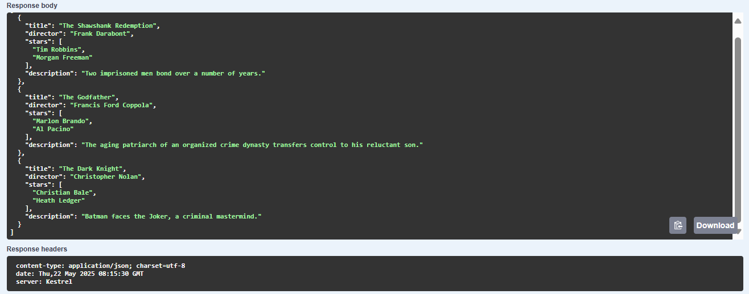

Setelah input data

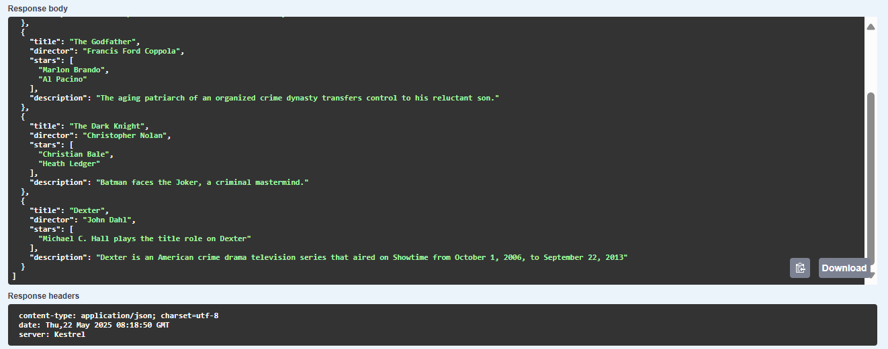

Source code:

1. Models/Movie.cs

namespace jurnal9_2311104059.Models

{

public class Movie

{

public string Title { get; set; }

public string Director { get; set; }

public List<string> Stars { get; set; }

public string Description { get; set; }

public Movie() { }

}

}

1. Controlers/MovieController.cs

using jurnal9_2311104059.Models;

using Microsoft.AspNetCore.Mvc;

namespace jurnal9_2311104059.Controllers

{

[ApiController]

[Route("api/[controller]")]

public class MoviesController : ControllerBase

{

private static List<Movie> movies = new List<Movie>

{

new Movie

{

Title = "The Shawshank Redemption",

Director = "Frank Darabont",

Stars = new List<string> { "Tim Robbins", "Morgan Freeman" },

Description = "Two imprisoned men bond over a number of years."

},

new Movie

{

Title = "The Godfather",

Director = "Francis Ford Coppola",

Stars = new List<string> { "Marlon Brando", "Al Pacino" },

Description = "The aging patriarch of an organized crime dynasty transfers control to his reluctant son."

},

new Movie

{

Title = "The Dark Knight",

Director = "Christopher Nolan",

Stars = new List<string> { "Christian Bale", "Heath Ledger" },

Description = "Batman faces the Joker, a criminal mastermind."

}

};

[HttpGet]

public ActionResult<IEnumerable<Movie>> GetMovies() => movies;

[HttpGet("{id}")]

public ActionResult<Movie> GetMovie(int id)

{

if (id < 0 || id >= movies.Count)

return NotFound();

return movies[id];

}

[HttpPost]

public ActionResult<Movie> AddMovie([FromBody] Movie movie)

{

movies.Add(movie);

return CreatedAtAction(nameof(GetMovie), new { id = movies.Count - 1 }, movie);

}

[HttpDelete("{id}")]

public IActionResult DeleteMovie(int id)

{

if (id < 0 || id >= movies.Count)

return NotFound();

movies.RemoveAt(id);

return NoContent();

}

}

}