Report “PupTrain” application: Usability Test [Short/ Informal]

Date of Report: January 22nd 2024
Date of Test: January 22nd 2024
Location of Test: Warsaw, Mazowieckie

Prepared for: Emilia Zawadzka- Gosk
Email: ezawadzka@pjwstk.edu.pl

Prepared by: Zhaisana Ismanova, Emre Ertan
Email: s23108@pjwstk.edu.pl , s23372@pjwstk.edu.pl

Executive Summary

In summary we took 7 participants to test our PupTrain application.
First scenario was to register a new user and login to account. Second scenario was to
choose an activity program and to complete a video material. The success rate obtained 75%. The third use case scenario was about setting a reminder/ where you had to choose any type of reminder like eat, sleep, walk, poop, pee, train etc. In general, all our participants enjoyed the process and evaluated our app as the satisfied PupTrain app among all other train dog applications available on an app store or google market.
Overall success rate was obtained as 57%

Methodology

Who we tested
Five participants, having the following characteristics, evaluated PupTrain app.

Audience Type  Students 7  TOTAL (participants) 7 | Computer Usage  0 to 10 hrs. wk. 2  11 to 25 hrs. wk. 3  26+ hrs. wk. 2  TOTAL (participants) 7
Age  19 1  22 2  24 2  25 1  33 1  TOTAL (participants) 7 | Gender  Women 3  Men 4  TOTAL (participants) 7

What participants did
Our seven participants took a test of our application PupTrain. Before taking a test , our participants completed user interview from us where we had to ask them questions about similar app they were using and asking personal background questions to better understand our users and their needs, complaints, preferences etc.

What data we collected
We collected useful information and feedbacks from users. We’ve completed a list of procedures and analyzed the market and researched our competitors apps by performing competitive analysis. Performed user interviews, creating 2 user personas. Completing user stories and user flow.

Detailed findings and recommendations

Introductory Questions & Tasks

Sample 1. Summary of introductory questions
Sample Questions | Sample Responses
Have you heard of PupTrain app? | 3 of the them heard about it.
Just from looking at this app, what kinds of information do you think you could get from it? Please be specific. | 3 out of 7 participants correctly defined the purpose of the app. Participants used phrases from major headers and labels to describe the information on the app. Rest of them couldn’t understand the goal of app.
Who do you think this app is designed for? Why? | 2 participants correctly defined it. One person suggested that it may useful for kids.
Who manages this app? | One participant identified the sponsor from the masterhead.

Scenario 1 – Register an user
You want to see what is this app is about. Now it’s time to register a new user by creating username which is also an email address and creating a password which should meet all requirements.
- Register
- Create username and password
- Login with your new created account
- Go to main page of app

Number of participants | 7
Percent successful | 43%

Sample Findings | Sample Recommendations
3 participants completed the task with ease by tapping register button and creating new account and be able to login.  4 participants did not complete the task skipped. | To include only register button in login page of the app.

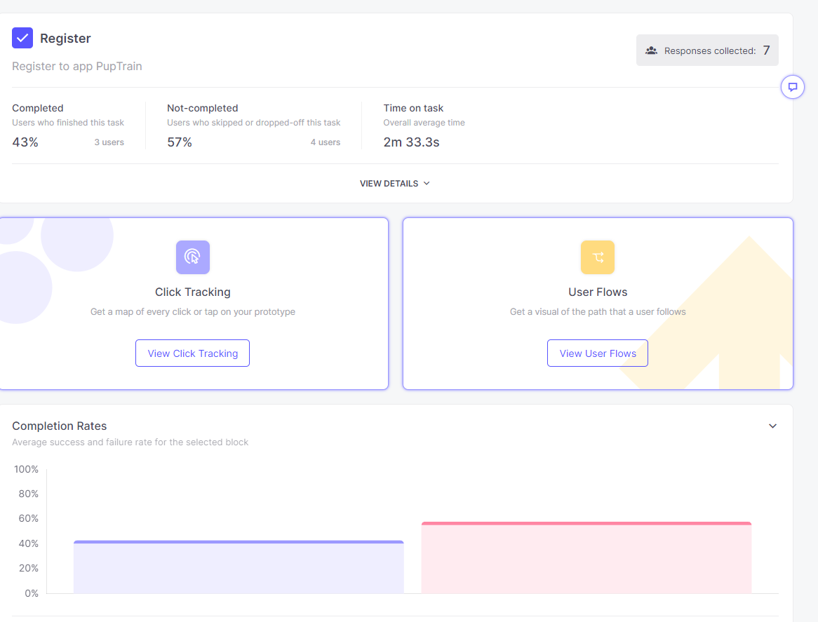

Scenario 2 - Exercises/Commands
You’re a pet owner and want to teach/train your dog to some commands and tricks. Beginning from the basic exercises of differentiating your voice and responding to it to performing different kinds of challenging tricks.

- Go to Training program
- Choose any type of program and material(video)
- Finish the video (exercise)

Number of participants | 4
Percent successful | 75%

Sample Findings | Sample Recommendations
3 participants completed the task with ease by finding the exercise material and completing it in a day.  1 participants needed prompting or had significant difficult completing the task and finding right tab | To include names on top of each icon to understand what exactly is what.

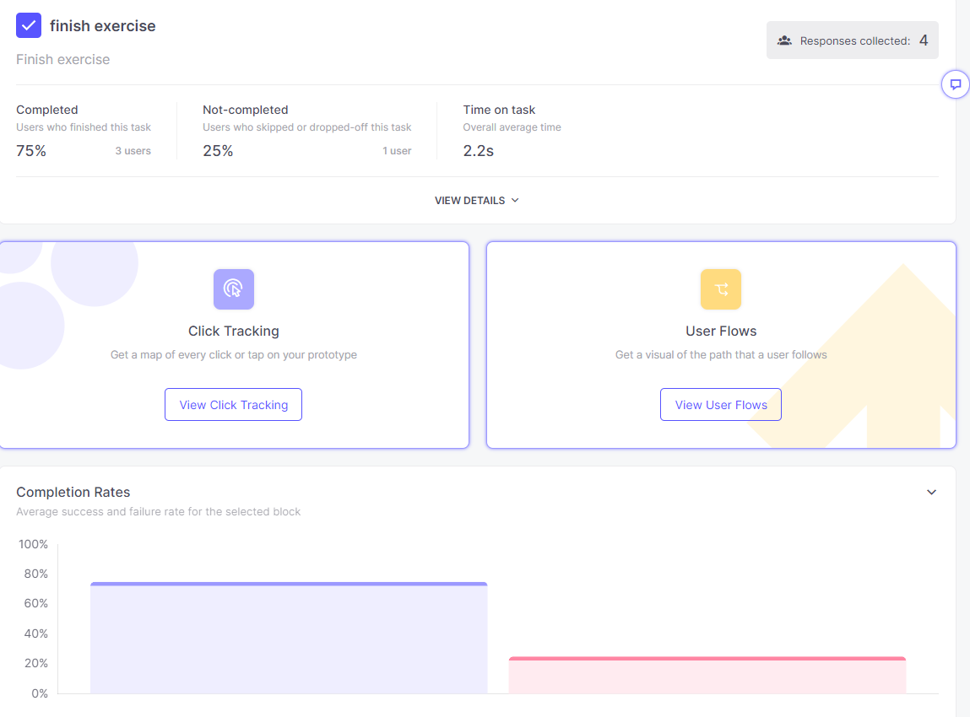
Scenario 3 – Setting a reminder
Now, you’d like to set a reminder of different tasks. Notifying you that its already time to eat, walk, poop, play, sleep, train etc. By choosing date and time to your reminder.
- Go to Reminder tab
- Choose any kind of reminder (eat, sleep, walk etc)
- Set date and time of that reminder

Number of participants | 4
Percent successful | 25%

Sample Findings | Sample Recommendations
1 participants completed the task with ease by finding the reminders tab and by choosing type of reminder and setting a date and time for the specified reminder.  3 participants needed prompting or had significant difficult completing the task. | Reminder tab was too small to notice.  Make it bigger.

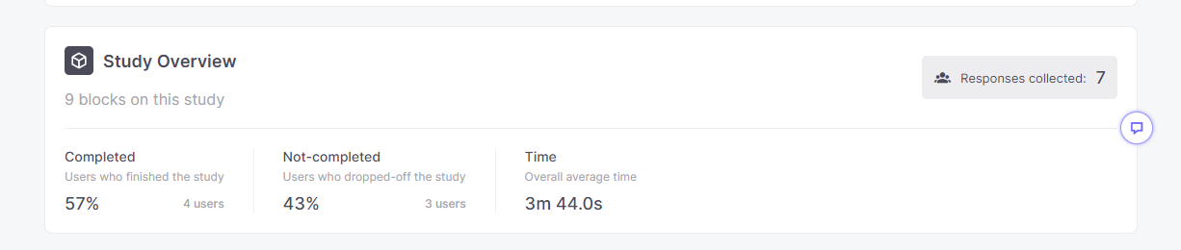
Exit Questions/User Impressions

Sample 1. Summary of user impressions
Sample Questions | Sample Responses
What is your overall impression to PupTrain? | Participants liked being able to find useful info.
What is your impression of the search capability? | Search worked not the best as they struggled fining tab.
Do you feel this app is current? Why? | The site is current because the information is dated with information from the past couple of days.
What did you like best about the app? | 1) Resources 2) Lifehacks 3) Health tips
What did you like least about the app? | 1) UX need to be improved 2) Everything only in video format
If you were the app developer, what would be the first thing you would do to improve the app? | 1) “Email a friend” 2) FAQs
Is there anything that you feel is missing on this app? | 1) “Email a friend” 2) FAQs 3) More advanced material
If you were to describe this app to a colleague in a sentence or two, what would you say? | It’s a useful app with a lot of good information.
Do you have any other final comments or questions? | Improve buttons.

Sample 2. User impressions by participant
Participant No. | Like best? | Like least? | Improvements
1 | Search | Registration | Add more color
2 | A-Z index | Pop-ups | Clickable charts
2 | Video materials | Short time to learn | Add a forum for all users

