**COMP 2044 Human Computer Interaction**

Workshop 3 - Hierarchical Task Analysis (HTA)

Name: Yuyang Zhang

Student ID: 20514470

Email: scyyz26@nottingham.edu.cn

Submission Date: 2025/3/7

Introduction

HTAs produce a hierarchy of tasks and subtasks. In addition, plans describing the order and conditions of the tasks are included.This document presents a Hierarchical Task Analysis (HTA) for the task of purchasing a book online, specifically “The Design of Everyday Things”by Donald Norman.

Overview

The HTA is organized into six main tasks, each further divided into sub-tasks:

1. Visit the book purchasing website

The process begins when the user enter the homepage of the book purchasing website.

1. Search and choose a book

The user searchs the title of a book in the search bar. After retrieving relevant results, the user chooses the desired book, navigates to the book details page to view the book information, such as price, version and description, and then decides whether to proceed with the purchase.

1. Add book to cart

If the user decides to purchase the book, the user adds it to cart and selects the desired quantity. At this stage, the user should choose whether to continue shopping or checkout. If the user chooses to continue shopping, the user can continue searching books. When the user decide not to proceed with the purchase, the user can enter the checkout stage. If the user does not want to buy this book, the user can remove the book from the shopping cart and leave the website.

1. Go to checkout

Upon completing the shopping, the user proceeds to the checkout process. The checkout experience varies based on user type: One is the user is the new user. The other is the user is the returning customer. As for new user, the user should choose between creating an account and guest checkout. If the user chooses the guest checkout, the user can fill in delivery information, chooses the payment method, confirm order and complete payment. If the new user chooses create an account, the user should register an account, then fills in the delivery information, chooses the payment method, confirms the order and completes payment. As for returning customer, the user should log in to the account directly. If the account is logged in, the user can skip this step. Once authenticated, the user must confirm or update their delivery information. If the saved delivery information is correct, the user can choose the payment method, confirm the order and complete payment. If modifications are required, the user updates the delivery details before proceeding. If a new delivery address needs to be added, the user inputs the new address and then finalizes the order.

1. Confirm order information

After completing the payment, the user can review the order details, verify accuracy, track the order status, such as order number, shipment date and estimated delivery time, and then wait for delivery.

1. Order after-sales service

The order after-sales service consists of two primary processes. The first is to confirm the order, and the second is to apply for after-sales service. In the aspect of confirming the order, the user can confirm the receipt after receiving the book. As for after-sales service, if the user encounters a problem in the order, the user can apply for after-sales services. This process is mainly divided into four types. The first is to return the goods. The second is to exchange the goods. The third is order modification or cancellation. The last is problematic orders. For returning the goods, the user should submit a request, specify the reason for return and the preferred return method. The book is then sent back to the merchant and the user will wait for a refund. As for exchanging the goods, the user provides a reason for the exchange and selects an exchange method. The book is returned to the merchant, and the user will wait to receive the replacement. As for order modification or cancellation, the user may request to change or cancel the order before it is shipped. As for problematic orders, if the user experiences problems such as incorrect or damaged books, the user may contact customer service to solve the issues.

Note: Since my chart has so much content, please zoom in for easier reading.Below is the HTA flow chart (Figure1).

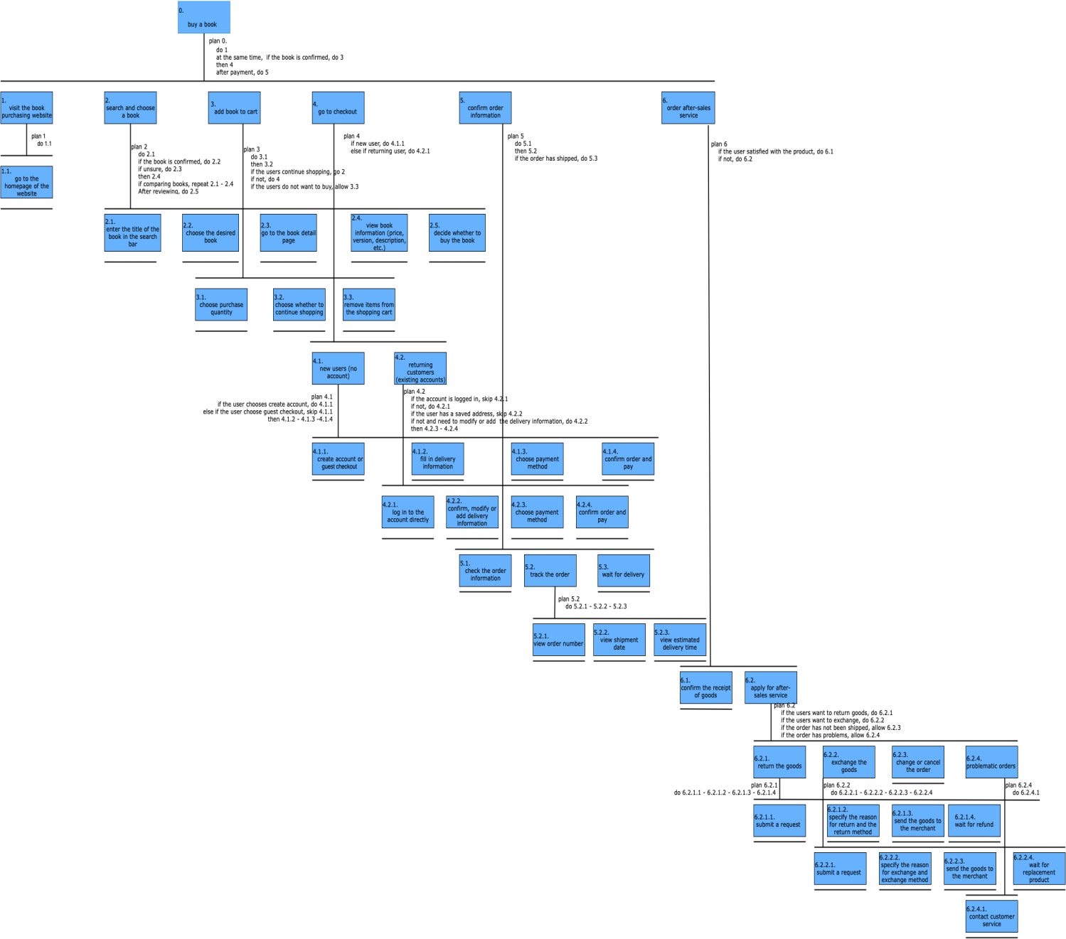

Figure1: HTA of Purchasing a Book

Conclusion

This HTA breaks down the online book-buying process in detail. By analyzing each step, we can improve usability, enhance the customerexperience, and simplify the entire shopping process.