Topic 1:

What is ML?
It is very hard to write programs that solve problems like recognizing a face.
Instead of writing a program by hand, we collect lots of examples that specify the correct output for a given input.
A machine learning algorithm then takes these examples and produces a program that does the job.

关键句:
A machine learning algorithm produces a program from data, instead of writing rules by hand.

- Automating automation
- Getting computers to program themselves
- Writing software is the bottleneck
- Let the data do the work instead!

Machine Learning is making great strides
– Large, good data sets
– Computer power ML发展迅速的三大推动因素
– Progress in algorithms
• Many interesting applications
– Commercial
– Scientific
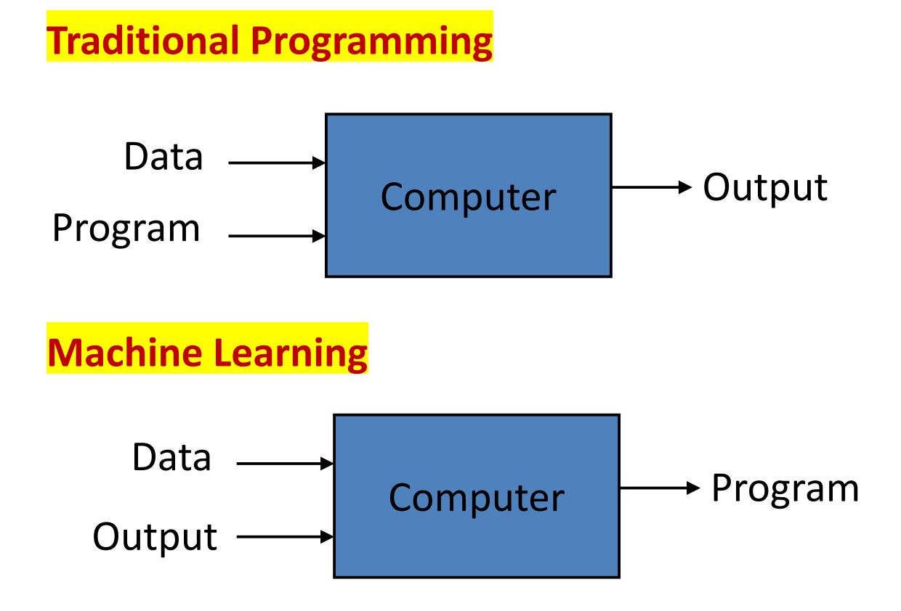
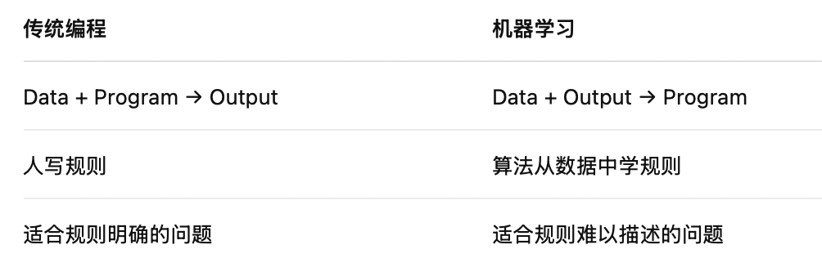
总结句:
In traditional programming, the program is written by humans, while in machine learning the program is learned from data.

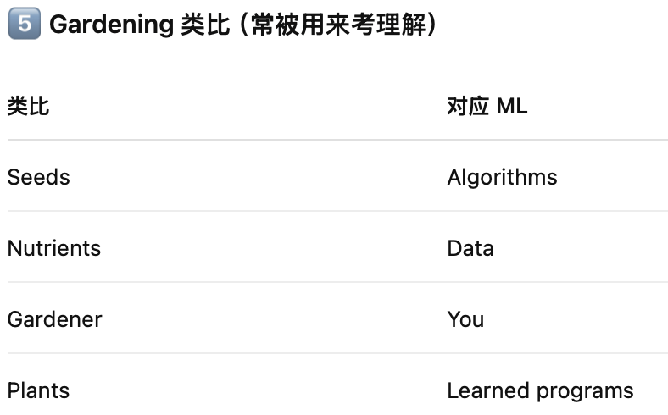

More Sample Applications
• Web search
• Healthcare
• Robotics
• Information extraction
• Finance
• E-commerce
• Computational biology
• Space exploration
• Social networks

Types of Learning:
- Supervised (inductive) learning: classification(分类)
Training data includes desired outputs
- Unsupervised learning: clustering(聚类)
Training data does not include desired outputs
This is the new frontier of machine learning because most big datasets do not come with labels
- Semi-supervised learning: Medical field(医疗领域)
Training data includes a few desired outputs

Evaluation
• Accuracy
• Precision and recall
• Squared error
• Likelihood
• Posterior probability
• Cost / Utility
• Entropy
• 分类题 → accuracy / precision / recall
• 回归题 → squared error
• 概率模型 → likelihood / posterior

Issues:
- Many machine learning/AI projects fail(Gartner claims 85%)
- Ethics

Reasons for failure:
• Asking the wrong question
• Trying to solve the wrong problem
• Not having enough data
• Not having the right data
• Hiring the wrong people
• Using the wrong tools
• Not having the right model
• Not having the right yardstick 衡量标准

总结:
Machine learning learns programs from data rather than writing rules by hand, and can be supervised, unsupervised, or semi-supervised depending on the availability of labels.

Topic 2:

Definition of learning:
A computer program is said to learn from experience E with respect to some class of tasks T and performance measure P, if its performance at tasks in T, as measured by P, improves with experience E.

For example, handwriting recognition problem
- Task T: Recognizing handwritten characters
- Performance measure P: percent of characters correctly classified
- Training experience E: a database of handwritten characters with given classifications

Design a Learning System
Step 0: Let’s treat the learning system as a black box
只关心 input X，Output D，以及如何让系统学会Map X D
Step 1: Collect Training Examples (Experience E)
Without examples, our system will not learn so-called learning from examples
Step 2: Representing Experience
Choose a representation scheme for the experience / examples
The sensor input represented by an n-d vector, called the feature vector, X = (x1, x2, x3, …, xn)
To represent the experience, we need to know what X is
So, we need a corresponding vector D, which will record our knowledge (experience) about X.
The experience E is a pair of vectors E = (X, D) X: input; D: desired output
Step 3: Choose a Representation for the Black Box F(X)
We need to choose a function F to approximate the block box. For a given X, the
value of F will give the classification of X. There are considerable flexibilities in choosing F.
F will be a function of some adjustable parameters, or weights, W = (w1, w2,
w3, …wN), which the learning algorithm can modify or learn F(W,X)
Step 4: Learning / Adjusting the Weights
We need a learning algorithm to adjust the weights such that the experience/prior
knowledge from the training data can be learned into the system: E=(X,D) F(W,X) = D Error = || D – F(W,X) ||
Step 5: Use / Test the System
Once learning is completed, all parameters W are fixed. An unknown input X is presented to the system, the system computes its answer according to F(W,X)

Feature Space:
Representing real world objects using feature vectors
From Objects to Feature Vectors to Points in the Feature Spaces

Objects can be represented as feature vectors:
- Faces
- Cars
- Fingerprints
- Gestures
- Emotions (a smiling face, a sad expression etc)

总结：
A learning system can be designed in five steps. First, collect training examples as experience. Second, represent the experience using feature vectors X and desired outputs D, where the experience is a pair (X, D). Third, choose a function F(W, X) to represent the system, where W are adjustable parameters. Fourth, use a learning algorithm to adjust W by minimizing the error between F(W, X) and D. Finally, after training, fix the parameters and use the system to predict outputs for new inputs.

What is the role of W in a learning system?
In a learning system, W represents the adjustable parameters (weights) of the model.
The learning process aims to adjust W such that the function F(W, X) produces outputs that are as close as possible to the desired outputs D.
In other words, W encodes the knowledge learned from the training data.
Once learning is completed, the parameters W are fixed and used to make predictions on unseen data.

Difference between training and testing
Training is the process of learning model parameters W using labeled training data by minimizing the error between the model output and the desired output.
Testing is the process of evaluating the trained model on unseen data, where the parameters W are fixed and no learning takes place.
Training aims to minimize the training error, while testing evaluates the generalization performance of the learning system.

组合回答:
In a learning system, W represents the adjustable parameters of the model and encodes the knowledge learned from training data. During training, the learning algorithm adjusts W to minimize the error between the model output and the desired output. During testing, the learned parameters W are fixed and the system is evaluated on unseen data to assess its generalization performance.

Topic 3:

Data Mining Process Model
CRoss Industry Standard Process for Data Mining (CRISP-DM):
- Industry Standard
- The most popular data mining methodology model

Step 1: Business Understanding
- Define the problem
- Choose a machine learning model(s)
- Estimate project cost
- Estimate project completion time
- Address legal issues
- Develop a maintenance plan

Step 2: Data Understanding
- Understanding existing data
- View data distribution, quality, and scale.

Step 3: Data Preparation
- Noisy data
– Locate duplicate records
– Locate incorrect attribute values
– Smooth data
- Missing data
– Discard records with missing values
– Replace missing real-valued items with the class mean
– Replace missing values with values found within highly similar instances
- Data transformation
– Data normalization
– Data type conversion
– Attribute and instance selection

Step 4: Modeling
- Choose training and test data
- Designate a set of input attributes
- If learning is supervised, choose one or more output attributes
- Select learning parameter values
- Train the model

Step 5: Evaluation
- Statistical analysis
- Heuristic analysis
- Experimental analysis
- Human analysis

Measures of effectiveness of the Model
- Accuracy
Percentage of total predictions that were correct
- Return on investment
Cost-benefit ratios
- Explanation
Able to justify intuition
- Validation
Automated checking of correctness, indexes

Step 6: Deployment
- Apply the model to real world usage
- Apps, API, etc.
- Regularly update the model with new data
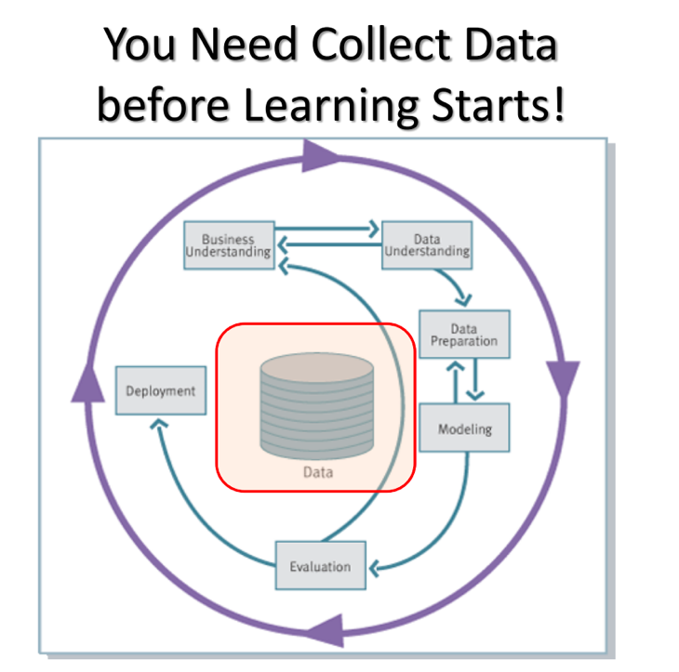
What is Data?
- Collection of data objects and their associated attributes
- An attribute is a property or characteristic of an object
- Examples: eye color of a person, temperature, etc.
- Attribute is also known as variable, field, characteristic, or feature
- A collection of attributes describe an object
- Object is also known as record, point, case, sample, entity, or instance

Type of Attributes
- Nominal
- The values of a nominal attribute are just different names, i.e., nominal attributes provide only enough information to distinguish one object from another.
- Examples: ID numbers, eye color, zip codes, sex:{Male, female}
- Operations: mode, entropy, contingency correlation, X^2 test
- Ordinal
- The values of an ordinal attribute provide enough information to order objects.
- Examples: hardness of minerals, {good, better, best}, grades, street numbers
- Operations: Median, percentiles, rank, correlation, run tests, sign tests
- Interval
- For interval attributes, the differences between values are meaningful, i.e., a unit of measurement exists.
- Examples: calendar dates, temperature in Celsius or Fahrenheit
- Operations: mean, standard deviation, Pearson's correlation, t and F tests
- Ratio
- For ratio variables, both differences and ratios are meaningful.
- Examples: temperature in Kelvin, monetary quantities, counts, age, mass, length, electrical current
- Operations: geometric mean, harmonic mean, percent variation

Discrete and Continuous Attributes
- Discrete attribute
- Has only a finite or countable set of values.
- Examples: zip codes, number of employees, or sale counts.
- Often represented as integer variables.
- Note: binary attributes are a special case of discrete attributes.
- Continuous attribute
- Has real numbers as attribute values.
- Examples: temperature, stock prices, or net income.
- Continuous attributes are typically represented as floating-point variables.

Type of Data:
- Record
- Data matrix
- Transaction data
- Graph
- Social networks We often deal with a mixture of different types data
- Molecular structures
- Ordered
- Spatial data
- Temporal data
- Sequential data
- Genetic sequence data

Record Data
Data that consists of a collection of records, each of which consists of a fixed set of attributes.
A row = a recorded data; A column = an attribute

- Data matrix
- If data objects have the same fixed set of numeric attributes, the data objects can be thought of as points in a multi-dimensional space, where each dimension represents a distinct attribute.
- Such data set can be represented as an m by n matrix, where there are m rows (one for each object) and n columns (one for each attribute).
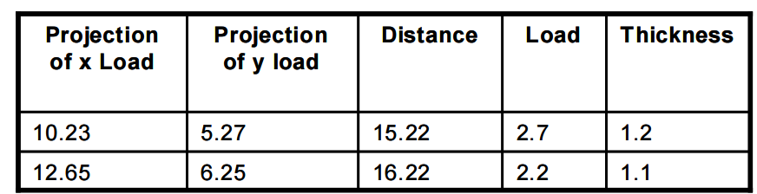

- Transaction Data
- A special type of record data, where
- Each record (transaction) involves a set of items.
- For example, consider a grocery store. The set of products purchased by a customer during one shopping trip constitute a transaction, while the individual products that were purchased are the items.
- A record = a transaction; A item = products in this example
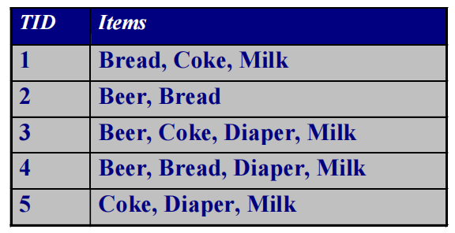

Graph Data
Examples:
Representation of HTML Links
Social Networks

Obtaining Data
- Data sources
– Obtained directly from owner: text file or relational database.
– Collect public available data: web.
- Unstructured VS. structured
– Text file: can be unstructured or structured.
– Relational database: structured.
– Web: unstructured.
– Need to structure the data if necessary. 需要结构化后才能做ML
- Data need to be cleaned
- Tools for data collection and cleaning
– Python, R, Excel, SQL, etc.

Text Files
Most companies use proprietary software to store data that can be exported into text files.
- Usually with .txt extension.
- Sometimes with .csv extension
Commonly used text file format
- Fixed-width: each attribute value starts and stops a fixed positions (columns) in the lines.
- Delimited: there is a delimiter character, usually a tab, space, or comma, that separates different values in the lines.
- CSV: comma separated values Use Python to read csv file

Relational Database
- A relational database is a set of related tables, where each table is a rectangular arrangement of fields and records.
– Rows corresponding to records.
– Columns corresponding to fields.
– Primary key contains unique values to index data.
– Foreign key links tables and can contain duplicate values.
- Python allows you to import data from many database packages
– You may need to install drive for different database, e.g. MySQLdb for MySQL database, before use.
- Basic steps
– Make connection with host name, user name, password, database name, etc.
– Create a cursor to the connected database
– Execute SQL queries and fetch the data through the cursor
– Close the database

Data from Web
- Web sites containing data are structured in all sorts of ways, and the steps required to collect the data for analysis vary greatly.
- No matter the server side is a program or file, what the client side received (and the browser shows) are all files.
– Usually in HTML (hypertext markup language) format.
– HTML uses tags for displaying various items on the web page.

HTML File and Representation
- Most html tags control font, color, images, actions, etc., which are not related to the content of data.
- The layout of html is often controlled using table (old fashion) or CSS (Cascading Style Sheets, new fashion).
- Tablet data are normally put inside table tag, but many data we are interested are not in the table.

Web Crawling
总结:
Data collection is a critical step before learning starts. Data can be described as a collection of objects and their associated attributes. Attributes can be nominal, ordinal, interval or ratio, and data can be organized as record data, transaction data, graph data or ordered data. In practice, data mining often follows the CRISP-DM process, which includes business understanding, data understanding, data preparation, modeling, evaluation and deployment.

Topic 4: （P16,P20）

Classification VS Regression
- Classification
- Predict a label (discrete value)
- Regression
- Predict a response (continuous value)

Model Selection
- Choosing order M of the polynomial (M是多项式的阶数/degree of freedom)
- Goal: achieve good generalization by making accurate predictions for new data
- We use Root-mean-square (RMS) error on data E_RMS = $\sqrt{2E\left(w*\right)}/N$
- Where 𝑁 allows us to compare different sizes of data set, and 𝑤∗ is the solution of minimizing 𝐸 (𝑤)(hypothesis).
- It measures how well the model 𝑤∗ doing in predicting the values of t for new data observations of x.

Overfitting
- Overfitting occurs when a model fits the training data very well but performs poorly on unseen test data.
Overfitting can occur when:
- Learning is performed for too long (e.g. in Neural Networks)
- The examples in the training set are not representative of all possible situations (is usually the case!)
- Model parameters are adjusted to uninformative features in the training set that have no causal relation to the true underlying target function!
- Solution:
- Increasing the size of the data set reduces the overfitting problem
- Regularization:
- Regularization can control the overfitting phenomenon, by adding penalty term to the error function to discourage the coefficients from reaching large values.
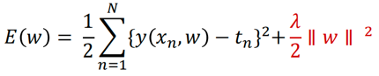
the coefficient 𝜆 governs the relative importance of the regularization term compared with the sum-of-squares error term. 𝜆: 正则化强度
𝜆 controls the effective complexity of the model and hence determines the degree of overfitting
𝜆 太大 underfitting; 𝜆 太小 overfitting

Cross Validation
- Cross Validation is often used to counter overfitting.

- Idea #1:
Choose hyperparameters that work best on the data
- Idea #2:
Split data into train and test, choose hyperparameters that work best on test data
- Idea #3:
Split data into train, val, and test; choose hyperparameters on val and evaluate on test
- Idea #4:
Cross-Validation: Split data into folds, try each fold as validation and average the results

Partition the dataset into S groups, with (S-2) training sets, a validation set and a testing set.
- The training set is used to determine the coefficients w
- The validation set is used to optimize the model complexity (hyperparameters, either M or 𝜆 in the previous example)
- The testing set is used to evaluate the final selected mode
• The procedure is then repeated for all S possible choices, the performance scores from the S runs are then averaged.

Evaluation procedure
- For large datasets, a single split is usually sufficient
- For smaller datasets, rely on cross validation
Cross validation procedure
- Split the data into training, validation and test sets in a repeated fashion
- Estimate the total error as the average of each fold error

Classification Measures
- Error Rate (Accuracy)
- Common performance measure for classification problems
- Classification error rate: proportion of instances misclassified over the whole set of instances
- Error Rate = (FP + FN) / (P + N)
- Accuracy = 1 – Error Rate
- Classification Error Rate on the Training Set can be too optimistic!
- Balanced data:
- roughly equal number of positive / negative examples Recall = TP / (TP + FN)
- Unbalanced data (Error Rate (Accuracy) 在unbalanced data不可靠)
- Unequal number of positive / negative examples Recall = TP / (TP + FN)
- Precision / Recall
- Recall = TP / (TP + FN) 找出正样本比例
- Precision = TP / (TP + FP) 预测为正样本中真正正确的比例

- F-measure (also called as F-Score)
- F-Measure (also called as F-Score) combines recall and precision into a single measure:
- 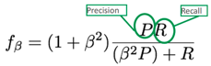, $β$is non-negative real values
- $β$ < 1 Precision 更重要
- $β$ = 1 Precision = Recall
- $β$ > 1 Recall 更重要
- $F$1-Measure 越高，Precision和Recall的平衡越好
- ROC curve
- Receiver Operator Characteristic (ROC) curves plot TP vs FP rates
- Can be achieved by e.g. varying decision threshold of a classifier
- Area under the curve is often used as measure of goodness
- X-arix: FPR = TP / (TP + FN); Y-arix: TPR = FP / (FP + TN); AUC 越大越好
- Confusion matrix
- A visualization tool used to present the results attained by a learner.
- Easy to see if the system is commonly mislabeling one class as another

Curse of Dimensionality
- As dimension 𝐷 increases, the number of independent coefficients grows proportionally
- The amount of data needed to support the result often grows exponentially with the dimensionality.
- 总结:
As dimensionality increases, the volume of the space increases exponentially, and the amount of data needed grows exponentially.

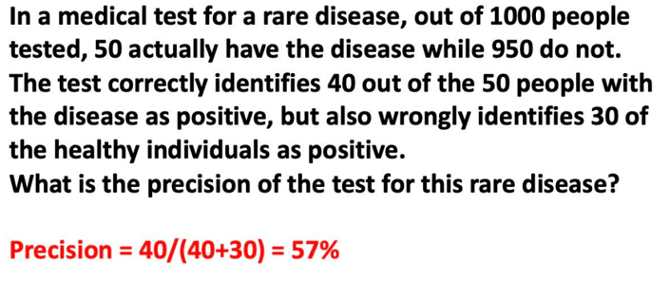

总结:
Good machine learning models aim for good generalization rather than perfect training performance, and techniques such as regularization and cross-validation are essential to prevent overfitting.

Topic 5:

Instance Based Learning
- Directly compare new problem instances with instances seen in training
- No explicit modeling of the training data
- Complexity grows with the training data
- Classical instance based learning technique
- K Nearest Neighbour
总结:
Instance based learning classifies a new instance by directly comparing it with training instances, without building an explicit model.

Nearest Neighbour Algorithm
Distance metric between points in inputs space, common measures are: Euclidean Distance
- 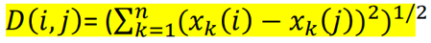 比较谁是最近邻

K-Nearest Neighbour Model:
The class of X is determined by the most common class among its K nearest neighbours.
- Given test point X
- Find the K nearest training inputs to X
- Instance based learning
- Picking K(using N-fold cross validation) to minimize the cross validation error: K小过拟合; K大 欠拟合 采取Majority voting,谁多选谁
- Distance Metrics:
- Euclidean Distance: d(x,y) = $√{(x_{i}-y_i)}^{2}$
- Manhattan Distance: d(x,y) = |x_i – y_i|
- Hamming distance: d(x,y) = $\frac{1}{N}$x_i $≠$ y_i
- Pros and Cons:
- Pros: Simple, effective; no training required; optimal with infinite data
- Cons: Have to select k; issues with unbalanced classes; often slow (need to find those k-neighbours); features must be selected carefully

总结:
Instance based learning classifies new instances by directly comparing them with training instances without building an explicit model. The most common instance based learning algorithm is K-Nearest Neighbour. Given a test point, KNN computes the distance to all training points, selects the K nearest neighbours, and assigns the class by majority voting. The value of K is usually chosen using cross validation.

KNN = store data + measure distance + vote.

Topic 6:

Probability:
Probability provides a principled way to handle uncertainty in machine learning.
All probabilities between 0 and 1: 0<= P(A) <=1
True proposition has probability 1, false has probability 0: P (not A) = P (~A) = 1-P (A)

Random Variables:
- A variable whose possible values are outcomes of a random phenomenon.
- Denotes a quantity (event) that is uncertain.

Boolean Random Variables:
- A is a Boolean-valued random variable
- if A denotes such event that there is some degree of uncertainty as to whether A occurs.

Multivalued Random Variables
- A random variable A can take on exactly one value out of {V1, V2, …, Vk}
- 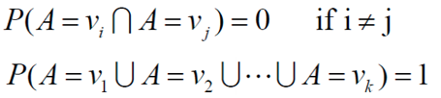

Discrete vs Continuous Random Variable
- Depends on weather outcome values are discrete or continuous
- Instead of summing over all possible outcome in discrete random variable, integrating the probability over all outcome should be 1 in continuous random variable.
- 连续变量某点概率 = 0

Joint Probability
- Consider two random variables A and B P(A $⋂$ B)：A 和 B 同时发生的概率

Marginalization
- We can recover probability distribution of any variable in a joint distribution by summing over the other variables P(A) = $\sum_{j=1}^{k}{P(A ⋂B)}$

Conditional Probability
- P(A|B) = Fraction of worlds in which B is true that also have A true.
- P(A|B) = $\frac{P(A∩B)}{P(B)}$ P(A$∩B)=P(A\left|B\right)P(B)$
- Note: P(A|B) $≠P(B|A)$

Probabilistic Inference
- 不能用 P(M|L) 代替 P(L|M)
- 推理要 反向条件 → Bayes Rule

Bayes Rule
- P(A|B) = $\frac{P(A ∩B)}{P(B)}$ = $\frac{P\left(B | A\right)P(A)}{P(B)}$
- P(A): Prior
- P(B|A): Likelihood
- P(B): Evidence
- P(A|B): Posterior

Bayesian Learning
- P(h|x) = $\frac{P(x|h)P(h)}{P(x)}$
- P(h): prior belief (probability of hypothesis before seeing any data)
- P(x|h): likelihood (probability of the data if the hypothesis is true)
- P(x) = $\sum_{h}{P\left(x | h\right)P(h)}$: data evidence (marginal probability of the data)
- P(h|x): posterior (probability of hypothesis after having seen the data )

Choosing Hypotheses:
- MAP (Maximum a posterior hypothesis)
- $h_{MAP}$= arg max p(h|x) = arg max $\frac{P\left(x | h\right)P(h)}{P(x)}$ = arg max P(x|h)P(h)
Note P(x) is independent of h, hence can be ignored
- ML (Maximum likelihood hypothesis)
- $h_{MAP}$= arg max P(x|h)P(h)

ML is a special case of MAP when priors are uniform.

Bayesian Classifier
Choose the class with the maximum posterior probability
- Y = arg max p($d_{i}$|X) = arg max p(x1, x2, x3, x4|$d_{i}$)P($d_{i})$
But, p (x1, x2, x3, x4|$d_{i}$) is much more difficult to estimate. Bayes Classifier

Naïve Bayes Classifier
The attribute values are conditionally independent given the target value.
- P(x1, x2, …, $x_{n}$|$d_{i}$) = $\prod_{i}^{n}{P(x_{i}|d_{i})}$
- Y = arg max P($d_{i}$) $\prod_{k=1}^{4}{P(x_{k}}$|$d_{i}$)

Estimating Probabilities
- P = $\frac{N_{c}}{N}$, if $N_{c}$ = 0, the P = 0
- M-estimate:
- $\frac{{mP+N}_{c}}{m+N}$,
- m is a constant called the equivalent sample size, which determines how heavily to weight P relative to the observed data.
- A typical method for choosing P in the absence of other information is to assume uniform priors: If an attribute has k possible values we set P=1/K.

总结:
Bayesian learning uses probability to model uncertainty. Given observed data, Bayes’ rule is used to update prior beliefs and compute posterior probabilities. In classification, the Bayesian approach assigns a new instance to the class with the maximum posterior probability. The Naïve Bayes classifier simplifies computation by assuming conditional independence among attributes given the class label.

Bayesian learning = prior × likelihood → posterior.

Topic 7:（P12-conditional probability,p14,p19,p57,算cluster）

Clustering
Clustering is the task of grouping data instances such that instances within the same cluster are more similar to each other than to those in different clusters.

K-Means Algorithm
An algorithm for partitioning (or clustering) N data points into K disjoint subsets $S_{j}$ containing $N_{j}$ data points
- Define X(i) = [$x_{1}\left(i\right), x_{2}\left(i\right), …, x_{n}\left(i\right)$], i= 1,2,…, N, as N data points
- We want to cluster these N points into K subsets, or K clusters, where K is pre-set
- For each cluster, M(j) = [$m_{1}\left(j\right), m_{2}\left(j\right), m_{n}\left(j\right),$], j=1,2,…,K, as its prototype or cluster centroids.
- Distance between data point and cluster prototype:
D(X(i), M(j)) = ||X(i) – M(j)|| = $\sqrt{\sum_{l=1}^{n}{{\left(x_{l}\left(i\right)-m_{l}\left(j\right)\right)}^{2}}}$

- Step 1
- Arbitrarily choose from the given sample set k initial cluster centres: it can be first K samples of the sample set or can also be generated randomly
- Step 2
- Assign each of the samples to one of the clusters according to the distance between the sample and the centre of the cluster:
- Step 3
- Update the cluster centres
- $M^{(t+1)}$(j) = $\frac{!}{N_{j}^{(t)}}\sum_{X(i)∈C^{(t)}(j)}{X(i)}$, $N_{j}^{(t)}$ is the number of samples in $C^{(t)}(j)$
- Step 4
- Calculate the error of approximation
- E(t) = $\sum_{j=1}^{K}{\sum_{X\left(i\right)∈C^{(t)}(j)}{|\left|X\left(i\right)-M^{\left(t\right)}\left(j\right)\right||}}$
- Step 5
- If the terminating criterion is met, then stop,
- Otherwise Set t = t+1Go to Step 2
- Stopping criterions:
- The errors do not change significantly in two consecutive epochs
|E(t)-E(t-1)|<e, where e is some preset small value
- No further change in the assignment of the data points to clusters in two consecutive epochs.
- It can also stop after a fixed number of epochs regardless of the error
总结:
K-means alternates between assignment and update steps until convergence.
- Strengths
- Simple: easy to understand and to implement
- Efficient
- The most popular clustering algorithm
- Note that: it terminates at a local optimum if cost function E is used. The global optimum is hard to find due to complexity.
- Weakness
- The user needs to specify k.
- The algorithm is sensitive to outliers
- Outliers are data points that are very far away from other data points.
- Outliers could be errors in the data recording or some special data points with very different values.
To deal with outliers:
- One method is to remove some data points in the clustering process that are much further away from the centroids than other data points. To be safe, we may want to monitor these possible outliers over a few iterations and then decide to remove them.
- Another method is to perform random sampling. Since in sampling we only choose a small subset of the data points, the chance of selecting an outlier is very small. Assign the rest of the data points to the clusters by distance or similarity comparison, or classification
- Some remarks:
- Is a gradient descent algorithm, trying to minimize a cost function E
- In general, the algorithm does not achieve a global minimum of E over the assignments
- Sensitive to initial choice of cluster centers. Different starting cluster centroids may lead to different solution
- Is a popular method, many more advanced methods derived from this simple algorithm

Hierarchical Clustering
Produce a nested sequence of clusters, a tree, also called Dendrogram.
- Agglomerative (bottom up) clustering: It builds the dendrogram (tree) from the bottom level, and
– merges the most similar (or nearest) pair of clusters
– stops when all the data points are merged into a single cluster (i.e., the root cluster).
- Divisive (top down) clustering: It starts with all data points in one cluster, the root.
– Splits the root into a set of child clusters. Each child cluster is recursively divided further
– stops when only singleton clusters of individual data points remain, i.e., each cluster with only a single point

Holes in data space:
- A hole is a region in the data space that contains no or few data points. Reasons:
• insufficient data in certain areas, and/or
• certain attribute-value combinations are not possible or seldom occur.
- Holes are useful: Holes can reveal useful constraints or hidden knowledge in data.
总结：
Clustering is an unsupervised learning technique that groups similar data instances together. K-means clustering partitions data into K clusters by iteratively assigning points to the nearest centroid and updating the centroids. Hierarchical clustering builds a tree structure called a dendrogram, which shows how clusters are merged or split at different levels. Clustering is widely used but difficult to evaluate due to the lack of ground truth.

K-means = assign + update; Hierarchical = merge + tree.

Topic 8:（p10,p13,p17,p19.p25,p28）

Trees
- Node
- Root
- Leaf
- Branch
- Path
- Depth

Decision Trees:
A hierarchical data structure that represents data by implementing a divide and conquer strategy
- Each node is associated with a feature (one of the elements of a feature vector that represent an object)
- Each node test the value of its associated feature
- There is one branch for each value of the feature
- Leaves specify the categories (classes)
- Can categorize instances into multiple disjoint categories – multi-class

Variation of Decision Trees:
- Classification tree
– The output is discrete (label).
– The leaves give the predicted class as well as the probability of class membership.
- Regression tree
– The output is continuous.
– The leaves give the predicted value of the output.
- Tree with binary splits
- Tree with multiway splits

Step 1: Picking the root node
- The goal is to have the resulting decision tree as small as possible (Occam’s Razor)
Step 2: Recursively branching

Entropy
Entropy(S) = -$P_{+}$log($P_{+}$) - $P_{-}$log($P_{-}$)
- S is a sample of training examples
- $P_{+}$ is the proportion of positive examples in S
- $P_{-}$ is the proportion of negative examples in S
- Entropy measures the impurity of S
- Note $P_{+}$ = 1- $P_{-}$
- The entropy become maximal(1.0) when $P_{+}$ = 0.5 and $P_{-}$ = 0.5 so that the positive and negative examples are maximally mixed
This is why it can be used as a measure of “impurity”
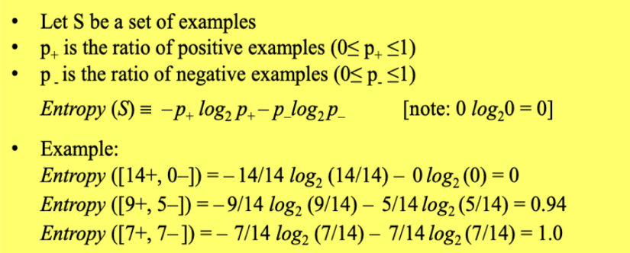

Entropy(IIP)
- The idea: associate information with probability
- A random event E with probability P(E) contains: I(E) = log($\frac{1}{P(E)}$) = -log(P(E)) units of information
- Suppose that grey level values are generated by a random variable, then $r_{k}$ contains: I ($r_{k})=-log⁡(P\left(r_{k}\right))$ units of information
- Note: I(E)=0 when P(E)=1
- Entropy is the average information content of an image, a measure of histogram dispersion

Information Gain
- Gain (S, A) = expected reduction in entropy due to sorting on A
Gain(S, A) $≡$ Entropy(S) - $\sum_{v∈Values\left(A\right)}{\frac{\left|S_{v}\right|}{\left|S\right|}}Entropy(S_{v})$
- Values (A) is the set of all possible values for attribute A, $S_{v}$ is the subset of S which attribute A has value v, |S| and |$S_{v}$| represent the number of samples in set S and set $S_{v}$ respectively
- Gain(S,A) is the expected reduction in entropy caused by knowing the value of attribute A.

Summary on Build Decision Tree
- Recursive partitioning
- a top-down, greedy algorithm to fit the decision tree for the data.
- Top-down
- Starting at the root node, split the data into subgroups that are as homogeneous as possible with respect to the output.
- Greedy method
- Always make a locally optimal choice in the hope that this will lead to a globally optimal solution.

Step 1: Selection of the best split
- Select the best split on each feature (i.e. choose number of branches and cut-off points).
- Select the best of these.

Step 2: Stop-splitting rule
- Stop expanding a node when all the data belong to the same class
- Stop expanding a node when all the data have similar feature values
- Early termination
- Rules:
- A simple method:
- Continue splitting until every node is pure or contains only one instance.
- Fit training data perfectly but may predict poorly on new data.
- Two approaches:
- Top-down stopping rules (pre-pruning).
- Bottom-up assessment criteria (post-pruning).
Step 3: Assignment of each leaf node to a class
- Predict the value of the output at each leaf node.
- Classification tree
Classify an input sample with the most common label in the leaf node (the percentage of the label is the probability).
- Regression tree
Predict an input in a node by the sample mean of the output values in the node.

Advantages:
- Easy to interpret
– Tree structured presentation.
- Allow mixed input data types
– Discrete or continuous.
- Allow discrete or continuous output
- Robust to outliers in feature vectors
- No problem with missing values
- Automatically
– Accommodates nonlinearity.
– Selects input variables.
Disadvantages:
- Most algorithms use univariate splits (split on only one variable)
– Solution: Linear combination split (a1x1+a2x2< c?).
- Unstable fitted tree
– Often a small change in the data result in a very different series of splits.
- Lack of smoothness (step function) in regression tree
- Splitting turns continuous input features into discrete features
- Spitting using a “greedy” algorithm
– While each split is optimal, the overall tree is not.

Overfitting
- Overfitting results in decision trees that are more complex than necessary.
- Training error no longer provides a good estimate of how well the tree will perform on previously unseen data.
- Need new ways for estimating errors

Address Overfitting:
- Pre-Pruning (Early Stopping Rule)
- Stop the algorithm before it becomes a fully-grown tree.
- Typical stopping conditions for a node
– Stop if all samples belong to the same class.
– Stop if all the features values are the same.
- More restrictive conditions
– Stop if number of samples is less than some user-specified threshold.
– Stop if expanding the current node does not improve impurity measures, e.g., information gain.
- Post-pruning
- Grow decision tree to its entirety.
- Trim the nodes of the decision tree in a bottom-up fashion.
- If generalization error improves after trimming, replace sub-tree by a leaf node.
- Class label of leaf node is determined from majority class of samples in the sub-tree.
总结：
Post-pruning usually gives better performance.

总结:
A decision tree is a hierarchical structure that classifies data using a divide-and-conquer strategy. At each node, the algorithm selects the attribute that maximizes information gain, which measures the expected reduction in entropy. The tree is grown recursively until stopping criteria are met. To avoid overfitting, pruning techniques such as pre-pruning and post-pruning are applied.

Decision Tree = split by information gain, stop wisely, prune to generalize.

Topic 9: (p5,)

Random Forest
- Random Forests can be regarded as ensemble learning with decision trees
- Combine their predictions using majority voting
- The main two concepts behind random forests are:
- The wisdom of the crowd — a large group of experts are collectively smarter than individual experts
- Diversification — a set of uncorrelated tress
- We have a single data set, so how do we obtain slightly different trees?
- Bagging (Bootstrap Aggregating):
• Take random subsets of data points from the training set to create N smaller data sets
• Fit a decision tree on each subset
• Results in low variance.
- Random Subspace Method (also known as Feature Bagging):
• Fit N different decision trees by constraining each one to operate on a random subset of features

- Why use random forest?
- Accurate predictions
- Standard decision trees often have high variance and low bias
High chance of overfitting (with ‘deep trees’, many nodes)
- With a Random Forest, the bias remains low and the variance is reduced, thus we decrease the chances of overfitting
- Flexible
- Can be used with many features
- Can be used for classification but also
- Disadvantages:
- When the number of variables is large, but the fraction of relevant variables is small, random forests are likely to perform poorly when m is small
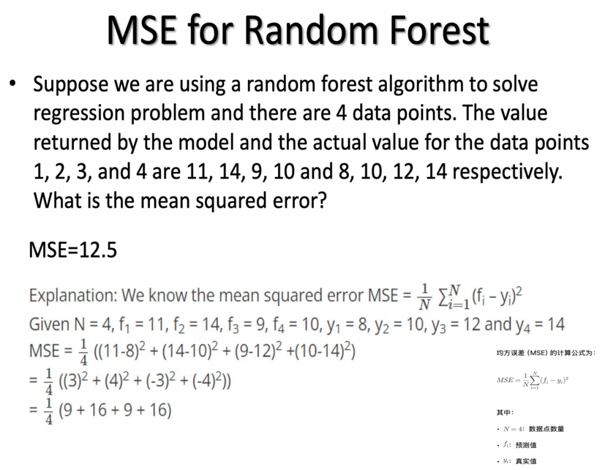
总结;
Random Forest is an ensemble learning method that constructs multiple decision trees using bagging and random subspace methods. Each tree is trained on a different bootstrap sample and a random subset of features, which reduces correlation between trees. The final prediction is made by majority voting for classification or averaging for regression. Random Forest achieves high accuracy by reducing variance while maintaining low bias.

Random Forest = many diverse trees + voting → low variance, less overfitting.

Topic 10: (p3,p7,p16-17,p26，p28,p34,)

Variance = Standard deviation ^2
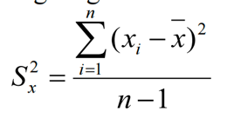
- Gives information on variability of a single variable

Covariance
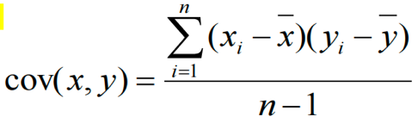
- Measures the correlation between X and Y
- Cov(X,Y) = 0: independent
- Cov(X,Y) > 0: move in the same direction
- Cov(X,Y) < 0: move in the opposite direction
- Gives information on the degree to which two variables vary together
- When X↑and Y↑: cov(x,y) = positive
- When X↑and Y↓: cov(x,y) = negative
- When no constant relationship: cov(x,y) = 0

Problem with Covariance:
- The value obtained by covariance is dependent on the size of the data’s standard deviations:
- if large, the value will be greater than if small…
- even if the relationship between x and y is exactly the same in the large versus small standard deviation datasets.

Correlation
- A link or relationship between two things that happen.
- Correlation $≠$ Causation:
- Hidden varriable; reverse causation; coincidence
- In order to infer causality: manipulate independent variable and observe effect on dependent variable

Scatter Plots:
Scatter plots are used to show whether there is a relationship between two sets of data. The relationship between the data can be described as either:
- Positive correlation. As one variable increases so does the other.
- Negative correlation. As one variable increases the other decreases.
- No correlation. Both variables vary with no clear relationship.
- It is difficult to judge correlational strength by eye alone

Pearson’s Correlation Coefficient(r)
- There are many kinds of correlation coefficients but the most commonly used measure of correlation is the Pearson’s correlation coefficient (r)
- The Pearson’s r range between -1 to +1([-1,1]).
- r = +1 all points on upward sloping line
- r = -1 all points on downward line
- r = 0 no line or horizontal line
- The closer r is to +1 or –1, the stronger the correlation
- Sign indicates the direction.
- The numerical value indicates the strength of the linear
- relationship between the variables.
- Perfect correlation : -1 or 1
- No correlation: 0
- A correlation of zero indicates the value are not linearly related.
- However, it is possible they are related in curvilinear fashion.
- Divides the covariance by the multiplied standard deviations of x and y:${ r}_{xy}= \frac{cov(x,y)}{S_{x}S_{y}}$, standardizes the covariance value.
- Direction: positive, negative, ≈0
- Strength: the closer |r| is to 1, the stronger the correlation
- 0.0 $≤$|r| < 0.3 weak correlation
- 0.3 $≤$ |r| < 0.7 moderate correlation
- 0.7 $≤$|r| < 1.0 strong correlation
- |r| = 1.0 perfect correlation

Topic 11: (p8,p10-p11,p23,p29,p55-p59,)

Data Processing:
In object detection, each window is very high dimension data, which cause high cost, redundancy, noise.

General Framework:
Raw Data Feature extraction Dimensionality Reduction Classifier

Feature extraction / Dimensionality Reduction
- It is impossible to processing raw image data (pixels) directly
- Too many of them (or data dimensionality too high)
- Curse of dimensionality problem
- Process the raw pixel to produce a smaller set of numbers which will capture most information contained in the original data – this is often called a feature vector (feature extraction)
- Basic Principle
- From a raw data (vector) X of N-dimension to a new vector Y of n-dimension (n < < N) via a transformation matrix A such that Y will capture most information in X

PCA
- Principal Component Analysis (PCA) is one of the most often used dimensionality reduction technique.
- Goals:
- We wish to explain/summarize the underlying variance-covariance structure of a large set of variables through a few linear combinations of these variables.
- Applications:
- Data Visualization
- Data Reduction
- Data Classification
- Trend Analysis
- Factor Analysis
- Noise Reduction
- Objective of PCA
- Minimize redundancy, measured by the magnitude of the covariance
- Maximize the signal, measured by the variance (diagonal element of the covariance matrix)

Covariance matrix
- If our goal is to reduce redundancy, then we want each variable co-vary a little as possible
- Precisely, we want the covariance between separate measurements to be zero.
- Diagonalise the covariance matrix
- Optimal covariance matrix—off-diagonal terms set zero can reduce redundancy
Solving PCA: diagonalizing the covariance matrix
- PCA choose the simplest method – eigenvector decomposition
- PCA assumes all basis vectors are orthonormal. P is an orthonormal matrix
- PCA assumes the directions with the largest variances are the most important or most principal.

PCA Procedures(50-59)
- Subtract the mean(零均值化)
- Calculate the covariance matrix
- Calculate the eigenvectors and eigenvalues of the covariance matrix

总结:
Data processing aims to handle high-dimensional data by extracting informative features and reducing dimensionality. PCA is a widely used technique that transforms data into a new coordinate system where the directions of maximum variance are identified as principal components. By projecting data onto the leading eigenvectors of the covariance matrix, PCA removes redundancy and reduces dimensionality, although the most significant components are not always the most discriminative for classification.

PCA finds directions of maximum variance, not necessarily maximum discrimination.

Topic 12: (p12,p22-p23,p50)

Perceptron
- Perceptron is a type of Artificial Neural Network (ANN)
- Perceptron takes a vector of realvalued inputs, calculates a linear combination of these inputs. Then it outputs 1 if the result is greater than some threshold and -1 otherwise.
- R = $w_{0}$ + $w_{1}x_{1}$ + … +$w_{n}x_{n}$ = $w_{0}$ + $\sum_{i=1}^{n}{w_{i}x_{i}}$
- Output = o = sign(R) = + 1, if R > 0
- 1, otherwise
5. Perceptron can be regarded as representing a hyperplane decision surface in the n-dimensional feature space of instances.
6. The perceptron outputs a 1 for instances lying on one side of the hyperplane and a -1 for instances lying on the other side. This hyperplane is called the Decision Surface
7. Perceptron can only solve Linearly Separable Problems (AND OR ✅ XOR ❌)

Training Algorithm
- Training sample pairs (X, d), where X is the input vector, d is the input vector’s classification (+1 or -1) is iteratively presented to the network for training, one at a time, until the process converges.
- The Procedure is as follows:
- Set the weights to small random values, e.g. in the range (-1,1)
- Present X, and calculate:
R = $\sum_{i=0}^{n}{w_{i}x_{i}}$, o=sign(R)= +1, if R>0;
-1, otherwise
- Update the weights
${ w}_{i}$ $w_{i}$+$η\left(d-o\right)x_{i}, i=0,1,…, n$. 0< $η$<1, is the raining rate
- Repeat by going to step 2
- Convergence theorem
- The perceptron training rule will converge (finding a weight vector correctly classifies all training samples) within a finite number of iterations, provided the training examples are linearly separable and provided a sufficiently small $η$ is used.

ADLINE VS Perceptron
- When the problem is not linearly separable, perceptron will fail to converge.
- ADLINE can overcome this difficulty by finding a best fit approximation to the target.

ADALINE overcomes non-linearly separable problems by finding a best-fit approximation.

Adaptive Linear Element (ADLINE) Error Function
- The training error specifies the difference between the output of the ALDLINE and the desired target.
- The error is defined as: E(W) = $\frac{1}{2}\sum_{k=1}^{K}{{(d\left(k\right)-o\left(k\right))}^{2}}$
o(k) = $W^{T}X(k)$ is the output of presenting the training input X(k)

- The smaller E(W) is, the closer is the approximation
- We need to find W, based on the given training set, that minimizes the error E(W)

The Gradient Descent Rule
- The gradient specifies the direction that produces the steepest increase in E. (i.e., speed of change (slope) of the function in one direction.)
- Negative of the vector gives the direction of steepest decrease in E.

Training procedure:
- Initialize $w_{i}$ to small vales, e.g., in the range of (-1, 1), choose a learning rate, e.g., $η$ = 0.2
- Until the termination condition is met, Do
- For all training sample pair (X(k), d(k)), input the instance X(k) and compute
- $δ_{i}= - \sum_{k=1}^{K}{(d\left(k\right)-o\left(k\right))x_{i}(k)}$
- For each weight $w_{j}$,Do
- $w_{i}$ $w_{i}-ηδ_{i}$
- Batch Mode: (使用所有样本计算梯度,再统一更新权重,稳定但慢)
- gradients accumulated over ALL samples first
- Then update the weights

Stochastic (Incremental) Gradient Descent
- Also called online mode, Least Mean Square (LMS), Widrow-Hoff, and Delta Rule
- Initialise $w_{i}$ to small vales, e.g., in the range of (-1, 1), choose a learning rate, e.g., $η$ = 0.01 (should be smaller than batch mode)
- Until the termination condition is met, Do
- For EACH training sample pair (X(k), d(k)), compute
- $δ_{i}= -(d\left(k\right)-o\left(k\right))x_{i}(k)$
- For each weight $w_{i}$, Do
- $w_{i}$ $w_{i}-ηδ_{i}$
- Online Mode: (每个样本立即更新,又称：LMS; Widrow–Hoff; Delta Rule)
- Calculate gradient for EACH (or a SUBSET of)samples
- Then update the weights

总结:
Delta Rule = Stochastic Gradient Descent for ADALINE

Training Iterations, Epochs
- Training is an iterative process; training samples will have to be used repeatedly for training.
- Note the order of the training sample presentation between epochs can (and should normally) be different.
- Normally, training will take many epochs to complete.
Termination of Training
To terminate training, there are normally two ways:
- When a pre-set number of training epochs is reached.
- When the error is smaller than a pre-set value.
E(W) = $\frac{1}{2}\sum_{k=1}^{K}{{(d\left(k\right)-o\left(k\right))}^{2}}$
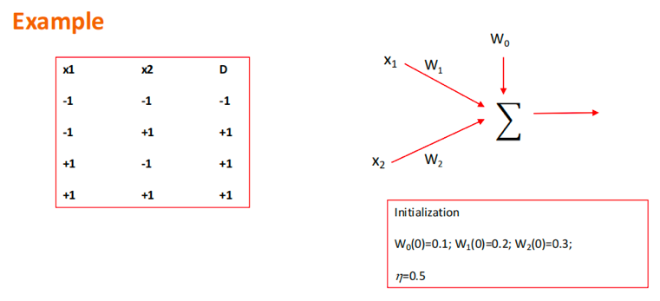
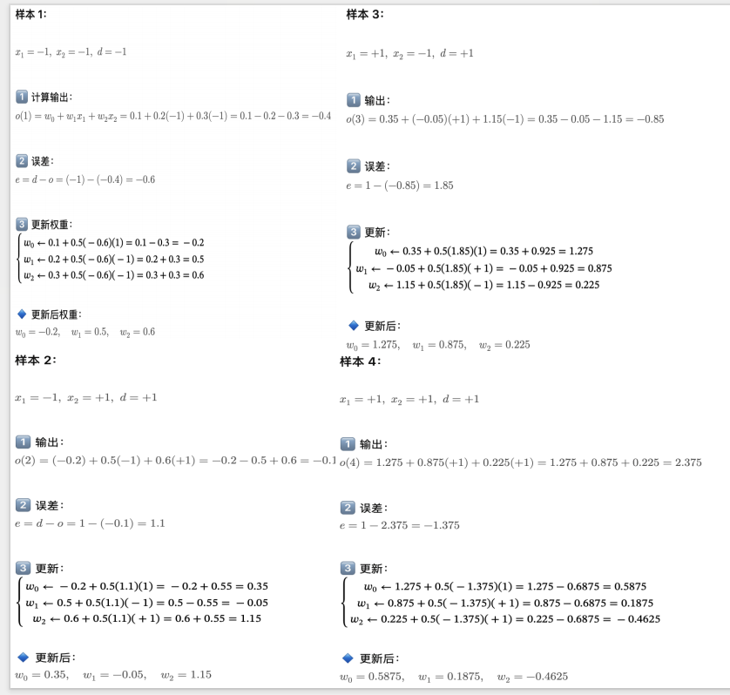
总结:
A perceptron is a linear classifier that computes a weighted sum of inputs followed by a threshold function, and can only solve linearly separable problems. Its learning rule updates weights only when misclassification occurs. ADALINE improves upon the perceptron by using a continuous output and minimizing a squared error function via gradient descent. This allows ADALINE to approximate solutions even when the data are not linearly separable.
Perceptron learns by mistakes; ADALINE learns by minimizing error.
Topic 13: (p5,p6,p7, p11, p51, )

Limitations of Single Layer Perceptron
Only express linear decision surfaces

Multilayer Perceptron (MLP)
- A more general network architecture: between the input and output layers there are hidden layers
- Hidden nodes do not directly receive inputs nor send outputs to the external environment
- Fully connected between layers

MLP Architecture
- Feedforward network: connections between the nodes do not form a cycle
- MLP usually interconnected in a feed-forward way
- The input layer does not count as a layer

Activation Function
- Activation functions are mathematical equations that determine the output of a neural network. The function is attached to each neuron in the network and determines whether it should be activated (“fired”) or not, based on whether each neuron’s input is relevant for the model’s prediction. Activation functions also help normalize the output of each neuron to a range between 1 and 0 or between -1 and 1.
- The activation function can be considered as a mathematical “gate” in between the input feeding the current neuron and its output going to the next layer.

Sigmoid: f(z) = $\frac{1}{1+e^{-x}}$
Tanh: f(z) = $\frac{2}{1+e^{-2x}}$ – 1
- Activations around 0 are better for gradient descent convergence
Rectified Linear (ReLU) : f(z) = max(0, z)
- Less smooth, but much faster (note: not differentiable at 0)
Leaky ReLU: f(z) = 0.001z, z<0
z, otherwise
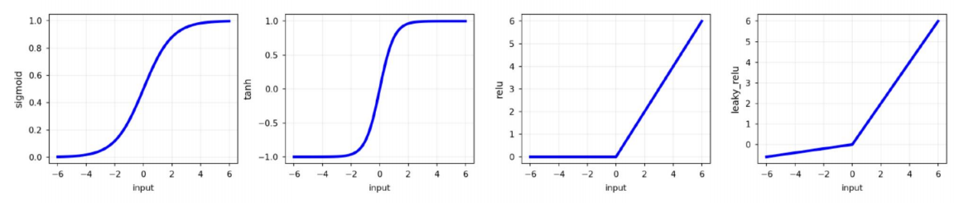

ReLU Advantages:
- Solves Vanishing Gradient Problem
- Computational Efficiency
- Sparsity
Disvantages:
- Can cause “dying ReLU” problem—neurons stuck in negative region output 0 permanently and stop learning

Objective Functions for Training: Objective = Loss + Regularization
- Quadratic Loss
- The same objective as Linear Regression. E.g., mean squared error$∆$
- Forward: J = $\frac{1}{2}{(y-y^{*})}^{2}$
- Backward: $\frac{dJ}{dy}=y-y^{*}$
- Cross-Entropy
- The same objective as Logistic Regression. E.g., negative log likelihood
- This requires probabilities, so we add an additional “softmax” layer at the end of our network
- Forward: J = $y^{*}$log(y) + (1-$y^{*})$log(1-y)
- Backward: $\frac{dJ}{dy}= y^{*}\frac{1}{y}+$(1-$y^{*})\frac{1}{y-1}$

Back-propagation Algorithm
- Present the training sample, calculate the outputs
- Note that we initialize all the weights similar to single perceptron.
- For each output unit k, calculate
- $δ_{k}=o_{k}(1-o_{k)}(d_{k}-o_{k})$
- For hidden unit h, calculate
- $δ_{h}= o_{h}\left(1-o_{h}\right) \sum_{k∈outputs}{W_{h,k}δ_{k}}$
- Update the output layer weights, $W_{h,k}$
- $W_{h,k}$ $W_{h,k}+ ∆W_{h,k}$
- $∆W_{h,k}= ηδ_{k}o_{h}$, where $o_{h}$ is the output of hidden layer h

Back-propagation Summary:
- Initialize weights randomly
- For input training example x compute the outputs (forward pass)
- Compute the output neurons errors and then compute the update rule for output layer weights (backward pass)
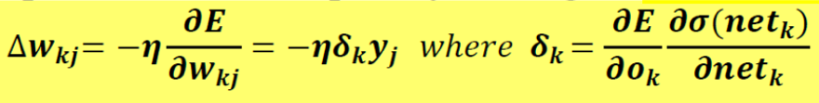
- Compute hidden neurons errors and then compute the update rule for hidden layer weights (backward pass)
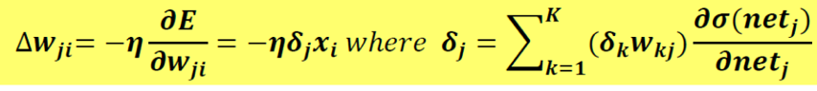
- Compute the sum of all $∆w,$ once all training examples have been presented to the network
- Update weights: $W_{i}$ $W_{i}+ ∆W_{i}$
- Repeat steps2-6 until stopping criterion is met
The algorithm will converge to a weight vector with minimum error, given that the learning rate sufficiently small

- Gradient descent over entire network weight vector.
- Will find a local, not necessarily a global error minimum.
- In practice, it often works well (can run multiple times).
- Minimizes error over all training samples.
– Will it generalize to subsequent examples? i.e., will the trained network perform well on data outside the training sample.
- Training can take thousands of iterations.
- After training, use the network is fast.

Generalization, Overfitting and Stopping Criterion
• Stop training when the validation set has the lowest error
• Error might decrease in the training set but increase in the ‘validation’ set (overfitting!)
• Early stopping: one way to avoid overfitting

Dropout
Randomly remove some nodes in the network (along with incoming and outgoing edges)
Notes:
- Usually p>=0.5 (P is probability of keeping node)
- Input layers p should be much higher (and use noise instead of dropout)
- Most deep learning frameworks come with a dropout layer

Weight Decay
- L2 Penalty: Penalize squared weights
- Keeps weight small unless error derivative is very large.
- Prevent from fitting sampling error.
- Smoother model (output changes slower as the input change).
- If network has two similar inputs, it prefers to put half the weight on each rather than all the weight on one.
- L1 Penalty: Penalize absolute weights
- Allow for a few weights to remain large

Normalization
- Network Input Normalization
- Batch Normalization (BatchNorm, BN)
- Normalize hidden layer inputs to mini-batch mean & variance
- Reduces impact of earlier layers on later layers
- Batch Renormalization (BatchRenorm, BR)
- Fixes difference b/w training and inference by keeping a moving average asymptotically approaching a global normalization.

总结：
A multilayer perceptron is a feedforward neural network with one or more hidden layers, which overcomes the limitation of single-layer perceptrons by learning non-linear decision boundaries. The network is trained using the backpropagation algorithm, which applies the chain rule to propagate errors backward and updates weights via gradient descent. While powerful, MLPs are prone to overfitting, which can be alleviated using techniques such as early stopping, dropout and weight decay.

Hidden layers + non-linear activations + backpropagation = MLP.

Topic 14: (p6,p7,p8,)

Classification Margin
- Distance from example $x_{s}$ to the separator is 𝑟 = $\frac{|w^{T}x_{s}+b|}{|\left|w\right||}$
- Examples closest to the hyperplane are support vectors.
- Margin ρ of the separator is the distance between support vectors.

Maximum Margin Classification
• Maximizing the margin is good according to intuition.
• Implying that only support vectors matter; other training examples are ignorable.

Linear SVM Mathematically
- Let training set {($x_{i}$, $y_{i}$)}𝑖=1..𝑤, $x_{i}$ ∈ $R^{d}$, $y_{i}$ ∈ {−1,1} be separated by a hyperplane with margin r=2d. Then for each training example ($x_{i}$, $y_{i}$):
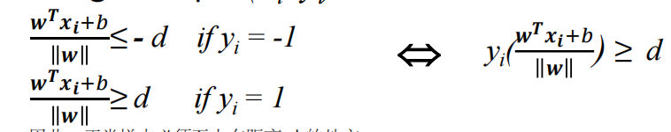
- For every support vector $x_{s}$ the above inequality is an equality. After rescaling, we can obtain
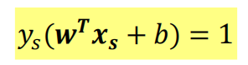
- Alternatively, we have
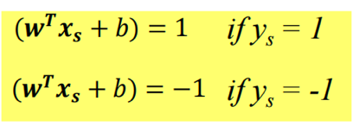
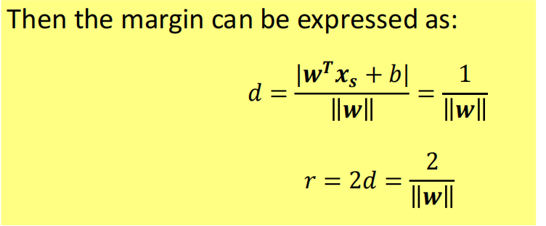

Soft Margin Classification
- Slack variables ξi can be added to allow misclassification of difficult or noisy examples, resulting margin called soft.
- Slack variables ξi which measures the distance of the point to its marginal hyperplane if it is on the wrong side, otherwise 0, can be added to allow misclassification of difficult or noisy examples, resulting margin called soft
- Applying Soft Margin, SVM tolerates a few dots to get misclassified and tries to balance the trade-off between finding a line that maximizes the margin and minimizes the misclassification.

Non-Linear SVM
- Datasets that are linearly separable with some noise work out great
- the original feature space can always be mapped to some higher-dimensional feature space where the training set is separable
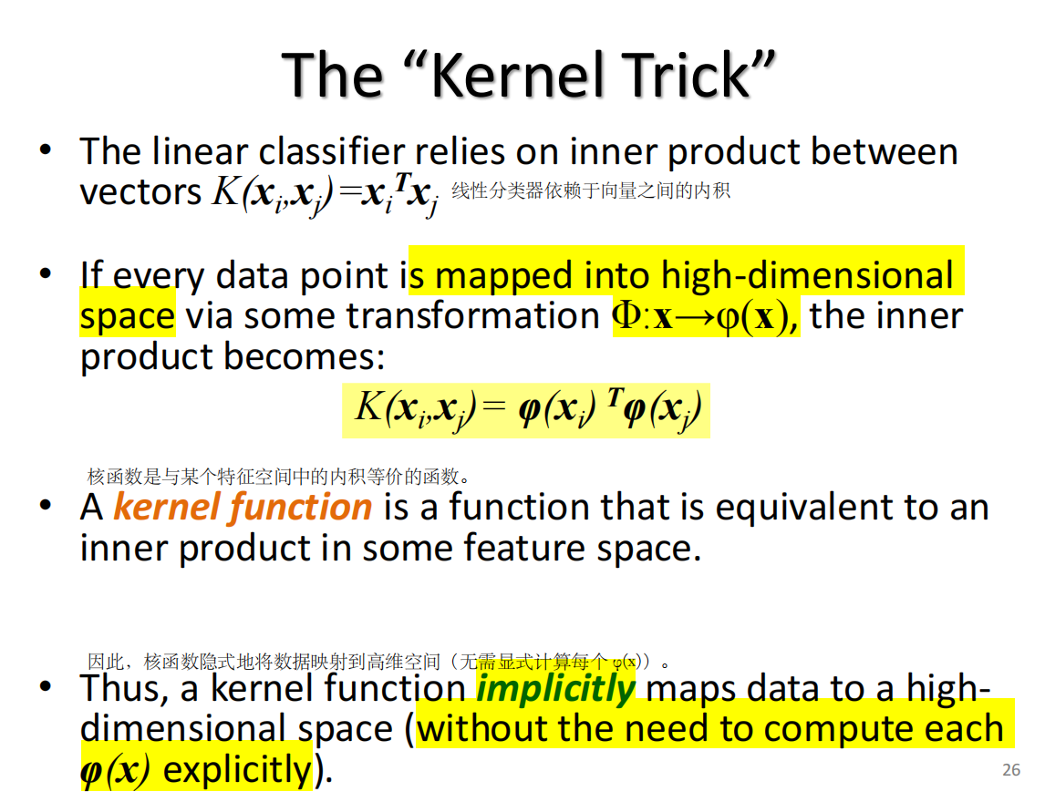
总结：The kernel trick allows us to compute inner products in a high-dimensional feature space without explicitly performing the mapping.
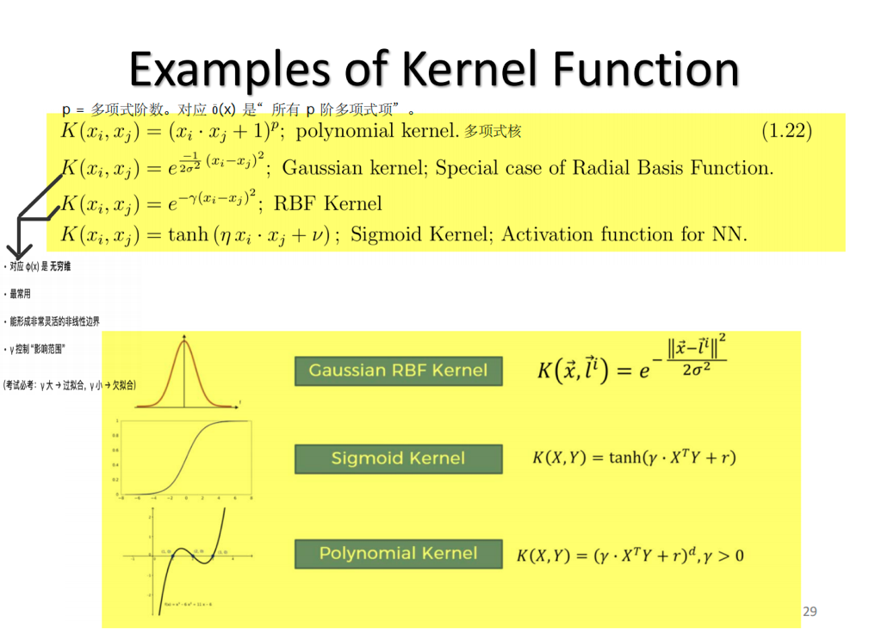

SVM Parameter Tuning
• The gamma parameter is the inverse of the standard deviation of the RBF kernel (Gaussian function), which is used as similarity measure between two points.
• Small gamma, large variance and vice versa.
• Large may cause complicated decision boundary or give rise to over-fitting.

Multi-Class Classification
- Some algorithms are designed for binary classification problems:
- – Logistic Regression
- – Perceptron
- – Support Vector Machines
- Instead, heuristic methods can be used to split a multi-class classification problem into multiple binary classification datasets and train a binary classification model each
- – One-vs-All (OVA)
- Every class is paired with the remaining classes
- The base classifier needs to produce a real-valued confidence score for its decision, rather than just a class label
- Making decisions means applying all classifiers to an unseen sample x and predicting the label k for which the corresponding classifier reports the highest confidence score
- – One-vs-One (OvO)
- Every class is paired with the every other class
- At prediction time, a voting scheme is applied: all classifiers are applied to an unseen sample and the class that got the highest number of "+1" predictions gets predicted by the combined classifier

总结:
Support Vector Machines are binary classifiers that aim to find a separating hyperplane with maximum margin. Only support vectors determine the decision boundary. When data is not linearly separable, soft margin SVM introduces slack variables to tolerate misclassification, and kernel methods are used to implicitly map data into a higher-dimensional space. Parameters such as C and gamma control the trade-off between margin size, training error and model complexity.

SVM = maximize margin + support vectors + kernel trick.

Topic 15:

What is Deep Learning?
- Most machine learning methods work well because of human-designed input features or representations
– Our job is to find the best features to send to learning techniques such as SVM.
- Machine learning becomes just optimizing weights to best make a final prediction.
- In contrast to standard machine learning
- Representation learning attempts to automatically learn good features or representations
- Deep learning algorithms learn multiple levels of representations (here: hidden layer 1, 2, 3) and an output layer
- From “raw” inputs x (e.g. sound, pixels, characters, or words)
- Neural networks are the currently successful method for deep learning
- A.k.a. “Differentiable Programming”

Why Deep Learning?
- To learn the underlying features directly
- Scalable machine learning

Why Now?(为什么现在Deep learning成功)
- Big data
- Easier collection and storage
- Larger datasets (ImageNet, COCO)
- Hardware
- Graphics Processing Units (GPUs)
- Massively parallelizable
- Software
- Toolboxes
- Powerful framework

Why Deep?
- More sophisticated models
- Learn more good features (representations)
- So better classification results

Problems with Going Deeper
- Vanishing gradients
- As more layers using certain activation functions are added to neural networks, the gradients of the loss function approaches zero, making the network hard to train
- Certain activation functions, like the sigmoid function, squishes a large input space into a small input space between 0 and 1. Therefore, a large change in the input of the sigmoid function will cause a small change in the output. Hence, the derivative becomes small

总结:
Vanishing gradients occur when gradients become very small as they are propagated back through many layers, making deep networks hard to train.

Vanishing Gradients
- Use better activation function
- Rectified Linear Units (ramp)
- 𝑓 (𝑥) = max(0, 𝑥)
- Derivative: All in or all out (unit step)
• 𝑓′ (𝑥) = 1 𝑖𝑓 𝑥 > 0 𝑒𝑙𝑠𝑒 0
- Dead ReLUs
- LeakyReLU: 𝑓 (𝑥) = max(𝑥, 0.01𝑥)
- PReLU: 𝑓 (𝑥) = max(𝑥, 𝑎𝑥)
- Use better architecture
- Residual networks(残差)
- provide residual connections straight to earlier layers
- his residual connection doesn’t go through activation functions that “squashes” the derivatives, resulting in a higher overall derivative of the block
- Use Normalization
- Batch Normalization

总结:
Vanishing gradients can be alleviated by ReLU, residual connections, and batch normalization.

Problems with Going Deeper
- Parameter explosion
- Too many weights to optimize as we go deeper
- Search space is much harder to navigate
Proposal: shared weights
- Spatially shared (CNN)
- Temporally shared (RNN)

总结:
Deep learning is a form of representation learning that automatically learns multiple levels of features from raw data using neural networks. Its recent success is driven by the availability of large datasets, powerful hardware such as GPUs, and mature software frameworks. While deeper networks can learn more sophisticated representations, they also suffer from problems such as vanishing gradients and parameter explosion, which can be alleviated using ReLU activations, residual connections, batch normalization and weight sharing.

Deep learning works because it learns representations automatically — but depth brings new optimization challenges.

Topic 16: CNN部分重点，多看

CNN Layers
- INPUT: will hold the raw data (e.g., pixel values of the image)
- CONV: will compute the output of neurons that are connected to local regions in the input, each computing a dot product between their weights and a small region they are connected to in the input volume
- RELU: will apply an elementwise activation function
- POOL: will perform a downsampling operation along the spatial dimensions (width, height)
- FC: will compute the class scores

What Does Convolution Do?
- Weighted moving sum
- Find matching location between kernel and image

Pooling Layer
- Makes the representations smaller and more manageable
- Operates over each activation map independently
- The result of using a pooling layer and creating down sampled or pooled feature maps is a summarized version of the features detected in the input.
- They are useful as small changes in the location of the feature in the input detected by the convolutional layer will result in a pooled feature map with the feature in the same location.
- This capability added by pooling is called the model’s invariance to local translation.
- In all cases, pooling helps to make the representation become approximately invariant to small translations of the input. Invariance to translation means that if we translate the input by a small amount, the values of most of the pooled outputs do not change

- Max-pooling: a non-linear down-sampling

总结:
Convolutional Neural Networks are designed for image data by exploiting local connectivity, weight sharing and pooling. Convolution layers extract local patterns using learnable filters, while pooling layers reduce spatial resolution and provide translation invariance. Compared to fully connected networks, CNNs require fewer parameters and are more efficient for visual tasks. Modern CNN architectures such as AlexNet demonstrated the power of deep learning in large-scale image classification.

CNN = local patterns + shared weights + pooling → efficient image learning.

Topic 17:

Recurrent Neural Networks
- Excellent models for problems more than one-to-one
- Time series prediction and classification.
- Sequence prediction and classification.
- Simplify some problems that are difficult for multi-layer perceptron.
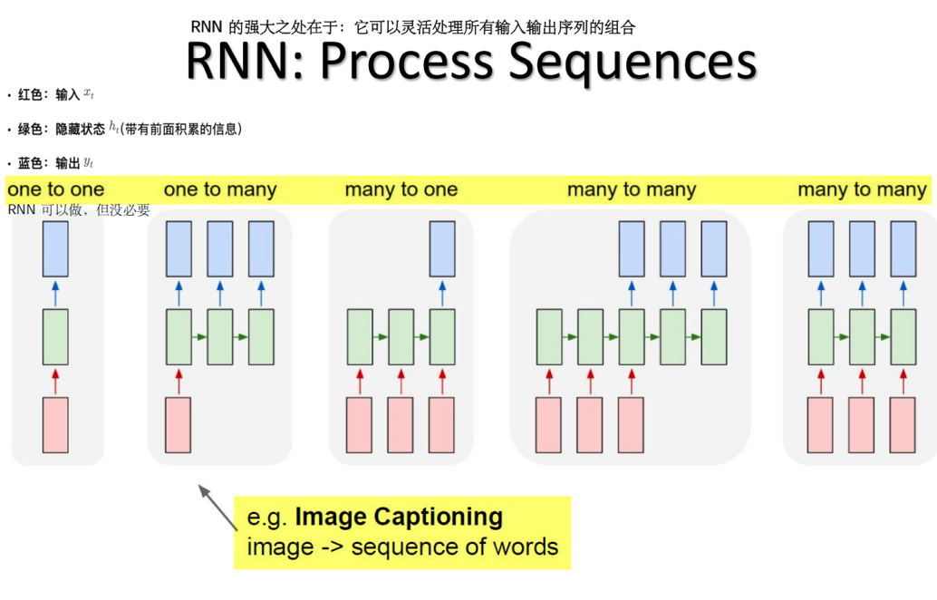
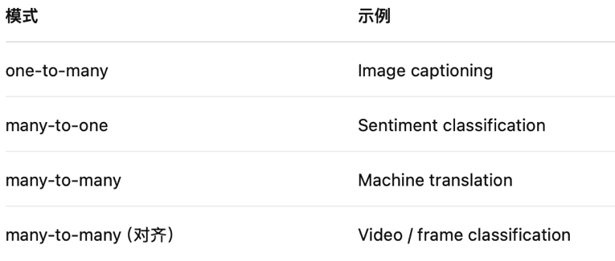

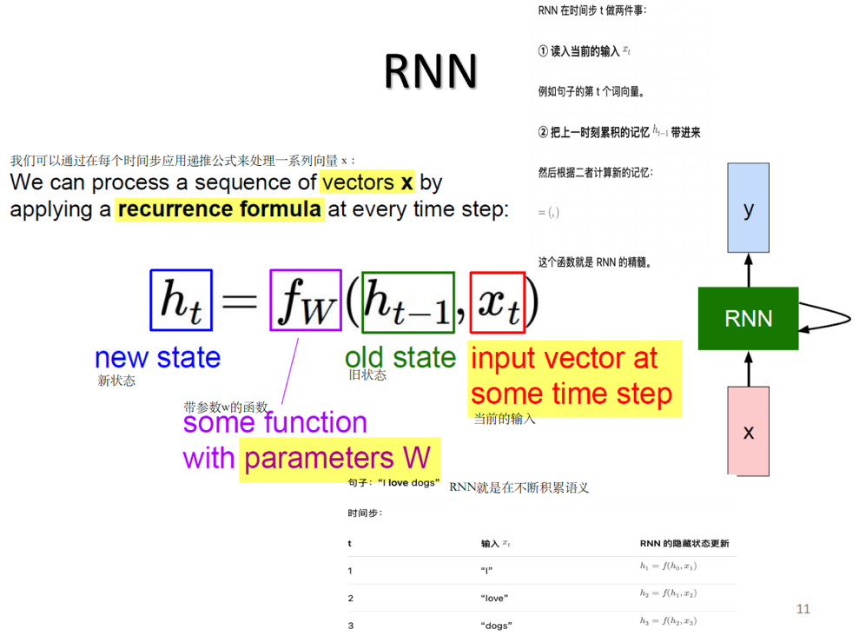
Note: The same function and the same set of parameters are used at every time step

Hidden State:
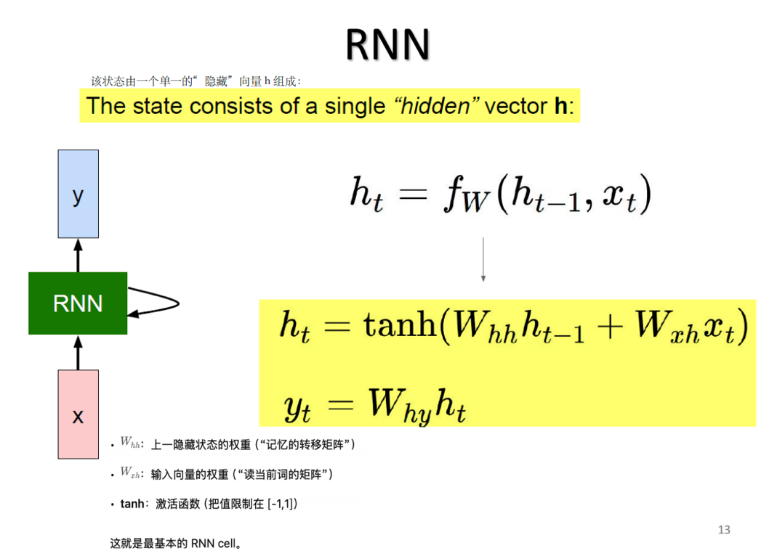

RNN: Computational Graph
- Re-use the same weight matrix at every time-step

RNN: Other design
- RNN can be designed very sophisticatedly with different layers different ways of recurrency

RNN
- In theory RNN retains information from the infinite past.
- All past hidden state has influence on the future state.
- In practice RNN has little response to the early states.
- Little memory over what seen before.
- The hidden outputs blowup or shrink to zeros.
- The “memory” also depends on activation functions.
- ReLU and Sigmoid do not work well. Tanh is OK but still not “memorize” for too long.
- Vanishing gradient problem
- Deeper layers do not have meaningful weights

Long-Term Dependency
- In theory, vanilla RNNs can handle arbitrarily long term dependence
- In practice, it’s difficult

RNN VS LSTM
- Recurrent neurons receive past recurrent outputs and current input as inputs.
- Processed through a tanh() activation function
- Current recurrent output passed to next higher layer and next time step.

LSTM
LSTM is designed to remember information over long periods of time and alleviate the vanishing gradient problem.
- Constant Error Carousel
• Key of LSTM: a remembered cell state
• Ct is the linear history carried by the constant error carousel.
• Carries information through and only effected by a gate
• Addition of history (gated).

LSTM - Gate
• A simple sigmoid function to project output in range (0, 1).
• Information is let through (~1)
• Information is not let through (~0)
• ⊗: element-wise multiplication
- Forget Gate
- The first gate determines whether to carry over the history or forget it
- Called “forget” gate.
- Actually, determine how much history to carry over.
- The memory C and hidden state h are distinguished.
- Input Gate
- The second gate has two parts
- A tanh unit determines if there is something new or interesting in the input.
- A gate decides if it is worth remembering.
- Memory Cell Update
- Add the output of input gate to the current memory cell
- After the forget gate.
- ⊕: Element-wise addition.
- Perform the forgetting and the state update
- Output and Output Gate
- The output of the memory cell
- Similar to input gate.
- A tanh unit over the memory to output in range [-1, 1].
- A sigmoid unit [0,1] decide the filtering.
- Note the memory is carried through without tanh.
- the “Peephole” Connection
- Let the memory cell directly influence the gates!

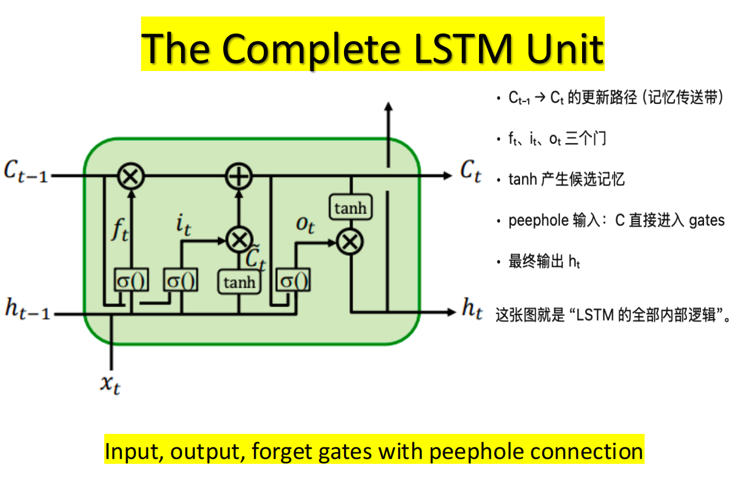

Back Propagation Through Time (BPTT)
- Forward through entire sequence to compute loss, then backward through entire sequence to compute gradient
- Truncated BPTT
- Run forward and backward through chunks of the sequence instead of whole sequence(前后来回移动)
- Carry hidden states forward in time forever but only backpropagate for some smaller number of steps(隐藏层永远向前，只进行较少反向)

Applications of LSTM
• Nowadays, considered as the default models for sequence labeling tasks.
• Does not suffer from Vanishing Gradient problem.
• Very powerful, especially in deeper networks.
• Very useful when you have a lot of data.
- Machine Translation
- Video to Text

总结:
Recurrent Neural Networks are designed to process sequential data by maintaining a hidden state that captures past information. However, vanilla RNNs suffer from vanishing gradients and have difficulty learning long-term dependencies. Long Short-Term Memory networks address this problem by introducing a memory cell and gating mechanisms that regulate information flow, allowing gradients to propagate over long sequences more effectively.

RNN remembers short-term, LSTM remembers long-term.

