The user login information is incomplete. In particular, there is missing data for 36% of users. Missing user_ids are evenly distributed among the 12,000 ids, which means that the data was lost via a systematic process and not temporary malfunction. When compared with other variables, the largest difference between observed and expected distributions was in the creation_source. Almost twice the number of personal project signups were missing, whereas for other types of signups it was a smaller fraction, and no data was missing from Google sign ups.

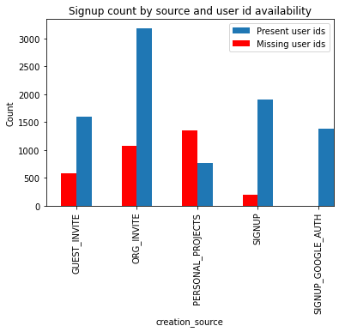

**Recommendation 1:** Based on this information the company should trace the data collection steps especially for personal project signups.

Of the remaining 64% of users 16% are adopted as per the definition of 3 logins per week. Given that 1/3 of the login data is missing it is difficult to be certain about the actual number of adopted users. Grouping user adoption variable with other variables again revealed the creation source as the only source of variation:

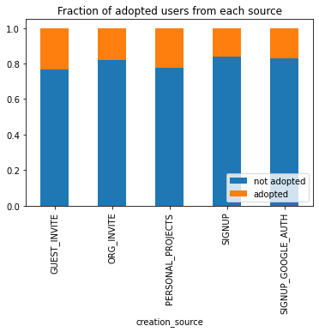

The fractions are fairly close. The preliminary observation is that users who signed up as guest invites or personal projects are more likely to be adopted.

**Recommendation 2:** If future data confirms this, the company can focus on marketing to users who sign up through guest invites and personal projects.

Contrary to expectation, email subscription or regular marketing drip subscription had no bearing on adopted user proportion.

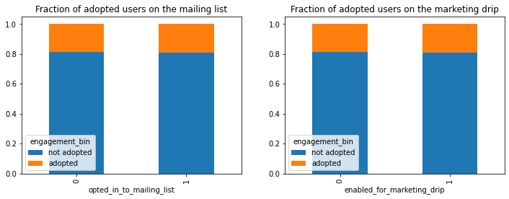

**Recommendation 3:** Do the marketing drips and emails have content relevant for users? What fraction of people unsubscribes after initial sign up? Perhaps the unsubscribe link is not obvious, so people stay subscribed but do not actually read the emails. Is there a way to confirm that the emails are actually being opened by the majority of subscribers?

On a more positive note, the account creation frequency has increased starting around October of 2013.

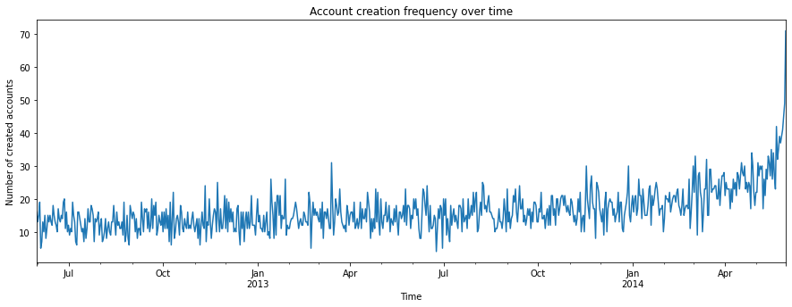

**Recommendation 4:** Review the events, marketing campaigns and promotional emails in the preceding few months to identify the potential cause.

**Recommendation 5:** The company needs to reconsider the definition of an adopted user. What if the user only signed up 3 times the first week and never signed up again? Under the current definition this user is considered adopted. Whereas another user that signed up twice per week on multiple weeks is considered not adopted. As an alternative one can consider “super” users who used the service > 50 times in 2 years. Those are 10% of the users with available data. Additionally, other metrics can be collected for login events, for example how long was the user logged in or how long was the user active. This additional information will help group the users better and perhaps send them more targeted emails.