Consumer Price Index - June 2026 | City of Tetouan
In June 2026, the consumer price index for households in the city of city of Tetouan decreased by 1,0% compared to the previous month. On an annual level, the consumer price index increased by 1,1%.

Over a month, The food product price index decreased by 1,6% in June 2026 compared to May 2026, due to the decline in prices of «Fish and Seafood» by 5,1%, «Vegetables» by 4,0%, «Fruits» by 2,8%, «Meat» by 2,4%, «Food Productsnot elsewhere classified» by 1,7% and «Milk, Cheese and Eggs» by 0,2%.
Similarly, the monthly variation of the index for the non-food products decreased by 0,5% due to drop in prices in the following divisions: «Transportation» by 3,0%, «Clothing and Shoes» by 0,9% and «Housing, Water, Gas, Electricity and Other Fuels» and «Various Goods and Services» by 0,2%. Also, the increase in prices of the following divisions: «Furniture, Household Items and Routine Home Maintenance» by 0,4% and «Restaurants and Hotels» by 0,2%. As well as, the stagnation of the indices of the other divisions did not impact the general evolution.
Over a year, the food product price index decreased by 1,3% in June 2026 compared to June 2025 , due to the decrease in the prices of «Oils and Fats» by 18,9%, «Milk, Cheese and Eggs» by 3,1%, «Vegetables» by 1,9%, «Fish and Seafood» by 0,7% and «Bread and Cereals» by 0,1%. Moreover, the rise in prices of «Meat» by 5,5%, «Tobacco» by 4,0%, «Sugar, Jam, Honey, Chocolate and Confectionery» by 1,8%, «Fruits», «Cafe and Tea and Cocoa» by 0,9% and «Mineral Waters, Soft Drinks, Fruit and Vegetable Juices (Nd)» by 0,7% and the stagnation in prices for «Food Productsnot elsewhere classified» by 0,0% did not affect the general evolution.
On the other hand, the annual variation in the non-food product index increased by 3,2%. While the price variation of the divisions that constitute non-food products fluctuated between a decrease of 1,1% for the division of «Leisure and Culture» and the rise of 10,9% for the division of «Education»
3- Annual evolution (%) of the consumer price index for the month of June
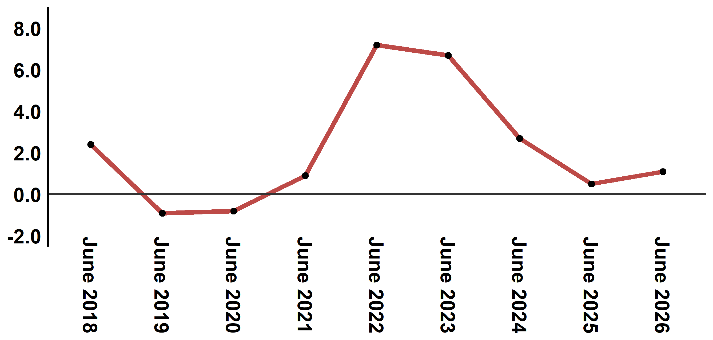
Reading: In June 2026, the consumer price index increased by 1,1% compared to June 2025
4- Evolution of the monthly variation of the consumer price index
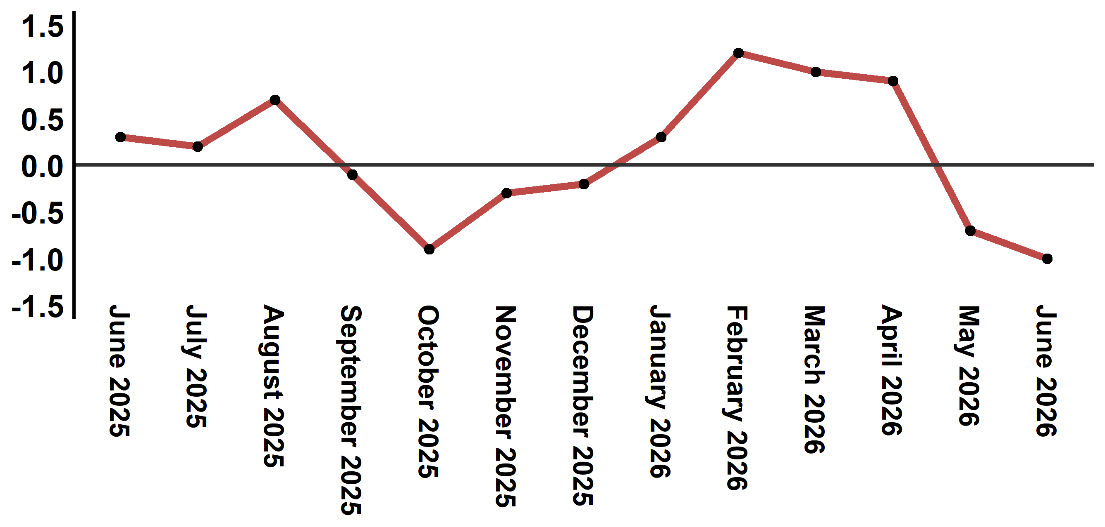
Reading: The level of price variation in June 2026 decreased by -1,0% after being -0,7% in May 2026

Table 3: Consumer price index for the city of Tetouan: June 2026 (base 2017: 100)
Product Divisions | Weightings | Monthly index |  |  |  |  | Variation (%)
Product Divisions | Weightings | June 2025 | March 2026 | April 2026 | May 2026 | June 2026 | 1 month | 3 months | 12 months
Food products | 40,725 | 133,9 | 136,3 | 136,5 | 134,2 | 132,1 | -1,6 | -3,1 | -1,3
01 – Food products and non-alcoholic | 38,964 | 133,3 | 135,7 | 135,8 | 133,4 | 131,2 | -1,6 | -3,3 | -1,6
02 –Alcoholicbeverages and tobacco | 1,761 | 146,1 | 150,5 | 152,0 | 152,0 | 152,0 | 0,0 | 1,0 | 4,0
Non foodproducts | 59,275 | 110,8 | 113,0 | 114,8 | 114,9 | 114,3 | -0,5 | 1,2 | 3,2
03 – Clothing and shoes | 5,835 | 113,2 | 114,7 | 114,0 | 113,2 | 112,2 | -0,9 | -2,2 | -0,9
04 - Housing, water, gas, electricity and other fuel | 14,202 | 109,2 | 109,5 | 109,5 | 111,0 | 110,8 | -0,2 | 1,2 | 1,5
05- Furniture, household items and routine maintenance of the home | 5,602 | 110,6 | 111,5 | 111,9 | 111,2 | 111,6 | 0,4 | 0,1 | 0,9
06 –Health | 6,594 | 103,5 | 103,4 | 103,0 | 103,0 | 103,0 | 0,0 | -0,4 | -0,5
07 – Transport | 7,416 | 110,6 | 115,0 | 127,1 | 125,6 | 121,8 | -3,0 | 5,9 | 10,1
08 – Communication | 2,560 | 97,6 | 96,8 | 97,1 | 97,3 | 97,3 | 0,0 | 0,5 | -0,3
09 – Leisure and culture | 2,432 | 106,8 | 106,3 | 106,5 | 105,6 | 105,6 | 0,0 | -0,7 | -1,1
10 –Education | 5,358 | 116,8 | 129,5 | 129,5 | 129,5 | 129,5 | 0,0 | 0,0 | 10,9
11 - Restaurants and hotels | 2,468 | 115,8 | 116,6 | 123,5 | 122,9 | 123,1 | 0,2 | 5,6 | 6,3
12 – Variousgoods and services | 6,808 | 119,3 | 121,2 | 122,1 | 122,7 | 122,4 | -0,2 | 1,0 | 2,6
General index | 100,000 | 120,3 | 122,6 | 123,7 | 122,8 | 121,6 | -1,0 | -0,8 | 1,1
Source: High Commission for Planning, Department of Statistics - National consumer price survey
Angle Avenue Ibn Tachafine et Avenue Ibn Toumart B.P.104 Tanger
****Tél:0539940698****Fax:0539940364 Site Web: www.hcp.ma/region-tanger Email:hcp.dr.tanger@hcp.ma
:::

