Information note from the regional directorate of Tangier-Tetouan-Al Hoceima
Consumer price index: city of
In January 2026, the national consumer price index increased by 0.3% compared to the previous month, while the consumer price index decreased by -0.8% over a full year.
The consumer price index experienced an increase of 0.8% during the month of January 2026 compared to the previous month. as a result of the rise in prices of «Fish and Seafood» by 10.4 %, «Tobacco» by 3.1 %, «Vegetables» by 2.7 %, «Fruits» by 0.7 %, «Meat» by 0.4 %, «Sugar, Jam, Honey, Chocolate and Confectionery», «Cafe and Tea and Cocoa» by 0.2 %, «Mineral Waters, Soft Drinks and Fruit and Vegetable Juices (Nd)» by 0.1 %
On the other hand, the monthly variation in the non-food index decreased by -0.2% due to price decreases in the following divisions: «Transportation» by -1.6 %, «Restaurants and Hotels» by -0.2 %, «Communications» by -0.1 %.
Over a year, the food product price index decreased by -2.2% in January 2026 compared to January 2025 , due to the decrease in the prices of «Oils and Fats» by -21.6 %, «Meat» by -8.6 %, «Bread and Cereals» by -1.1 %, «Milk, Cheese and Eggs», «Mineral Waters, Soft Drinks and Fruit and Vegetable Juices (Nd)» by -1 %. Moreover, the rise in prices of «Vegetables» by 13.6 %, «Fish and Seafood» by 11.9 %, «Cafe and Tea and Cocoa» by 5.8 %, «Tobacco» by 3.8 %, «Fruits» by 3.4 %, «Sugar, Jam, Honey and Chocolate and Confectionery» by 0.4 %, «Food Products N.C.A.» by 0.3 % and the stagnation in prices for did not affect the general evolution.
On the other hand, the annual variation in the non-food index increased by 0.4%. While the variation in prices of the divisions that make up non-food products fluctuated between a decrease of the division of «Transportation» by -2.9 % and the rise of the division of «Miscellaneous Goods and Services» by 2.8 %
Annual evolution (%) of the consumer price index for the month of January
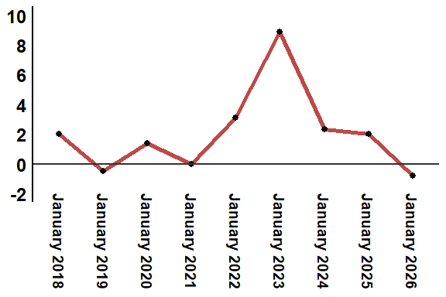
Reading: In January 2026, the consumer price index decreased by -0.8% compared to January 2025
Annual evolution (%) of the consumer price index for the month of January
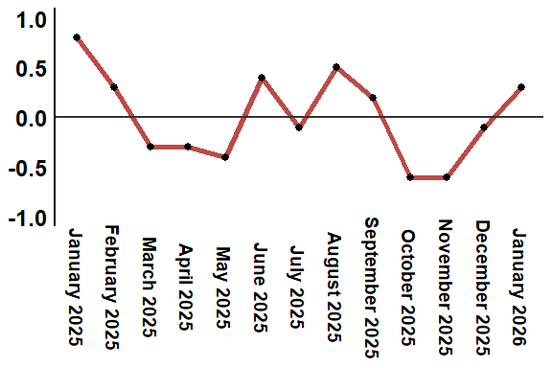
Reading: In January 2026, the consumer price index increased by 0.3% compared to December 2025
Consumer price index for the city of : January 2026 (2017 base: 100)
Product Divisions | Weightings | Monthly index |  |  |  |  | Variation (%)
 |  | January 2025 | October 2025 | November 2025 | December 2025 | January 2026 | 1 month | 3 months | 12 months
Food products | 39,009 | 132,1 | 130,3 | 128,6 | 128,2 | 129,2 | 0,8 | -0,8 | -2,2
01 – Food products and non-alcoholic | 37,502 | 131,6 | 129,7 | 127,9 | 127,5 | 128,4 | 0,7 | -1,0 | -2,4
02 –Alcoholicbeverages and tobacco | 1,507 | 144,0 | 145,0 | 145,0 | 145,0 | 149,3 | 3,0 | 3,0 | 3,7
Non foodproducts | 60,991 | 112,0 | 112,5 | 112,5 | 112,6 | 112,4 | -0,2 | -0,1 | 0,4
03 – Clothing and shoes | 4,323 | 116,4 | 117,6 | 117,4 | 117,5 | 117,5 | 0,0 | -0,1 | 0,9
04 - Housing, water, gas, electricity and other fuel | 14,575 | 108,9 | 109,5 | 109,5 | 109,6 | 109,6 | 0,0 | 0,1 | 0,6
05- Furniture, household items and routine maintenance of the home | 4,407 | 112,3 | 113,0 | 113,1 | 113,2 | 113,2 | 0,0 | 0,2 | 0,8
06 –Health | 7,741 | 101,2 | 101,5 | 101,5 | 101,5 | 101,5 | 0,0 | 0,0 | 0,3
07 – Transport | 10,040 | 117,3 | 115,9 | 115,8 | 115,7 | 113,9 | -1,6 | -1,7 | -2,9
08 – Communication | 2,958 | 104,1 | 103,8 | 103,8 | 103,8 | 103,7 | -0,1 | -0,1 | -0,4
09 – Leisure and culture | 2,735 | 105,3 | 105,0 | 104,9 | 104,9 | 104,9 | 0,0 | -0,1 | -0,4
10 –Education | 5,636 | 121,8 | 124,4 | 124,4 | 124,4 | 124,4 | 0,0 | 0,0 | 2,1
11 - Restaurants and hotels | 1,461 | 119,8 | 122,2 | 122,2 | 122,8 | 122,5 | -0,2 | 0,2 | 2,3
12 – Variousgoods and services | 7,115 | 115,9 | 117,4 | 117,8 | 117,9 | 119,1 | 1,0 | 1,4 | 2,8
General index | 100,000 | 119,9 | 119,5 | 118,8 | 118,7 | 119,0 | 0,3 | -0,4 | -0,8
Source: High Commission for Planning, Department of Statistics - National consumer price survey

